**Applet**

* Applet is a special type of program to generate a dynamic content.
* It runs inside the browser and works at client side.
* Plugins r required to client browser to execute applet.
* Hierarchy of applet:

Hierarchy of Applet

* 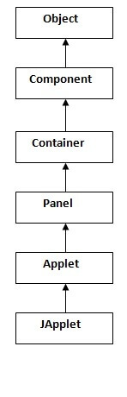
* Applet class extends Panel. Panel class extends Container which is the subclass of Component.

Life-Cycle of APPLET

1. Applet is initialized.
2. Applet is started.
3. Applet is painted.
4. Applet is stopped.
5. Applet is destroyed.

### java.applet.Applet class

1. **public void init():** is used to initialized the Applet. It is invoked only once.
2. **public void start():** is invoked after the init() method or browser is maximized. It is used to start the Applet.
3. **public void stop():** is used to stop the Applet. It is invoked when Applet is stop or browser is minimized.
4. **public void destroy():** is used to destroy the Applet. It is invoked only once.

### java.awt.Component class

1. **public void paint(Graphics g):** is used to paint the Applet. It provides Graphics class object that can be used for drawing oval, rectangle, arc etc.

There are two ways to run an applet

1. By html file.
2. By appletViewer tool

P1.html

1. <html>
2. <body>
3. <applet code="First.class" width="300" height="300">
4. </applet>
5. </body>
6. </html>

First.class:

**import** java.applet.Applet;

**import** java.awt.Graphics;

**public** **class** First **extends** Applet

{

**public** **void** paint(Graphics g)

{

g.drawString("welcome",150,150);

}

}