Packages

* group of same type of class,interface &subpackages.
* Type
  1. Built in package
  2. Udf package (java, lang, awt, javax, swing, net, io, util, sql etc.)

Advantage:

1.easy to maintain

2.access protection

3.remove name collision(naming mistake)

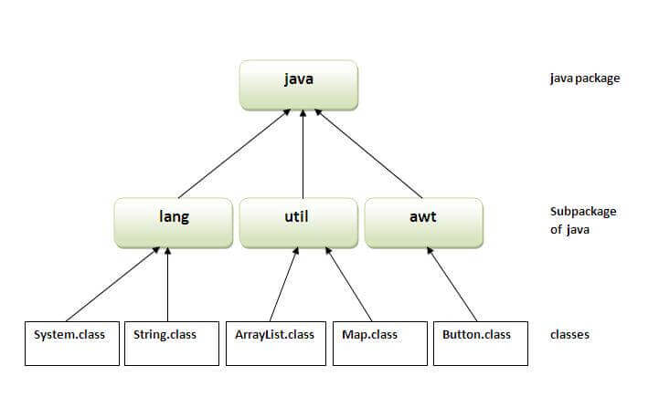

Compile packages program:

javac –d g:/java_prog/packages simple_pack.java

(make packages foder and put classfile in specified path)

run package:

java simple_packages.java

access package from another package

three ways to access the package from outside the package.

1. import package.*;
2. import package.classname;
3. fully qualified name.

**1.using package.* :-**

if you use package.* then all the classes and interfaces of this package will be **accessible** but **not subpackages.**

The import keyword is used to make the **classes and interface** of **another package accessible** to the current package.