SALESTORM
HLD
Functional requirements:
1. Customer must be able to browse products
2. Customer must be able to view the available pdts details
3. Customer can search/ find the pdts(search)
4. Able to view any sale info
5. Should be able to add the pdts to cart
6. Should be able to update the items in cart
7. Should be able to view the items in cart
8. Customer must be able to initiate the buy or purchase
9. The system must determine whether the requested quantity can be purchased(inventory check)
10. If available, if the customer wants to buy it then the pdt should be reserved(if customer clicks “buy now”)
11. System Should prevent from overselling
12. System should be able to create reservation(for reservation lifecycle)
13. System should be working with the cilent’s request
14. The system should release the expired reservation(so the ui or item count will be update with this)
15. If the payment is successful, the reservation is completed successfully
16. The system should prevent duplicate reservation
17. If reservation is valid, the system should be able to create a checkout session(to the payment gateway or platform)
18. The checkout session must be validated
19. System should be able to initiate a payment
20. Should be able to handle the successful payment
21. Should be able o handle the failure or cancellation payment
22. Should handle payment timeout or session expiry
23. System should prevent duplicate payments
24. Should be able to create order after successful purchase
25. Should maintain the order state
26. The order failure or recovery should be handled
27. On confirmation of order, the fulfilment must be initiated
28. The system should create shipment
29. Should be able to track the shipment
30. Should be able to edit the address
31. Should send purchase or order notifications
32. Apply sale rules
33. Should validate promotional rules
Non-functional requirements:
1. Scalability: ->Horizontal scalability
->The burst in traffic must be handled
-> No single-instance dependency
2. Performance: ->Low latency for normal operations(pdt browsing, card ops, and others should be responsive but under expected load
-> During flash sale or high traffic period, the latency must be controlled
-> We should focus on the inventory correctness rather than latency during high traffic.
3. Consistency: ->There should be no overselling of the pdts
-> The pdts in inventory cant be/ become negative
-> The reservation must be consistent
4. Idempotency: -> The duplicate purchase requests must be safe i.e., the system should not create multiple reservations/orders on duplicate requests
-> Duplicate payment requests should not lead to duplicate charges/ transactions
->The event processing must be idempotent
5. Availability: ->The architecture should remain available despite failure of the individual services or service instances.
->Critical services should be deployed redundantly.
6.Reliability & Fault Tolerance: -> Failure of one service should not unnecessarily bring down unrelated services.
->External dependency failure handling
->Payment success + Order failure recovery
7.Recoverability: ->Failed operations must have recovery paths
->Failed asynchronous messages must not disappear silently
8.Security: ->Authentication
-> Authorization
->HTTPS
->Rate limiting
-> Input validation
->Payment data protection
->Audit logging

9.Observability: ->Metrics
Track:
Request rate
Latency
Error rate
Inventory reservation failures
Payment failures
Order conversion
Queue backlog
->Structured logging
->Distributed tracing
->Alerts
10.Maintainability: ->Clear service boundaries
->Loose coupling
->API contracts
System architecture
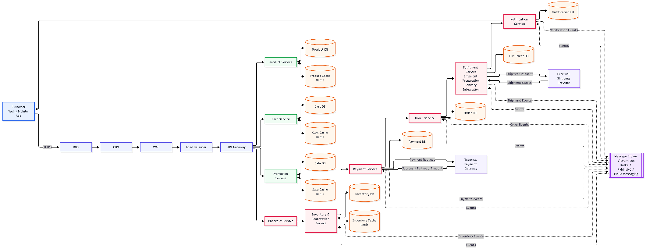

Context Diagram
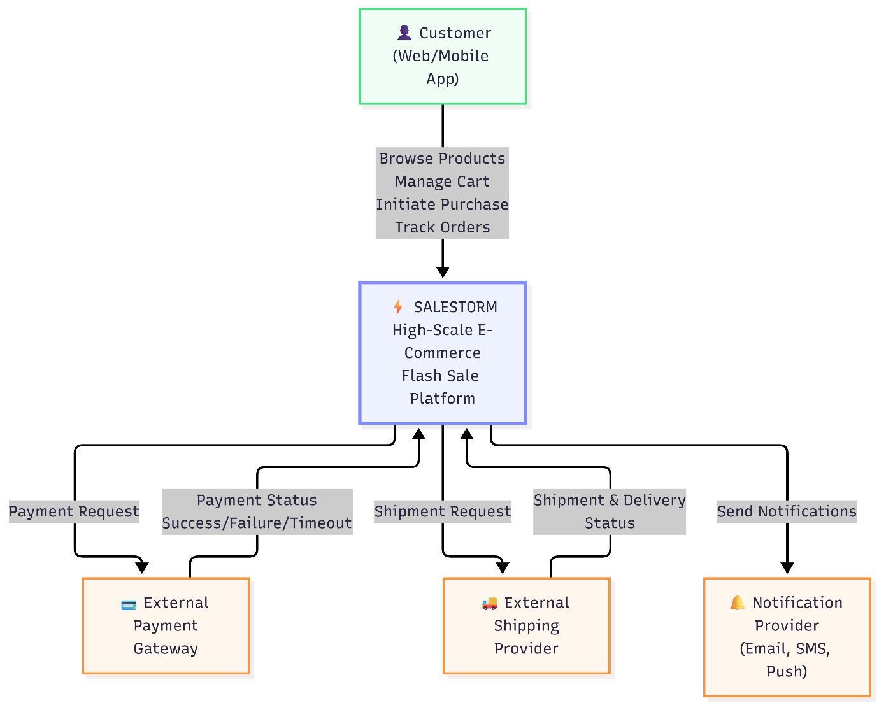

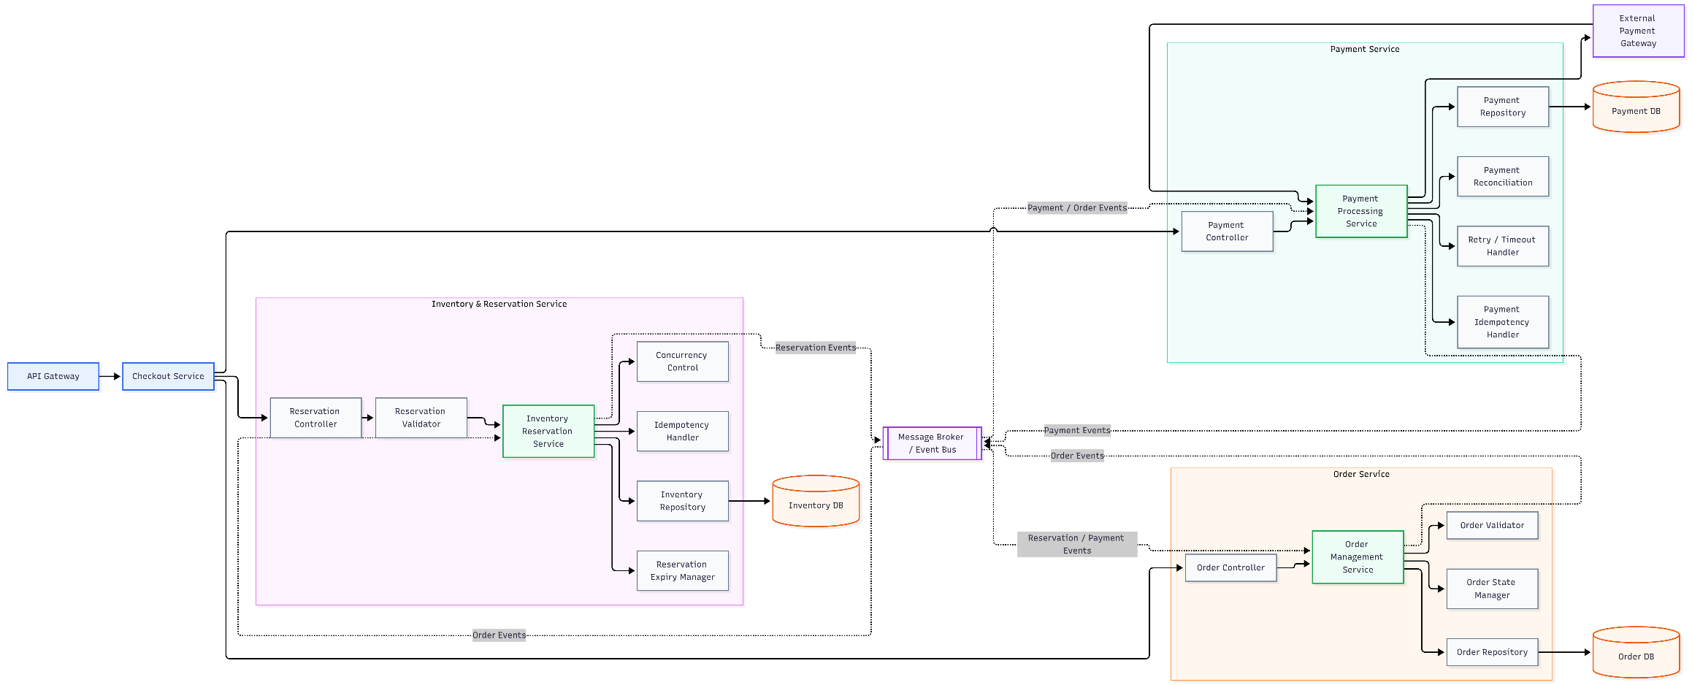
Component Diagram

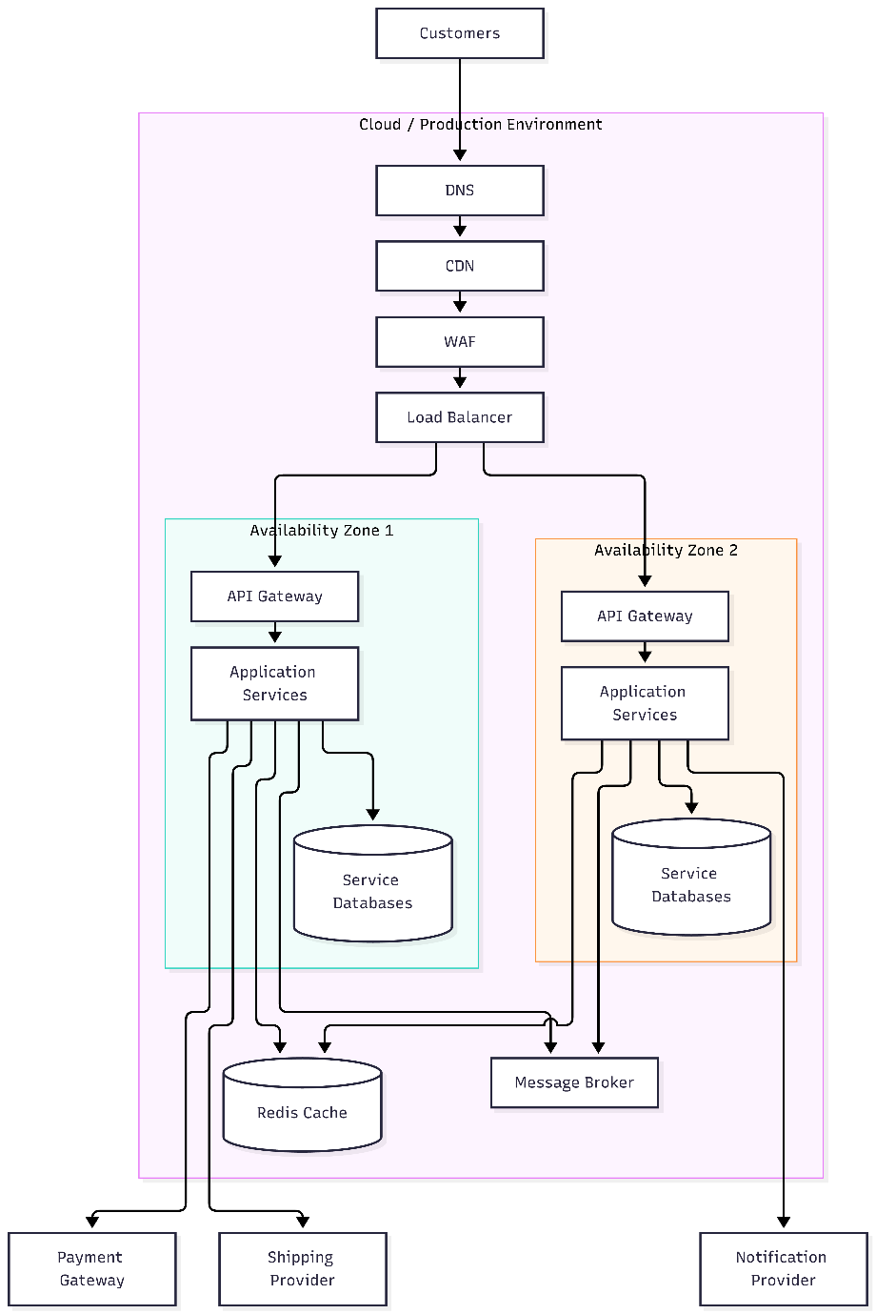
Deployment Diagram
Architecture Decision Record (ADR)

ADR | Decision
ADR-001 | Use microservices with clear service ownership
ADR-002 | Use strong consistency for inventory reservation
ADR-003 | Use synchronous communication for critical purchase steps
ADR-004 | Use asynchronous events for downstream processing
ADR-005 | Use idempotency for purchase/payment operations
ADR-006 | Deploy services across multiple availability zones
ADR-007 | Use cache for read-heavy product data, but not as inventory source of truth

Initial Service Boundaries
Service | Owns
Product | Products, categories
Cart | Cart and cart items
Sale | Deals, coupons, promotions
Checkout | Purchase orchestration
Inventory | Stock and reservations
Payment | Payment transactions
Order | Orders and order states
Fulfilment | Shipment and tracking
Notification | Notifications

Architecture Consistency Review
Flow
- Does the complete purchase flow work logically?
- Customer → Product → Cart → Inventory → Payment → Order → Shipment?
Scalability
- Can services scale horizontally?
- What happens with 10,000 simultaneous requests?
- What happens with 50× traffic?
Inventory
- Can 100 units ever become 101 successful sales?
- Are duplicate reservations prevented?
- Are expired reservations released?
Payment
- Can retry create duplicate payment?
- What happens when payment times out?
- What happens if payment succeeds but Order Service is down?
Failure
- What happens if a service crashes?
- What happens if the database is unavailable?
- What happens if a message is duplicated?
Integration
- Do APIs match?
- Do events match?
- Are service responsibilities clear?
- Are database ownership boundaries respected?
Deployment
- Are critical services redundant?
- Are there multiple availability zones?
- Is there a single accidental point of failure?

LLD

Class Diagrams:
Inventory Class Diagram
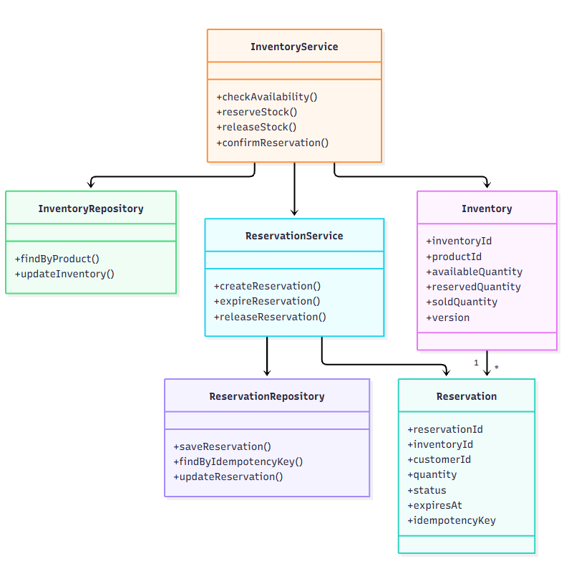

Payment Class Diagram

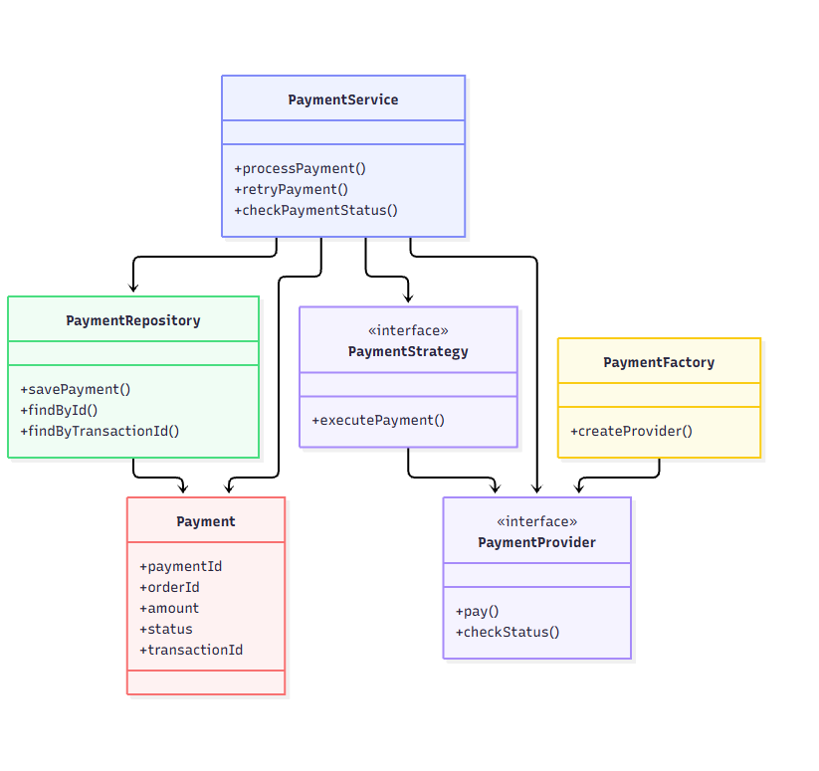

Order Class Diagram

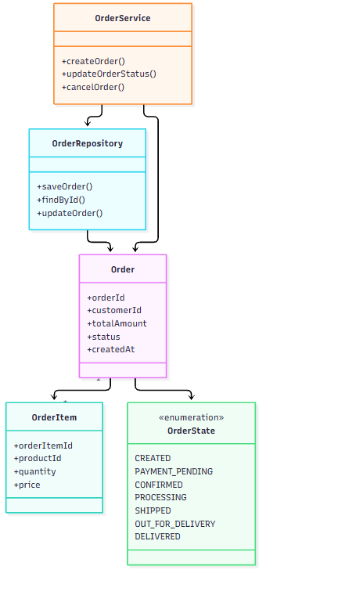
Sequence Diagrams
Purchase / Reservation Sequence
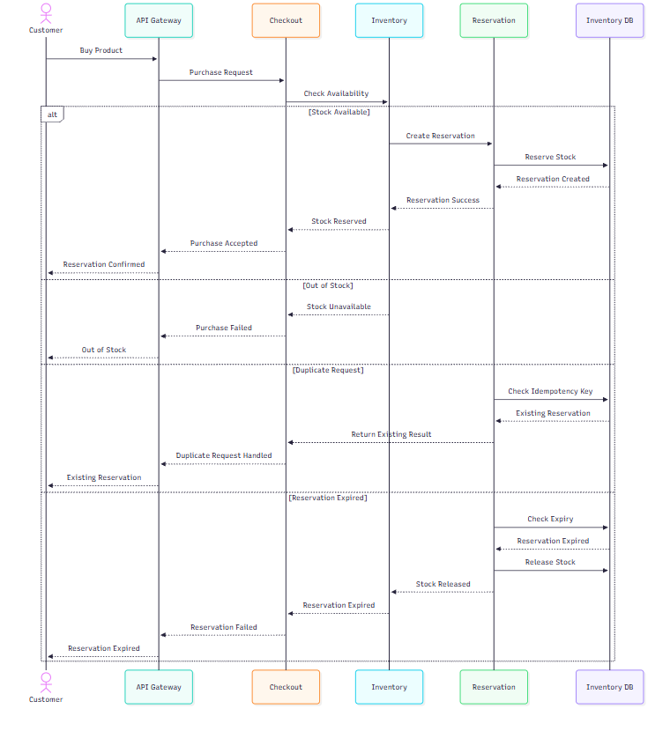
Payment Sequence
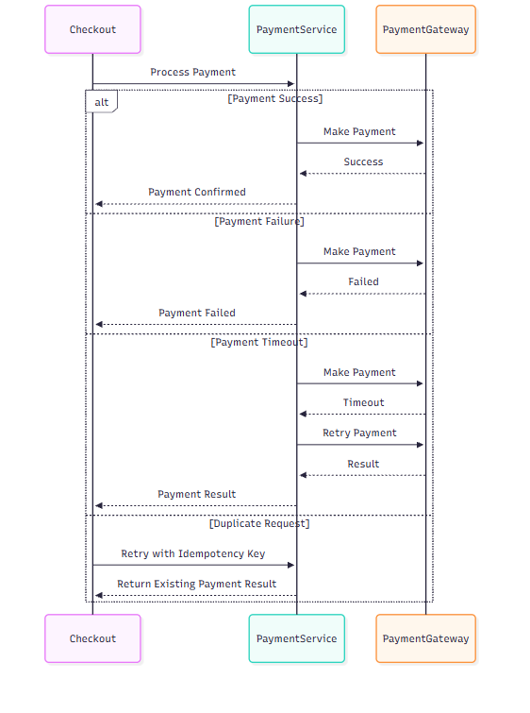

Order Creation + Recovery Sequence
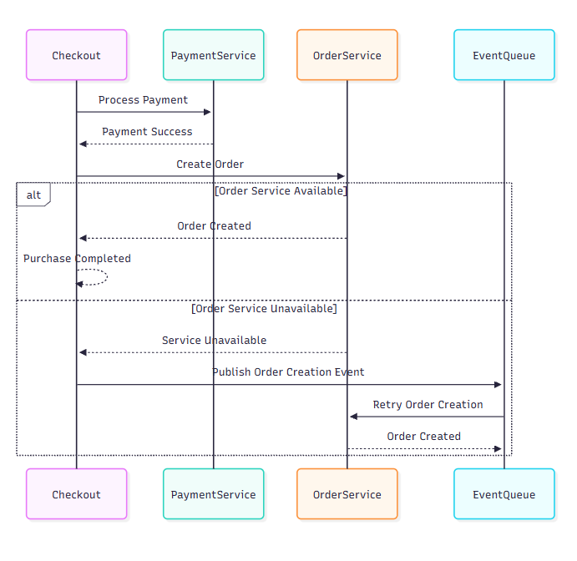

SALESTORM — SOLID Mapping
1. Single Responsibility Principle (SRP)
ClassResponsibilityPaymentServiceHandles payment processing and payment-related operationsOrderServiceHandles order creation and order lifecycle managementReservationServiceHandles reservation creation, expiry and releaseInventoryRepositoryHandles inventory data persistencePaymentRepositoryHandles payment data persistenceOrderRepositoryHandles order data persistence
Design benefit: Each class has one focused responsibility, making the system easier to maintain, test and modify. SALESTORM_SYSCRAFTERS_2026_Desi…
2. Open/Closed Principle (OCP)
PaymentService should support adding new payment strategies without modifying its core logic.
PaymentService ↓ PaymentStrategy ↙ ↘ UPI Card
Example: A new WalletPaymentStrategy can be added without changing PaymentService.
3. Liskov Substitution Principle (LSP)
Different payment providers should be replaceable through the PaymentProvider interface.
PaymentProvider ↙ ↘ ProviderA ProviderB
Any implementation of PaymentProvider should be usable wherever the interface is expected.
4. Interface Segregation Principle (ISP)
Use small, focused interfaces instead of one large interface.
PaymentProvider → pay() → checkStatus() PaymentRepository → savePayment() → findById()
Classes only depend on the operations they actually need.
5. Dependency Inversion Principle (DIP)
High-level services should depend on abstractions rather than concrete implementations.
PaymentService ↓ PaymentProvider (Interface) ↓ External Payment Provider
Similarly:
OrderService ↓ OrderRepository ↓ Database
This makes external providers and persistence implementations easier to replace. SALESTORM_SYSCRAFTERS_2026_Desi…

Design Pattern Mapping
Pattern | Problem | Where Used | Why Useful | Trade-off
Strategy | Multiple payment methods | Payment | Easy to add new methods | More classes
Factory | Provider creation | Payment | Reduces coupling | Extra logic
State | Status-based behavior | Order/Reservation | Clear state transitions | More complexity
Repository | DB access in services | Inventory/Payment/Order | Separates data access | Extra abstraction
Adapter | Different provider APIs | Payment | Common interface | Extra layer
Facade | Complex checkout flow | Checkout | Simple entry point | Can become large
Circuit Breaker | External service failure | Payment | Improves resilience | More configuration

Entity Relationship diagram
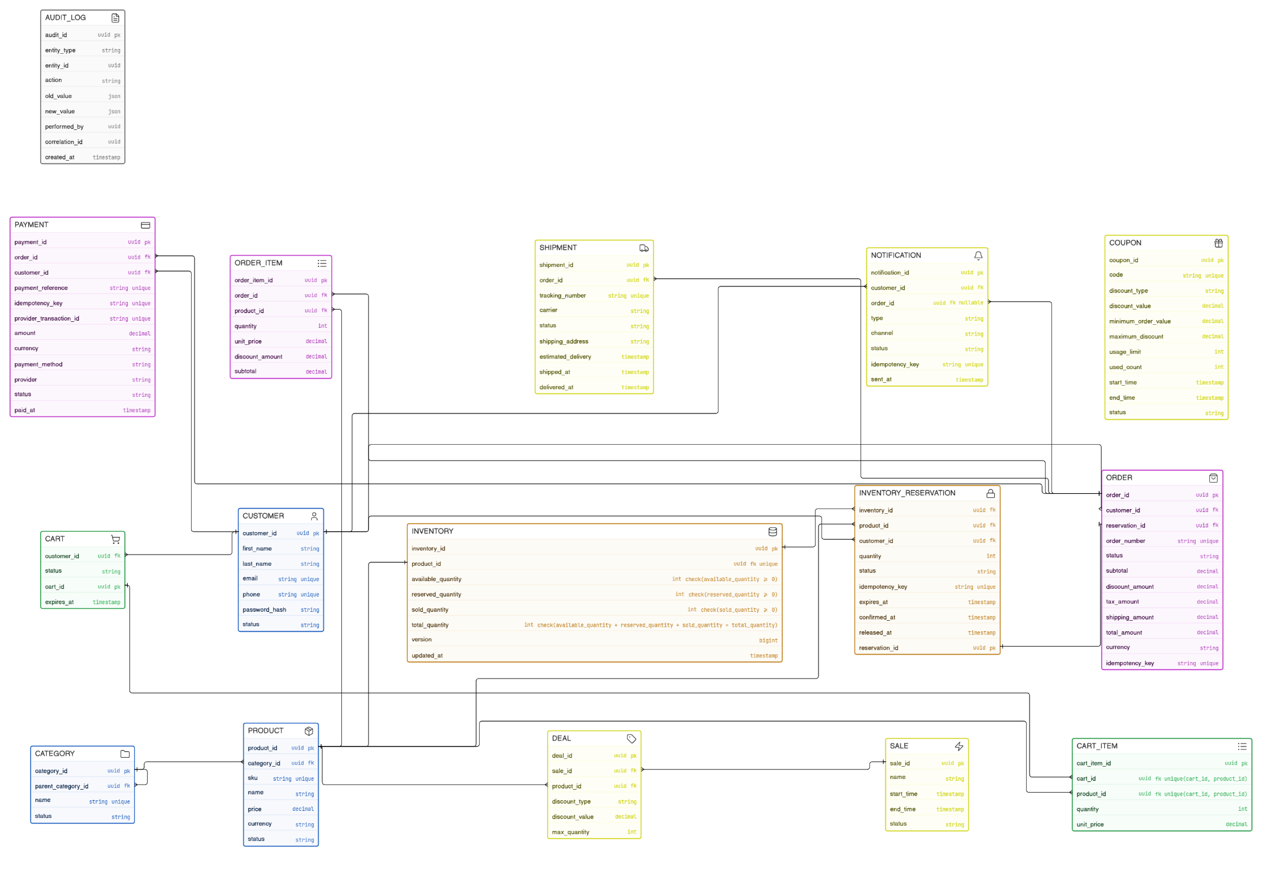

Service Integration:

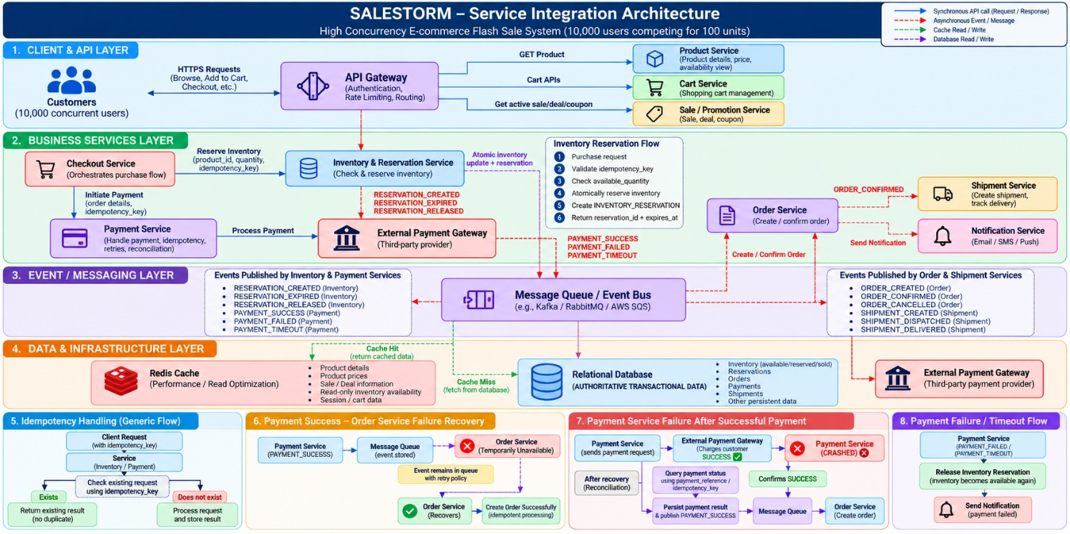

Event Specification

Event | Producer | Consumer | Purpose
RESERVATION_CREATED | Inventory & Reservation Service | Order Service / Monitoring | Inventory successfully reserved
RESERVATION_EXPIRED | Inventory & Reservation Service | Inventory Service | Reservation expired before payment completion
RESERVATION_RELEASED | Inventory & Reservation Service | Inventory Service / Order Service | Reserved inventory returned to available stock
PAYMENT_SUCCESS | Payment Service | Order Service | Payment completed successfully
PAYMENT_FAILED | Payment Service | Inventory & Reservation Service | Payment failed; reservation can be released
PAYMENT_TIMEOUT | Payment Service | Inventory & Reservation Service | Payment did not complete within the allowed time
ORDER_CREATED | Order Service | Shipment Service / Notification Service | Order has been created
ORDER_CONFIRMED | Order Service | Shipment Service / Notification Service | Order successfully confirmed
ORDER_CANCELLED | Order Service | Inventory & Reservation Service / Notification Service | Order was cancelled
SHIPMENT_CREATED | Shipment Service | Notification Service | Shipment has been created
SHIPMENT_DISPATCHED | Shipment Service | Notification Service | Shipment has been dispatched
SHIPMENT_DELIVERED | Shipment Service | Notification Service | Shipment has been delivered

Event Ownership

Event | Event Owner / Producer | Responsibility
RESERVATION_CREATED | Inventory & Reservation Service | Owns inventory reservation lifecycle
RESERVATION_EXPIRED | Inventory & Reservation Service | Detects expired reservations and releases stock
RESERVATION_RELEASED | Inventory & Reservation Service | Confirms reserved stock has been released
PAYMENT_SUCCESS | Payment Service | Owns payment status and confirms successful payment
PAYMENT_FAILED | Payment Service | Records and publishes payment failure
PAYMENT_TIMEOUT | Payment Service | Detects and publishes payment timeout
ORDER_CREATED | Order Service | Owns order creation and lifecycle
ORDER_CONFIRMED | Order Service | Confirms the order after successful payment
ORDER_CANCELLED | Order Service | Owns order cancellation
SHIPMENT_CREATED | Shipment Service | Owns shipment creation
SHIPMENT_DISPATCHED | Shipment Service | Owns shipment dispatch status
SHIPMENT_DELIVERED | Shipment Service | Owns final delivery status

Idempotency Contracts
1. Purpose
Idempotency contracts define how SALESTORM handles repeated requests safely. In a high-concurrency flash-sale environment, network retries, client retries, duplicate clicks, or service retries can cause the same operation to be submitted multiple times.
The system must ensure that repeating the same operation does not create duplicate business effects.

2. Idempotency Key
Each critical request contains an idempotency_key.
The key uniquely identifies a business operation from the client or calling service.
Example:
POST /inventory/reserve
X-Idempotency-Key: RES-12345

If the same request is received again with RES-12345, the service must return the result of the original operation instead of executing it again.

3. Inventory Reservation Contract
Operation: Reserve Inventory
Idempotency key: idempotency_key
Behaviour
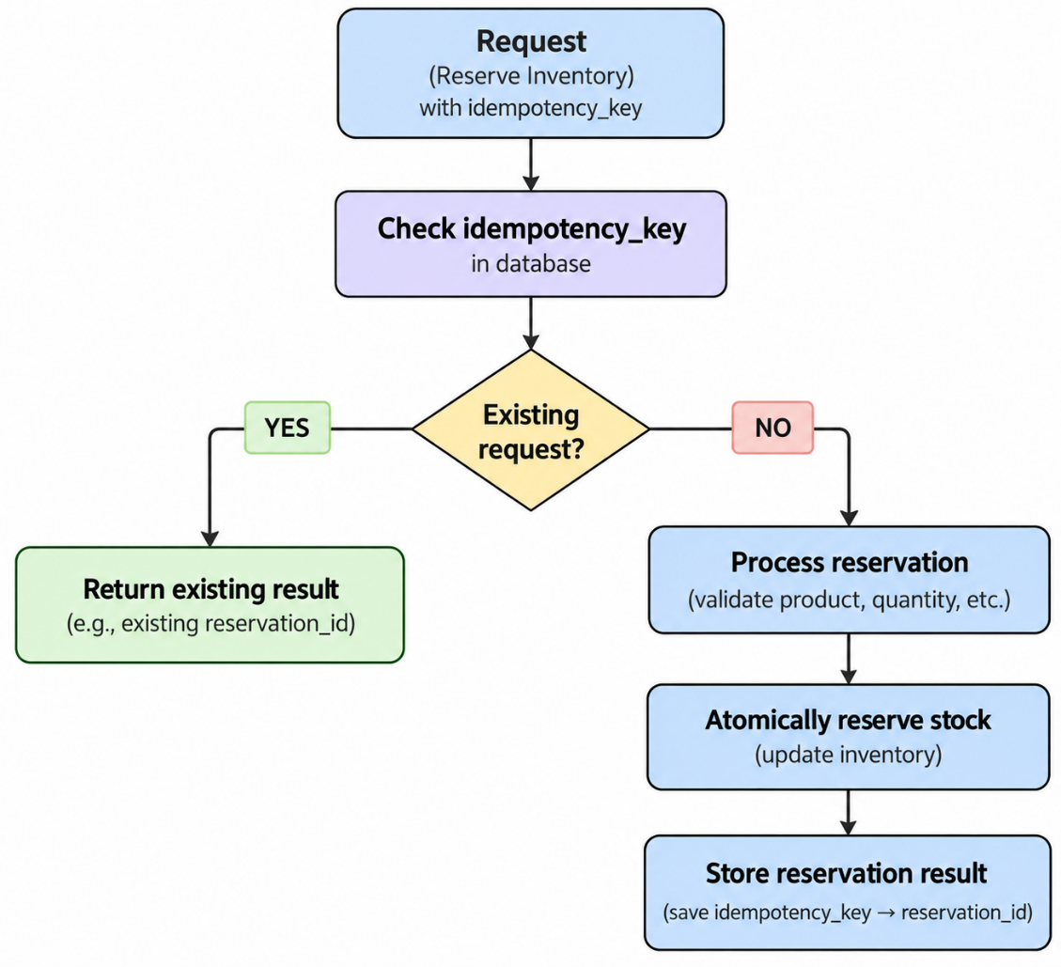
Contract
- The same idempotency_key must not create multiple reservations.
- A successful retry returns the existing reservation_id.
- Inventory must be decremented only once.
- The idempotency key should have a unique constraint in the database.

4. Payment Idempotency Contract
Operation: Process Payment
Idempotency key: idempotency_key
Behaviour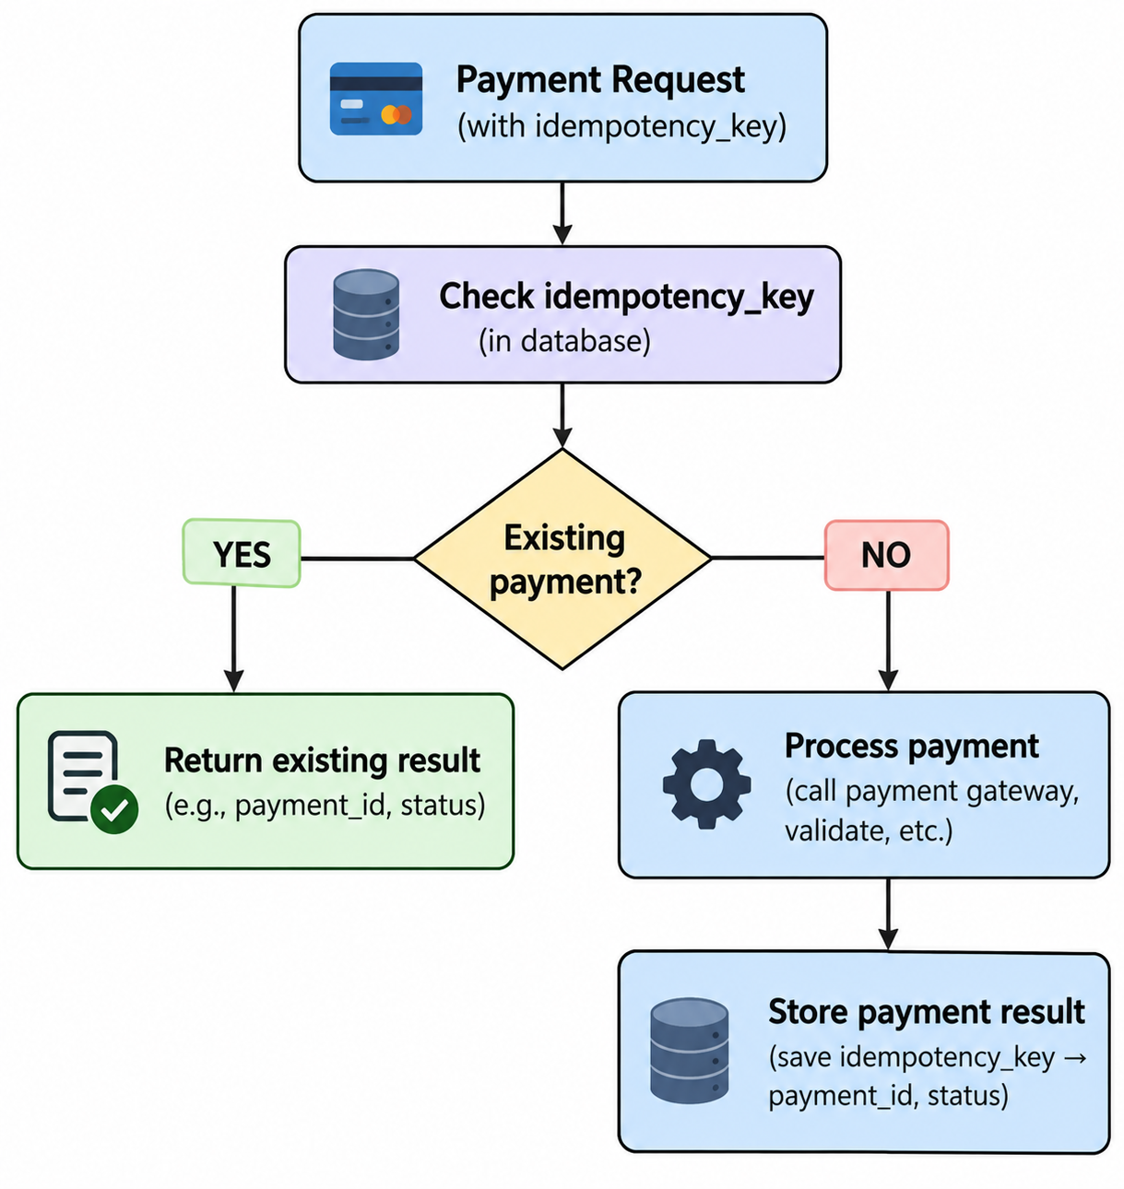

Contract
- The same payment request must not charge the customer twice.
- A retry with the same key returns the existing payment result.
- The payment provider transaction reference should also be stored.
- Payment status must be persisted before downstream processing.
- If the Payment Service fails after the customer is charged, the payment must be reconciled using the payment reference/idempotency key.

5. Order Idempotency Contract
Operation: Create Order
Idempotency key: idempotency_key
Contract
- The same payment success must not create multiple orders.
- Repeated CreateOrder requests return the existing order_id.
- The database should enforce uniqueness on the idempotency key.
- Order creation should be safe to retry after service failures.

6. Event Processing Idempotency
Events may also be delivered more than once because message processing can be retried.
Each event contains a unique event_id.
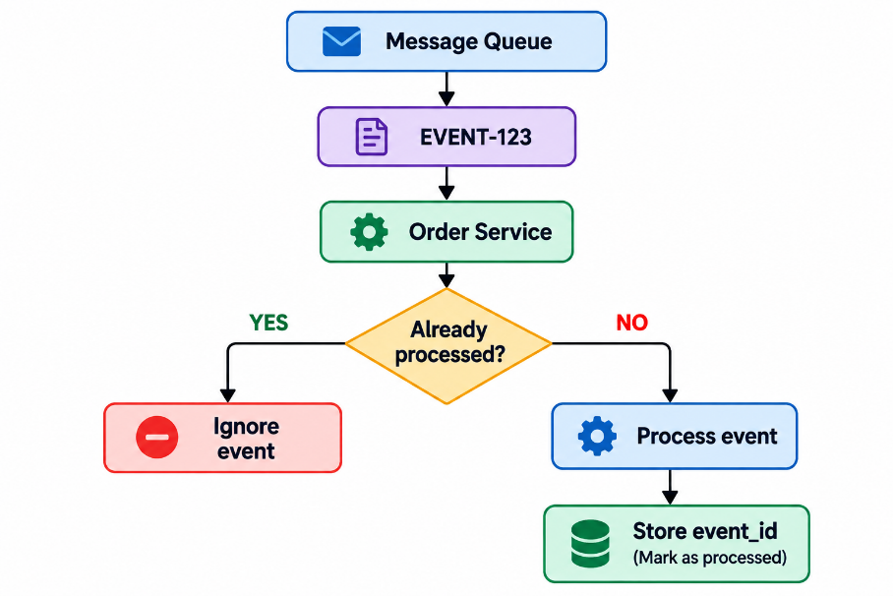
Contract
A consumer must process the same event_id only once.

7. Database Enforcement
Idempotency should not depend only on application code.
The relational database should enforce uniqueness using constraints such as:
UNIQUE(idempotency_key)
UNIQUE(event_id)
This provides an additional safeguard against concurrent duplicate requests.

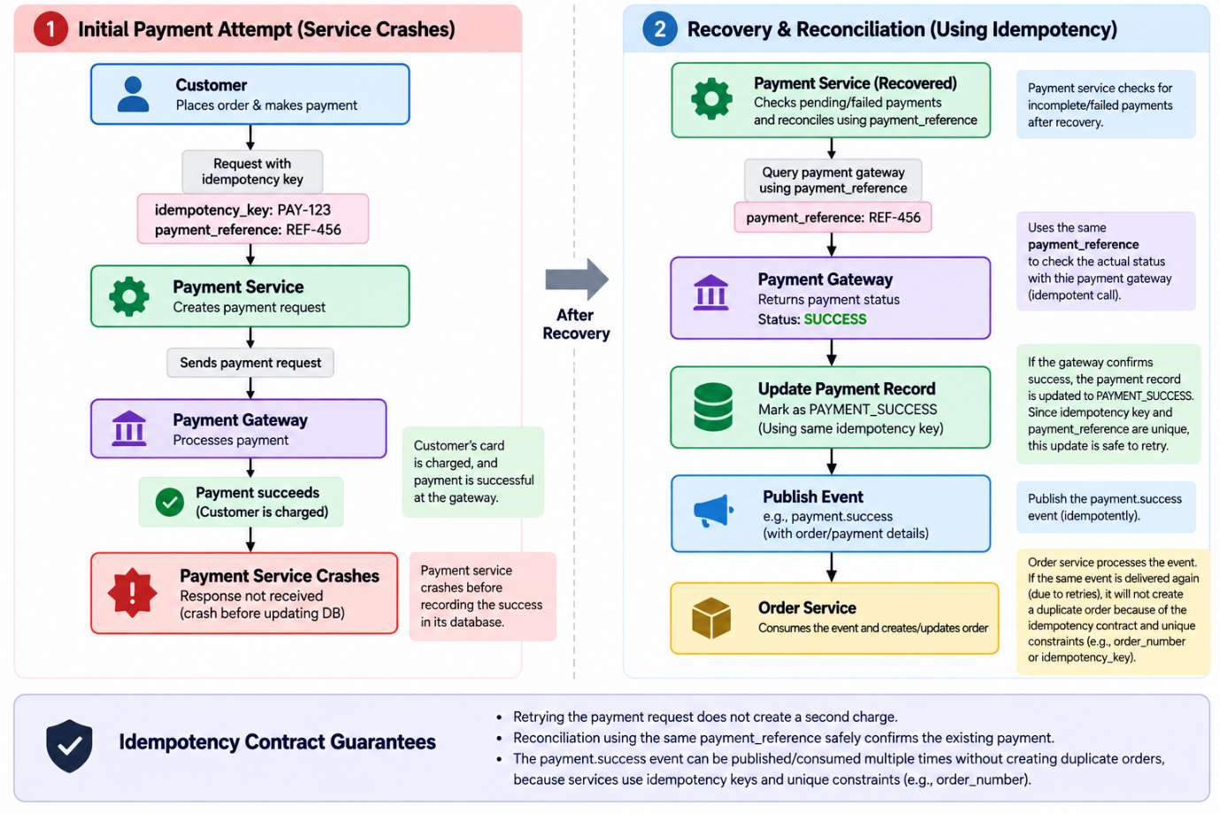

API Specification
The SALESTORM API layer provides REST-based interfaces for product discovery, cart management, inventory reservation, checkout, payment, order processing, and shipment tracking. Critical write operations use idempotency keys to prevent duplicate reservations, payments, and orders.
The API design supports the flash-sale scenario where 10,000 concurrent customers compete for 100 units and inventory must remain consistent under concurrent requests.
1.API Conventions

Item | Specification
Protocol | HTTPS
API Style | REST
Data Format | JSON
Authentication | JWT / OAuth 2.0
Identifier Format | UUID
Idempotency Header | X-Idempotency-Key
Correlation Header | X-Correlation-ID
Success Format | JSON
Error Format | Standard error response
Versioning | /api/v1/...

2. Product APIs
Method | Endpoint | Purpose
GET | /api/v1/products | List products
GET | /api/v1/products/{productId} | Get product details
GET | /api/v1/products/{productId}/availability | Get read-only inventory availability

Communication: Synchronous.
Product reads can use Redis cache to reduce database load.

3. Cart APIs
Method | Endpoint | Purpose
POST | /api/v1/carts | Create customer cart
GET | /api/v1/carts/{cartId} | Get cart
POST | /api/v1/carts/{cartId}/items | Add product to cart
PUT | /api/v1/carts/{cartId}/items/{itemId} | Update quantity
DELETE | /api/v1/carts/{cartId}/items/{itemId} | Remove item

Communication: Synchronous.
4. Inventory Reservation API
Reserve Inventory
POST /api/v1/inventory/reservations

Required header:
X-Idempotency-Key: <unique-key>

Request:
{
"product_id": "prod-001",
"customer_id": "cust-001",
"quantity": 1
}

Successful response:
{
"reservation_id": "res-001",
"product_id": "prod-001",
"quantity": 1,
"status": "RESERVED",
"expires_at": "2026-10-05T15:05:00Z"
}

Contract
- Validate idempotency_key.
- Check available_quantity.
- Atomically reserve inventory.
- Create INVENTORY_RESERVATION.
- Return reservation_id and expires_at.
- Repeated requests with the same key return the existing reservation rather than reserving stock again.
The reservation lifecycle includes RESERVED, PAYMENT_PENDING, CONFIRMED, PAYMENT_FAILED, EXPIRED, and RELEASED

5. Release Reservation API

POST /api/v1/inventory/reservations/{reservationId}/release

Purpose: Release reserved stock after payment failure, timeout, or reservation expiry.
Response:
{
"reservation_id": "res-001",
"status": "RELEASED"
}

6. Checkout API
POST /api/v1/checkout
Required header:
X-Idempotency-Key: <unique-key>
Request:
{
"customer_id": "cust-001",
"cart_id": "cart-001",
"reservation_id": "res-001",
"coupon_code": "FLASH20"
}
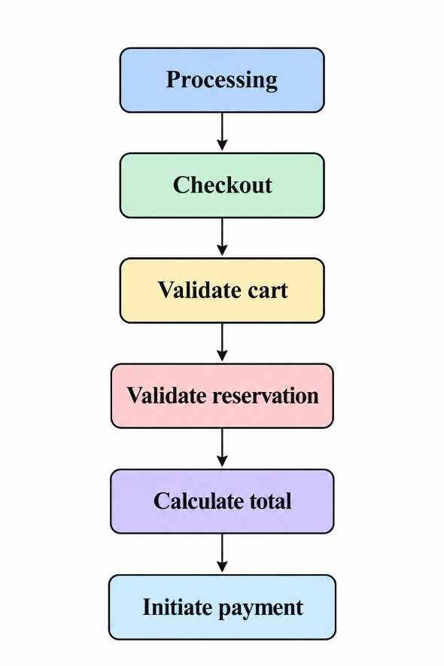

Checkout coordinates the critical purchase flow but does not become the authoritative owner of inventory or payment state.

7. Payment APIs
Initiate Payment
POST /api/v1/payments
X-Idempotency-Key: PAY-12345
Request
{
"order_id": "ord-001",
"amount": 999.00,
"currency": "INR",
"payment_method": "CARD"
}
Response
{
"payment_id": "pay-001",
"payment_reference": "PAY-REF-001",
"status": "PENDING"
}
The payment model supports INITIATED, PENDING, SUCCESS, FAILED, TIMEOUT, and REFUNDED states.
Payment Idempotency
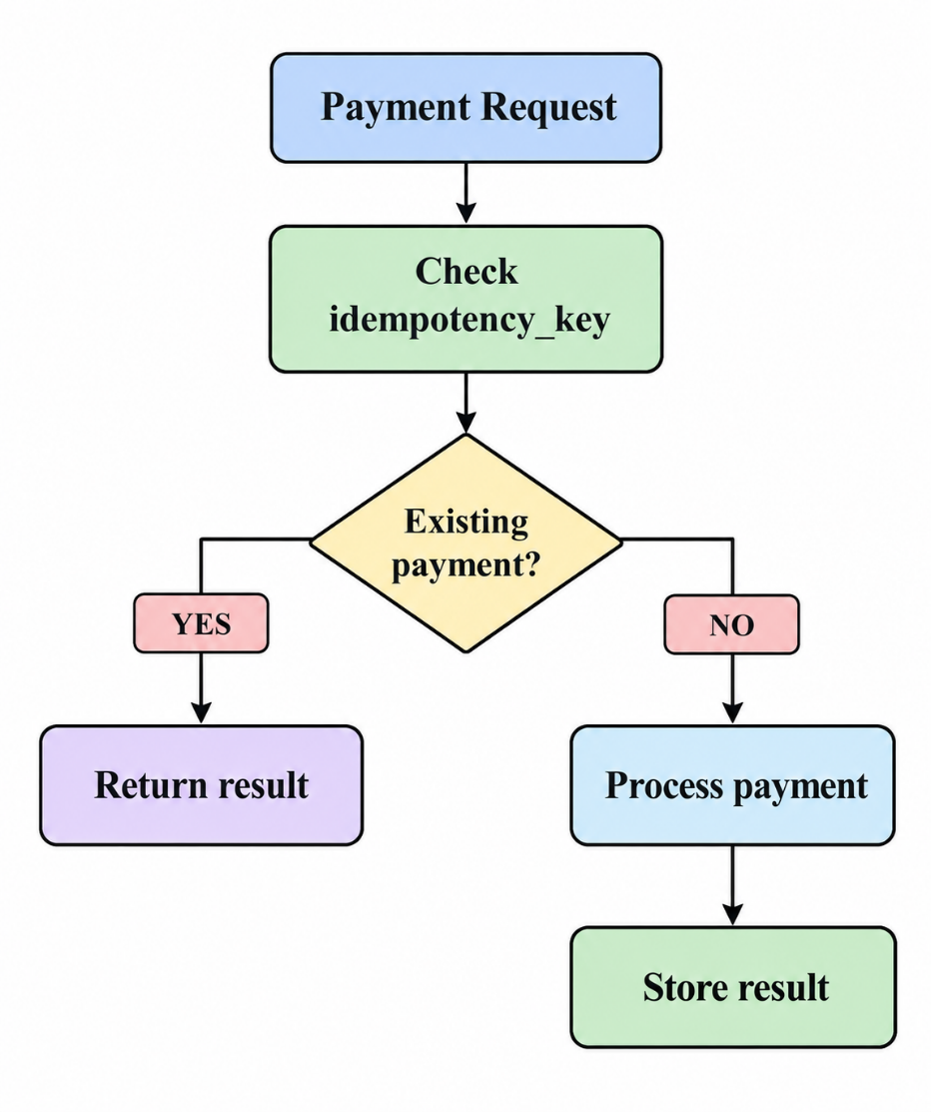

The same idempotency key must never cause the customer to be charged twice.

8. Order APIs
Method | Endpoint | Purpose
POST | /api/v1/orders | Create order
GET | /api/v1/orders/{orderId} | Get order details
POST | /api/v1/orders/{orderId}/cancel | Cancel order

Order Creation
Order creation occurs after successful payment processing.

PAYMENT_SUCCESS
↓
Message Queue
↓
Order Service
↓
Create Order

The order lifecycle is:
CREATED
↓
PAYMENT_PENDING
↓
CONFIRMED
↓
PROCESSING
↓
SHIPPED
↓
OUT_FOR_DELIVERY
↓
DELIVERED

CANCELLED and PAYMENT_FAILED can be handled as failure states.

9. Shipment APIs
Method | Endpoint | Purpose
GET | /api/v1/shipments/{shipmentId} | Get shipment status
GET | /api/v1/orders/{orderId}/shipment | Get order shipment
GET | /api/v1/shipments/{shipmentId}/tracking | Get tracking information

Shipment processing is triggered asynchronously after order confirmation.

ORDER_CONFIRMED
↓
Message Queue
↓
Shipment Service

10. Idempotency Contracts

Idempotency prevents duplicate business operations when requests are retried.
Operation | Idempotency Mechanism | Expected Behaviour
Inventory Reservation | X-Idempotency-Key | Return existing reservation
Payment | X-Idempotency-Key | Return existing payment result
Order Creation | X-Idempotency-Key | Return existing order
Event Processing | event_id | Do not process duplicate event

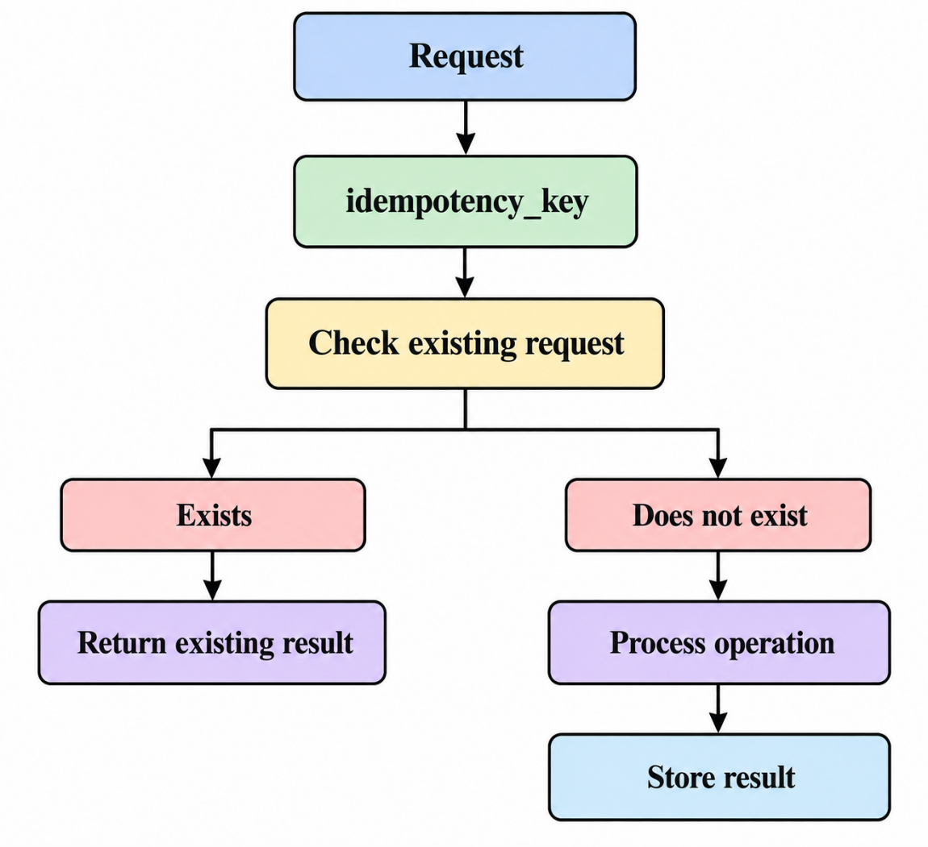

11. Synchronous vs Asynchronous Communication
Synchronous
Used when the caller needs an immediate response.
From | To | Operation
API Gateway | Product Service | Get Product
API Gateway | Cart Service | Cart APIs
Checkout | Inventory Service | Reserve Inventory
Inventory Service | Database | Atomic inventory update
Checkout | Payment Service | Initiate Payment
Payment Service | Payment Gateway | Process Payment

Asynchronous
Used for downstream processing, retries, and failure recovery.
Producer | Event | Consumer
Inventory Service | RESERVATION_CREATED | Interested services
Inventory Service | RESERVATION_EXPIRED | Inventory processing
Payment Service | PAYMENT_SUCCESS | Order Service
Payment Service | PAYMENT_FAILED | Inventory Service
Order Service | ORDER_CONFIRMED | Shipment / Notification
Shipment Service | SHIPMENT_DELIVERED | Notification

The architecture uses asynchronous messaging to decouple downstream services and support retry/recovery.

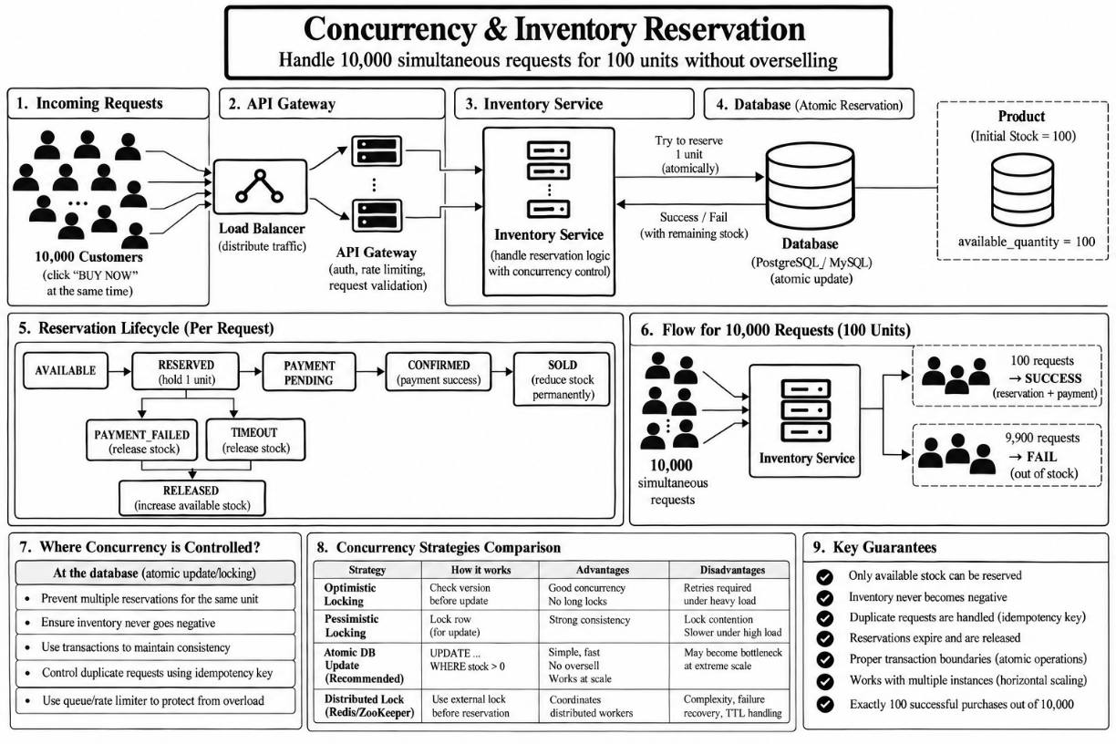
1)

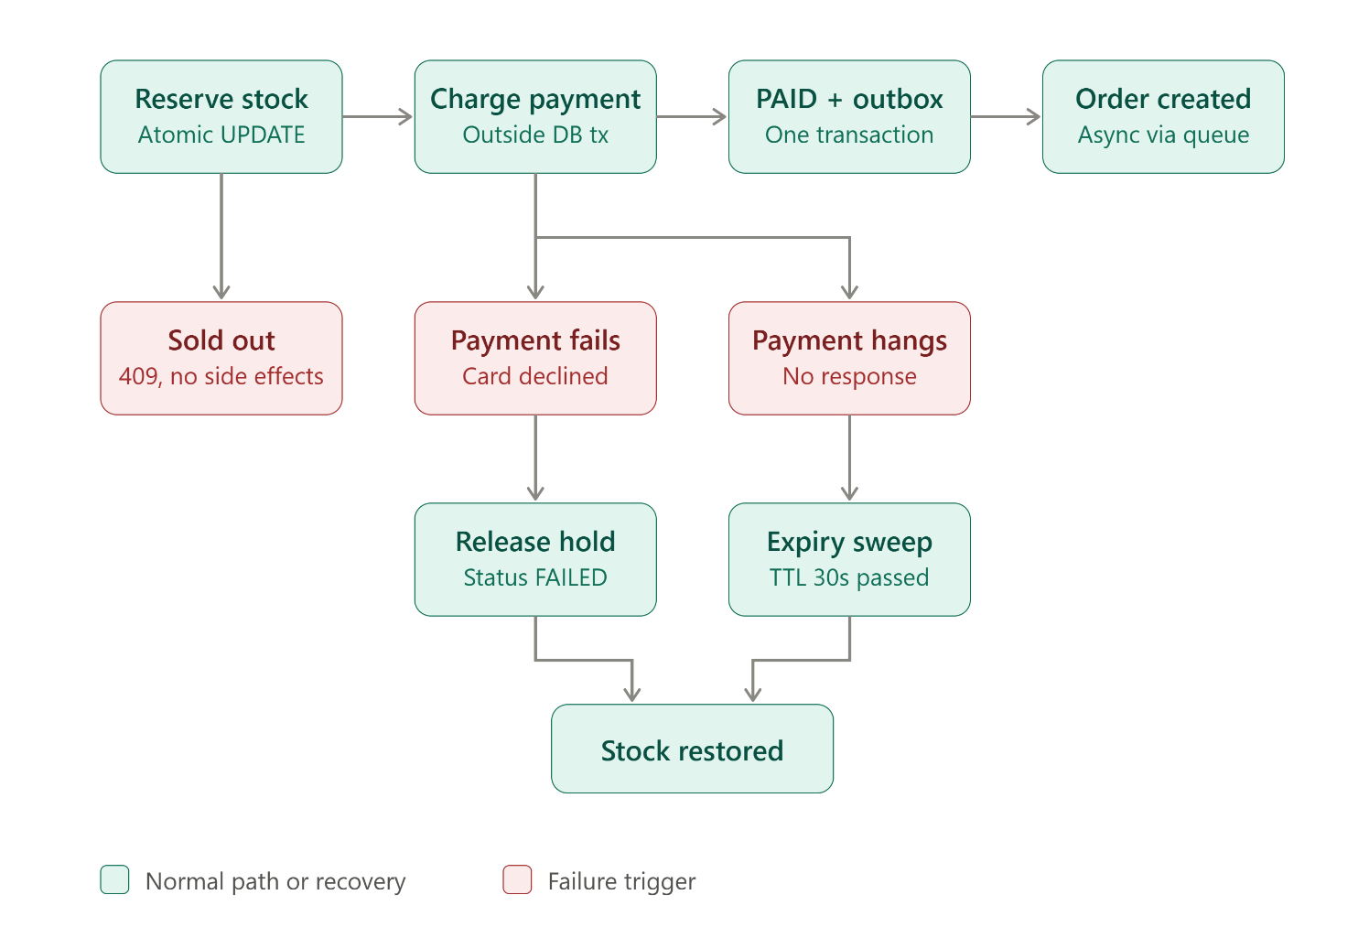
2) Failure Handling & Recovery

3) Scalability & Reliability Design:

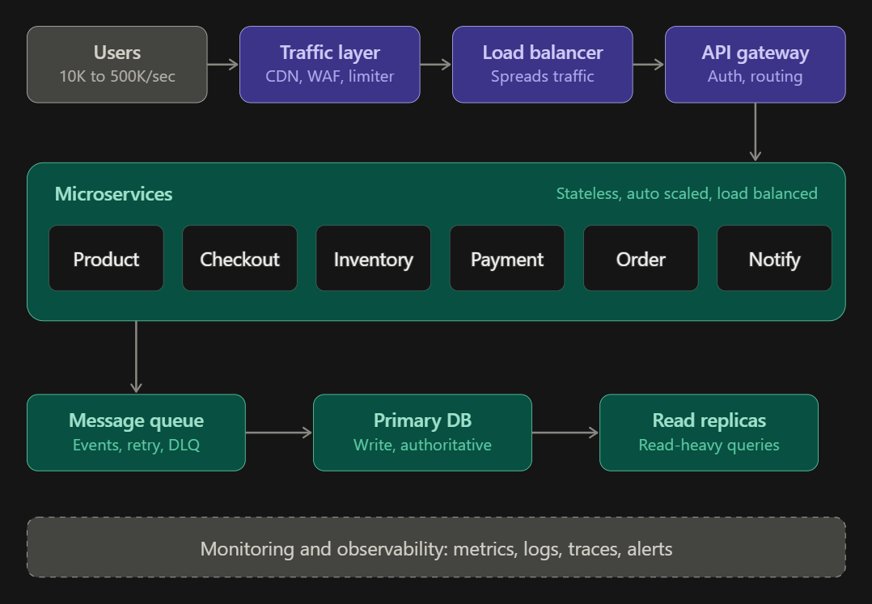

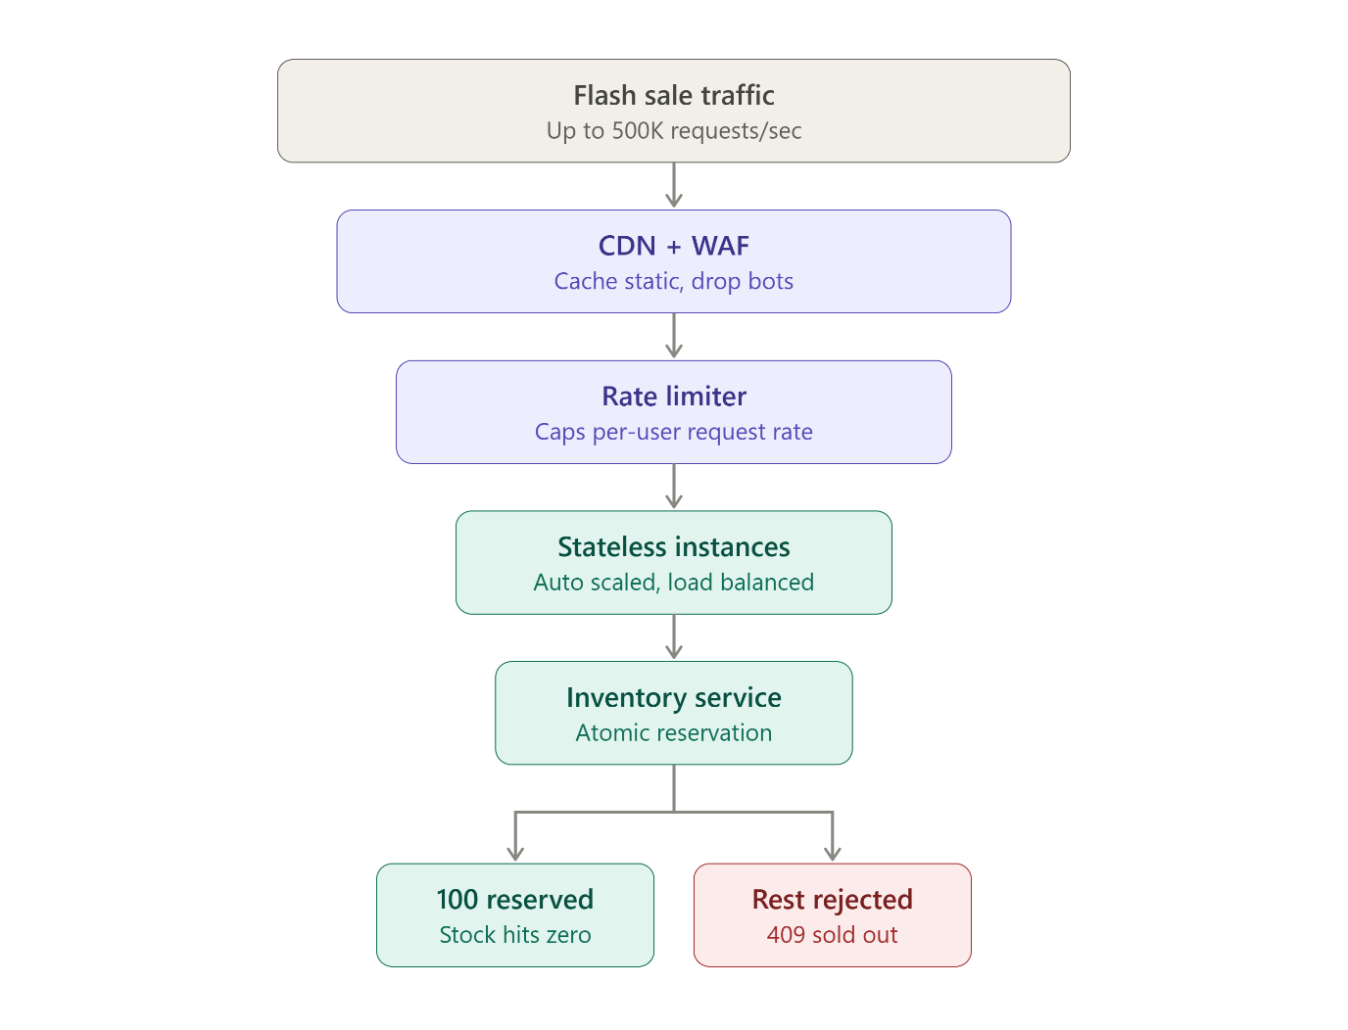

4)

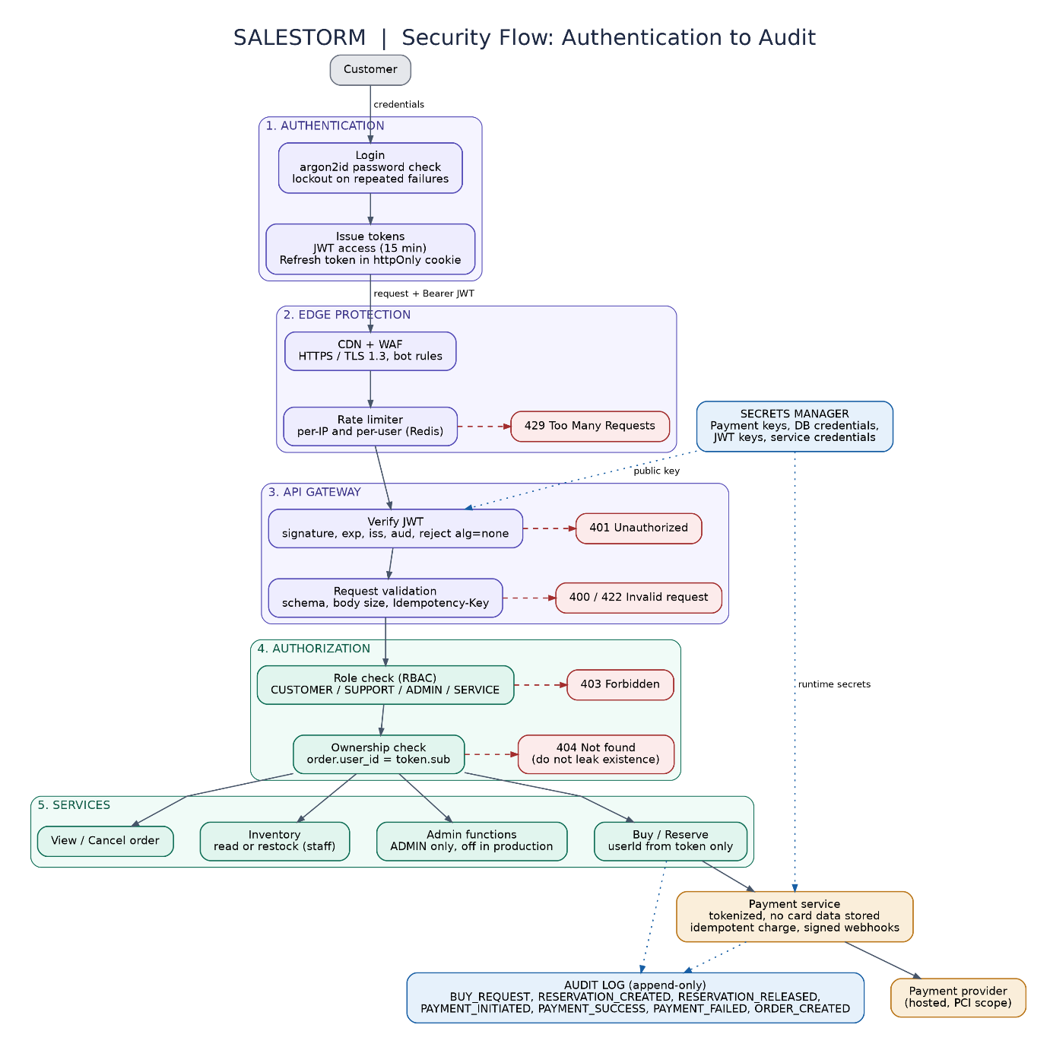

4)

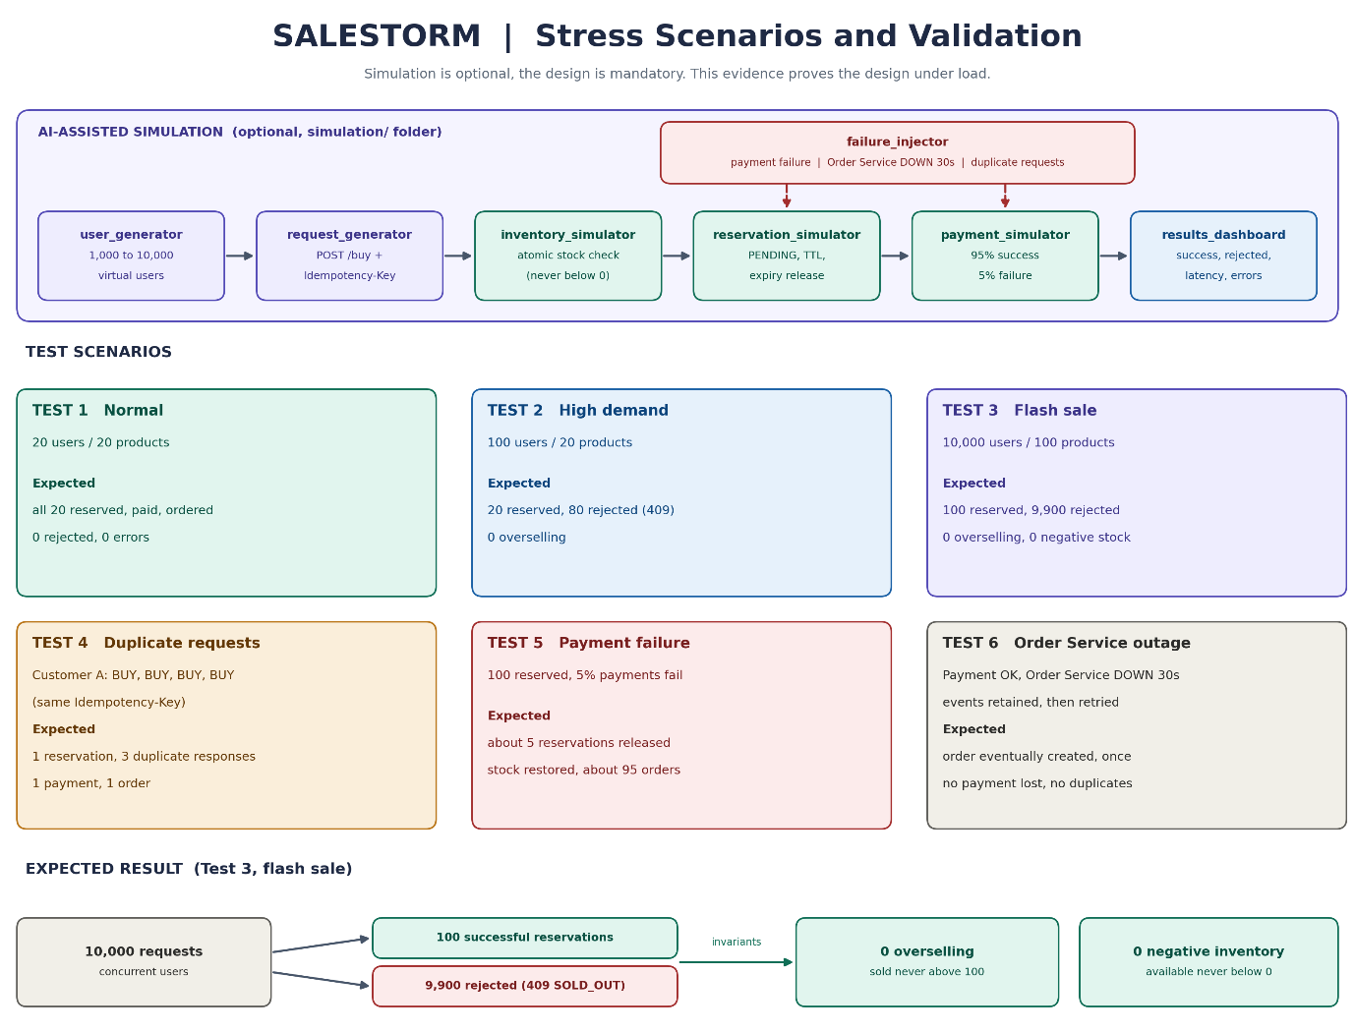
5)

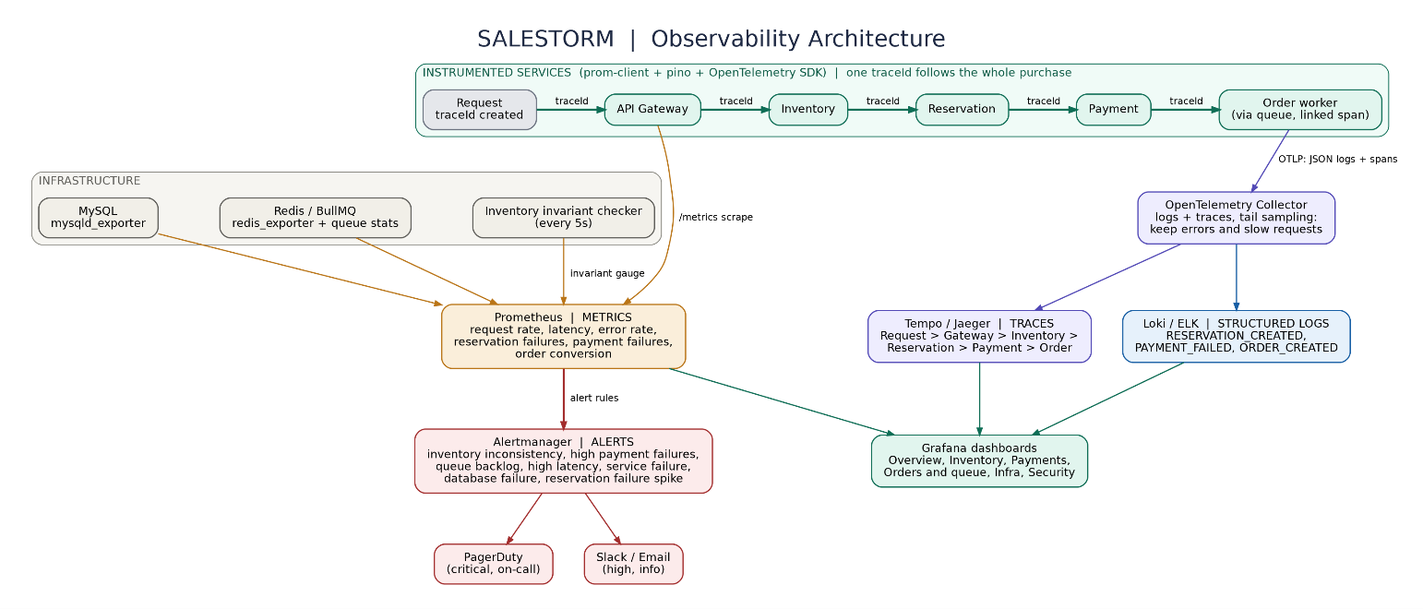
6)

