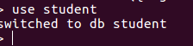
1) Create a Database called student?

2) Create a collection called studentmarks?



3) Create the documents listed in above table?
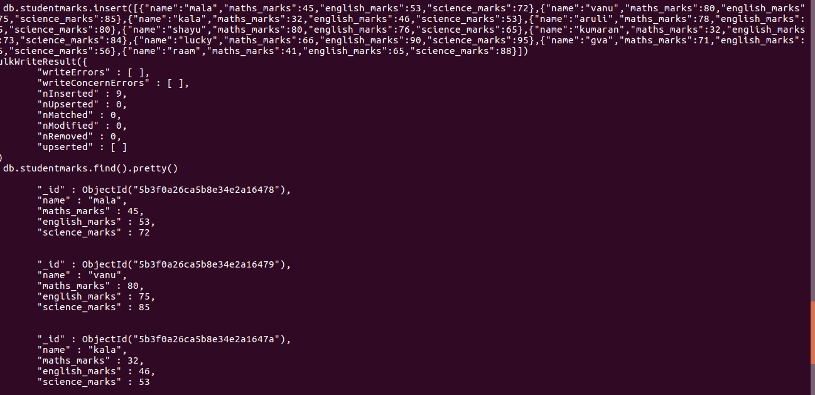

4) Increase the maths marks of Mala by 6 marks?
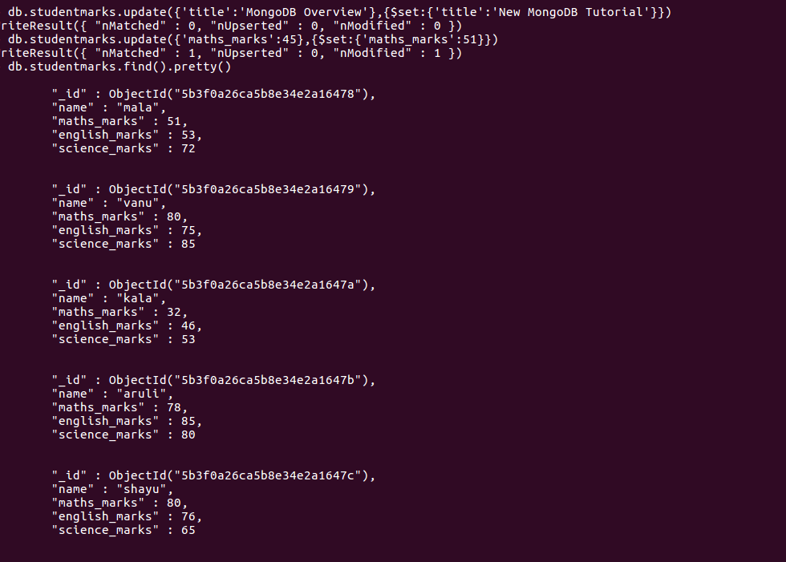

5) List the names of students who got more than 50 marks in Maths Subject?
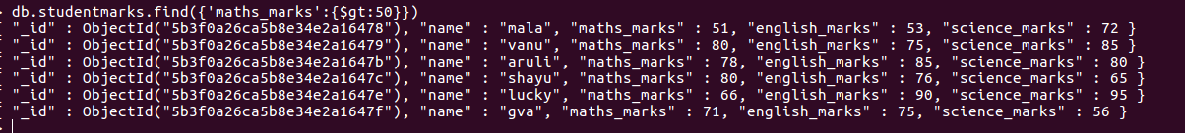

6)Add a new column(field) for Average for all students ?

7) Update Marks_Science=75 to Lucky ?
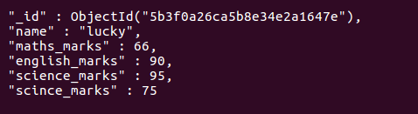

8) List the names who got more than 50 marks in all subjects?

