CHAPTER 1

INTRODUCTION

1.1 Banks as a Lender

A bank lends funds collected through deposits made by it’s customers. The bank is totally responsible for these deposits and needs to pay back, on demand, during the business hours. So the bank needs to maintain the balance between its deposits and loans. The risk being the non-payment of the money lent or advanced, within the agreed period. A borrower who does not repay the money is called a defaulter. Hence it is absolutely necessary to carry out a realistic evaluation of the customer before granting a credit facility if not the loan could end up being defaulted. Certain principles of good lending widely practiced by the banks guide the decision about whether or not to lend money to a particular customer. Since the purpose of lending is to make profits based on the rate of interest on lending, it could also lead to loss if the customer defaults it follows that these principles of good lending are mostly capable of ensuring, as far as possible, that the borrower will be able to make the scheduled repayments, in full and within the agreed period of time. Reaching such a beneficial decision is the key to good lending.

1.2 Analyzing the Lending Proposition

A logical approach can be introduced by considering each important factor in the lending proposition separately and assessing whether it satisfies the lending criteria. This customer evaluation process has so many methods and two of highly practiced time tested ones are mentioned below with dedicated acronyms. These methods allow the Credit Officer/Manager, a practical way of decision making though somewhat subjective in nature.

METHOD – 1

“C A M P A R I”
C - Character of the Borrower
A - Ability to borrow and repay
M - Margin of profit
P - Purpose of the facility
A - Amount of the facility
R - Repayment terms
I - Insurance against the possibility of non-payment
(i.e collateral provided)

METHOD – 2

- “P A P E R C H A M P S”

P - Purpose of the Facility
A - Amount of the facility
P - Period
E - Exchange Regulations
R - Repayment

CHA - Character of the borrower
M - Mandate
P - Profitability of the related business
S - Security offered

The proposed system has been implemented using the route “PAPER CHAMPS”. This was selected for its popularity over the other methods. The prospective borrower, a personal customer or a company, depending on the case, will be interviewed and related information together with data based on the acronym will be collected. Each field represented in the above acronym may be further sub divided into extra fields depending on the segment.

1.3 “PAPER CHAMPS” Explained

Purpose

This describes the purpose for which the facility is requested. It is important to ensure that the purpose is not illegal and unreasonable. Further it is essential to structure the facility to match the request of the customer. (i.e grambling, money laundering , arms purchase, illegal brewery/drugs etc) Full details of the purpose should be obtained in order to avoid future problems arising out of instalment amount/repayment etc.

Amount

This refers to the amount of the facility requested based on the purpose. The repayment capacity of the borrower has to be analyzed thoroughly after computing the monthly commitment together with the exact request of funds based on the proposal. Further details like existing loan, Mastercard payments, family expenditure etc should be obtained for proper analysis. When evaluating this, it is a must to check whether the amount is exceeding the single borrower limit of the bank, which at present Rs.2.2 Bn.

Period

This relates to the time in months, allocated for the repayment of Loan or Overdraft. This depends on the facility type i.e housing loan can be considered for a long or period upto 25 years based on the date of birth of the borrower where as a normal term loan is restricted to maximum period of 5 years. Depending on the merits of the borrower, this period may vary. Nevertheless, period too has an effect on computing the monthly commitment.

Exchange Regulations

This has an impact mainly on imports and exports, related credit facilities. Any facility, should be within the frame work of exchange regulations, outlined by the Exchange Controller of Sri Lanka. Violation of regulations is not permitted strictly and such regrets will be declined.

Repayment

This indicates the basis and source of repayment. If salaried, it should be verified whether all the deductions (i.e other loans, EPF/ETF payments etc) exceed 60% of the monthly salary. If so, the request should be declined. No facilities should be allowed if the source of repayment is the monthly pension only. A request for a facility from a person who is above 55 years should be analysed mainly if it is a long-term facility. If the repayment source is business income, then the networth and the cash flow of the firm together with monthly profit figure should be verified.

Character

Meant by character of the borrower is not what the general thinking is. It is the borrowers history of financial behavior and can be traced in several ways.
- Report of Credit Information Bureau of Sri Lanka (CRIB)
- Status Reports from other banks
- Existing data of the bank

Credit Information Bureau of Sri Lanka is the central authority where the details of performing advances above Rs.0.5Mn and non - performing advances of above
Rs.0.1Mn are maintained. The information includes ID No, full name, address amount, type of facility and the institute granted. Any bank registered in Sri Lanka is authorized to call for the details when necessary.

Status reports can be called from other banks where the customer maintains
accounts or enjoying facilities. Normally, complete details are not provided due
to the extreme competitive nature among the banks.

By checking the existing database of the bank, it is possible to assess the past
performance of the customer. Banks date includes all the details of performing accounts as well as non performing accounts. This is in addition to the basic information available with CRIB above.

Mandate

Mandate means legal authority to operate accounts and obtain loans and advances.
Before granting a facility or even before opening an account, there are certain criteria that should be fulfilled.
Eg:

- If a personal customer is considered, he/she should be over 18 years It is illegal to grant credit facilities to minors.
- If it is a limited liability company, a document called “ Memorandum and Articles of Asset” should indicate the company’s capacity to borrow and the company should be registered in Sri Lanka

Profitability

This refers to the profit earned by the business or the person for a certain period of operation, usually a month or year. It is mainly to evaluate the repayment capacity based on other expenditure and commitments of the borrower.

Security

Security or collateral is another important consideration in the lending decision. A banker must ask what the bank’s position would be if the customer failed to make the repayment as planned. To issue against an undesireable situation it is normal to ask for collateral to cover the bank exposure. In such an event, available collateral is disposed in order to settle the outstanding. However, it is necessary to stress the fact that no facilities should be allowed if any signs of realizing the security to recover the dues are foreseen. Different types of securities can be identified.

- Mortgages over property, machinery, stocks etc
- Life Insurance Policies – surrender value
- Quoted company shares
- Personal guarantors etc

  - Problem Statement

Initial credit evaluation process in the bank has not been streamlined or rather automated due to the subjective nature of the process. This has been further aggreviated by existing network’s inability to support such a process. Analyzing the logic and lengthy initial credit evaluation process is highly time consuming and a hassle to the officers involved. Further, rejected credit proposals are not recorded, restraining future reference & use of such data.

1.5 Objectives

It is proposed to develop a Credit Evaluator using intelligent modeling incorporating the field structure of “PAPER CHAMPS” which will act as a DSS in order to
(1) To decide whether to grant credit facilities or not.
(2) Prepare reports on existing customers based on
- Arrears of existing advances
- Irregular advances
- Past-due advances
(3) Record/save the information collected in CIF (Customer Information File) separately for approval and rejected requests for future reference.

These goals will be achieved through the following strategies.

- Define scope of the system with a view towards addressing all possible functional areas within the allotted time frame
- Study the procedures and ways of Initial Credit Evaluation process in the bank
- Research on component based development technologies with a view towards understanding the true nature, the potential and its applicability within the proposed system
- Gain a sound knowledge of SQL database and Visual Basic component based development technologies
- Prepare Requirement Specification based on analysis of the problem and the findings of the literature survey

- Design the system
- Implement the new system on a trial basis under test condition
- Critically evaluate and time frame the new system in order to identify possible performance issues strengths and weaknesses of the architecture

CHAPTER 2

BACKGROUND

2.1 Moneylenders

Before the banks wee formed many lending has been practiced by a group called “Money Lenders”. These people lend money at very high rates of interest creating lot of social unrest and economic calamity. A fine example is the story of “Merchant of Venice” by Shakespere. Hence, the need to have a regulated lending system based on realistic rates of interest were highlighted and demanded. To fill this demand only, the banks were created. Nowadays, in each country has its own governing body called Central Bank and financial institutions are controlled by through the respective governments. Further, world bodies such ase International Monetary Fund, International Finance Corporation, World Bank etc have been established. The Network is complicated with the regional players such as Asian Development Bank, South America Regional Association etc. Additionally, various types of finance companies, industries have been created due to heavy demand for credit facilities in the society. However, the concept of moneylender still prevails in the society but on a low-key basis.

2.2 Bank as a lender

In Sri Lanka there are three types of banks based on the ownership
1.State owned - Peoples Bank, Bank of Ceylon etc
2.Local private banks - City Bank, Sampath Bank, Seylan etc
3.Foreign Banks - HSBC, Standard Chartered Bank etc

All these are governed by the regulations of monitory authority of the Central Bank of Sri Lanka. As a means of control, 10% of the deposit base should be maintained with the Central Bank, called a reserve, so that at least 10% of deposits could save in unforeseen eventuality. When it comes to lending, the rate of interest charged is calculated based on the following factors.

1.Cost of funds - Internet cost paid to depositors by the bank
2. Risk factor - Anticipated cost of non settlement based on another type,
facility type and loss opportunity cost
3. Income - In addition to above, cost of servicing the facility and intended
profit over all the costs

The bank analysis these three factors and arrive at a rate of interest on the merits of each lending proposal.

2.3 Advances

In this study, we concentrate mainly on two categories of credit facilities.

- Overdrafts
- Loans

2.3.1 Overdrafts

Overdraft is available only to current account holders which allows them to withdraw money over the actual balance. Overdrafts are mainly considered to meet the working capital requirement. Besides, overdrafts are costlier since it attracts interest on interest or compound interest. Due to same reason, in normal practice, overdrafts are not grated for the purchase of fixed assets to avoid cash flow constraints to the borrower. A particular rupee value limit is granted to the customer in the current account where it is allowed to draw up to the limit. Whenever the borrower makes deposits to the account, overdrawn amount is reduced. The repayment of this facility is always “on demand” which means the borrower is liable to pay back the overdraft anytime when the bank demands. Settlement can be done fully at the end of the agreed period. Overdrafts exist in two different categories.

- Temporary Overdrafts (TOD)
- Permanent Overdrafts or Regular Overdrafts (ROD)

Temporary Overdrafts are considered only for a short period of time with a maximum of 6 months on the other hand Regular Overdrafts are granted as a permanent facility spreading up to 1 year on a revolving basis. In both cases, interest is calculated on daily balance and debited to the account at the end of the month.

2.3.2 Loans

Loans are different from Overdrafts and mostly utilized to purchase assets.. A loan is to be repaid within a particular period of time as agreed. Interest is calculated on daily basis and such interest is incorporated into monthly installment which is calculated including a part of capital. It may be either an equated installment or on the reducing balance depending on the loan type.

2.4 Computation of the Monthly Installment

2.4.1 Installment on the reducing balance

A - Loan Amount (also called capital)
P - Period (in months)
R - Interest Rate

R
-------- X A
100
A
Monthly Installment = -------- + --------------------- X 30
P 365

This installment is getting reduced every month since the interest component is reduced when the capital is repaid.

2.4.2 Equated Monthly Installment

A - Loan Amount
P - Period (in months)
R - Interest Rate(%) per month

(A X R)
Equated Monthly Installment = ---------- + ( A X R)
(1+R) ^{P} - 1

The customer pays a fixed instalment monthly as compared to previous case. Hence also interest is calculated daily on a reducing balance basis.

2.5 Types of Loans Available

There are different types of loans available depending on the borrower’s requirement.
- Personal Loan
- Normal Term Loan
- Housing Loan
- Refinance Loans
- Import Demand Loan
- Preshipment Loan
- Short Term Loan

2.5.1 Personal Loan
This product has been designed to meet the personal needs of middle and upper income earners. The maximum period granted is 4 years. Personal Loans can be considered for the following purposes.
- Educational Expenses
- Setting up / expansion of Professional Practice
- Travel abroad on business, holiday or for studies
- Purchase of a vehicle, home appliances or a personal computer
- Family social function (wedding)

Purpose | Maximum Loan Amount (whichever is less) | Maximum Period
Educational Expenses | Upto six months salary or Rs. 500,000/- | 3 years
Professional Practice | Upto 18 months salary or Rs. 500,000/- | 4 years
Travel Abroad-Educational | Upto six months salary or Rs. 200,000/- | 3 years
Travel Abroad – Holiday | Upto four months salary or Rs. 100,000/- | 2 years
Purchase of a vehicle | Upto 12 months salary / 80% FSV of the vehicle or Rs. 750,000/- | 4 years
Home appliances / PC | Upto four months salary / 60% of Value of the goods or Rs. 100,000/- | 2 years
Social function | Upto six months salary or Rs. 100,000/- | 2 years

Table 1:Pahana Personal Loan Scheme

2.5.2 Normal Term Loan
A term loan may be considered for personal needs as well as for business purposes including purchase of machinery, property, vehicles etc. A maximum period of four years can be allowed for the repayment depending on the capacity of the customer.

2.5.3 Housing Loan (Nivahana)
Specially designed for the housing purposes. It is possible to purchase a land and construct the house or even to purchase a completely constructed house. The subject property has to be mortgaged to the bank. The maximum repayment period allowed is 25 years while the minimum is 5 years. Generally, equated monthly installment is applied. Nevertheless, an installment based on the reducing capital is also allowed. Additionally, assurance policy for loan protection needs to be obtained. A penalty is charged in case of an early settlement of the loan.

2.5.4 Refinance Loans
This is similar to a normal term loan in the nature. But, The Central Bank of Sri Lanka or Asian Development Bank provides the Capital. Hence, the bank can grant the loan at a lower rate and the loans are for specific purposes specially development or agro based

industries. Interest rates are much lower due to funding arrangement is from foreign donors.

2.5.5 Import Demand Loan
Granted for importers to get the goods cleared from the port. Generally, a short period of time (3 - 4 months) is considered for the repayment. These are to be settled with the income generated from the goods sold.

2.5.6 Preshipment Loan
This has been designed for the exporters to manage their expenditure before the shipment. Preshipment loans are also granted only for a short period of time as requirement is for arranging and preparation of goods for shipment.

2.5.7 Other Categories
Following products can also be noted in the banking environment.

- Leasing
- Letter of Credit
- Letters of Guarantee
- Local Bill Purchase
- Credit Cards

Leasing

This facility is allowed for the purchase of vehicles, machinery, office equipment etc. Bank has the absolute ownership over the leased asset. The maximum repayment period allowed is 5 years depending on the depreciation rate of the asset and the capital allowance, Based on the amount lent, the borrower pays a monthly payment called “rental” to the bank which indicates capital, interest and VAT. The borrower should pay at least one rental upfront. Unlike in other credit facilities, VAT is charged on the rental @ 15%as of today. Computation of rental is as follows.

A - Lease Amount
P - Period (in months)
R - Interest Rate(%) per month
a - No. of initial rentals

(A X R)
Monthly Rental = ---------------------------
((a X R) + 1) - (1+ R)^{a-p}

Letter of Credit
Such facilities normally relate to import financing but could be extended to cover domestic business as well. Letter of Credit (L/C) facility allows both importer and exporter to adhere to the undertakings while satisfying the needs of both parties according to LC conditions.

There are two types of Letters of Credit

(1) Sight Letter of Credit - The exporter ships the goods as per L/C terms and
send the relevant documents to the bank. The
Importer should pay for the goods in exchange of
documents, which allows him to clear the goods
from the harbour.

(2) Usance Letter of Credit - Exporter ships the goods as per L/C terms and sends
the relevant documents with a Bill of Exchange
payable on a future date for the value involved. The
importer obtains the documents by signing on the
Bill of Exchange agreeing to pay on the future date.
The period could be 90 – 150 days.

Irrespective of the Letter of Credit type, the bank is liable to pay for the goods if the Letter of Credit terms are adhered by the exporter. The usual procedure adopted by the bank in considering a letter of credit facility is to examine the availability of funds with the customer establishing the credit to retire the bills at the time of establishment of the letter of credit . If 100% of the value is not collected the bank will see whether an Import Demand Loan facility is available.

The difference between an import letter of credit and a domestic letter of credit is that the bank would in the case of the letter of credit have the underlying goods under their constructive control, but where as in a domestic letter of credit would be dependant only on the “GOODS RECEIVED NOTE”.

Though the liquidation of the liability arising from the establishment of the letter of credit has been positively ascertained, the nature of the liability in this instance is categorized as “Contingent”.

Letters of Guarantee

There are various types of guarantees including Bid Bonds, Performance bonds, Credit Guarantees, Advance Payment Guarantees etc. The liability on letters of guarantee is stated to be “contingent” in nature, in that the default situation relates to either inaction or non-performance on the part of the borrower. Bank only charges a commission depending on the collateral and the amount involved.

However, if for some reason claims lodged under the guarantee are not met on demand by the borrower the indirect nature of the liability becomes a DIRECT liability when the bank honors the claim.

Credit Cards

A credit limit is granted to the borrower depending on the income where borrower is allowed to use the card maximum up to the limit. This has not at all been designed for business purposes, but for the personal needs of the borrower. At the end of the month, a

detailed bill is sent to the borrower with a grace period for settlement. It indicates the usage of the card and the outstanding as of end of the period. It is necessary to pay at least 5% of the outstanding on the due date. Interest will be charged on the outstanding if not fully settled, after the grace period.

Local Bill Purchase (LBP)
When a customer receives a cheque, it takes more than a day for him to get the funds as it takes time to realize though the clearing system of Central Bank. To avoid this delay this facility is available to recognize the customer. In determining a limit for this facility, the nature and extent of the transactions, the creditworthiness of the clients of the company and the time lag for realization of cheques purchased are examined in detailed so as to assess the risk.

2.6 Categories of Advances
According to the Central Bank, Loans and Overdrafts are categorized into two main sections.

2.6.1 Performing Advances
Loans having no arrears installments or having less than 4 installments in arrears are called performing advances.

2.6.2 None Performing Advances
Basically, these are the advances, which are in default. There are two stages in none performing advances.
- Irregular Advances
- Past due Advances
A loan is said to be in “irregular” stage if the arrears position is more than 3 months and less than 7 months. When a loan is having more than six installments in arrears, that particular loan is said to be in past due stage. At the none performing stage the customer information will be advised to CRIB. Further, the bank will include such names in a “Black List” at the “Past Due” category.

2.7 The American system

2.7.1 Credit Report
Customers apply for credit for many reasons -- maybe it's to buy a new car, house, computer, or get a personal loan. In the USA, however, there is a special number that can determine whether the customer can do these things, or at least how much it will cost? It is the customer’s ‘credit score’, a three-digit number that can do just that.
How can a single number be meaningful enough to determine whether the customer can buy a house or a car? The credit score is mentioned in the customer’s credit report, which contains a history of how the customer has paid bills, how much open credit the customer has, and anything else that would affect customer’s creditworthiness. The customer’s credit report incorporates all of that information into a three-digit number.

2.7.2 What’s a credit score
A credit score is a number that is calculated based on the particular customer’s credit history to give lenders a simpler "lend/don't lend" answer for people who apply for credit or loans. This number helps the lenders identify the level of risk they may be taking if they lend to someone. While the same end result can come through reviewing the actual credit report, the credit score is quicker and less subjective. The system awards points based on information in the credit report, and the resulting score is compared to that of other consumers with similar profiles. With this information, lenders can predict how likely someone is to repay a loan and make payments on time. It's the credit score that makes it possible to get instant credit at places like electronics stores and department stores in America.

Although there are several scoring methods, the score most commonly used by the American lenders is known as a FICO because of its origins with Fair Isaac & Company of USA. Fair Isaac is an independent company that came up with the scoring method used by banks, lenders, insurers and other businesses.
Unlike in Sri Lanka, there are three national independent credit bureaus in the USA. The three national credit bureaus each have their own version of the FICO score with their own

names. Equifax has the ‘Beacon’ system, Trans Union has the ‘Empirica’ system, and Experian has the ‘Experian/Fair Isaac’ system. Each is based on the original Fair Isaac FICO scoring method and produces equivalent numerical results for any given credit report.

CHAPTER 3

ANALYSIS AND DESIGN

3.1 Existing System for the Primary Credit Evaluation Process

The primary credit evaluation process in the bank has not yet been automated and hence no software is available at present to carry out this task. Nevertheless, it is being manually handled by the officials of the bank which is lengthy & inefficient. When a customer comes for a credit facility, manager or the credit officer analyze the proposal on the basis of “PAPER CHAMPS” method, which has been in practice for more than a century, in banking sector. Accordingly, it is analyzed whether,

- the purpose is acceptable,
- the amount requested can be granted,
- the repayment period is sufficient,
- it violates any exchange control regulations
- the borrower has the repayment capacity
- the borrower has a good character, ( previous defaulters/misconduct in any other bank, etc)
- it fulfills the mandatory requirements ( whether the borrower is above 18 years, etc)
- the company is profitable and having a good networth (for non-personal borrowers)
- any acceptable security has been proposed to cover the exposure.

As an outcome of the above analysis, the officer decides whether the requested facility can be considered or not. In this study, it is intended to automate the same procedure in evaluating a credit proposal as indicated above.

3.2 Weaknesses & Drawbacks of the Manual Procedure
- It is unnecessarily time consuming
- It is a hassle to the officer to analyze the proposal manually
- It is of subjective nature, depending on the officer’s experiences & exposure
- It affects the quality of the customer service & the productivity as well
- Infrastructural constraints - Since the CRIB report and the status report are not immediately available at the time of the evaluation, the character of the customer can not be properly evaluated.
- Credit proposal analyzed previously are not saved for future references
- Complex computations may bring incorrect answers when the loan installments are calculated manually.

3.3 Solutions Proposed
- Time consumption can be drastically reduced by automating the evaluation process
- The new system brings relief to the officers and the hassle is substantially erased.
- The subjective nature of the process is eradicated when an algorithm is developed to carry out the evaluation according to a specific logic
- By automating the process, the quality of the customer service and the productivity are increased
- CRIB report constraint can not be avoided since the Credit Information Bureau does not provide the online access. Further, the status report constraint too can not be avoided. Therefore, until such improvements are in place, the decision of the system can be given subject to same.
- Decision taken are saved in the database for future references and extracted automatically when needed
- Separate modules are developed and embedded to the system to carry out the computational tasks

3.4 Other Available Systems

In Sri Lankan context, there are few systems practiced by mainly foreign banks ie. Standard Chartered Bank, Hongkong & Shanghai Banking Corporation, etc stationed here. These systems mainly calculate an index called “Credit Score” based on customer’s income, existing liabilities and age. However, in comparison to the Credit Evaluator, these systems are inferior in content & lack the complete evaluation process as incorporated in the “Automated Credit Evaluator”. The credit score is basically a down sized system of credit report available in USA and other countries as mentioned earlier. Further, the officers who use credit score method need to do the evaluation manually and the score plays just a supporting role.

In the above scenario, the “Automated Credit Evaluator” is much more superior to existing systems practiced in Sri Lanka by few foreign banks.

3.5 The Proposed System

It is proposed to develop a software called “Automated Credit Evaluator” to automate the primary credit evaluation process in the bank by implementing the field structure of the acronym “PAPER CHAMPS” and embedding further modules to carryout computational tasks as well.

3.5.1 Studying the Primary Credit Evaluation Process

The main and the initial step to study the Primary Credit Evaluation Process in the bank was mainly by interviewing the Manager and the Credit Officers at Commercial Bank, Kotahena Branch. There, a deeper study of “PAPER CHAMPS” was done which allows the officers, a practical way of decision making in a systematic manner.

Aditionally, random samples of credit applications (including rejected applications) were also analyzed. Observing and studying the interviewing process between the bank officer and the customer was also helpful to identify the requirements. Accordingly, customers were differentiated in to four main categories as follows.

- Individual or Joint borrowers
- Proprietorships
- Partnerships
- Limited Liability Companies

(a) Individual or Joint borrowers
This refers to the individuals who are come to the bank requesting for credit facilities. If a facility is considered in the joint names, then they are called Joint borrowers.

(b) Proprietorships
If an individual carries out a business on his own, it is called a proprietorship.
He/she may run it with or without employees and earns the profit or stands the loss in it’s entirely.

( c ) Partnership
It’s a relation which, exist between persons carrying on a business in common with a view of earning profit where the minimum and maximum number of partners is 2 and 20 respectively. A partnership can be called as a firm. According to the section 18 of the prevention of frauds ordinance, where the capital exceeds Rs.1000/- the partnership agreement must be in writing and it must be signed.

(d) Limited Companies
The limited company is a separate legal entity from its members. The liability of directors is limited to the unpaid share capital on liquidation.

3.5.2 Role of the Manager/Credit Officer in the Credit Evaluation Process
The viability or the feasibility of the proposal of the customer is analyzed by the manager or the credit officer in order to decide whether the facility can be considered. His decision is final and will be subject to ratification by the Head office/Regional office of the bank.

3.5.3 Prototyping for User Requirements
The user interfaces are now becoming a norm for the interactive systems. It plays a crucial role in acceptance of the system by the user mainly due to pleasant appearance. As the software is designed for Microsoft platforms, all the interfaces will follow the standard interface features. Further, as a common feature, it will inherit the color scheme of the system selectable by the user.

There are many advantages of using prototypes when designing the interfaces. Because of the programming language used, designing an interface that will appear as a form after implementation is quick and easy, because of the tools available in the integrated development tool. i.e. Microsoft Visual Basic.

3.6 Capturing of Requirements

The proposed system will handle only the customer evaluation process in order to decide whether the requested facility can be granted and the decision should be saved in the database.
When a new facility is granted to a customer, it should be added to the existing database. The system should support such provision to input new advances granted.
A facility may be moved from regular stage to irregular stage or to past due stage and back to regular stage as well. A customer may be marked as a black listed customer in case of a default. Hence, it should also be able to change the status of a facility and a status of a customer at any time in the system.
A frequent necessity is to search for the customers and facilities when analyzing a customer request. Hence, the proposed system should facilitate such needs as well.
At any time, the manager or the credit officer should be able to generate following reports.

- Regular facilities report
- Facilities in arrears report
- Irregular facilities report
- Past due facilities report
- Last visit report
- Black listed customer report

The above first four reports are generated purely based on the status of the facility. When a customer comes asking for a facility, the outcome of that should always be recorded in the database and any given time, it should be able to generate a special report to see the summery of the last visits of the customers. When a customer defaults a facility, it should be immediately recorded in the database and the customer should be blacklisted. The proposed system should also facilitate to generate a report containing all the existing blacklisted customers as well.
At present, the computations of the loan installments, interest component & lease rentals carried out manually which is unnecessarily time consuming and prone to errors. Therefore, it is intended to embed a module for computations as well. Accordingly, the system should be able to compute the followings.

- Lease rental
- Term loan installment
- Nivahana housing loan installment

The system should allow the maintenance such as adding / deleting users and be provided only for the administrator. Following maintenance activities are possible in the proposed system.

- Add user
- Delete user
- Modify user

The proposed system will provide a help facility as well for the users and it should also be able to logout or exit from the system at any time.
The access to the system will be controlled by assigning user names and passwords so that only the authorized persons can use the system. The system is designed to display the login screen soon after the splash screen enabling users to login. Two different types of users are defined as follows.
- Administrator (Only the manager will be privileged)
- Normal user (This may be assigned to the credit officer/second officer)
The access to following functions will not be given to the normal user
- User maintenance
  - Add user
  - Delete user
  - Modify user
- Edit facility status
- Edit blacklist flag

3.7 Functional Requirements of the system
Having analyzed all the requirements, the system functionalities have been grouped as Activities, Inquiries, Reports and System Administration.

3.7.1 Activities
- System will handle the “Customer Evaluation Process”
This consist of two sub processors.
  - Collecting Customer Information
  - Evaluating the request
Personal details of the customer are collected through a separate interface and saved in the database. In case of a personal borrower, for example, the following details are captured.
- Name 6. Date of birth
- Address 7. Nationality
- Office Address 8. Civil Status
- Employer 9. Accommodation
- NIC Number 10. No. of dependants

Then, a separate interface is given to capture the details of the facility requested in order to carry out the evaluation. Through this particular module, the following details are captured.
- Facility type 7. Exchange regulations
- Purpose 8. Repayment source
- Amount 9. Monthly income
- Interest rate 10. Character
- Period 11. Security
- Age 12. Influential range

Based on the facility requested, the required evaluation module is called and the evaluation is carried out. The evaluation result or the decision is displayed on the screen with a comment so that the user can save the decision in the database for future reference.

- System shall handle the “Input New Advances” process
A separate interface is given to the user to enter the necessary data of the advance already granted. Eg. CIF No, Name, Address, Account Number,

Facility type, Amount, etc. After entering the required details of the advance, user can update the same in the database.

- System shall handle “Edit Facility Status” process
User is given an interface to enter the account number of the facility and the system allows the user to change the status flag. Then, the user can confirm the change and the same will be updated in the database. This is allowed only for the administrators.

- System shall handle “Edit Blacklist Flag” process
User is given an interface to enter the CIF number and the system automatically changes the blacklist flag of the respective borrower. (Whether blacklisted or not) This is allowed only for the administrators.

- System shall handle the “Computation of Loan Installment” process
This consist of three different computations.
- Lease Rental
- Term Loan Installment
- Nivahana Housing Loan Installment

According to the request of the user, the appropriate interface is given to input the required data and the system calls for the respective computation module. The final result is displayed to the user.

3.7.2 Inquiries

- System shall handle the “Search for Customers” process
User is given an interface to enter either the name or the national identity card number of the customer. Then the system starts searching in the database and the results will be sent back to the same interface.

3.7.3 Reports

It was decided to generate some more reports from the system and the System Audit Report was taken out. A System Audit Report was not necessary to generate through the proposed system since the actual movements and changes of the facilities are thoroughly handled by the main system in the bank. Accordingly, the system can generate the following reports
- Regular facilities report
This contains the details of the regular facilities.
- Arrears facilities report
This contains the details of the facilities having arrears
- Irregular facilities report
This brings the list of the facilities that are in irregular section
- Past due facilities report
This brings the list of the facilities that are in past due section
- Last visit report
This contains the details of the last visit of the customers
- Black listed customer report
This report indicates details of the all blacklisted customers

3.7.4 System Administration

System administration functions are granted only for the administrators. The normal users will not be having the options to do the administrative tasks of the system. Mainly, the following administrative functions should be handled by the system.

- User Maintenance
System should allow the administrator to do the following maintenance.
- Add user
- Delete user
- Modify user
All three modules have been restricted with a supervisor override. Once the override is accepted, the system provides the user with the appropriate interface to do the necessary changes.

3.8 Nonfunctional Requirements of the System

Since the system is for a bank, the data security, reliability and availability become very important aspects in the project. The proposed system is based on MS-SQL database. Therefore the database itself has certain built-in features to address some of the above noted critical issues. List of the techniques that have been used to overcome these issues are mentioned below.

- Utilize certain cryptographic techniques
- Assign certain functions to different modules
- Check data integrity for critical variables.

Reliability and the availability of the system are to be achieved through component based development, because the individual components can be tested separately and again as a whole to eliminate error at their origin. Since the client already has decided to use the system under Windows 2000 platform, the portability of the system is not a critical problem.
Correctness of the system is verified after demonstrating some sample operations, to the user. Further, the gathered requirements have already been cross checked with their manual procedures. Almost all the transactions will be processed in less than 2 seconds. Efficiency plays a major role when considering customer service, therefore code reuse, use of minimal number of code to perform functions, efficiency of code and use of mathematics are manipulated tactfully.
The system will keep provision for function code changes with minimal affect to other functions and is designed to perform all of its functions very accurately, without any runtime errors or malfunctions. It will further test all the components extensively including their interfaces. It shall pass all the test cases provided by the bank.
The usability of the system should achieve through user interface prototyping. All the required user interfaces have been captured through prototyping. The system shall produce user manuals in order to simplify the operations as well.

3.9 Hardware & Software Requirements

3.9.1 Hardware Requirements
I. Server
Intel Pentium III 1GHz processor with 384MB Memory, would be sufficient.

II. Client
Intel Pentium 3 866MHz upwards system with Minimum of 128MB RAM, with a minimum of 6GB Hard disk, minimum 4MB VGA Memory, with a VGA/SVGA Colour Monitor,

3.9.2 Software Requirements
I. Server
Windows 2000 Server, MS SQL Server 2000 (Enterprise Edition), Crystal Reports 8.5 (runtime components – included with the setup)

II. Client
Windows 98, Windows 2000, Professional or Windows XP
VB Runtime

3.9.3 Special Requirements: Networking Accessories

Note: The above are the minimum requirements

3.10 Developing the System

In developing the system, a combination of Prototyping together with Object Oriented Analyzing and Design (OOAD) was used. OOAD enables the clear representation of expected user interfaces from the system. Object Oriented Analysis (OOA) transforms a glimmer product in to an object-oriented model of same problem. Object Oriented Design (OOD) entails transforming the analysis model in to a feasible design.
Since the reusable components and encapsulated implementations support prototyping, Object Oriented systems are relatively easy to prototype. This approach will be used as a supplement to ensure that a proper understanding of the system has been

obtained. Hence it was decided to use a combination of OOAD and Prototyping. The initial idea of developing the system with a Single Document Interface (SDI) environment was later changed to a Multiple Document Interface (MDI) to make the system more user friendly and less complex, allowing extraction of more information

All the user interfaces were designed using Microsoft Visual Basic 6.0 and Microsoft SQL Server was used to create the back end. The entire coding including the algorithm to process the evaluation process was implemented using Microsoft Visual Basic 6.0. Microsoft Visual Basic 6.0 is a Rapid Application Development (RAD) tool, which is commonly used for prototyping as well. It provides an easier way to design user

interfaces without much effort. Further, the common preference as well as clients prefers to communicate with the system using a Graphical User Interface (GUI) and also the SQL Server is from Microsoft it was decided to use the same for the backend.

3.11 Use Case Diagram

Actors of the Proposed System
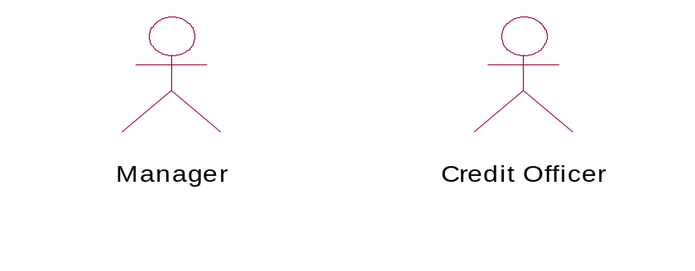

The initial Use Case Diagram of the proposed system is indicated below.

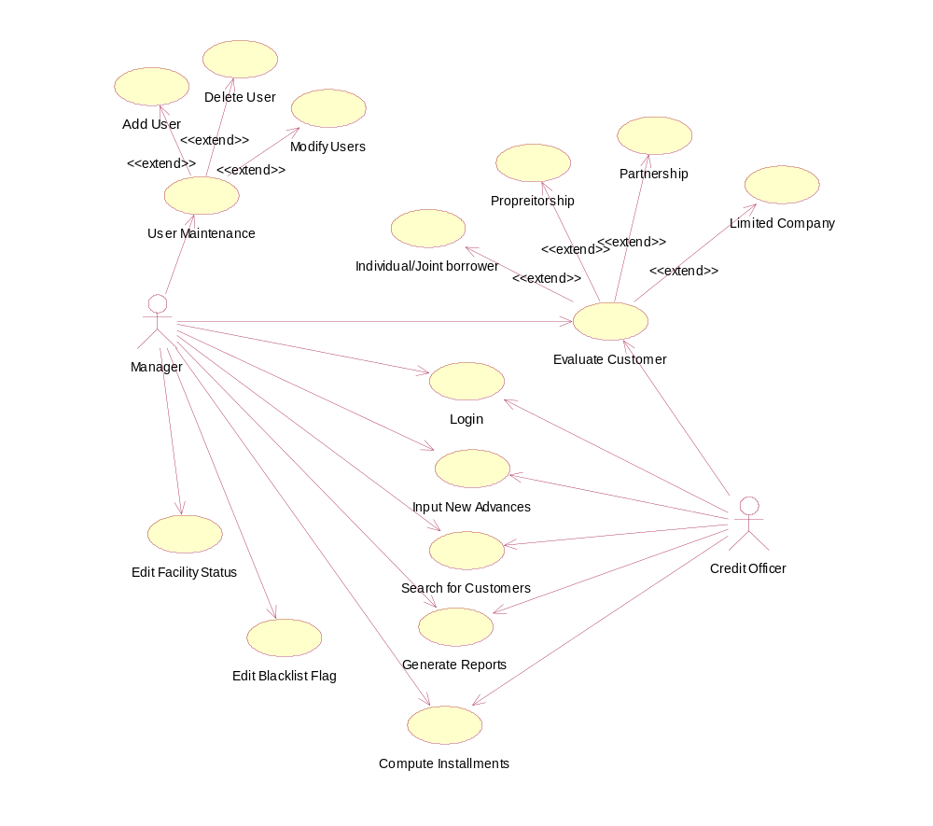

Figure 1: Initial Use Case Diagram

3.12 Database Structure Diagram

The database structure diagram of the proposed system is indicated below.

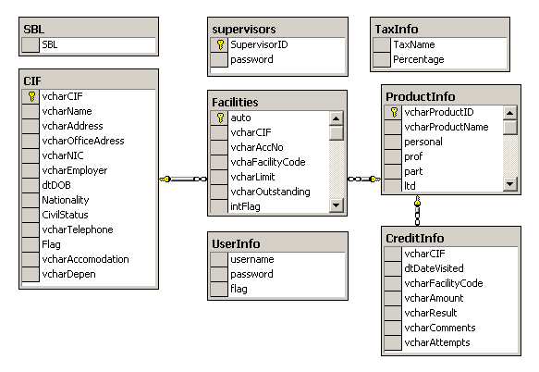

Figure 2: Database Structure Diagram

User interfaces have been designed based on the user needs. Appropriate components such as text boxes, command buttons, combo boxes, labels, etc have been placed according to the user requirements.

In designing, the system has been modularized and a global module has been defined to declare the global variables and functions that can be accessed from any module of the system. The evaluation process has been segregated in to two sub modules as follows.
- Collecting customer information and save the same in the database
- Collect the details of the facility, evaluate the request and display the decision with a comment
Collecting customer information is carried out using a separate interface and the system calls for the respective evaluation module based on the type of the facility requested. The respective evaluation module analyzes the proposal logically and sequentially, and arrive at a decision whether to consider the request favorably or not. Then, the decision and the comment are passed back to the evaluation interface through the global module. Further, it facilitates the user to save the decision in the database, to print the request and the outcome so that it can be attached to the customer’s application for the credit facility.
Different modules have been introduced to carry out the different processes of the system so that the maintenance becomes easier. Hence, additional functions or the changes can be implemented without affecting the other modules of the system up to a greater extent.

CHAPTER 4

USER INTERFACES

4.1 Human – Computer Interaction Design

All the interfaces were designed using Microsoft Visual Basic 6.0. MDI environment provides an easy and pleasant navigation. Login screen accepts the user name and the password from the user and verifies the same with the decrypted password, retrieved from the database. Interfaces have been designed with less complexity and the less ambiguity to make the system more user friendly. In customer evaluation process, all the required details of the borrower (if already not available) are collected through the interfaces specially designed for the purpose.
The above information will be saved for each customer in a CIF (Customer Information File) in the database together with the firm’s “Evaluation Report”. This will enable the bank to extract information when necessary and check on previous attempt for advances, enabling the officers involved to provide a speedier service, next time.

Different interfaces have been developed to collect the required information depending on the case. ie : Personal Borrower, Partnership, Limited Liability Company, etc.

The user interface module is subdivided as follows.
- Normal User Interface Module
- Administrator Interface Module

Administrator is the Manager of the branch only. Access to User management and maintenance of the black list is not allowed to the Normal User Interface Module.

4.2 Selecting a tool
Client prefers to communicate with the system using Graphical User Interfaces due to its attractiveness and simplicity. Therefore it was decided to use Microsoft Visual Basic 6.0 to develop the Interfaces.

4.3 Login Screen
User Name should be entered here

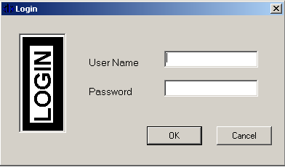
Here is to enter the password
Figure 3 : Login Screen

4.4 Main Screen of the System (MDI Form)

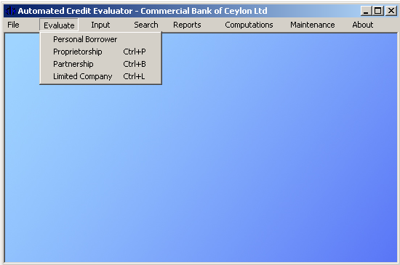
This directs to the evaluation interface

Figure 4 : Main Screen of the System (MDI Form)

4.5 Personal Borrower Evaluation – Collecting Personal Information

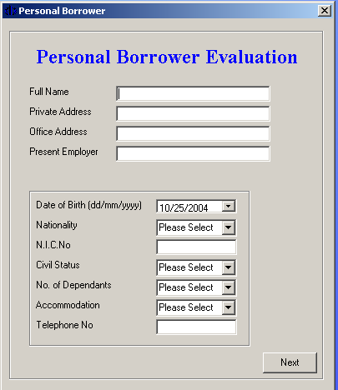
To enter the name
Office Address (optional)
Address should be placed here
Employer Name (optional)

Once everything is filled, “Next” button should be clicked

Figure 5 : Personal Borrower Evaluation – Collecting Personal Information

4.6 Personal Borrower Evaluation – Collecting Request Information

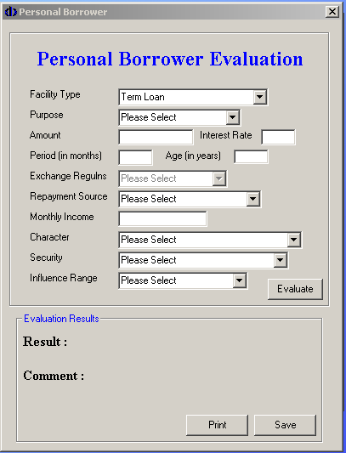

It is necessary to input all the information

Should be clicked to start evaluation

Decision is displayed here

Comment is displayed here

Figure 6 : Personal Borrower Evaluation – Collecting Request Information

The complete snaps of user interaction screens are shown in Appendix

CHAPTER 5

TESTING AND IMPLEMENTATION

After development of the “Automated Credit Evaluator” final phase includes testing and verification in order to confirm the successful development. This section details the preliminary run in procedure in order to verify the smooth functioning and to trace and eliminate errors while providing the system.

5.1 Test Plan

The test plan for the Automated Credit Evaluator was designed at the beginning of the software development. Accordingly, testing procedure and techniques are as follows
- User requirements testing and validation
- User interface testing and validation
- Code development testing
- Integrity testing and verification
- Testing the system in development environment, under test conditions
- Testing the system in user environment, under real life conditions.

5.2 Test Techniques

User requirements testing and validation was done in several stages. In the progress of the software development, the software requirements were compared with the bank’s requirements, which were identified at the stage of “requirements definition”.

Several prototypes were designed and presented to the bank for verification and validation of the user interfaces. In few stages of the development process, some requirements were changed and accordingly software development had to be amended. User interfaces too were changed to suit the bank’s accepted norms and standard appearance

Code testing was done through the graphical user interface designed using Microsoft Visual Basic and test data generated by user interface. The system was functioning properly. Major interfaces are shown in the appendix.

Integrity testing and verification were done through several trial runs using 10 samples of customer requests of size 25 each selected from existing database of the branch. Eight samples were from performing advances section and 2 were from non-performing advances. The result was compared with the decisions already made on the same customers.

The 10 samples of size 25 each gain the following result.

Actual Data
Accepted Rejected

Accepted 199 0 199
Test Data
Rejected 1 50 51

200 50 250

Hence the rate of accuracy of Accepted Facilities as per the programme is 99.5%, and rate of Rejected facilities is 100%.
The system was found to be in consistence with the anticipated results. This can be proved by a statistical test called “Chi-squared” test. But it is not intended to go in to details at this juncture.
Development test environment was Pentium III (1GHz) and 384MB RAM under Windows 2000 Server. The system was running perfect.

Automated Credit Evaluator was installed at Commercial Bank, Kotahena Branch and tested with both accepted and rejected applications available at the branch. It was perfectly functioning with a variation of less than +- 0.5%

5.3 Test Cases
A continuous test strategy was adopted since the early stage of system development through implementation, which included
* User requirements validation and verification (summarizing the requirements)
* User interface validation and verification
* Code testing under normal & unusual scenarios
* Module level testing & System integration testing

5.3.1 User Login Test Case
Valid user name: Administrator, Valid password: deepsleep
Description |  | Value | Expected | Actual output
1 | No user name or password entered |  | Enter the user name | Please Enter the user name!
2 | Type only the valid user name and no password | Administartor | Enter the password | Please Enter the password!
3 | Type an invalid user name with a password or without | Admin/ | User not found | User not found
4 | Type a valid user name and an invalid password | Administrator /deep | Invalid Password | Invalid Password, try again
5 | Type a valid password and a blank user Id | / deepsleep | Enter the user name | Please Enter the user name!
6 | Type the valid user id and password | Administrator/  deepsleep | Should login and the main screen should appear | Login accepted and MDI form loaded

Table 2: User Login Test Case

Part of the test data on the evaluation process are given in Appendix

5.4 Encrypt / Decrypt Algorithm
Two different algorithms have been developed to handle the encryption and decryption tasks. Encryption algorithm is responsible in encrypting the user passwords before saving in the database. On the other hand, decryption algorithm decrypts the password read from the database before passing to the logic. Both the algorithms have been developed using creaser shift method.

The implementation of the encryption algorithm is as follows.

Public Function Encrypt(ByVal icText As String) As String
Dim icLen As Integer
Dim icNewText As String
Dim icChar As String
Dim i As Integer

icChar = ""
icLen = Len(icText)
For i = 1 To icLen
icChar = Mid(icText, i, 1)
Select Case Asc(icChar)
Case 65 To 90 ' A - Z
icChar = Chr(Asc(icChar) + 127)
Case 97 To 122 ' a - z
icChar = Chr(Asc(icChar) + 121)
Case 48 To 57 ' 0 - 9
icChar = Chr(Asc(icChar) + 196)
Case 32
icChar = Chr(32) ' Space
End Select
icNewText = icNewText + icChar
Next
Encrypt = icNewText
End Function

CHAPTER 6

EVALUATION

This chapter consists of the summery of the study with an emphasis on achievement of objectives, recommendations from the results gathered, critical appraisal and directions for further improvements.

The objectives and goals of this study i,e obtaining a decision rule and saving the data for further reference carried out successfully at the end of the project within allocated time frame. Results obtained from sample data are included in the annexure.

The model developed is a tool which assists the Manager / Credit Officer in deciding whether a particular facility can be granted. It is also noted that the program has been allowed to be tested by various line managers of the branch including officers who are not familiar with credit work and accepted it to be more user friendly and informative.

The main objective which was to assist the Manager / Credit Officer in deciding whether to grant the requested facility by automating the logic and the sequence of the primary credit evaluation process has been successfully achieved and the time consumption of the said process has been drastically reduced. The hassle that the credit officer had to face in physically analyzing the information has now been avoided by the Automated Credit Evaluator

Automated Credit Evaluator has been developed to run on Microsoft Windows platform. This development is a good example of Rapid Application Development (RAD) where a combination of Prototyping together with Object Oriented Analysis and Design (OOAD) was used.

The basic limitations and constraints faced when developing the Credit Evaluator are as follows.
- Inability to direct access, the “Credit Information Bureau” database due to regulatory constraints

- The prospective borrower can willfully distort information such as expenditure, loans obtained, salary, etc leading to a wrong decisions.

De-limitation of above (2) may be possible with a hard ruling of calling proof of whatever the information supplied. But, as it is there is no-way of delimiting the CRIB related constraint. Therefore, Credit Evaluator proposed it’s positive decision subject to CRIB is cleared which means that the final product is not capable of handling the said constraint.

In the original project plan, it was decided to embed a particular module to the Credit Evaluator to handle the process of “Edit Customer Information”. Nevertheless, it was later taken out since the main system of Commercial Bank is very much capable in handling the same and further it is not that important to include to this. The initial idea of generating a System Audit Report was also not implemented since the same is not a primary requirement of the user. It was later decided to include the following modules to the system which is frequently accessed by the user
  - Computation of Lease Rental
  - Computation of Term Loan Installment
  - Computation of Nivahana Housing Loan Installment

It was also decided to include the provision to generate the following reports from the system, though not included in the original project plan.
- Regular facilities report
- Facilities in arrears report
- Irregular facilities report
- Past due facilities report

At the stage of requirement analysis, the major problem encountered was the lack of availability of printed literature materials particularly on credit evaluation. The process had to be understood mainly by interviewing the Manager / Credit Officer of the bank and by observing the conventional dialog between the manager and the customers who are making requests for credit facilities. Obtaining the necessary approval for data collection got unusually delayed due to the deficiencies in administrative process in the bank.

In developing the system, it was absolutely necessary to implement an encryption algorithm to save the passwords in the database. Therefore, both the encryption techniques and the corresponding implementation in Visual Basic as well had to be thoroughly studied. Further, SQL Server functions too, had to be mastered to a great extent. It was also understood that the influential range of the customer critically effects on the final decision.

CHAPTER 7

CONCLUTION AND RECOMMENDATIONS

During the test sessions it was revealed that the developed program is highly successful in concluding a Decision Rule, which indicated:
Accuracy of sample data on accepted facilities - 99.5%
Accuracy of sample data on rejected facilities - 100%

Additionally the system generates profits when a existing customer approaches for a credit facility as follows;
      - Arrears position
      - Irregular printout
      - Past due printout (Black List)
There will further assist the officers in arriving at a final decision, effectively. However, the request is not in a position to support the following situation as it is for the existing manual procedure.

- Willful defaulter submitting incorrect information
- Inability to obtain CRIB report quickly

Though the above (1) is an impossible task which is dependent on human psychology and hard to curtail, later one may be solved, once the CRIB is computerized with online access. In that case it is recommended to incorporate software development to access the CRIB, once the Central Bank introduces such infrastructure developments and strategies. Until such time it is highly recommended to put this program into practice to evaluate credit decisions subject to CRIB.

This proposal is a very much valuable tool for the lending officers of the bank and further it can be utilized by any financial institute, in general, with minimal adjustments to the program.
The final product can be further improved to analyze the entire balance sheet and the profit & loss account of the companies through a specially developed user interface called balance sheet runner which may access an additional computational module

that will carry out the computational tasks, so that the following financial ratios can be computed enabling the evaluation process to be more realistic and accurate.

- Current ratio
- Quick ratio
- Stock turnover ratio
- Debtors ratio
- Creditors ratio
- Gearing ratio

Further it is suggested to improve the Credit Evaluator to function on AS400 platform as a future work which will be even more important since the existing network of Commercial Bank is running on AS400 platform

BIBLIOGRAPHY

- Evangelos Petroutsos, 2000. Mastering Database Programming with Visual Basic 6
- Evangelos Petroutsos, Kelvin Hough, 1998. Visual Basic 5, Developer’s Hand bok
- Booch, G, Object-Oriented Development, IEEE Transactions on Software Engineering; Feb 1986, Vol.12 No.2 P211-221 A survey on Object Oriented Methods – University of Durham
- Booch, G, Object Oriented Design with Applications, Benjamin/Cummings, California; 1991
- Charles Richter, 2000. Software Engineering Series, Designing Flexible Object-Oriented Systems with UML
- Ivar Jacobson, Grady Booch & James Rumbaugh, The Unified Software Development Process, Addison-wesley
- Ian Sommerville, Software Engineering 6th Edition, Pearson Education Asia
- Igor Hawryszkiewycz, Introduction to Systems Analysis and Design 4th Edition, Prentice Hall of India
- Microsoft workbook, Programming Microsoft SQL Server 2000 Database – course no: 2073A
- K C Nanda, 1999. Credit and Banking, What Every Small Entrepreneur (and Banker) Must Know
- Commercial Bank internal circular CAU/2003/270,11/09/2003, Amended Single Borrower Limt (SBL) for 2003
- Commercial Bank Advance Instruction Circular 99/01, 27/08/99, Personal Loan Scheme
- Commercial Bank Credit Manual – Part 1 – CR facilities
- Commercial Bank Credit Manual – Part 7 – International import export financing
- Article in Sunday Observer, Lending – The American Way, by Kapila Muniratne

Web Reference

http://www.mactech.com - Object Oriented Software Engineering
http://www.rational.com – Using Rational Rose 2000
http://www.cbsl.lk - Credit Evaluation Process

Development Environment Help

MSDN Library 2001
Rational Unified Process v2000 - Rose Help (UML Terminology)

APPENDIX A

VISUAL BASIC CODING - EVALUATION OF A TERM LOAN
(PERSONAL BORROWER)

………………………………………………
Evaluating term loan for a personal borrower
……………………………………………………
Private Sub TermLoan()
If cmbPurpose.Text = "Not Acceptable" Then // checking the purpose
basGlobal.Result = "Rejected" // pass the decision to the global module
basGlobal.Comment = " Purpose Not Acceptable" // pass the comment to the global module
lblResult2.Caption = basGlobal.Result // Accessing the result from the global module
lblReason2.Caption = basGlobal.Comment //Accessing the comment from global module

ElseIf Val(txtAmount.Text) > basGlobal.SBL Then // checking the single borrower limit
basGlobal.Result = "Rejected"
basGlobal.Comment = " Request exceeds the Single Borrower Limit"
lblResult2.Caption = basGlobal.Result
lblReason2.Caption = basGlobal.Comment

ElseIf Val(txtPeriod.Text) > 48 Or Val(txtPeriod.Text) < 12 Then // checking the period
basGlobal.Result = "Rejected"
basGlobal.Comment = " Repayment Period out of the range"
lblResult2.Caption = basGlobal.Result
lblReason2.Caption = basGlobal.Comment

ElseIf Val(txtAge.Text) < 18 Then // checking the age
basGlobal.Result = "Rejected"
basGlobal.Comment = " Age is below 18 years,Still a minor"
lblResult2.Caption = basGlobal.Result
lblReason2.Caption = basGlobal.Comment

ElseIf Val(txtAge.Text) > 75 Then // checking the age
basGlobal.Result = "Avoid granting whether influencial or not"
basGlobal.Comment = " Age is above 75 years, A high risk involved"

lblResult2.Caption = basGlobal.Result
lblReason2.Caption = basGlobal.Comment

ElseIf Trim(cmbRepayment.Text) = "Purely on Pension" Then // checking the repayment
basGlobal.Result = "Rejected"
basGlobal.Comment = " Pension can not be accepted as a repayment source "
lblResult2.Caption = basGlobal.Result
lblReason2.Caption = basGlobal.Comment

ElseIf Trim(cmbCharacter.Text) = "Defaulter in an Other Bank" Then // character
basGlobal.Result = "Rejected"
basGlobal.Comment = " A defaulter in an other bank. Risky..!! "
lblResult2.Caption = basGlobal.Result
lblReason2.Caption = basGlobal.Comment

ElseIf (((Val(txtIncome.Text) - ((Val(txtAmount.Text) / Val(txtPeriod.Text)) + (Val(txtAmount.Text) * ((Val(txtInterest.Text) / 100) / 12)))) / Val(txtIncome.Text)) * 100) < 40 And cmbInfluence.Text = "Average Customer" Then // repayment capacity
basGlobal.Result = "Rejected"
basGlobal.Comment = " Repayment Capacity is poor "
lblResult2.Caption = basGlobal.Result
lblReason2.Caption = basGlobal.Comment

ElseIf (((Val(txtIncome.Text) - ((Val(txtAmount.Text) / Val(txtPeriod.Text)) + (Val(txtAmount.Text) * ((Val(txtInterest.Text) / 100) / 12)))) / Val(txtIncome.Text)) * 100) < 40 And Val(txtAmount.Text) > 200000 Then // repayment capacity
basGlobal.Result = "Rejected"
basGlobal.Comment = " Repayment Capacity is poor "
lblResult2.Caption = basGlobal.Result
lblReason2.Caption = basGlobal.Comment

ElseIf Trim(cmbSecurity.Text) = "No Security" And cmbInfluence.Text = "Average Customer" And cmbCharacter.Text = "Can't Judge" Then // security
basGlobal.Result = "Rejected"
basGlobal.Comment = " No Security, Not influential, risky to lend if can't judge "
lblResult2.Caption = basGlobal.Result
lblReason2.Caption = basGlobal.Comment

ElseIf Trim(cmbSecurity.Text) = "No Security" And cmbInfluence.Text = "Average Customer" And Val(txtAmount.Text) > 50000 Then // security & the influential range
basGlobal.Result = "Rejected"
basGlobal.Comment = " No Security, Not influential "
lblResult2.Caption = basGlobal.Result
lblReason2.Caption = basGlobal.Comment

ElseIf Trim(cmbSecurity.Text) = "No Security" And Trim(cmbInfluence.Text) = "Highly Influential" And Val(Trim(txtAmount.Text)) > 200000 Then
basGlobal.Result = "Rejected" // security & the influential range
basGlobal.Comment = " No Security, Amount is high though influential "
lblResult2.Caption = basGlobal.Result
lblReason2.Caption = basGlobal.Comment

ElseIf Trim(cmbSecurity.Text) = "No Security" And Trim(cmbInfluence.Text) = "Influential" And Val(txtAmount.Text) > 100000 Then
basGlobal.Result = "Rejected" // security & the influential range
basGlobal.Comment = " No Security, Amount is high though influential "
lblResult2.Caption = basGlobal.Result
lblReason2.Caption = basGlobal.Comment

ElseIf Trim(cmbSecurity.Text) = "Personal Guarantee" And Val(txtAmount.Text) > 300000 Then // security & the amount
basGlobal.Result = "Rejected"
basGlobal.Comment = " Amount is high when compared with the security"
lblResult2.Caption = basGlobal.Result
lblReason2.Caption = basGlobal.Comment

ElseIf Trim(cmbSecurity.Text) = "Absolute Ownership over the assests" Then
basGlobal.Result = "Rejected" // checking the security
basGlobal.Comment = " Better go for a Lease..!! Security is not sufficient"
lblResult2.Caption = basGlobal.Result
lblReason2.Caption = basGlobal.Comment

ElseIf Trim(cmbSecurity.Text) = "Life Insurance Policy " And Trim(Val(txtAmount.Text)) > 300000 Then // security & the amount
basGlobal.Result = "Not highly recommended, "
basGlobal.Comment = " It is risky if the surrender value is not realistic..!"
lblResult2.Caption = basGlobal.Result
lblReason2.Caption = basGlobal.Comment

ElseIf Trim(cmbSecurity.Text) = "Shares (Blue Chip Company)" And Trim(Val(txtAmount.Text)) > 500000 Then // security & the amount
basGlobal.Result = "Not highly recommended, though blue chips"
basGlobal.Comment = " If the share comes down due to any reason, loss is high!"
lblResult2.Caption = basGlobal.Result
lblReason2.Caption = basGlobal.Comment

Else
‘customer request can be considered
basGlobal.Result = " Allowed subject to CRIB clearence" // Request Allowed
basGlobal.Comment = "Evaluation Satisfactory..!" // Comment
lblResult2.Caption = basGlobal.Result
lblReason2.Caption = basGlobal.Comment

End If

End Sub

(Please refer to the CD for the entire coding)

APPENDIX B

USER INTERFACES OF AUTOMATED CREDIT EVALUATOR

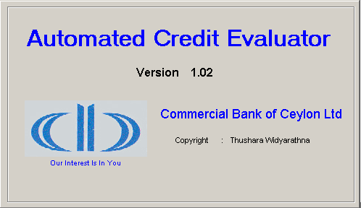
Figure 7 : Splash Screen

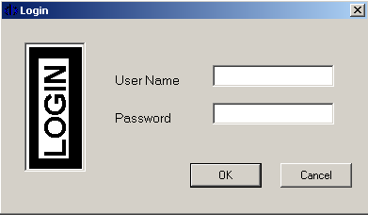
Figure 8 : Login Screen

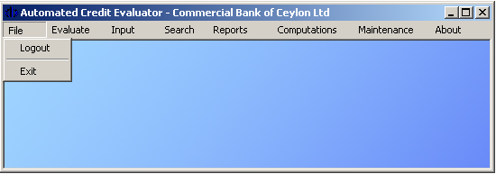

Figure 9 : MDI Environment – File Menu

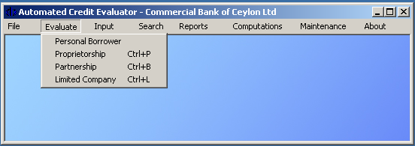

Figure 10 : MDI Environment – Evaluate Menu

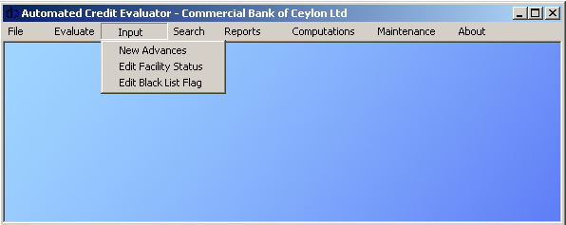
Figure 11 : MDI Environment – Input Menu

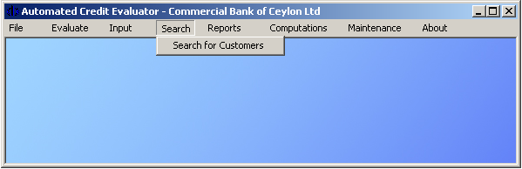
Figure 12 : MDI Environment – Search Menu

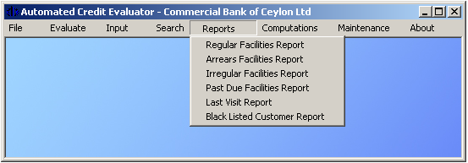
Figure 13 : MDI Environment – Reports Menu

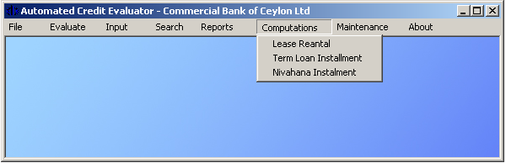
Figure 14 : MDI Environment – Computations Menu

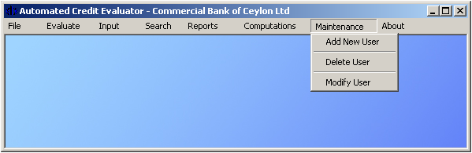
Figure 15 : MDI Environment – Maintenance Menu

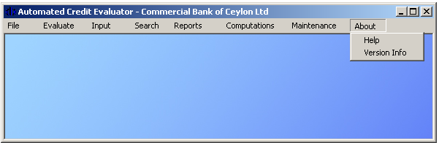
Figure 16 : MDI Environment – About Menu

Figure 17 : Personal Borrower Evaluation – Personal Data

Figure 18 : Personal Borrower Evaluation – Facility Information
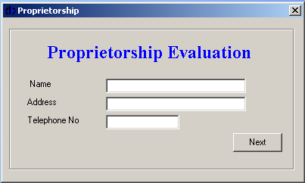

Figure 19 : Proprietorship Evaluation – Customer Information

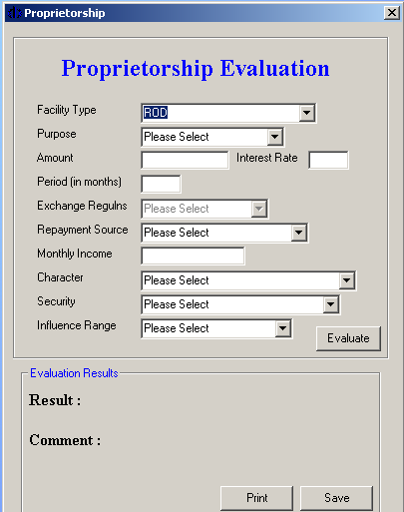
Figure 20 : Proprietorship Evaluation – Facility Information

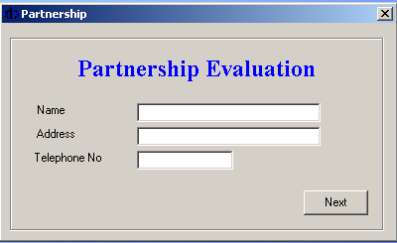

Figure 21 : Partnership Evaluation – Customer Information

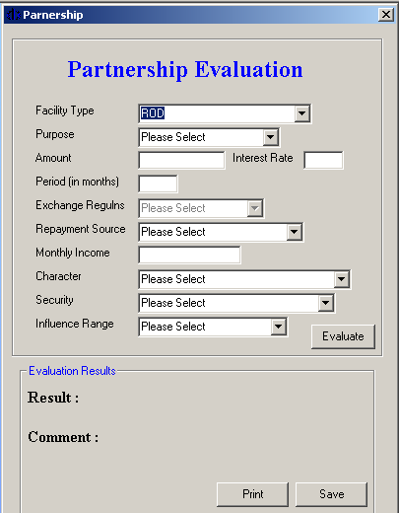
Figure 22 : Partnership Evaluation –Facility Information
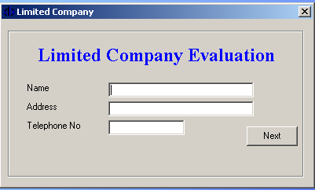

Figure 23 : Limited Company Evaluation – Customer Information

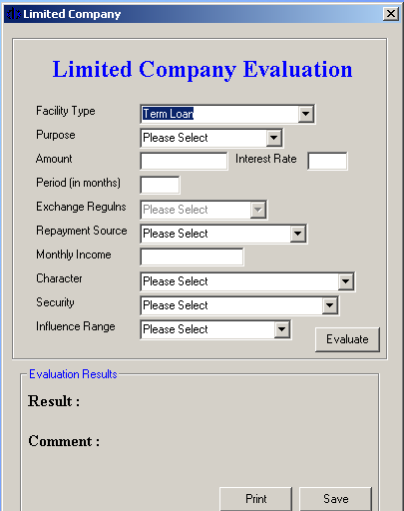

Figure 24 : Limited Company Evaluation – Facility Information

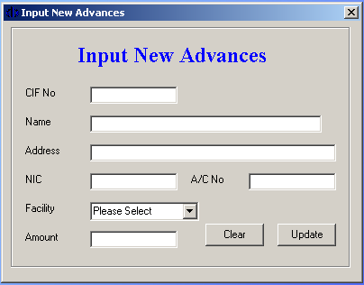

Figure 25: Input New Advances

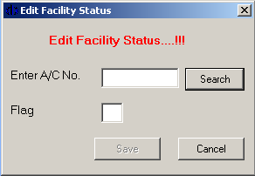
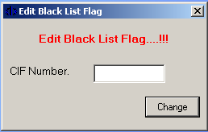

Figure 26: Edit Facility Status
Figure 27: Edit Black List Flag

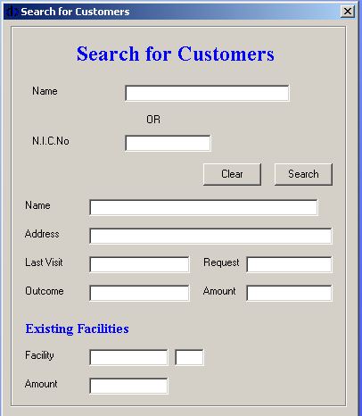

Figure 28: Search for Customers

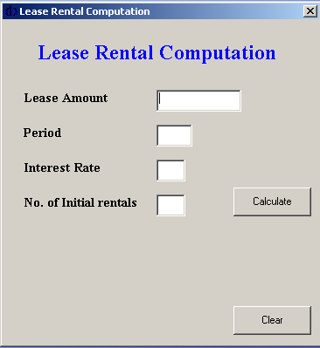

Figure 29: Lease Rental Computation

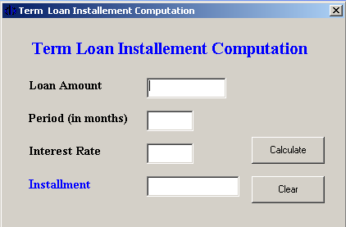

Figure 30: Term Loan Installment Computation

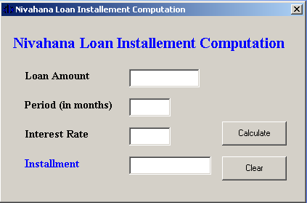

Figure 31: Nivahana Loan Installment Computation

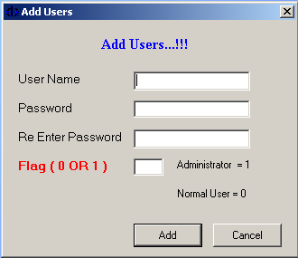
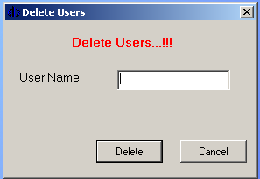

Figure 32: Add Users
Figure 33: Delete Users

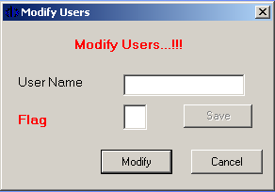
Figure 34: Modify Users

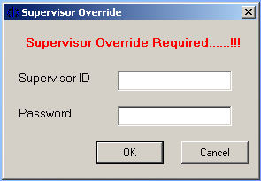
Figure 35: Supervisor Override

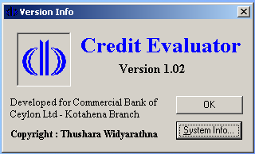
Figure 36: Version Information

APPENDIX D

USE CASE DIAGRAM OF AUTOMATED CREDIT EVALUATOR

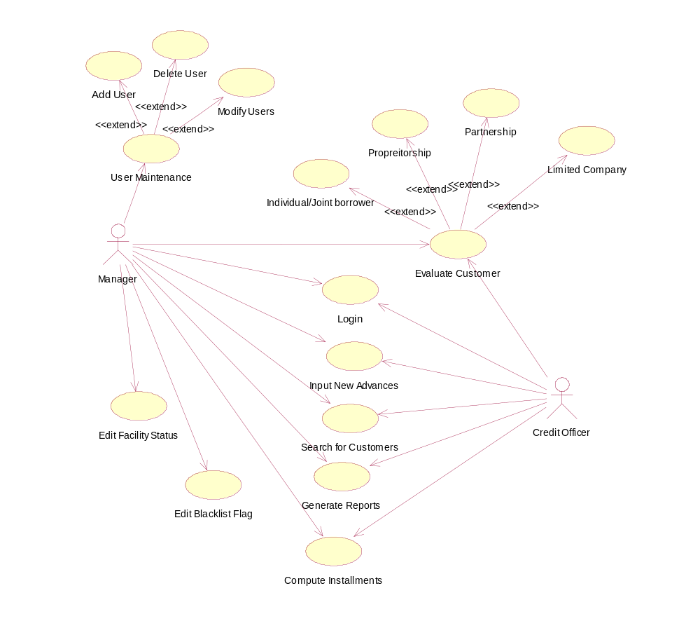

DATABASE STRUCTURE DIAGRAM OF AUTOMATED CREDIT EVALUATOR

APPENDIX E

SYSTEM & USER DOCUMENTATION

SYSTEM DOCUMENTATION

INSTALLING THE SETUP

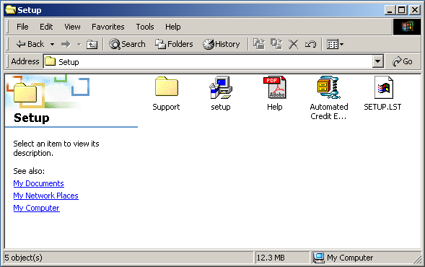
Double click “setup.exe” to start the installation
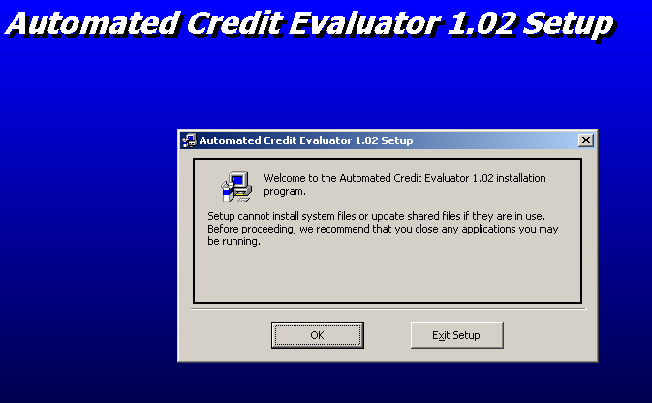

In order to start the setup wizard click OK

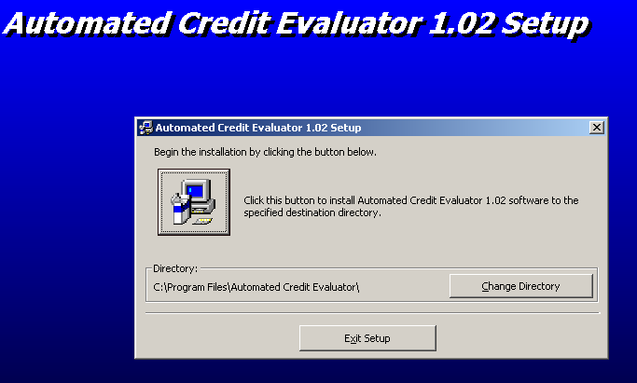
Select the destination location to install and press the blue setup button

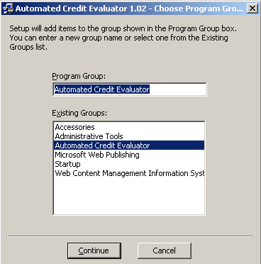
Select the location on start menu and the name to be used to refer the application

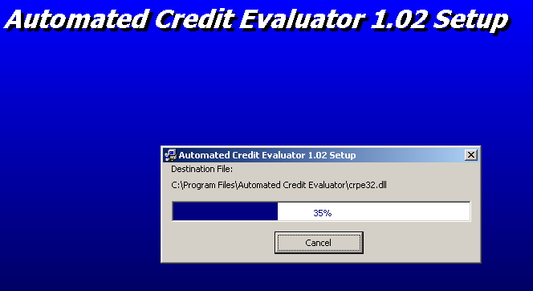

The setup wizard starts the installation

NOTE
- After the installation completes, copy the reports folder and the help.pdf file to the final destination where the application resides.
- Create a System DSN as CreditInfoDSN in order to access the database
- Attach the database CreditInfo to the SQL Server
- Supervisor ID is 0599 and the password remains as 0599test to override the security functions
- Initially, two different users have been created

User Name Password

  - Administrator deepsleep
  - Teller wakeup

USER DOCUMENTATION

AUTOMATED CREDIT EVALUATOR HELP

SPLASH SCREEN
When the program runs, this screen appears for few seconds to display the product details

LOGIN
This screen allows you to login to the system by entering the user name and the password. Enter the user name & password and press OK

MAIN SCREEN OF THE SYSTEM (MDI FORM)

Selecting “Logout” from the menu, it is possible to logout from the system & let an other user to login. You can exit from the system by selecting “Exit” from the menu.

CUSTOMER EVALUATION PROCESS

Select the customer type to evaluate. If the “Personal Borrower” is selected from the menu, the following screen appears.

Fill the details asked for and click “Next” to go to the next step of the evaluation process. Office Address, Employer and the Telephone number are optional. The data you entered will be saved in the database when you click on “Next” and the following screen will appear.

Fill all the required information based on the customer request and click on “Evaluate” button in order to start the evaluation process. Sooner, the evaluation results (decision & a comment) will be displayed on the form. If you want to save the outcome in the database click on “Save” or to print the result, click on “Print”. Snapshots of both the screens of the evaluation process will be sent to the printer.

Details of the proprietorship should be entered here and click on “Next” to proceed to the next step of the evaluation process as described above.

Simply enter the details of the partnership ands click on “Next” to proceed to the next stage of the evaluation process.

Details of the Limited Liability Company should be entered here. Click on “Next” to proceed to the second stage of the evaluation process as discussed in above

INPUT OF NEW ADVANCES GRANTED
Enter the required data and click on “Update” to save the same in the database. If you click on “Clear”, the form will be refreshed.

EDIT FACILITY STATUS
Enter the account number and click on “Search”. Then the other text box will be activated and the respective flag related to the facility status will be displayed in it. After making changes to that, click on “Save” to update the change in the database.

EDIT BLACK LIST FLAG
Simply enter the CIF number of the customer and click on “Change” to make the change permanently in the database

REPORTS GENERATION
The above reports can be generated at any time just by clicking on the required report in the menu.

SEARCH FOR CUSTOMERS
Enter either name of the customer or the NIC No and click on “Search”. If the customer is already available in the database, corresponding details will be displayed. Form can be refreshed by clicking on “Clear”

COMPUTATIONS
LEASE RENTAL COMPUTATION
Enter the lease amount, period, interest rate and the no. of initial rentals and click on “Calculate”. Lease rental, VAT component and the total rental will be displayed on the screen. Form can be refreshed by clicking on “Clear”

COMPUTATION OF TERM LOAN INSTALLMENT

Simply enter the loan amount, period and the interest rate and click on “Calculate”. The monthly installment on reducing balance will be displayed. Clear button will refresh the form

COMPUTATION OF NIVAHANA HOUSING LOAN INSTALLMENT

Enter the loan amount, period and the interest rate and click on “Calculate”. The equated monthly installment will be displayed on the screen. Text boxes can be cleared by clicking on the clear button

USER MAINTENANCE

It consist of three different operations. Namely, Add User, Delete User and Modify User. All these three modules are restricted and a supervisor override is requested to carry out the task.

Enter the supervisor ID and the password and click OK. The corresponding screen for the particular task will be appeared. Operation can be cancelled by clicking on the “Cancel” command button.

ADDING USERS
Simply fill the required information and click on “Add” to create a new user. If the cancel button is clicked, the operation will be cancelled.

DELETING USERS
Enter the name of the user to delete and click on “Delete” button. User will be deleted from the system.

MODIFYING USERS
Enter the user name to be modified and click on the “Modify” button. The flag corresponding to the user privileges will be displayed. Amend it accordingly and click on the “Save” button to confirm the change.

ACCESSING THE IN BUILT HELP FACILITY & THE VERSION INFORMATION
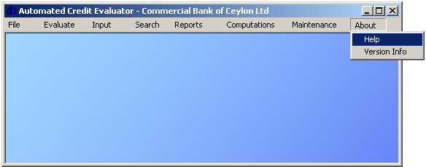
Click on the Help menu as indicated above. A PDF file will be opened which contained the help facility. Version Information can be found just by clicking on the Version Info menu. The following screen shows the version information.

System Information can also be viewed by clicking on the “System Info” button

SYSTEM INFORMATION
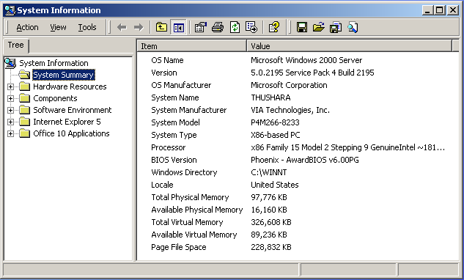
This shows the summery of the system you are using. Even though this is a Windows component, it has been inherited by the Credit Evaluator in order to facilitate the user in need.

