ERP FINANCIAL CONTROL

ERP Financial Request &
Payment Control System
  - User Manual and Role-Based Operating Guide
ADMIN | SOLICITOR | APPROVER | ACCOUNTING | TREASURY
Version 1.0 | 13 July 2026
Prepared from the current implemented system and verified local interface

Contents and Guide Scope
Scope: This manual explains the features that are available in the current web application. It does not present planned features as completed features.

How to use this manual
Start with your login role. Then use the screen and button reference when you need help with a specific page.
Part | Section | What you will find
1 | Getting Started | Open the system, choose a language, sign in, and understand the common layout.
2 | System Workflow | See how a request moves from creation to approval, payment, accounting, and closure.
3 | Role Guides | Follow the exact responsibilities of Admin, Solicitor, Approver, Accounting, and Treasury.
4 | Screen and Button Reference | Learn what each visible control does and when to use it.
5 | Business Rules | Understand request types, documents, XML checks, exchange rates, statuses, and closed periods.
6 | Troubleshooting and Checklists | Resolve common errors and confirm each task before finishing.

Important implementation boundary
- XML invoices are read and checked locally against the supplier and entered amounts.
- The current system does not call a live SUNAT API.
- Approval is one approval step. There is no dynamic approval hierarchy by amount in the current version.
- The system generates accounting entries, bank TXT files, consolidation CSV files, and SIRE/RCE review files.

1. Getting Started

Open the system
- Ask the administrator for the system address. On the local computer, the default web address is http://localhost:5174.
- Wait for the sign-in page to appear.
- Choose English or Spanish with the Language button in the top-right corner.
- Enter your email and password, then select Login.
Local services: The web application uses port 5174. The backend service uses port 5000. Normal users only need the web address.

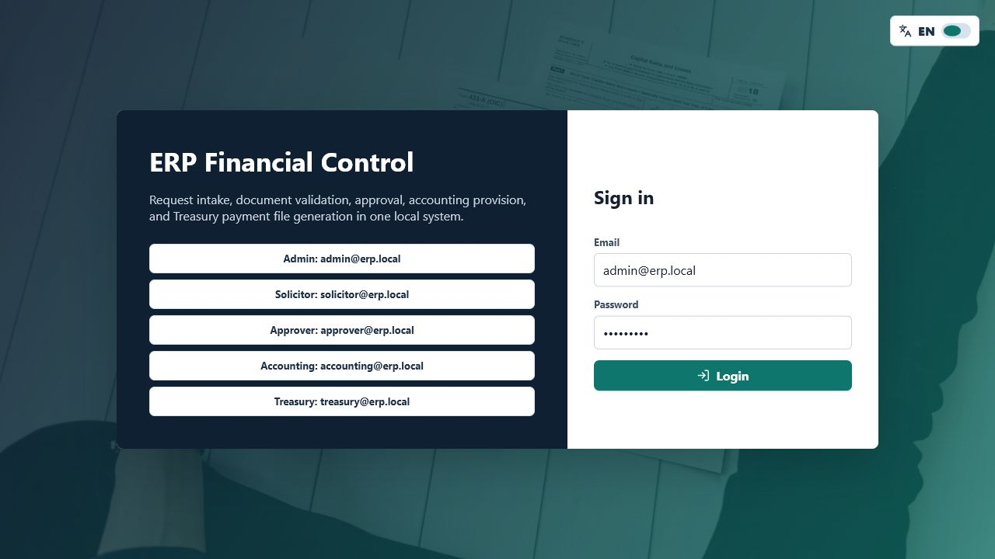
Figure 1. Sign-in page with language control, demo role selectors, email, password, and Login button.

Login page controls
Language - Switches between English and Spanish. Your choice is saved in the browser.
Role demo buttons - Fill the matching demo email and password. They do not sign in by themselves.
Email - Enter the email assigned to your account.
Password - Enter the password for your account.
Login - Checks the credentials and opens the dashboard.

Demo accounts
Role | Email | Demo password | Main purpose
Admin | admin@erp.local | Admin123! | Full system administration
Solicitor | solicitor@erp.local | User123! | Create and follow own requests
Approver | approver@erp.local | Approver123! | Approve or reject pending requests
Accounting | accounting@erp.local | Accounting123! | Accounting, master data, periods, and SIRE
Treasury | treasury@erp.local | Treasury123! | Bank payment TXT processing

Security: These are demo credentials. Replace shared passwords and remove demo access before production use.

Common page layout
- Left menu: shows the pages available to the signed-in role.
- Top bar: shows the user name, role, area, Language button, and Log out button.
- Main area: shows the selected page, filters, forms, tables, messages, and action buttons.
- Green messages: confirm successful actions. Red messages: explain validation or permission errors.

2. System Workflow
A financial request follows the sequence below. The exact final step depends on the request type.
Step | Stage | What happens
1 | Prepare master data | Admin or Accounting maintains suppliers, cost centers, expense types, exchange rates, and periods.
2 | Create request | The Solicitor enters the header, accounting lines, amounts, supplier, and required documents.
3 | Validate | The system checks open period, active supplier, line dimensions, XML data, amounts, and USD exchange rate.
4 | Submit | The request changes from BORRADOR or RECHAZADO to PENDIENTE_APROBACION.
5 | Approve or reject | The Approver accepts the request or returns it with required rejection comments.
6 | Pay | Treasury selects approved requests and generates a bank TXT file. Payment entries are created.
7 | Close | Accounting closes normal requests. Entrega a Rendir closes after receipts or supporting files are submitted.
8 | Report | Accounting reviews entries, monthly consolidation, and the SIRE/RCE export.

Immediate effects: Approval creates provision entries. Bank TXT generation creates payment entries and changes request status. These are workflow actions, not preview actions.

Who owns each stage
Role | Primary responsibility
Admin | Setup, permissions, support, and access to every functional area
Solicitor | Request entry, submission, follow-up, and Entrega a Rendir support
Approver | Business approval or rejection
Accounting | Accounting setup, entries, consolidation, SIRE, periods, and closing
Treasury | Approved payment selection and bank TXT generation

3. Role Access Matrix
Role | Request visibility | Approval | Specialized work | Master data
Admin | All requests | Approve/reject | Accounting + Treasury + SIRE | All master data + users
Solicitor | Own requests | No | No | Suppliers read-only
Approver | All non-draft requests | Approval Inbox | No | Supplier menu is visible, but supplier API access is not granted
Accounting | All requests | No Approval Inbox | Entries, consolidation, periods, SIRE, closing | Suppliers, cost centers, expense types, exchange rates
Treasury | All requests | No | Treasury queue and bank TXT | Suppliers read-only

Recommended use: The New request screen is technically reachable by all signed-in users, but normal request creation should be performed by the Solicitor or Admin role.
Approver note: The Suppliers menu is currently visible for Approver, but the backend does not grant supplier-list access to that role. Supplier information needed for approval is available inside each request.

4. Admin Login Guide
Purpose: Use Admin for system setup, user management, exception handling, and access to every functional area.

Menus available
- Dashboard
- Requests
- Approval Inbox
- Accounting
- Treasury
- Suppliers
- Cost Centers
- Expense Types
- Exchange Rates
- Periods
- SIRE Export
- Admin Users

Recommended setup order
- Create or confirm active users in Admin Users.
- Create suppliers and verify RUC/DNI, bank account, and CCI.
- Create cost centers and check assigned, executed, and available amounts.
- Create expense types with the correct accounting account.
- Enter the daily or period exchange rate before any USD request is submitted.
- Create the accounting period and keep it OPEN while work is in progress.
- Use Dashboard and Requests to monitor the full process.

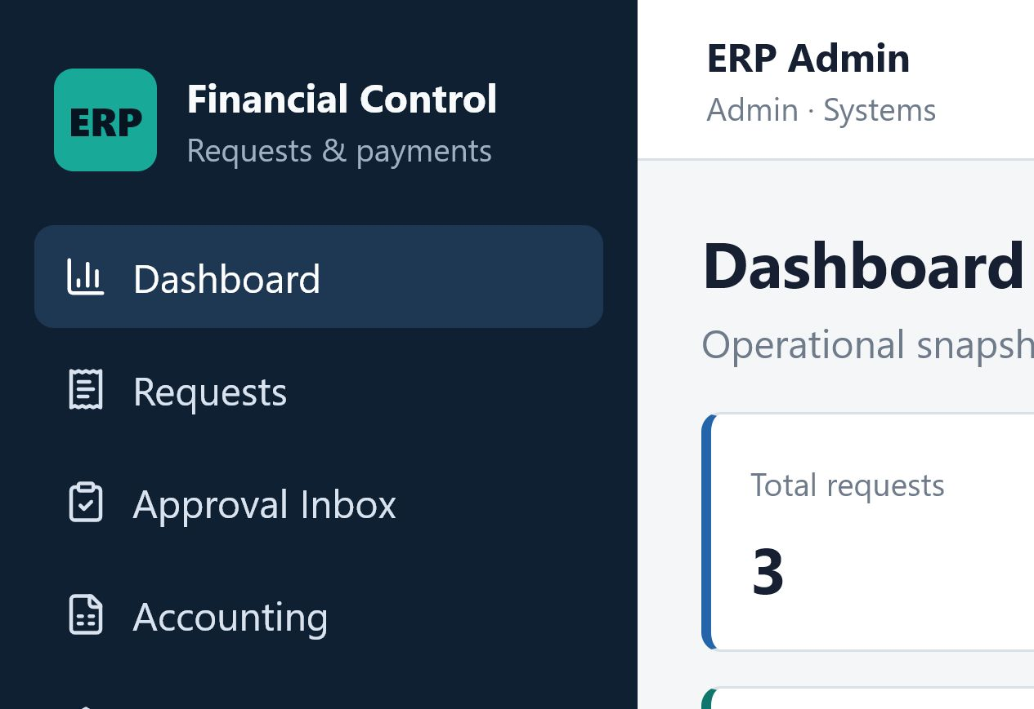
Figure 2. Admin dashboard with all navigation areas and system-wide request totals.

Dashboard information
Total requests - Counts all requests visible to the signed-in user.
Pending approval - Shows requests waiting for Approver action.
Approved / payable - Shows requests ready for Treasury.
Rejected - Shows requests returned to the Solicitor.
Processed by bank - Shows normal requests already included in a bank TXT.
Closed requests - Shows requests in LIQUIDADO_CERRADO status.
The tables below the cards group requests by status, request type, and currency. PEN equivalent helps compare PEN and USD activity.

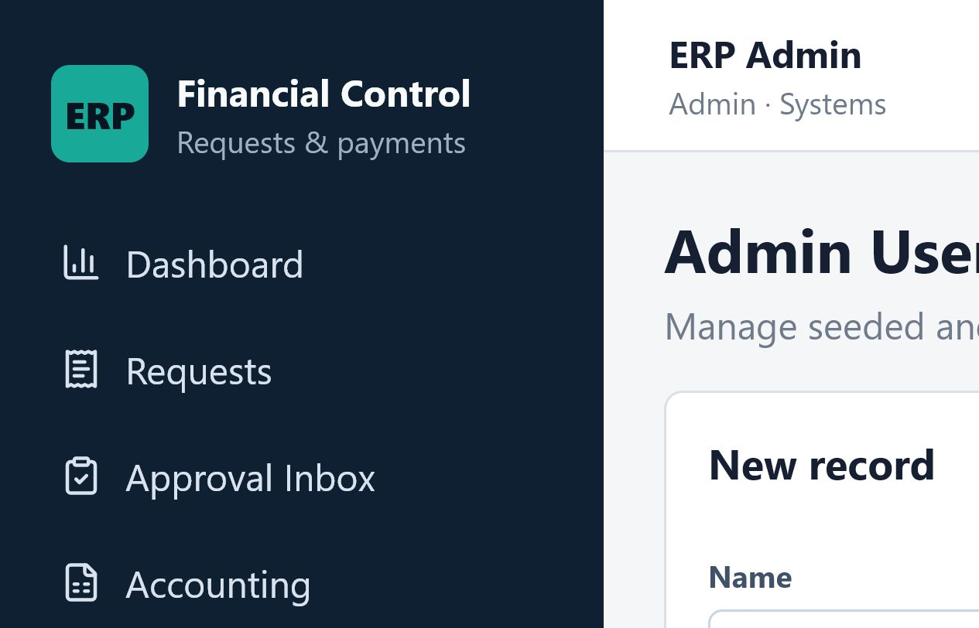
Figure 3. Admin Users page with create form, user list, Edit button, and Delete or deactivate button.

Admin Users controls
Create - Adds a user. Name, email, password, and role are required.
Edit (pencil) - Loads the selected user into the form. Change fields, then select Update.
Update - Saves changes. Leave Password empty to keep the current password.
Cancel - Stops editing and returns to a blank New record form.
Delete or deactivate (trash) - Marks the user inactive. An inactive user cannot sign in.
No confirmation: The current web page does not show a confirmation dialog before the trash action. Check the selected row carefully.

5. Solicitor Login Guide
Purpose: Use Solicitor to create financial requests, submit them, follow their status, and complete Entrega a Rendir support.

Menus available
- Dashboard - shows only the Solicitor's own requests.
- Requests - lists only the Solicitor's own requests.
- Suppliers - read-only supplier lookup.

Create a request
- Open Requests and select New request.
- Choose the Request type.
- Enter Issue date. The page automatically copies the year and month into Accounting period.
- Choose PEN or USD. For USD, an exchange rate must exist for the date or period.
- Select an active Supplier and enter a clear Description.
- For every request line, select Cost center and Expense type / account.
- Enter Net, IGV, and Total. The totals at the bottom are calculated from all lines.
- Upload the required and supporting files.
- Select Save draft to keep it as BORRADOR, or Submit for approval to send it immediately.

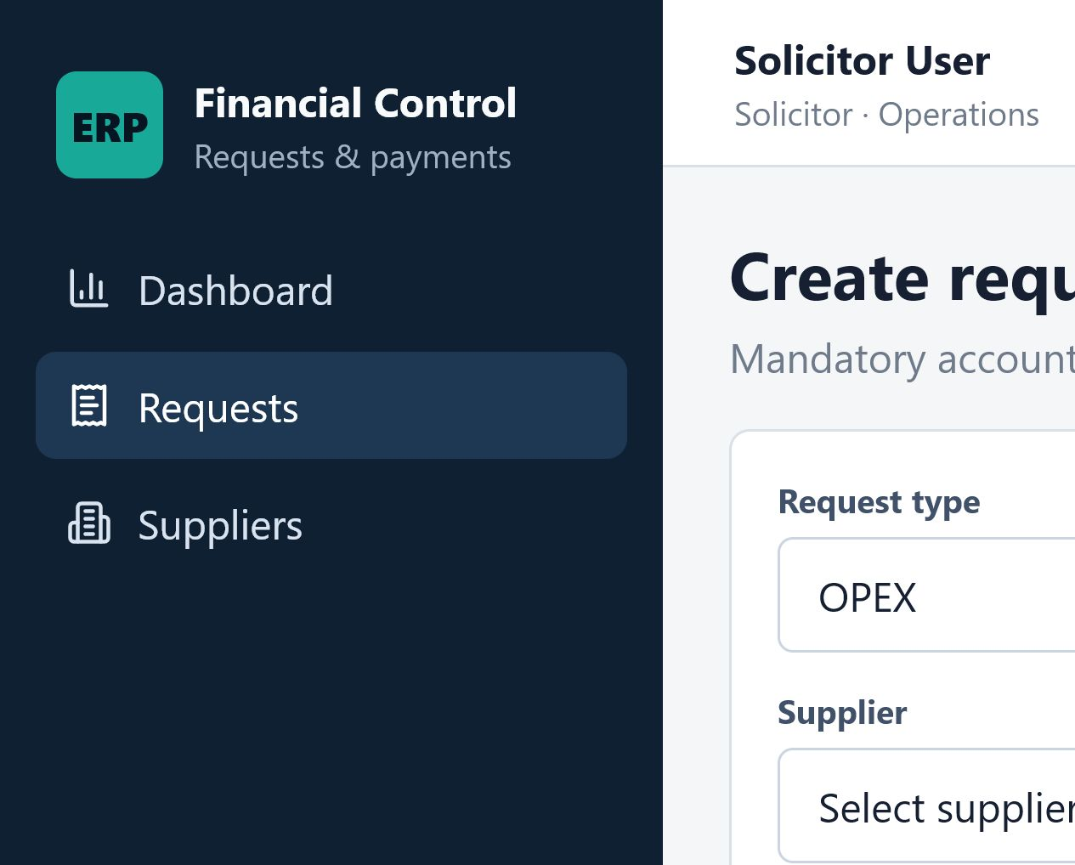
Figure 4. Solicitor request form with header fields, accounting line, attachments, totals, and submission buttons.

Request form fields
Request type - Determines the business path and document rules.
Issue date - Date of the request or supporting document. It also suggests the accounting period.
Accounting period - Must use YYYY-MM format, for example 2026-07. A CLOSED period blocks the action.
Currency - PEN uses rate 1. USD uses the saved SUNAT selling rate.
Supplier - Only active suppliers can be used.
Description - Explain the business reason for the payment or expense.
Cost center - Assigns responsibility and reporting dimension to the line.
Expense type / account - Assigns the accounting account to the line.
Net / IGV / Total - Enter the line amounts. For XML requests, they must match the invoice within 0.02.

Line and file buttons
Add line - Adds another cost center and expense-account line.
Remove line (trash) - Removes that line. It is disabled when only one line remains.
XML - Uploads one electronic invoice XML file.
PDF - Uploads one invoice or supporting PDF.
Quotation - Uploads up to two quotation files.
Supporting documents - Uploads up to eight supporting files.
Save draft - Creates a BORRADOR without sending it to approval.
Submit for approval - Validates the request and changes it to PENDIENTE_APROBACION.

After saving or submitting
- Select the request number in the Requests list to open its details.
- Use Open beside an attachment to view it in a new browser tab.
- The Approval timeline shows who performed each workflow action, the status change, comments, and date.
- A BORRADOR or RECHAZADO request shows Submit for approval when the signed-in user owns it.
Current edit limitation: The current web interface does not show Edit or Delete buttons for saved drafts or rejected requests. It can resubmit an unchanged draft or rejected request from the detail page.

Entrega a Rendir
- After Treasury processes the payment, the status becomes RENDICION_PENDIENTE.
- Open the request and choose one or more receipts or supporting files.
- Enter comments that explain the rendition.
- Select Submit rendition.
- The system creates the real expense recognition entry and changes the request to LIQUIDADO_CERRADO.

6. Approver Login Guide
Purpose: Use Approver to review pending requests and make the approval decision.

Menus available
- Dashboard - system-wide summary.
- Requests - all requests except BORRADOR.
- Approval Inbox - only requests waiting for approval.
- Suppliers - visible in the menu, but supplier-list API access is not currently granted to Approver.

Review and decide
- Open Approval Inbox.
- Select the request number to review lines, amounts, supplier, attachments, XML result, and approval timeline.
- Return to the inbox or make the decision on the detail page.
- For approval, enter an optional comment and select the check button.
- For rejection, enter a clear required comment and select the X button.

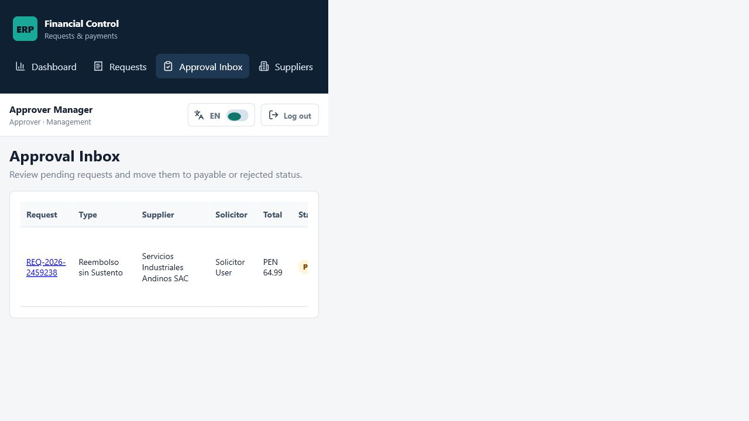
Figure 5. Approval Inbox with pending request, comment box, Approve check button, and Reject X button.

Decision effects
Approve (check) - Changes the request to APROBADO_POR_PAGAR and generates provision accounting entries.
Reject (X) - Requires comments, changes the request to RECHAZADO, and returns it to the Solicitor.
Approval check: The period must still be OPEN. Required XML/PDF documents and XML validation must pass before approval.

7. Accounting Login Guide
Purpose: Use Accounting to maintain accounting data, review generated entries, consolidate monthly activity, prepare SIRE/RCE data, control periods, and close requests.

Menus available
- Dashboard
- Requests
- Accounting
- Suppliers
- Cost Centers
- Expense Types
- Exchange Rates
- Periods
- SIRE Export

Accounting Entries page
- Enter the period in YYYY-MM format.
- Select Load entries to list generated PROVISION, PAYMENT, and RENDITION entries.
- Select Consolidate to group eligible request lines by period, cost center, expense account, and currency.
- Review the Month-end consolidation preview.
- Select Export CSV to download the consolidation file.

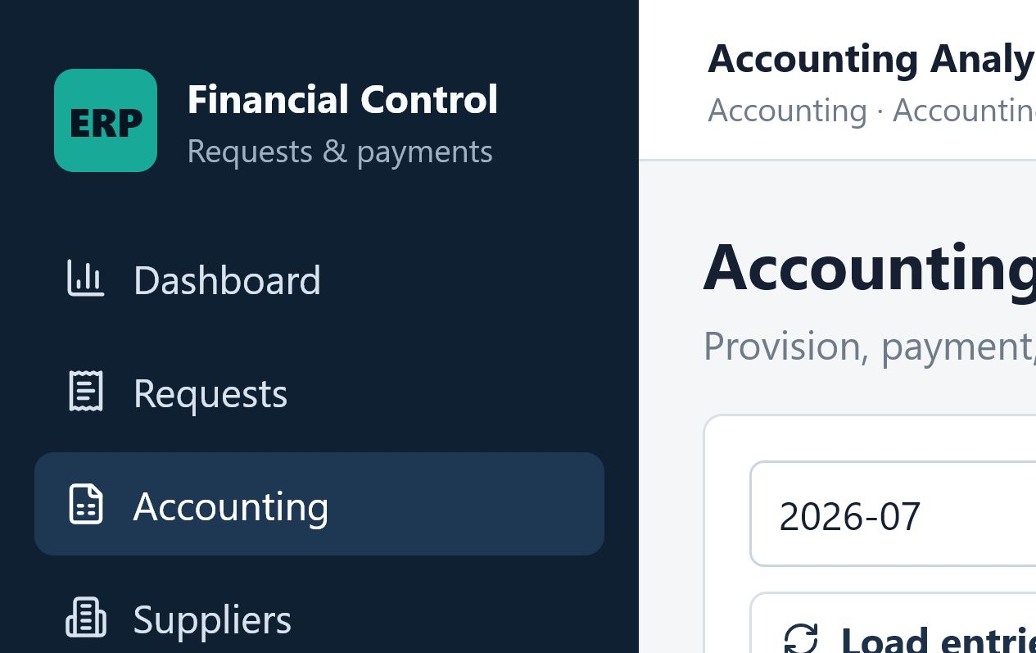
Figure 6. Accounting workspace with period control, entry loading, consolidation, CSV export, and entry table.

Accounting buttons
Load entries - Reloads accounting entries for the entered period.
Consolidate - Builds the on-screen month-end summary. This is a preview action.
Export CSV - Downloads the month-end consolidation as consolidation-YYYY-MM.csv.

Close a normal request
- Open Requests and select a request in APROBADO_POR_PAGAR or PROCESADO_BANCO status.
- Enter Closing comments.
- Select Close request.
- The request changes to LIQUIDADO_CERRADO.
Use carefully: Accounting can close an approved request even before bank processing because APROBADO_POR_PAGAR is accepted by the current backend. Confirm the intended business process before closing.

SIRE RCE Export
- Open SIRE Export and enter the period.
- Select Preview to view eligible rows on screen.
- Check supplier RUC, invoice number, issue date, net, IGV, total, currency, and request number.
- Select Export CSV to download sire-rce-YYYY-MM.csv.
Only approved or later requests with successful XML validation are included.

Accounting periods
Create - Adds a period such as 2026-07 with OPEN or CLOSED status.
Edit (pencil) - Loads the period into the form.
Update - Saves the status. CLOSED records the closing date and user. OPEN clears both.
Delete (trash) - Permanently deletes the period record.
Period control: A CLOSED period blocks request creation, modification, deletion, submission, approval, bank-file generation, rendition, and closing for that period.

8. Treasury Login Guide
Purpose: Use Treasury to select approved requests and generate the bank mass-payment TXT file.

Menus available
- Dashboard - system-wide summary.
- Requests - all requests.
- Treasury - approved payment queue.
- Suppliers - read-only bank and CCI lookup.

Generate the bank TXT
- Open Treasury.
- Select Refresh to load requests in APROBADO_POR_PAGAR status.
- Check the supplier bank account or CCI and the amount.
- Select the checkbox for every request to include.
- Select Generate bank TXT.
- Review the generated file name and content, then select Download generated TXT.

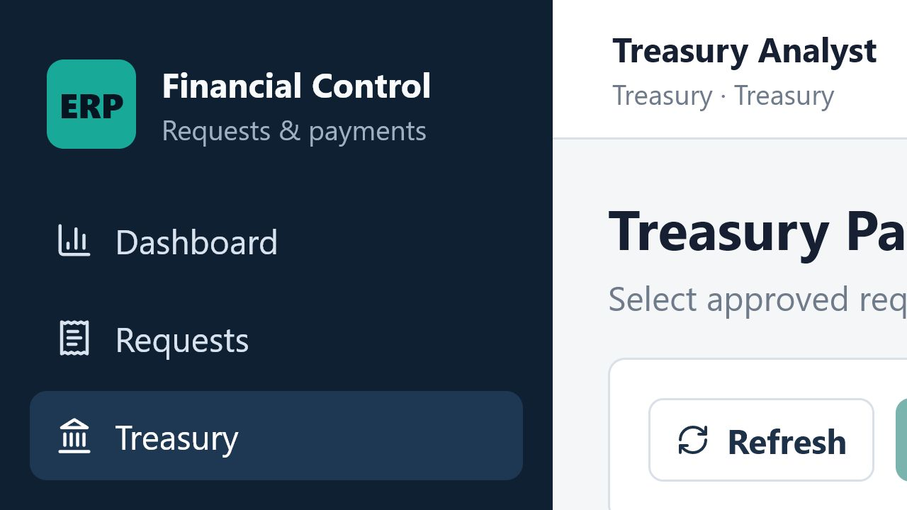
Figure 7. Treasury Payment Queue. Generate bank TXT stays disabled until at least one payable request is selected.

Treasury controls
Refresh - Reloads the list of approved payable requests.
Request checkbox - Adds or removes a request from the next bank file.
Generate bank TXT - Creates a pipe-separated bank file and processes every selected request.
Download generated TXT - Opens or downloads the file stored by the backend.
No preview or undo: Generate bank TXT immediately creates payment entries and changes statuses. Normal requests become PROCESADO_BANCO. Entrega a Rendir becomes RENDICION_PENDIENTE.

9. Screen and Button Reference

Requests list
New request - Opens the request-entry form.
All statuses - Filters the list by request status.
All types - Filters the list by request type.
Period - Filters by YYYY-MM accounting period.
Apply filters - Reloads the list with the selected filters.
Request number link - Opens the request detail page.

Request detail
Back to list - Returns to Requests.
Open - Opens the selected attachment in a new tab.
Submit for approval - Available for owned BORRADOR or RECHAZADO requests, and for Admin.
Approve - Available to Admin or Approver only while status is PENDIENTE_APROBACION.
Reject - Available to Admin or Approver; rejection comments are required.
Close request - Available to Admin or Accounting for APROBADO_POR_PAGAR or PROCESADO_BANCO.
Submit rendition - Uploads receipts for RENDICION_PENDIENTE and closes the request.

Reusable master-data form
Suppliers, Cost Centers, Expense Types, Exchange Rates, Periods, and Admin Users use the same basic form pattern.
Create - Creates a record from the fields on the left.
Edit (pencil) - Loads the selected row into the form.
Update - Saves changes to the selected record.
Cancel - Leaves edit mode without saving further changes.
Delete or deactivate (trash) - Removes, deactivates, or deletes the record depending on the page.

What the trash button does
Page | Trash action | Important result
Suppliers | Changes status to INACTIVE | Supplier remains in history and cannot be selected for new requests
Admin Users | Changes Active to No | User can no longer sign in
Cost Centers | Permanently deletes the record | Use only when it is not needed by requests
Expense Types | Permanently deletes the record | Use only when it is not needed by requests
Exchange Rates | Permanently deletes the record | May block USD processing
Accounting Periods | Permanently deletes the record | Removes the period-control record

Warning: There is no confirmation dialog before these trash actions in the current interface.

Complete button index
Button or control | What it does | When to use it
Language | Changes English/Spanish | Any time
Log out | Ends the browser session | When finished or changing roles
New request | Opens the request form | Starting a financial request
Apply filters | Reloads filtered requests | Finding requests by status, type, or period
Add line | Adds another accounting line | Splitting cost centers or accounts
Remove line | Deletes one unsaved form line | Correcting the current request form
Save draft | Saves as BORRADOR | Request is incomplete or not ready
Submit for approval | Validates and sends the request | Request is complete
Open | Opens an attachment | Reviewing support
Approve / check | Approves and creates provision entries | Approver decision
Reject / X | Rejects with required comments | Request needs correction
Close request | Changes request to closed | Accounting finalization
Submit rendition | Uploads receipts and closes Entrega a Rendir | Completing rendition
Refresh | Reloads the Treasury queue | Before payment selection
Generate bank TXT | Creates file, payment entries, and status changes | Treasury payment run
Download generated TXT | Retrieves the created bank file | Sending to bank process
Load entries | Loads accounting entries for a period | Accounting review
Consolidate | Builds the monthly preview | Month-end review
Export CSV | Downloads accounting or SIRE data | External review or reporting
Preview | Loads SIRE rows on screen | Check before export
Create | Creates a master-data record | System setup
Edit / pencil | Starts editing a row | Correcting a record
Update | Saves an edited record | Completing an edit
Cancel | Leaves edit mode | Stopping an edit
Trash | Deactivates or deletes by page | Only after checking the row carefully

10. Business Rules and Validation

Request types
Type | Meaning | Special rule
OPEX | Operating expense | XML/PDF not automatically mandatory
CAPEX | Capital expenditure | XML/PDF not automatically mandatory
Entrega a Rendir | Advance that needs later receipts | Moves to RENDICION_PENDIENTE after bank processing
Reembolso con Sustento | Reimbursement with documents | XML and PDF are mandatory
Reembolso sin Sustento | Reimbursement without formal support | XML/PDF not automatically mandatory
Pago con Cotización | Payment supported by quotation | XML and PDF are mandatory

Document rules
- XML: maximum one file.
- PDF: maximum one file.
- Quotation: maximum two files.
- Supporting documents: maximum eight files.
- Rendition documents: maximum eight files.
- Maximum size: 10 MB per file.
- Allowed extensions: XML, PDF, TXT, CSV, JSON, JPG, JPEG, PNG, DOC, DOCX, and XLSX.

XML validation
- The system reads supplier RUC/DNI, supplier name, invoice number, issue date, net, IGV, and total when available.
- Supplier RUC/DNI must match the selected supplier.
- Net, IGV, and total must match the request within 0.02.
- If validation passes, the request detail shows XML validated against supplier and request amounts.
- If validation fails, the request is not submitted or approved until the data is corrected.
Local check: XML validation is performed inside this system. It does not confirm the document against a live SUNAT service.

Currency conversion
- PEN requests use exchange rate 1.
- USD requests first use an exchange rate saved for the exact issue date.
- If no exact-date rate exists, the system uses the latest saved rate in the accounting period.
- If no suitable rate exists, the request is blocked with a missing exchange-rate error.

Accounting entries
Entry type | Created when | Accounting behavior
PROVISION | Approval | Expense/asset account is debited. Entrega a Rendir uses transit account 14.
PAYMENT | Bank TXT generation | Bank account 10 is credited.
RENDITION | Entrega a Rendir support submission | Real expense account is debited.

Cost-center budget
The current version tracks annual budget, executed amount, and available amount. It does not block a request when the available amount is low or negative.

11. Request Status Guide
System status | Simple meaning | What it tells the user
BORRADOR | Draft | Saved but not submitted
EN_VALIDACION | In validation | Reserved status; the current UI normally submits directly to pending approval
PENDIENTE_APROBACION | Pending approval | Waiting for Approver or Admin
RECHAZADO | Rejected | Returned with rejection comments
APROBADO_POR_PAGAR | Approved / payable | Provision entries exist; ready for Treasury
PROCESADO_BANCO | Processed by bank | Normal request included in bank TXT; payment entries exist
RENDICION_PENDIENTE | Rendition pending | Entrega a Rendir is waiting for receipts/support
LIQUIDADO_CERRADO | Closed | Workflow is finished

Main status paths
Normal request: BORRADOR -> PENDIENTE_APROBACION -> APROBADO_POR_PAGAR -> PROCESADO_BANCO -> LIQUIDADO_CERRADO
Rejected request: PENDIENTE_APROBACION -> RECHAZADO -> PENDIENTE_APROBACION
Entrega a Rendir: BORRADOR -> PENDIENTE_APROBACION -> APROBADO_POR_PAGAR -> RENDICION_PENDIENTE -> LIQUIDADO_CERRADO

12. Troubleshooting
Message or symptom | Meaning | What to do
Invalid credentials | The email/password is wrong, the user is inactive, or the account does not exist. | Check the email, password, and Active status in Admin Users.
Mandatory attachment missing | XML or PDF is missing for Pago con Cotización or Reembolso con Sustento. | Upload both required files.
XML validation failed | RUC/DNI or amounts do not match the XML. | Compare supplier, net, IGV, and total with the invoice.
Missing exchange rate | A USD request has no exact-date or period rate. | Accounting must create the exchange rate, then try again.
Accounting period is closed | The request period is CLOSED. | Accounting or Admin must confirm whether the period should be reopened.
Generate bank TXT is disabled | No requests are selected or no payable requests exist. | Refresh, then select at least one APROBADO_POR_PAGAR row.
No records found | The list is empty, filters exclude records, or data is still loading. | Wait briefly, clear filters, and reload the page.
Permission error | The role is not allowed to use the endpoint. | Return to an available menu or ask Admin for the correct role.
File type is not allowed | The attachment extension is outside the approved list. | Convert the file to an allowed format.
File is too large | The file is above 10 MB. | Reduce file size and upload again.

Safe recovery rules
- Read the red message before repeating an action.
- Do not click Approve, Generate bank TXT, Close request, or Trash more than once.
- Use the Approval timeline and accounting entries to confirm whether the action already completed.
- For a browser session problem, select Log out and sign in again.

13. Quick Checklists

Solicitor before submission
- Correct request type, date, period, currency, and supplier
- Clear description
- Cost center and expense account on every line
- Net, IGV, and total checked
- Required XML and PDF attached
- Supporting files attached
- USD exchange rate available
- Period is OPEN

Approver before decision
- Supplier and business purpose checked
- Amounts and accounting lines reviewed
- Attachments opened
- XML validation result confirmed when applicable
- Rejection reason is clear when rejecting
- Period is still OPEN

Treasury before bank file
- Only intended payable requests selected
- Supplier RUC/DNI checked
- Bank account or CCI checked
- Amount and currency checked
- Period is OPEN
- Generated file name and content reviewed

Accounting before period closure
- Required exchange rates entered
- Provision, payment, and rendition entries reviewed
- Monthly consolidation preview checked
- Consolidation CSV exported when needed
- SIRE/RCE preview and CSV checked
- Open requests in the period reviewed
- Closing status approved by the responsible team

14. Current Interface Notes
Why this section exists: These notes describe current web-interface behavior so users know what to expect. They are not future feature promises.
Area | Current behavior
Saved-request editing | Backend rules allow editing or deleting owned drafts and rejected requests, but the current web UI does not provide Edit or Delete buttons on request detail.
Approver supplier page | Suppliers appears in the Approver menu, but the backend does not permit supplier-list access for Approver.
Request creation visibility | New request is visible to all signed-in roles. Operationally, use Solicitor or Admin for request creation.
Single approval step | The current workflow has one Approver decision. It does not calculate a multi-level hierarchy by amount.
No live SUNAT lookup | The application reads XML and compares its values locally. It does not check SUNAT online.
No delete confirmation | Master-data trash buttons act immediately.
Bank file action | Generate bank TXT has no preview or undo step and immediately creates entries and status changes.

End of guide
Use the role checklist at the start of each task, and use the button index when you are unsure about a control. For permission, period, or master-data problems, contact the Admin or Accounting owner before repeating a workflow action.
Document version: Version 1.0, prepared from the application implementation and interface reviewed on 13 July 2026.

