THREE-PAGE OPERATIONAL GUIDE

ERP Financial Request & Payment Control System
  - Quick User Manual
Version 1.0 | July 2026 | English / Spanish
Purpose: Create, approve, pay, account for, and close financial requests while keeping documents, status history, and role permissions controlled.

1. Access and navigation
- Open https://uma-financial-access.onrender.com and select Open ERP. The access page always shows the latest Cloudflare link.
- Sign in with your assigned company email and password. The system shows only the modules permitted for your role.
- Use the left sidebar for modules, the bell for pending tasks, EN/ES for language, and the user menu to view your role or log out.
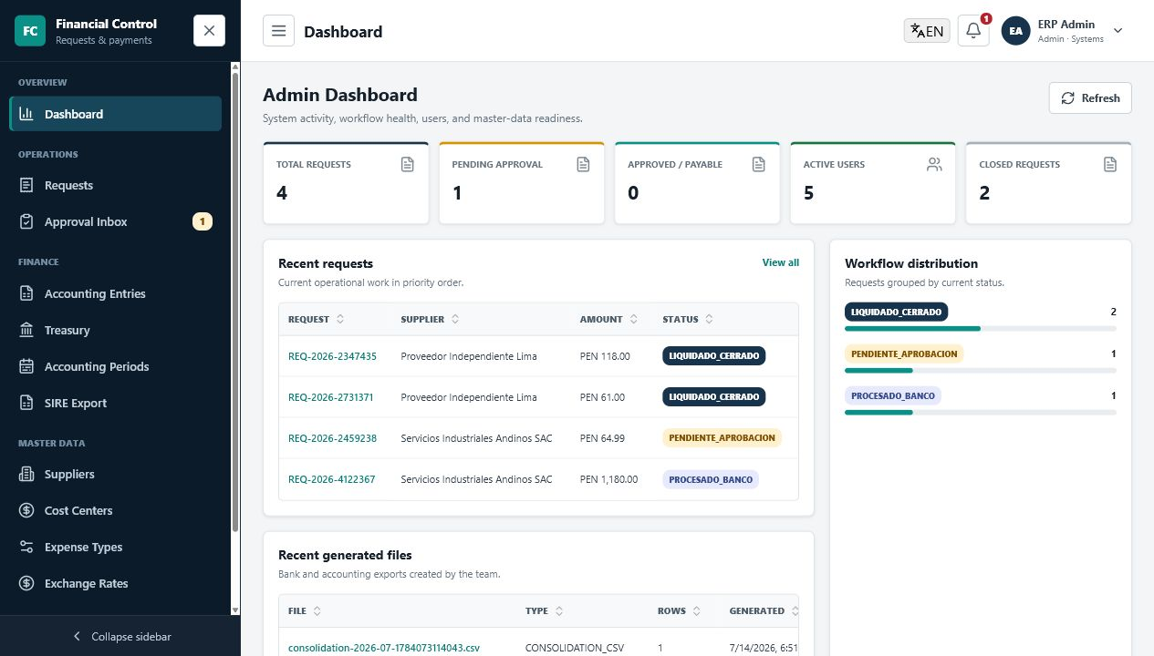
The workspace combines role-based navigation, task alerts, metrics, and searchable tables.

Role access at a glance
Role | Main work | Important permissions
Admin | All modules and system health | Users, master data, requests, approvals, accounting, Treasury
Solicitor | Own requests and renditions | Create; edit/delete own BORRADOR or RECHAZADO; supplier view
Approver | Approval Inbox | View non-draft requests; approve or reject with comments
Accounting | Entries, periods, SIRE, master data | Maintain suppliers/rates; close eligible requests and periods
Treasury | Payable queue and bank files | Select payable requests; generate/download bank TXT; supplier view

CORE WORKFLOW

2. Create and submit a request
Who can create: Admin and Solicitor users. A Solicitor sees only their own requests; an Admin can work across requests.
- Basic information
Select the request type, issue date, accounting period, currency, supplier, and business description.
- Closed accounting periods cannot be used.
- USD requests require an exchange rate for the date or period.
- A bank/CCI warning means Treasury cannot pay until supplier details are corrected.
- Accounting lines
Choose a cost center and expense account for each line, then enter Net, IGV, and Total.
- Add line creates another allocation; the trash icon removes a line.
- Totals update automatically. Correct any Net + IGV versus Total warning before submission.
- Documents
Attach invoice and supporting files. Pago con Cotizacion and Reembolso con Sustento require both XML and PDF before submission.
- The XML is checked against supplier RUC/DNI and request amounts.
- Quotation and supporting uploads accept the additional evidence used by the business.
- Review and submit
Check the final summary. Use Edit or Back without losing entered data, Save draft to keep BORRADOR, or Submit for approval to start the workflow.
- The form autosaves locally while you work.
- The owner or Admin may edit or permanently delete BORRADOR and RECHAZADO requests.

What happens next
Status | Meaning | Next user action
BORRADOR | Saved but not submitted | Owner edits, submits, or deletes
PENDIENTE_APROBACION | Waiting for decision | Approver reviews details, XML, attachments, and timeline
RECHAZADO | Returned for correction | Owner reads the required comment, edits, and resubmits
APROBADO_POR_PAGAR | Approved and in Treasury queue | Treasury verifies bank/CCI and selects payment
PROCESADO_BANCO | Bank TXT generated | Accounting reviews entries and closes when complete
RENDICION_PENDIENTE | Advance paid; evidence is due | Owner/Accounting uploads rendition documents
LIQUIDADO_CERRADO | Workflow completed | Read-only record and audit history
Approval creates provision accounting entries. Bank-file generation changes request statuses and creates payment entries; these effects are shown before confirmation.

DAILY OPERATIONS

3. Process, control, and support

Approver
Open Approval Inbox, review the oldest requests and amounts, then open the request or use the decision buttons. Approve moves it to APROBADO_POR_PAGAR. Reject requires a clear comment and returns it to the Solicitor.

Treasury
In Treasury Payment Queue, select ready rows, review totals by PEN/USD, and resolve missing bank/CCI warnings. Select Review bank file, confirm the exact result, generate the TXT, then use Bank file history to download previous files.

Accounting and SIRE
Use Accounting Entries to load a period, compare debit/credit totals, review consolidation, and export CSV history. Use SIRE Export to validate XML-backed purchases before export. Accounting Periods can be closed or reopened; a closed period blocks workflow and accounting changes.

Master data and administration
Admin/Accounting maintain suppliers, cost centers, expense types, exchange rates, and periods. Get latest online rate loads the current published USD/PEN selling rate into an editable form; review it before saving. Admin manages users and roles. Deactivation preserves history; permanent deletion cannot be undone.

Common controls
Control | Use
Search / filters / sort | Find records, narrow status or currency, and order a table column.
Clear filters | Return the table to its complete result set.
Checkboxes | Select one row or all visible rows for supported bulk actions.
Three-dot menu | Open row actions such as View, Edit, Download, Deactivate, or Delete.
Refresh | Reload the latest dashboard, queue, rate, or table data.
Download icon | Open or download an attachment, bank file, consolidation, or SIRE export.
Back / Continue / Edit | Move through the request wizard without losing completed information.
Save draft / Submit | Keep editable work or send a validated request into approval.

Important operating rules
- Read confirmation dialogs carefully: they state the exact status, accounting, or deletion result.
- Disabled buttons include a reason; correct the missing document, bank detail, selection, status, or period first.
- If data looks old, select Refresh. If access is denied, confirm your assigned role with the Admin.
- The shared ERP requires the host PC, MongoDB, ERP server, and Cloudflare tunnel to remain running.
- Use only authorized accounts. Do not share passwords or financial files outside approved channels.

