Contacts-Manager

Darshan Naryana Reddy(dxr141430)

Darshan Bidkar(dmb140230)

This is an android Application to manage contacts and this is a standalone application, which will not modify the actual contacts of the phone. This is our attempt to emulate the way the contacts app works in adroid phone.

This application matches all the requirements of the problem statement. Please find attached screenshots of different screens in the contact management workflow

Contact List

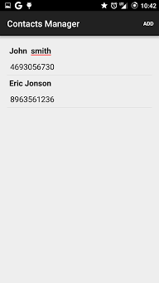

Add contact

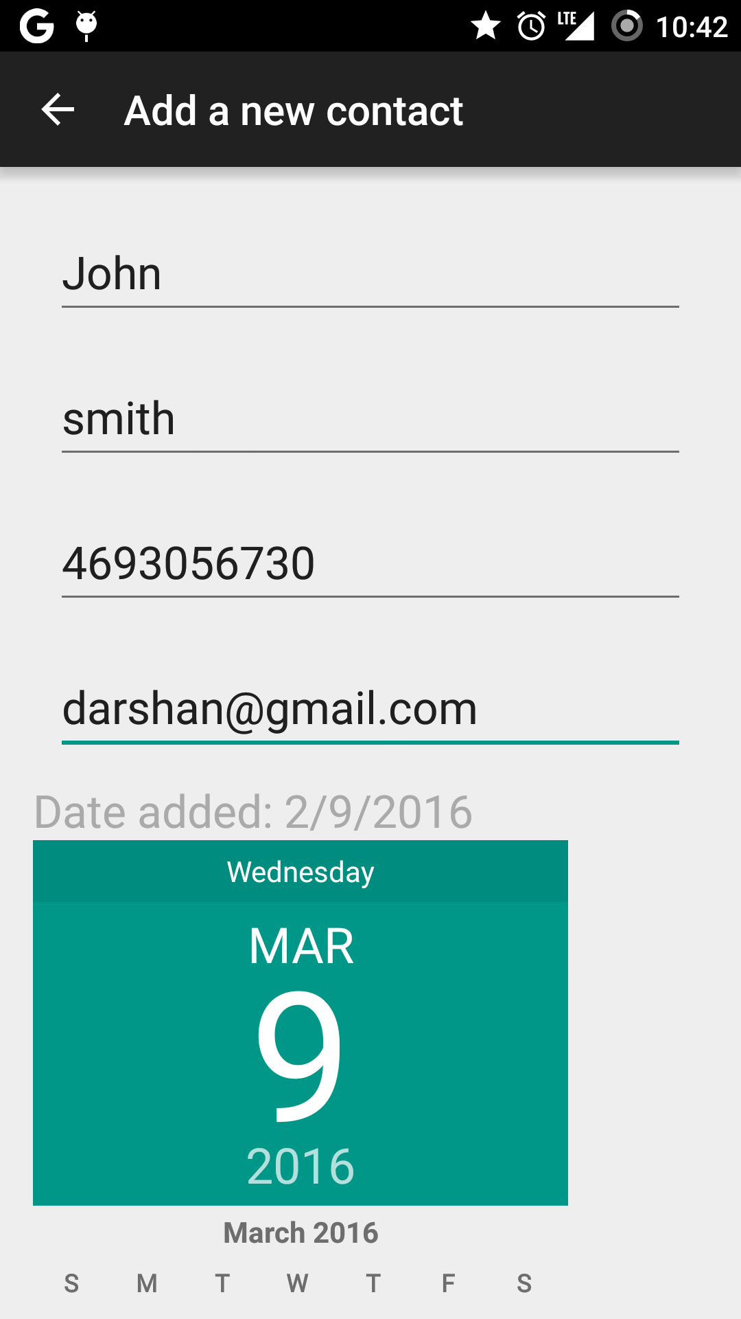

Confirm Delete

