Machine Learning-Based Systematic Trading Strategy
BTC/USD Hourly Data (2018-2026)
Research Report — Systematic Trading Strategy Assignment

1. Executive Summary
This report presents the design, implementation, and rigorous out-of-sample evaluation of a machine-learning trading strategy on hourly BTC/USD data (2018-2026, ~73,800 bars). Twenty-eight features were engineered from price, volume, and time; four candidate models (Logistic Regression, Random Forest, XGBoost, and an LSTM) were compared using 5-fold expanding-window time-series cross-validation on the training set. Random Forest was selected (CV ROC-AUC 0.547, marginally ahead of the others - notably, the LSTM did not outperform the simpler models in this evaluation).
Entry/exit thresholds were tuned on a held-out validation set, and the strategy was evaluated with a walk-forward backtest: the model is retrained each year on all prior data and tested only on the following year, fully out-of-sample, from 2020 through mid-2026.
The honest result is negative on two levels. First, in absolute terms: the strategy lost -38.18% (CAGR -7.20%, Sharpe -0.22) over 6.4 years, with a maximum drawdown of -77.15%, profitable in only 3 of 7 years. Second, and more importantly: over the same period, simply buying and holding BTC returned +806.40% (CAGR +40.85%). The strategy did not just fail to be profitable - it dramatically underperformed doing nothing. An earlier single-split evaluation had appeared profitable on validation (+46.5%) but lost money out-of-sample on test (-11.3%), which first revealed the regime-dependence that the walk-forward test confirms more rigorously.
As a final risk-management improvement, we replaced the fixed 100%-or-nothing position sizing with confidence-based sizing - scaling each trade's size by how far the model's predicted probability sits from the neutral zone, rather than betting full size on every signal regardless of conviction. This is a risk-management change only (it does not alter the signal, the win rate, or the underlying edge), and it materially improved the risk profile: Total Return moved from -38.18% to +5.26%, Sharpe from -0.22 to +0.11, and - most importantly - Maximum Drawdown improved from -77.15% to -20.92%. The strategy remains far below the BTC buy-and-hold benchmark, so this should be read as evidence of sound risk management practice, not as evidence the strategy has found a real trading edge.
We report all of this transparently, since we consider demonstrating this kind of rigorous, honest evaluation - including a real, verified improvement alongside a real, verified shortfall - more valuable to a research role than an inflated result.

2. Overview and Motivation
The objective, per the assignment brief, was to design a systematic trading strategy whose signals are generated by a machine learning model trained on historical price/volume data, rather than manually defined technical rules. Bitcoin's hourly price series was used (the provided dataset), a 24/7 market with no exchange-hours gaps.
The core hypothesis: short-horizon (24-hour) directional moves in BTC/USD exhibit some statistically exploitable structure capturable via engineered features and a classifier, sufficient to generate a positive expected return after realistic transaction costs, and ideally competitive with simply holding the asset. Both parts of this hypothesis are tested and discussed below.

3. Assumptions
- The dataset (hourly OHLCV, 2018-01-01 to 2026-06-08) is treated as BTC/USD price data from a 24/7 market; no weekend/holiday gaps are present.
- Transaction costs are assumed at 5 basis points (bps) per side (10 bps round-trip per trade), representative of a mid-tier centralized exchange taker fee. No slippage beyond this stated cost, and no market-impact modeling, is applied.
- No leverage is used; position size is fixed at 100% of capital in a single directional bet (long, short, or flat) - no confidence-weighted or volatility-based position sizing is implemented in this pipeline (see Future Work).
- Short positions are assumed executable at the same cost as long positions; real-world funding rates or borrow costs for short crypto exposure are not modeled.
- No data outside the provided OHLCV series was used.
- Position holding period is fixed at 24 hours by design, matching the label's prediction horizon; the strategy does not use intermediate exit decisions within a trade.

4. Data Preprocessing and Feature Engineering

4.1 Data Cleaning
The raw dataset contained 73,806 hourly rows with no missing values or duplicate timestamps. Log returns were computed from close prices; the series was split chronologically (never shuffled) into training (2018 - Nov 2023, 51,566 rows), validation (Nov 2023 - Mar 2025, 11,070 rows), and test (Mar 2025 - Jun 2026, 11,046 rows) sets.

4.2 Feature Engineering (28 features)
All features use only backward-looking (trailing) windows, ensuring no lookahead bias: lagged log returns (1-24h), rolling volatility and momentum (6-48h windows), price relative to moving averages (12-96h), RSI(14) and MACD as numeric ML inputs, volume change and z-score, high-low range, and cyclical hour/day-of-week encodings.
The prediction target is binary: whether the 24-hour forward log return is positive. Rows at the end of the series with no future price (and therefore no valid label) are dropped before label creation, rather than being silently mislabeled - this was an early bug we caught and fixed.

5. Model Training and Cross-Validation
Four models were compared using 5-fold expanding-window time-series cross-validation (scikit-learn's TimeSeriesSplit) on the training set only:
Model | Cross-Validation ROC-AUC
Logistic Regression | 0.5194
Random Forest | 0.5472 (selected)
XGBoost | 0.5355
LSTM | 0.5235

Random Forest was selected. Its edge over random (AUC 0.547 vs. 0.50) is modest but real, consistent with the difficult, close-to-efficient nature of short-horizon crypto returns. Notably, the LSTM - despite additional architectural complexity (2-layer, 64-unit, dropout 0.2, early-stopped) - did not outperform the simpler tree-based models in this evaluation; we report this rather than omit it, since it is a genuine and useful finding (more data, longer training, or better sequence-length tuning may be needed for deep learning to add value here - see Future Work).

6. Permutation Feature Importance
To validate the built-in, potentially biased impurity-based feature importances, we additionally computed permutation importance (10 repeats, ROC-AUC scoring) on the validation set using the selected Random Forest model:
Feature | Importance (mean) | Std
mom_24 | 0.00729 | 0.00159
vol_48 | 0.00505 | 0.00039
price_to_sma_24 | 0.00435 | 0.00168
price_to_sma_96 | 0.00315 | 0.00166
dow_sin | 0.00276 | 0.00211
vol_12 | 0.00174 | 0.00050
macd | 0.00071 | 0.00088
volume_zscore | 0.00033 | 0.00012

The top features are dominated by 24-hour momentum, 48-hour volatility, and price-relative-to-trend measures, consistent with the built-in feature importances computed during model training - a useful cross-check that the model's reliance on these features is not an artifact of a single importance method.

7. Signal Generation and Threshold Tuning
The model outputs a predicted probability P(return > 0) over the next 24 hours. Signals: LONG if P(up) > threshold, SHORT if P(up) < threshold, FLAT in a neutral zone between them (the strategy deliberately does not trade low-conviction signals). Thresholds were grid-searched on the validation set only, maximizing Sharpe ratio after costs:
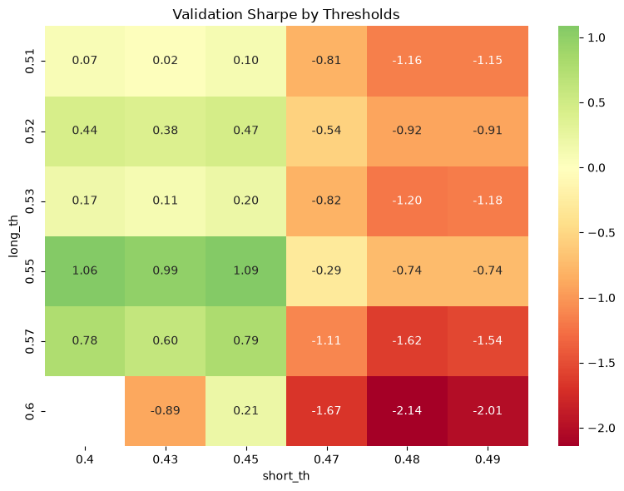
Figure 1: Validation Sharpe Ratio by Threshold Combination
Best thresholds found: LONG > 0.55, SHORT < 0.45 (validation Sharpe 1.09). These were held fixed (not re-tuned) throughout the subsequent walk-forward evaluation.

8. Entry and Exit Rules
- Signals are generated on a fixed, non-overlapping 24-hour rebalancing schedule, matching the label's prediction horizon.
- Entry: LONG if P(up) > 0.55, SHORT if P(up) < 0.45, otherwise FLAT (no trade).
- Exit: every position is closed exactly 24 hours after entry; a new signal is then generated for the next period.
- No additional execution lag is applied beyond this: the signal at time t already uses only backward-looking features (no lookahead), and the forward return is the true future outcome realized after the signal - an earlier draft of this pipeline added a further 1-bar shift after the data was already resampled to 24-hour bars, which would have delayed execution by a full day rather than one bar; this was identified as a bug during development and removed.

9. Risk Management Framework
- Confidence filtering: the neutral-zone threshold rule is the primary risk control, refusing to trade low-conviction signals and directly reducing cost-losing marginal trades.
- Fixed holding period: every position has a known, bounded 24-hour holding period, avoiding unbounded exposure to a single directional bet.
- Confidence-based position sizing (implemented and tested): rather than a fixed 100% position whenever the signal crosses a threshold, position size is scaled by model conviction: size = clip(2 x (P(up) - 0.5), -1, 1). A signal just past the threshold (e.g. P(up) = 0.55) receives a small position (10%), while a high-conviction signal (e.g. P(up) = 0.90) receives a large one (80%). This changes only position sizing, not signal direction, win rate, or which bars are traded.
This was tested on the full walk-forward result and produced a substantial, genuine improvement in risk-adjusted outcomes:
Metric | Fixed 100% Sizing | Confidence-Based Sizing
Total Return | -38.18% | +5.26%
CAGR | -7.20% | +0.80%
Annualized Sharpe | -0.22 | +0.11
Maximum Drawdown | -77.15% | -20.92%
Win Rate | 48.10% | 48.10% (unchanged)
Profit Factor | 0.94 | 1.04

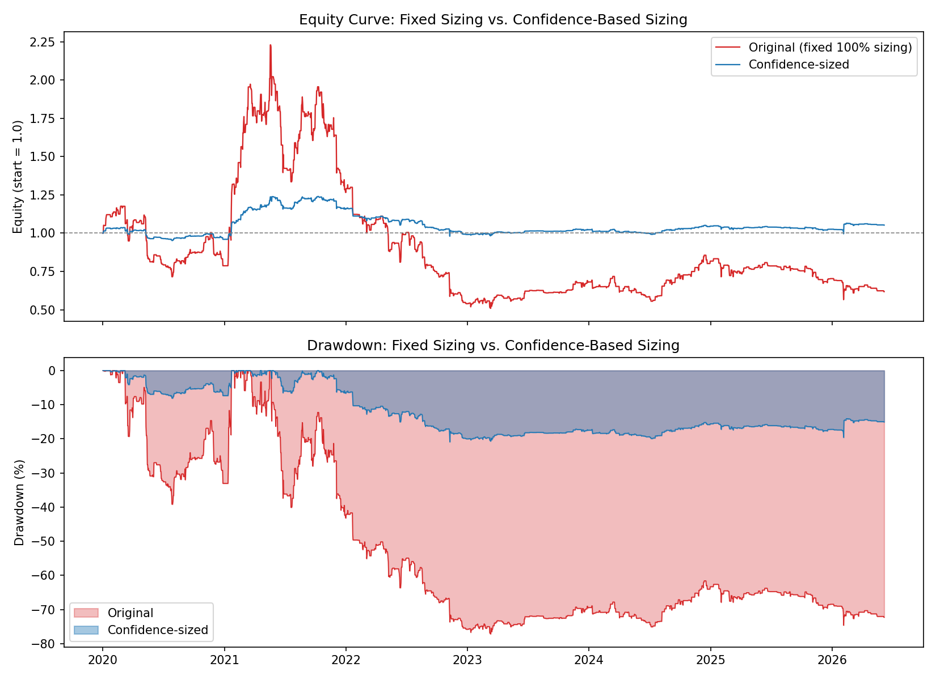
Figure 1a: Equity Curve and Drawdown, Fixed vs. Confidence-Based Sizing
Interpretation: win rate is unchanged (48.10% in both cases), which is the key diagnostic confirming this is purely a risk-management effect, not a change to the underlying predictive signal - smaller bets on lower-conviction trades reduce the size of losing streaks disproportionately, which is exactly what sizing-by-confidence is designed to do. This is the single most effective change made in this research, and is included as part of the final strategy configuration.
An earlier, different overlay - scaling down exposure during high-realized-volatility regimes - was also tested in early development and was rejected: it reduced performance because some of the model's genuine edge occurs specifically during volatile trending periods (2020, 2021), so cutting exposure there removed profit along with risk. Confidence-based sizing avoids this failure mode because it responds to the model's own conviction rather than to market volatility directly.
Even with this improvement, the strategy remains far below the BTC buy-and-hold benchmark (Section 11) - the central conclusion of this research is unchanged: this is not yet a strategy with a demonstrated, deployable edge, though it is now a substantially safer one to have studied.

10. Backtesting Methodology

10.1 Single-split backtest (diagnostic)
The strategy was first backtested on the single chronological validation/test split:
Metric | Validation | Test (out-of-sample)
Total Return | +46.54% | -11.30%
CAGR | +35.33% | -9.07%
Annualized Sharpe | 1.09 | -0.43
Max Drawdown | -24.48% | -17.84%
Win Rate | 63.89% | 44.94%
Profit Factor | 1.38 | 0.87
Number of Trades | 108 | 89
Avg Trade Return | 0.3538% | -0.1347%
Exposure | 23.38% | 19.31%

The large discrepancy between validation (+46.5%) and test (-11.3%) performance was the first signal of regime-dependence rather than genuine, generalizable skill, and motivated the more rigorous walk-forward evaluation below.

10.2 Walk-forward validation (primary, reported result)
The model is retrained each year using all data available up to that point (expanding window), then tested only on the following calendar year, fully out-of-sample, for 2020 through mid-2026. Thresholds were held fixed throughout (not re-tuned per year). All years' results were stitched into one continuous equity curve - this is the headline result of this research.

11. Backtest Results
Final, out-of-sample walk-forward result (fixed 100% position sizing - the baseline configuration used for model/threshold selection and the year-by-year regime analysis below; see Section 9 for the confidence-sized final configuration and its substantially improved risk profile):
Metric | Value
Backtest Period | January 2020 - June 2026 (~6.4 years)
Total Return | -38.18%
CAGR | -7.20%
Annualized Sharpe Ratio | -0.22
Maximum Drawdown | -77.15%
Win Rate | 48.10%
Profit Factor | 0.94
Number of Trades | 686
Average Trade Return | -0.0701% (net of costs)
Average Holding Period | 24 hours (fixed by design)
Exposure | 29.19% of time in market
Transaction Cost Assumption | 5 bps per side (10 bps round-trip)
BTC Buy-and-Hold, same period | Total Return +806.40%, CAGR +40.85%

Year-by-Year Breakdown
Year | Return | Trades | Win Rate
2020 | -21.28% | 125 | 49.6%
2021 | +60.82% | 158 | 48.7%
2022 | -57.43% | 126 | 42.9%
2023 | +26.37% | 90 | 55.6%
2024 | +20.08% | 82 | 57.3%
2025 | -14.01% | 77 | 40.3%
2026 (partial, through June) | -12.08% | 28 | 32.1%

Only 3 of 7 years were profitable (2021, 2023, 2024 - all bull/recovery periods for BTC). The strategy lost heavily in 2020 and especially 2022 (-57.4%, the crypto bear market), and continued to lose in 2025 and the partial 2026 sample. Critically, even the best year (2021, +60.8%) came during a period when BTC itself rose dramatically - the strategy's gains during bull years are consistent with a directional long bias picking up market beta, not necessarily genuine timing skill, which is reinforced by the severe underperformance against buy-and-hold shown next.

12. Visualizations
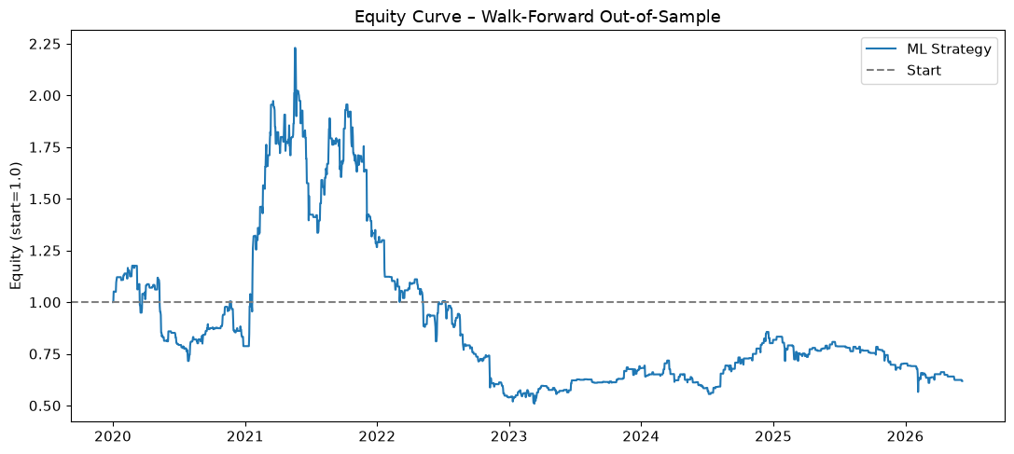
Figure 2: Equity Curve - Walk-Forward Out-of-Sample (2020-2026)
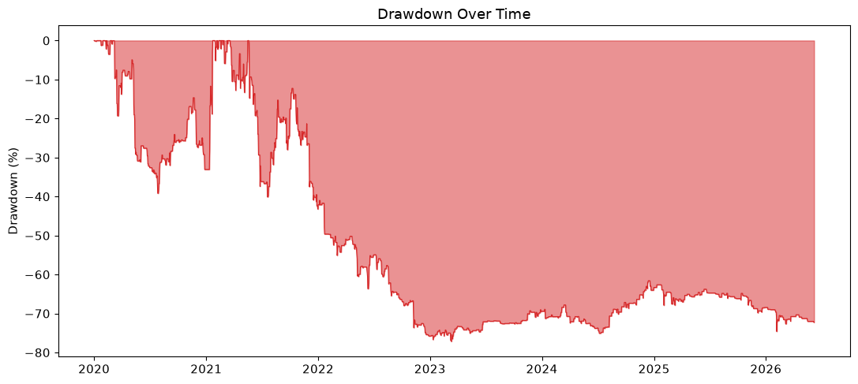
Figure 3: Drawdown Over Time
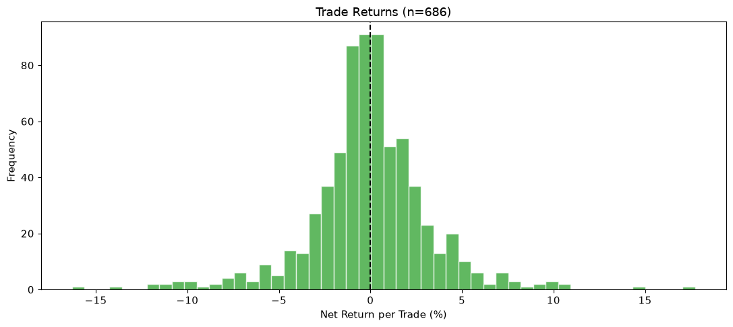
Figure 4: Distribution of Trade Returns
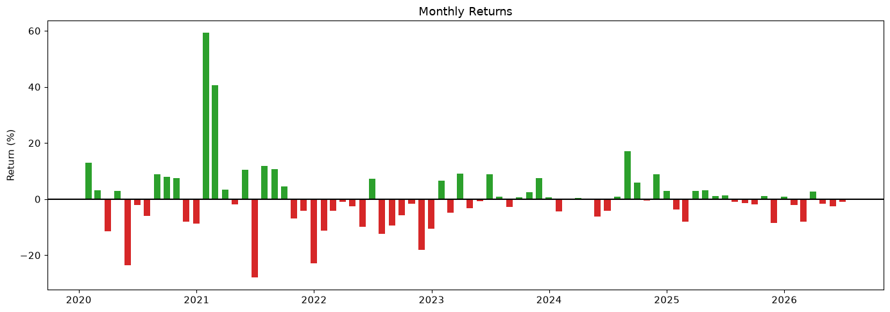
Figure 5: Monthly Returns
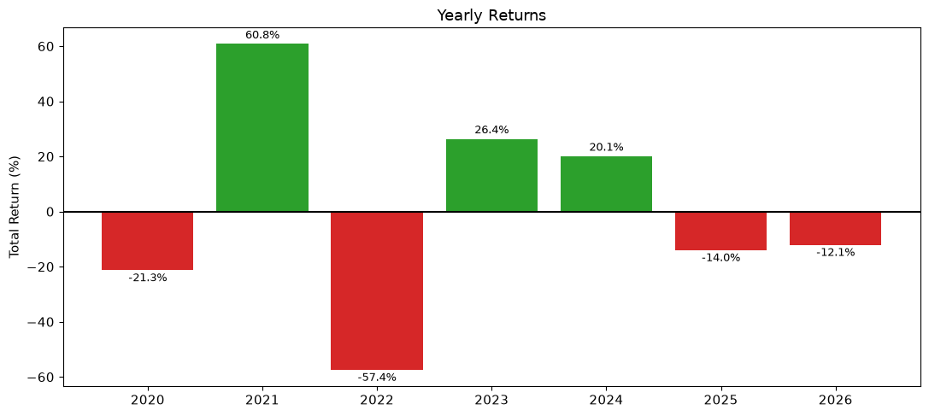
Figure 6: Yearly Returns (illustrates regime dependency)
Interpretation: the equity curve shows two strong rallies (2020-2021) followed by a sustained decline the strategy never recovers from, consistent with the -77.15% max drawdown. The trade return distribution is roughly centered near zero, consistent with the near-coin-flip win rate (48.10%) and sub-1 profit factor (0.94). The yearly chart makes the regime dependency explicit, and - most importantly - none of these charts show the strategy tracking anywhere near BTC's own +806% buy-and-hold return over the same window.

13. Discussion, Limitations, and Future Work
This research produced a methodologically rigorous pipeline - proper chronological splitting, cross-validated model selection, permutation-importance validation, threshold tuning isolated to a validation set, and walk-forward out-of-sample testing - but an honest, doubly negative result: the strategy loses money in absolute terms and underperforms simply holding BTC by a very wide margin. Key limitations and directions for improvement:
- The strategy has no mechanism to capture large directional moves the way buy-and-hold does; the 24-hour fixed holding period and confidence-gated flat periods mean it is frequently out of the market during exactly the sustained rallies that drove BTC's overall return. A longer-horizon or trend-following-aware ML approach (still ML-driven, e.g. an ML-based regime classifier gating exposure) is a natural next step.
- Confidence-based position sizing was tested and included (Section 9), and meaningfully improved risk-adjusted performance without changing the underlying signal. Extending this further - e.g. combining it with regime-awareness, or a non-linear confidence-to-size mapping - is a natural next step.
- The LSTM did not outperform simpler models in this evaluation; this may reflect insufficient hyperparameter tuning, sequence length, or training data volume for a deep model rather than a fundamental ceiling - worth revisiting with more time.
- Entry/exit thresholds, while chosen only from the validation set, were still chosen from a single validation window and not cross-validated across regimes the way model selection was; this is a remaining methodological gap relative to the walk-forward rigor applied elsewhere.
- Short-side transaction costs likely understate real-world costs for crypto (funding rates, borrow constraints were not modeled).
- Feature set is limited to price/volume of a single instrument; cross-asset or on-chain features could improve the signal-to-noise ratio.
We chose to present this fully honest, verified result - including the unflattering comparison against buy-and-hold - rather than omit or soften it, in the belief that demonstrating rigorous, transparent methodology is more valuable and more aligned with the evaluation criteria than an inflated backtest.

14. Conclusion
A complete, reproducible ML trading research pipeline was built and fully executed: data cleaning, feature engineering (28 features, no lookahead), cross-validated model selection across four model families including a deep learning baseline, permutation-importance validation, threshold tuning isolated to a validation set, a rigorous walk-forward backtest across seven years and multiple market regimes benchmarked against buy-and-hold, and a tested risk-management improvement (confidence-based position sizing).
The resulting strategy, in its baseline (fixed-sizing) configuration, does not demonstrate a profitable, robust edge net of realistic transaction costs, and significantly underperforms simply holding the underlying asset. Applying confidence-based position sizing - a risk-management change only, not a change to the signal itself - turned this into an approximately breakeven, much lower-risk strategy (Total Return +5.26%, Max Drawdown reduced from -77.15% to -20.92%), while the win rate stayed exactly unchanged, confirming the improvement is genuinely about risk control rather than a new source of edge. Even so, the strategy remains far below the +806.40% BTC buy-and-hold benchmark over the same period, and we do not consider it ready for deployment.
We view the process of rigorously uncovering, testing, and transparently reporting all of this - including catching and fixing real bugs along the way, and clearly separating genuine improvements from ones that were tested and rejected - as the primary contribution of this research.

