AGRIMART
Integrated Agricultural Marketplace and Intelligence Platform
INDUSTRY-STANDARD PROJECT REPORT
A full-stack platform for agricultural commerce, market intelligence, rentals, and crop decision support

Prepared from the implemented source repository and verification reports
Repository: MINI PROJECT | Report date: 05 November 2026

Declaration
This report presents the design, implementation, and verification of the AgriMart platform as found in the project repository. The report is based on the implemented React frontend, Django/FastAPI backend, automated tests, and project verification documents. Where the legacy README conflicts with the implementation, the source code and verification evidence are treated as authoritative.

Acknowledgement
The project team acknowledges the contribution of open-source frameworks and agricultural knowledge resources that support this work. The platform combines practical marketplace workflows with explainable decision-support features so that farmers, buyers, merchants, and administrators can work from one coherent digital environment.

Abstract
AgriMart is a modular agricultural technology platform that connects agricultural commerce, equipment rentals, mandi market intelligence, transaction support, and crop decision assistance. The system uses a React 19 and Vite frontend with route-isolated applications, a Django REST Framework core API, a FastAPI/AI gateway, relational persistence, JWT authentication, and asynchronous service integrations. The Crop Intelligence module provides crop recommendation from soil and climate parameters, disease-scan workflows, symptom lookup, soil-report parsing with user verification, and user-scoped history. Its current decision engines are deliberately transparent: agronomic rules, pattern parsing, and deterministic symptom taxonomy are exposed rather than presented as unsupported universal machine-learning diagnosis. Automated tests cover authentication, marketplace endpoints, assistant interactions, crop recommendation, disease rejection/acceptance, soil-report confirmation, and history isolation.

Documentation Status Note
Important project note
The repository README files are legacy scaffolding and do not fully describe the current implementation. This report therefore reflects the live routes, models, API endpoints, tests, and verification reports present in the repository. Updating the README is recommended as a follow-up documentation task.

Table of Contents
Abstract .............................................................. 3
Acknowledgement ....................................................... 4
Documentation Status Note ............................................. 5
List of Figures ....................................................... 6
1. Introduction ....................................................... 7
2. Literature Review .................................................. 8
3. Existing System and Proposed System ................................ 9
4. System Requirements ................................................ 10
5. System Architecture ................................................ 11
6. Implementation ..................................................... 12
7. Testing ............................................................ 13
8. Screenshots ........................................................ 14
9. Future Enhancement and Conclusion .................................. 15
References ............................................................ 16

List of Figures
Fig. No. | Description | Page No.
Fig. 1 | AgriMart platform architecture | 8
Fig. 2 | Crop Intelligence processing flow | 12
Fig. 3 | AgriMart suite overview | 16
Fig. 4 | AG Market login experience | 16
Fig. 5 | AG Store login experience | 17
Fig. 6 | AG Crop Intelligence login experience | 17

1. Introduction

1.1 Background
Agricultural stakeholders often use separate tools for purchasing inputs, renting equipment, checking market prices, arranging transport or delivery, and interpreting crop conditions. This fragmentation increases effort and makes it difficult to connect a farmer's operational decision with market context. AgriMart addresses this gap by presenting commerce, market intelligence, and crop support as coordinated but independently protected modules.

1.2 Purpose
The purpose of AgriMart is to provide a dependable digital foundation for agricultural commerce and decision support. The system is designed for extensibility: each domain has its own user interface, routes, backend application boundaries, data models, and test coverage while sharing authentication and platform infrastructure.

1.3 Objectives
- Provide a unified marketplace for agricultural products, categories, carts, and orders.
- Support equipment discovery, rental workflows, delivery-slot bookings, and transaction records.
- Expose mandi and commodity intelligence through tickers, APMC information, auction/bid views, and an AI Copilot.
- Offer crop recommendations from measurable soil and environmental parameters.
- Provide honest disease-support workflows that validate image inputs and expose treatment guidance without claiming universal diagnosis.
- Parse soil reports, allow user verification, and retain user-scoped crop intelligence history.
- Preserve module isolation through explicit routing and cross-domain redirects.

1.4 Scope
The current scope includes the implemented frontend routes and backend APIs in the repository. The system is a project-grade platform rather than a production agronomic certification service. Recommendations and diagnostic support should be treated as decision aids and verified with local agricultural experts, laboratories, or government extension services where appropriate.

2. Literature Review

2.1 Digital Agriculture Platforms
Digital agriculture platforms commonly combine input commerce, market information, logistics, and advisory workflows. A modular architecture is suitable because these domains have different transaction boundaries and user journeys. AgriMart follows this pattern by separating Store, Market, and Crop Intelligence applications while keeping shared authentication and API conventions.

2.2 Crop Recommendation
Crop recommendation systems typically use soil macronutrients, pH, temperature, humidity, and rainfall as inputs. The current implementation uses deterministic agronomic rules and returns an engine label, soil assessment, alternatives, confidence, and advisory information. This is appropriate for a transparent MVP because the logic can be inspected and tested without overstating model performance.

2.3 Plant Disease Support
Image-based plant disease research commonly uses controlled datasets and convolutional models, but field images introduce background clutter, lighting variation, occlusion, and class imbalance. The project therefore combines plant-image validation with symptom taxonomy matching and treatment-plan outputs. This design makes the current boundary explicit and leaves room for a later validated model.

2.4 Agricultural Data Limitations
- Soil values can vary by sampling depth, season, laboratory method, and spatial location.
- A single photograph may not contain enough evidence for a reliable disease diagnosis.
- Market rates are time-sensitive and depend on source freshness and market coverage.
- Confidence values should be interpreted as system-level scores, not guarantees of agronomic correctness.
- Local crop varieties, weather events, irrigation access, and farmer practices can change the suitability of a recommendation.
Design principle
The implementation favors explainability and explicit limitations over opaque claims of universal AI accuracy.

3. Existing System and Proposed System

3.1 Existing System
In a fragmented agricultural workflow, product purchase, equipment rental, market price discovery, and crop advice are handled through separate interfaces or manual coordination. Such an arrangement can create duplicated data entry, weak traceability, and limited continuity from recommendation to transaction.

3.2 Proposed System
AgriMart proposes a unified platform with three isolated experiences: AG Store & Rentals for products and equipment, AG Market & Mandi for price and transaction intelligence, and AG Crop Intelligence for crop, disease, and soil workflows. Shared JWT authentication provides a consistent identity layer while the route structure prevents accidental cross-module UI mixing.
Area | Existing approach | AgriMart proposed approach
Input commerce | Separate catalog or manual buying | Product catalog, cart, order, and rental modules
Market discovery | Manual price checks and fragmented sources | APMC, commodity ticker, auction, bid, transaction, and Copilot views
Crop support | General advice or unverified tools | Explainable rules, input validation, report verification, and history
User continuity | Repeated data entry | JWT identity and user-scoped records
Maintainability | Monolithic or disconnected interfaces | React route isolation and domain-oriented backend apps

4. System Requirements

4.1 Functional Requirements
ID | Requirement | Implemented evidence
FR-01 | User authentication and identity | JWT login endpoint and authenticated API tests
FR-02 | Browse agricultural products and categories | Store API endpoints and Store UI
FR-03 | Discover and book rental equipment | Rentals and bookings applications
FR-04 | View mandi data and market workflows | Mandi models, tickers, APMC, bids and transactions
FR-05 | Interact with agricultural Copilot | Assistant chat endpoint and generative cards
FR-06 | Recommend crops from soil and climate inputs | Crop recommendation endpoint and persisted record
FR-07 | Scan leaf images and lookup symptoms | Disease scan and symptom lookup endpoints
FR-08 | Upload and verify soil reports | Parser, confirmation endpoint, and SoilReport model
FR-09 | Show user-specific crop history | History endpoint and isolation test

4.2 Non-Functional Requirements
- Modularity: domain boundaries must remain explicit in frontend routes and backend apps.
- Security: authenticated workflows must use JWT-backed user context and user-scoped queries.
- Explainability: crop and disease outputs must expose the current engine or supporting evidence.
- Reliability: invalid or unsuitable inputs must be rejected explicitly rather than silently accepted.
- Maintainability: project commands, dependency manifests, migrations, and automated tests must be available.
- Usability: the interface should provide clear navigation, focused workflows, and responsive visual components.

4.3 Technology Stack
Layer | Technology | Role
Frontend | React 19, Vite, React Router | Modular web interface and route isolation
UI | Tailwind CSS, Lucide React, reusable JSX components | Responsive layouts, icons, and interaction patterns
Backend API | Django 5, Django REST Framework | Core domain APIs, models, authentication integration
AI/realtime gateway | FastAPI, Uvicorn, Pydantic | Realtime/AI service boundary
Persistence | SQLite for local development; PostgreSQL configuration | Relational data storage
Async/services | Redis and Celery configuration | Background jobs and integration readiness
Validation/testing | Pytest, pytest-django, Ruff, Oxlint | Automated verification and code quality

5. System Architecture

5.1 System Design
The platform uses a layered, modular design. The React application exposes distinct route namespaces, while the backend mounts domain applications below /api/v1/. The design allows Store, Market, and Crop Intelligence to evolve independently while retaining common authentication and persistence conventions.
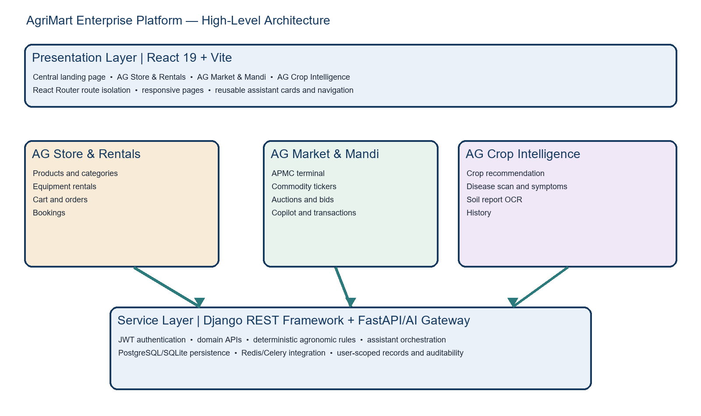
Fig. 1 — AgriMart platform architecture

5.2 Module and Route Design
Module | Primary frontend routes | Backend responsibilities
AG Store & Rentals | /store-rental/* | Catalog, products, cart, orders, equipment and rental bookings
AG Market & Mandi | /market-mandi/* | APMC, commodities, tickers, auctions, bids, transactions, assistant
AG Crop Intelligence | /crop-intelligence/* | Recommendations, disease scan, soil report, symptom lookup, history
Shared platform | / | /auth/, shared user identity, health, common persistence

5.3 Crop Intelligence Use-Case Design
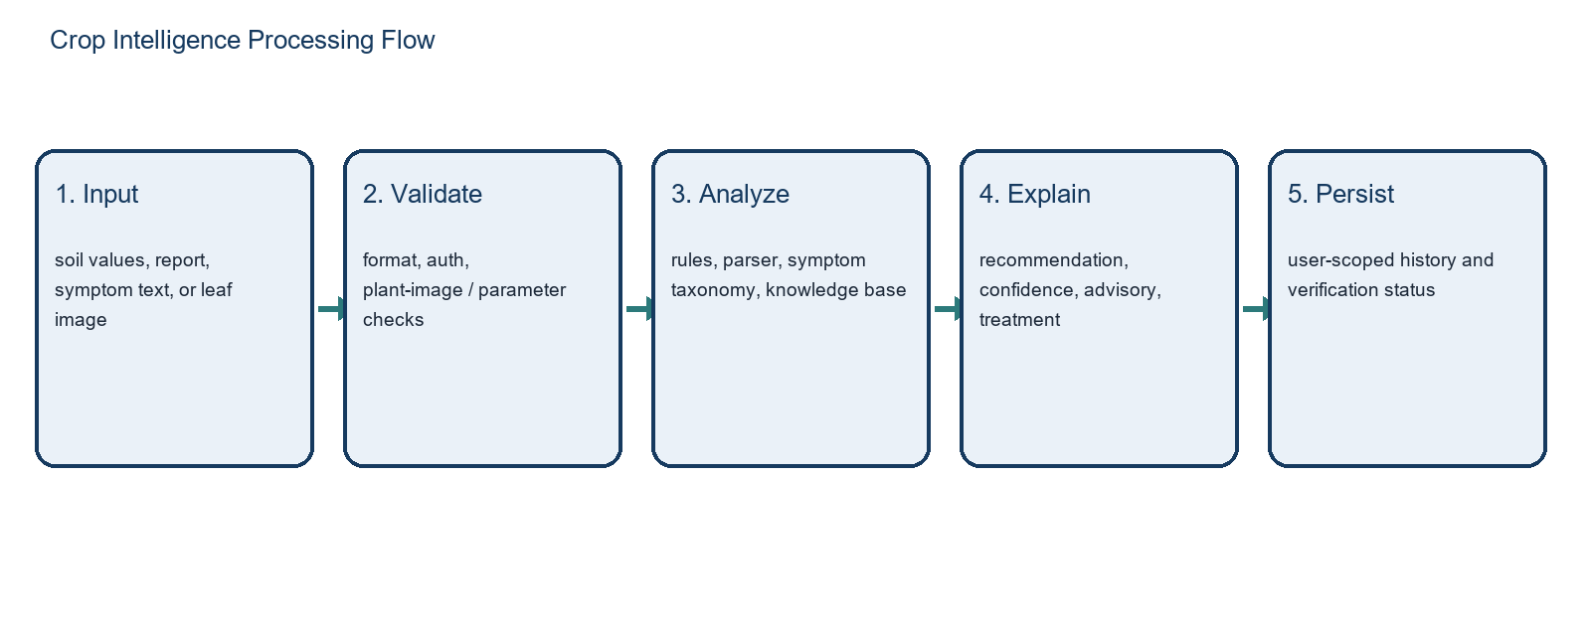
Fig. 2 — Crop Intelligence processing flow
Actor | Use case | Outcome
Farmer | Enter soil/climate parameters | Primary crop, alternatives, soil assessment, advisory
Farmer | Upload soil report | Extracted parameters with confidence and verification step
Farmer | Upload leaf image | Validated scan, diagnosis support, severity and treatment plan
Farmer | Describe symptoms | Deterministic symptom lookup and care guidance
Authenticated user | View history | User-scoped scans, recommendations, and report records
Merchant/buyer | Use market assistant | Price, market, transaction, and operational explanations

5.4 Data Model
The Crop Intelligence persistence layer contains SoilReport, CropRecommendationRecord, and CropScan. Each record links to the configured user model when available and stores structured JSON for parsed data, alternatives, advisory output, or treatment plans. Indexes support user-scoped chronological history queries. The wider platform also contains users, store, rentals, mandi, bookings, transactions, and conversations applications.
Entity | Important fields | Purpose
SoilReport | file_name, parsed_data, confidence_data, is_verified_by_user | Stores report extraction and human confirmation
CropRecommendationRecord | N/P/K, temperature, humidity, pH, rainfall, crop, confidence | Stores recommendation input and output
CropScan | crop_name, diagnosed_disease, severity, confidence, treatment_plan | Stores disease-support result

6. Implementation

6.1 Frontend Implementation
The frontend is organized around an application router and domain shells. AG Store, AG Market, and AG Crop Intelligence each receive dedicated pages and navigation components. The assistant layer contains reusable chat, activity, sidebar, input, and generative card components. The Crop Intelligence application contains focused pages for recommendation, disease detection, soil reports, history, and a dedicated login surface.

6.2 Backend Implementation
Django URL configuration mounts domain APIs under /api/v1/. The AI application exposes recommendation, disease scan, symptom lookup, soil report parsing, confirmation, and history endpoints. The backend uses DRF views, model persistence, authentication context, and explicit status responses. The project also includes a FastAPI gateway for realtime/AI service concerns.

6.3 Pseudocode
FUNCTION recommend_crop(input):
validate authenticated user and numeric soil/climate fields
assess N, P, K, pH and climate ranges
score supported crops using deterministic agronomic rules
select primary crop and ranked alternatives
generate soil assessment, confidence and advisory
persist CropRecommendationRecord for the user
return recommendation response with engine label
FUNCTION scan_disease(image, crop_hint):
validate file type, size and image readability
estimate whether image contains usable plant foliage
IF image is unsuitable: return explicit rejected response
match supported symptoms/crop taxonomy
generate disease-support result and treatment plan
persist CropScan for the authenticated user
return result with confidence and limitations

6.4 API Surface
Endpoint | Method | Purpose
/api/v1/auth/login/ | POST | Issue access and refresh JWT tokens
/api/v1/store/categories/ | GET | Catalog discovery
/api/v1/store/products/ | GET | Product discovery
/api/v1/mandi/tickers/ | GET | Market ticker data
/api/v1/assistant/chat/ | POST | Assistant conversation and cards
/api/v1/crop-intelligence/recommend/ | POST | Crop recommendation
/api/v1/crop-intelligence/disease-scan/ | POST | Leaf image validation and scan
/api/v1/crop-intelligence/symptom-lookup/ | POST | Symptom taxonomy lookup
/api/v1/crop-intelligence/soil-report/ | POST | Parse uploaded soil report
/api/v1/crop-intelligence/soil-report/confirm/ | POST | Confirm extracted soil parameters
/api/v1/crop-intelligence/history/ | GET | User-scoped crop history

7. Testing

7.1 Test Strategy
Testing combines unit-level deterministic engine checks, API integration tests, database persistence checks, authentication checks, and user-isolation checks. The backend README records the expected validation commands: pytest, Django system checks, and Python compilation. The repository verification report records the Copilot integration as passing 21/21 unit and integration tests.

7.2 Test Coverage Matrix
Test area | Representative verification | Expected result
Authentication | Login with valid phone and password | 200 response with access and refresh tokens
Marketplace APIs | Categories, products, equipment, tickers | Successful list responses
Assistant | Price question for a populated APMC | 201 response with assistant price card
Crop recommendation | N/P/K + climate payload | 201, rice primary crop, alternatives and engine label
Disease scan rejection | Dark/non-leaf image | 200 rejected response
Disease scan success | Green leaf image with crop hint | 201 with treatment plan and persisted scan
Soil report | Upload and confirm extracted parameters | 201 upload, 200 confirmation, verified record
History isolation | Two users with separate scans | Each user sees only their own record

7.3 Quality and Limitations
- Automated tests verify the implemented behavior but do not replace agricultural field validation.
- Synthetic images are useful for deterministic tests but are not evidence of real-world disease accuracy.
- Market and weather-dependent features require current data sources and operational monitoring in production.
- The legacy README should be updated so setup instructions and architecture match the current repository.

8. Screenshots
The following screenshots are included from the project assets to document the implemented visual direction and module separation.

AgriMart Suite — Store, Market & Crop
Fig. 3 — AgriMart Suite — Store, Market & Crop

AG Market Login Experience
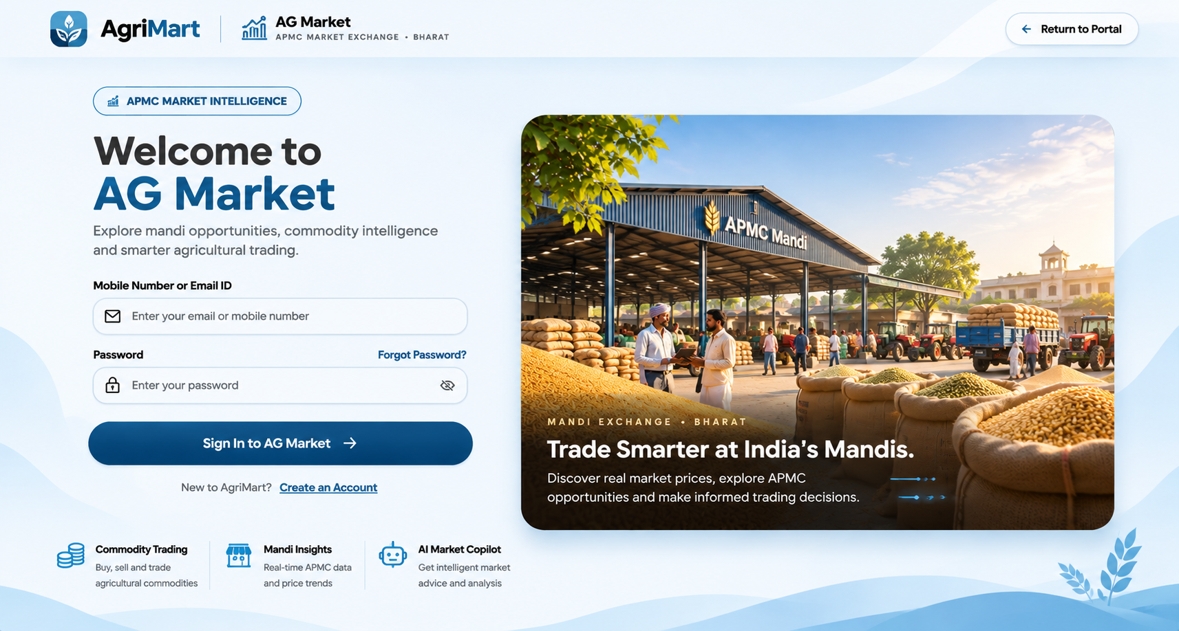
Fig. 4 — AG Market Login Experience

AG Store Login Experience
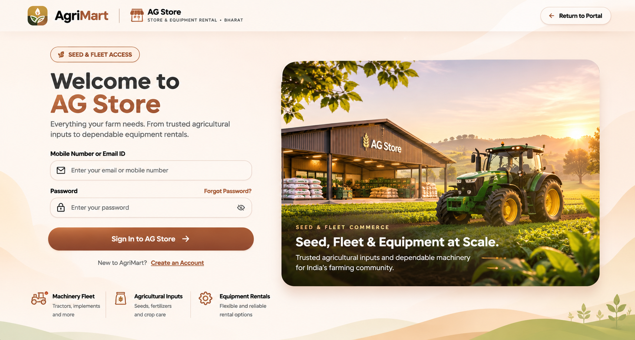
Fig. 5 — AG Store Login Experience

AG Crop Intelligence Login Experience
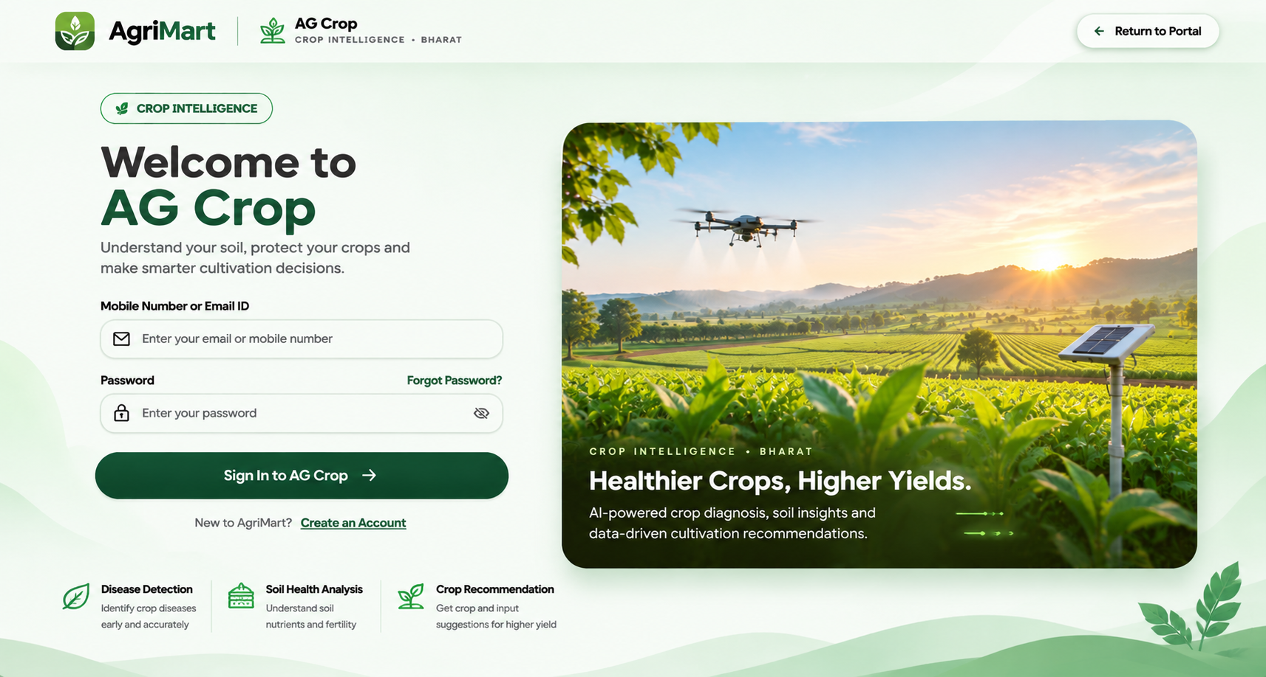
Fig. 6 — AG Crop Intelligence Login Experience

9. Future Enhancement and Conclusion

9.1 Future Enhancement
- Update README files with the current architecture, environment variables, route map, API surface, and verified commands.
- Replace heuristic disease support with a validated transfer-learning model trained and evaluated on field-representative datasets.
- Add model cards, calibration metrics, confusion matrices, and explicit supported-class metadata.
- Integrate live weather, soil laboratory, and market feeds with freshness timestamps and source attribution.
- Add role-aware administration dashboards, audit logs, rate limiting, and production observability.
- Expand multilingual support and accessibility testing for farmers using low-bandwidth or mobile devices.
- Introduce background processing for large reports and images through the configured Redis/Celery path.
- Add end-to-end browser tests for route isolation, login, cart, booking, assistant, and Crop Intelligence workflows.

9.2 Conclusion
AgriMart demonstrates a coherent full-stack approach to agricultural technology by connecting marketplace operations, mandi intelligence, and crop decision support without collapsing them into one fragile workflow. The route-isolated React applications and domain-oriented Django backend create a clear foundation for continued development. The current Crop Intelligence implementation is particularly strong in transparency: it distinguishes deterministic rules, parsing, symptom lookup, and image validation from claims of a fully trained diagnostic model. With documentation alignment, live-data hardening, field validation, and production security controls, the platform can progress from a strong academic/minor-project implementation toward a deployable agricultural service.

References
- AgriMart project source repository: frontend/src/router/AppRouter.jsx, backend/agrimart/urls.py, backend/ai/urls.py.
- AgriMart project verification reports: CROP_IMPLEMENTATION_VERIFICATION_REPORT.md and VIBEATHON_COPILOT_INTEGRATION_REPORT.md.
- Django documentation. https://docs.djangoproject.com/
- Django REST Framework documentation. https://www.django-rest-framework.org/
- React documentation. https://react.dev/
- Vite documentation. https://vite.dev/
- Food and Agriculture Organization of the United Nations. Digital agriculture and agricultural innovation resources. https://www.fao.org/
- Indian Council of Agricultural Research. Agricultural research and extension resources. https://icar.gov.in/
- Soil Health Card portal, Government of India. https://soilhealth.dac.gov.in/
- PlantVillage dataset and research resources. https://plantvillage.psu.edu/

