**PROCEDURE FOR API:**

**STEP 1:**

Create the model and train the model using the training dataset. Then download the model and dump it. Save the file as model.py and compile it.

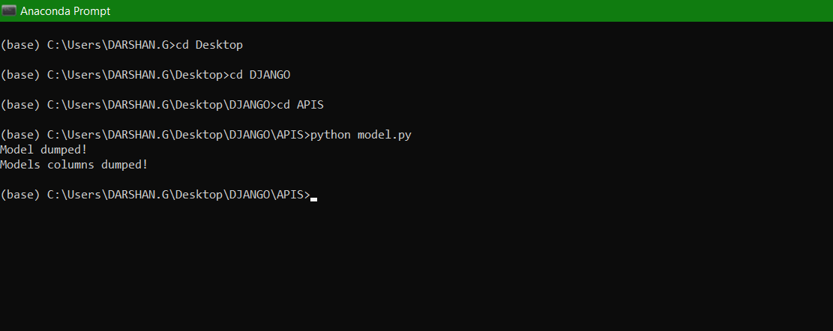

**STEP 2:**

Create an python file called api.py and write the code for the api that is to be used to send data and get output. Then compile the code.

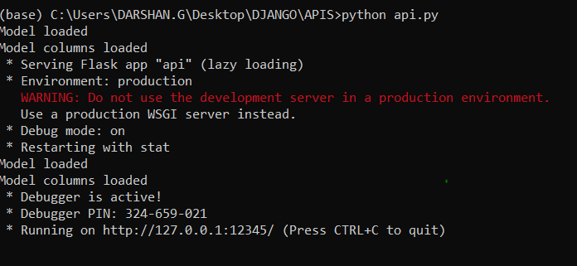

On compiling the files you shoud not get any errors.

**STEP 3:**

Look into the folder whether the necessary model that is created by us in the model.py is properly downloaded.

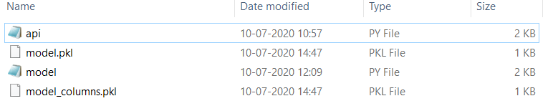

After compiling the two files, the following things should be present inside your folder.

**STEP 4:**

The next step is to use a API Client to send and get the request and response respectively. Here I have used postman API Client app to send and receive request and response.

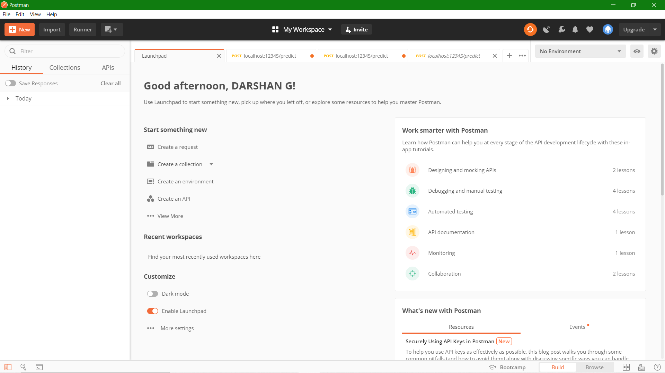

**STEP 5:**

Click the new symbol and select the Request option.

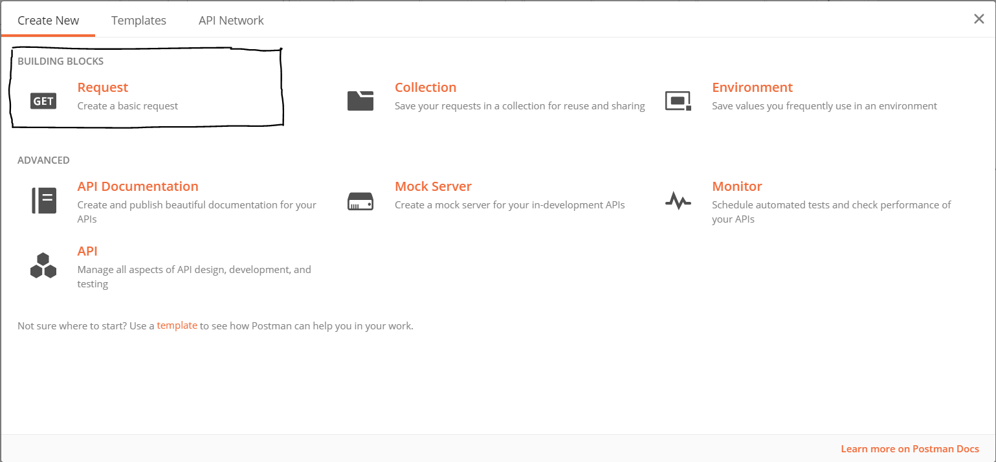

**STEP 6:**

Then change the GET method to POST method. Enter the Request URL as localhost:12345/predict and select the request as JSON request.

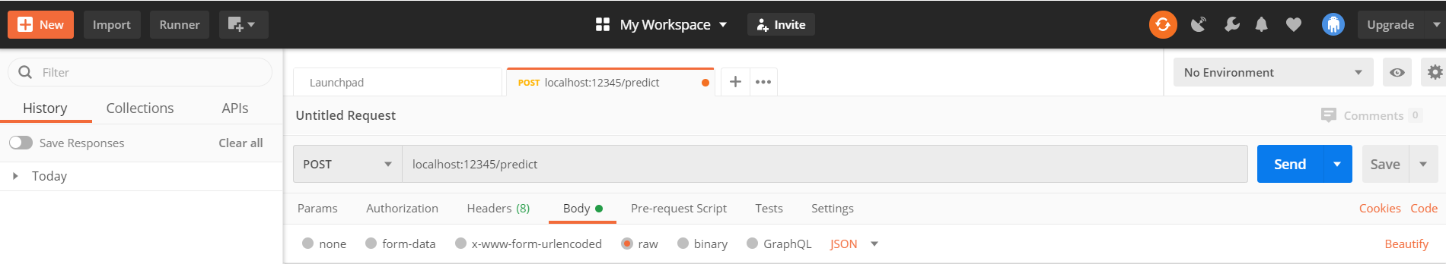

**STEP 7:**

Enter the inputs that is to be given in the body.

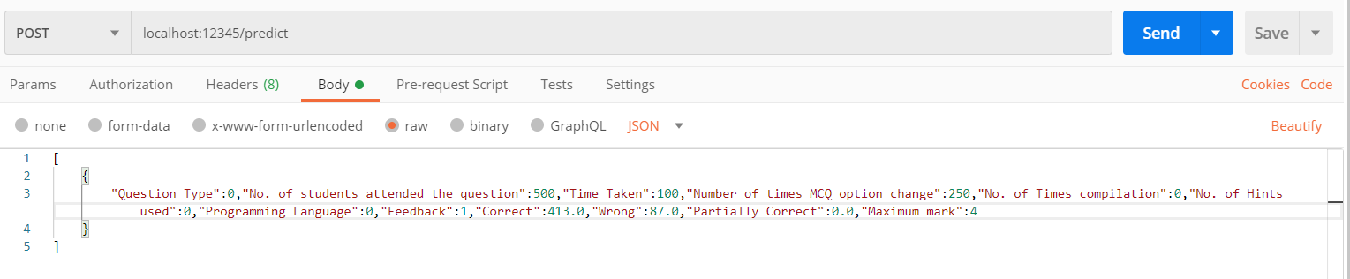

**STEP 8:**

Press the send button. You will get the predicted output along with the http code (whether the http request has been accepted or not).

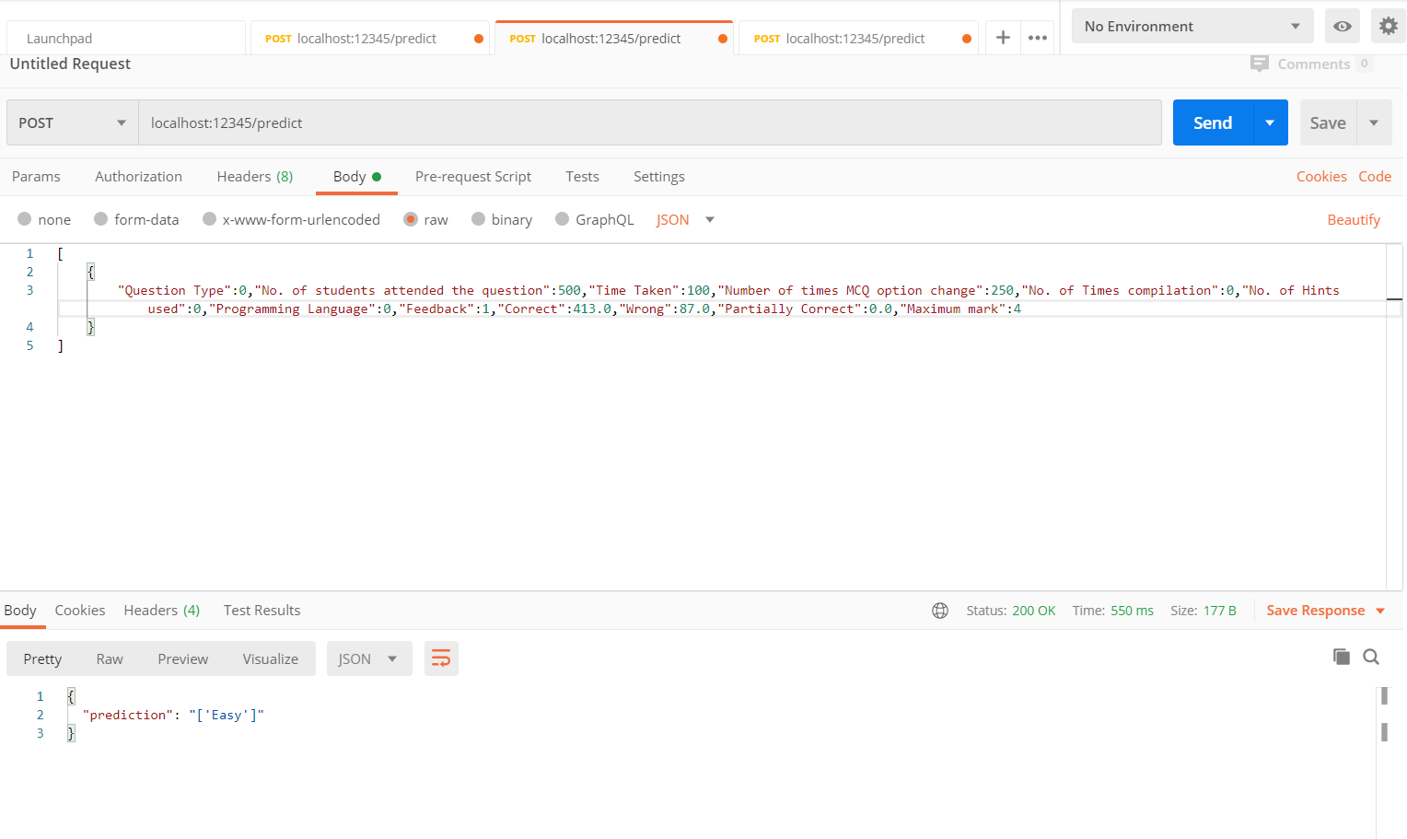

**INPUT FORMAT:**

[

    {

        "Question Type":0,"No. of students attended the question":500,"Time Taken":100,"Number of times MCQ option change":250,"No. of Times compilation":0,"No. of Hints used":0,"Programming Language":0,"Feedback":1,"Correct":413.0,"Wrong":87.0,"Partially Correct":0.0,"Maximum mark":4

    }

]

**OUTPUT FORMAT:**

{

  "prediction": "['Easy']"

}