**DATASET DESCRIPTION**

**DATASET DESCRIPTION**

The dataset contains images of two classes of which one of the set contains the low-resolution image and another contains the high-resolution image. Each set consist of 91 images of both low and high resolution. This dataset is used to train the pretrained model. The image are pre-processed using a BM3D filter i.e.., Block matching and 3D Transformation filter which is used to remove the noise if any present. So the filter is applied with entire dataset so that it can remove the available noises.

**SRCNN ARCHITECTURE**

**SRCNN** is a convolutional neural network architecture named after, as it is used for super resolution of the given images. It can able to map the features and help to produce a high-resolution image. It takes input image of size 224 * 224 * 3 (RGB image).

It is built using

1. Patch Extraction and Representation (9*9 into 1*1) (64 Feature Maps)

2. Non-Linear mapping (1*1 into 5*5) (32 Feature Maps)

3. Reconstruction

## BLOCK DIAGRAM

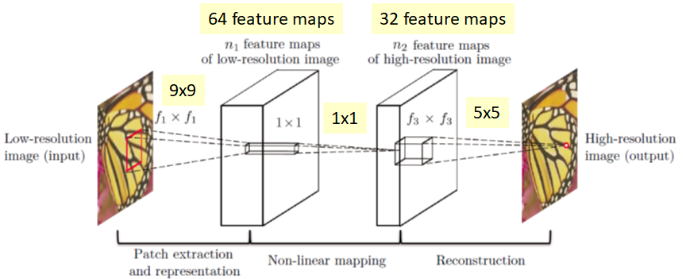

## SRCNN ARCHITECTURE

**PATCH EXTRACTION AND REPRESENTATION**

It is important to know that the low-resolution input is first upscale to the desired size using bicubic interpolationbefore inputting to the SRCNN network. Thus,   
X: Ground truth low-resolution image Y: Upsampled version of low-resolution image. And the first layer perform a standard convolution with Relu to get F1(Y)

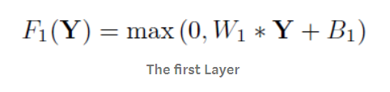

**FORMULA FOR PATCH EXTRACTION**

Size of W1: c*f1*f1*n1

Size of B1: n1

Where c is number of channels of the image, f1 is the filter size, and n1 is the number of filters. B1 is the n1-dimensional bias vector which is just increasing the degree of freedom by 1.

**NON-LINEAR MAPPING**

After that a non-linear mapping is performed.

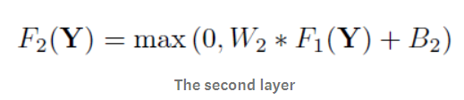

**FORMULA FOR NON-LINEAR MAPPING**

Size of W2: n1*1*1*n2

Size of B2: n2

It is a mapping of n1-dimensional vector to n2-dimensional vector. When n1>n2, we imagine something like PCA stuffs but in a non-linear way. This 1*1 actually is a 1*1 convolution suggested in Network. In NIN, 1*1 convolution is suggested to introduce more non-linearity to improve the accuracy. It is also suggested in GoogLeNet for reducing the number of connections. Here, it is used for mapping low-resolution vector to high-resolution vector.

**RECONSTRUCTION**

After mapping, we need to reconstruct the image. Hence, we do convolution again.

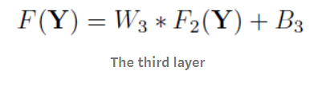

**FORMULA FOR RECONSTRUCTION**

Size of W3: n2*f3*f3*c

Size of B3: c

**LOSS FUNCTION**

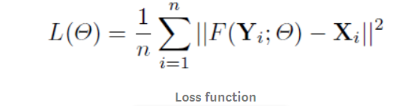

**FORMULA FOR LOSS FUNCTION**

For super resolution, the loss function L is the average of mean square error (MSE) for the training samples (n), which is a kind of standard loss function.

**RELATIONSHIP WITH SPARSE CODING**

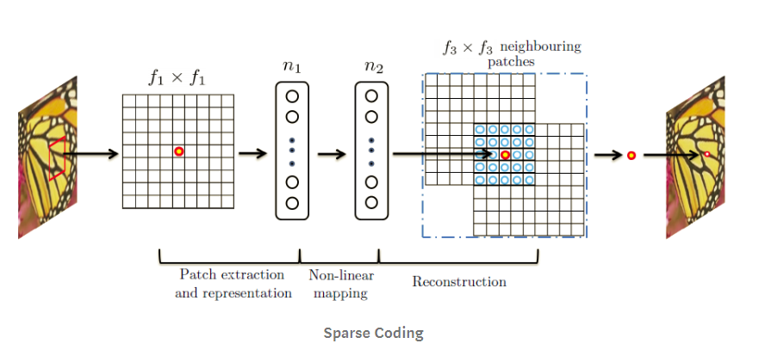

**SPARSE CODING**

For Sparse Coding (SC), in the view of convolution, the input image is conv by f1 and project to onto a n1-dimensional dictionary. n1=n2 usually is the case of SC. Then mapping of n1 to n2 is done with the same dimensionality without reduction. It is just like a mapping of low-resolution vector to high-resolution vector. Then each patch is reconstructed by f3. And overlapping patches are averaged instead of adding together with different weights by convolution.

**BM3D INTRODUCTION**

Image denoising is considered a salient pre-processing step in sophisticated imaging applications. Over the decades, numerous studies have been conducted in denoising. Recently proposed Block matching and 3D (BM3D) filtering added a new dimension to the study of denoising. BM3D is the current state-of-the-art of denoising and is capable of achieving better denoising as compared to any other existing method. However, there is room to improve BM3D to achieve high-quality denoising. In this study, to improve BM3D, we first attempted to improve the Wiener filter (the core of BM3D) by maximizing the structural similarity (SSIM) between the true and the estimated image, instead of minimizing the mean square error (MSE) between them. Moreover, for the DC-only BM3D profile, we introduced a 3D zigzag thresholding. Experimental results demonstrate that regardless of the type of the image, our proposed method achieves better denoising performance than that of BM3D.

**BM3D ARCHITECTURE**

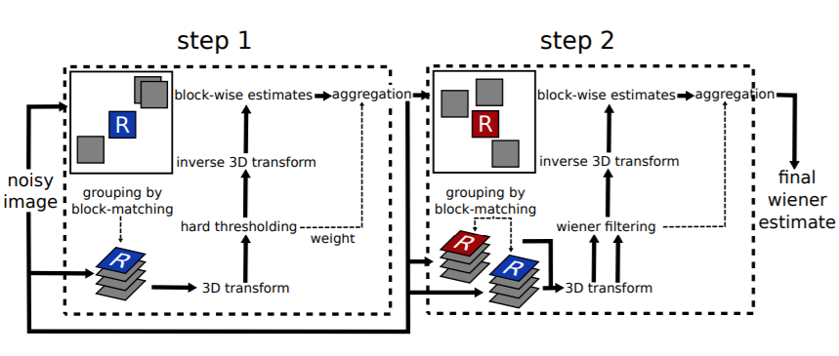

**BM3D ARCHITECTURE**

**FIRST BLOCK**

The first step estimates the denoised image using hard thresholding during the collaborative filtering. Parameters in this step are denoted by the exponent hard.

**SECOND BLOCK**

The second step is based both on the original noisy image, and on the basic estimate obtained in the first step. It uses Wiener filtering. The second step is therefore denoted by the exponent wiener.