**ANALAYSIS OF RESULT**

**RESULT**

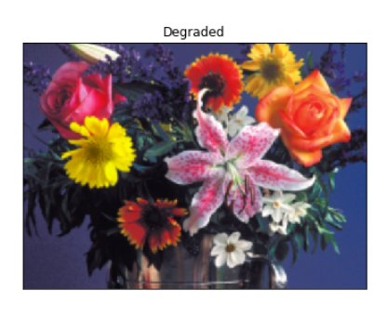

**DEGRADED IMAGE**

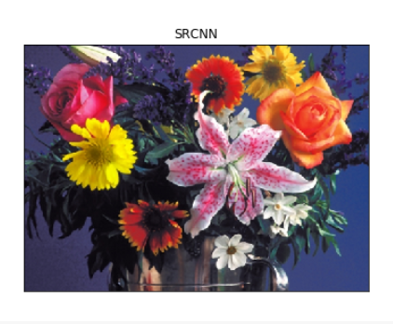

**SRCNN APPLIED IMAGE**

**COMPARISION WITH OTHER ALGORITHMS**

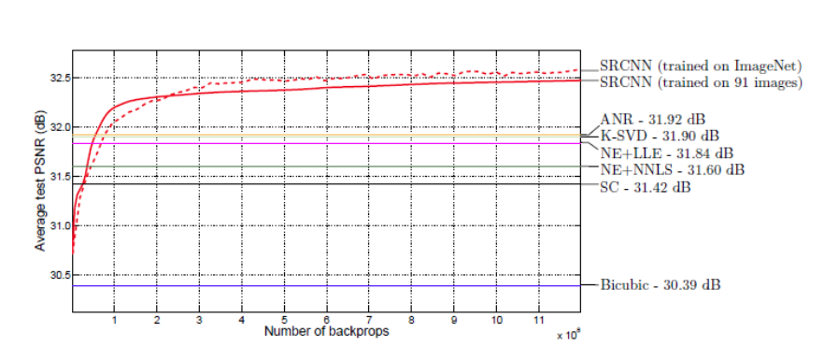

**COMPARISION WITH OTHER METHODS**

**CHAPTER 7**

**CONCLUSION AND FUTURE WORK**

**7.1. CONCLUSION**

This approach, SRCNN, learns an end to end mapping between low-resolution and high-resolution images, with little extra pre/post processing beyond the optimization. With a lightweight structure, the SRCNN achieves a superior performance than the state-of-the-art methods. Additional improvement in performance can be gained further by exploring more filters and different training strategies.

**7.2. FUTURE WORK**

FSRCNN has a relatively shallow network which makes us easier to learn about the effect of each component. It is even faster with better reconstructed image quality than the previous SRCNN. By comparing SRCNN and FSRCNN-s, FSRCNN-s (a small model size version of FSRCNN) has a better PSNR (image quality) and much shorter running time, in which 43.5 fps is obtained.

**7.3. REFERENCES**

1. Breiman, L. (2001). Random forests. Machine Learning, 45(1):5–32.
2. Buades, A., Coll, B., and Morel, J. (2005). A non-local algorithm for image denoising. In Proc. IEEE International Conference on Computer Vision and Pattern Recognition (CVPR).
3. Chaudhury, K. N. and Singer, A. (2012). Non-local euclidean medians. IEEE Signal Processing Letters, 19(11):745–748.
4. Dabov, K., Foi, A., and Egiazarian, K. (2007a). Video denoising by sparse 3d transform-domain collaborative filtering. In Proc. European Signal Processing Conference (EUSIPCO).
5. Dabov, K., Foi, A., Katkovnik, V., and Egiazarian, K. (2006). Image denoising with block-matching and 3d filtering. In Proc. SPIE Electronic Imaging.
6. Dabov, K., Foi, A., Katkovnik, V., and Egiazarian, K. (2007b). Color image denoising via sparse 3d collaborative filtering with grouping constraint in luminancechrominance space. In Proc. IEEE International Conference on Image Processing (ICIP).
7. Aharon, M., Elad, M., Bruckstein, A.: K-SVD: An algorithm for designing overcomplete dictionaries for sparse representation. IEEE Transactions on Signal Processing 54(11), 4311–4322 (2006).
8. Bevilacqua, M., Roumy, A., Guillemot, C., Morel, M.L.A.: Lowcomplexity single-image super-resolution based on nonnegative neighbor embedding. In: British Machine Vision Conference (2012)
9. Burger, H.C., Schuler, C.J., Harmeling, S.: Image denoising: Can plain neural networks compete with BM3D? In: IEEE Conference on Computer Vision and Pattern Recognition. pp. 2392–2399 (2012)
10. Chang, H., Yeung, D.Y., Xiong, Y.: Super-resolution through neighbor embedding. In: IEEE Conference on Computer Vision and Pattern Recognition (2004)
11. Cui, Z., Chang, H., Shan, S., Zhong, B., Chen, X.: Deep network cascade for image super-resolution. In: European Conference on Computer Vision, pp. 49–64 (2014)