
ALLIANCE UNIVERSITY
Alliance School of Advanced Computing
Student Name: Darshan HD
Register Number: PROV/ASAC/MCA/7/26/085
Project Name: “Exploratory Data Analysis and Data Visualization Using Power BI for Company Business and Financial Growth Analysis.”
Project Faculty & Guide: Oleti Durga Bravish
ACADEMIC YEAR: 2026-2028

Department of Computer Applications
Program - Master of Computer Applications
Semester 1

ACKNOWLEDGEMENT
I take this opportunity to thank everyone who helped me, in different ways, to bring this project to a successful conclusion.
My special thanks go to my Project Guide, whose clear direction, useful suggestions and steady encouragement shaped every stage of this work, from choosing the dataset to preparing the final dashboards. I am equally grateful to the faculty members and to the institution for the laboratory facilities, software tools and academic atmosphere that made this learning possible.
I also appreciate the help and motivation I received from my friends and classmates during discussions and trial runs of the dashboards. Above all, I thank my family for their patience, trust and constant moral support.
Finally, I thank every person who contributed to this project, whether directly or indirectly.
Student Name: Darshan HD
Register Number: PROV/ASAC/MCA/7/26/085
Project Title: “Exploratory Data Analysis and Data Visualization Using Power BI for Company Business and Financial Growth Analysis”
Signature of Student:
Signature of Faculty & Project Guide:
Faculty & Project Guide Name: Oleti Durga Bravish

1. Abstract:
Automobile manufacturers and dealers record a large amount of technical information about every vehicle they build or sell: how far it travels on a gallon of fuel, how large its engine is, how much power it produces, how heavy it is and where it comes from. In raw table form this information is hard to read, and the trends that decide a company’s costs, product mix and long-term growth stay hidden. This project, titled “Exploratory Data Analysis and Data Visualization Using Power BI for Company Business and Financial Growth Analysis,” turns such raw records into clear visual evidence that supports business and financial decisions.
The work is based on the Automobile dataset of 398 vehicle records and nine attributes: name, mpg, cylinders, displacement, horsepower, weight, acceleration, model_year and origin. In the preparation stage, Python with the Pandas and NumPy libraries was used inside a Jupyter notebook to inspect and clean the data. Six horsepower values (1.51 percent of the rows) were missing and were filled with the median value of 93.5, because the median is not pulled by extreme values. No duplicate rows were present. Column names were converted to lower case with underscores, text columns were trimmed and standardised, and all seven numeric columns were validated. The cleaned file was saved as Automobile_Cleaned.csv.
The cleaned file was then loaded into Microsoft Power BI Desktop, where two interactive dashboard pages were designed to answer twelve business questions. Line, column, bar, area, pie, doughnut, gauge, funnel and scatter charts show how fuel efficiency, weight and horsepower moved between model years 1970 and 1982, which engine configuration gives the best balance of economy and power, how engine size relates to fuel use, and how vehicles from the USA, Japan and Europe differ.
The results show that average fuel efficiency improved from 17.69 mpg in 1970 to 31.71 mpg in 1982, while the average vehicle weight dropped from about 3,373 to 2,454. Four-cylinder engines were the most economical at 29.29 mpg on average, whereas eight-cylinder engines produced the highest average horsepower (158.3) at the lowest efficiency (14.96 mpg). Japanese vehicles averaged 30.45 mpg against 20.08 mpg for American vehicles. Since fuel economy, weight and engine size influence running cost, material cost and customer demand, these findings give a practical basis for judging business and financial growth.
The study followed a simple and repeatable pipeline. The raw file was first inspected for size, structure, data types and quality problems. It was then cleaned and saved as a new file so that the original stayed untouched. The cleaned data was imported into Power BI, measures were defined once, and each business question was assigned the chart type best suited to it.
The significance of the work lies in its method as much as in its numbers. Any company that holds product records can follow the same path: clean the data in code, model it once in Power BI, and let managers explore it through slicers instead of waiting for new reports. Because the dataset contains no price or revenue columns, the report treats efficiency, weight and engine size as indicators of cost and demand, and it states clearly where that indirect reading stops.
The two dashboard pages are organised by theme. The first, MPG, Weight and Cars, covers fuel efficiency by model year and by cylinders, the link between engine size and efficiency, the movement of average weight over the years, and the vehicle names that appear most often. The second, Horsepower, Engines and Origin, covers power by cylinders and by model year, the total displacement and average horsepower of the dataset, and the differences between the USA, Japan and Europe in cylinders, weight and efficiency.
Key results at a glance:
- Average MPG rose from 17.69 (1970) to 31.71 (1982), with a peak of 33.70 in 1980.
- Average weight fell from about 3,373 to 2,454, and average horsepower from about 148 to 82.
- Four-cylinder engines averaged 29.29 mpg; eight-cylinder engines averaged 158.3 hp but only 14.96 mpg.
- Displacement and mpg are strongly and negatively related (correlation about -0.80).
- The USA contributes about 71 percent of total weight, and Japan leads on efficiency with 30.45 mpg.
Keywords: Exploratory Data Analysis, Data Visualization, Power BI, DAX, Automobile Dataset, Fuel Efficiency, Business Growth, Financial Growth Analysis, Python, Pandas.

2. Introduction:

2.1 Background
Every modern organisation depends on data. Sales figures, product specifications, customer details and cost records are collected daily, but they create value only when someone studies them and draws conclusions. Data analytics is the discipline that does this. It is commonly described in four levels: descriptive analytics explains what happened, diagnostic analytics explains why it happened, predictive analytics estimates what is likely to happen next, and prescriptive analytics recommends what should be done. This project works mainly at the descriptive and diagnostic levels, using exploration and visualization to make past performance understandable.

2.2 Exploratory Data Analysis
Exploratory Data Analysis (EDA) is the habit of looking carefully at a dataset before building any model on it. The idea was promoted by the statistician John Tukey and relies on summary statistics, grouping and simple plots. A good EDA checks the size and structure of the data, finds missing values and duplicates, looks for outliers, and reveals relationships between variables. In this project the notebook used shape, columns, dtypes, info, describe, isnull, duplicated and value_counts. These checks confirmed 398 rows and nine columns, showed that only horsepower had gaps, and showed that the vehicles split into 249 from the USA, 79 from Japan and 70 from Europe.

2.3 Data Visualization and Power BI
A chart lets the eye find in seconds what a table of 398 rows would hide for minutes. Microsoft Power BI is a business intelligence tool that connects to many data sources, prepares data through Power Query, defines calculations in the DAX language and publishes interactive reports. Readers can click a bar or a slice and watch every other visual on the page react, which supports discovery rather than passive reading. Finished reports can be shared through the Power BI Service and opened on a browser or a phone.

2.4 Link to Business and Financial Growth
In the automobile industry, technical features translate directly into money. Fuel efficiency determines what a customer spends to run the vehicle and how well it meets fuel regulations. Weight decides how much steel and material goes into each unit, and so the cost of building it. Engine displacement and the number of cylinders place a vehicle in a market segment and affect production cost. Horsepower and acceleration influence the price a buyer will accept. By following how these features changed over thirteen model years and how they differ by country of origin, a company can tell whether its product range is heading toward profitable and sustainable growth.

2.5 Scope of the Project
The project covers the full analytics cycle at the scale of a student study: collecting the dataset, cleaning it in Python, loading it into Power BI, building visuals for the project questions, and interpreting the findings. The dataset covers model years 1970 to 1982 and has no price, sales or revenue columns. Financial growth is therefore studied indirectly, through the product features that drive cost and demand. This point is explained further in the About Dataset and Conclusion sections.

2.6 Role of Data Cleaning in Analysis
Charts and averages are only as reliable as the data behind them. A missing horsepower value that is ignored can shift an average, a category spelled in two ways is counted as two groups, and a number stored as text cannot be summed at all. Data cleaning is therefore the first and most important step of the project. Here it meant measuring how much data was missing, choosing a suitable replacement (the median), confirming that no rows were duplicated, making text and column names consistent, and checking that every numeric field really behaved as a number. Each of these steps is recorded in the notebook, so another person can repeat the work and obtain the same cleaned file.

2.7 Importance of Interactive Dashboards
A static chart answers one question once. An interactive dashboard answers the first question and then invites the next one. If a manager notices that eight-cylinder engines give poor mileage, a single click on that bar can filter every other visual to those engines and show their origin, their weight and the years in which they were built. This shortens the time between curiosity and evidence. It also reduces dependence on the analyst, because the reader can test an idea personally. For this reason the project places most of its effort on dashboard design rather than on producing long tables of figures.

2.8 Organisation of the Report
The report follows ten parts: Abstract, Introduction, Problem Statement, Existing System, Proposed System, About Dataset, Technologies Used, Data Flow Diagram, Output and Conclusion. The Output part presents the Power BI dashboards as screenshots together with a written reading of every chart.

3. Problem Statement:

3.1 Statement of the Problem
Automobile companies keep detailed technical records for hundreds of models, yet these records usually sit in spreadsheets as rows and columns. A manager looking at such a sheet cannot easily tell how fuel efficiency has changed over the years, whether large and heavy engines still make business sense, which engine type gives the best balance between power and economy, or how products from different countries compare. Without clear answers, decisions on product planning, pricing and cost control rest on instinct instead of evidence.
The problem handled by this project is therefore: how can raw automobile data be cleaned, explored and presented through interactive visualizations so that business managers can quickly see the trends and relationships that influence business performance and financial growth?

3.2 Summary of the Problem and Approach
Component | Description and Key Details
Project Title | Exploratory Data Analysis and Data Visualization Using Power BI for Company Business and Financial Growth Analysis
Core Objective | Bridge the gap between raw vehicle records and management-level insight so that decisions on product mix, cost and growth are backed by evidence.
Phase 1: Exploratory Data Analysis | Python, Pandas, NumPy and Jupyter Notebook are used to inspect, clean and standardise the data and to measure averages, spreads and relationships.
Phase 2: Power BI Visualization | Two interactive dashboard pages answer twelve business questions with line, column, bar, area, pie, doughnut, gauge, funnel and scatter charts.
Expected Impact | Managers gain fast, interactive and repeatable insight into efficiency, power, weight and origin, and can judge the direction of the product portfolio.

3.3 Specific Problems Identified
- Data quality gaps. Six horsepower values were missing, text columns were not standardised and column names were not uniform. Dirty data gives misleading averages and charts.
- Hidden time trends. MPG and weight are stored for each vehicle, so the year-wise movement is invisible until the data is grouped and plotted.
- Hidden relationships. The strong negative link between engine displacement and mpg (correlation near -0.80) cannot be read from a table of numbers.
- Hard group comparison. Comparing cylinder types and countries of origin on mpg, horsepower and weight needs repeated grouping that is slow to do by hand.
- Static reporting. A fixed report cannot respond to a follow-up question, such as showing only one origin or one year, without being rebuilt.

3.4 Objectives of the Project
- To collect the Automobile dataset and clean it by treating missing values, checking duplicates and validating data types.
- To carry out exploratory data analysis and obtain descriptive statistics for every numeric attribute.
- To design Power BI dashboards that answer twelve defined business questions using suitable chart types.
- To identify trends in fuel efficiency, weight and horsepower across model years 1970 to 1982.
- To compare cylinder configurations and countries of origin on efficiency, power and weight.
- To convert the findings into observations that support business and financial growth decisions.

3.5 Scope and Constraints
- In scope: cleaning of the Automobile dataset, descriptive and diagnostic analysis, and two interactive Power BI dashboard pages answering twelve questions.
- Out of scope: price forecasting, sales prediction and machine learning models, which need financial and larger data than the dataset offers.
- Constraint: the data covers model years 1970 to 1982 only and has no revenue columns, so conclusions about financial growth are drawn from cost-driving and demand-driving attributes.

3.6 Expected Outcomes
The project is expected to deliver a clean, documented dataset; a Power BI report that a non-technical manager can operate; a clear reading of the trends in efficiency, weight and power; and a comparison of cylinder types and regions of origin. Together these outcomes should help a reader judge whether a product portfolio is moving toward lower cost, better efficiency and stronger market appeal.

3.7 Success Criteria
- The cleaned dataset has no missing values, no duplicates and correct data types.
- Every one of the twelve questions is answered by a visual of a suitable type.
- A reader with no programming knowledge can filter and explore the dashboards unaided.
- The numbers shown in the dashboards can be traced back to the cleaned dataset and agree with the notebook output.

3.8 Research Questions
The analysis is guided by these questions: How does average MPG change across model years? Which cylinder configuration has the highest average MPG and the highest average horsepower? How are engine displacement and fuel efficiency related? How does average weight vary by model year? Which vehicle names appear most often? What are the total displacement and the average horsepower of the dataset? Which origin has the highest average cylinder count and the greatest total weight, and how does average MPG differ by origin? Is displacement related to model year?

4. Existing System:

4.1 Description
In the traditional way of working, vehicle data is kept in flat files such as CSV files or Excel workbooks and is studied by hand. An analyst opens the file, scrolls through rows, applies filters, types formulas for averages and totals, and draws a few charts one by one. The charts are pasted into a document or slide deck and sent to managers. Whenever the data changes or a new question arises, most of this work has to be repeated from the start.
A second common approach is to analyse the data only through code, for example in a Python notebook. Code is excellent for cleaning and statistics, but its output is a long sequence of tables and fixed plots. A manager without programming skills cannot filter such a notebook or ask a new question without the analyst’s help.

4.2 Working of the Existing System
- The data is exported from a source system or downloaded as a CSV file.
- The analyst opens it in a spreadsheet or notebook and inspects it manually.
- Missing values and formatting faults are corrected by hand, often with no record of what was changed.
- Summary values are calculated separately for each question using formulas or code.
- Charts are produced one at a time and pasted into a report.
- The report is circulated as a static document that goes out of date as soon as the data changes.

4.3 Limitations of the Existing System
- Slow. Every new question needs new formulas, code and charts.
- Error-prone. Manual cleaning and copying between files introduces mistakes that are hard to trace.
- Not interactive. Readers cannot click a category and see all charts update, or drill into one origin or year.
- Poor scalability. Spreadsheets become slow and unreliable as rows and calculations increase.
- Weak visibility of trends. Plain tables hide patterns that a line or scatter chart would show at once.
- Dependence on technical staff. Notebook-based results require programming skill, so non-technical managers rely on the analyst for each answer.
- No single version of the truth. Different people may calculate the same measure differently and report conflicting numbers.
- Difficult sharing. Updated reports must be sent again, and there is no central place where the latest version can be viewed.

4.4 Illustrative Scenario
Suppose a product manager wants to know whether the company’s vehicles are becoming more economical. In the existing way of working, an analyst must filter the sheet by year, calculate the average mpg for each of the thirteen years, build a chart, and paste it into a slide. If the manager then asks to see the same trend only for four-cylinder vehicles, or only for Japanese models, the analyst repeats the entire process. A request that a dashboard answers with one click can take an hour or more.
Challenge | Effect on the Business
Slow reporting cycle | Decisions on pricing and product mix are delayed
Manual errors | Wrong averages or totals can mislead planning
Fixed views | Managers cannot test their own questions
Scattered files | Several versions of the same numbers circulate

4.5 Tools in Common Use Today
Approach | Strength | Weakness for this problem
Spreadsheet (Excel or CSV viewer) | Familiar and quick for small checks | Manual, hard to repeat, charts are fixed once built
Python notebook only | Powerful cleaning and statistics | Static output, needs coding skill to change
Printed or emailed report | Easy to circulate | Outdated quickly and cannot be filtered

4.6 Impact on Decision-Making
When insight arrives slowly and in a fixed form, managers tend to rely on experience and on whichever chart happens to be in the latest report. They may not notice that average fuel efficiency has been rising for a decade, or that the heaviest and most powerful engines belong to one region of origin. Such blind spots matter in a business where material cost, fuel regulation and customer taste change from year to year. A system that makes these patterns obvious, and lets the manager question them, directly improves the quality and speed of product and cost decisions.

4.7 Need for a New System
These limitations show the need for a system that keeps the strengths of Python for cleaning and statistical checking, but delivers the results through an interactive, reusable and easily shared dashboard. The proposed system, described next, is designed to meet this need.

5. Proposed System:

5.1 Overview
The proposed system joins Python-based data preparation with Power BI-based visualization. Python handles what it does best: inspecting the structure of the data, treating missing values, removing duplicates and standardising formats. The cleaned output, Automobile_Cleaned.csv, is imported into Power BI Desktop, where each business question is answered by a visual chosen for that question. The finished report can be published to the Power BI Service for wider sharing.

5.2 Framework Architecture
- Data collection and ingestion: loading the Automobile.csv file (398 records, nine attributes) into a Pandas DataFrame.
- Exploratory Data Analysis: statistical summaries, missing-value checks and category counts to learn the baseline of the data.
- Data cleaning and storage: median filling of six horsepower gaps, duplicate check, text and column-name standardisation, numeric validation, and saving to Automobile_Cleaned.csv.
- Power BI data modelling: importing the cleaned file through Power Query, confirming data types and defining DAX measures such as Average MPG, Average Horsepower, Average Weight, Total Weight and Total Displacement.
- Interactive visualization: two dashboard pages with slicers, cross-filtering and tooltips so that every chart responds to the reader’s selection.

5.3 Key Indicators and Metrics
Metric Category | Target Variables | Analytical Focus
Fuel Efficiency | mpg by model year, cylinders, origin | Running-cost appeal and regulatory fit of the portfolio; direction of efficiency over 1970 to 1982.
Power and Engine | horsepower, displacement, cylinders | Balance between performance and economy; engine size as a driver of production cost and segment.
Weight and Material Cost | weight by model year and origin | Material use per unit and the shift toward lighter vehicles.
Market Origin | origin (USA, Japan, Europe), vehicle count | How products from different regions differ in efficiency, weight and engine layout.

5.4 Dashboard Layout
- Dashboard 1 (MPG, Weight and Cars): average MPG by year, MPG by cylinders, displacement against MPG, average weight by year as an area chart and a pie chart, and the most frequent vehicle names.
- Dashboard 2 (Horsepower, Engines and Origin): horsepower by cylinders, a gauge of total displacement and average horsepower, horsepower by year, cylinders by origin, weight and MPG by origin, and a scatter of displacement against model year.
Each question is paired with the chart type that suits it. Line charts show change over time, column and bar charts compare categories, area charts emphasise the volume of change, pie and doughnut charts show shares, a gauge shows one value against a scale, a funnel ranks groups, and a scatter chart exposes the relationship between two numeric variables.

5.5 Comparison with the Existing System
Dimension | Existing System | Proposed System
Data cleaning | Manual and undocumented | Scripted in Python and repeatable
Reporting | Static tables and images | Interactive Power BI dashboards
New questions | Rebuild formulas and charts | Drag fields or use slicers
Skill needed by reader | Spreadsheet or coding skill | Basic click-and-explore
Trend visibility | Low | High
Sharing | Files sent by email | Published report that can be refreshed
Consistency | Different people, different numbers | Measures defined once in DAX

5.6 Working of the Proposed System
- Automobile.csv is loaded into a Pandas DataFrame inside a Jupyter notebook.
- Structure and quality are checked with shape, info, describe and null counts.
- Missing horsepower values are filled with the median and duplicates are checked.
- Names and categories are standardised and numeric columns are validated.
- The result is stored as Automobile_Cleaned.csv.
- Power BI imports the file, confirms data types and defines DAX measures.
- Visuals are created for each of the twelve questions and arranged on two dashboard pages.
- The user applies slicers or clicks a chart element and all related visuals update at once.
This sequence separates the work into preparation, modelling and presentation. Each layer can be improved without disturbing the others: a new cleaning rule only changes the CSV, and a new chart only changes the report.

5.7 Advantages
- Faster insight, because any new question is answered by placing a field on a visual.
- Interactivity that lets managers explore the data without technical help.
- Repeatable and consistent results, since cleaning steps are in code and measures are defined once.
- Clear communication of trends, comparisons and relationships to non-technical readers.
- Scalability: the same design can handle larger data or be extended with price, sales and revenue fields to analyse financial growth directly.

6. About Dataset:

6.1 Source and Description
The project uses the Automobile dataset, widely known as the Auto MPG dataset, a public collection of car characteristics from the 1970s and early 1980s. The raw file Automobile.csv holds 398 records and 9 columns. Each row describes one vehicle model and each column one attribute of it. After cleaning, the data was saved as Automobile_Cleaned.csv, which is the single source for all Power BI visuals.

6.2 Attribute Description
Column | Data Type | Description
name | Text | Make and model of the vehicle, e.g. chevrolet chevelle malibu
mpg | Decimal | Miles per gallon; higher means better fuel efficiency
cylinders | Whole number | Number of engine cylinders (3, 4, 5, 6 or 8)
displacement | Decimal | Engine displacement in cubic inches, a measure of engine size
horsepower | Decimal | Power output of the engine
weight | Whole number | Vehicle weight in pounds
acceleration | Decimal | Time to accelerate, in seconds
model_year | Whole number | Year of manufacture, coded 70 to 82 (1970 to 1982)
origin | Text | Region of origin: usa, japan or europe

6.3 Data Quality Findings
- Shape: 398 rows and 9 columns.
- Missing values: only horsepower had gaps, 6 records or 1.507538 percent. All other columns were complete.
- Treatment: the 6 gaps were filled with the median horsepower, 93.5, after which every column showed zero missing values.
- Duplicates: none were found, so no rows were removed.
- Formatting: column names were stripped, lower-cased and joined with underscores; the name and origin fields were trimmed and lower-cased so one category is never counted as two.
- Type validation: the seven numeric columns were converted with to_numeric (errors set to coerce) and a re-check showed no new nulls.

6.4 Descriptive Statistics
Statistic | mpg | cylinders | displacement | horsepower | weight | acceleration
Mean | 23.51 | 5.45 | 193.43 | 104.30 | 2970.42 | 15.57
Std. deviation | 7.82 | 1.70 | 104.27 | 38.22 | 846.84 | 2.76
Minimum | 9.0 | 3 | 68.0 | 46.0 | 1613 | 8.0
Median | 23.0 | 4 | 148.5 | 93.5 | 2803.5 | 15.5
Maximum | 46.6 | 8 | 455.0 | 230.0 | 5140 | 24.8

The spread is wide: the heaviest vehicle is more than three times the lightest, and the largest engine is more than six times the smallest. The mean displacement (193.43) is well above the median (148.5), showing that a group of large engines lifts the average.

6.5 Category Distribution
- Origin: USA 249 vehicles (62.6 percent), Japan 79 (19.8 percent), Europe 70 (17.6 percent).
- Cylinders: 4-cylinder 204, 8-cylinder 103, 6-cylinder 84, 3-cylinder 4, 5-cylinder 3.
- Model year: every year from 1970 to 1982 has between 27 and 40 records, the highest being 1973 with 40.

6.6 Relationships Between Attributes
Correlation values calculated on the cleaned data show how strongly each attribute moves with fuel efficiency (mpg):
Attribute compared with mpg | Correlation | Meaning
weight | -0.83 | Heavier vehicles travel fewer miles per gallon
displacement | -0.80 | Larger engines use more fuel
cylinders | -0.78 | More cylinders, lower efficiency
horsepower | -0.77 | More power usually costs economy
model_year | +0.58 | Later models are more efficient
acceleration | +0.42 | Slower acceleration goes with better mileage

6.7 Differences by Origin
Origin | Vehicles | Avg MPG | Avg Horsepower | Avg Weight | Avg Displacement
USA | 249 | 20.1 | 118.6 | 3,362 | 245.9
Japan | 79 | 30.5 | 79.8 | 2,221 | 102.7
Europe | 70 | 27.9 | 80.9 | 2,423 | 109.1

6.8 Relevance and Limitation
Although historical, the dataset has the same kinds of attributes that product and finance teams track today: efficiency, size, power, weight and origin. It does not contain price, sales volume or revenue, so financial growth is studied indirectly: fuel efficiency is treated as a driver of customer running cost and demand, weight and displacement as drivers of material and manufacturing cost, and horsepower as a driver of price and segment. The same dashboards can be extended with financial columns when such data is available.

7. Technologies Used:

7.1 Core Technologies Summary
Category | Technology / Tool | Purpose and Usage in the Project
Programming Language | Python 3 | Main language for loading, cleaning, inspecting and summarising the data.
Data Manipulation | Pandas and NumPy | DataFrame operations, missing-value treatment, duplicate handling, type conversion, grouping and numeric data types.
Development Environment | Jupyter Notebook | Cell-by-cell execution and documentation of every cleaning step; exported as the project notebook PDF.
BI and Dashboarding | Microsoft Power BI Desktop | Data model, measures, interactive dashboards, slicers and cross-filtering.
Data Querying and Modelling | Power Query and DAX | Power Query confirms column types and shapes the data; DAX defines measures such as Average MPG and Total Weight.
Data Storage | CSV file | Raw (Automobile.csv) and cleaned (Automobile_Cleaned.csv) data and the exchange format between Python and Power BI.

7.2 Python, Pandas and NumPy
Python is the standard language for data work because of its readable syntax and rich libraries. Pandas provides the DataFrame, a table-like structure with many functions. The notebook used read_csv to load the file; shape, columns, dtypes, info and describe to understand the structure; isnull with sum to count gaps; fillna with the median to repair them; duplicated and drop_duplicates to check repeats; str.strip and str.lower to standardise text; value_counts to see category frequencies; to_numeric to validate numbers; and to_csv to save the result. NumPy is the numerical library underneath Pandas and supplies the int64 and float64 types seen in the output.

7.3 Jupyter Notebook
Jupyter Notebook keeps code, results and notes together in cells. Each cleaning step could be run, checked and documented in order before the data went to Power BI, which makes the preparation transparent and easy to repeat.

7.4 Microsoft Power BI Desktop
- Get Data: importing Automobile_Cleaned.csv.
- Power Query: checking column data types and applying final shaping.
- Data model: the cleaned table serves as the single table behind all visuals.
- DAX: measures such as Average MPG, Average Horsepower, Average Weight, Total Weight and Total Displacement.
- Visuals: line, column, bar, area, pie, doughnut, gauge, funnel and scatter charts.
- Interactivity: slicers, cross-filtering and tooltips.
- Publishing: the report is saved as ADST_Power_BI.pbix and can be published to the Power BI Service.

7.5 Reasons for Choosing These Tools
- Free and accessible: Python, Jupyter and Power BI Desktop can all be used without cost by students.
- Suited to the data size: a file of 398 rows is handled comfortably by both Pandas and Power BI, and the same tools scale to far larger data.
- Clear division of work: Python is strong at cleaning and statistics, while Power BI is strong at modelling and interactive presentation.
- Industry relevance: Pandas and Power BI are widely used in analytics roles, so the skills gained apply directly to professional work.
- Easy integration: a plain CSV file passes data between the two tools with no special connector.

7.6 Data Preparation Code Used
The main cleaning statements used in the notebook are shown below.
median_horsepower = data["horsepower"].median()
data["horsepower"] = data["horsepower"].fillna(median_horsepower)
data = data.drop_duplicates()
data.columns = data.columns.str.strip().str.lower().str.replace(" ", "_")
data["name"] = data["name"].str.strip().str.lower()
data["origin"] = data["origin"].str.strip().str.lower()
data[numeric_columns] = data[numeric_columns].apply(pd.to_numeric, errors="coerce")

7.7 Software Requirements
Requirement | Details | Use in the Project
Operating system | Windows 10 or later | Required to run Power BI Desktop
Python environment | Python 3 with Pandas, NumPy and Jupyter | Data preparation and exploratory analysis
Power BI Desktop | Free desktop edition | Modelling and dashboard design
Viewer | Browser or PDF reader | Reading the notebook export and the report

8. Data Flow Diagram:
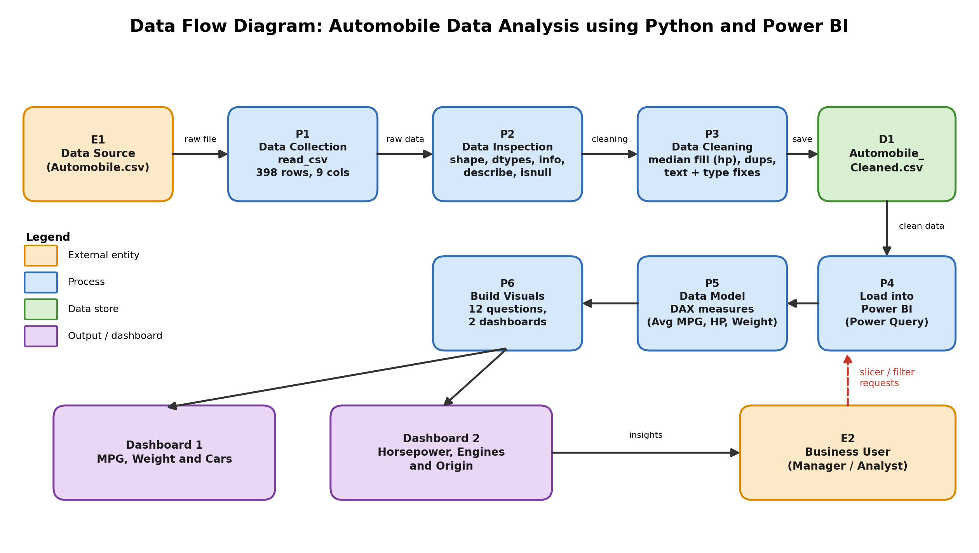

9. Output:
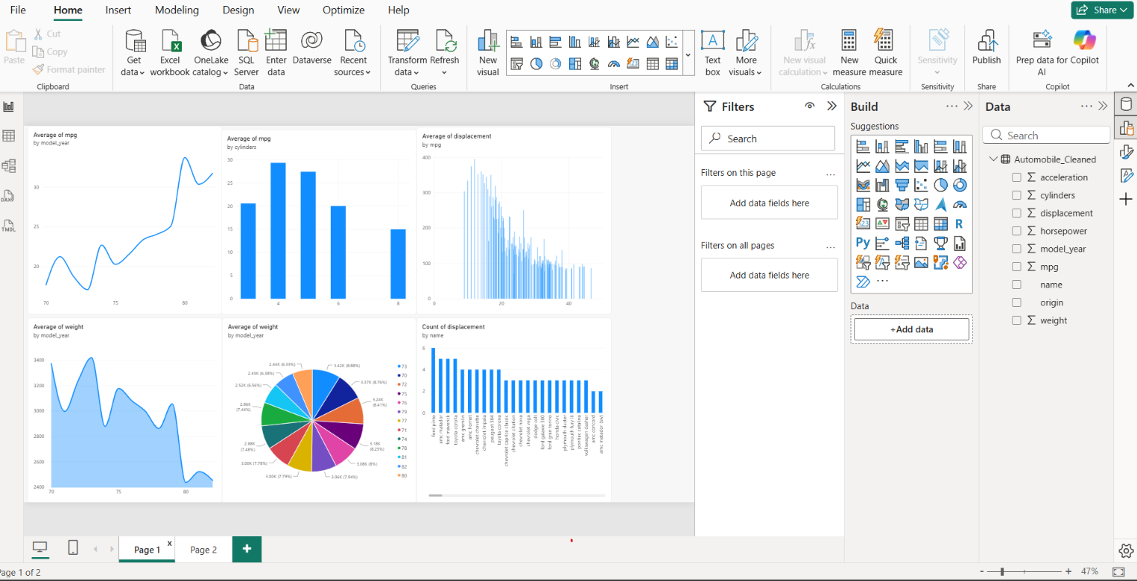
Dashboard 1: MPG, Weight and Cars
Dashboard 1 shows that average MPG rose from 17.69 in 1970 to 31.71 in 1982, while average weight fell from about 3,373 to 2,454. Four-cylinder engines are the most efficient at 29.29 mpg and eight-cylinder engines the least at 14.96 mpg. Larger displacement goes with lower mpg (correlation about -0.80), and Ford Pinto is the most frequent vehicle name with 6 records.
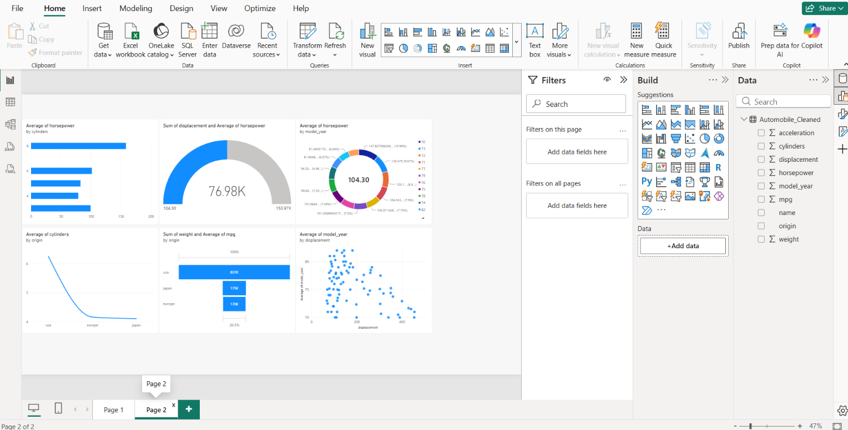
Dashboard 2: Horsepower, Engines and Origin
Dashboard 2 shows that eight-cylinder engines give the highest average horsepower (158.3) against 78.7 for four-cylinder engines. The dataset totals 76,983.5 in displacement with an average of 104.30 horsepower. The USA has the highest average cylinders (6.25) and the greatest total weight (837K), while Japan leads on efficiency with 30.45 mpg against 20.08 for the USA.

10. Conclusion:
This project cleaned the Automobile dataset in Python (six missing horsepower values filled with the median, no duplicates) and used Power BI to build two interactive dashboards that answer twelve business questions. The analysis shows that vehicles became lighter, less powerful and far more fuel efficient between 1970 and 1982, with average MPG almost doubling from 17.69 to 31.71.
- Four-cylinder engines are the most economical; eight-cylinder engines give the most power but the poorest mileage.
- Engine size and fuel efficiency are strongly and negatively related.
- Japanese vehicles are the most efficient (30.45 mpg); American vehicles are the heaviest and least efficient (20.08 mpg).
Although the dataset has no financial columns, these findings show that light, small-engine vehicles mean lower material and running costs and stronger demand, which supports business and financial growth. The main limitations are the small, historical dataset and the absence of price and revenue data. Future work can add financial fields, newer data including electric vehicles, machine learning forecasts and live data refresh in Power BI.

