1 Write a program to read a file and count how many vowels are present in its content.
Sol:-
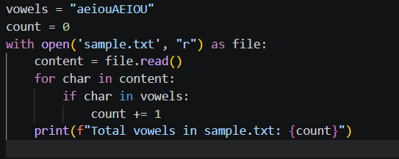
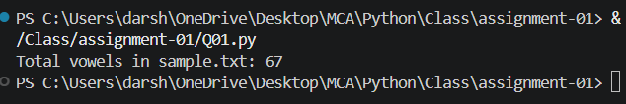

2 Read all lines from a file into a list. Print the total number of lines and display the 2nd and 4th line
Sol:-
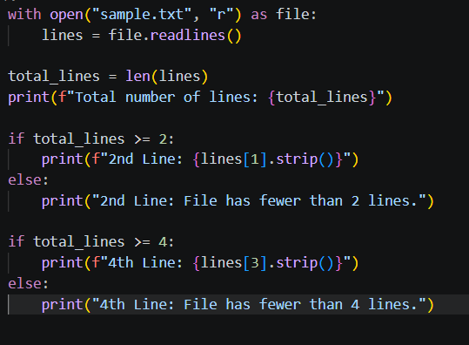
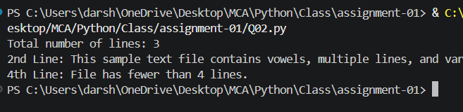

3 Take a sentence from the user, split it into words, and store them in a list. Print the longest word.
Sol:-
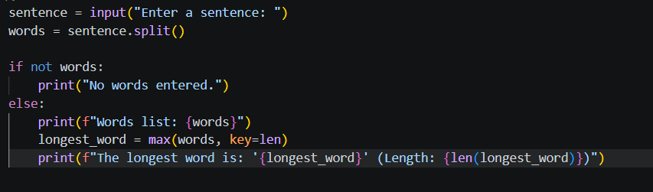
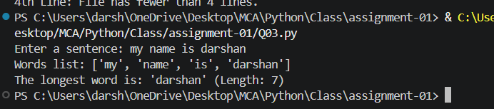

4 Read a file, split its content into words, and store them in a list.
Print the total number of words.
Print all unique words.
Sol:-
