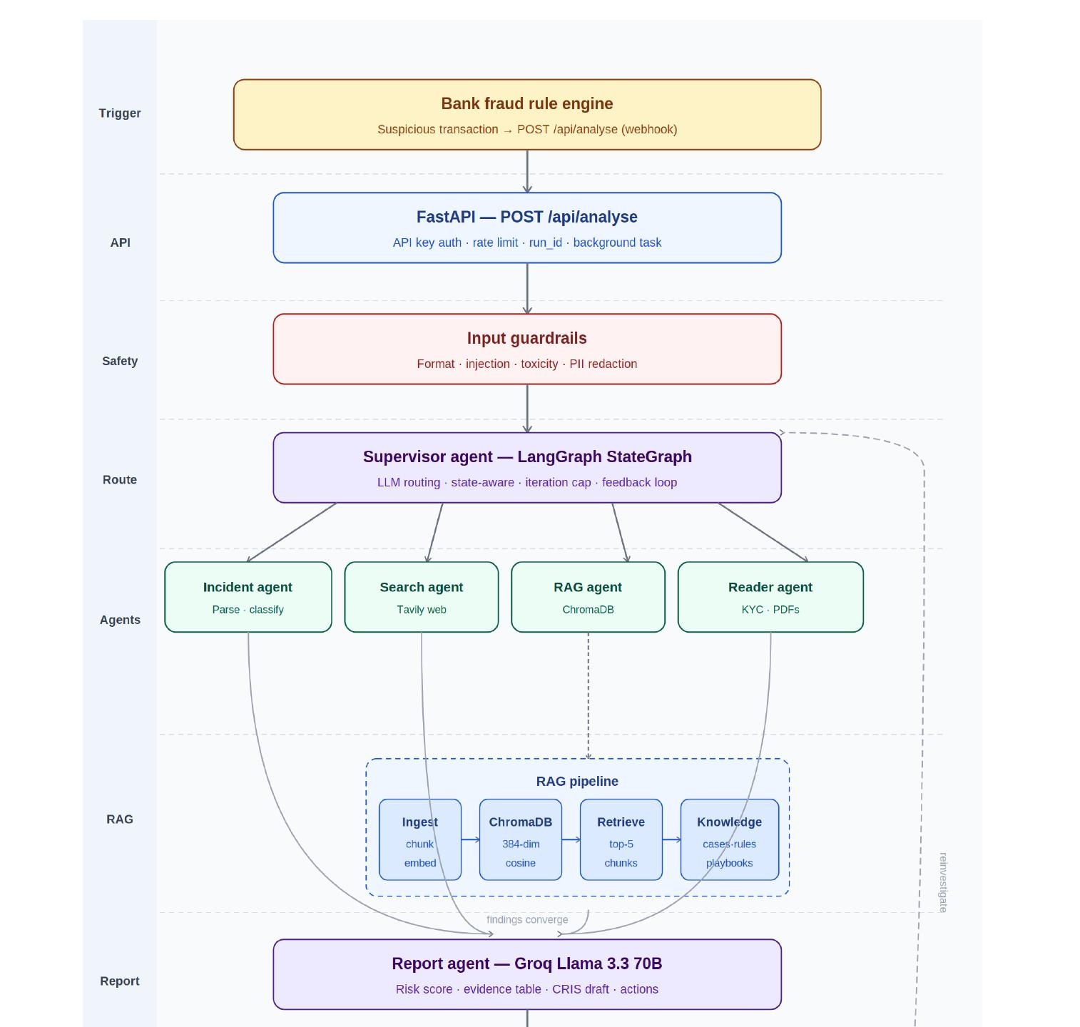
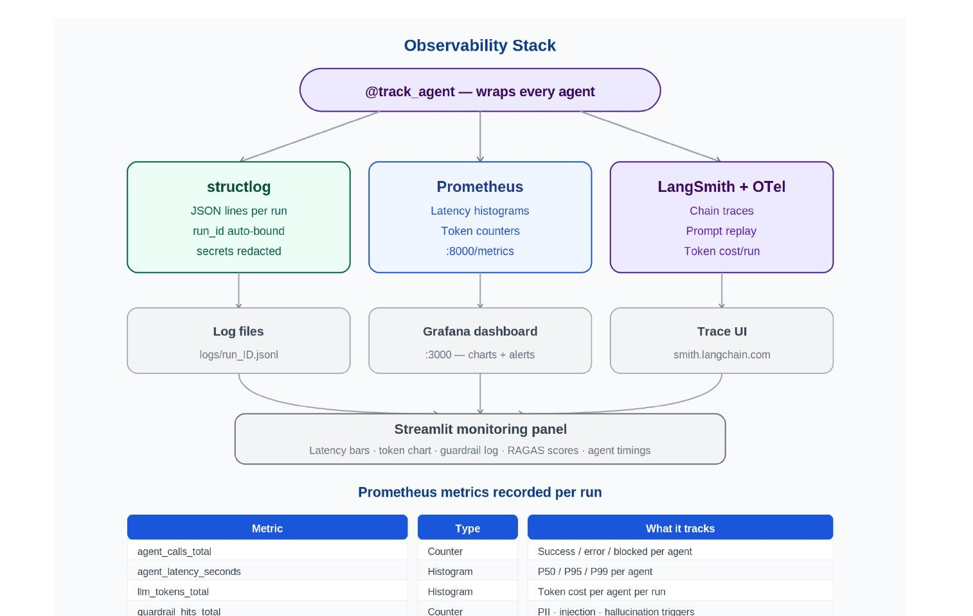
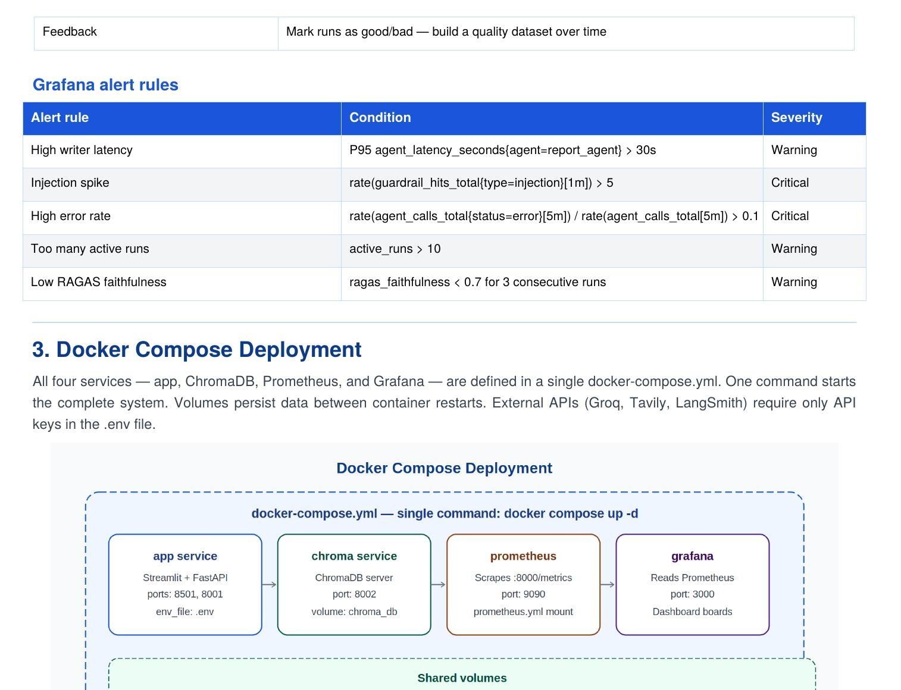
Fraud Intelligence AI Assistant
FIAA
Capstone Design Document
EY GDS | AI & Data Practice
Capstone Project 2025
Team Members | Role
Darshan J | AI Engineer — Agent pipeline, RAG, LangGraph orchestration
Sabi Qunnar | AI Engineer — Guardrails, Observability, UI, Deployment

Item | Detail
Project name | Fraud Intelligence AI Assistant (FIAA)
Domain | Banking — Fraud Detection & Reporting
Document type | Capstone Design Document
Version | v2.0 — 2025
Stack | LangGraph · Groq · ChromaDB · Tavily · Streamlit · Docker

1. Objective
Fraud Intelligence AI Assistant (FIAA) is an autonomous multi-agent GenAI system that automates fraud incident investigation and reporting in banking. When a suspicious transaction is detected by the bank's fraud rule engine, FIAA automatically researches the case using live web intelligence and institutional knowledge, synthesises a complete fraud incident report with risk score and recommended actions, and delivers it to the analyst's dashboard — all in under 90 seconds with zero manual input.

Core problem: Fraud analysts manually spend 45–90 minutes per case — searching for fraud patterns, checking regulatory deadlines, pulling past cases, and writing reports. The 2-hour SLA for SWIFT recall decisions means slow investigation directly costs money that cannot be recovered.

Core solution: FIAA replaces 45–90 minutes of manual research with a 90-second autonomous agent pipeline. The analyst's job becomes: read the report, click one action button.

2. Goals

Stage 1 — Core pipeline (MVP)
- Webhook receiver — FastAPI endpoint that auto-accepts fraud alerts from bank rule engine
- Multi-agent pipeline — LangGraph Supervisor routing four research agents in sequence
- RAG knowledge base — ChromaDB with past fraud cases, RBI guidelines, response playbooks
- Report generation — Groq Llama 3.3 70B synthesising all context into structured fraud report
- Evaluator quality gate — verifies evidence, score, PII masking, RBI accuracy
- Input and output guardrails — injection detection, PII redaction, hallucination check
- Streamlit dashboard — live agent status, report display, action buttons, download

Stage 2 — Production hardening
- Structured logging — structlog JSON lines with run_id binding and secret redaction
- Prometheus metrics — 7 metrics exposed at /metrics for Grafana scraping
- LangSmith tracing — full LangGraph chain traces with prompt/response replay
- RAGAS evaluation — faithfulness, answer relevance, context recall scored per run
- Docker Compose — 4-service containerised deployment (app, chroma, prometheus, grafana)
- Auto-trigger modes — manual fire, timer stream, random stream for demo

3. Non Goals
- Real bank system integration — FIAA simulates the webhook; no live core banking connection
- Account freezing execution — FIAA recommends the action; analyst executes manually
- SWIFT recall execution — FIAA provides case details; correspondent banking executes
- Real-time Aadhaar/PAN validation — KYC verification out of scope
- Training a custom LLM — uses Groq-hosted Llama 3.3 70B via API, no fine-tuning
- Multi-bank deployment — single bank instance; multi-tenancy is future work
- Mobile application — web-only Streamlit UI for this capstone
- Continuous transaction monitoring — alert-based trigger only

4. Project Architecture Diagram and Flow

4.1 System overview
FIAA follows a hub-and-spoke orchestration pattern. The Supervisor Agent sits at the centre of a LangGraph StateGraph, routing sub-tasks to four specialised research agents. All outputs converge at the Report Agent which synthesises a structured fraud incident report. The Evaluator and RAGAS quality-gate the output simultaneously. High-risk cases route to human approval; low-risk cases auto-close. A reinvestigate loop (dashed arc) sends rejected reports back to the Supervisor.

4.2 End-to-end pipeline — architecture diagram
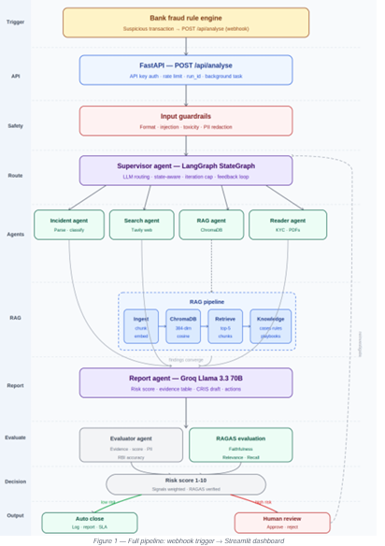
Figure 1 — Full pipeline: Bank fraud rule engine → webhook → FastAPI → Supervisor → Research agents → RAG pipeline → Report agent → Evaluator + RAGAS → Risk decision → Streamlit dashboard

4.3 Pipeline layer descriptions
Layer | Description
Trigger | Bank fraud rule engine fires POST /api/analyse the moment suspicious transaction detected
FastAPI | API key auth · rate limiting · run_id assigned · pipeline started as background task
Input guardrails | Format check · injection detection (10 regex) · toxicity filter · PII auto-redaction — all before any LLM call
Supervisor | LLM reads state at each iteration · routes to correct agent · handles evaluator feedback loop
Incident agent | Parses and classifies alert · logs to PostgreSQL/CSV incident database
Search agent | Tavily API — live web: fraud patterns, RBI circulars, SWIFT advisories
RAG agent | ChromaDB cosine search — top-5 past cases, playbooks, RBI guidelines retrieved
Reader agent | PyMuPDF — extracts text from uploaded KYC PDFs and account statements
Report agent | Groq Llama 3.3 70B — synthesises all context into structured fraud report
Evaluator | Evidence grounding · score proportionality · PII check · RBI deadline accuracy
RAGAS | Faithfulness · Answer relevance · Context recall — stored in SQLite per run
Risk decision | Score ≥ 7 → human review · Score < 7 → auto close · Reject → reinvestigate
Output guardrails | PII scan · hallucination detection · citation audit on final report
Dashboard | Streamlit — report, risk score, action buttons, monitoring panel, download

4.4 Supervisor routing logic
The Supervisor is an LLM call — not a hardcoded rule engine. It reads the investigation state at every iteration and decides which agent to call next. Three safety mechanisms prevent infinite loops:
- Iteration cap — force WRITE after 5 iterations regardless of state
- Done-check — never re-call an agent already marked complete in state
- Approval-check — immediately route to END when Evaluator approves

Iteration | State it reads | Decision | Reason
0 | Everything missing | → SEARCH | Need live RBI + fraud corridor data
1 | Search done, RAG missing | → RAG | Need past cases + playbooks
2 | Search + RAG done | → WRITE | Sufficient context gathered
3 | Evaluator approved | → END | Pipeline complete
3 | Evaluator rejected | → WRITE | Revise with evaluator feedback
5 | Iteration cap reached | → WRITE | Force report — prevent infinite loop

4.5 RAG pipeline
Step | Tool | Detail
1. Ingest | rag/ingestor.py | Reads: fraud_playbooks.txt (312 chunks), rbi_guidelines.txt (428 chunks), past_cases.json (107 cases)
2. Chunk | 512-token windows | 64-token overlap preserves context across chunk boundaries
3. Embed | all-MiniLM-L6-v2 (local) | 384-dimension vectors — CPU only, no external API, no customer data leaves machine
4. Store | ChromaDB PersistentClient | Cosine similarity index, persistent across restarts, metadata alongside each vector
5. Retrieve | collection.query() | Top-5 chunks by cosine similarity to current alert embedding
6. Augment | LangGraph state | Chunks injected into Report Agent prompt as structured context

Why ChromaDB: Runs locally (no cloud dependency), persists across restarts (FAISS loses index on Streamlit rerun), stores metadata alongside vectors, and is free. Pinecone sends data to cloud — banking compliance violation.

5. Features

Feature 1 — Automated Alert Ingestion (Webhook)
When the bank's fraud rule engine detects a suspicious transaction it fires a POST request to FIAA's FastAPI endpoint automatically. The pipeline starts without any analyst involvement.

Webhook payload example:
POST http://fiaa-server:8001/api/analyse
X-API-Key: fiaa-secret-key-2025
{
"alert_id": "FR-2025-8821",
"account": "****4729",
"amount": 487000,
"destination": "Cayman Islands",
"signals": ["velocity_breach", "geo_anomaly", "new_device"],
"sla_minutes": 120
}

Design decision: FastAPI responds to rule engine immediately (< 100ms) with {"status":"accepted"} and runs pipeline as background task. The rule engine is never kept waiting 90 seconds for the report.

Mode | Trigger | What happens
Demo — manual | Analyst clicks Fire alert | Writes to SQLite → pipeline runs → report appears
Demo — timer | Auto-fires every 60 seconds | Hands-free for presentation — no button clicking
Demo — random | Random alert every 45 seconds | Mixed fraud alert stream simulation
Production | Bank rule engine calls webhook | Zero human involvement — alert to report automatic

Feature 2 — Multi-Agent Research Pipeline
Agent | Responsibility | Model | Design decision
Supervisor | LLM routing — reads state, decides next agent | Groq Llama 3.3 70B | LLM not rules — handles alert types never seen before
Incident Agent | Parse, classify alert, log to database | Groq Llama 3.1 8B | Small model sufficient for extraction
Search Agent | Tavily live web — fraud patterns, RBI, SWIFT | Groq Llama 3.1 8B | Small model for synthesis; saves 70B quota
RAG Agent | ChromaDB cosine search — cases, playbooks, rules | Local + Groq | Local embeddings — no customer data to external API
Reader Agent | Extract from uploaded KYC / account PDFs | Groq Llama 3.1 8B | Only runs if analyst uploads a document
Report Agent | Synthesise all context into fraud report | Groq Llama 3.3 70B | Large model reserved here — report quality critical
Evaluator | Quality gate — evidence, score, PII, RBI | Groq Llama 3.3 70B | Mirrors EY preparer-reviewer model

6. Tech Stack
Layer | Package | Version | Design decision
Agent orchestration | LangGraph | 0.2+ | Typed shared state + conditional routing + parallel fan-out
LLM inference | Groq SDK + LangChain-Groq | latest | 500 tok/s throughput. Fallback chain on 429: 70b→8b→gemma2.
Vector database | ChromaDB | 0.5+ | PersistentClient survives reruns. Local — privacy compliant.
Embeddings | sentence-transformers | 2.7.0 | all-MiniLM-L6-v2 — local CPU, no API cost, GDPR safe.
Web search | Tavily | 0.3+ | Pre-extracted content not raw HTML. Relevance-scored.
API layer | FastAPI + uvicorn | 0.110+ | Async background tasks, rate limiting, Pydantic validation.
UI | Streamlit | 1.35+ | Live agent cards, monitoring panel, auto-trigger modes.
Logging | structlog | 24.1+ | JSON lines, run_id binding, secrets redacted automatically.
Metrics | Prometheus + Grafana | 0.20+ | @track_agent decorator — zero boilerplate in agents.
Tracing | LangSmith + OTel | latest | Full chain traces, prompt replay, token cost. 3 env vars.
RAG evaluation | RAGAS | 0.1+ | Faithfulness, relevance, recall per run in SQLite.
Deployment | Docker Compose | latest | 4 services, single command, shared volumes.

7. Directory Structure
fiaa/
├── app.py Streamlit UI — live agent dashboard
├── start.py Starts Streamlit :8501 + FastAPI :8001
├── requirements.txt
├── .env.example GROQ_API_KEY, TAVILY_API_KEY, LANGCHAIN_API_KEY
├── docker-compose.yml 4-service deployment
├── Dockerfile
├── prometheus.yml Scrape config: localhost:8000/metrics
├── api/
│ └── webhook.py FastAPI — POST /api/analyse
├── graph/
│ ├── state.py ResearchState TypedDict
│ └── workflow.py LangGraph StateGraph wiring
├── agents/
│ ├── supervisor.py LLM routing brain
│ ├── incident_agent.py Parse, classify, log
│ ├── search_agent.py Tavily web search
│ ├── rag_agent.py ChromaDB retrieval
│ ├── reader_agent.py KYC / PDF extraction
│ ├── report_agent.py Groq synthesis
│ └── evaluator_agent.py Quality gate
├── rag/
│ └── ingestor.py Build ChromaDB KB (run once)
├── guardrails/
│ ├── input_guard.py Format, injection, toxicity, PII
│ └── output_guard.py PII scan, hallucination, citations
├── monitoring/
│ ├── logger.py structlog JSON lines
│ ├── metrics.py Prometheus + @track_agent
│ └── tracer.py OpenTelemetry spans
├── configs/
│ ├── settings.py Pydantic BaseSettings
│ └── prompts.py All agent system prompts
└── data/
├── knowledge_base/
│ ├── fraud_playbooks.txt 312 chunks
│ ├── rbi_guidelines.txt 428 chunks
│ └── past_cases.json 107 cases
└── sample_alerts/ 5 demo scenarios

8. Logging

8.1 Structured logging — structlog
All logging uses structlog with JSON output. Every log line carries a run_id that ties all events for one pipeline run together — filter by run_id to see the complete story of one fraud case from webhook to dashboard.

Feature | Implementation | Design decision
JSON lines | structlog.processors.JSONRenderer() | Machine-parseable — ingestible by Loki, Datadog, CloudWatch
run_id binding | structlog.contextvars.bind_contextvars() | Set once per run — all agent lines carry it automatically
Secret redaction | Custom _redact_secrets processor | Scans for api_key/token/secret — replaces with ***REDACTED***
Per-run files | FileHandler(logs/run_{id}.jsonl) | One file per pipeline run — easy per-case post-mortem
Global log file | FileHandler(logs/fiaa.jsonl) | All runs in one file for aggregation and monitoring
Dev format | ConsoleRenderer(colors=True) | Human-readable coloured terminal output during development
Prod format | JSONRenderer to file only | Clean JSON — no colour codes, no console noise

8.2 Events logged per pipeline run
Event | Level | Key fields
pipeline.start | INFO | run_id, alert_id, trigger_len, env
guardrail.pii_redacted | WARNING | run_id, fields_redacted
supervisor.decision | INFO | next, reason, iteration, run_id
agent.success | INFO | agent, duration_s, tokens, run_id
agent.failed | ERROR | agent, error, duration_s, run_id
rag_agent.chunk | INFO | case_id, similarity, source, run_id
evaluator.decision | INFO | approved, score, flags, run_id
pipeline.complete | INFO | iterations, total_tokens, risk_score, duration_s, approved

8.3 Sample log output
{"timestamp":"2025-06-19T02:17:00Z","level":"info",
"event":"pipeline.start","run_id":"a1b2c3d4","alert_id":"FR-2025-8821"}

{"timestamp":"2025-06-19T02:17:00Z","level":"warning",
"event":"guardrail.pii_redacted","fields":["name","mobile"],"run_id":"a1b2c3d4"}

{"timestamp":"2025-06-19T02:17:01Z","level":"info",
"event":"supervisor.decision","next":"SEARCH",
"reason":"Need live RBI + Cayman corridor data","iteration":0,"run_id":"a1b2c3d4"}

{"timestamp":"2025-06-19T02:17:04Z","level":"info",
"event":"agent.success","agent":"search_agent","duration_s":2.814,"tokens":1240}

{"timestamp":"2025-06-19T02:17:05Z","level":"info",
"event":"rag_agent.chunk","case_id":"FR-2024-3341","similarity":0.912}

{"timestamp":"2025-06-19T02:17:09Z","level":"info",
"event":"agent.success","agent":"report_agent","risk_score":9.2,"tokens":2108}

{"timestamp":"2025-06-19T02:17:11Z","level":"info",
"event":"pipeline.complete","iterations":3,"total_tokens":4812,
"approved":true,"duration_s":13.2}

8.4 Distributed tracing — LangSmith
Setup: LANGCHAIN_TRACING_V2=true · LANGCHAIN_API_KEY=ls_xxxx · LANGCHAIN_PROJECT=fiaa-fraud — LangGraph picks these up automatically. Zero code changes in agent files.

LangSmith feature | What you can see
Run timeline | Full LangGraph chain — which agent ran, how long, in what order
Prompt inspect | Exact prompt sent to every LLM call — what context Report Agent received
Response inspect | Exact LLM output — spot where report went wrong on failed run
Token cost | Token count and cost per agent per run — find expensive agents
Run replay | Replay any historical run — debug evaluator rejections or wrong risk scores
Cross-run compare | Compare two runs — why did run A score 9.2 and run B score 6.1?

9. Monitoring · Observability · Metrics

9.1 Three-pillar observability stack
Every agent call passes through the @track_agent decorator which emits to three observability pillars simultaneously. Zero monitoring boilerplate exists inside agent code.

Figure 2 — Three-pillar observability: structlog → log files | Prometheus → Grafana | LangSmith + OTel → trace UI

Pillar | Tool | Output | Purpose
Logging | structlog | logs/run_ID.jsonl | Per-case audit trail — filter by run_id
Metrics | Prometheus + Grafana | localhost:8000/metrics → :3000 | Real-time charts, alert rules, capacity planning
Tracing | LangSmith + OTel | smith.langchain.com | Full chain replay, prompt inspection, cost per run

9.2 Prometheus metrics — complete list
Metric | Type | Labels | Purpose | Alert threshold
fiaa_agent_calls_total | Counter | agent, status | Success/error per agent | Error rate > 10% in 5 min
fiaa_agent_latency_seconds | Histogram | agent | P50/P95/P99 per agent | P95 report_agent > 30s
fiaa_llm_tokens_total | Histogram | agent | Token cost breakdown | —
fiaa_guardrail_hits_total | Counter | type, severity | PII, injection, hallucination count | Injection > 5/min
fiaa_pipeline_latency_seconds | Histogram | — | End-to-end pipeline duration | —
fiaa_last_risk_score | Gauge | — | Most recent risk score | —
fiaa_active_runs | Gauge | — | Concurrent pipelines now | Active > 10
fiaa_supervisor_iterations | Histogram | — | Routing iterations per run | Mean > 4

9.3 Grafana alert rules
Alert | Condition | Severity
High report latency | P95 fiaa_agent_latency_seconds{agent="report_agent"} > 30s | Warning
Injection spike | rate(fiaa_guardrail_hits_total{type="injection"}[1m]) > 5 | Critical
High error rate | rate(fiaa_agent_calls_total{status="error"}[5m]) / rate(...[5m]) > 0.1 | Critical
Too many active runs | fiaa_active_runs > 10 | Warning
Low RAGAS faithfulness | ragas_faithfulness < 0.7 for 3 consecutive runs | Warning

9.4 RAGAS — RAG pipeline quality evaluation
RAGAS metric | Question it answers | Target | Low score means
Faithfulness | Are all report claims grounded in retrieved RAG chunks? | > 0.85 | Report Agent hallucinated — cited case not in retrieved chunks
Answer relevance | Does the report answer the actual fraud alert question? | > 0.80 | Response is generic — missed specific alert signals
Context recall | Did RAG Agent retrieve the chunks actually needed? | > 0.75 | Right playbook not found — knowledge base needs refresh

10. Stress Testing Scenario
Scenario | Load | Expected behaviour | Pass criteria
Normal load | 5 concurrent alerts | All complete < 90s | 0% error, P95 < 30s
Peak load | 20 concurrent alerts | Queuing, no crashes | < 5% error rate
Injection attack | 100 injection attempts/min | All blocked at guardrail | 0 reach LLM
RAG empty | KB not built | Graceful degradation, LOW confidence | No crash
Groq rate limit | Primary model hits 429 | Fallback to llama-3.1-8b | Pipeline completes
LangSmith down | Tracing endpoint unavailable | Tracing disabled, pipeline continues | 0 pipeline failures
ChromaDB restart | Container restarted mid-run | Persistent volume preserves vectors | No data loss
Large alert text | Alert > 5000 chars | Format guardrail blocks at entry | HTTP 400, no pipeline

11. Deployment — Docker Compose
All four services — app, ChromaDB, Prometheus, and Grafana — are defined in a single docker-compose.yml. One command starts the complete system with correct inter-service networking and shared volumes.

Figure 3 — Four-service Docker Compose: app (Streamlit + FastAPI) · chroma · prometheus · grafana — with shared volumes and external API connections

11.1 docker-compose.yml
services:
app:
build: .
ports: ["8501:8501","8001:8001","8000:8000"]
env_file: .env
volumes: ["./chroma_db:/app/chroma_db","./logs:/app/logs"]
depends_on: [chroma]

chroma:
image: chromadb/chroma
ports: ["8002:8000"]
volumes: ["./chroma_db:/chroma/.chroma"]

prometheus:
image: prom/prometheus
ports: ["9090:9090"]
volumes: ["./prometheus.yml:/etc/prometheus/prometheus.yml"]

grafana:
image: grafana/grafana
ports: ["3000:3000"]
environment: ["GF_SECURITY_ADMIN_PASSWORD=fiaa2025"]
depends_on: [prometheus]

11.2 Service URLs
Service | URL | What you see
Streamlit UI | http://localhost:8501 | Live agent dashboard, report, auto-trigger, monitoring
FastAPI webhook | http://localhost:8001/api/analyse | POST endpoint — accepts fraud alert payloads
FastAPI docs | http://localhost:8001/docs | Swagger UI — test webhook from browser
Metrics endpoint | http://localhost:8000/metrics | Raw Prometheus metrics — verify @track_agent
Grafana | http://localhost:3000 | Charts, alerts, latency — admin/fiaa2025
LangSmith | https://smith.langchain.com | Full chain traces — project: fiaa-fraud

11.3 Startup sequence
- Configure: cp .env.example .env — add GROQ_API_KEY, TAVILY_API_KEY, LANGCHAIN_API_KEY
- Build RAG KB (one time): docker compose run app python -m rag.ingestor
- Start all services: docker compose up -d
- Verify dashboard: http://localhost:8501
- Test webhook: curl -X POST localhost:8001/api/analyse -H "X-API-Key: fiaa-secret-key-2025" -d '{...}'
- Open Grafana: http://localhost:3000 — add Prometheus data source (http://localhost:9090)

12. Design Decisions
Decision | What was chosen | Why — design rationale
LLM-based Supervisor | LangGraph LLM routing | Handles alert types never seen. Rule engine breaks on edge cases.
Local embeddings | sentence-transformers on CPU | No customer data to external API — banking compliance. No cost. Offline.
Vector database | ChromaDB over FAISS/Pinecone | FAISS: no persistence. Pinecone: cloud = compliance violation. ChromaDB: local, free, metadata built-in.
Model size split | Small 8B for extract, 70B for report | Report quality needs 70B. Extraction does not. Saves token quota.
Webhook trigger | FastAPI POST endpoint | Millisecond latency vs 30s polling. Critical for SWIFT 2-hour window.
Decorator observability | @track_agent wraps agents | Zero boilerplate in agent code. Add/remove monitoring without touching business logic.
RAGAS evaluation | Per-run RAG scoring | Catches knowledge base decay. If faithfulness drops, KB needs refresh.
Docker Compose | Single docker compose up -d | Reproducible. All 4 services start together with correct networking.
Fallback model chain | 70b → 8b → gemma2-9b | Groq rate limits on free tier. Ensures pipeline never fails on 429.
Background tasks | FastAPI BackgroundTasks | Rule engine gets 200 OK in < 100ms. Pipeline runs async independently.

Fraud Intelligence AI Assistant (FIAA) · Darshan J & Sabi Qunnar · EY GDS Capstone 2025

