# Download Manager

## System Requirements

1. **Operating system**: Windows (.net framework 4.6 and above)
2. **Features and Supported Protocols**:
   1. FTP(anonymous with no username and password required)
   2. HTTP
   3. HTTPS
   4. SFTP (Username and password to be configured in a config file show in How to run section)
      * File > 1GB of size will be downloaded in 5 chunks and then will be merged into one file.
      * **(Note)** Downloading works well without connecting to company’s private VPN. To download with VPN you will need to change firewall config on your side.

## How to Run Project.

1. Open App.Config and configure correct paths as shown below.

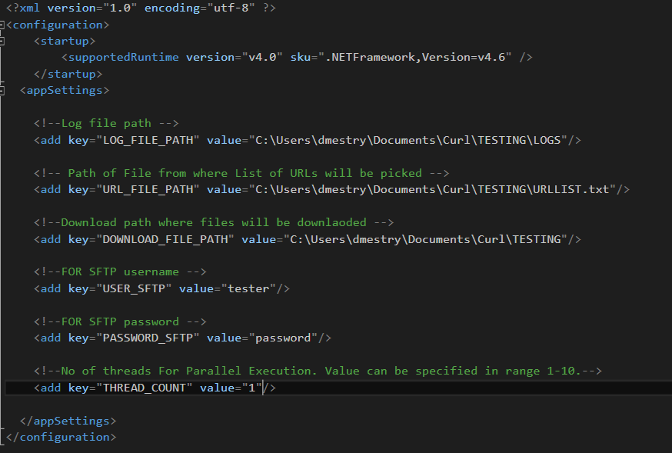

Details of Config file.

* **LOG_FILE_PATH**: Log file for status of downloading
* **URL_FILE_PATH**: URL file to be given as input.
  + Supported File Extension **.txt**
  + Each **URL** should be entered on line new.

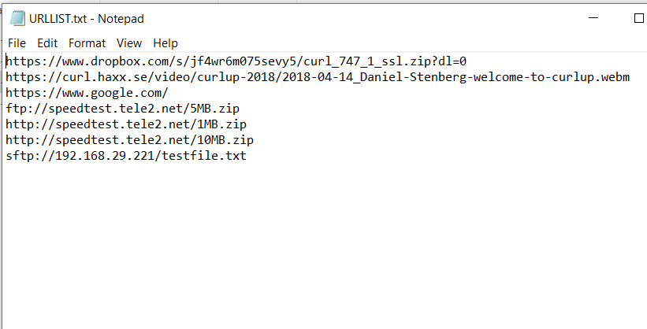

* **DOWNLOAD_FILE_PATH**: Download path where files will be downloaded
* **USER_SFTP, PASSWORD_SFTP**: Username and password for SFTP
* **THREAD_COUNT**: Thread count for parallel download.

As shown below.

1. Run the project