COURSE PROJECT REVIEW 1
BACSE324 | Embedded Systems Architecture
Submission Template

Project Title
VisionGuard: Smart Cane for Visually Impaired People with Ultrasonic Obstacle Detection and Wet-Surface Warning
Student name(s) | S Darshan – 25BCE2883
Student name(s) | Tanay Agarwal – 25BCE2475
Programme / Section | B.Tech Computer Science and Engineering – Slot E2+TE2
Faculty / Guide | Dr. Shabeeb Ahmed
Submission date | 27 October 2026

1. Abstract (100 words)
Visually impaired people depend on the white cane, which detects obstacles only on contact and cannot warn about water, puddles or open drains. VisionGuard is a low-cost smart cane built around an Arduino Nano (ATmega328P). An HC-SR04 ultrasonic sensor measures the distance to obstacles ahead, and a resistive moisture probe at the tip, read through the on-chip ADC, detects water or wet ground. Alerts are prioritised: a continuous buzzer tone for water, and beeps that get faster as an obstacle comes within 50 cm. Its distinguishing feature is combining obstacle and wet-surface sensing for under ₹900 in parts. Bench tests confirm obstacle alerts on battery power; threshold calibration and haptic feedback are in progress.

2. Circuit and Block diagram
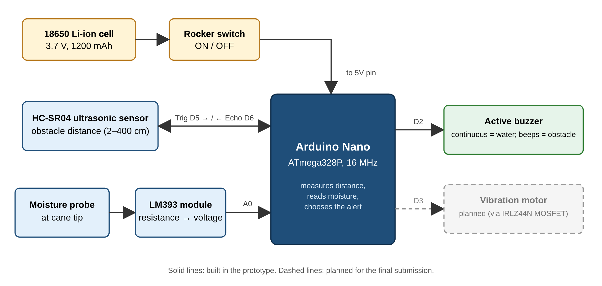
Figure 1. Block diagram of VisionGuard
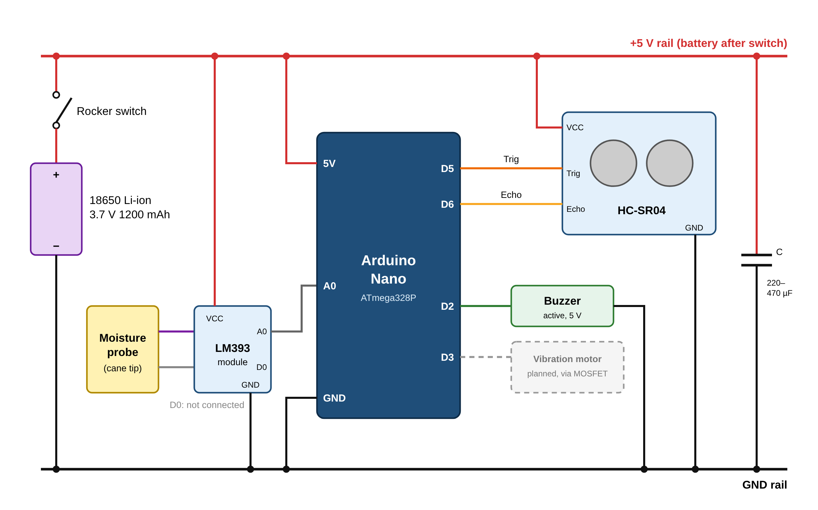
Figure 2. Circuit diagram. Pins as used in the firmware: Trig D5, Echo D6, moisture A0, buzzer D2; battery feeds the 5V pin through the rocker switch.

3. List of Components
List the main hardware and electronic components used in the prototype. Add or remove rows as required.
S. No. | Component | Specification / Model | Function in the project
1 | Arduino Nano | ATmega328P, 16 MHz, 5 V logic, 10-bit ADC | Main controller: reads both sensors, runs the alert logic, drives the buzzer
2 | Ultrasonic sensor | HC-SR04, 40 kHz, 2–400 cm range | Measures distance to obstacles in front of the cane (Trig D5, Echo D6)
3 | Moisture probe | Fork-type resistive probe | Mounted at the cane tip; detects water or wet mud on contact
4 | Moisture signal module | LM393 comparator board (A0 / D0 outputs) | Converts probe resistance into an analog voltage read on A0
5 | Buzzer | Active buzzer, 5 V | Audio alert on D2: beeps for obstacles, continuous tone for water
6 | Battery | 18650 Li-ion cell, 3.7 V, 1200 mAh | Portable power source
7 | Battery holder | 18650 single-cell holder | Holds the cell on the cane
8 | Rocker switch | SPST, 6 A | Power ON/OFF between battery and the 5V pin
9 | Electrolytic capacitor | 220 µF / 470 µF | Smooths the supply during buzzer switching
10 | Cane body and wiring | PVC pipe, jumper wires, berg strips, single-strand wire | Mechanical structure and electrical interconnections

4. Bill of Materials (BOM)
Provide the estimated or actual cost of the components. Use the same currency throughout.
S. No. | Item / Component | Qty. | Unit cost (₹) | Total cost (₹) | Remarks
1 | Arduino Nano (ATmega328P) | 1 | 250.00 | 250.00 | Vellore Robo Electronics
2 | HC-SR04 ultrasonic sensor | 1 | 105.00 | 105.00 | Vellore Robo Electronics
3 | Soil-moisture sensor (probe + LM393 module) | 1 | 45.00 | 45.00 | Vellore Robo Electronics
4 | 18650 Li-ion cell, 3.7 V 1200 mAh | 2 | 65.00 | 130.00 | One fitted, one spare
5 | 18650 cell holder | 1 | 30.00 | 30.00 | Billed as 2-cell; 1-cell holder fitted
6 | Rocker switch, 6 A | 1 | 15.00 | 15.00 | Vellore Robo Electronics
7 | Electrolytic capacitors (470 µF ×2, 220 µF ×2) | 4 | – | 45.00 | Supply filtering
8 | Jumper wires (F-F, M-M, M-F; 10 each) | 3 sets | 20.00 | 60.00 | Vellore Robo Electronics
9 | Berg strips (2 female, 3 male) | 5 | 10.00 | 50.00 | Vellore Robo Electronics
10 | Single-strand wire | 3 | 12.00 | 36.00 | Vellore Robo Electronics
11 | Nano USB cable | 1 | 40.00 | 40.00 | For programming
12 | Active buzzer, 5 V | 1 | 20.00 | 20.00 | Estimated; not on bill
13 | PVC pipe, hot glue, cable ties | – | – | 50.00 | Estimated; cane body
14 | Tools: soldering iron, solder, flux, breadboard | 4 | – | 660.00 | Not part of the cane
15 | Parts for planned features: IRLZ44N MOSFET, 1 A fuse + holder, JST connector, resistor box, 0.1 µF capacitors | – | – | 269.00 | For Review 2 upgrades
Estimated total project cost |  |  |  | 1,805.00 | Cane hardware (items 1–13): ₹876
Prices are from invoice Ref. 3293, Vellore Robo Electronics (07-10-2026), including 18% GST; the billed total is ₹1,735. Items 12–13 (₹70) are estimates.

4. Prototype Photograph (Working Hardware)
Insert a clear, recent photograph of the assembled working prototype below. The photograph should show the actual hardware (not only a simulation or circuit diagram). Ensure that the main components are visible; use a caption to briefly identify the prototype and, if useful, indicate its operating condition.
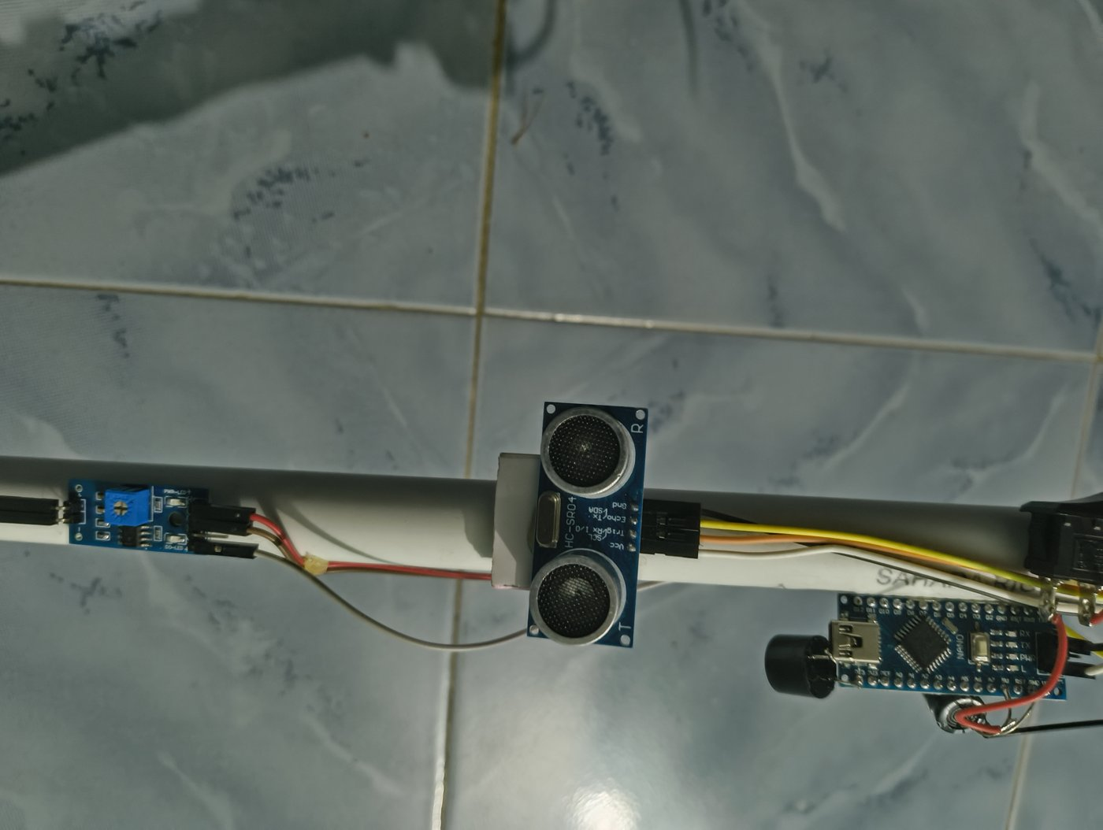
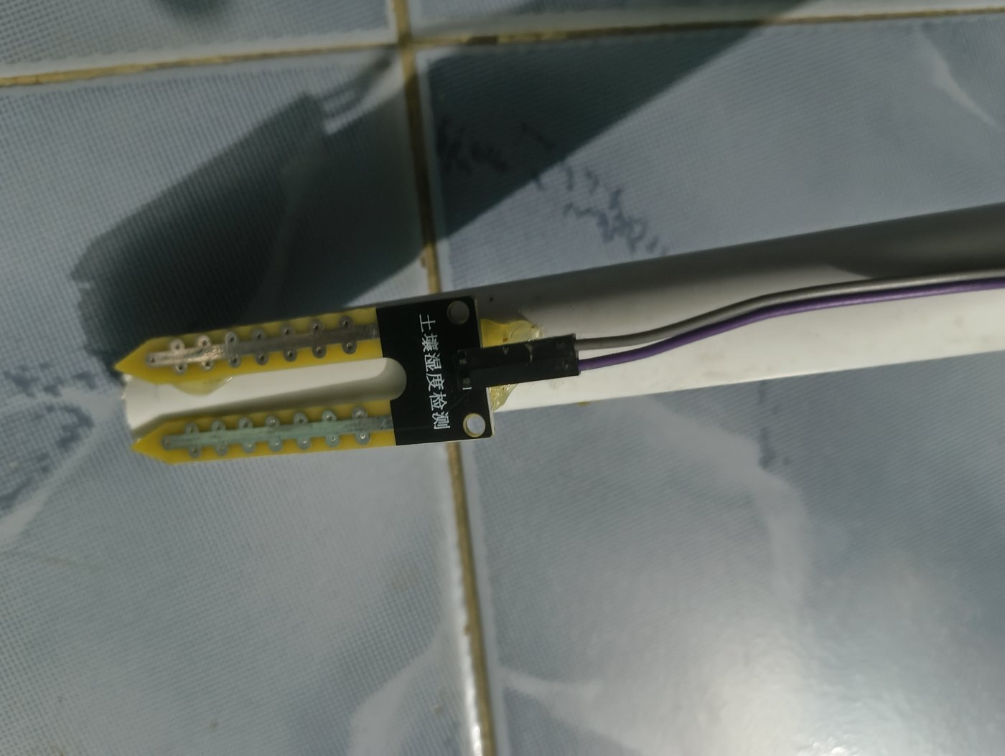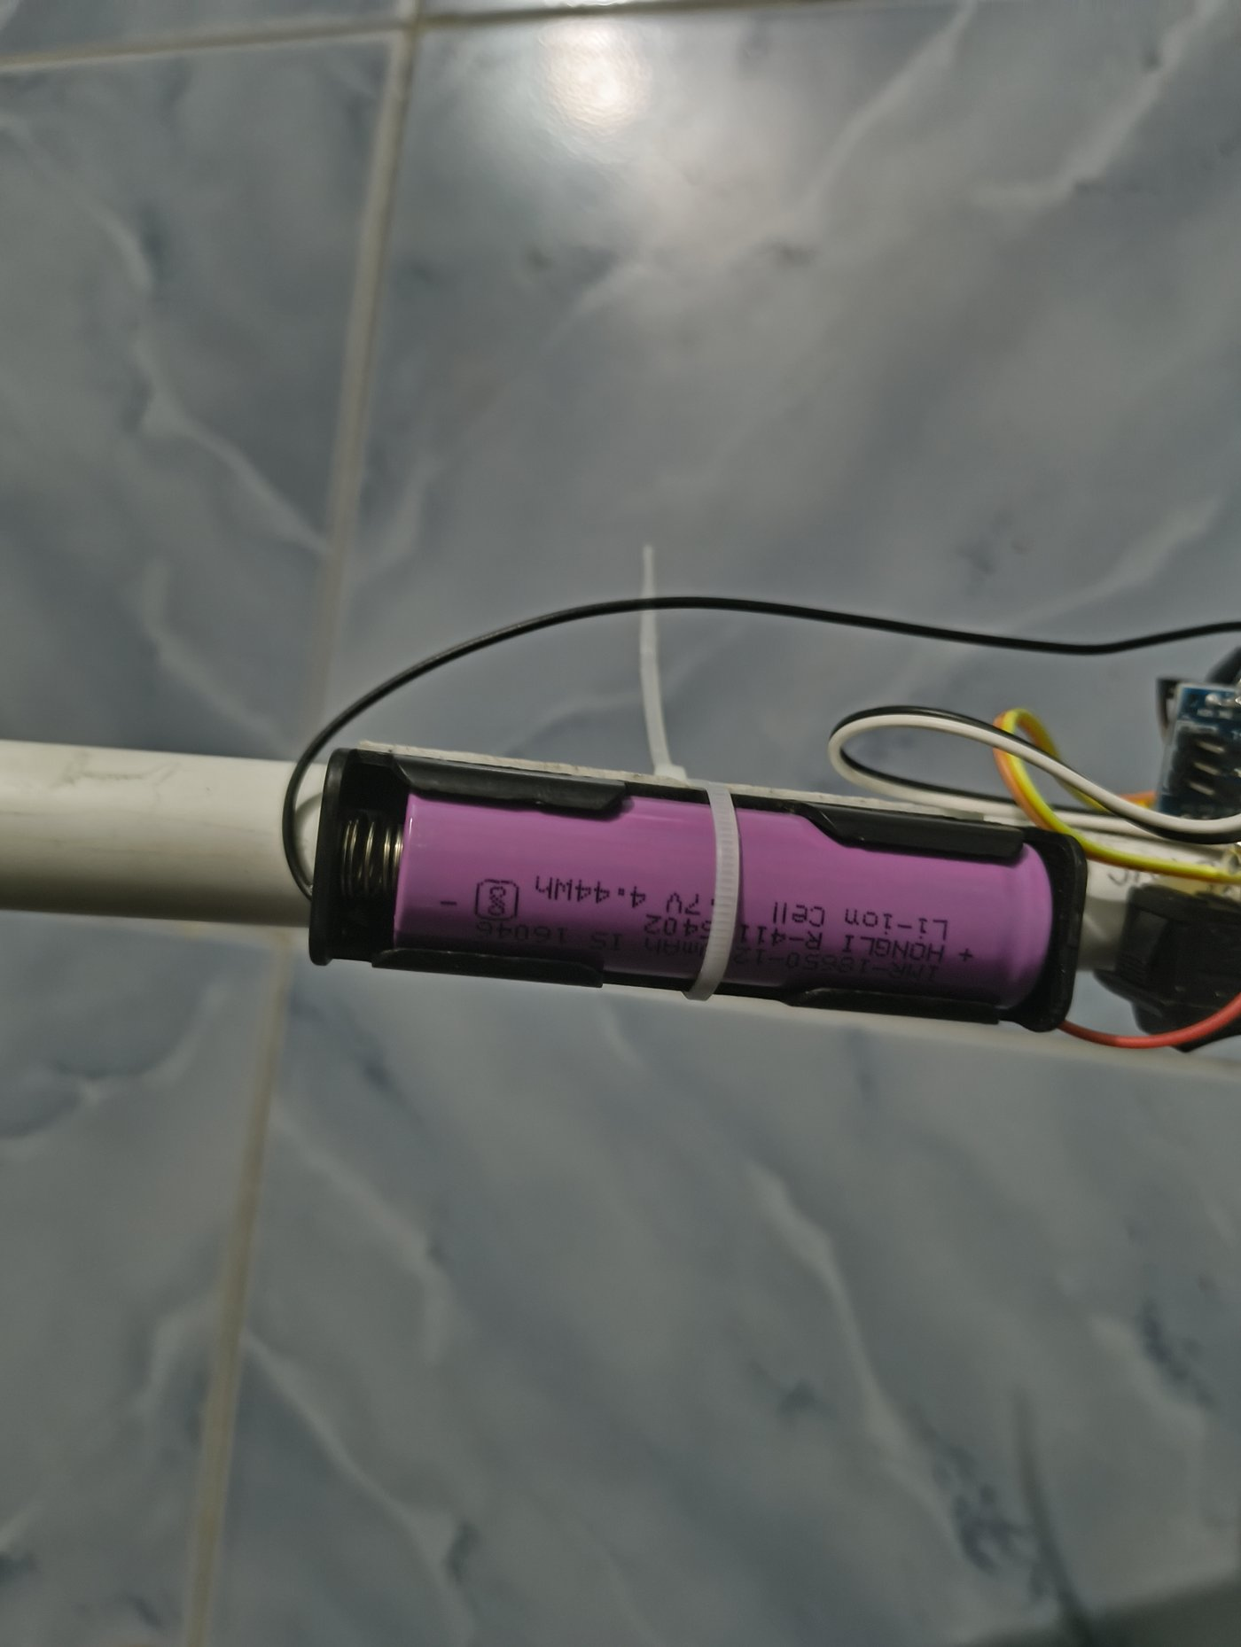
Figure 3. VisionGuard prototype on a PVC cane. Top: LM393 module, HC-SR04 sensor, Arduino Nano with buzzer and switch. Bottom left: moisture probe at the tip. Bottom right: 18650 cell in its holder. Powered ON, the prototype gives obstacle alerts on battery power.

5. Current Status at Review 1 and Potential improvements for final submission
Briefly indicate what has been completed and what remains.
- Completed: problem study; concept refined from an initial smart-shoe design to a cane (the tip reaches water before the foot, and a shaft-mounted sensor is steadier); component selection; assembly of the cane on a PVC pipe (sensors, Arduino Nano, buzzer, battery and switch soldered and mounted); firmware for ultrasonic ranging, moisture sensing and prioritised alerts written and uploaded.
- Demonstrated functionality / preliminary results: on battery power, the buzzer beeps when an obstacle comes within 50 cm, and the beep rate increases as it moves closer (verified by moving a hand or notebook toward the sensor). The water alert (continuous tone) is implemented; dry and wet probe readings are being recorded on the Serial Monitor to calibrate the threshold.
- Challenges or limitations: a single 3.7 V cell feeds the 5V pin directly, with no regulation or low-battery warning; the HC-SR04’s narrow (~15°) cone misses head-level and thin obstacles and drop-offs; the probe detects water only on contact and corrodes over time; the buzzer is hard to hear in traffic; the 50 cm range gives little warning at walking speed.
- Next steps before Review 2: calibrate the moisture threshold and extend the obstacle range to about 100 cm; add a vibration motor driven by the IRLZ44N MOSFET; add a 5 V boost converter, charging module and the 1 A fuse; average several readings and space pings at least 60 ms apart (per the HC-SR04 datasheet) to reduce false alerts; tidy the wiring into an enclosure and field-test the cane.

