VisionGuard: Smart Cane for Visually Impaired People
PROJECT REPORT

School of Computer Science and Engineering (SCOPE) – B.Tech CSE
Vellore Institute of Technology, Vellore
BACSE324 | Embedded Systems Architecture
Fall Semester 2026–27

Submitted by
S Darshan – 25BCE2883
Tanay Agarwal – 25BCE2475
[Submission Date]

1. Team Members
Enter the full names and registration numbers of all team members.
S. No. | Name | Registration Number
1 | S Darshan | 25BCE2883
2 | Tanay Agarwal | 25BCE2475

2. Objectives
State the main goals of the project clearly and briefly. Use measurable objectives where possible.
- Detect obstacles in front of the cane within 50 cm using an HC-SR04 ultrasonic sensor (rated range 2–400 cm) and warn the user before contact.
- Indicate how close the obstacle is through the beep rate: the gap between 50 ms beeps varies linearly from 50 ms at 2 cm to 400 ms at 50 cm.
- Detect water or wet ground at the cane tip when the moisture reading falls below a calibrated threshold (default 500 of 1023), with a continuous tone that takes priority over obstacle alerts.
- Keep the device portable and low-cost: powered by one 18650 Li-ion cell with an on/off switch, with cane hardware costing under ₹900.

3. Working Principle
Briefly explain how the project works. Describe the relevant physics principles, the input–processing–output sequence, and how the hardware/software components work together.
Input → processing → output. Two sensors are the inputs: the HC-SR04 ultrasonic module (distance ahead) and a resistive moisture probe with an LM393 module (wetness at the tip). The Arduino Nano (ATmega328P) is the processor: it times the echo, converts it to distance, reads the moisture voltage with its 10-bit ADC, and chooses an alert. The output is an active buzzer on pin D2. Everything runs from an 18650 cell connected through a rocker switch to the Nano’s 5V rail, which also powers both sensors.

3.1 Physics Involved
(a) Ultrasonic echo ranging. When the Nano holds the Trig pin HIGH for 10 µs, the HC-SR04 emits a burst of eight 40 kHz sound pulses. It then holds Echo HIGH until the reflection returns. The Echo pulse width t is the round-trip time, so the one-way distance is:
d = (v × t) / 2
where v is the speed of sound, about 343 m/s at 20 °C (0.0343 cm/µs; the code uses 0.034). Example: t = 1000 µs gives d = 0.034 × 1000 / 2 = 17 cm. The speed of sound rises with air temperature T (v ≈ 331.3 + 0.606·T m/s), which adds an error of about 0.2% per °C. The sensor’s beam is a cone of about 15°, so it detects hard, flat surfaces facing it best. Soft or steeply angled surfaces can absorb or deflect the sound. A 30 ms pulseIn() timeout limits the measurement to about 5 m round trip.
(b) Resistive moisture sensing. The probe is two exposed copper tracks. Dry air between them is an insulator (very high resistance R_p). Water containing dissolved salts conducts, so R_p falls sharply. On the module, the probe forms a voltage divider with a fixed resistor R_f connected to the supply V_cc, and the A0 output is the divider midpoint:
V_A0 = V_cc × R_p / (R_p + R_f) N = 1023 × V_A0 / V_ref
N is the 10-bit ADC result. Dry gives R_p → ∞, so V_A0 ≈ V_cc and N ≈ 1023. Wet gives low R_p, so V_A0 and N drop. Because V_ref is the same supply that feeds the divider, the reading is ratiometric: N depends on the resistance ratio, not on the exact battery voltage. The LM393 comparator’s digital D0 output (threshold set by its potentiometer) is not used. The threshold is applied in software instead.
(c) Sound output. The active buzzer contains its own oscillator and piezoelectric element. A DC voltage from a GPIO pin set HIGH makes the piezo disc vibrate at its resonant frequency (a few kHz), producing a tone.
(d) Power. The 18650 Li-ion cell gives 4.2 V when full and about 3.0 V when empty (3.7 V nominal). The ATmega328P and this HC-SR04 version both operate in this range. The electrolytic capacitor across the supply stores charge and supplies the short current pulses drawn when the buzzer switches (i = C·dV/dt), which limits voltage dips. At roughly 30–40 mA total current, a 1200 mAh cell gives a theoretical runtime of about 30 hours (1200 mAh ÷ 40 mA).

3.2 Algorithm / Program Logic
- Initialise: set D5 (Trig), D2 (buzzer) and D3 (reserved vibration output) as outputs and D6 (Echo) as an input. Start Serial at 9600 baud and turn the buzzer OFF.
- Measure distance: drive Trig LOW for 2 µs, HIGH for 10 µs, then LOW. Measure the Echo HIGH time t with pulseIn() (30 ms timeout; t = 0 if no echo). Compute d = t × 0.034 / 2 cm.
- Read moisture: m = analogRead(A0), from 0 to 1023.
- Report: print d, m and the chosen state on the Serial Monitor.
- Decide (priority order): if m < 500, go to the WATER state and turn the buzzer ON continuously.
- Else if 0 < d < 50 cm, go to the OBSTACLE state. Clamp d to 2–50 cm (dc), compute the gap g = map(dc, 2, 50, 50, 400) ms, sound the buzzer for 50 ms, then stay silent for g ms. A closer obstacle gives a shorter gap, so the beeps come faster.
- Otherwise (d = 0, meaning no echo, or d ≥ 50 cm), go to the CLEAR state and turn the buzzer OFF.
- Repeat: wait 30 ms so the previous echo dies out, then return to step 2. The loop runs continuously while the cane is switched on.
Expected responses: open space gives silence. A hand moving from 60 cm toward the sensor starts beeping at 50 cm, and the beeps get faster as it approaches. Dipping the tip in water gives a continuous tone, even when an obstacle is also present.

3.3 Data Flow Graph (DFG)
Insert a DFG showing the computational steps and dependencies between operations. Label inputs, operations, intermediate variables, and outputs.
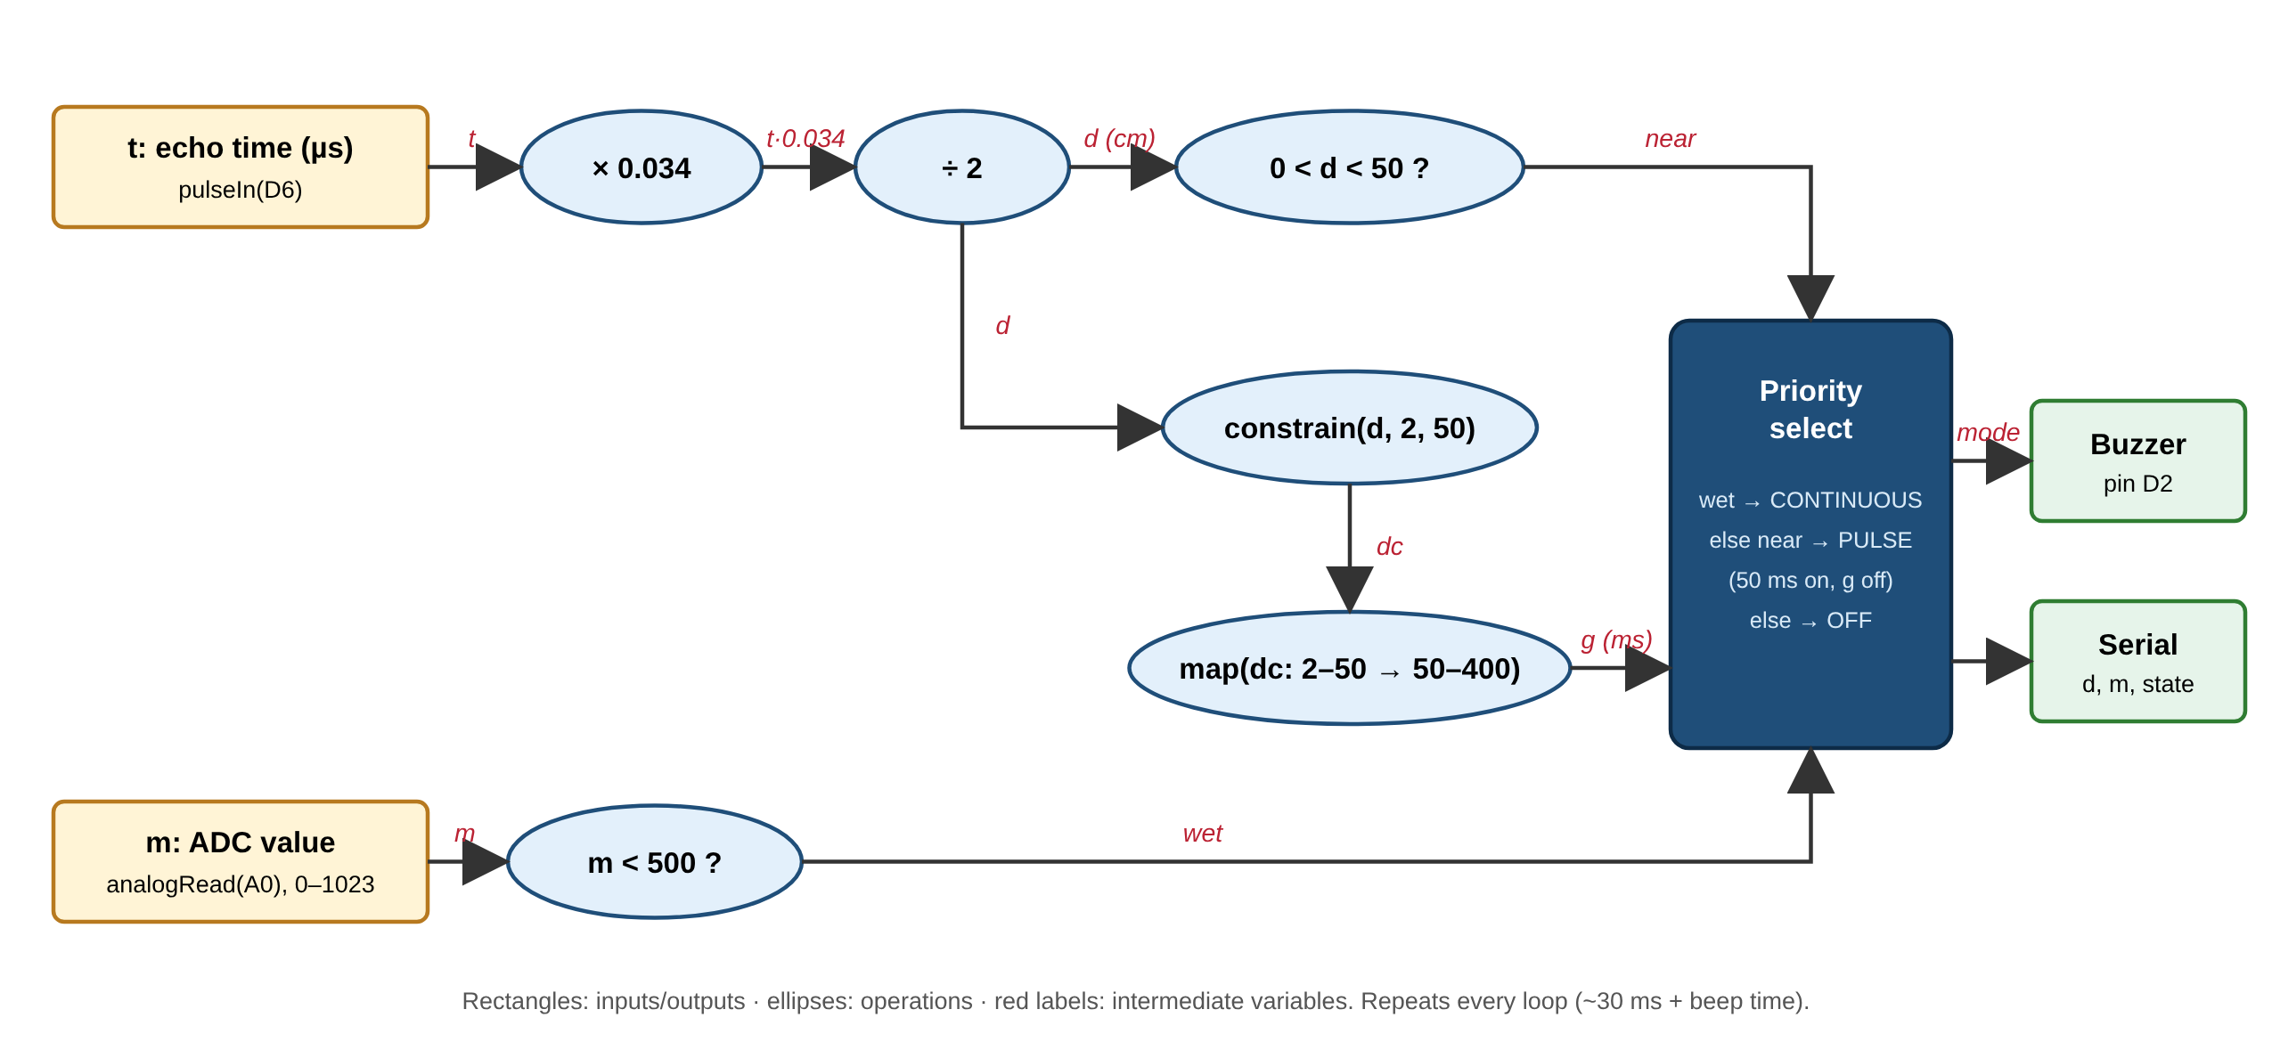
Figure 1. Data Flow Graph of the proposed system.
The echo time t passes through two arithmetic operations (× 0.034, ÷ 2) to give the distance d. The distance feeds two independent branches: a range comparison (near) and a clamp-and-map that produces the beep gap g. The ADC value m is compared with the threshold to give wet. The priority-select node combines wet, near and g to drive the buzzer. Because the two sensor paths do not depend on each other, they could be computed in either order.

3.4 State Diagram
Insert a state diagram showing the system states, transition conditions, and actions performed in each state.
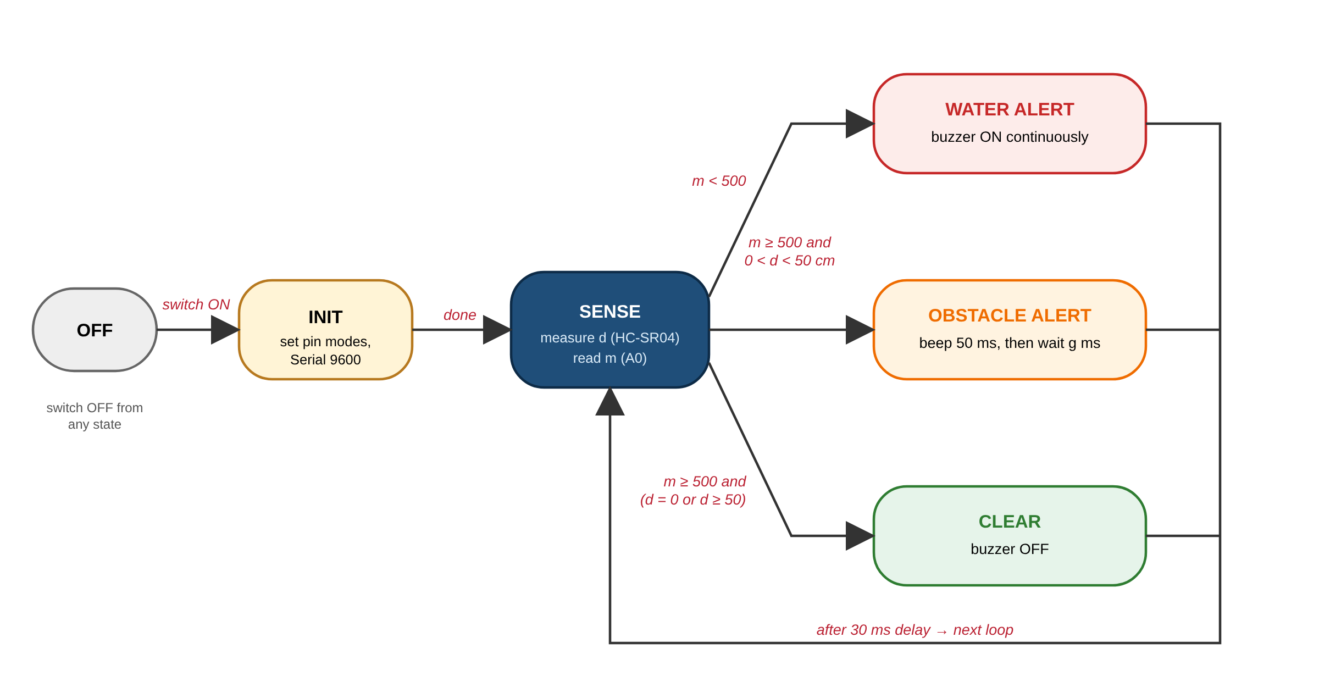
Figure 2. State diagram of the system.
After power-on, the system initialises once and then cycles through SENSE on every loop. From SENSE it enters exactly one output state: WATER (m < 500), OBSTACLE (m ≥ 500 and 0 < d < 50 cm) or CLEAR (otherwise). Each output state returns to SENSE after the 30 ms loop delay. Turning the rocker switch off returns the system to OFF from any state.

4. Final Circuit Diagram
Insert a clear, labelled circuit diagram of the final implementation. Show component names, pin connections, supply voltages, ground connections, and relevant component values.
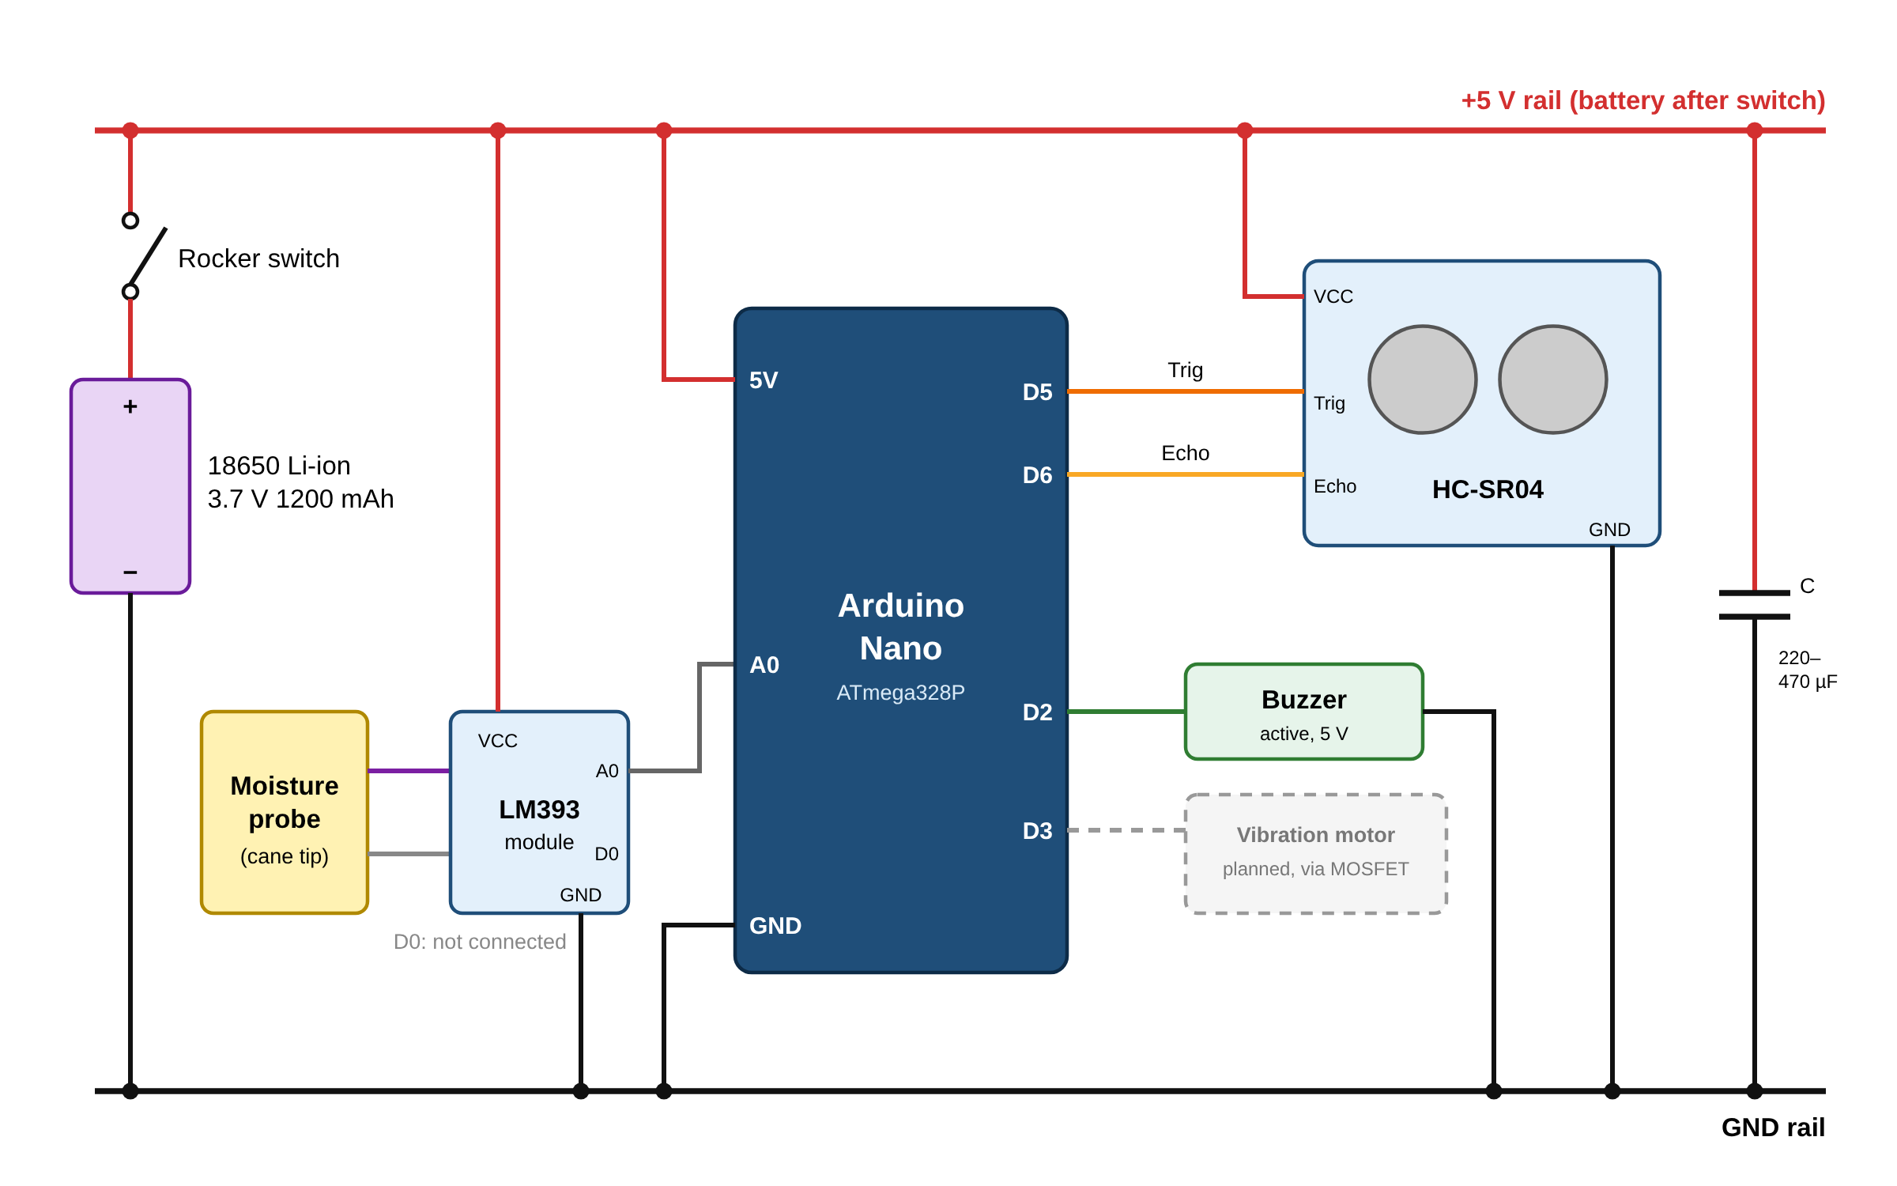
Figure 3. Final circuit diagram.
Table 1. Pin connections.
Device pin | Arduino Nano pin | Notes
18650 cell + (via rocker switch) | 5V | 3.0–4.2 V (3.7 V nominal) on the 5V rail
18650 cell − | GND | Common ground
HC-SR04 VCC / GND | 5V / GND
HC-SR04 Trig | D5 | 10 µs trigger pulse (output)
HC-SR04 Echo | D6 | Echo pulse width (input)
LM393 module VCC / GND | 5V / GND
LM393 module A0 | A0 | Analog moisture value, 0–1023
LM393 module D0 | Not connected | Threshold applied in software
Moisture probe (2 wires) | LM393 probe header | Non-polarised
Active buzzer + / − | D2 / GND | HIGH = ON
Electrolytic capacitor + / − | 5V / GND | 220–470 µF supply filter
Vibration motor (planned) | D3 via IRLZ44N MOSFET | Not fitted in this prototype

5. Photograph of the Final Product
Insert a clear photograph of the completed prototype. Prefer a well-lit image with the important components visible. Add labels or multiple views if they help explain the build.
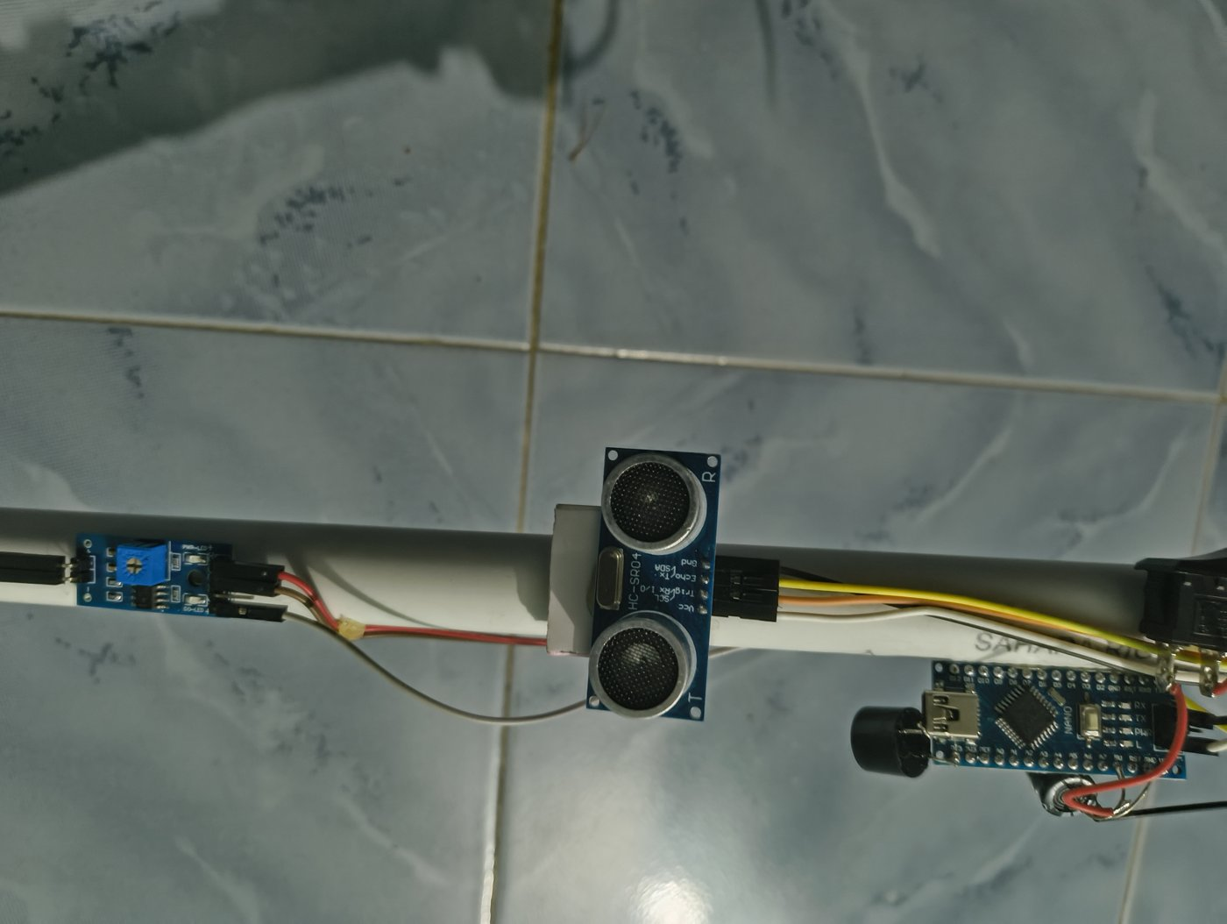
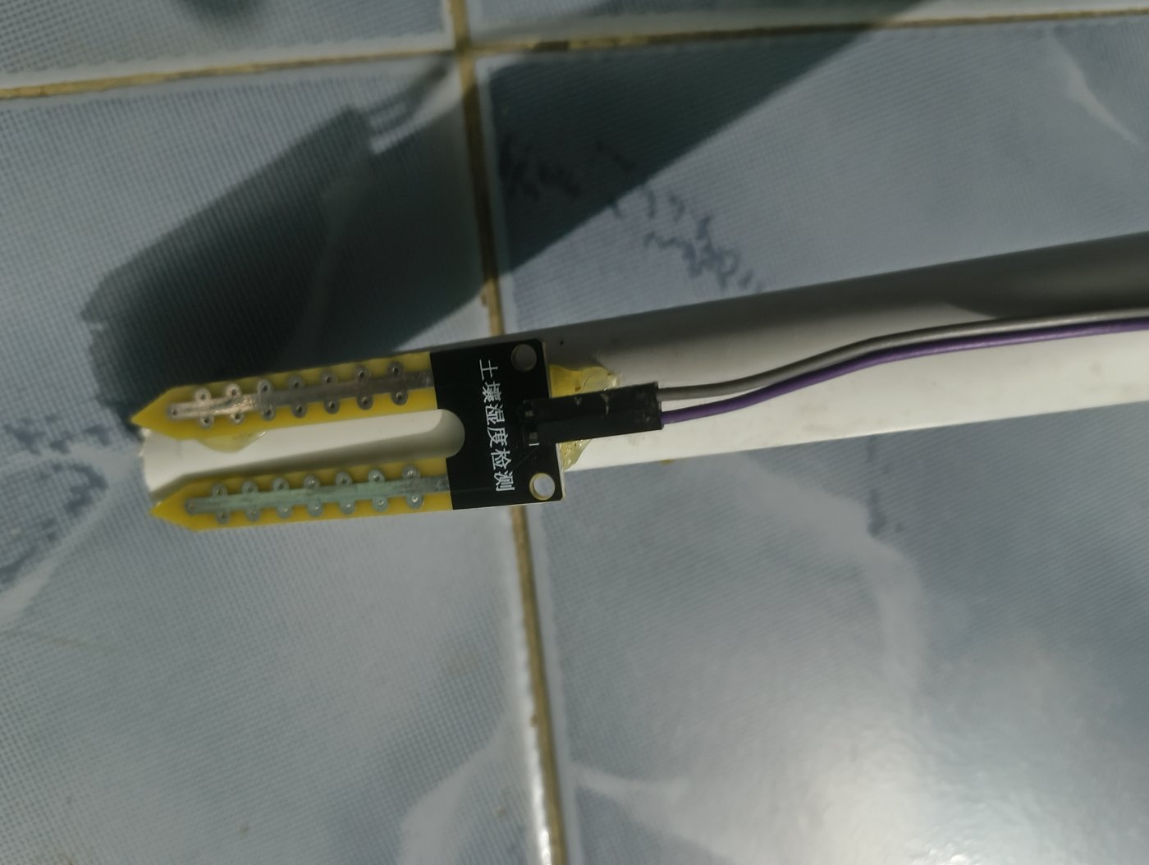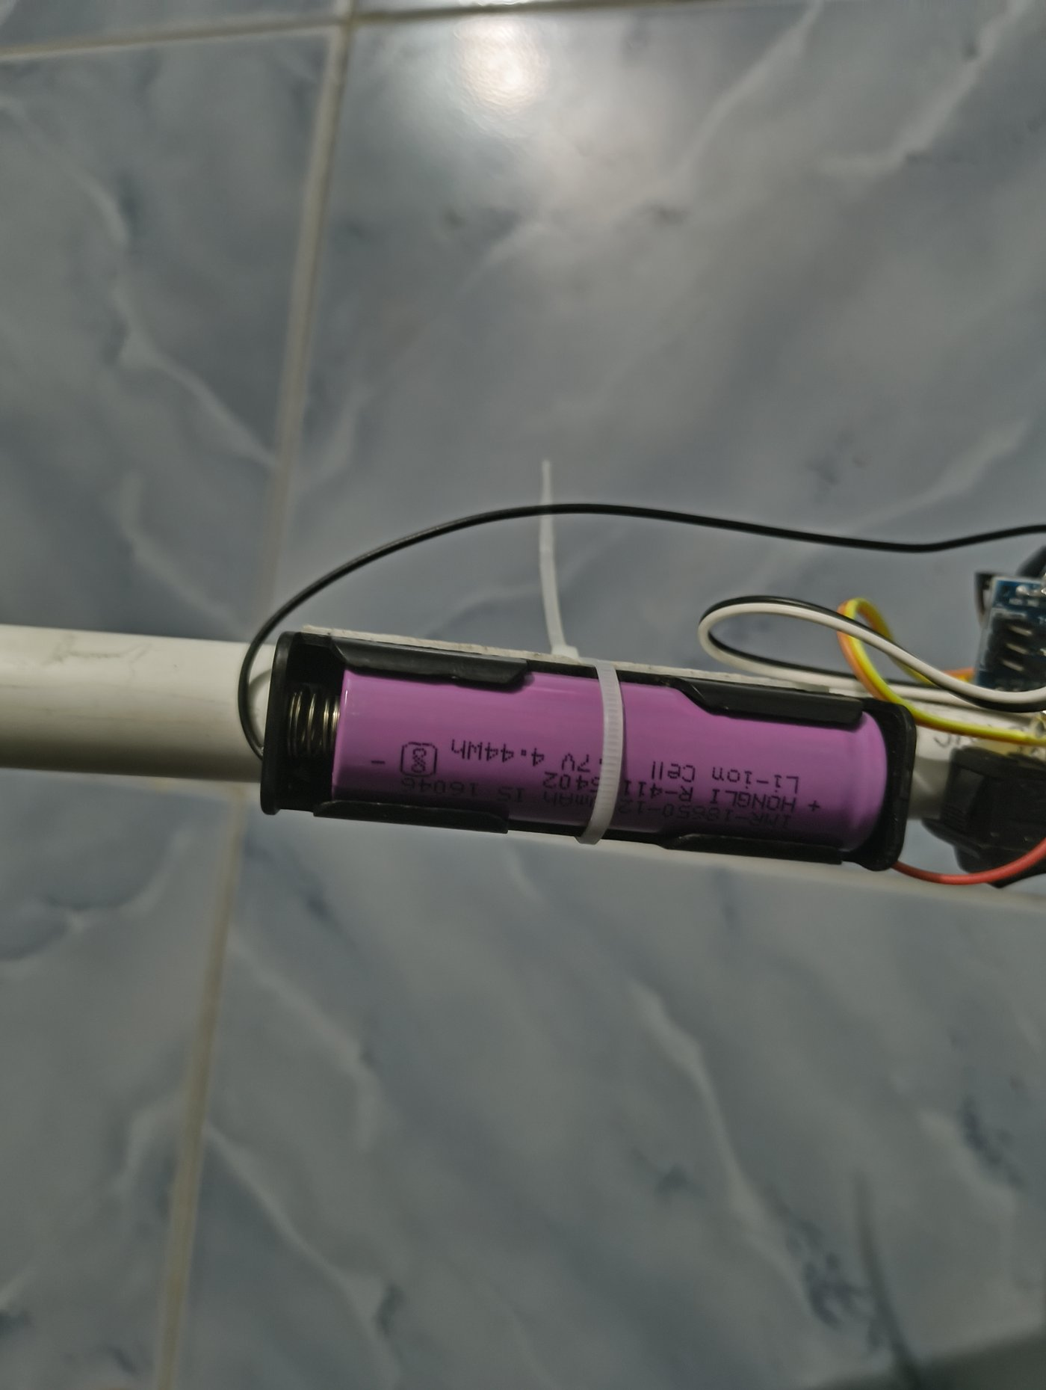
Figure 4. Photograph of the completed project. Top: LM393 module, HC-SR04 sensor and Arduino Nano with buzzer and switch mounted on the PVC cane. Bottom left: moisture probe at the tip. Bottom right: 18650 cell in its holder.

6. Conclusion
Summarise the project outcome using the following prompts:
- Objectives achieved: on battery power, the cane beeps when an obstacle comes within 50 cm, and the beep rate increases as the obstacle approaches (Objectives 1 and 2, checked by moving a hand or notebook toward the sensor while watching the distance on the Serial Monitor). The water alert (Objective 3) is implemented with priority over obstacle alerts; dry reading ≈ dry value, wet reading ≈ wet value, threshold set to value. The cane runs from a single 18650 cell with a rocker switch, and the cane hardware cost ₹876 (Objective 4).
- Challenges faced: the single 3.7 V cell feeds the 5V rail with no regulation, so readings can become unreliable as the cell discharges. The ultrasonic beam misses thin, soft and head-level obstacles. In the original code, a missed echo blocked the loop for up to 1 s (the default pulseIn() timeout); a 30 ms timeout fixed this. The moisture threshold must be calibrated for each probe.
- Improvements: add a 5 V boost converter, a TP4056 charging module and the 1 A fuse for stable, protected power. Average several distance readings and add temperature compensation for accuracy. Replace the resistive probe with a capacitive one to stop corrosion. Add a vibration motor (via the IRLZ44N MOSFET) for silent alerts that work in noise. Move the wiring onto a PCB inside a waterproof enclosure.
- Future scope: add extra ultrasonic sensors angled up (head-level obstacles) and down (steps and potholes), GPS with GSM or Bluetooth for an SOS message to family, a low-battery warning, and field trials with visually impaired users to tune the alert distance (for example 100–150 cm).
VisionGuard shows that an Arduino Nano, an ultrasonic sensor and a resistive moisture probe can turn a plain cane into a low-cost electronic travel aid. It warns about obstacles before contact, encodes distance in the beep rate, and gives priority warnings for water underfoot, all from a single rechargeable cell. The prototype meets its core sensing and alerting objectives in bench tests. The main improvements identified are regulated, protected power, haptic feedback and wider sensing coverage, which together would make the cane ready for real-world trials.

7. References
List every source used, including textbooks, research papers, datasheets, official documentation, websites, and software libraries. Use one consistent citation style (IEEE or APA).
[1] Elecfreaks, “Ultrasonic Ranging Module HC-SR04,” datasheet, 2011. [Online]. Available: https://cdn.sparkfun.com/datasheets/Sensors/Proximity/HCSR04.pdf
[2] Microchip Technology, “ATmega48A/PA/88A/PA/168A/PA/328/P megaAVR Data Sheet,” DS40002061, 2020.
[3] Arduino, “Arduino Nano,” Arduino Documentation. [Online]. Available: https://docs.arduino.cc/hardware/nano
[4] Arduino, “Language Reference: pulseIn(), analogRead(), map(), constrain(),” Arduino Documentation. [Online]. Available: https://www.arduino.cc/reference/en/
[5] Texas Instruments, “LMx93-N Low-Power, Low-Offset Voltage, Dual Comparators,” datasheet. [Online]. Available: https://www.ti.com/product/LM393
[6] World Health Organization, “World Report on Vision,” Geneva, 2019.

