**REPORT**

**ON**

**THE TASTY KITCHEN RESTAURANT WEBSITE**

By,

DARSHAN R

ADICHUNCHANAGIRI INSTITUTE OF TECHNOLOGY,

CHIKMAGALUR

OVERVIEW

The project ‘THE TASTY KITCHEN’ is a restaurant website made using HTML and CSS for customer to get to know about the restaurant.

GOALS

* Landing page for the restaurant.
* To provide the information about the restaurant.
* To provide the recipe menu list and services provided by the restaurant.
* Directing the website visitors to order the food in food ordering website like zomato.
* Making the website visitors to follow the social media page of the restaurant.

SPECIFICATIONS

* We added a logo and navigation bar items for easy use of the website.
* Added the picture with details of the recipes and the information services provided by restaurant.
* People can use Contact Us form to give feedback or for any queries.

TOOLS

* HTML
* CSS
* VS CODE
* GOOGLE FONTS

FILE STRUCTURE

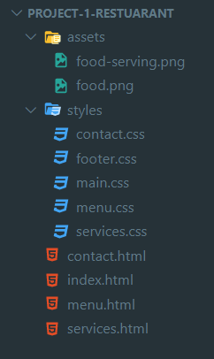

SOURCE CODE

HTML

index.html

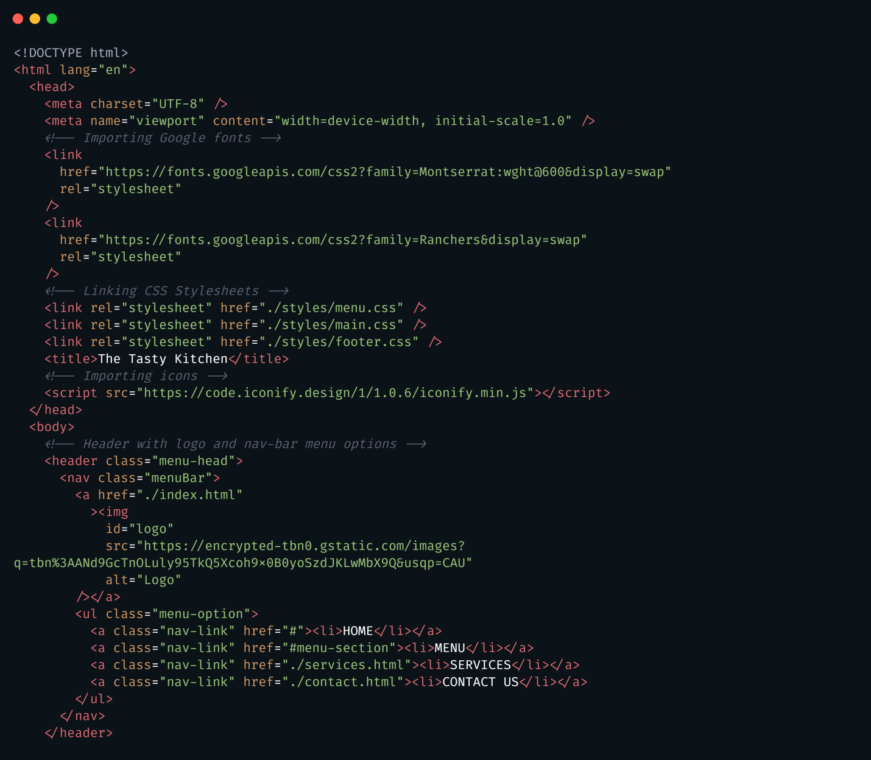

index.html [continue…]