**Assignment 3 Submission Report**

Git Repository Link:- [Github Link](https://github.com/darshanrana023/Python_Project)

**1. Project Setup:**

* Open a terminal or command prompt and navigate to the directory where you want to create your project.
* Initialize a new Git repository with the command: `git init`
* Create your Python project files.
* Commit your changes using:
* git add . (to stage all changes)
* git commit -m "Initial commit"
* Create a new repository on GitHub.
* Link your local repository to the remote GitHub repository:
* git remote add origin “GitHub repository URL”
* git branch -M main
* git push -origin main

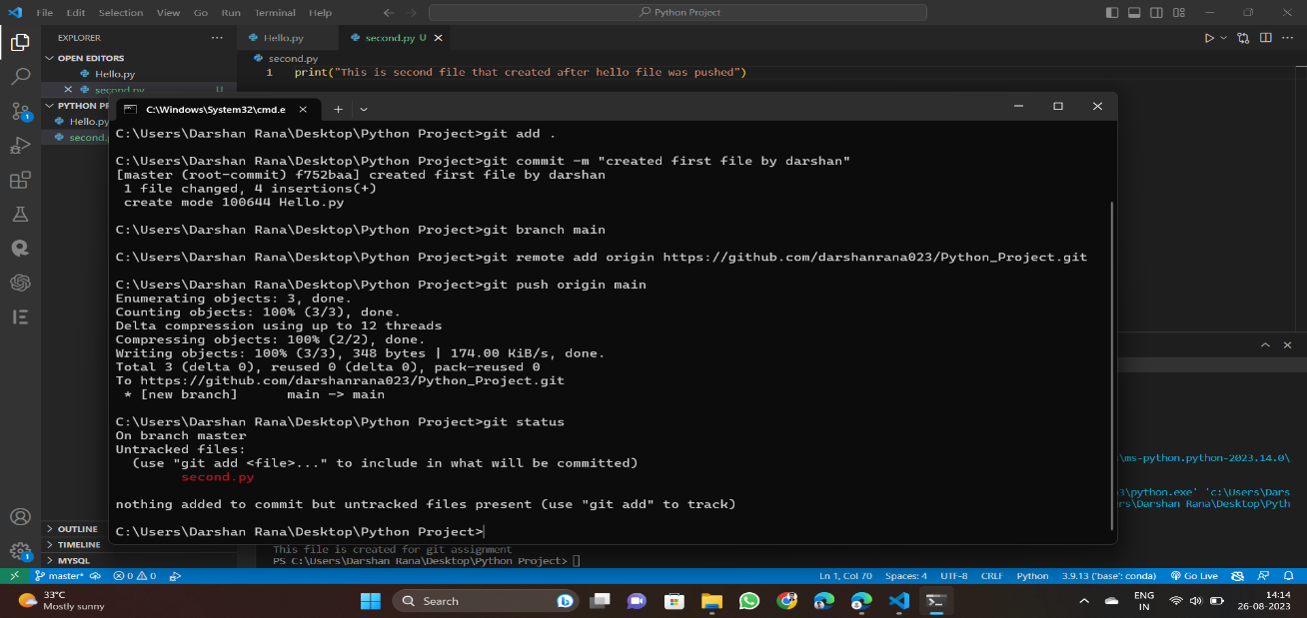

2. Branching and Development:

* Create a new branch for a feature:
* git checkout feature
* Develop your feature and commit changes:
* git add .
* git commit -m "Implement feature: your feature description"

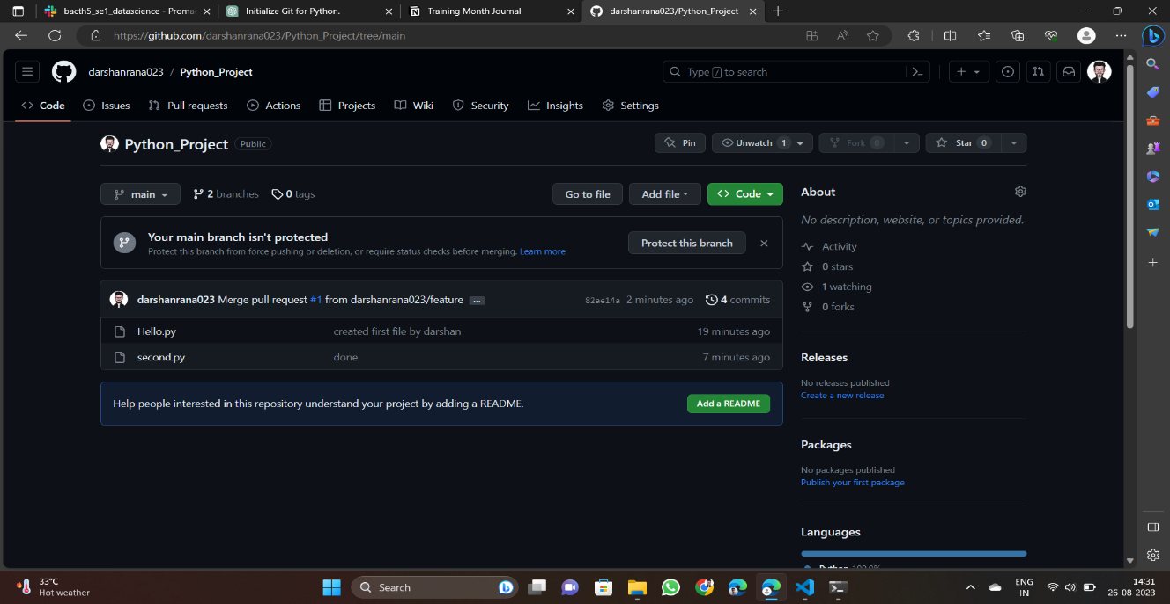

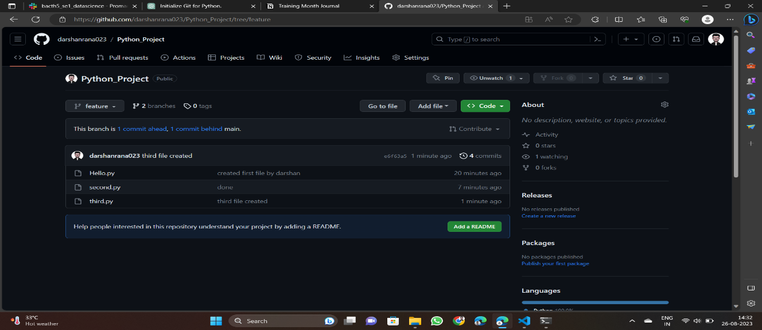

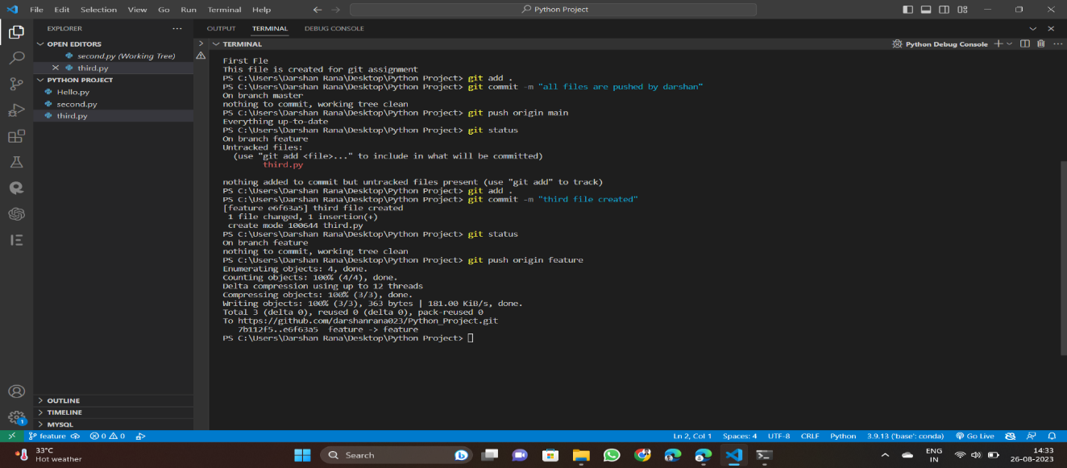

**3. Collaboration Simulation**:

* Peer should clone the repository:
* git clone <GitHub repository URL>
* Peer creates a new branch, makes changes, and commits:
* git checkout -b feature/peer-feature
* Peer pushes changes to their branch:
* git push origin feature/peer-feature
* Create a pull request on GitHub. Review, comment, and merge the pull request.

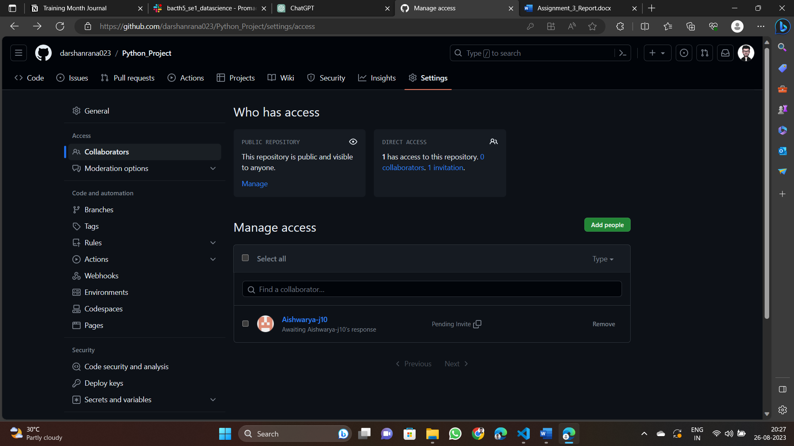

**4. Handling Merge Conflicts:**

* Introduce a merge conflict by editing the same lines in the same file on different branches.
* Commit changes on one branch.
* Attempt to merge the other branch:
* git checkout main
* git merge feature/other-branch
* Resolve the conflict by editing the conflicted file. Then:
* git add .
* git commit -m "Resolve merge conflict"

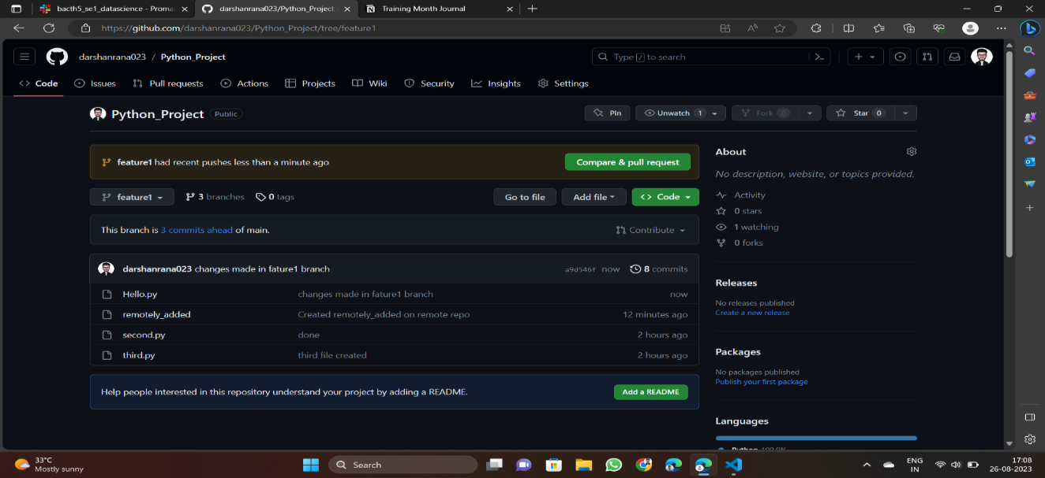

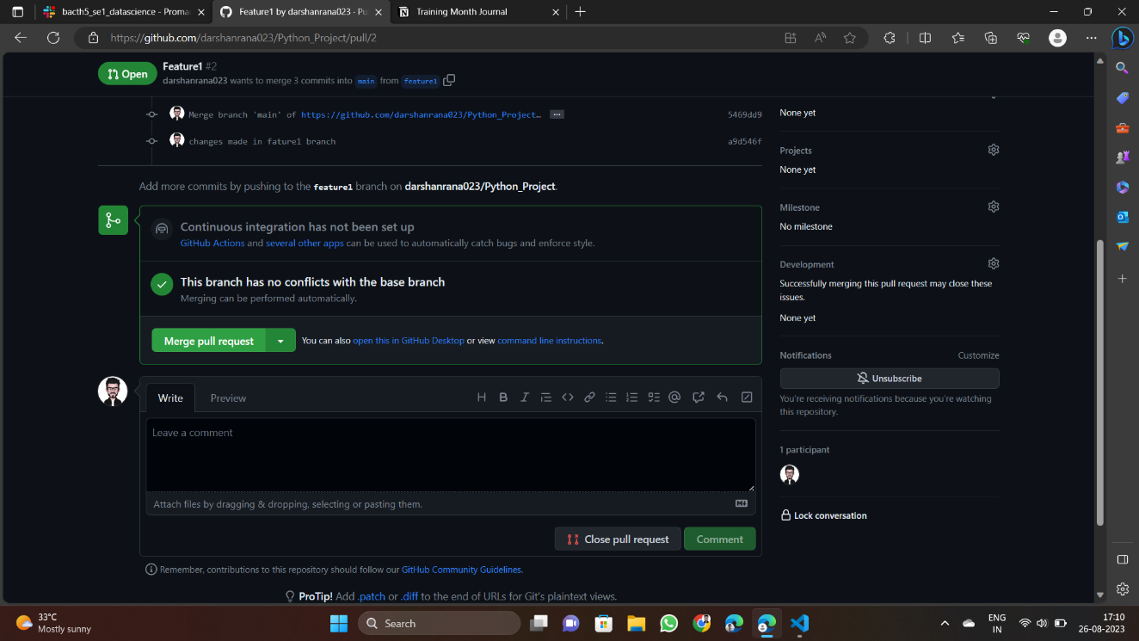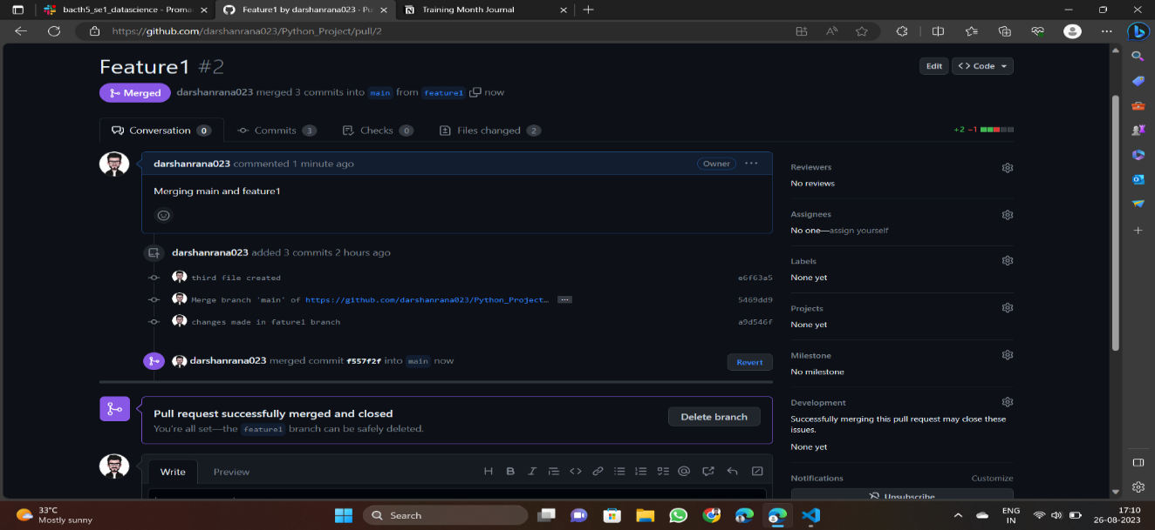

**5. Rebasing and History Cleanup:**

* Create a new branch and make several commits.
* Rebase the branch interactively:
* git checkout feature/rebase-branch
* git rebase -i HEAD~<number of commits>

* Squash, reword, or rearrange commits in the interactive rebase menu.
* Merge the branch back to main using a fast-forward merge:
* git checkout main
* git merge feature/rebase-branch

