CS 6650 — Homework 10

Replicated key–value stores (Leader–Follower & Leaderless)
AI / tooling disclosure: Implementation, infrastructure (Docker, Terraform, ECR/EC2), load-test automation, plotting, and this report document were produced with assistance from an AI coding agent. All measurements below were produced by running the provided load tests against your deployed cluster; align wording with the instructor’s disclosure policy.

Experimental setup & raw summary
Cloud load tests (50s each, 8 workers) vs terraform Elastic IP. LF quorum switched on EC2 via SSM (scripts/aws_ec2_set_lf_quorum.sh); full sweep: scripts/aws_loadtest_cloud_all_lf.sh
EIP: terraform output -raw kv_public_ip (this run: 35.174.237.75)
Leader–follower w5r1: 1421 / 1221 / 536 / 319 ops @ w 0.01,0.1,0.5,0.9 — stale 0
Leader–follower w1r5: 843 / 1538 / 1825 / 2160 ops — stale 0
Leader–follower r3w3: 1273 / 1259 / 797 / 549 ops — stale 0
Leaderless: 1841 / 1223 / 524 / 304 ops — stale 6, 4, 0, 0 (writes 1%, 10%, 50%, 90%)
Manual / no SSM: REMOTE_UPDATE=0 PROMPT_BETWEEN_PROFILES=1 ./scripts/aws_loadtest_cloud_all_lf.sh
Plots: ./scripts/plot_results_dir.sh results/aws results/aws/figs
Report draft: results/aws/WRITEUP_SNIPPETS.txt

Analysis (edit as needed)

Setup (one sentence)
- Five-node leader–follower and five-node leaderless stacks on one EC2 host behind an Elastic IP; load generators ran from a laptop against public HTTP ports; LF quorum was switched across w5r1 / w1r5 / r3w3 via SSM editing docker-compose on the instance.

Throughput vs write fraction (leader–follower)
- w5r1 (W=5,R=1): throughput drops sharply as write ratio rises (1421 → 319 ops in 50s) because every write pays for synchronized replication to all followers before ack.
- w1r5 (W=1,R=5): reads dominate cost (parallel fan-out + simulated fetch delay); writes return quickly after the leader commit, so at high write ratios aggregate ops can exceed w5r1 (2160 ops at 90% writes vs 319 for w5r1).
- r3w3: sits between the extremes; writes are cheaper than w5r1 but reads still do a three-way merge, so curves reflect a balanced quorum.

Staleness
- Leader–follower: 0 stale reads in this AWS run for all three profiles and all write ratios—reads go through the leader’s quorum/merge path as implemented.
- Leaderless: R=1 local reads allow temporary lag behind the writer’s replica; observed stale reads at low write mix (6 at 1% writes, 4 at 10%) when reads are frequent relative to completed replication; 0 stale at 50% and 90% writes where the workload behaves more write-heavy or replication catches up within the client’s hot-key window.

Figures
- Histograms: results/aws/figs/*-{read-latency,write-latency,rw-interval}.png (and local results/figs for laptop Docker if you compare environments).

Histograms (AWS, 50s × 8 workers)
Generated by scripts/plot_loadtest.py via scripts/plot_results_dir.sh. Each file: read latency, write latency, time since last write to same key.
lf-r3w3-w0.01-read-latency.png
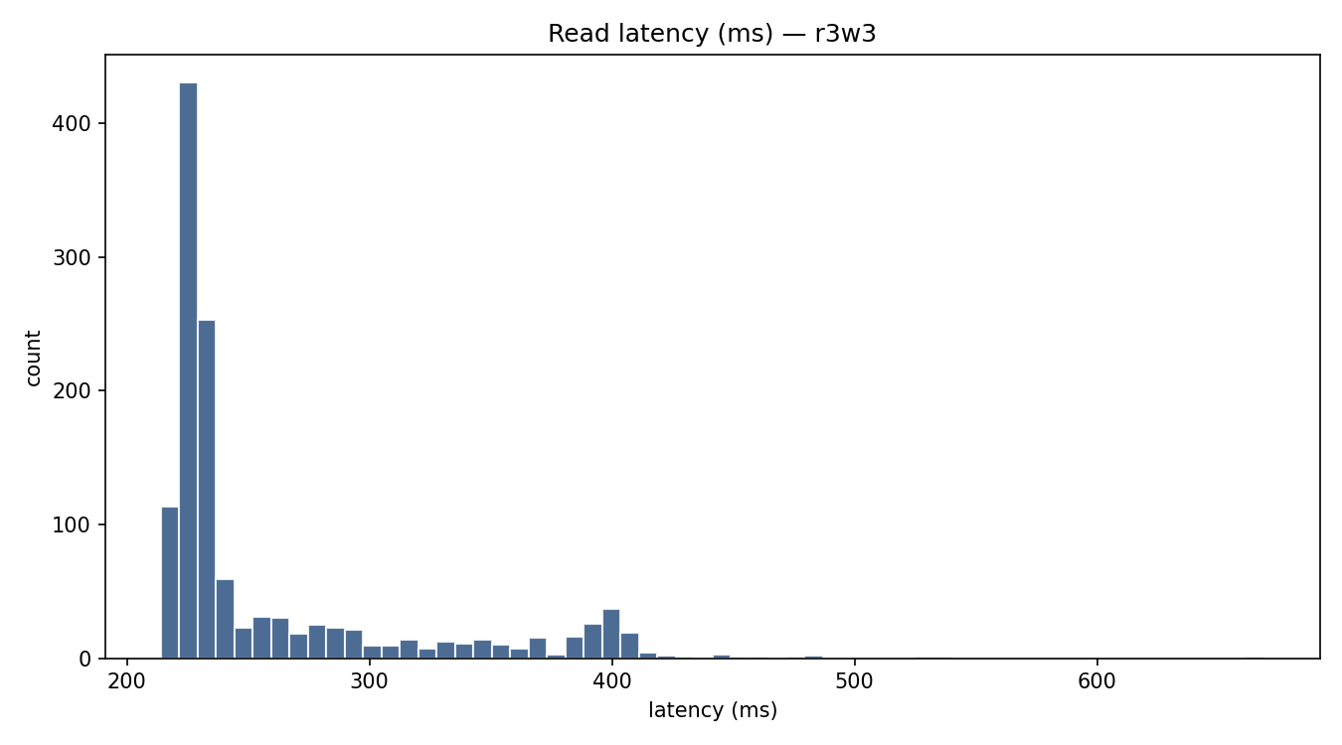
lf-r3w3-w0.01-rw-interval.png
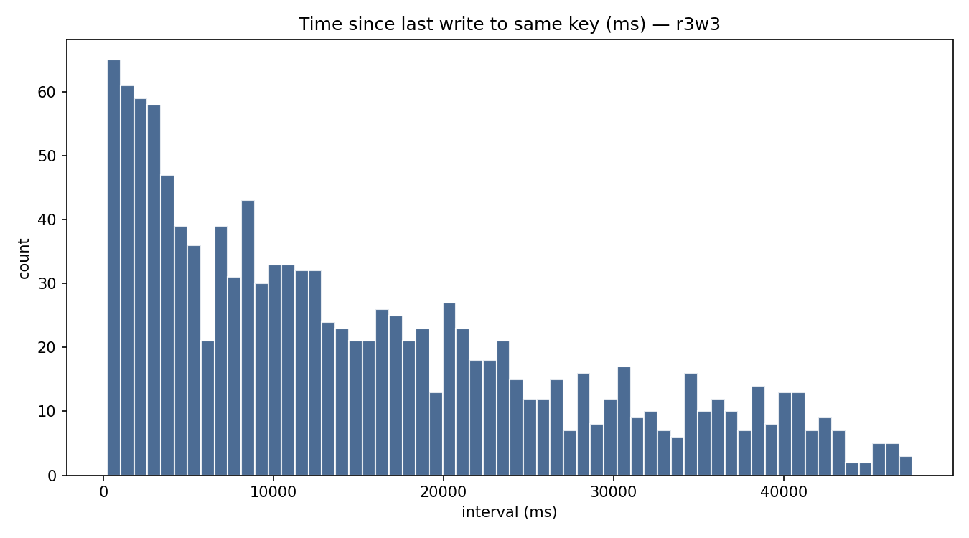
lf-r3w3-w0.01-write-latency.png
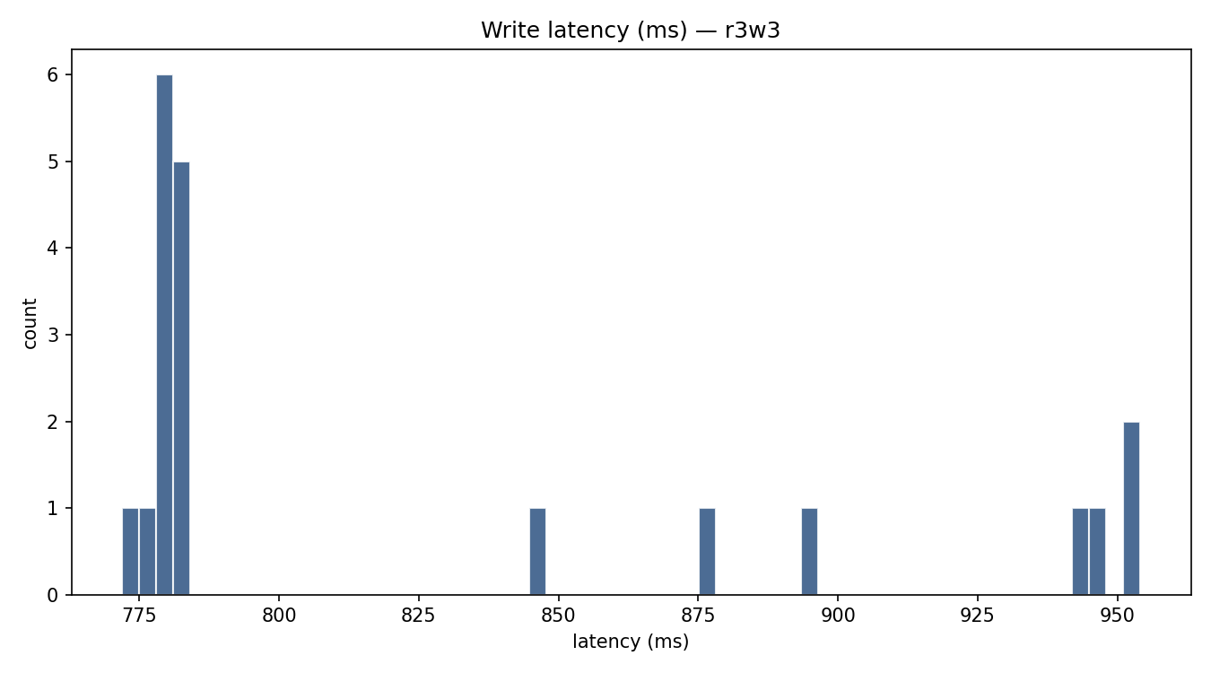
lf-r3w3-w0.1-read-latency.png
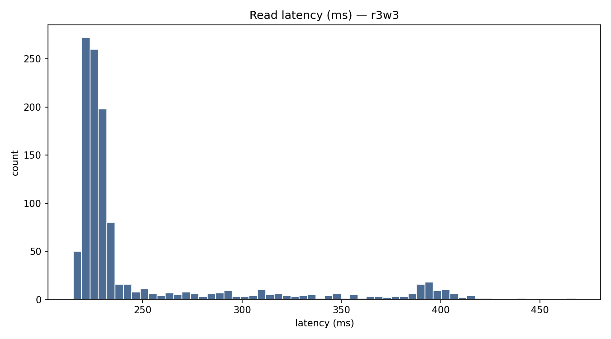
lf-r3w3-w0.1-rw-interval.png
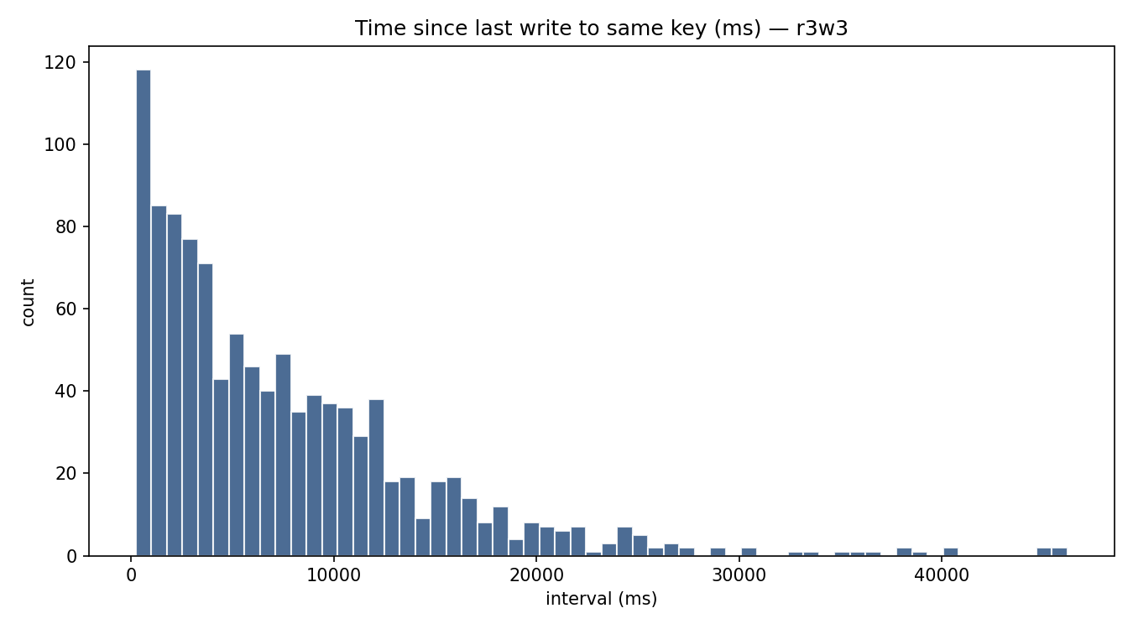
lf-r3w3-w0.1-write-latency.png
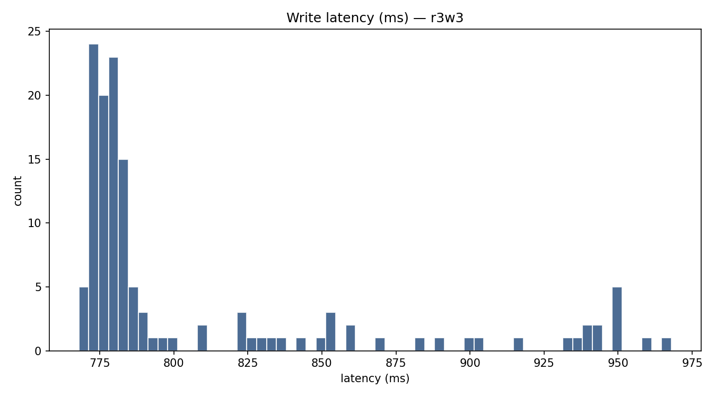
lf-r3w3-w0.5-read-latency.png
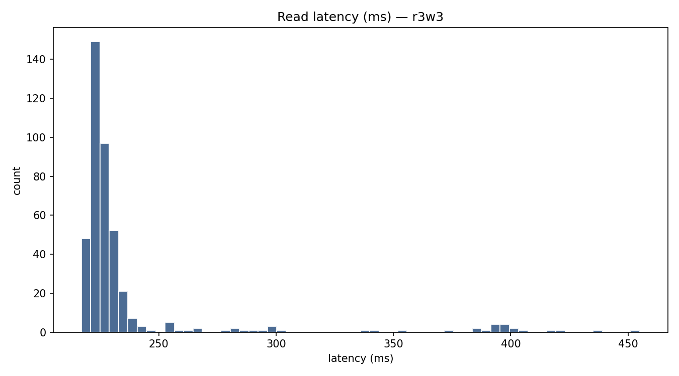
lf-r3w3-w0.5-rw-interval.png
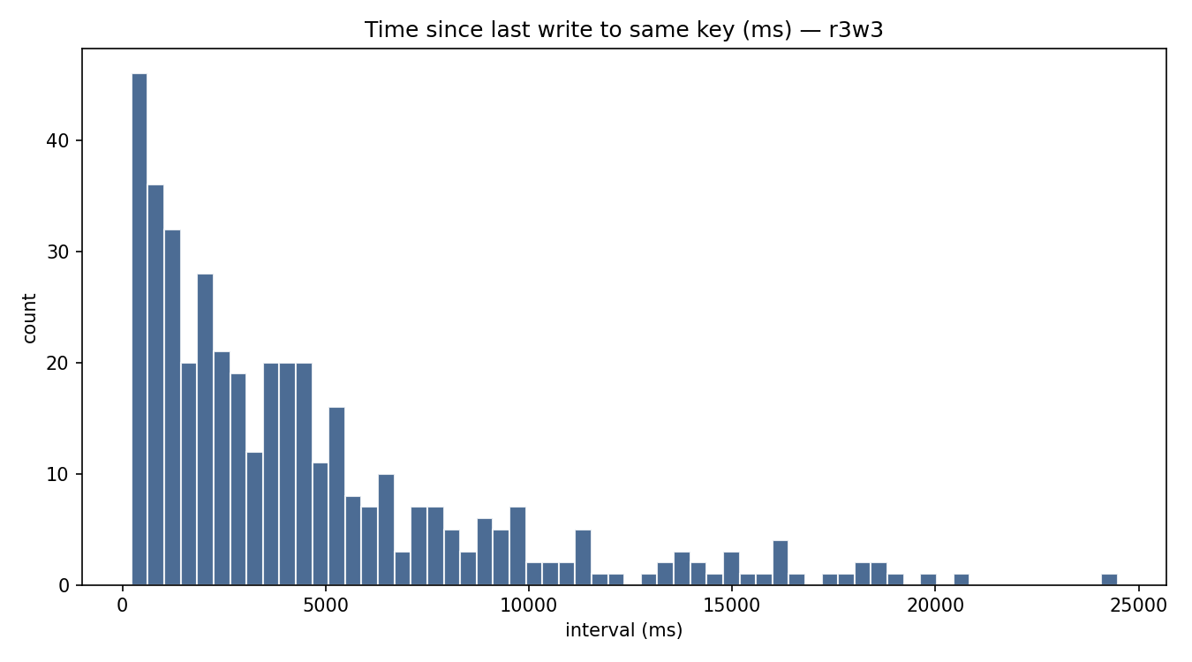
lf-r3w3-w0.5-write-latency.png
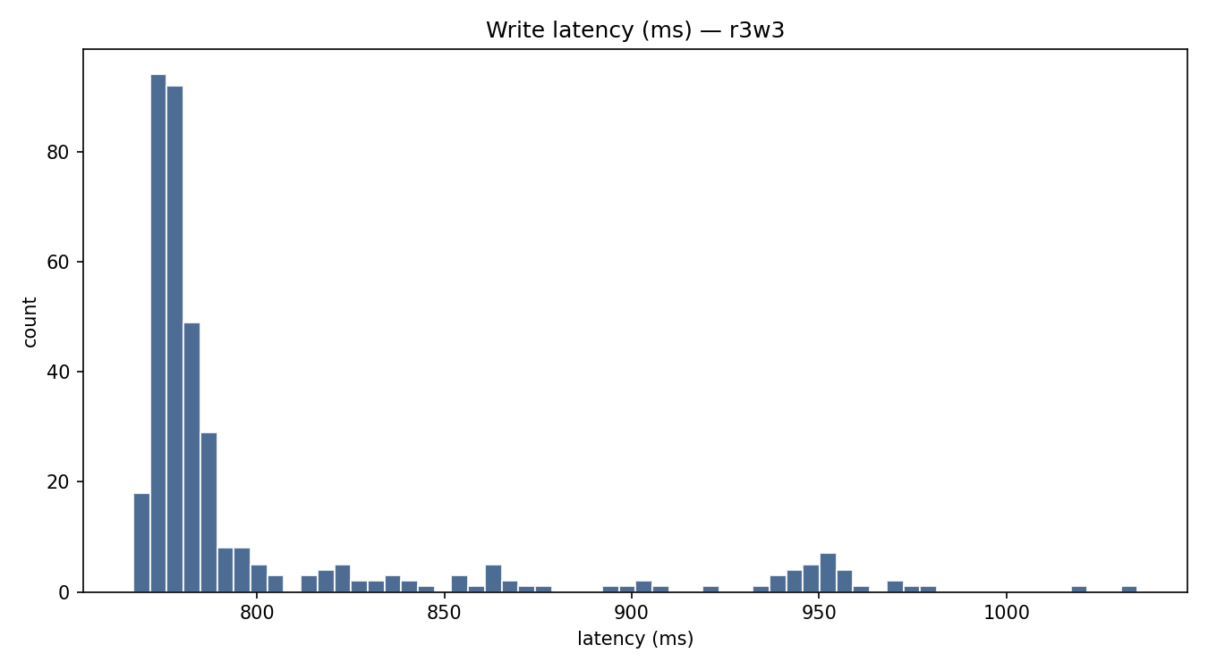
lf-r3w3-w0.9-read-latency.png
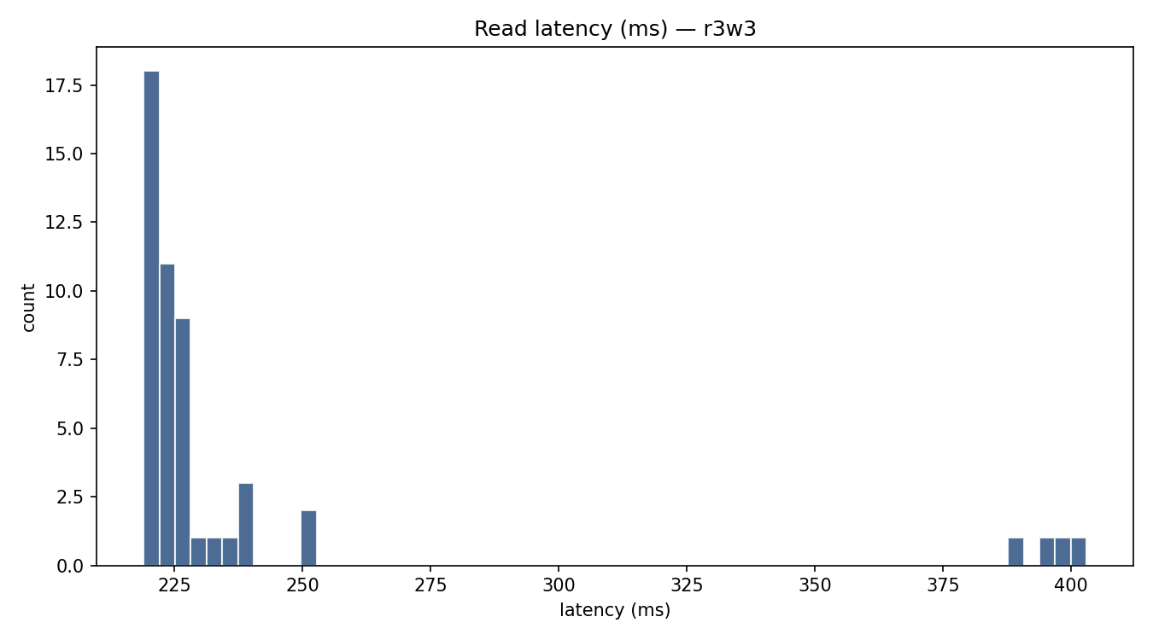
lf-r3w3-w0.9-rw-interval.png
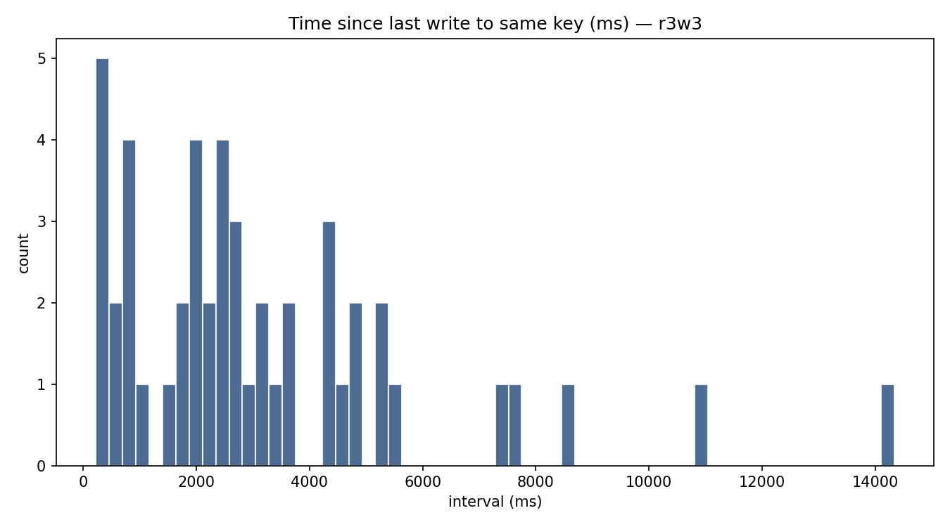
lf-r3w3-w0.9-write-latency.png
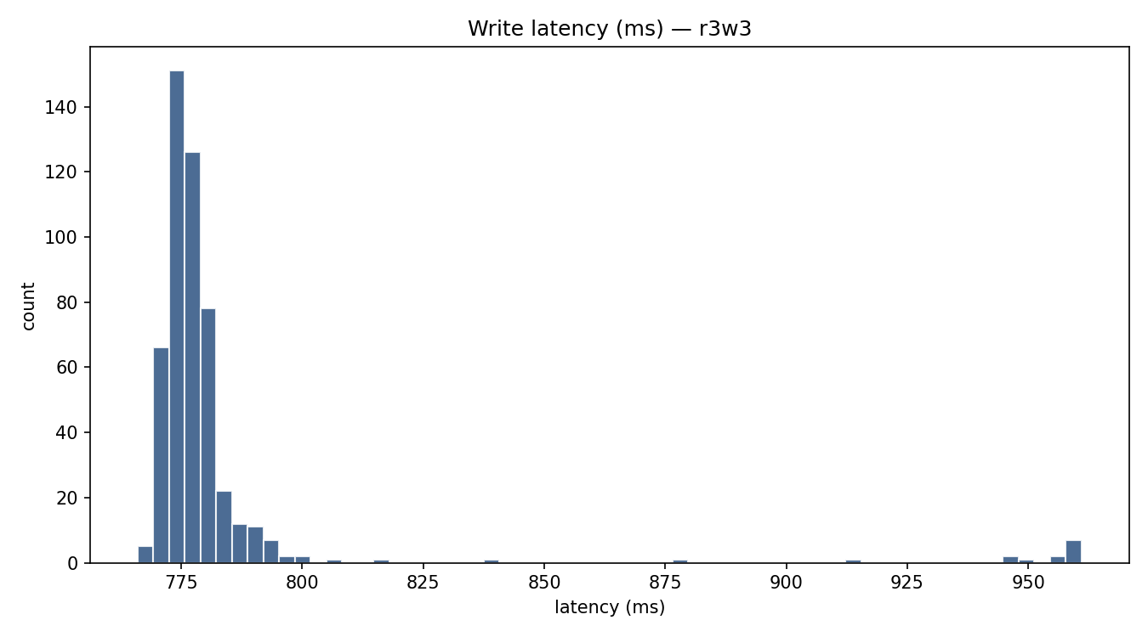
lf-w1r5-w0.01-read-latency.png
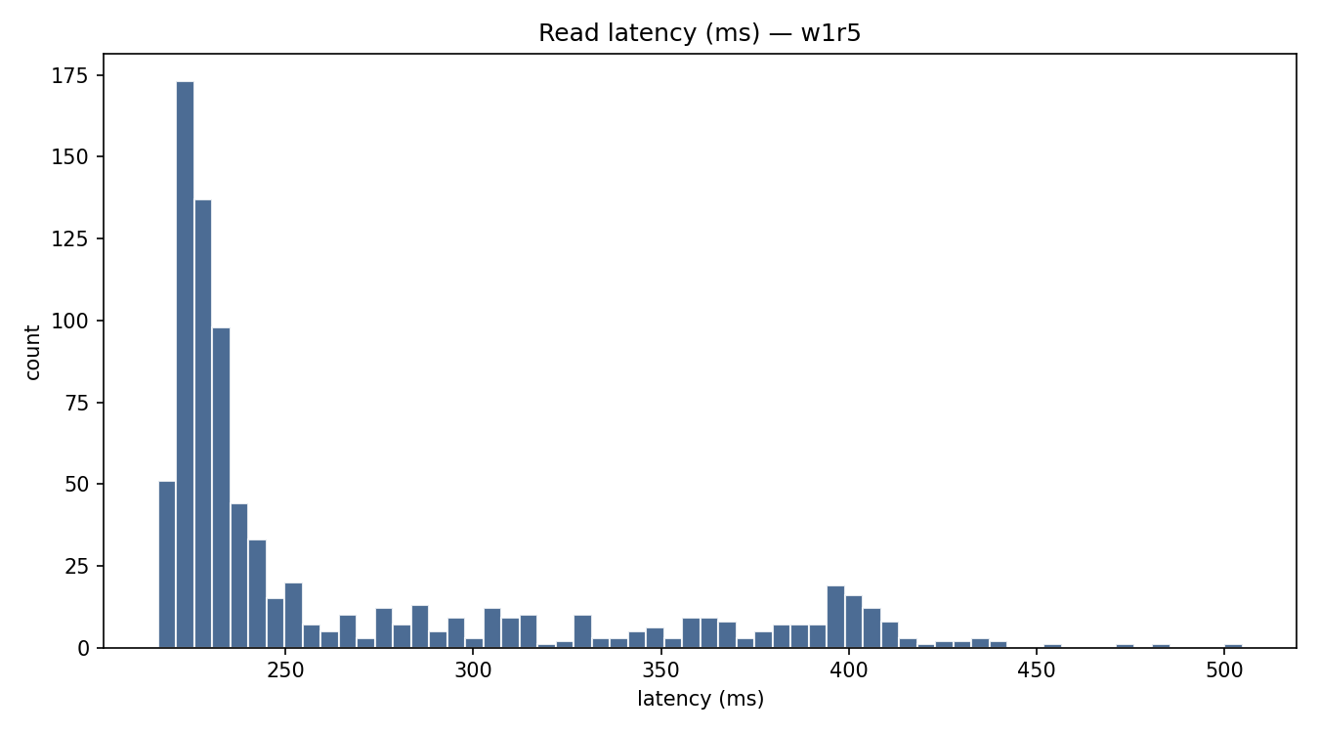
lf-w1r5-w0.01-rw-interval.png
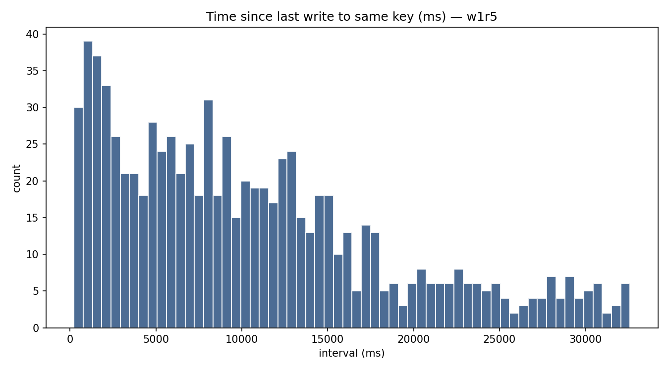
lf-w1r5-w0.01-write-latency.png
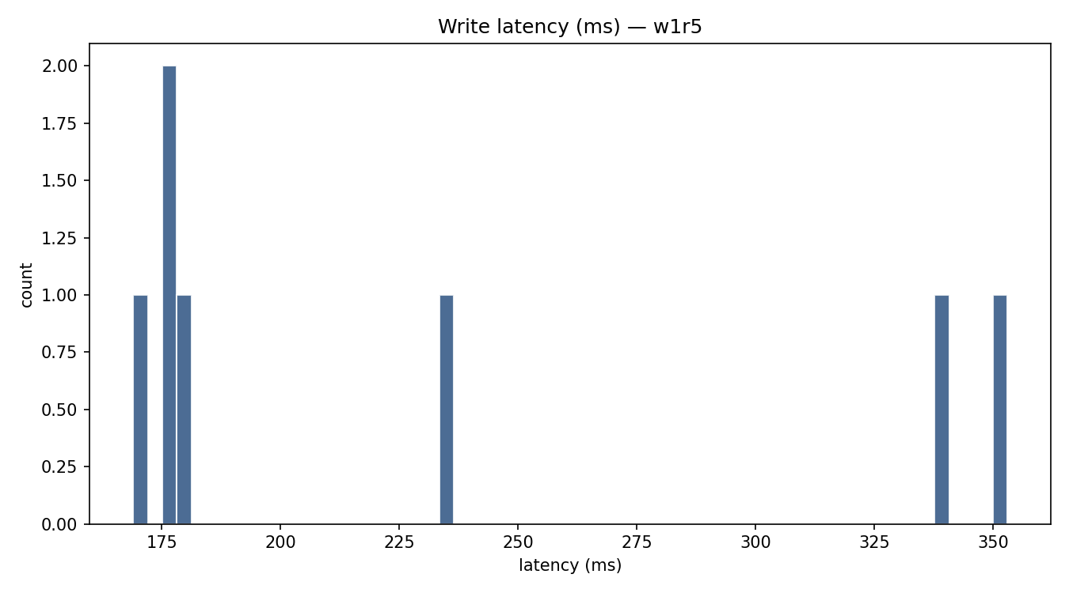
lf-w1r5-w0.1-read-latency.png
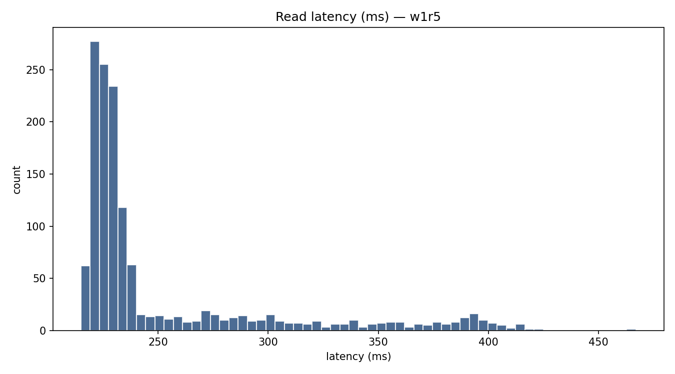
lf-w1r5-w0.1-rw-interval.png
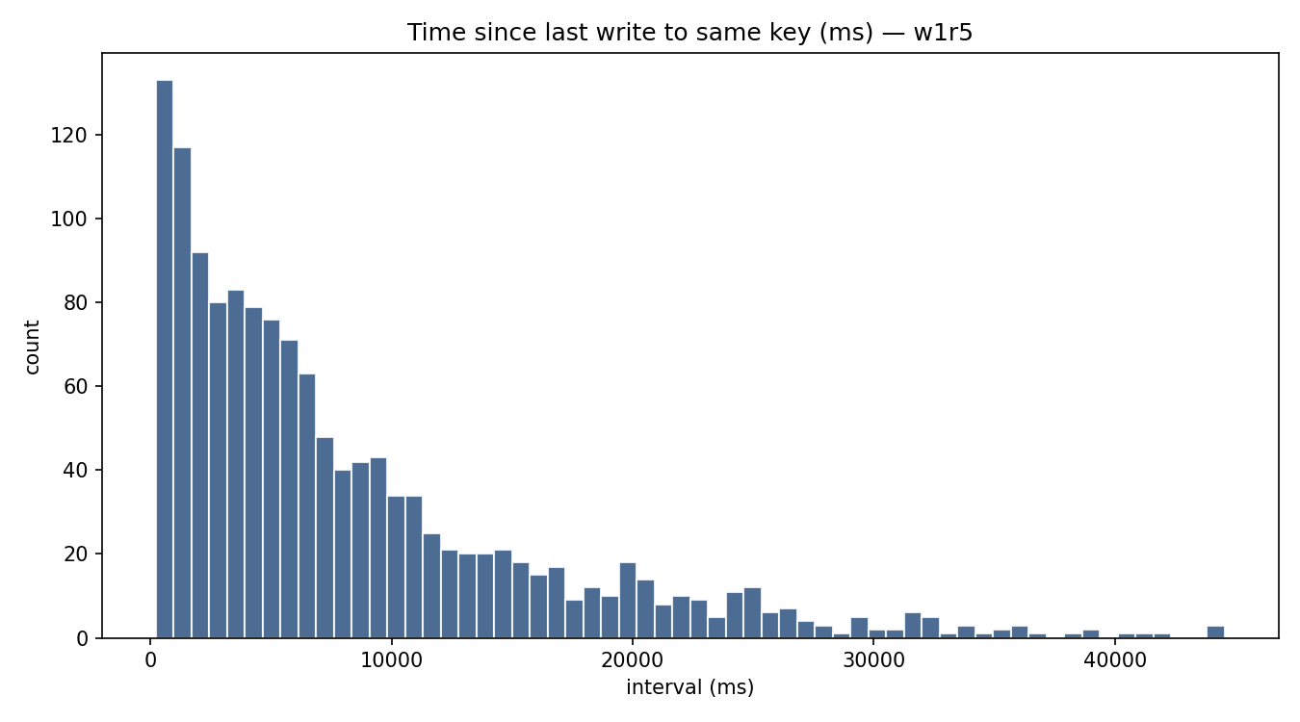
lf-w1r5-w0.1-write-latency.png
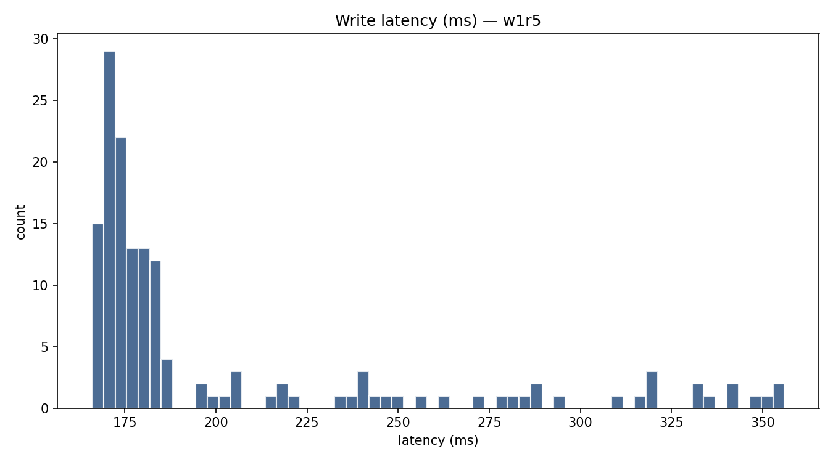
lf-w1r5-w0.5-read-latency.png
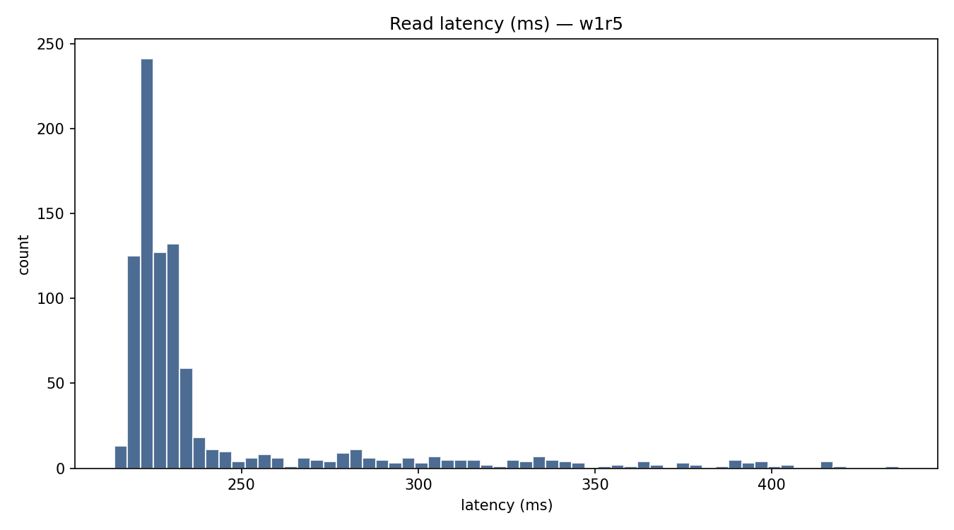
lf-w1r5-w0.5-rw-interval.png
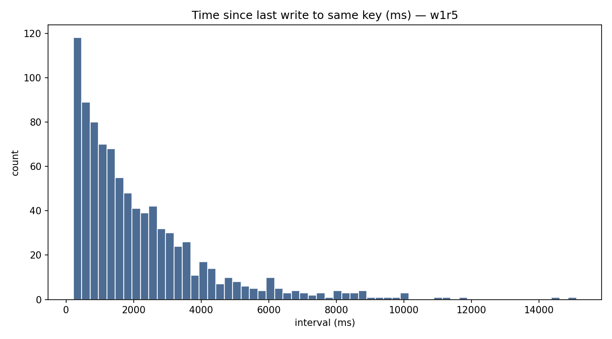
lf-w1r5-w0.5-write-latency.png
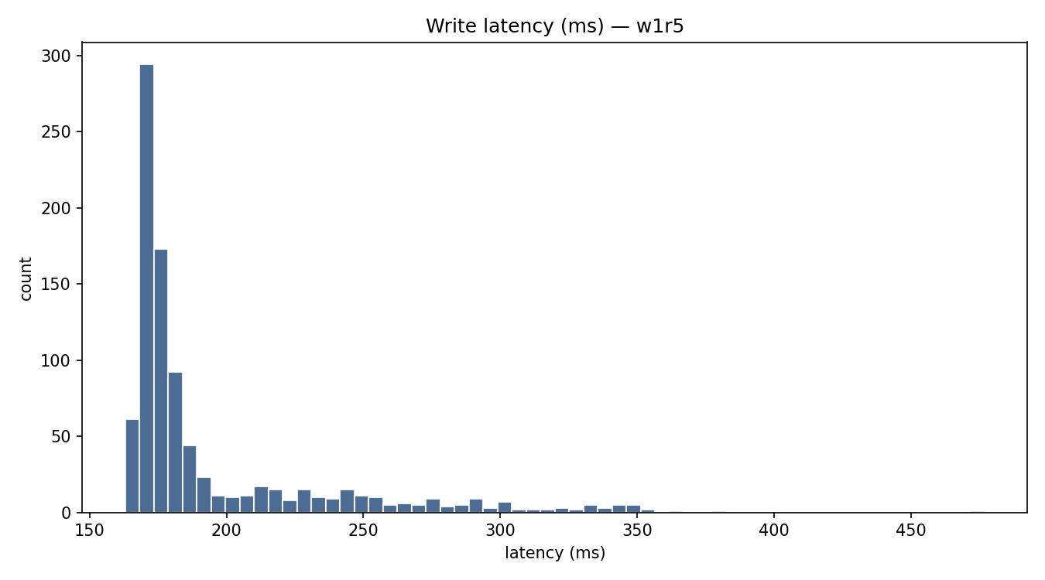
lf-w1r5-w0.9-read-latency.png
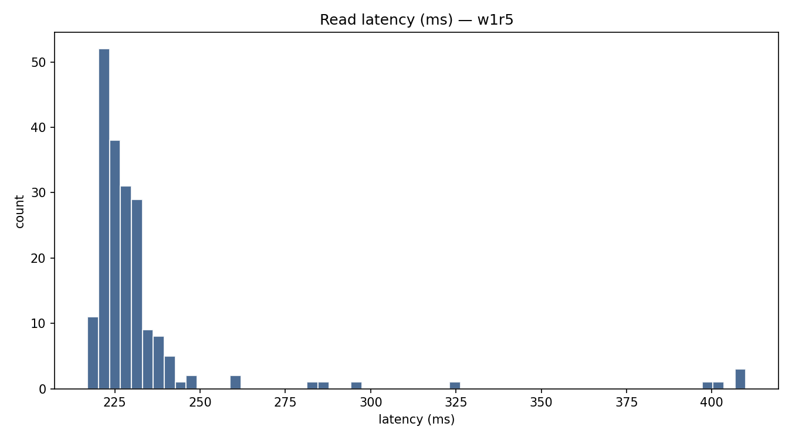
lf-w1r5-w0.9-rw-interval.png
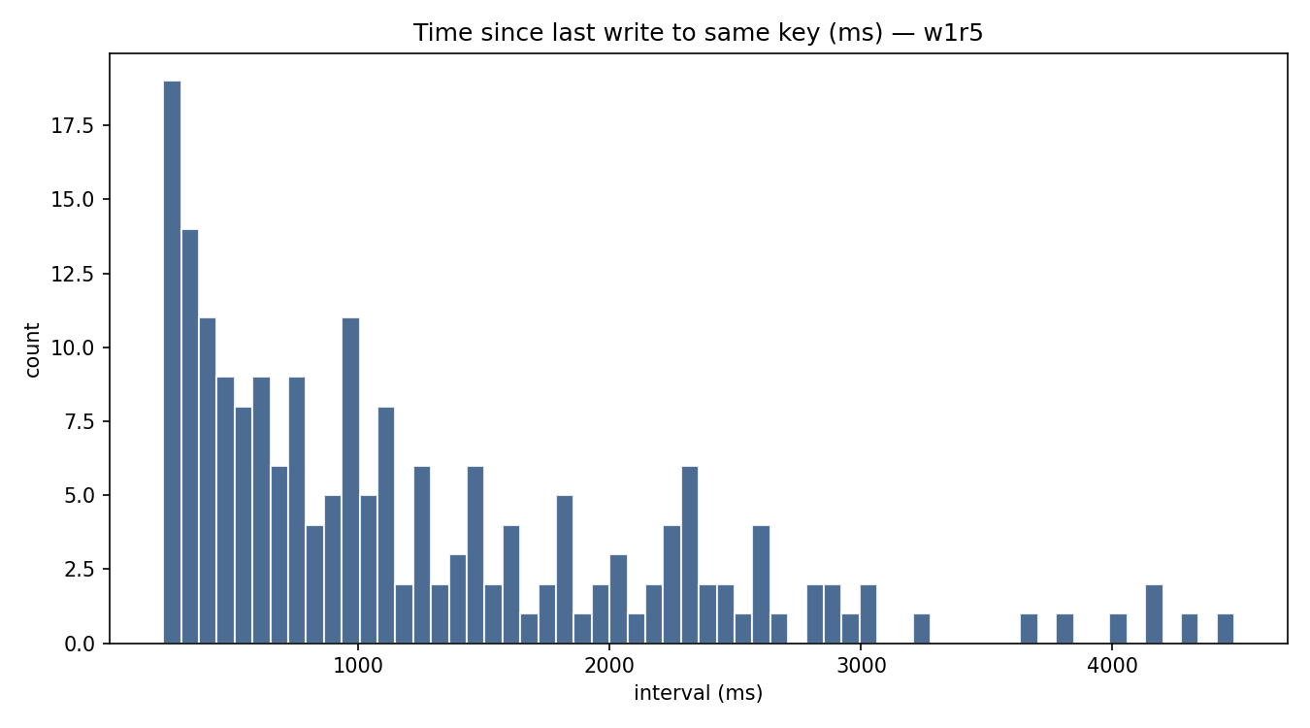
lf-w1r5-w0.9-write-latency.png
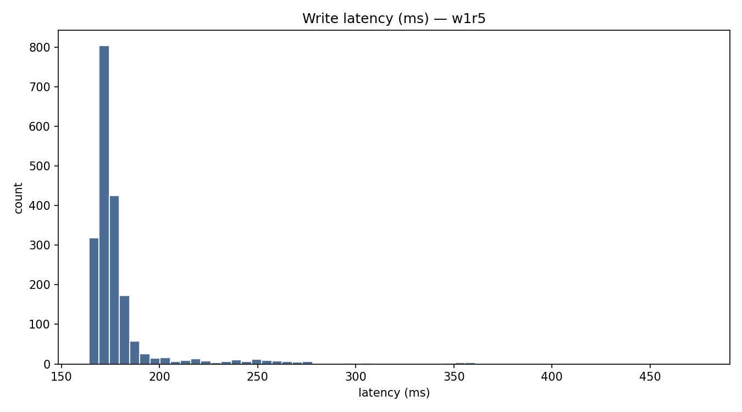
lf-w5r1-w0.01-read-latency.png
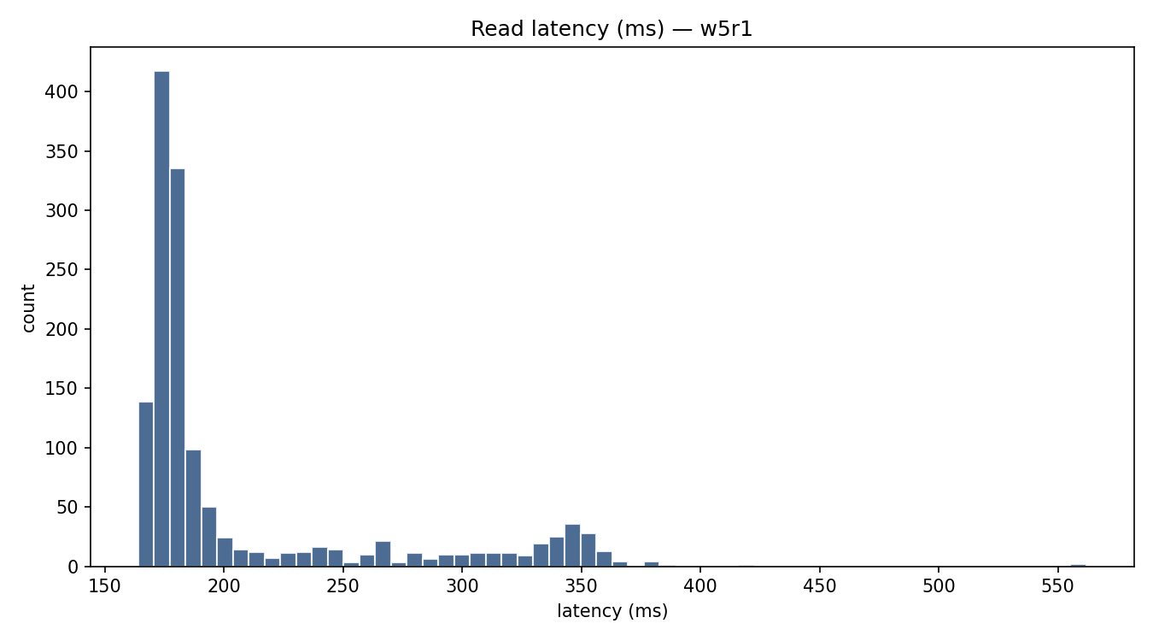
lf-w5r1-w0.01-rw-interval.png
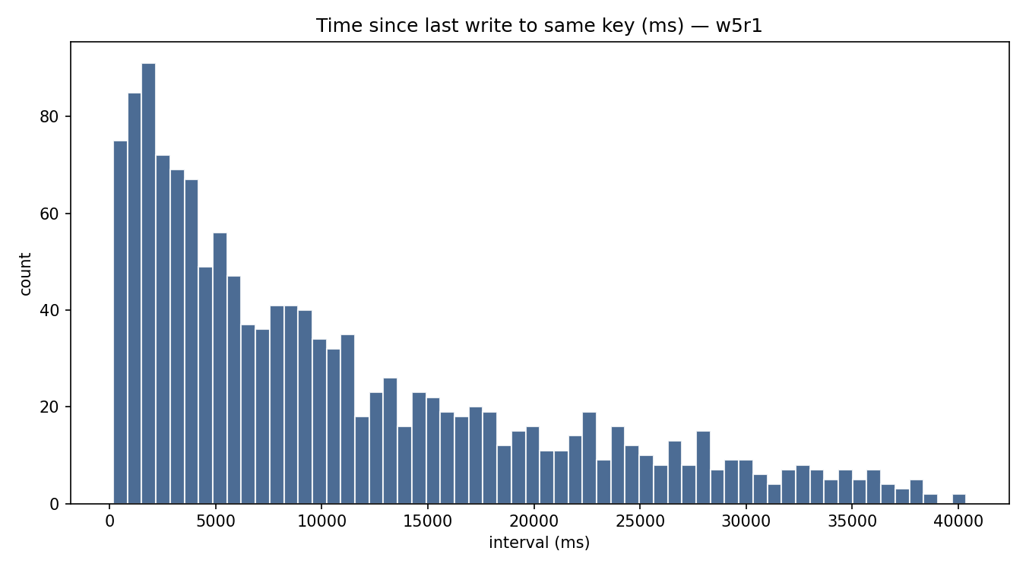
lf-w5r1-w0.01-write-latency.png
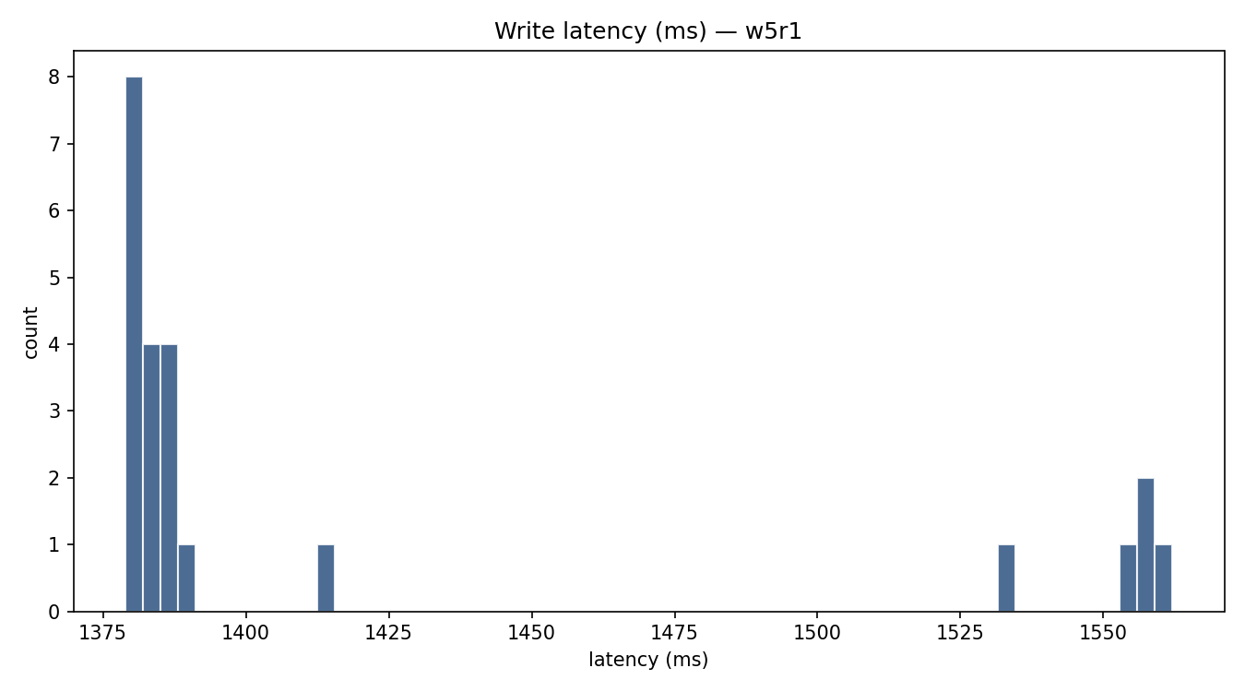
lf-w5r1-w0.1-read-latency.png
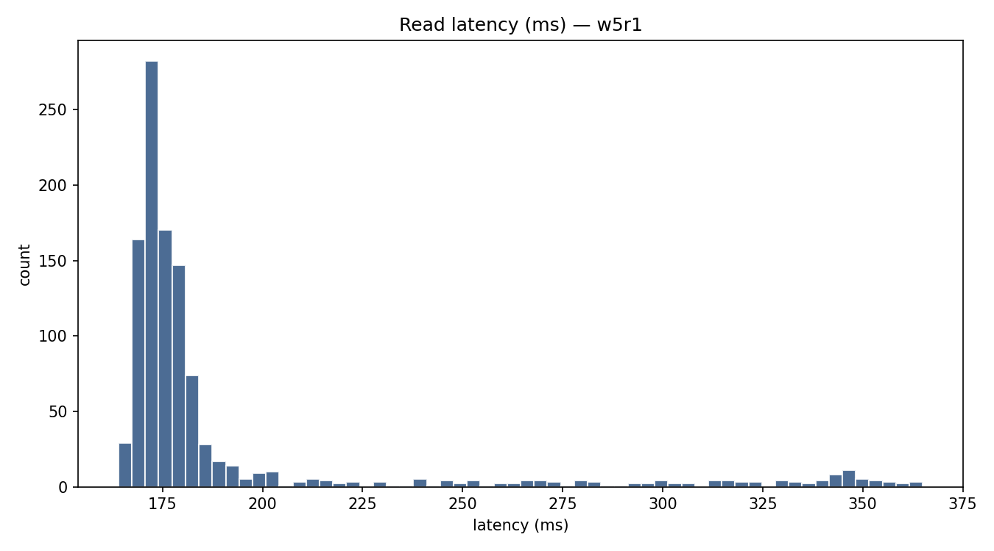
lf-w5r1-w0.1-rw-interval.png
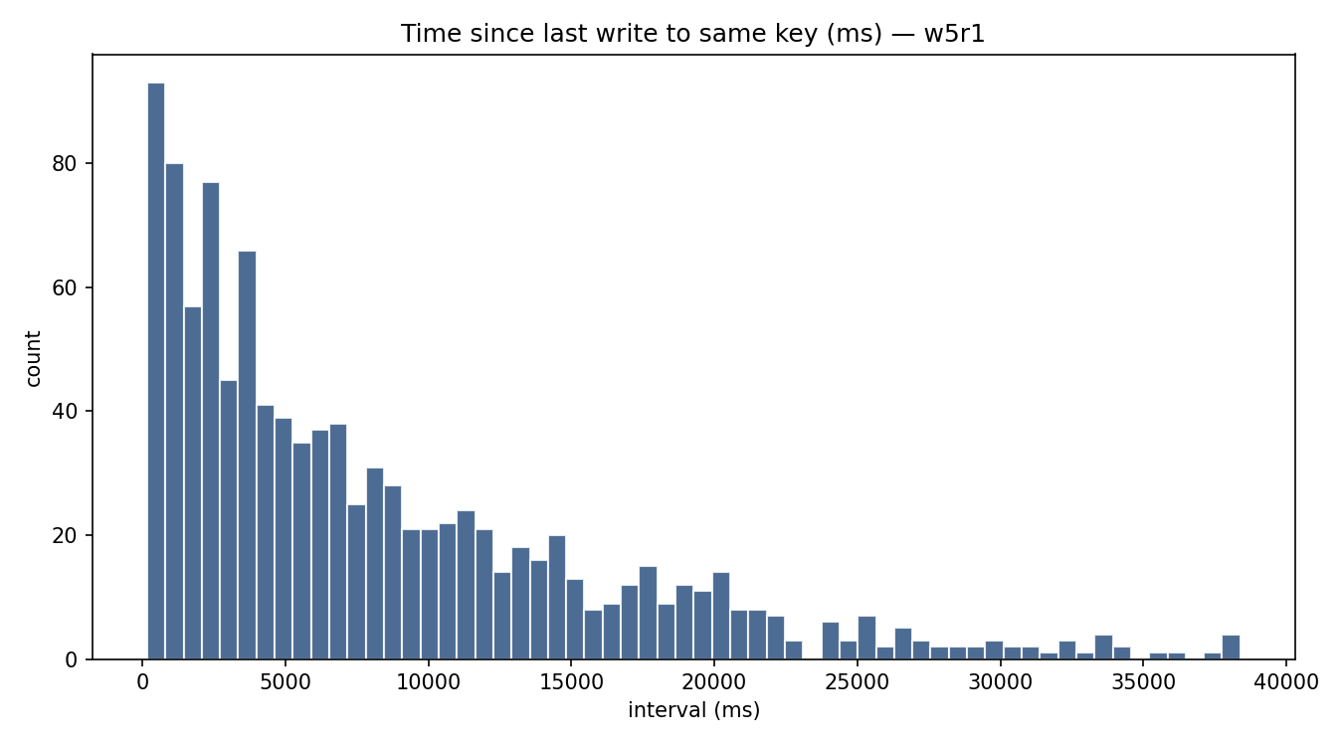
lf-w5r1-w0.1-write-latency.png
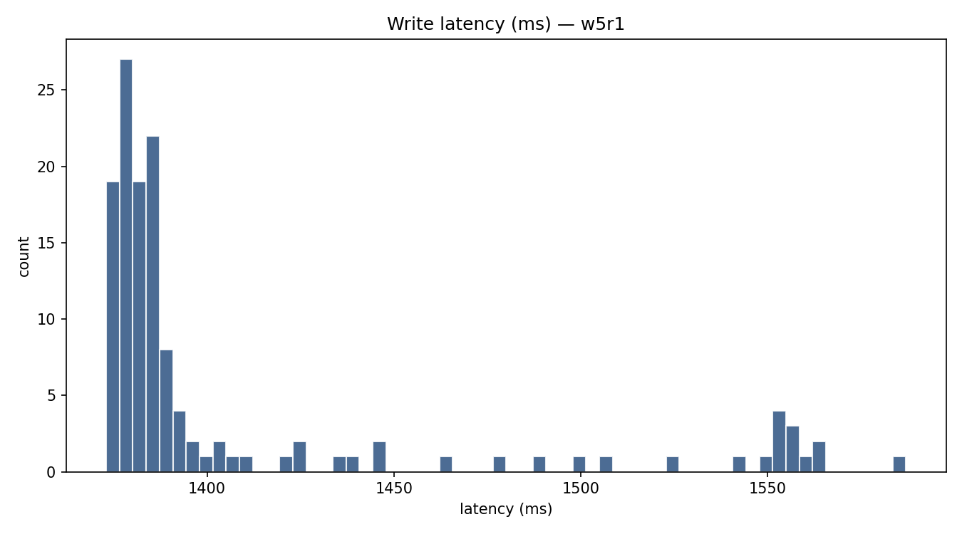
lf-w5r1-w0.5-read-latency.png
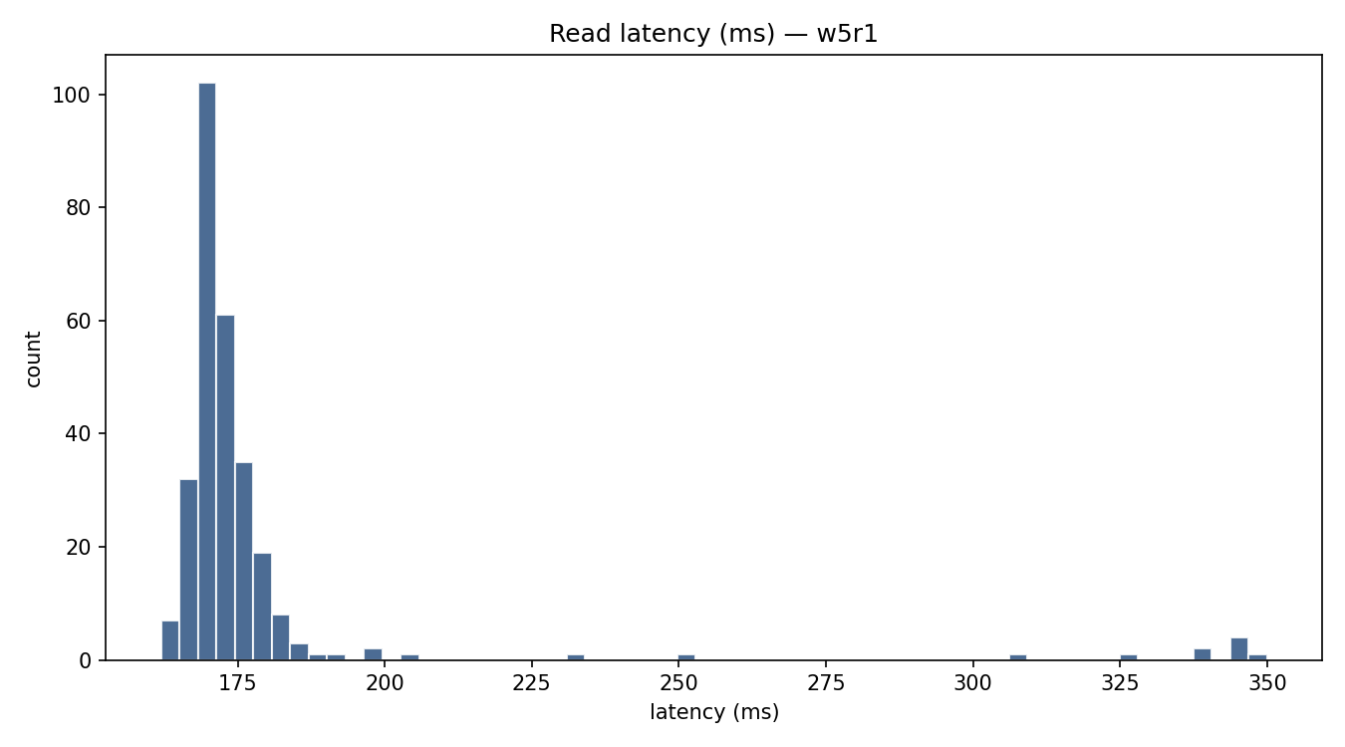
lf-w5r1-w0.5-rw-interval.png
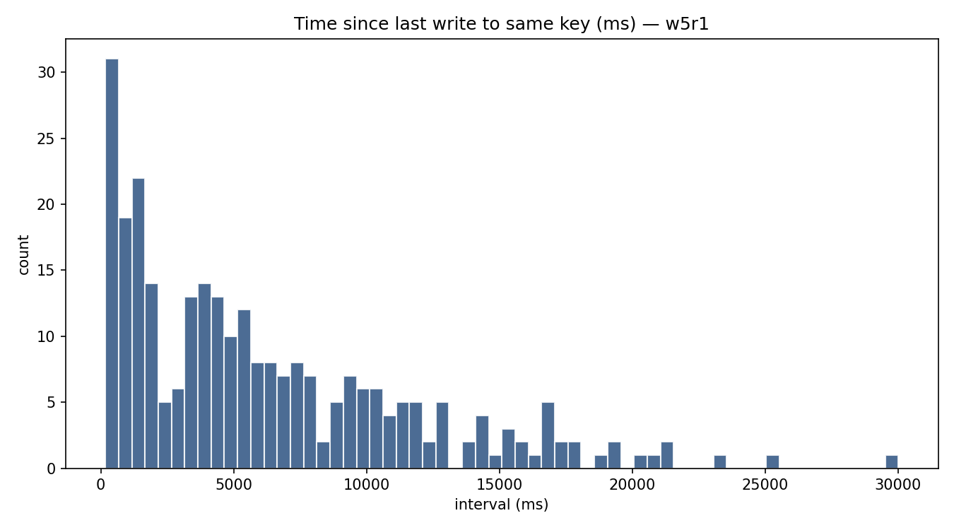
lf-w5r1-w0.5-write-latency.png
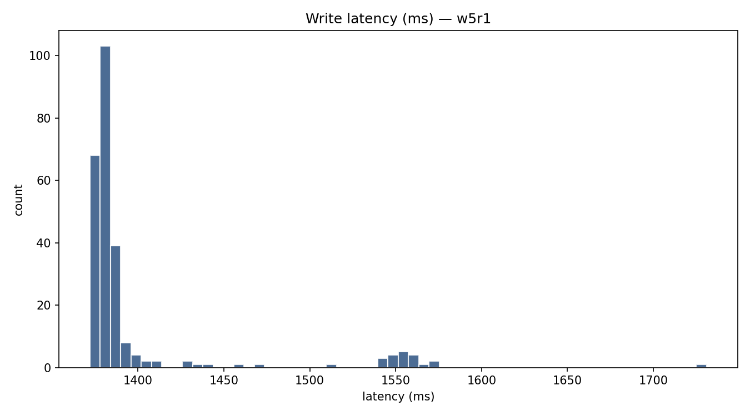
lf-w5r1-w0.9-read-latency.png
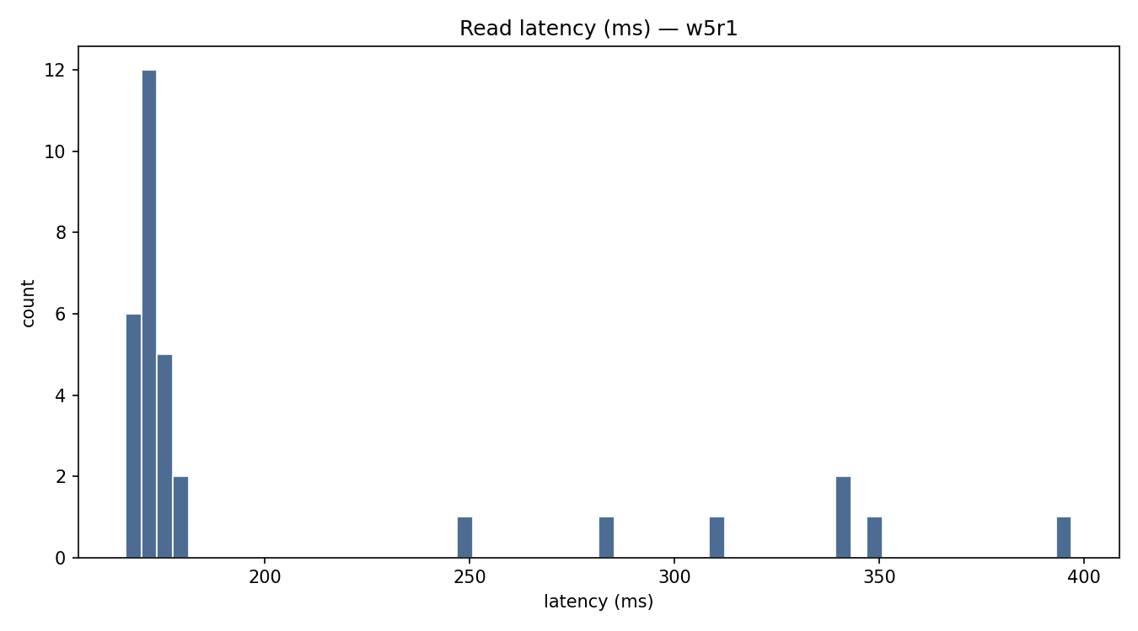
lf-w5r1-w0.9-rw-interval.png
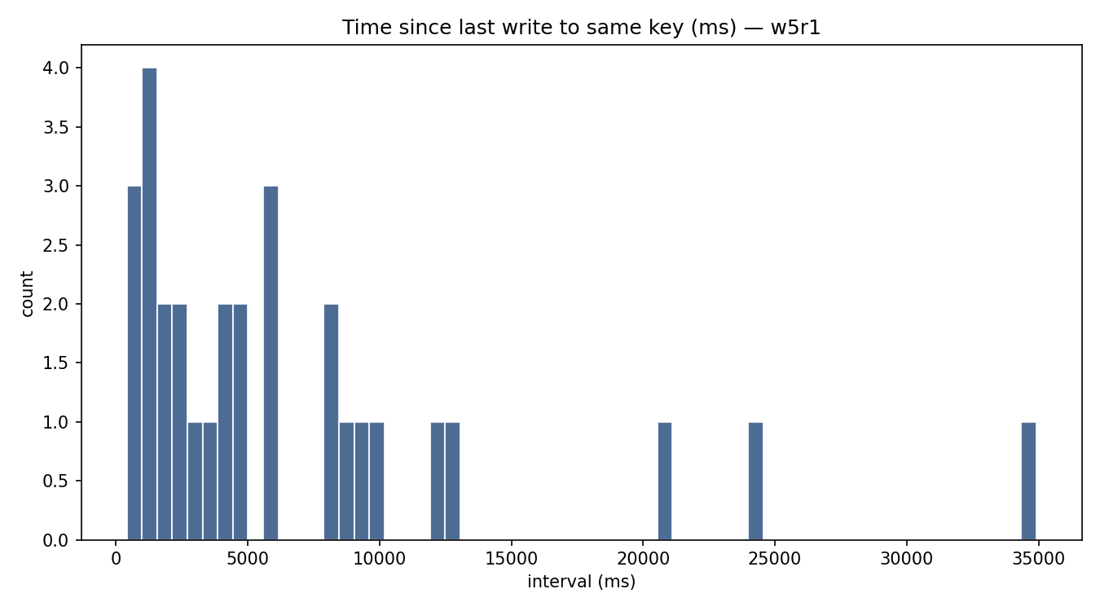
lf-w5r1-w0.9-write-latency.png
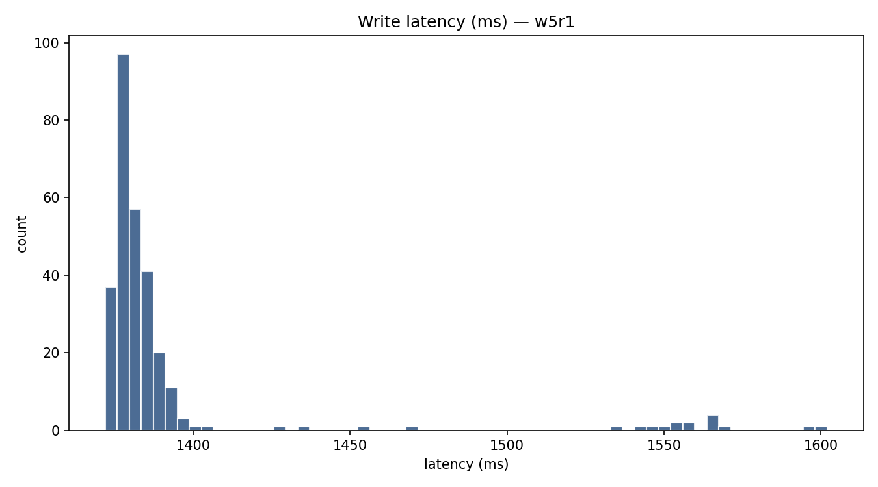
ll-w0.01-read-latency.png
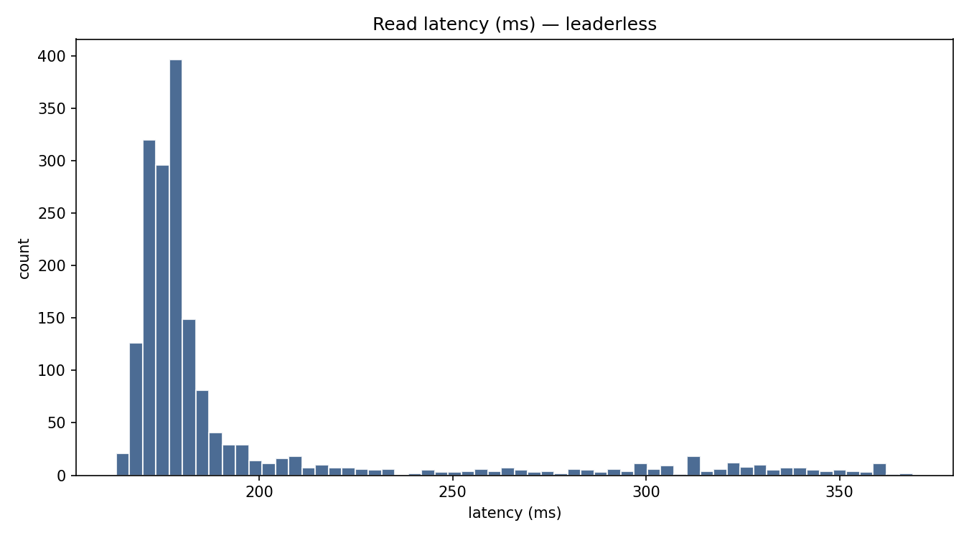
ll-w0.01-rw-interval.png
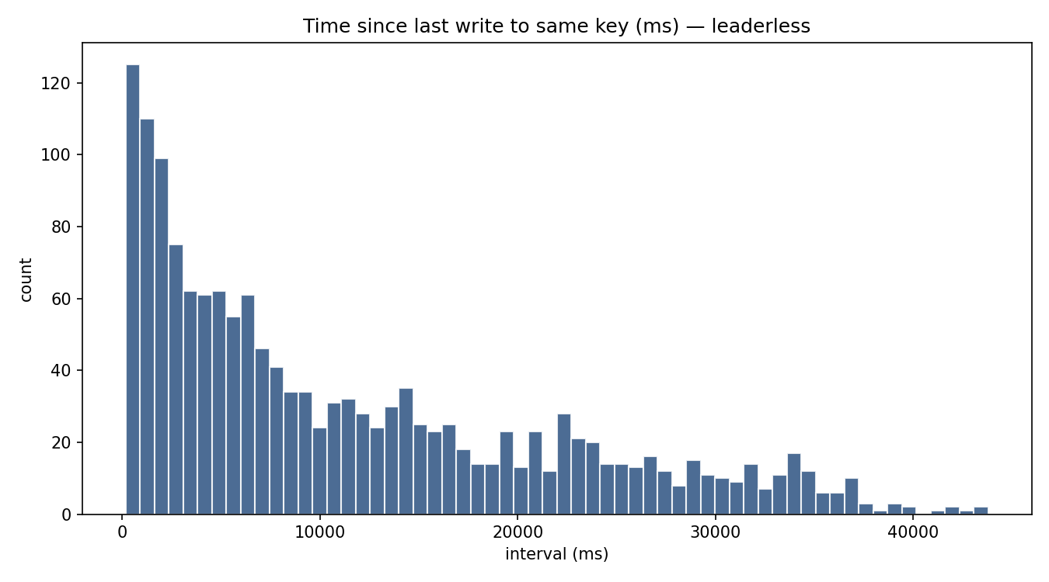
ll-w0.01-write-latency.png
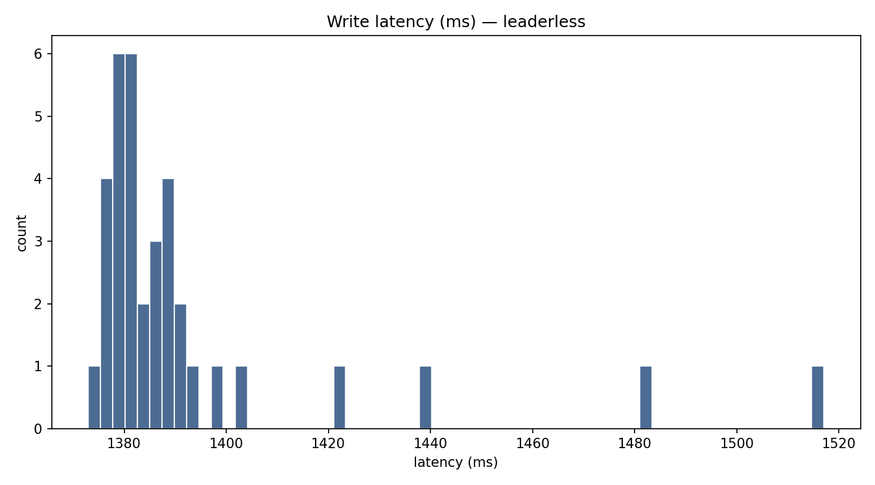
ll-w0.1-read-latency.png
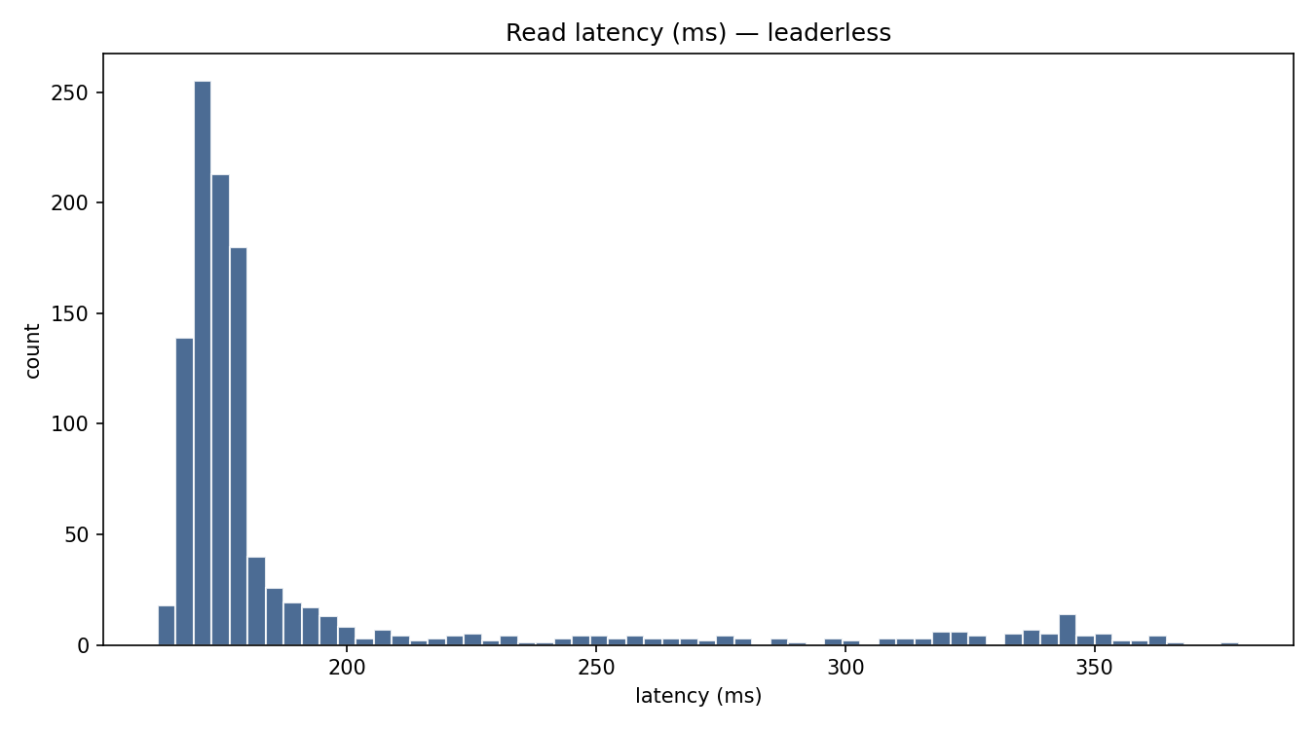
ll-w0.1-rw-interval.png
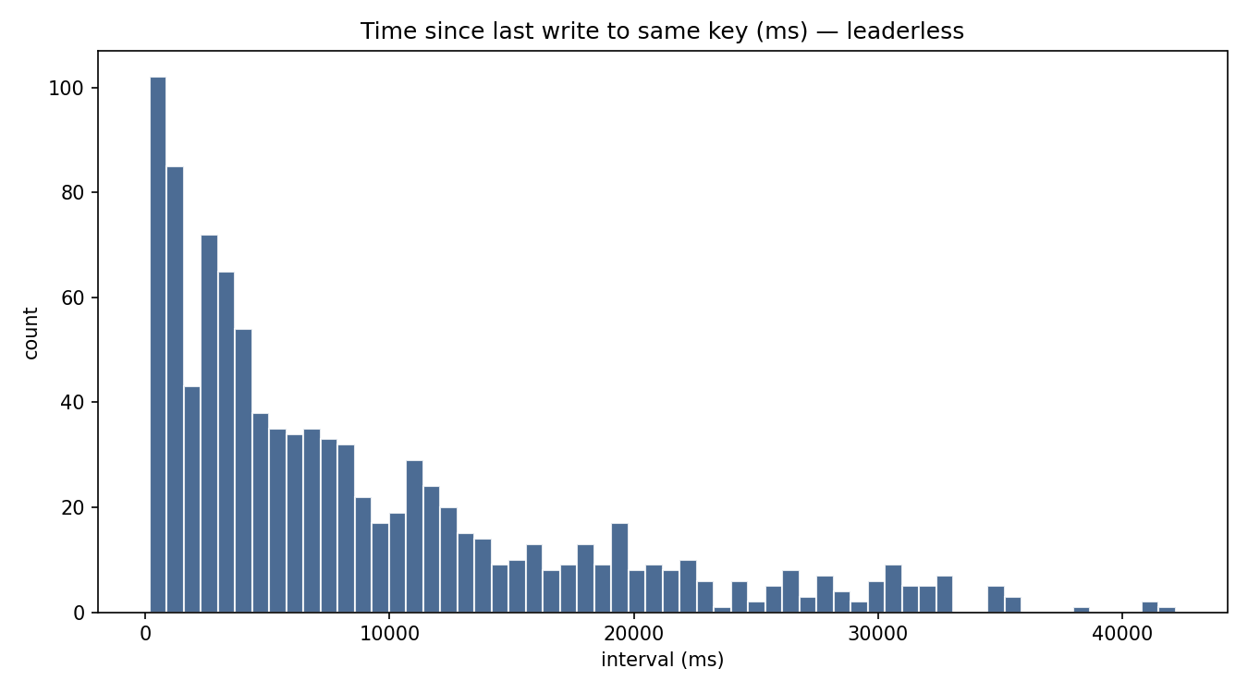
ll-w0.1-write-latency.png
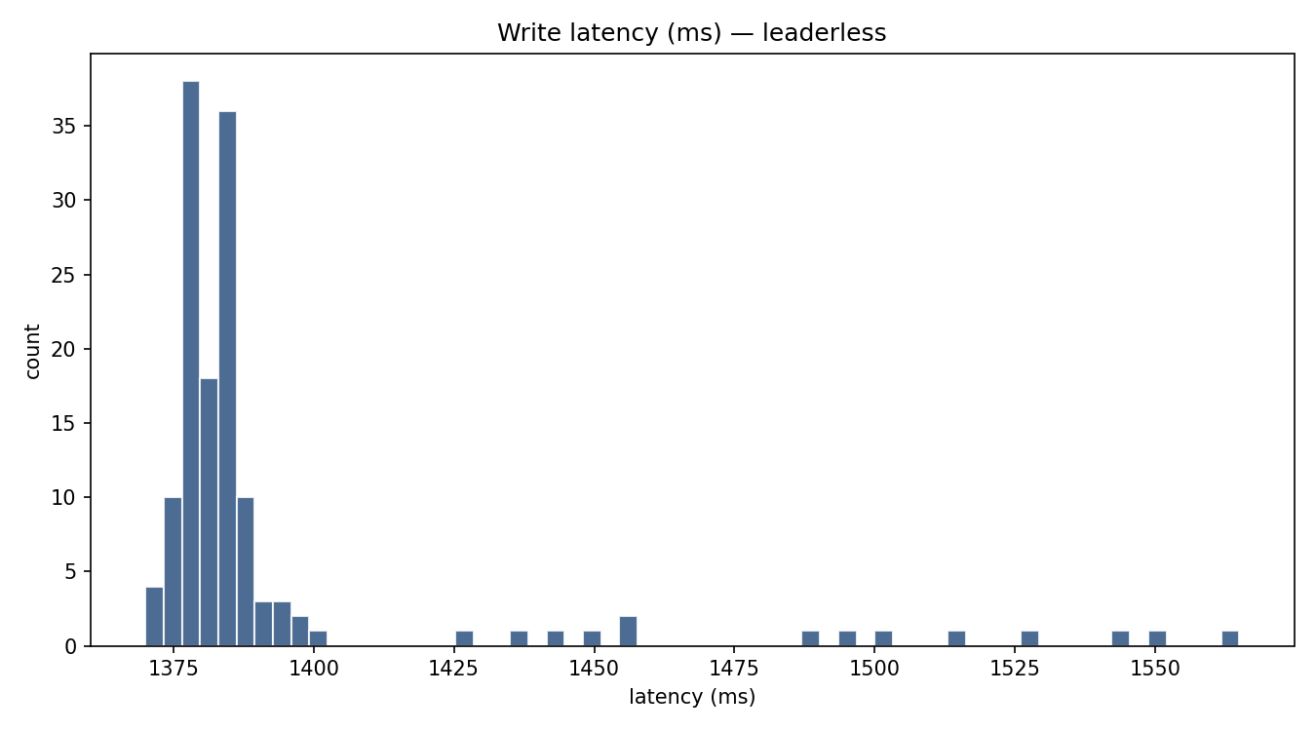
ll-w0.5-read-latency.png
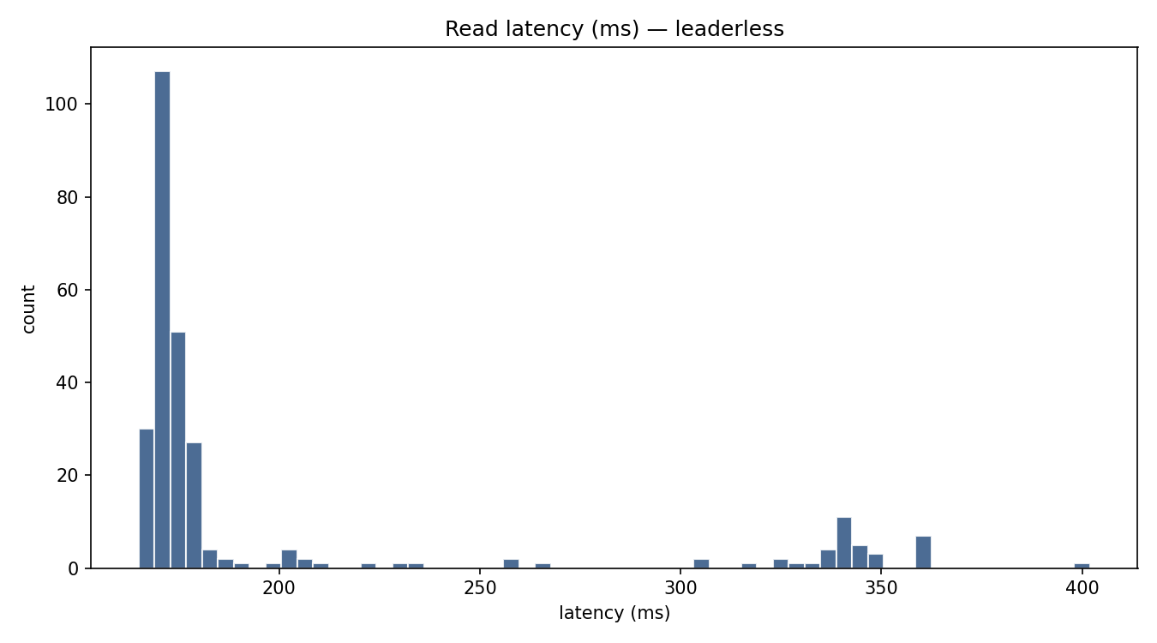
ll-w0.5-rw-interval.png
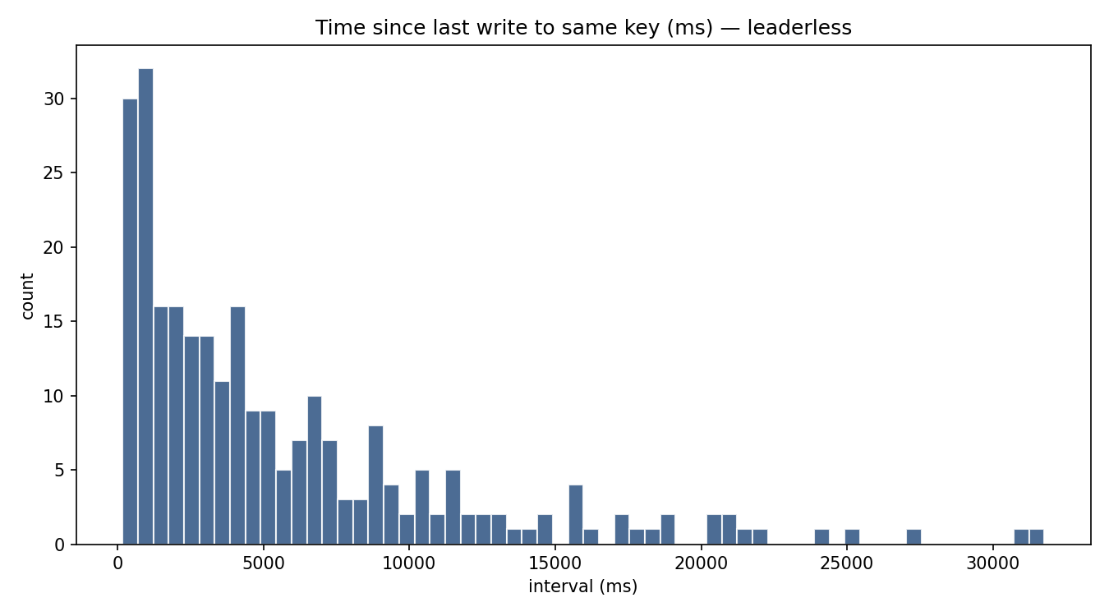
ll-w0.5-write-latency.png
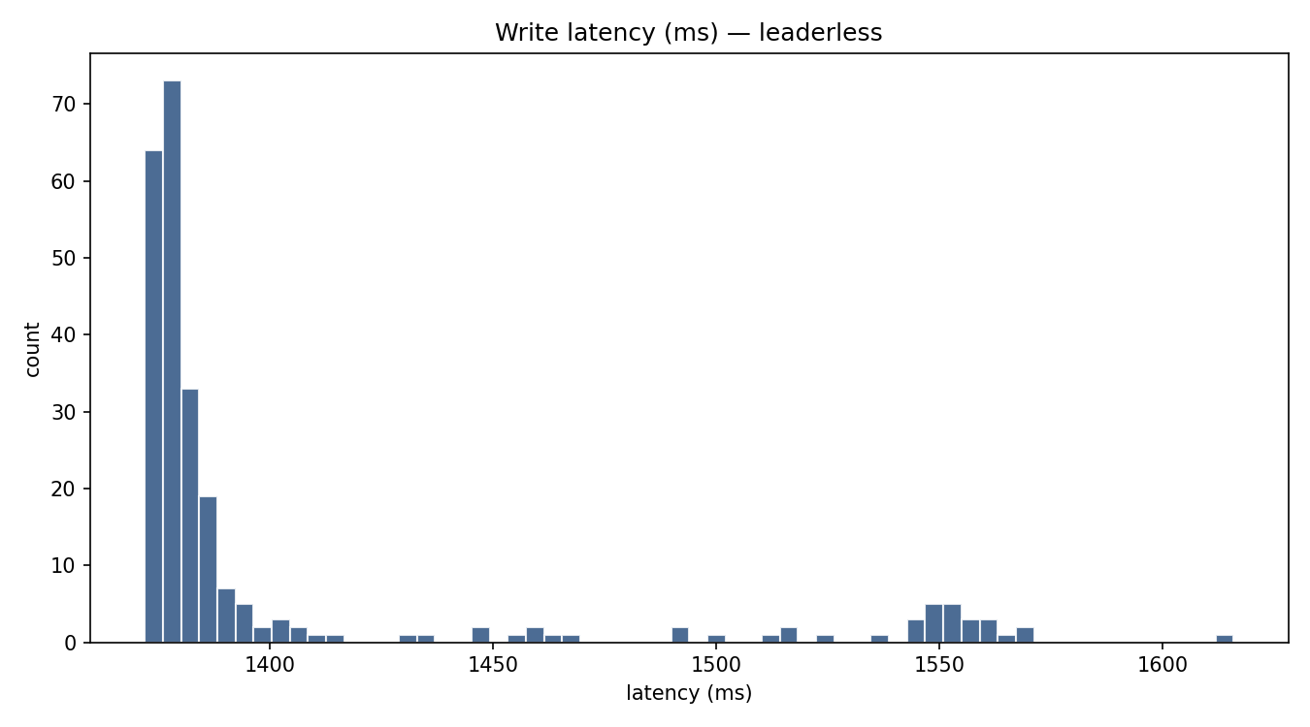
ll-w0.9-read-latency.png
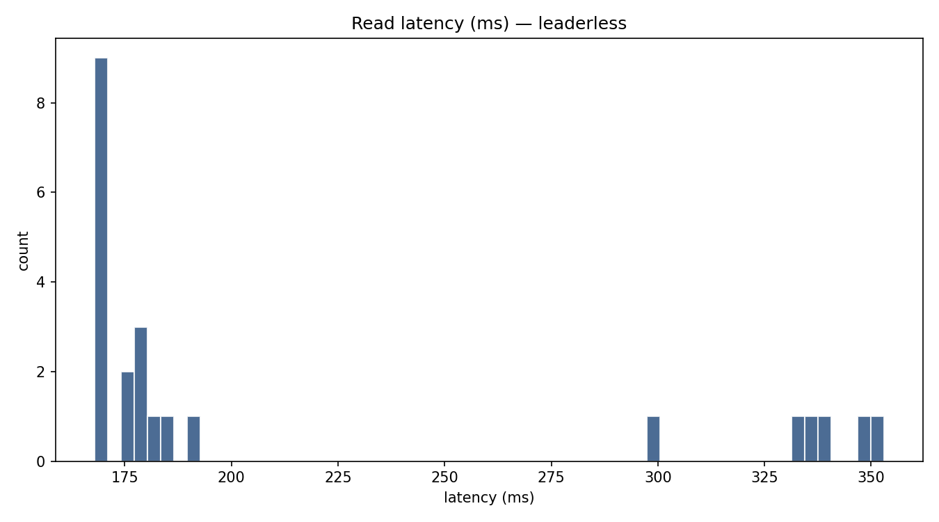
ll-w0.9-rw-interval.png
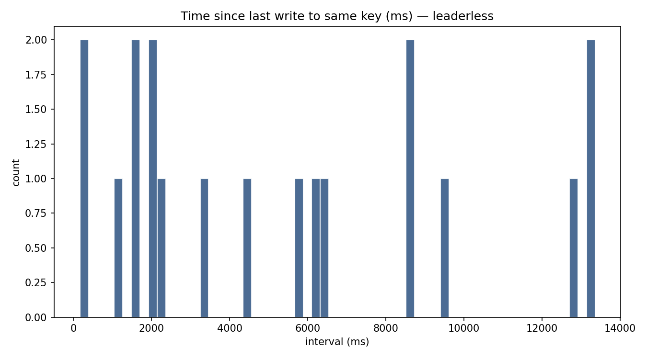
ll-w0.9-write-latency.png
