PROJECT 02

Active Directory User Management
& Access Control
A practical Level 1 IT Support home-lab project

Project owner | Darshan Thanuj
Lab domain | darshanhome.local (update if changed)
Environment | Windows Server / Active Directory + Windows client
Portfolio evidence | Screenshots, test results, incident tickets and final report

Purpose
Demonstrate a repeatable, secure workflow for provisioning, maintaining, troubleshooting and deprovisioning Active Directory user accounts, including group-based access and shared-folder permission validation.

Portfolio document template — complete each task in your own lab and insert genuine evidence.

Contents
1. Project Overview 2
Objectives 2
Scope and boundaries 3
2. Lab Environment and Prerequisites 3
3. Naming, Identity and Access Design 8
Principles to apply 8
4. Required Practical Workflows 9
4.1 New employee onboarding 9
4.2 Password reset and first sign-in 20
4.3 Account lockout investigation and unlock 29
4.4 Mover / Department change 37
4.5 Account disablement / offboarding 45
4.6 Account reactivation and access review 50
5. Reflection and Next Steps 55

1. Project Overview
This project demonstrates practical experience in Active Directory user account management and access control within a Windows Server home lab. It focuses on common Level 1 IT support tasks, including user onboarding, password resets, account lockout resolution, security group management, shared-folder access verification, and employee offboarding.
The project follows a structured troubleshooting and verification process to ensure that user accounts and resource access are managed securely and efficiently. Each task is documented with relevant screenshots, testing results, and service-desk-style incident notes.
All activities are performed in a controlled lab environment using test accounts and non-sensitive sample data.

Objectives
- Create and configure Active Directory user accounts using a consistent naming convention and appropriate organisational unit (OU) structure.
- Perform joiner, mover and leaver (JML) tasks, following appropriate authorisation and verification procedures.
- Perform password resets and troubleshoot account lockouts using appropriate identity-verification and security practices.
- Manage security group membership and apply the principle of least privilege to user access.
- Validate shared-folder access from a domain-joined client, confirming both authorised access and the denial of unauthorised access.
- Investigate common sign-in and resource-access issues using built-in Windows tools, diagnostic commands and relevant event logs.
- Document support activities using structured service-desk tickets, including investigation steps, resolutions, verification results and escalation notes where required.

Scope and boundaries

In Scope

- Active Directory Users and Computers (ADUC), including user properties, organisational units (OUs), and security group membership.
- User account administration, including account status, password resets, account lockouts, and account deactivation.
- NTFS and shared-folder permissions, including access verification from a domain-joined client.
- Basic troubleshooting using Windows diagnostic tools, commands, and relevant event logs.
- Service desk ticket documentation, including investigation steps, resolutions, verification results, and escalation notes.

Out of Scope

- Modifications to production accounts, systems, or employee data.
- Domain-wide configuration changes that are unrelated to the project or lack an appropriate backup and rollback plan.
- Actions performed outside the project owner's lab environment or without proper authorisation.
- Advanced enterprise identity management, automated provisioning, and complex security policy implementation.

Security and Data Protection

- Use fictional test accounts and non-sensitive sample data throughout the project.
- Take a snapshot or backup where practical before making significant or potentially disruptive configuration changes.
- Never include passwords, recovery codes, or other credentials in screenshots, documentation, or public portfolio materials.
- Review screenshots and command outputs before publishing, and redact sensitive information such as internal IP addresses, hostnames, and account details where appropriate.
- Perform all testing within the authorized lab environment and verify the results of each change.

2. Lab Environment and Prerequisites
Component | Record your setup | Evidence to capture
Domain controller | Hostname: WIN-4T7LA5PFRV6  OS: Windows Server 2022 | 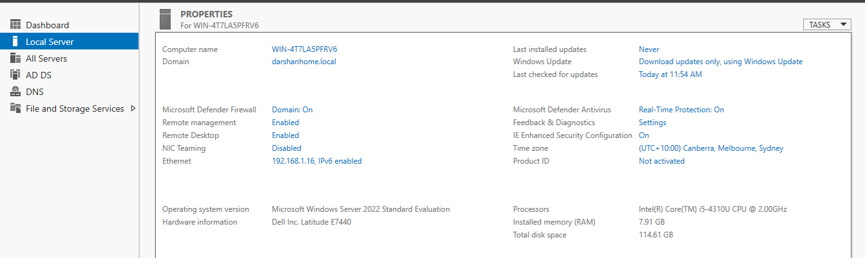
Domain / DNS | Domain:  darshanhome. local  DC IP: 192.168.1.16
Windows client | Hostname: Darshan  OS/edition: Windows 11 Pro | 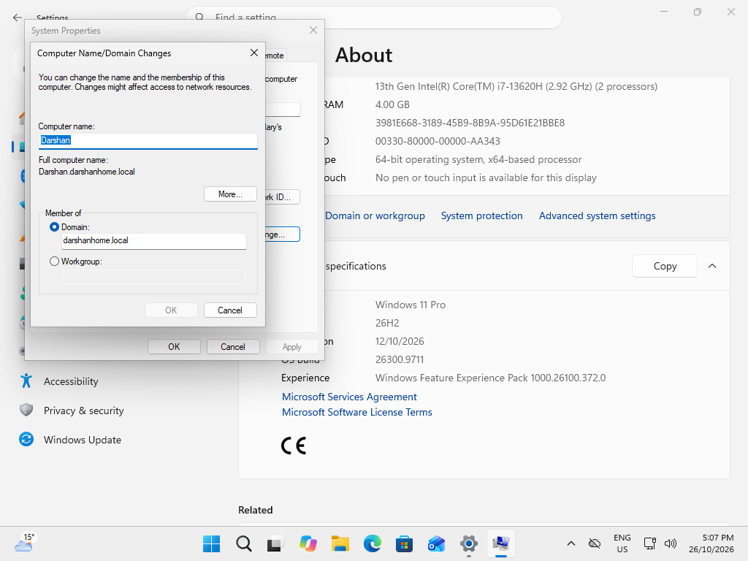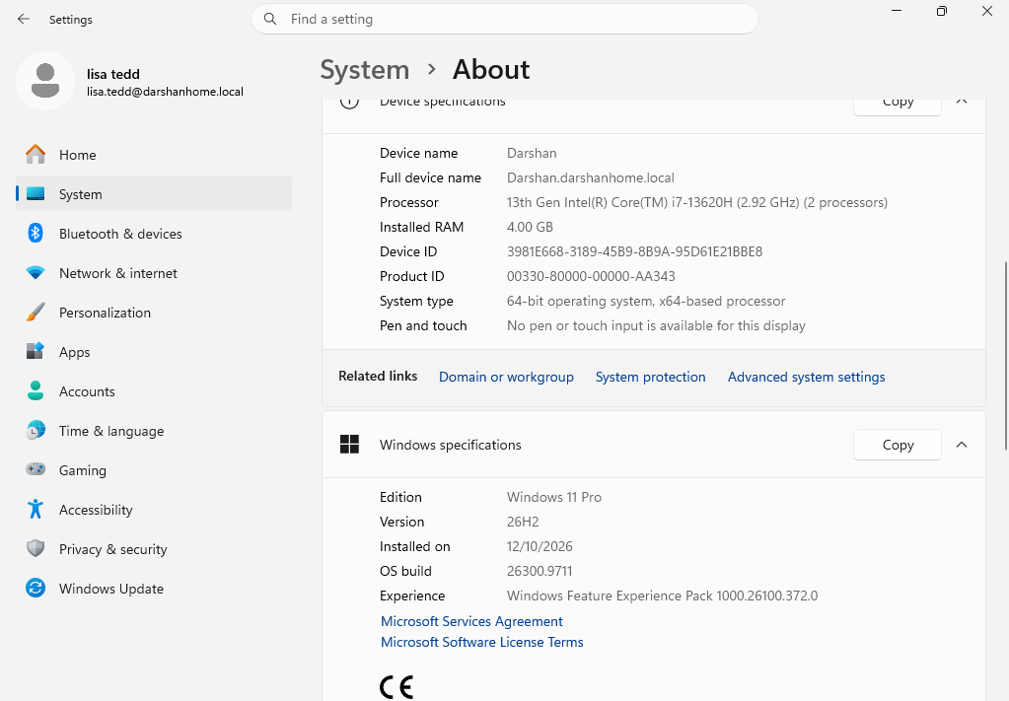
Admin account | Lab-only admin identity: darshanhome\administrator | 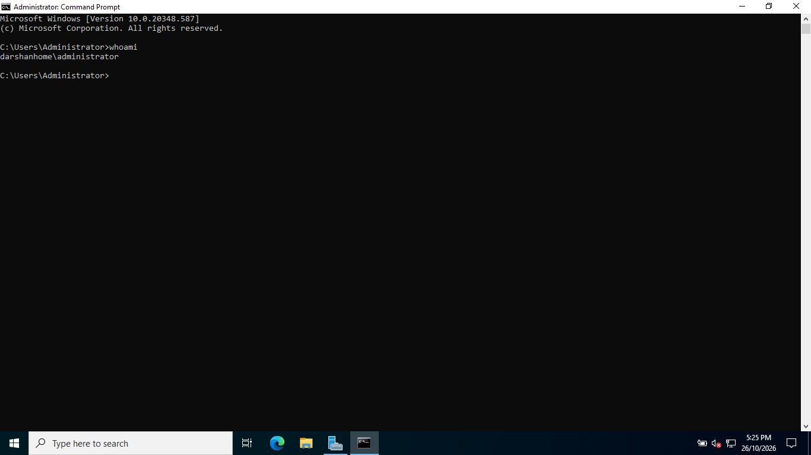
Shares / groups | Share path: \\WIN-4T7LA5PFRV6\Company-Data  Groups: Finance-Users , HR-Users , IT-Admins , IT-Helpdesk | 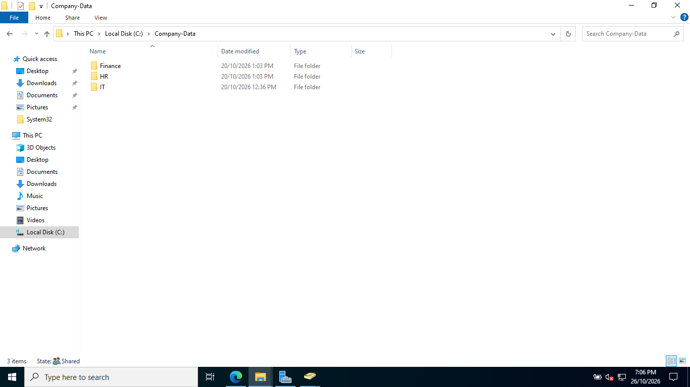  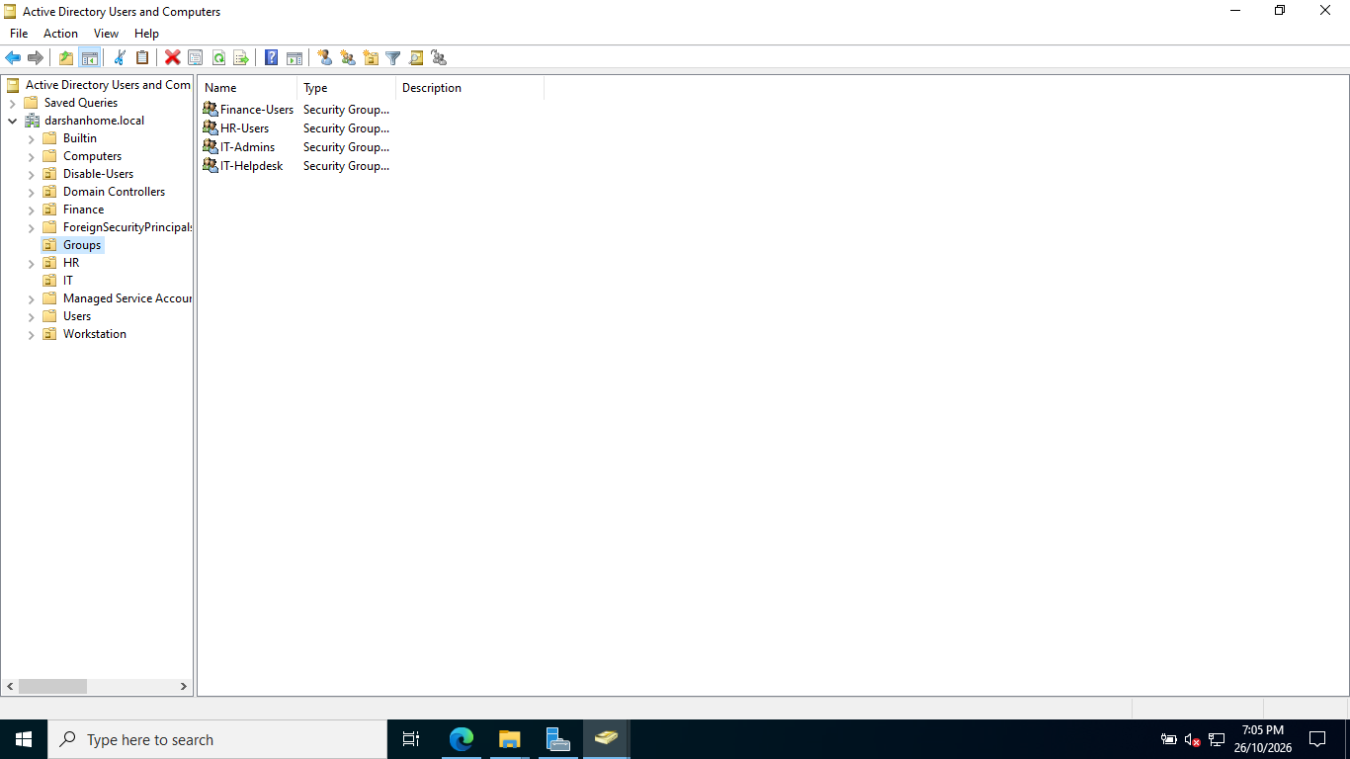  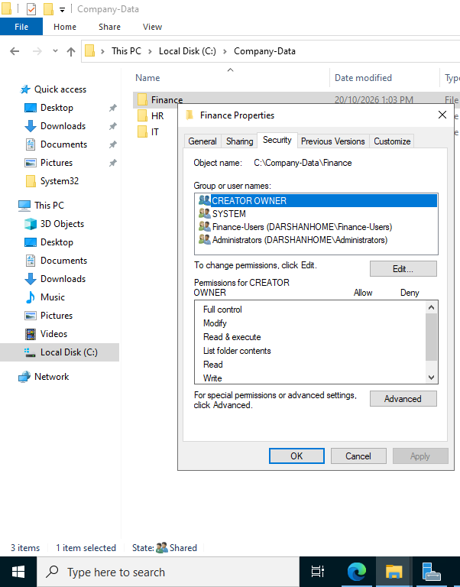  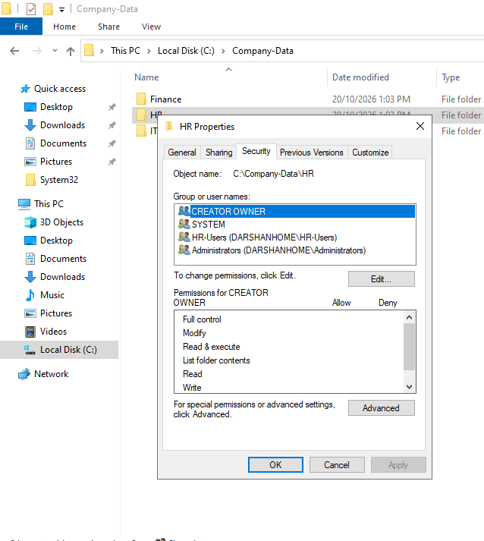  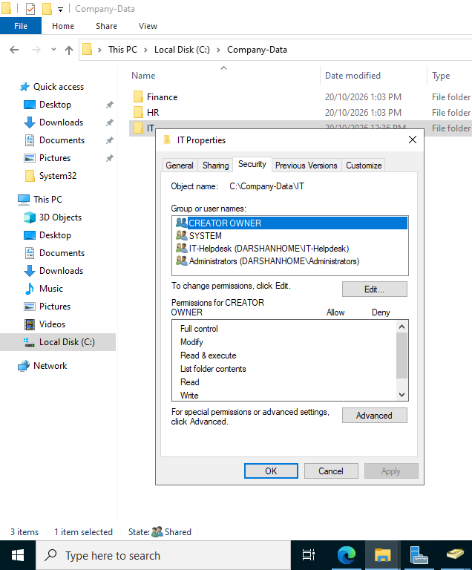
.

3. Naming, Identity and Access Design

Object | Your convention
Username / sAMAccountName | First name + .+Surname (eg: Lisa.Tedd)
Display name | First Name + Surname (Lisa.Tedd)
Security group | Eg: Finance-Users, HR-Users
OU | Eg:IT , HR,Fiance
Ticket ID | HD-2026-001

Principles to apply
- Least privilege: Grant each test user only the folder access and permissions required for their departmental role.
- Group-based access: Assign shared-folder permissions to departmental security groups rather than individual users wherever practical.
- Separation of duties: Use an authorised administrator account for administrative tasks and a standard test account for ordinary user activities.
- Approval and identity verification: In this lab, use documented test scenarios and verify the target account before making changes. In a real IT environment, follow the organisation's approval and identity-verification procedures.
- Traceability: Document each support task, including the request, investigation, action taken, verification and outcome. Never record passwords in project notes or screenshots.

4. Required Practical Workflows
For every workflow, capture genuine screenshots and write what you did, why you did it, and how you verified the result. Avoid screenshots containing passwords.

4.1 New employee onboarding

- Use a fictional, approved onboarding request and identify the required department, start date, manager and access.

Service Desk Ticket — New Employee Onboarding
Ticket ID: HD-2026-001
Request Type: User Account Creation / Onboarding
Priority: Normal
Status: Open — Pending Implementation
Requested By: Sarah Mitchell — HR Coordinator
Request Date: 26 October 2026
Employee Start Date: 2 November 2026
Employee Details
Employee Name: Daniel Perera
Job Title: IT Support Officer
Department: IT
Manager: Michael Thompson — IT Manager
Username: dperera
Display Name: Daniel Perera
Request Description
HR has requested the creation of a new Active Directory user account for Daniel Perera, who will join the IT department on 2 November 2026.
The account must be created in the appropriate departmental OU, with the required identity details and security group membership. The employee must be able to sign in to a domain-joined Windows 11 client and access the resources authorised for the IT department.

3.Implementation and Verification

  - Confirm the onboarding request and required access.
  - Create the user account in the correct OU.
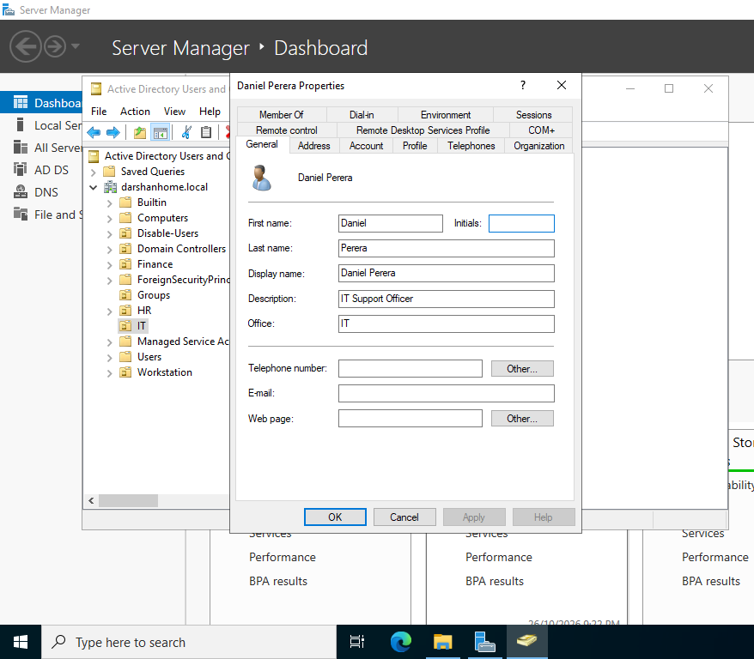
Figure 1 — Creating a New Active Directory User in the IT OU
Using Active Directory Users and Computers (ADUC), I navigated to the IT Organizational Unit (OU), right clicked the OU, and selected New → User to create the new employee account in the correct location. This ensures that the user account is organised according to the department's Active Directory structure and can be managed according to the appropriate administrative policies.

  - Configure the account properties and temporary password.
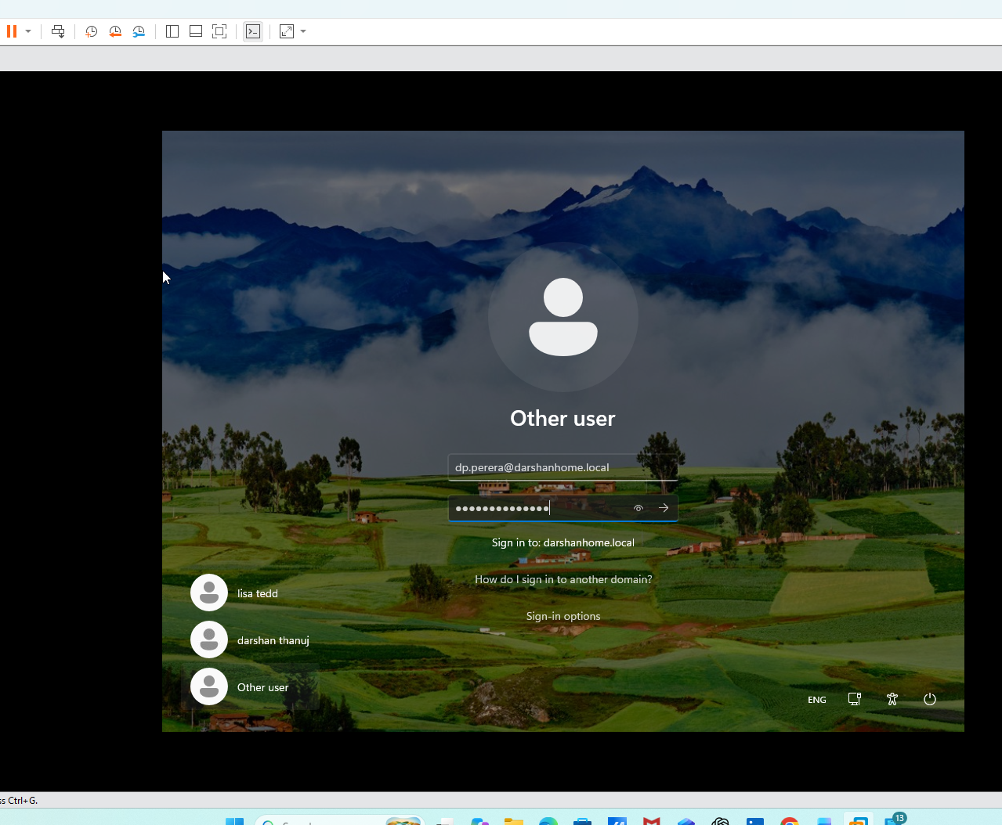

Figure 2 — Configuring the User's Initial Password
I configured a temporary password for the new Active Directory user and enabled the “User must change password at next logon” option. This requires the user to set their own password when signing in for the first time, supporting secure account onboarding.

  - Add the user to the appropriate security group.

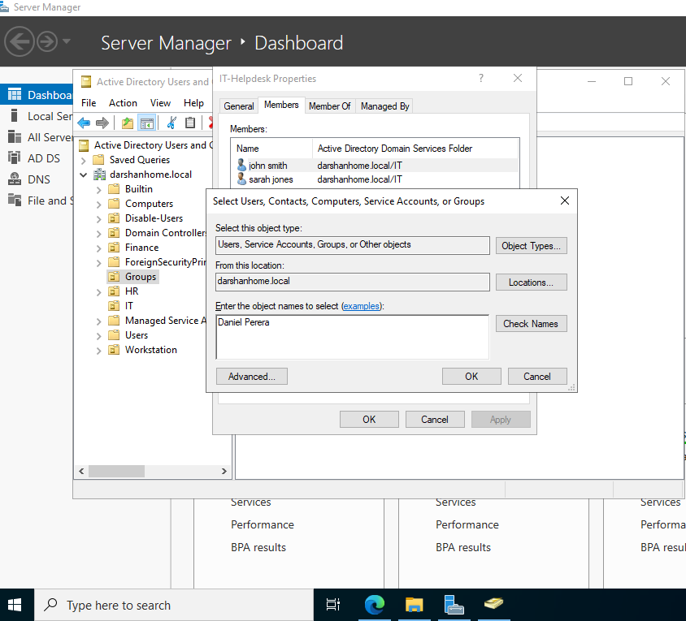

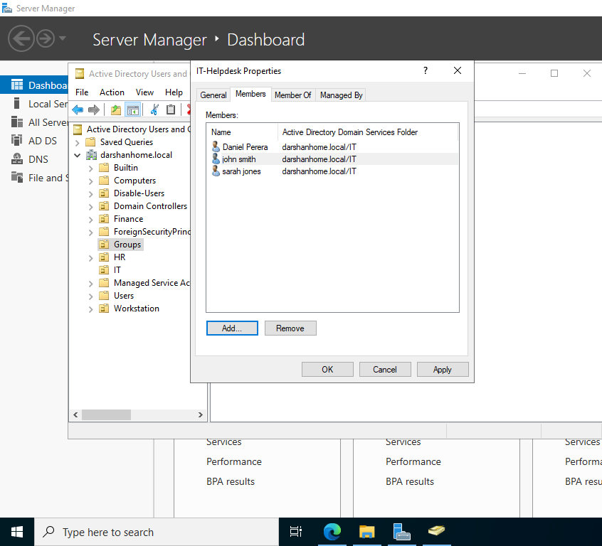

Figure 3 and 4 — Adding the User to the IT Security Group
Using Active Directory Users and Computers (ADUC), I navigated to the Groups OU, opened the properties of the IT security group, and selected the Members tab. I clicked Add, entered the new user's account name, and confirmed the selection. This assigns the user to the appropriate departmental security group, allowing access to resources according to the group's configured permissions.

  - Test domain sign-in from the Windows 11 client.
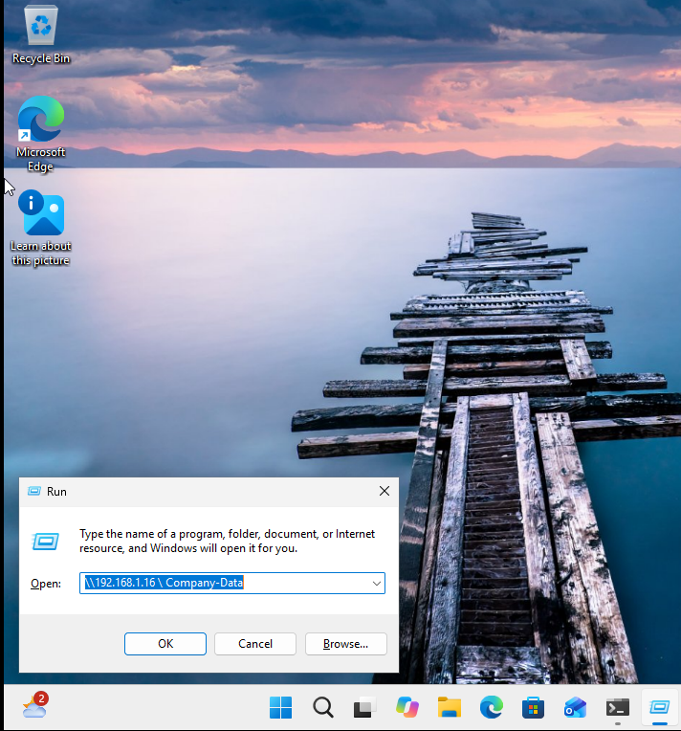

Figure 5 — Accessing the Network Share
After signing in to the Windows 11 virtual machine using the test domain user account, I pressed Windows + R to open the Run dialog and entered the network share path for the Company-Data folder. I pressed Enter to access the shared resource.

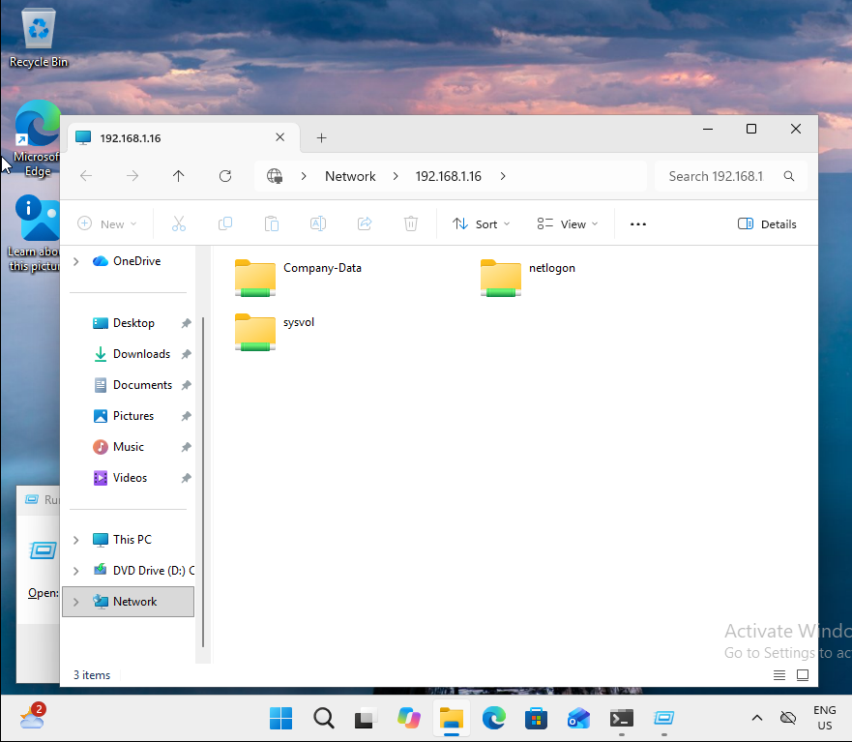

Figure 6 — Verifying Network Share Access
The Company-Data network share opened successfully from the Windows 11 client. This demonstrated that the test user could access the shared resource over the network using the configured domain environment.

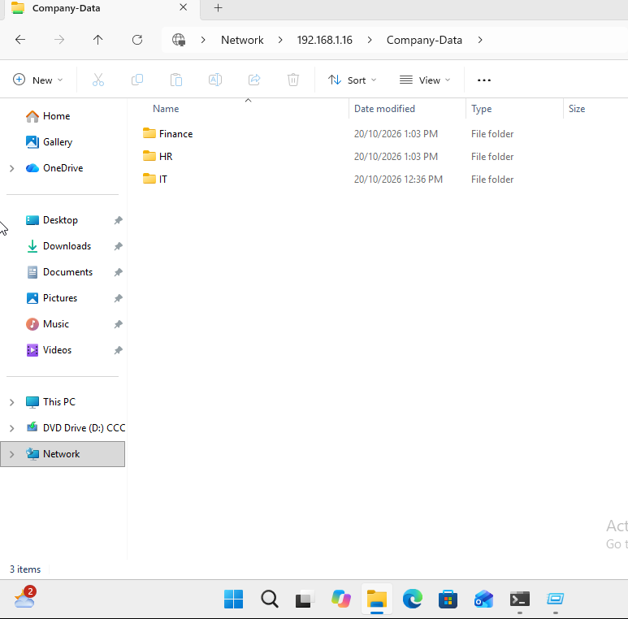

Figure 7— Reviewing the Departmental Folder Structure
Inside the Company-Data folder, I verified that the departmental subfolders for IT, Finance and HR were present. This confirmed that the shared folder structure was accessible from the client. Individual folder permissions were tested separately to verify that access was restricted according to departmental security group membership.

  - Confirm authorised and restricted folder access.

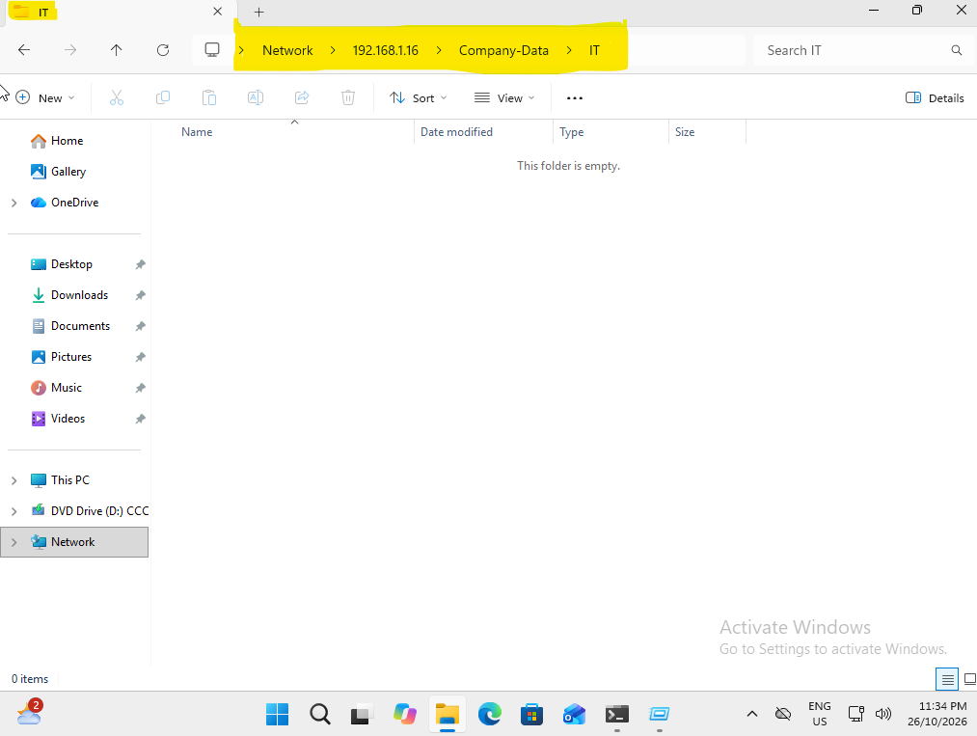

Figure 8— Verifying Authorised Access to the IT Department Folder
Signed in to the Windows 11 client using the test domain user account and accessed the IT departmental folder successfully. This confirms that the user's configured security group membership grants the required access to the IT folder.

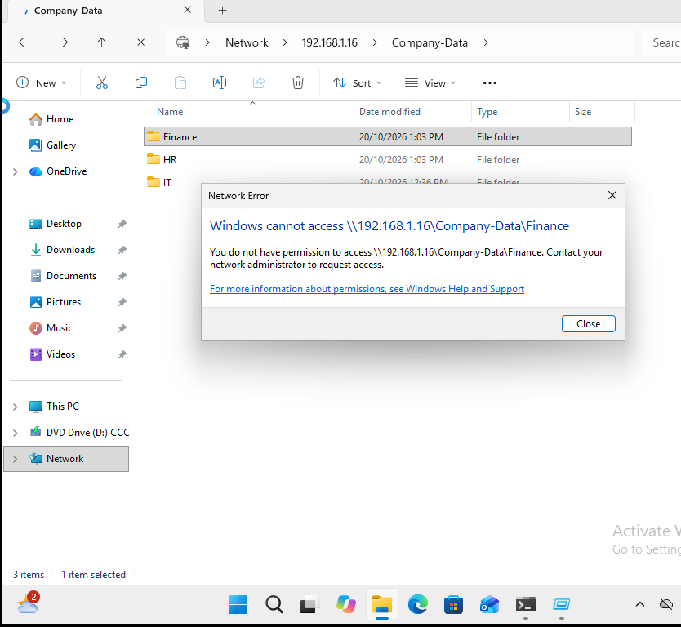

Figure 9 — Verifying Restricted Access to the Finance Department Folder
Attempted to access the Finance departmental folder using the IT test user account. Access was denied, demonstrating that the configured permissions restrict access to departmental resources the user is not authorised to access.

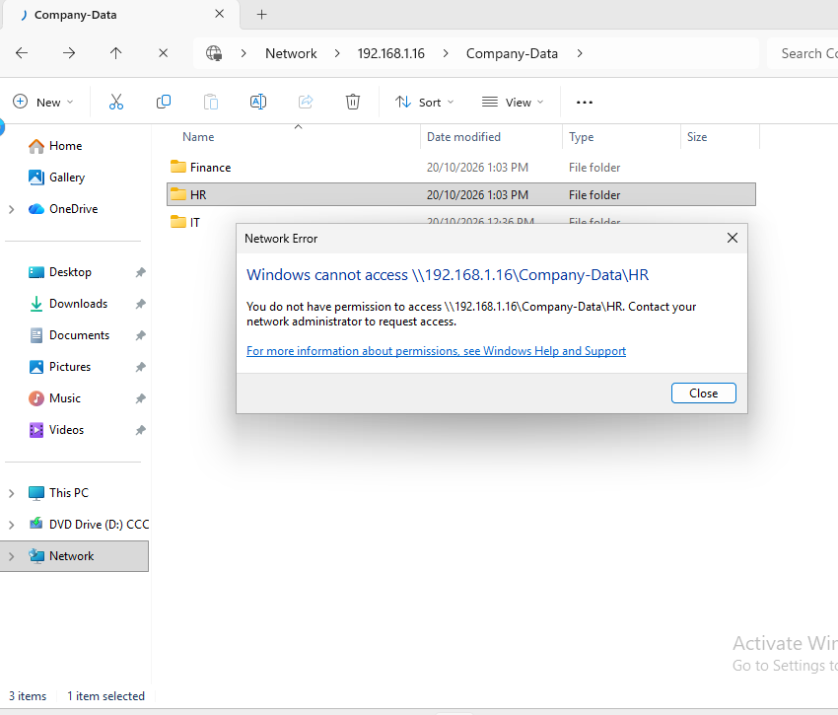

Figure 10 — Verifying Restricted Access to the HR Department Folder
Attempted to access the HR departmental folder using the IT test user account. Access was denied, confirming that the user cannot access the HR departmental resources with their current permissions. This supports the principle of least privilege by limiting access to resources required for the user's role.

Result / notes: The access control tests were completed successfully using the Windows 11 client and the test domain user account. Access to the IT departmental folder was granted, while access to the Finance and HR departmental folders was denied as expected. These results confirm that the configured permissions are working as intended and that departmental access is appropriately restricted based on the user's role.

4.2 Password reset and first sign-in
- Confirm the fictional request and practise the identity-verification step you would follow in a real service desk.

Ticket ID: HD-2026-002
Request Type: Password Reset / Account Access
Priority: Normal
Status: Open — Pending Implementation
Date Raised: 26 October 2026

1. User Details
- Employee Name: Emily Wilson
- Job Title: Finance Officer
- Department: Finance
- Username: ewilson
- Requested By: Emily Wilson
- Manager: Sarah Mitchell — Finance Manager

2. Issue Description
Emily Wilson has contacted the IT help desk because she cannot sign in to her Windows computer using her current domain credentials. She has requested a password reset so she can regain access to her account and continue her work.
The help desk technician must verify the user's identity according to the organisation's procedures before resetting the password.

3. Requested Action and Implementation Checklist
- Locate and verify the correct user account.
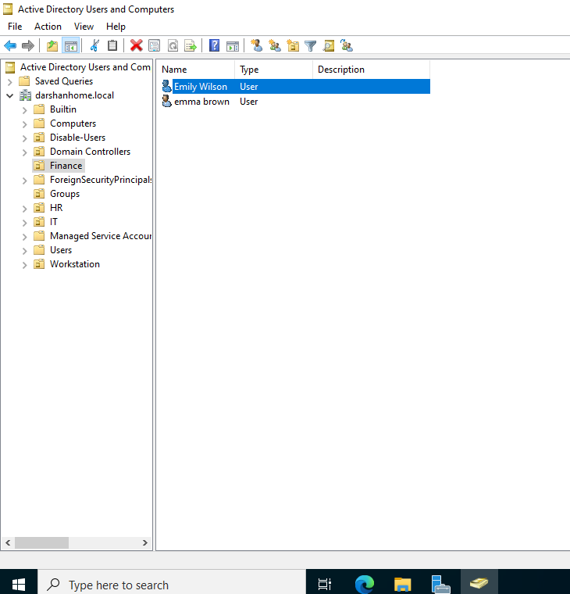

Figure 11 — Locating and Verifying the User Account in Active Directory
Opened Active Directory Users and Computers (ADUC), navigated to the Finance organisational unit (OU), and located the user account Emily Wilosn. Verified that the account was listed in the correct departmental OU before proceeding with the password reset. This helps ensure that the correct account is selected and reduces the risk of making administrative changes to the wrong user.

- Reset the password in ADUC.
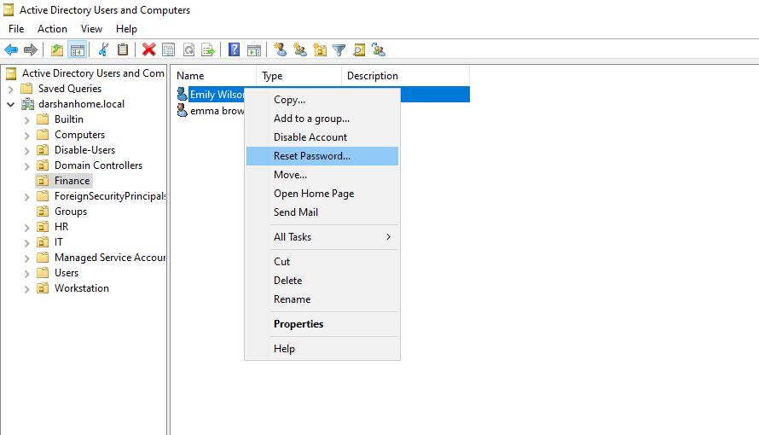

Figure 12 — Selecting the Password Reset Option in Active Directory
Opened Active Directory Users and Computers (ADUC), navigated to the Finance OU, and right clicked the Emily Wilson user account. Selected the Reset Password option to begin resetting the user's password. This demonstrates the process of locating the correct account and initiating a password reset using the authorised administrator account.

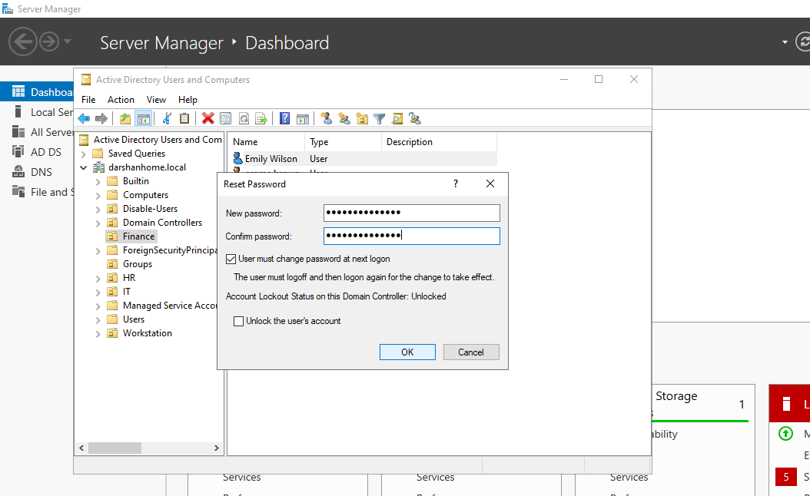

Figure 13 — Resetting the Password and Configuring First Sign-in
Entered and confirmed a new temporary password in the Reset Password window and selected User must change password at next logon. This requires the user to choose a new password when signing in for the first time, supporting secure account management and password handling.

- Check the account status and lockout state.
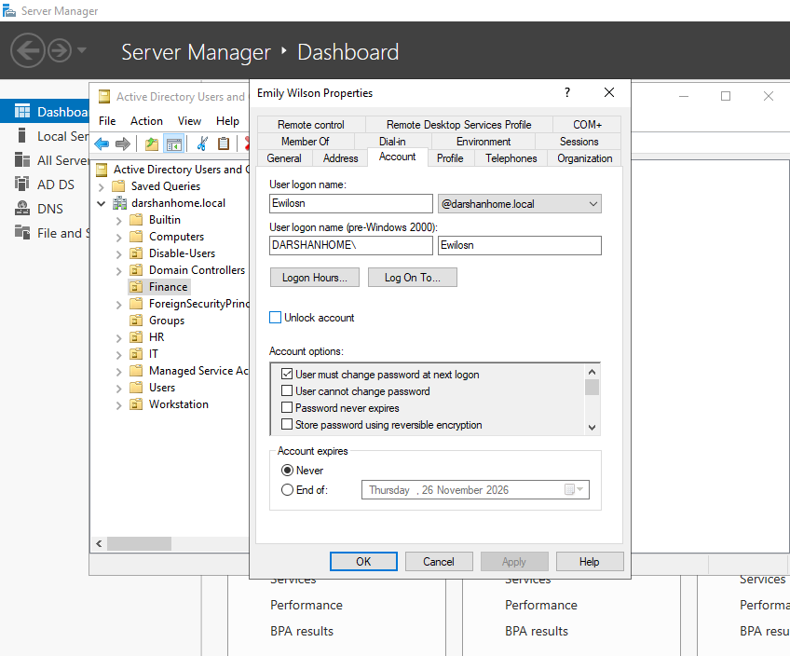
Figure 14 — Verifying the Active Directory Account Status and Lockout State
Opened the properties of the Emali Wilson account in Active Directory Users and Computers (ADUC) and reviewed the Account tab. Checked whether the account was enabled and whether it was locked out before proceeding with the password reset and sign-in verification. This helps identify account-status issues that could prevent successful domain authentication.

- Test domain sign-in on the Windows 11 client.
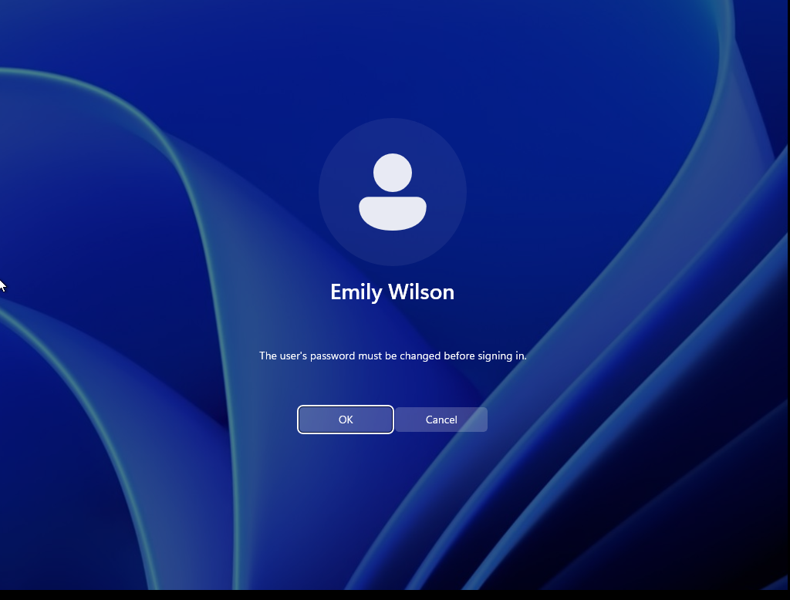

Figure 15 — Verifying Domain Sign-in and First-Logon Password Change
Signed in to the Windows 11 virtual machine using the Emali Wilson domain account and the temporary password configured in Active Directory. Windows prompted the user to change the password at first sign-in, confirming that the User must change password at next logon setting was applied correctly.

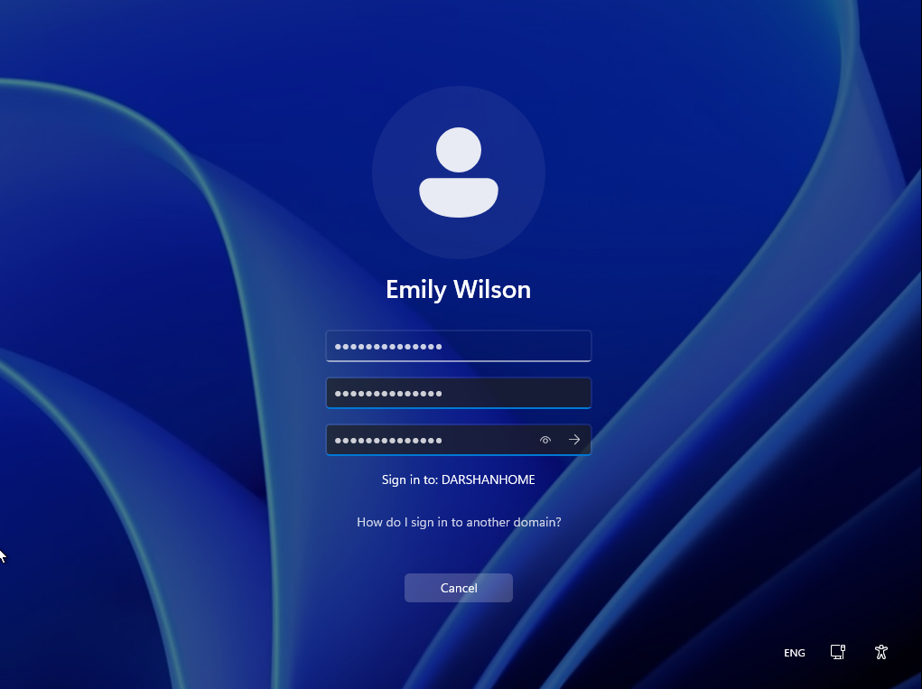

Figure 16 — Setting the New Password at First Sign-in
Entered and confirmed a new password when prompted by Windows during the first sign-in process. This demonstrates the first-logon password change workflow and allows the user to replace the temporary password with a new one. The password itself is not included in the project evidence for security reason

- Confirm authorised and restricted folder access.
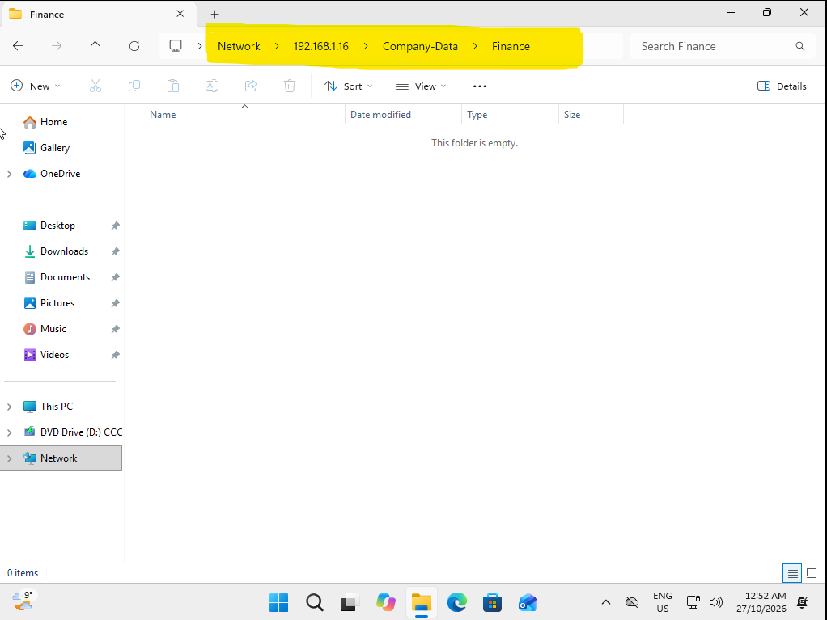

Figure 17 — Verifying Authorised Access to the Finance Department Folder
Signed in to the Windows 11 client using the Emily Wilson domain account and accessed the network share through the Run dialog by entering the network folder address. Successfully opened the Finance departmental folder, confirming that the account has the required permissions to access resources assigned to the Finance department.

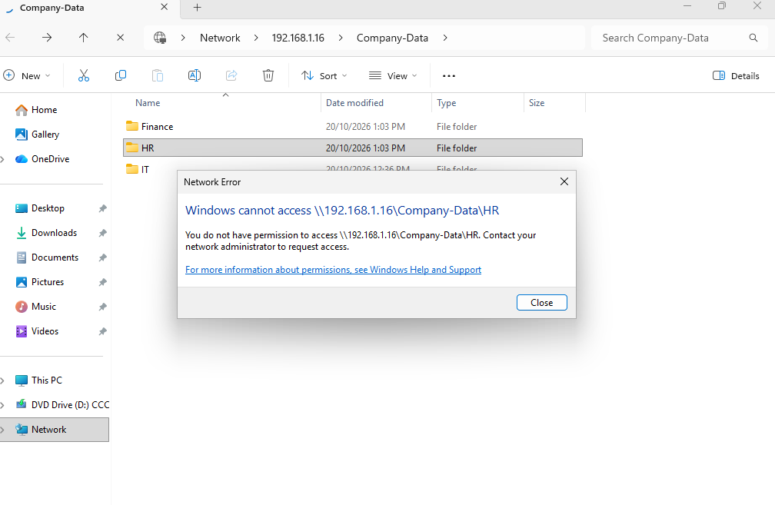
Figure 18 — Verifying Restricted Access to the HR Department Folder
Attempted to access the HR departmental folder using the Emily Wilson domain account. The system denied access, demonstrating that the user's permissions restrict access to resources outside the Finance department. This supports the principle of least privilege.

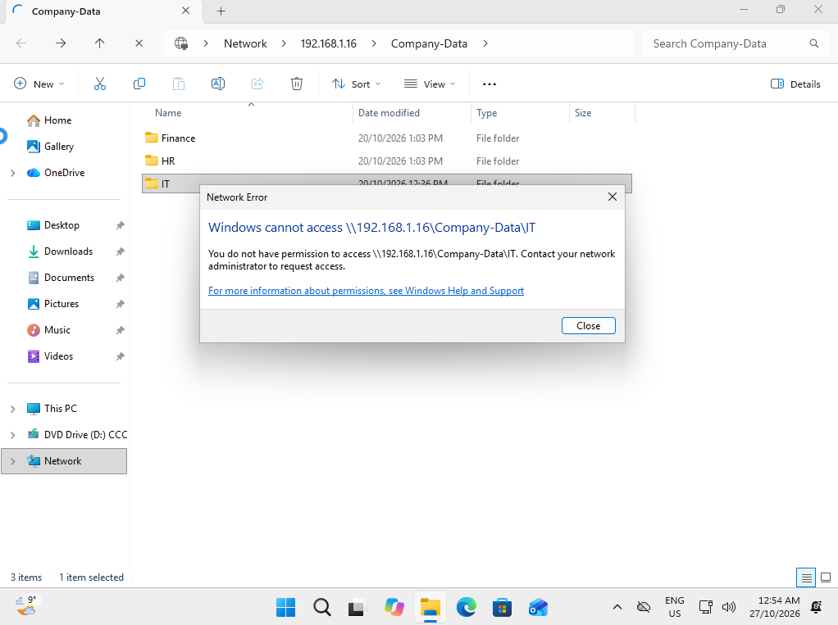
Figure 19 — Verifying Restricted Access to the IT Department Folder
Attempted to access the IT departmental folder from the Windows 11 client using the Emily Wilson domain account. Access was denied, confirming that the Finance user does not have permission to access the restricted IT departmental resources.

5. Resolution Notes
Resolution Summary:
Located the Emily Wilson account in the Finance OU using Active Directory Users and Computers (ADUC). Checked the account status and lockout state, then reset the password and enabled the User must change password at next logon option.
Tested domain sign-in on the Windows 11 client. The user was prompted to change the temporary password at first sign-in, and the new password was entered and confirmed.
Verified departmental folder permissions using the Emily Wilson account. Access to the Finance folder was granted, while access to the IT and HR folders was denied as expected.
Outcome: The password-reset and first-sign-in process was completed, and departmental access permissions behaved as expected during testing.
Ticket Status: Resolved — Pending final confirmation that sign-in completed successfully.
Environment: Simulated Active Directory home lab. All employee details are fictional.

6.Final Status: Resolved — Completed Successfully.
Closure Notes: The password reset and first-sign-in password change were completed successfully in the Active Directory home lab. The Emily Wilson account signed in through the Windows 11 client, and departmental folder access was verified. Access to the Finance folder was granted, while access to the IT and HR folders was denied as expected.
Ticket Closed Date: 27 October 2026.
Environment: Simulated Active Directory home lab using fictional employee details.

Notes: The user's identity and account details must be verified using the organisation's approved identity verification procedure before the password reset is performed. The target account, username and department must be confirmed to prevent changes to the wrong account. Verification must be documented in the ticket without recording passwords or unnecessary personal information.
For this simulated home lab, the verification process will be documented as a test procedure. In a production environment, the organisation's identity verification and password-reset policies must be followed.

4.3 Account lockout investigation and unlock
☐ Use a test account that is locked by a safe lab exercise or use a simulated ticket if lockout is not enabled.
Ticket ID: HD-2026-003
Request Type: Account Lockout / Account Access
Priority: Normal
Status: Open — Pending Investigation
Date Raised: 27 October 2026
1. User Details
- Employee Name: Sam Thompson
- Job Title: Finance Officer
- Department: HR
- Username: Sthompson
- Manager: Sarah Mitchell — Finance Manager
2. Issue Description
Sam Thompson has contacted the IT help desk because he is unable to sign in to his Windows computer. He reports that his domain account appears to be locked out after several unsuccessful sign-in attempts.
Sam needs access to his account to continue his normal work duties.
3. Requested Action
- Verify the user's identity using the approved identity verification procedure and Confirm the username and locate the correct account in Active Directory Users and Computers (ADUC).
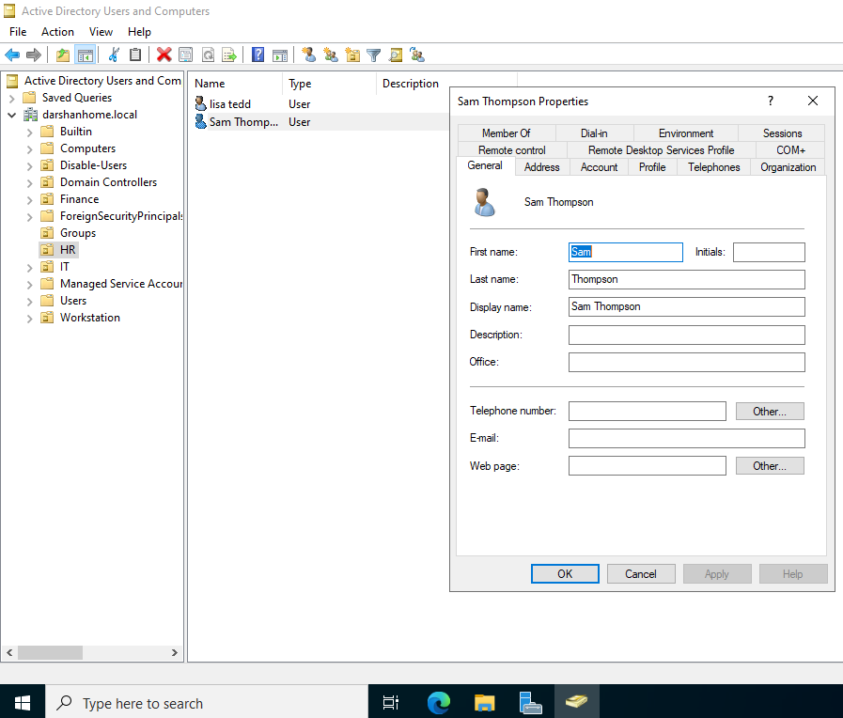

Figure 20 — Locating the User Account for Lockout Investigation
Opened Active Directory Users and Computers (ADUC), navigated to the Finance organisational unit (OU), and located the Sthompson user account. This confirms that the correct departmental account was identified before proceeding with the account lockout investigation.
Identity Verification Note: In this simulated home lab, identity verification is documented as a required procedural step. In a real IT environment, the user's identity must be verified using the organisation's approved verification process before any account changes are made.

- Check whether the account is enabled and locked out.
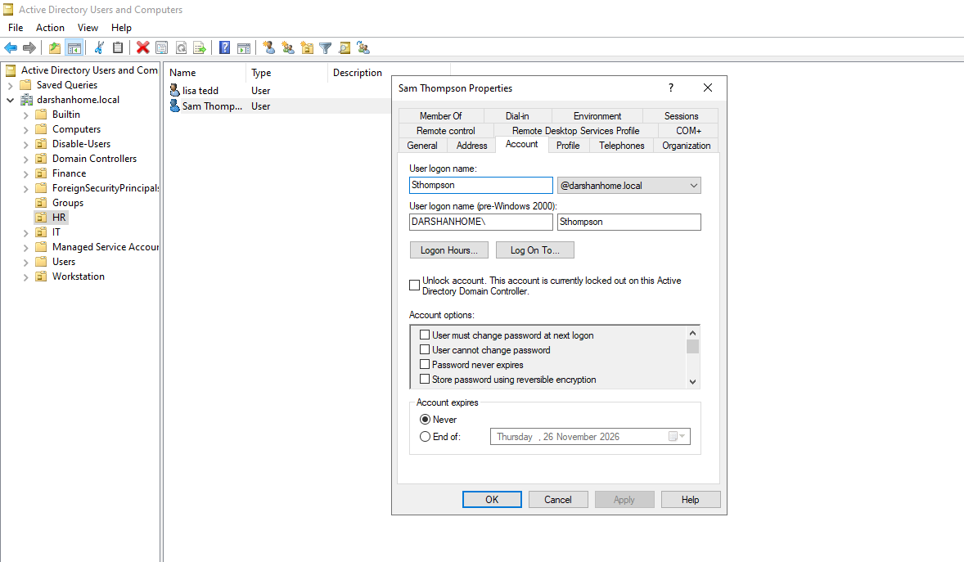

Figure 21 — Verifying the Account Status and Lockout State
Opened the properties of the sthompson account in Active Directory Users and Computers (ADUC) and reviewed the Account tab. Confirmed that the account was enabled and identified the lockout state following five unsuccessful password attempts. The Unlock account option was displayed, providing evidence that the account had been locked out during the lab exercise.
Result / Notes: The test account was locked after five incorrect password attempts, consistent with the configured account lockout policy. The account status was checked before proceeding with the investigation and unlock procedure.

- Investigate possible causes, including repeated incorrect password attempts, stale saved credentials, or a mapped network drive using an outdated password.
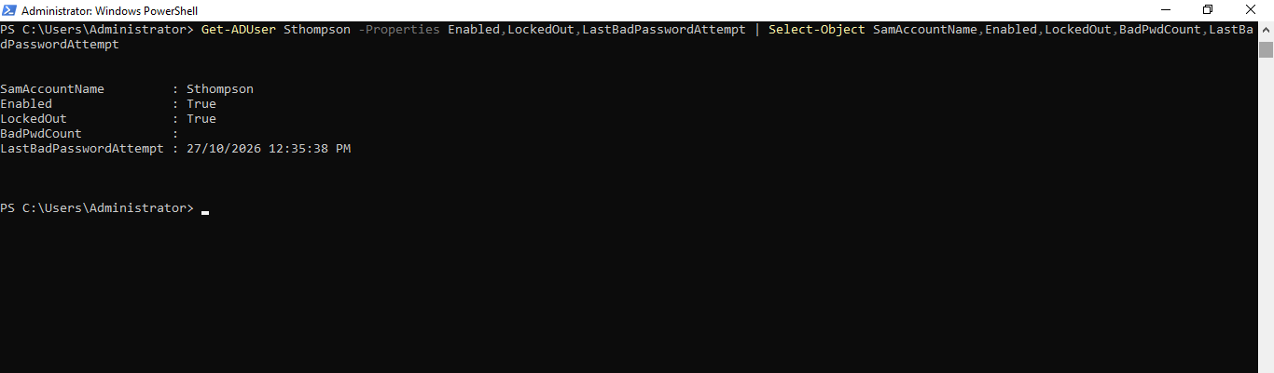

Figure 22 — Investigating the Account Lockout Using PowerShell
PowerShell was used to query the Sthompson Active Directory account and review its enabled status, current lockout state, and available failed-password information. The results were used to investigate the account's status and determine the appropriate next troubleshooting step.

- Determine the likely cause before or alongside unlocking the account.
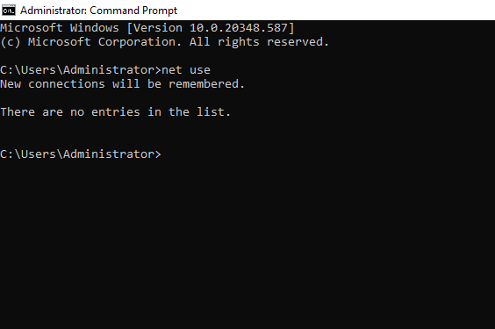

Figure 23 — Checking Network Connections on Windows Server Using net use
The net use command was executed in Command Prompt on the Windows Server to inspect the current user's mapped network drives and network connections. The command returned no listed connections, indicating that no current network connections were reported in the server's session. This check did not identify any mapped network connections in that session as a potential cause of the account lockout.

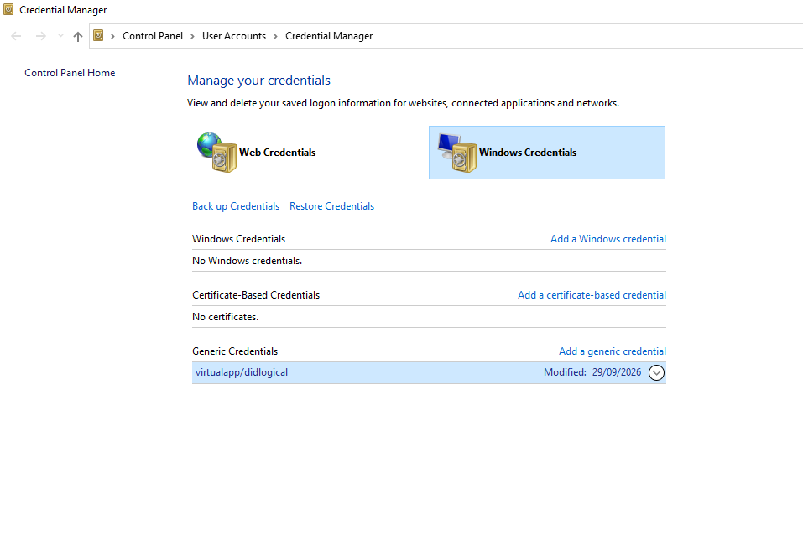
Figure 24 — Reviewing Windows Credential Manager
Windows Credential Manager was inspected on the Windows 11 client to identify saved credentials that could be attempting to authenticate with an outdated password. No saved Windows credentials were displayed in the screenshot. Therefore, no relevant saved credentials were identified as a potential cause of the account lockout during this check.

- Unlock the account only if it is confirmed to be locked and the action is authorised.
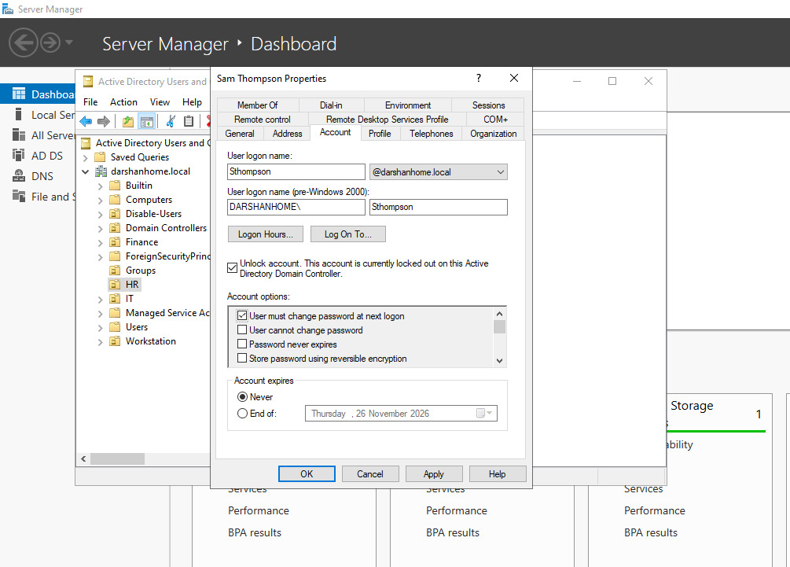

Figure 25 — Unlocking the Account and Requiring a Password Change
In Active Directory Users and Computers (ADUC), the Sthompson account was located in the Finance OU and its properties were opened. After confirming that the account was locked, the Unlock account option was selected to restore account access. The User must change password at next logon option was also selected to require the user to establish a new password at the next sign-in. These actions demonstrate the account recovery procedure performed by an administrator in the lab environment.

- Test domain sign-in from the Windows 11 client.

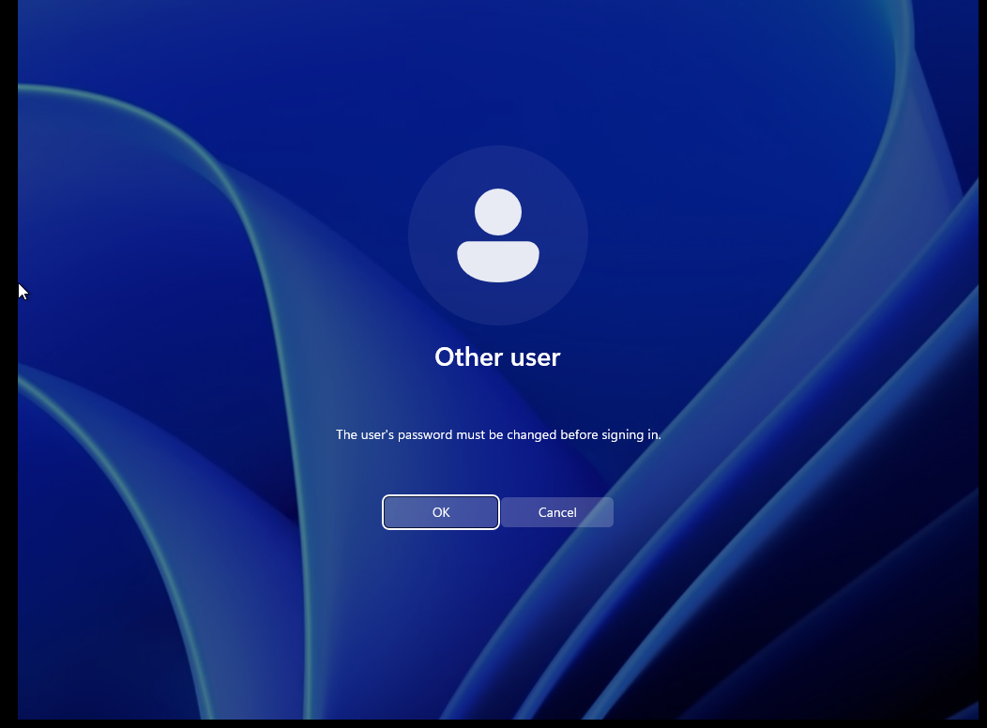

Figure 26 — Verifying the Password Change Requirement at First Sign-In
The sthompson account was accessed from the Windows 11 virtual machine after the administrator configured the account to require a password change at the next logon. The sign-in screen displayed the password-change requirement, demonstrating that the Active Directory setting was applied and that the user was prompted to establish a new password.

- Confirm that the account remains accessible and document the investigation results.

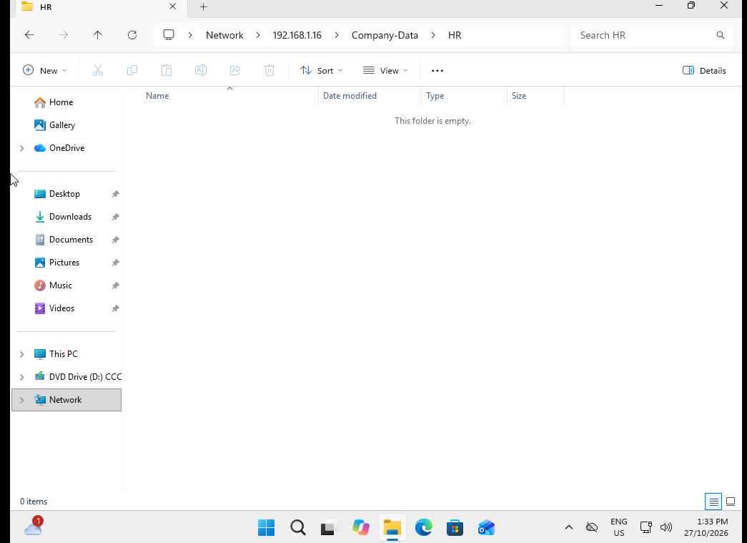

Figure 27 — Verifying Access to the HR Department Folder
The Sthompson account was used to access to the HR department folder from the Windows 11 virtual machine. Access to the folder was granted. This result was recorded as part of the access-control verification process and requires further investigation to determine whether the permissions match the intended departmental access policy.

4. Investigation and Resolution Notes
- Located the Sthompson account in the appropriate organisational unit in Active Directory Users and Computers (ADUC).
- Triggered a simulated account lockout by entering an incorrect password five consecutive times, demonstrating the configured Account Lockout Policy.
- Reviewed the account's properties in ADUC and used PowerShell to investigate the account's enabled status, lockout state and available failed-password information.
- Inspected Windows Credential Manager. No saved Windows credentials were displayed in the screenshot.
- Executed the net use command on the Windows Server. No current network connections were listed in that server session.
- Unlocked the account in ADUC and selected User must change password at next logon.
- Tested the account from the Windows 11 virtual machine and confirmed that the password-change requirement was displayed.
- Tested access to the HR department folder. Access was granted as expected for the account's assigned department.

Root Cause
The simulated account lockout was caused by five consecutive incorrect password attempts, which triggered the configured Account Lockout Policy.
The checks performed did not identify saved Windows credentials or mapped network connections in the sessions examined as contributing causes.
Resolution
The account was unlocked through ADUC, and the option requiring a password change at the next logon was selected. The Windows 11 virtual machine displayed the password-change requirement. Access to the HR department folder was also tested successfully.

5. Final Status
Resolved — The account recovery procedure was performed, and the password-change requirement was verified at sign-in. HR folder access was confirmed. Successful completion of the password change and sign-in should only be recorded if separately verified.

4.4 Mover / Department change
☐ Use a fictional request that changes a test user's department or role.

1. Ticket Details
Ticket ID: HD-2026-004
Request Type: User Account Management / Department Transfer
Priority: Normal
Status: Open — Pending Investigation
Date Raised: 27 October 2026
Employee Name: Emily Wilson
Username: ewilson
Current Department: Finance
New Department: HR
Requested By: Sarah Mitchell — Department Manager
Request: Transfer the employee's Active Directory account and access permissions from Finance to HR.
2. Issue Description
The IT Help Desk has received a request to transfer Emily Wilson from the Finance department to the HR department. The employee requires access to HR resources and should no longer have access to Finance departmental resources unless separately authorised.
The account's department details, organisational unit placement and security group memberships must be reviewed and updated according to the approved transfer request.
3. Requested Actions
- Verify the transfer request and confirm that the required approval has been obtained.
Approval Verification
For this simulated lab scenario, the department transfer request for Emily Wilson from Finance to HR was treated as approved by the fictional requesting manager, Sarah Mitchell. The requested access changes were reviewed before proceeding with the Active Directory account update. In a real help desk environment, the technician would verify the manager's approval through the organisation's approved request or ticketing system before making changes.

- Review the employee's current Active Directory account, organisational unit and security group memberships.
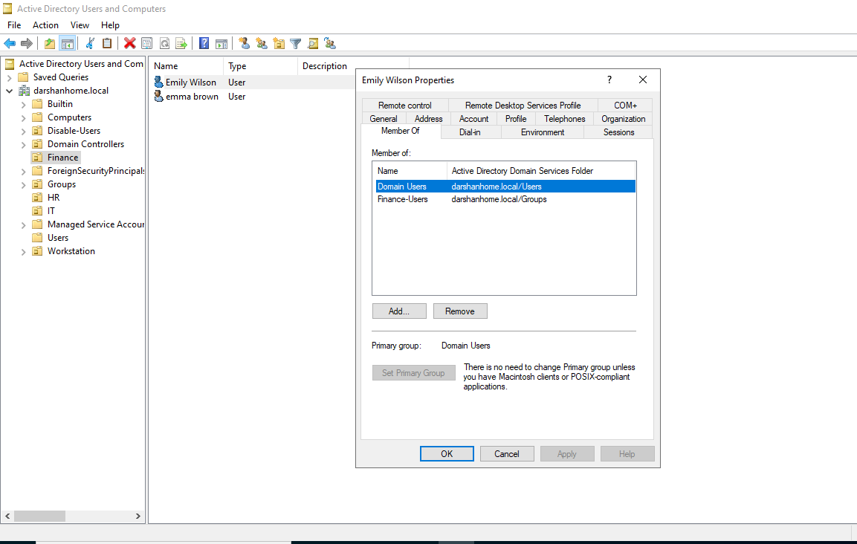

Figure 28 — Reviewing the Employee's Current Active Directory Account and Group Membership
The Emily Wilson account was located in the Finance organisational unit (OU) in Active Directory Users and Computers (ADUC). The account properties were reviewed to verify its current configuration and security group membership. The screenshot confirms that the account was a member of the Finance security group before the simulated department transfer.

- Update the department information and OU placement if required by the organisation's design.
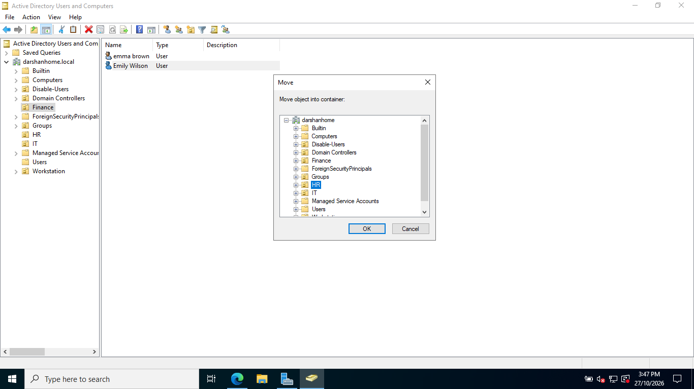
Figure 29 — Updating Employee Details and Moving the Account to the HR OU
The Emily wilson account was prepared for the simulated department transfer by updating Emily Wilson's account description and selecting the HR organisational unit (OU) as the destination in Active Directory Users and Computers (ADUC). This step demonstrates how an administrator updates account information and relocates a user account to reflect a department change.

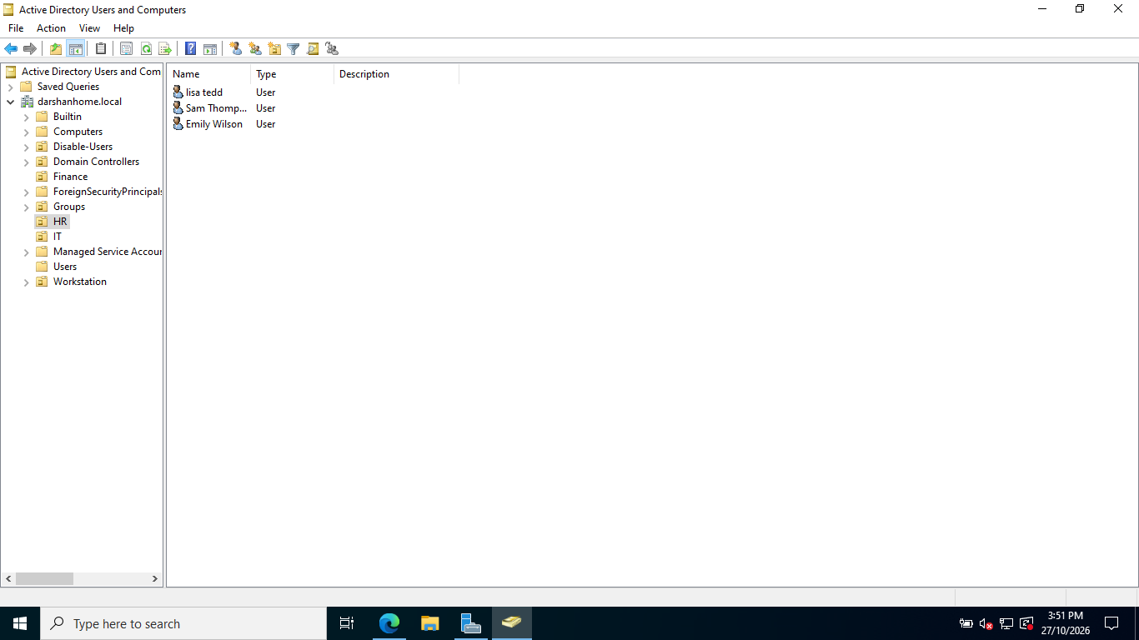

Figure 30 — Verifying the Employee's New HR OU Placement
The Emily Wilson account was located in the HR organisational unit (OU) after the simulated department transfer. This screenshot confirms that the account was successfully moved from the Finance OU to the intended HR OU in Active Directory Users and Computers (ADUC).

- Remove obsolete Finance security group memberships.
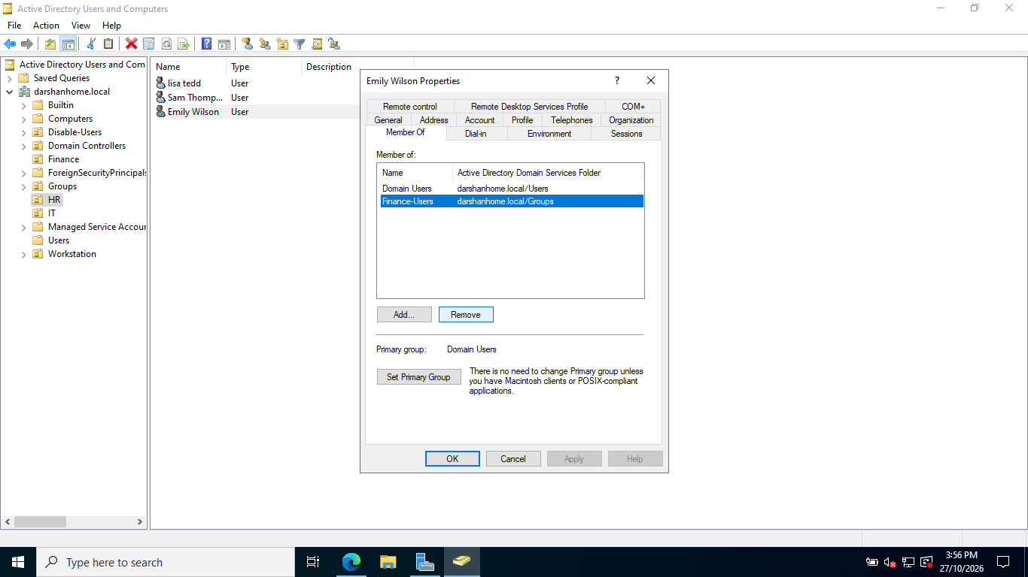

Figure 31 — Verifying Existing Finance Security Group Membership
The Emily Wilson account properties were reviewed before updating group memberships. The screenshot shows that Emily Wilson was a member of the Finance security group before the simulated department transfer. This establishes the account's original access configuration.

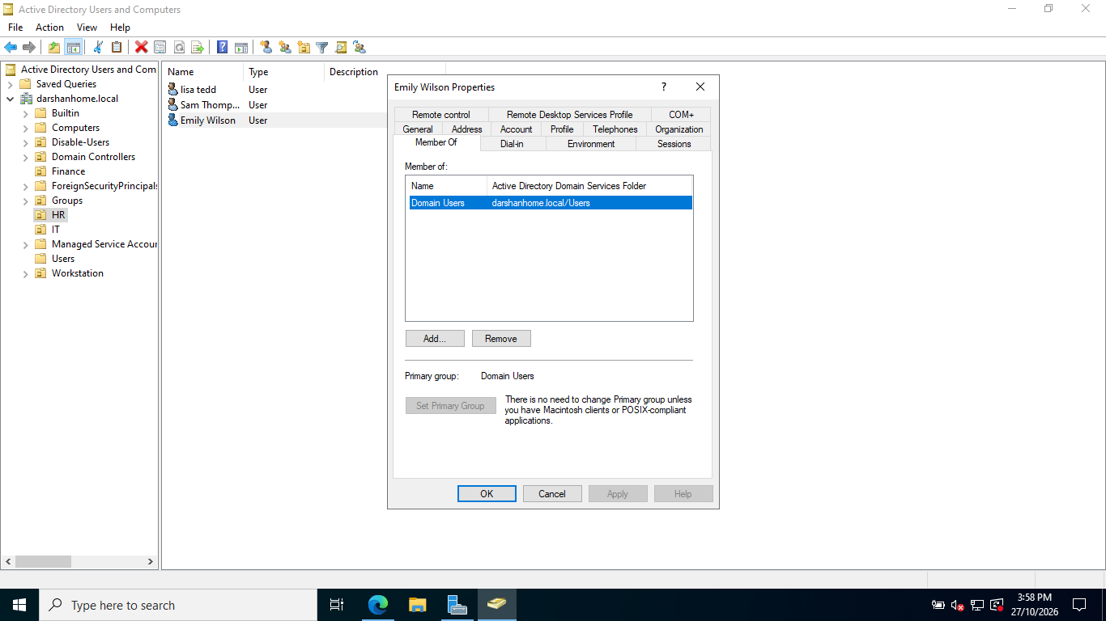
Figure 32 — Removing Obsolete Finance Security Group Membership
The Finance security group was removed from the Emily Wilson account's group memberships as part of the simulated transfer from Finance to HR. This change removes the account's direct membership in the obsolete Finance group, supporting the transition to the new department's access permissions.

- Add the approved HR security group memberships.
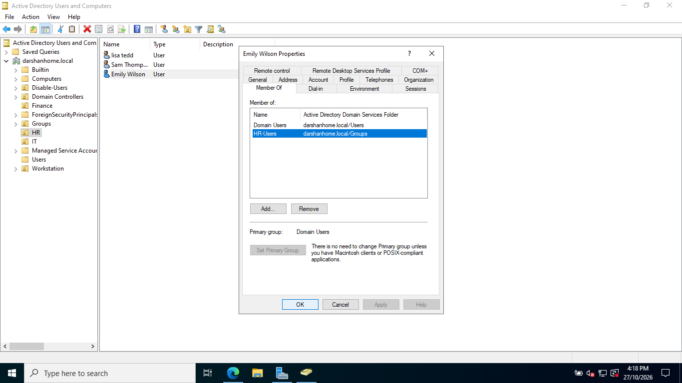
Figure 33 — Adding the Employee to the HR-Users Security Group
The Emily Wilson account was added to the HR-Users security group in Active Directory as part of the simulated department transfer. This membership grants the account the group-based permissions assigned to HR users, subject to the configured folder and share permissions.

- Test access to the HR folder and confirm that access to the Finance folder is no longer available.
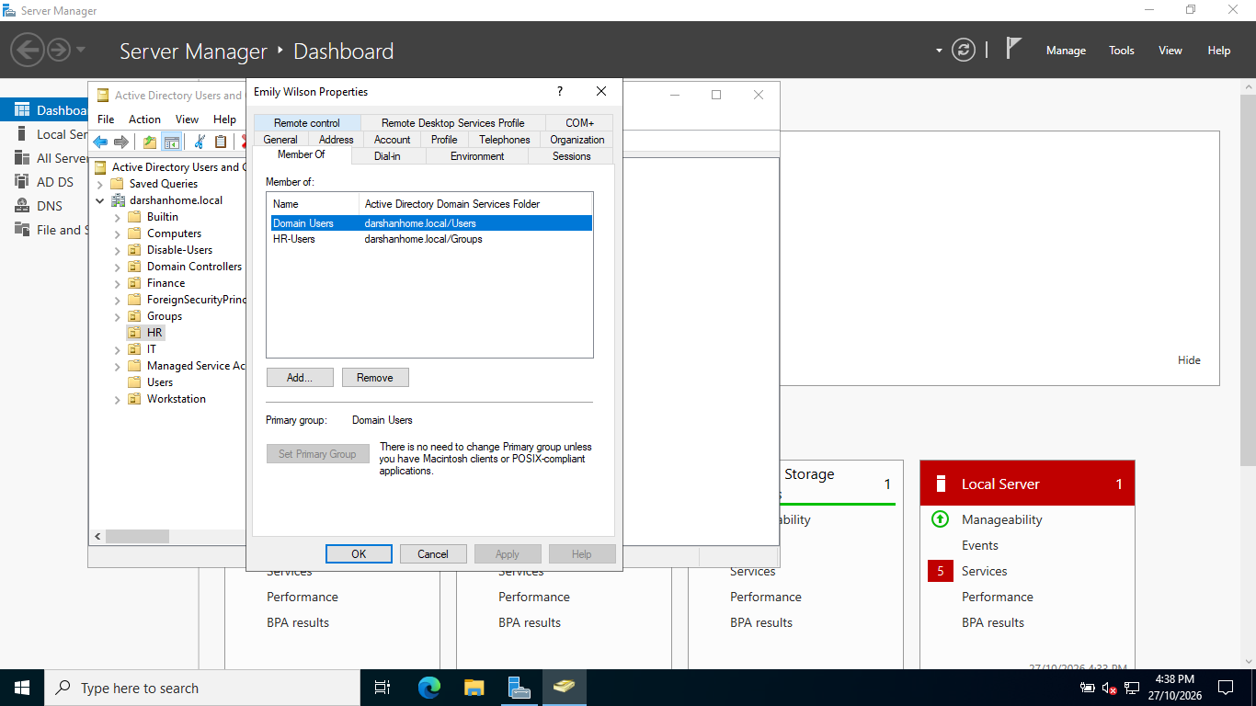
Figure 34 — Verifying HR-Users Security Group Membership
The ewilson account was reviewed in Active Directory to verify its membership in the HR-Users security group following the simulated department transfer. This confirms that the account was assigned to the intended HR security group.

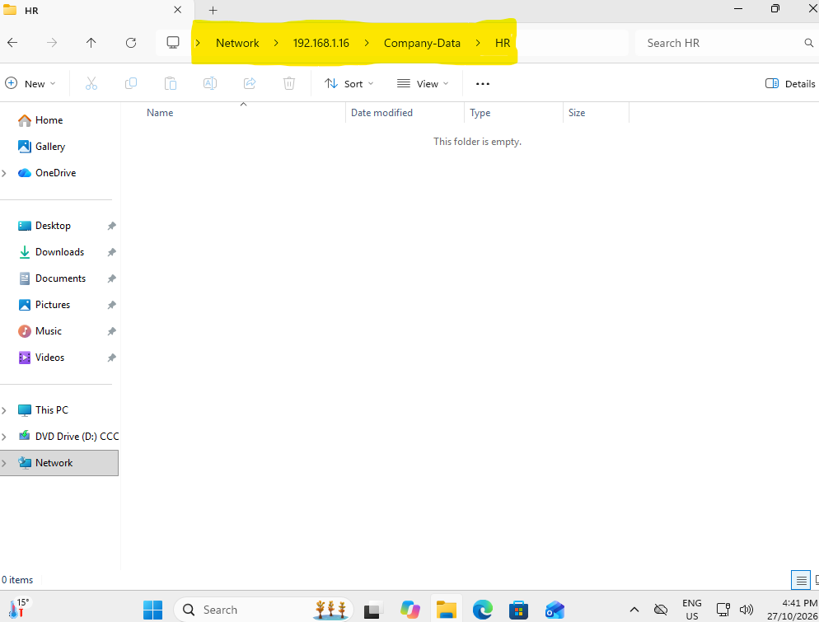

Figure 35 — Verifying Access to the HR Shared Folder
The ewilson account was used in the Windows 11 virtual machine to access the HR shared folder. Access was granted successfully, demonstrating that the account could access the intended departmental resource following the group membership change.

- Record the changes made and the verification results.
4. Investigation and Resolution Notes
Approval Verification:
For this simulated home lab scenario, the department transfer request for Emily Wilson from Finance to HR was treated as approved by the fictional requesting manager, Sarah Mitchell. The requested changes were reviewed before modifying the Active Directory account. In a real IT environment, approval would be verified through the organisation's authorised ticketing or request management system.
Changes Performed:
- Updated Emily Wilson's account description to reflect the department transfer.
- Moved the ewilson account from the Finance OU to the HR OU.
- Removed the Finance security group membership.
- Added the account to the HR-Users security group.
- Captured screenshots documenting the account's original configuration and the changes made in Active Directory Users and Computers (ADUC).

Access Verification:
- HR shared folder: Access was successfully tested from the Windows 11 virtual machine. The account was able to access the HR shared folder.
- Finance shared folder: [Record the actual result after testing. Confirm access was denied before marking this requirement as complete.]

Issues Identified:
No unexpected issues have been reported during the account transfer and HR folder access test so far. Finance folder access remains to be verified before confirming that the employee's previous departmental access has been removed.

Final Resolution:
Emily Wilson's Active Directory account was transferred from Finance to HR. The account's OU placement and security group memberships were updated, and access to the HR shared folder was successfully verified. The final resolution depends on confirming that the account can no longer access the Finance shared folder.

Final Status: Open — Pending Verification of Finance Folder Access.

4.5 Account disablement / offboarding
☐ Use a fictional leaver request with a clear effective date and authorization.

Ticket HD-2026-005 — Account Disablement / Employee Offboarding

1. Ticket Details
Ticket ID: HD-2026-005
Request Type: Account Management / Employee Offboarding
Priority: High
Status: Open — Pending Investigation
Date Raised: 27 October 2026
Effective Date: 30 October 2026, 5:00 PM
Employee Name: Michael Brown
Job Title: Finance Officer
Department: Finance
Username: mbrown
Requested By: Sarah Mitchell — Finance Manager
2. Issue Description
The IT Help Desk has received a simulated employee offboarding request for Michael Brown, whose employment is scheduled to end on 30 October 2026 at 5:00 PM.
The request asks IT to disable the employee's Active Directory account at the authorised effective time to prevent further access to company systems and resources. The account must not be disabled before the effective time unless separately authorised.
The technician must verify the request's authorisation, identify the correct account, confirm the effective date and time, and perform the required account disablement according to the approved procedure.
3. Requested Actions
- Verify the offboarding request and confirm authorisation from the appropriate manager or HR representative.
Authorisation Verification
For this simulated offboarding scenario, the request to disable Michael Brown's (mbrown) Active Directory account was treated as authorised by the fictional requesting manager, Sarah Mitchell, Finance Manager. The request specified an effective date and time of 30 October 2026 at 5:00 PM. The account details and requested action were reviewed before proceeding.

In a real help desk environment, the technician would verify the request through an approved HR or ticketing system and confirm the effective date and time before disabling the account.

- Locate the correct account in Active Directory Users and Computers (ADUC).
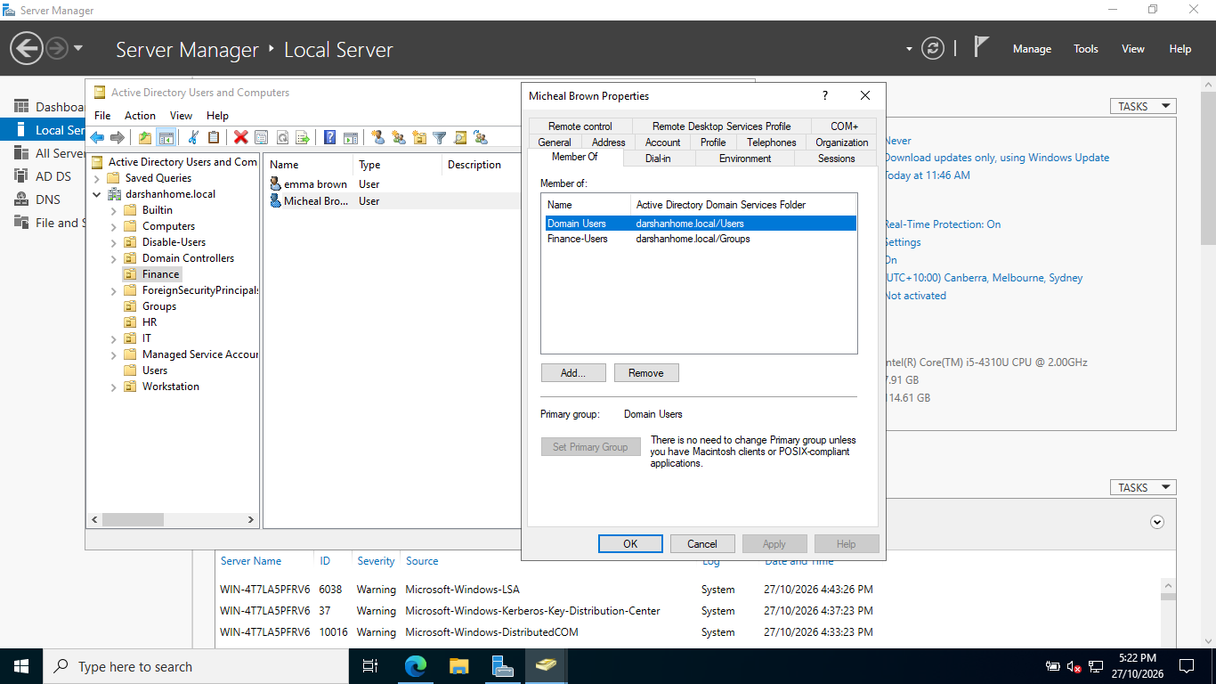
Figure 37 — Identifying the Employee Account and Reviewing Group Memberships
The mbrown account was located in the Finance organisational unit (OU) in Active Directory Users and Computers (ADUC). The account's group membership details were reviewed to help confirm the account's identity and identify the departmental access associated with it before offboarding. This establishes the account's existing configuration before disablement.

- Review the account status before making changes.
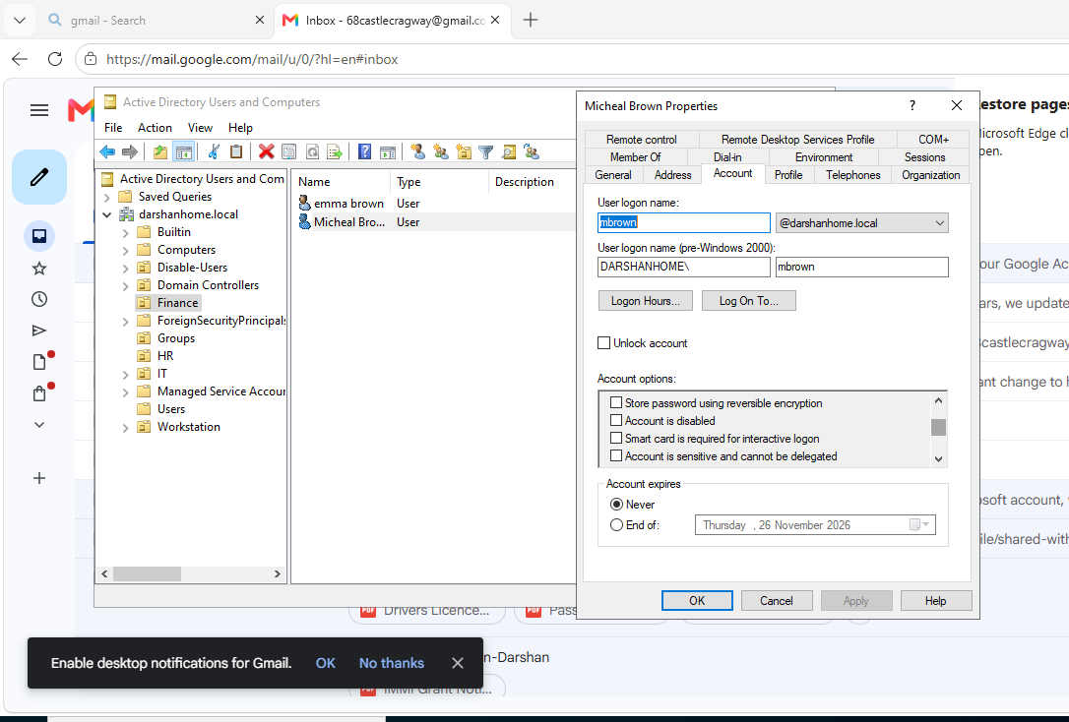

Figure 38 — Reviewing the Account Status Before Disablement
The mbrown account properties were reviewed in Active Directory Users and Computers (ADUC) before performing the offboarding action. The Unlock account option was unticked, indicating that the account was not marked as locked at the time of inspection. The Account is disabled option was also unticked, confirming that the account was enabled before the simulated offboarding process.

- Disable the account at the authorised effective time.
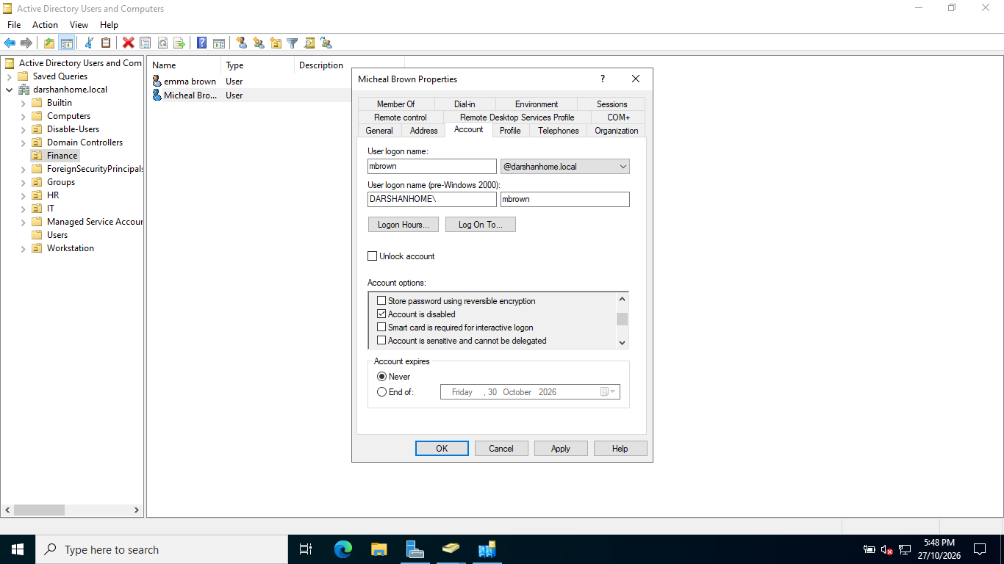
Figure 39 — Disabling the Employee Account in Active Directory
The mbrown account was disabled in Active Directory Users and Computers (ADUC) as part of the simulated employee offboarding process. The Account is disabled option was selected, while the account expiry setting was left as Never. This demonstrates how to disable an account without deleting it, preserving the account and its configuration for auditing and future reference.

- Verify that the account is disabled in Active Directory.
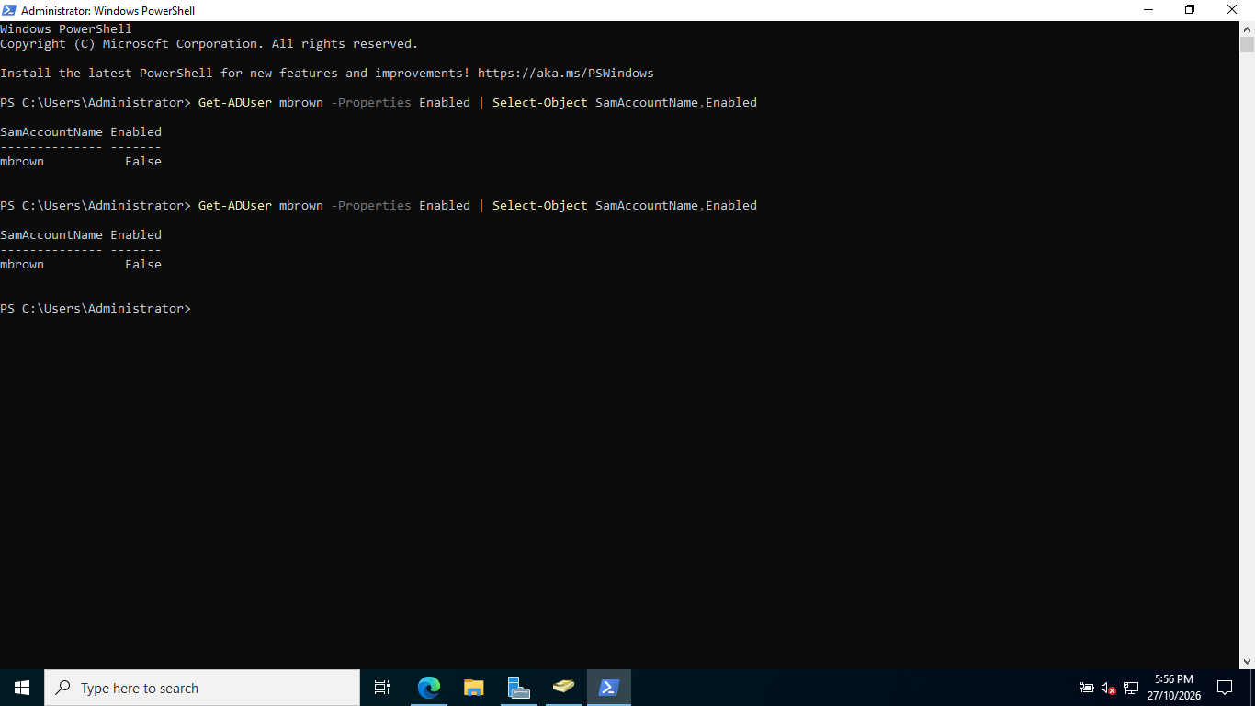

Figure 40 — Verifying Account Disablement Using PowerShell
PowerShell was used to verify the status of the mbrown Active Directory account. The output showed Enabled = False, confirming that the account was disabled. This verification provides additional evidence that the account disablement action was applied successfully as part of the simulated employee offboarding process.

- Attempt a sign-in using the test account to confirm that interactive domain access is blocked.

Figure 41 — Verifying Sign-In Restriction for a Disabled Account
An interactive domain sign-in was attempted using the mbrown test account from the Windows 11 virtual machine. The sign-in was denied, and the displayed message indicated that the account was disabled. This confirmed that the disabled Active Directory account could not be used to sign in interactively to the domain in the lab environment.

- Record the actions taken, verification results and any outstanding offboarding tasks.
Actions Taken:
- Reviewed the simulated offboarding request and treated it as authorised by the fictional requesting manager, Sarah Mitchell, Finance Manager.
- Located Michael Brown's (mbrown) account in the Finance organisational unit (OU) in Active Directory Users and Computers (ADUC).
- Reviewed the account's existing status and group memberships before making changes.
- Disabled the account using ADUC without deleting it, preserving the account for auditing and record-keeping.
- Set the account expiry setting to Never, with the account disabled explicitly through the Account is disabled option.

4. Investigation and Resolution Notes
Authorisation Verification:
- Verified the account status using PowerShell, which returned Enabled = False.
- Attempted an interactive domain sign-in from the Windows 11 virtual machine using the test account.
- The sign-in was denied, and the displayed message indicated that the account was disabled.
- The verification steps confirmed that the account disablement was effective in the lab environment.

Outstanding Actions:
- In a real environment, confirm that all offboarding requirements have been completed, including any required access removal, session revocation, asset return and record updates, according to organisational policy.
- Confirm that relevant stakeholders have been notified and the ticket evidence has been retained.
- This was a lab simulation performed before the fictional effective date of 30 October 2026 at 5:00 PM. In a real environment, disablement should occur at the authorised time unless earlier action has been separately approved.

Final Status: Completed — Verified in Lab Simulation.

4.6 Account reactivation and access review
☐ Use an authorised fictional request to re-enable a disabled test account.
IT Help Desk Practical Project — Ticket HD-2026-006
Account Reactivation and Access Review
Ticket ID: HD-2026-006
Request Type: Account Management / Account Reactivation
Priority: Medium
Status: Open — Pending Investigation
Date Raised: 27 October 2026
Requested Reactivation Date: 27 October 2026
Environment: Home Lab — Windows Server Active Directory and Windows 11 VM
1. User Details
- Employee Name: Michael Brown
- Username: mbrown
- Department: Finance
- Organisational Unit: Finance
- Requester: Sarah Mitchell — Finance Manager (fictional)
2. Issue Description
The employee's Active Directory account was previously disabled as part of a simulated employee offboarding exercise. A new fictional request has been received to reactivate the account because the employee is assumed to be returning to work.
The requester has asked the IT Help Desk to re-enable the account and verify that the employee can sign in successfully.
3. Request and Authorisation
For this lab exercise, the fictional request is treated as authorised by Sarah Mitchell, Finance Manager.
Before making changes, the technician should confirm the requester's authority, the employee's identity, the reason for reactivation and the authorised reactivation date. In a real environment, approval should be verified through the organisation's approved ticketing or HR process.
4. Resolution Criteria
The ticket can be marked as completed when:
- The account is confirmed as enabled in Active Directory.
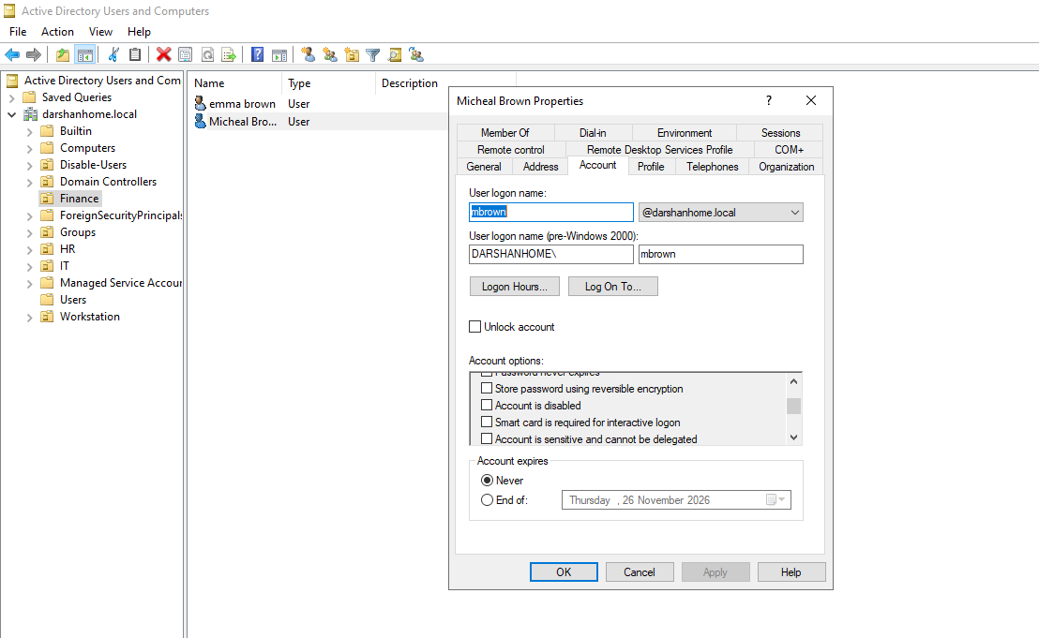

Figure 42 — Re-enabling the Employee Account in Active Directory
The mbrown account was located in the Finance organisational unit (OU) in Active Directory Users and Computers (ADUC). The Account is disabled option was unticked, and the changes were applied to re-enable the account. The existing password was retained because a password reset was not required as part of this simulated reactivation task.

- PowerShell verification returns Enabled = True.
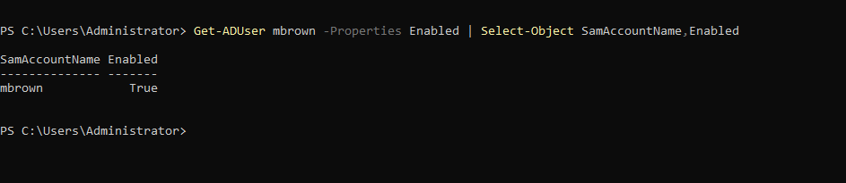
Figure 43 — Verifying Account Reactivation Using PowerShell
PowerShell was used to verify the status of the mbrown Active Directory account following reactivation. The output returned Enabled = True, confirming that the account was enabled successfully. This verification provides evidence that the account reactivation action was applied correctly in the simulated lab environment.

- The employee can successfully sign in to the domain.
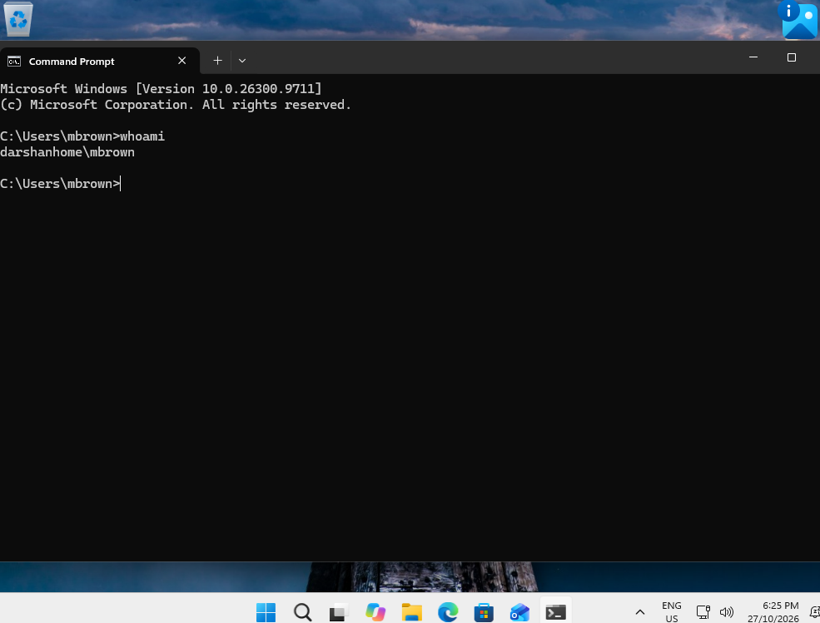
Figure 44 — Verifying Successful Domain Sign-In After Account Reactivation
After re-enabling the mbrown account in Active Directory, an interactive sign-in was performed from the Windows 11 virtual machine. The whoami command was executed in Command Prompt to verify the identity of the signed-in user. The output confirmed that the session was running under the expected domain account, demonstrating successful sign-in following account reactivation in the lab environment.

- Appropriate Finance folder access is verified.
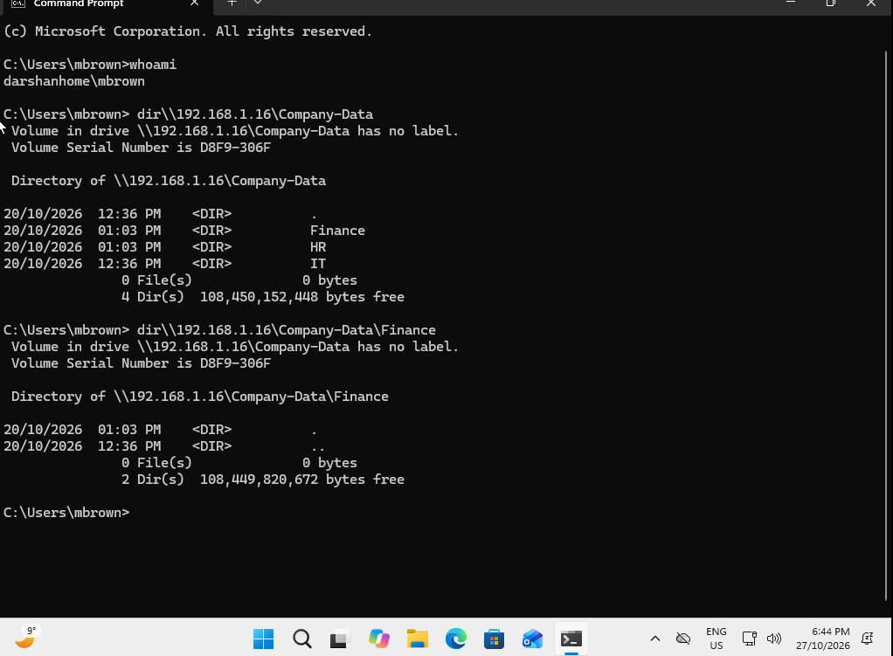
Figure 45 — Verifying Finance Shared Folder Access Using Command Prompt
The whoami command was used to confirm that the signed-in user was the reactivated mbrown domain account. The dir command was then used to access the Company and Finance shared folders. The command output confirmed that the account could access the relevant shared resources, demonstrating that authorised Finance folder access was available following account reactivation in the lab environment.

- Unauthorised departmental access remains restricted.
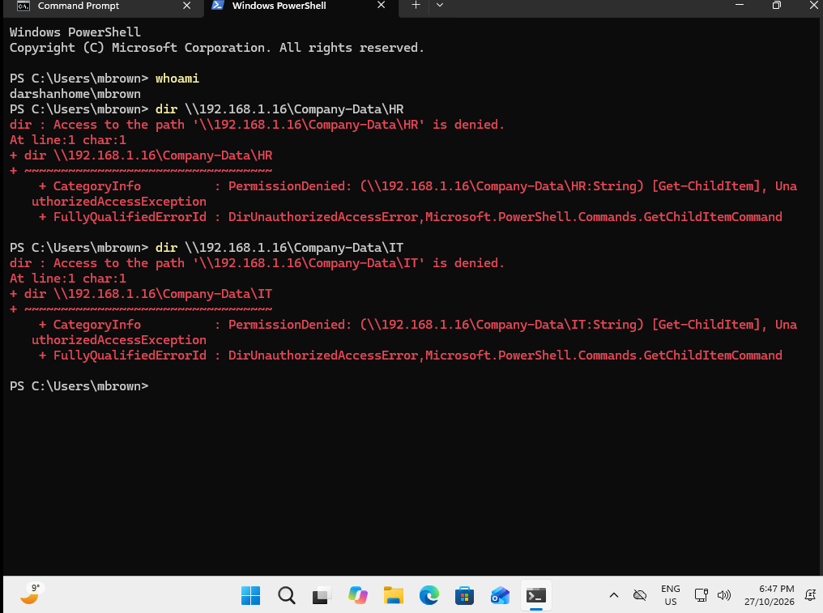
Figure 46 — Verifying Restricted Access to Unauthorised Departmental Folders
The whoami command was used to confirm that the signed-in user was the reactivated mbrown domain account. The dir command was then used to test access to the HR and IT shared folders. Both access attempts were denied, confirming that the account remained restricted from these departmental resources. This demonstrates that account reactivation restored access to the authorised Finance resources while maintaining the existing departmental access restrictions in the lab environment.

Final Status: Pending Completion of Lab Verification.

Resolution Summary: The mbrown Active Directory account was successfully re-enabled. PowerShell confirmed that Enabled = True, and an interactive domain sign-in was successful. Access to the authorised Finance shared folder was verified, while access to the HR and IT shared folders remained restricted. All verification results were documented as part of the simulated account reactivation and access review process.

5. Reflection and Next Steps
Which workflow was easiest, and why?
The group membership workflow was the easiest because Active Directory Users and Computers provides a straightforward way to manage security group membership. I could add or remove a test user, verify the membership and test access to the shared folder. This helped me understand how group-based permissions simplify access management.

Which issue took the longest to diagnose?
Domain sign-in troubleshooting required the most investigation because several factors can cause authentication failures, including incorrect username or domain format, account status, network connectivity, DNS configuration and time synchronisation. Checking each factor systematically helped narrow down the possible causes without making unnecessary changes.

What evidence helped you confirm the root cause?
The most useful evidence was the exact sign-in error message, Active Directory account status, ipconfig /all output, DNS lookup results, domain controller discovery results and the outcome of a sign-in test after a controlled change. Comparing the results before and after the change helped determine whether the suspected cause was supported by evidence. If the available evidence was insufficient, the root cause would remain unconfirmed.

What would you escalate to a Level 2 technician?
I would escalate issues affecting multiple users, domain controller or DNS service failures, suspected Active Directory replication or trust problems, and authentication issues that remain unresolved after standard Level 1 checks. I would provide the ticket history, exact error messages, relevant command outputs, troubleshooting steps completed and any changes made.

What would you improve if this were a production environment?
In a production environment, I would follow the organisation's incident management procedures, verify the user's identity and authorisation, and obtain approval before making changes that could affect access. I would document all actions in the ticketing system, protect sensitive information, minimise disruption and follow change management procedures where required. I would also ensure that access permissions follow the principle of least privilege.

What is the next skill or project to practise?
My next step is to practise more Windows troubleshooting scenarios, including DNS resolution failures, network connectivity problems, locked accounts, password resets and Microsoft 365 sign-in issues. I would also continue developing my Active Directory and PowerShell skills, then progress to Microsoft Entra ID and Azure fundamentals to prepare for an entry-level IT Help Desk role.

