**CMPE 202 – Gym Management System – API screenshot Documentation**

To retrieve all the location objects

GET

<http://localhost:8000/api/locations/>

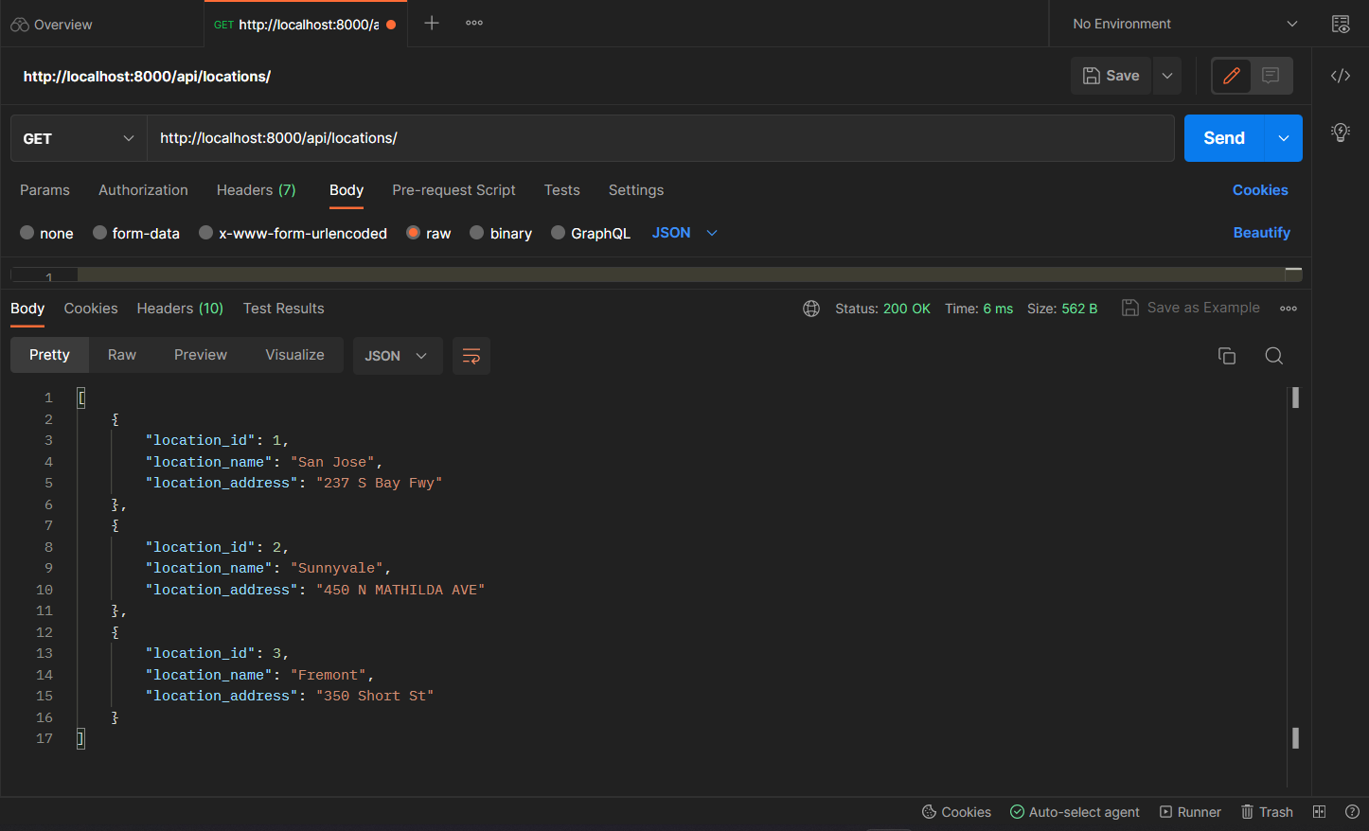

To retrieve all location names and addresses

GET

<http://localhost:8000/api/locationdetails/>

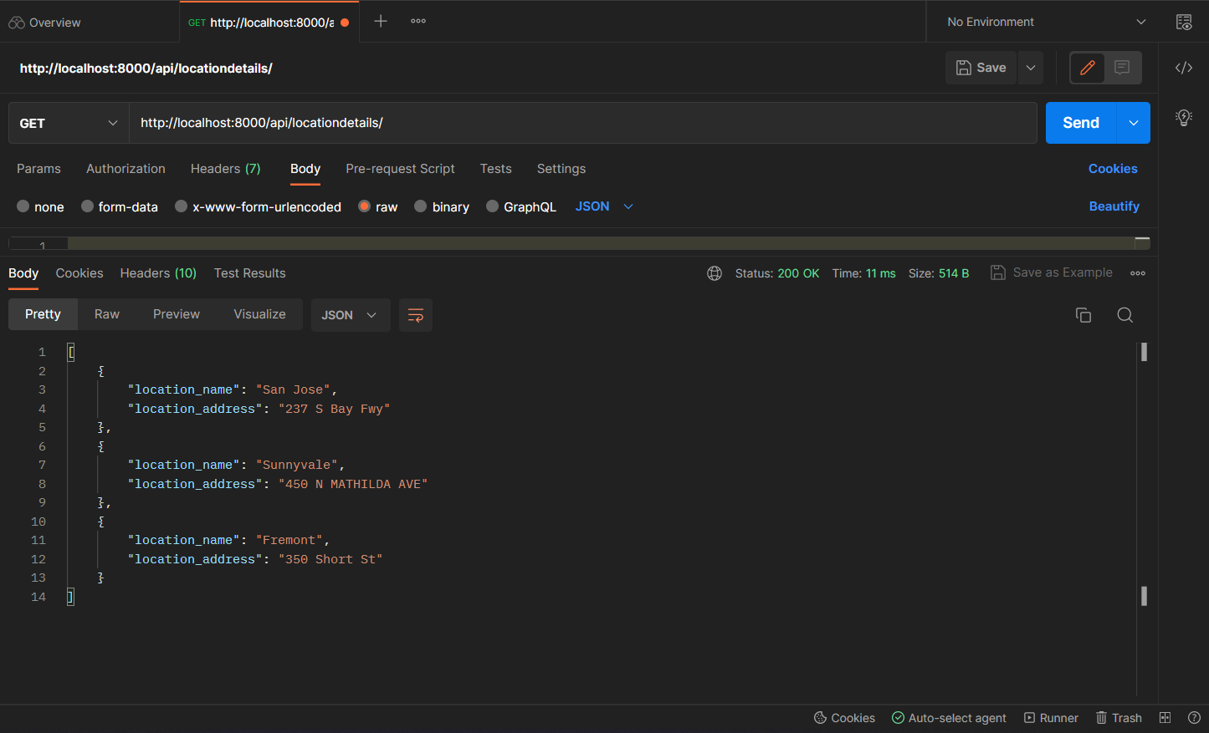

Admin can only add class Trainings

POST

<http://localhost:8000/api/addClassSchedules/>

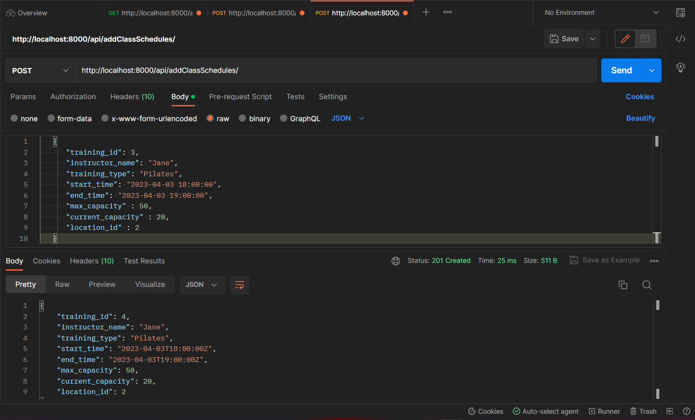

Members cannot add the class as shown in the below screenshot

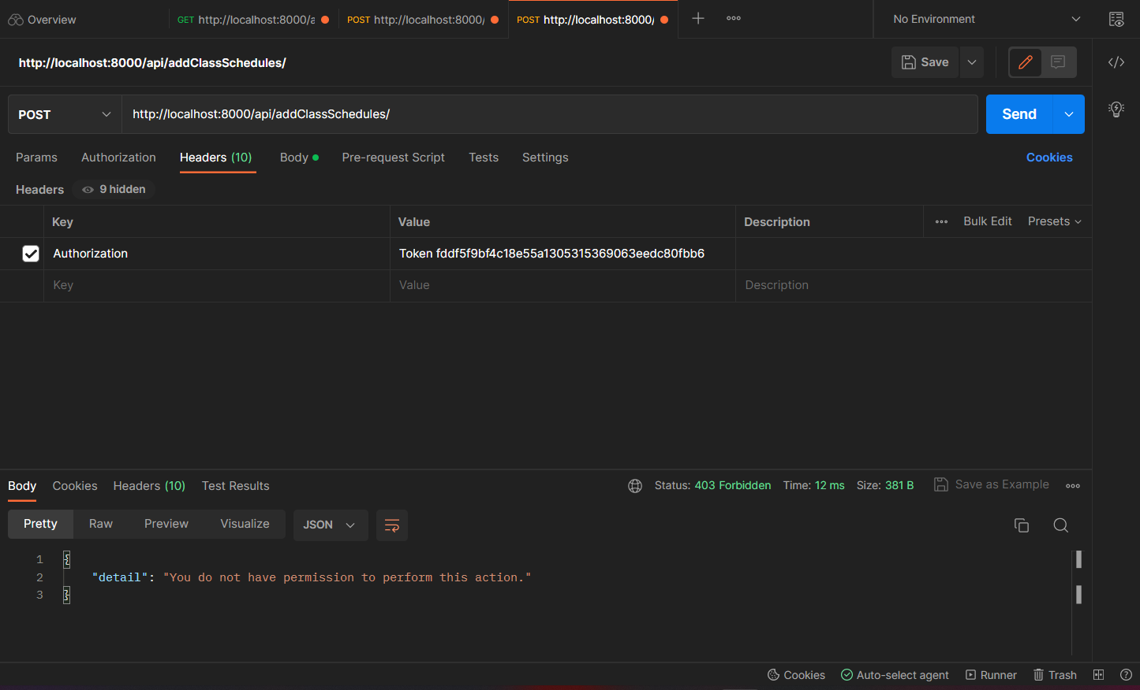

If end time is < start time classes cannot be added as expected

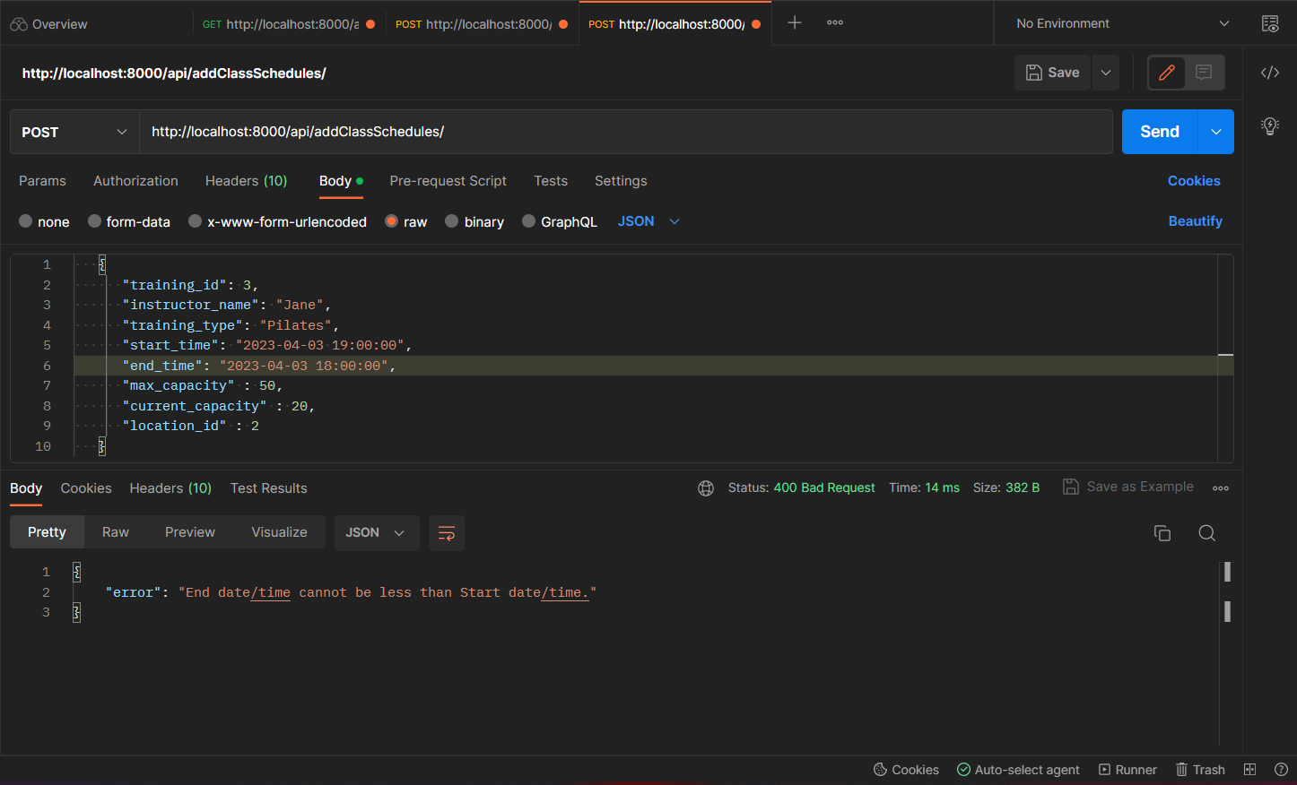

To view member specific enrollment details

GET

<http://localhost:8000/api/viewmembertrainingenrollment/>

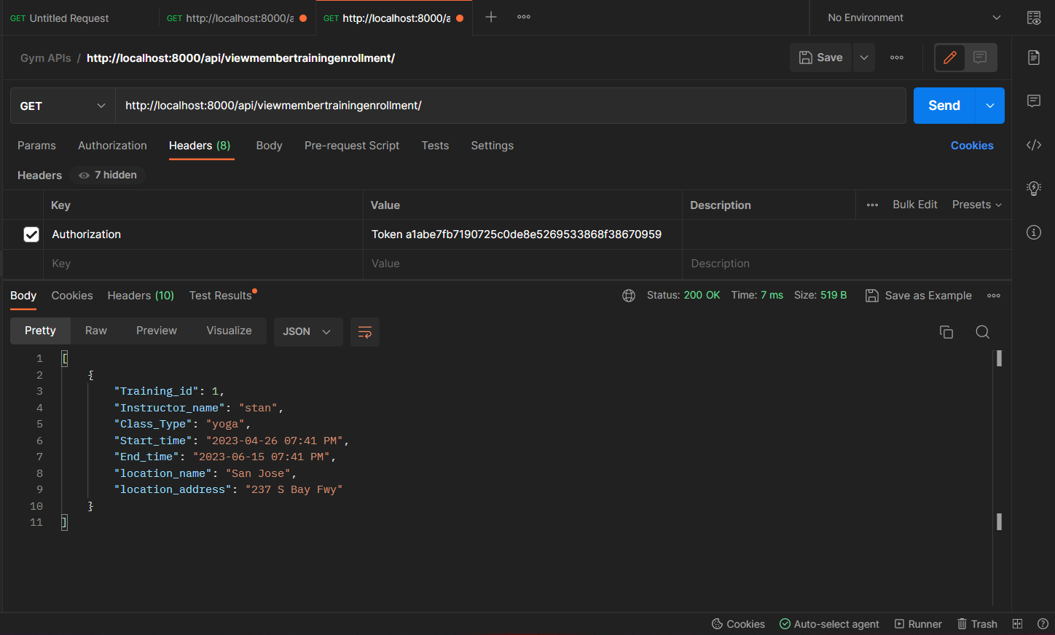

To view the usage of equipments based on location for admin dashboard

GET

<http://localhost:8000/api/equipmenttypes/1>

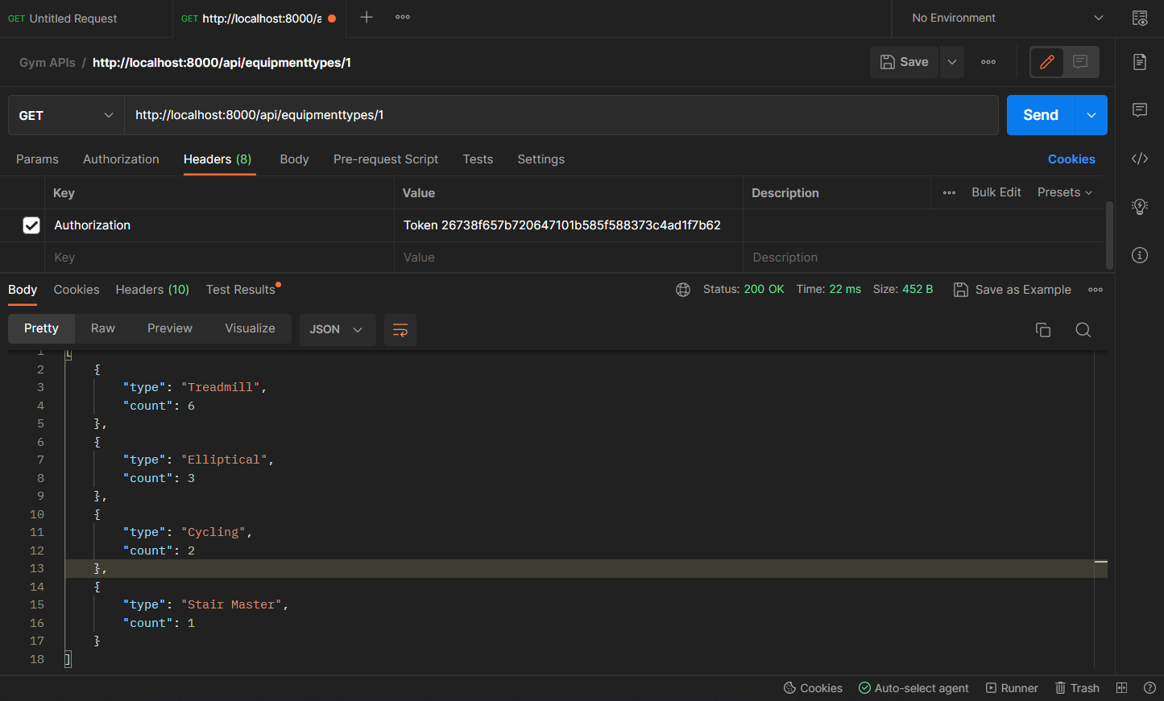

To Login:

POST

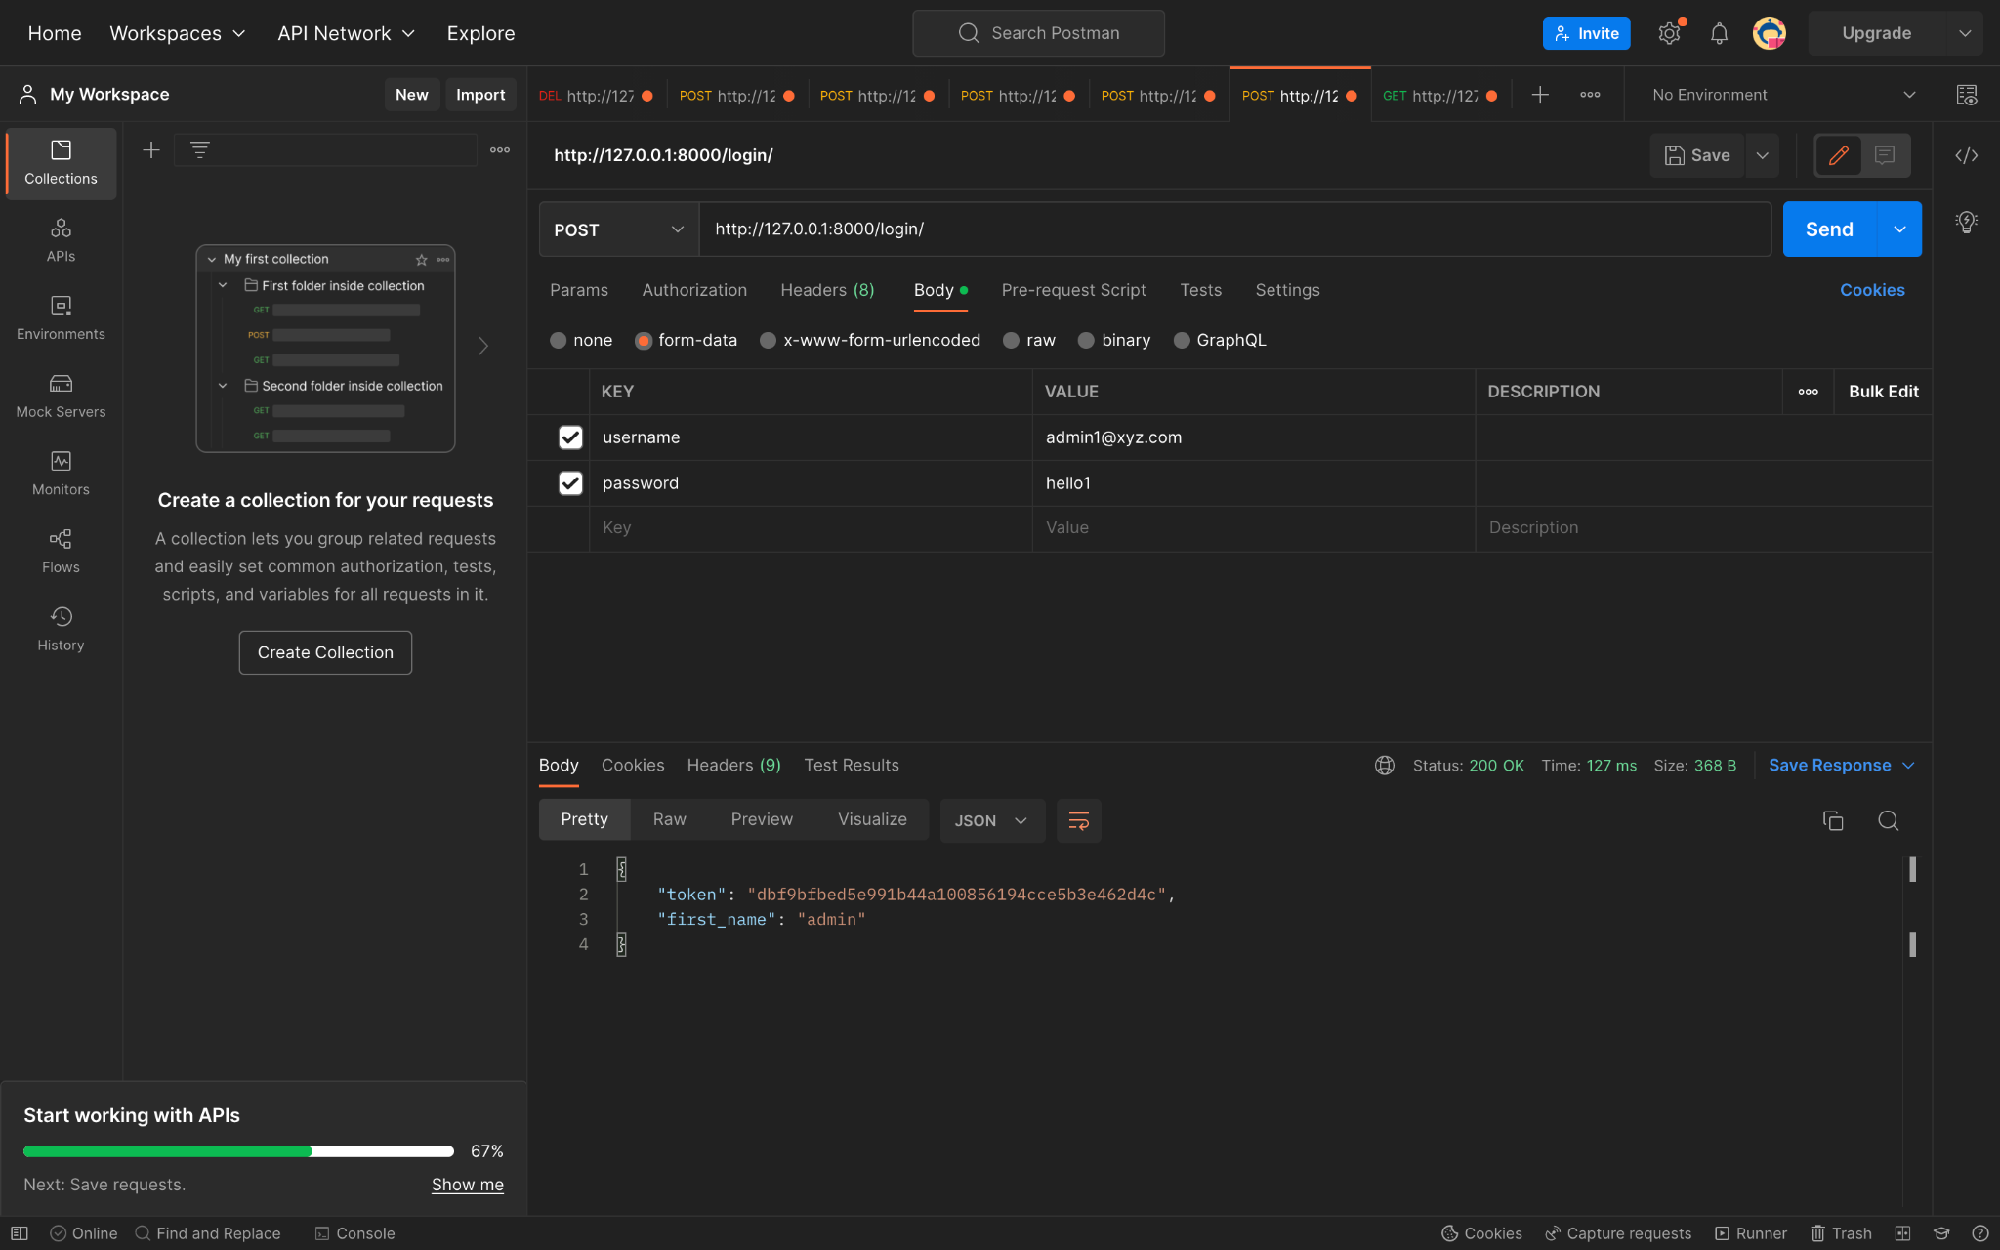

Invalid credentials in login:

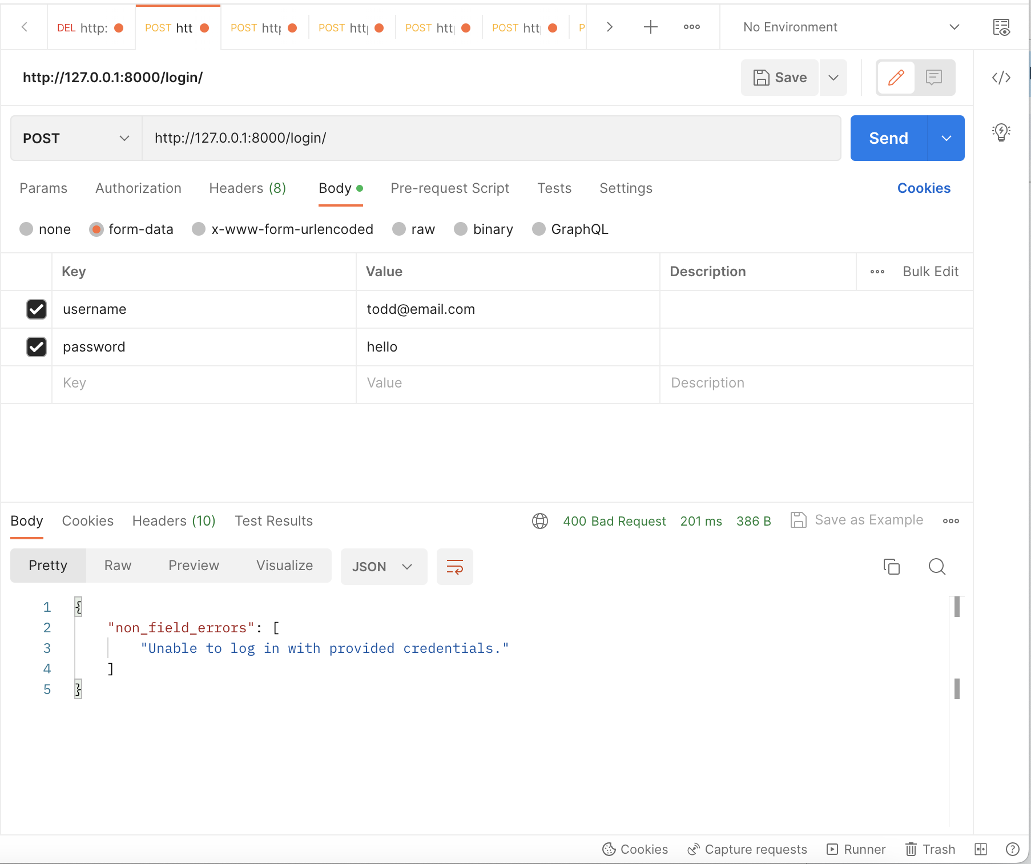

To Logout:

DELETE

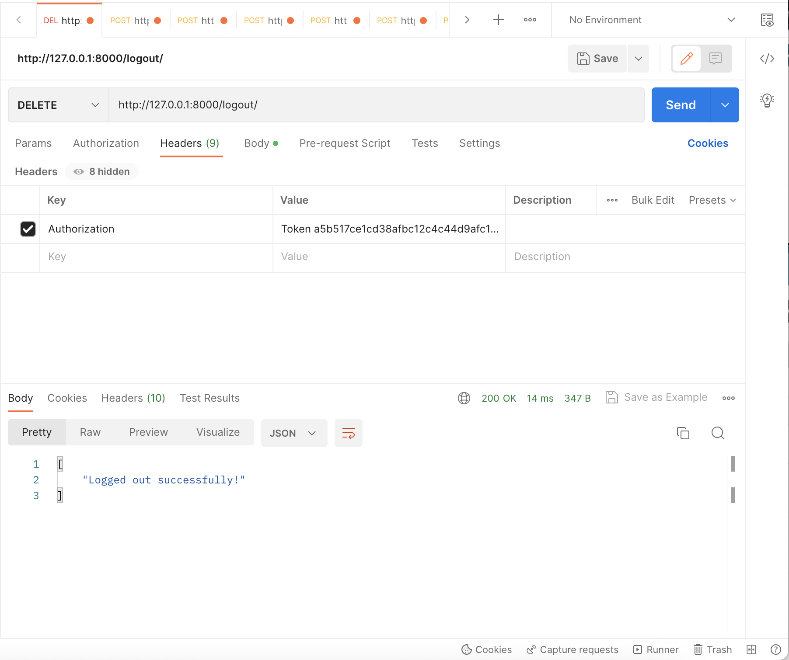

To enroll Users:

POST:

To add members:

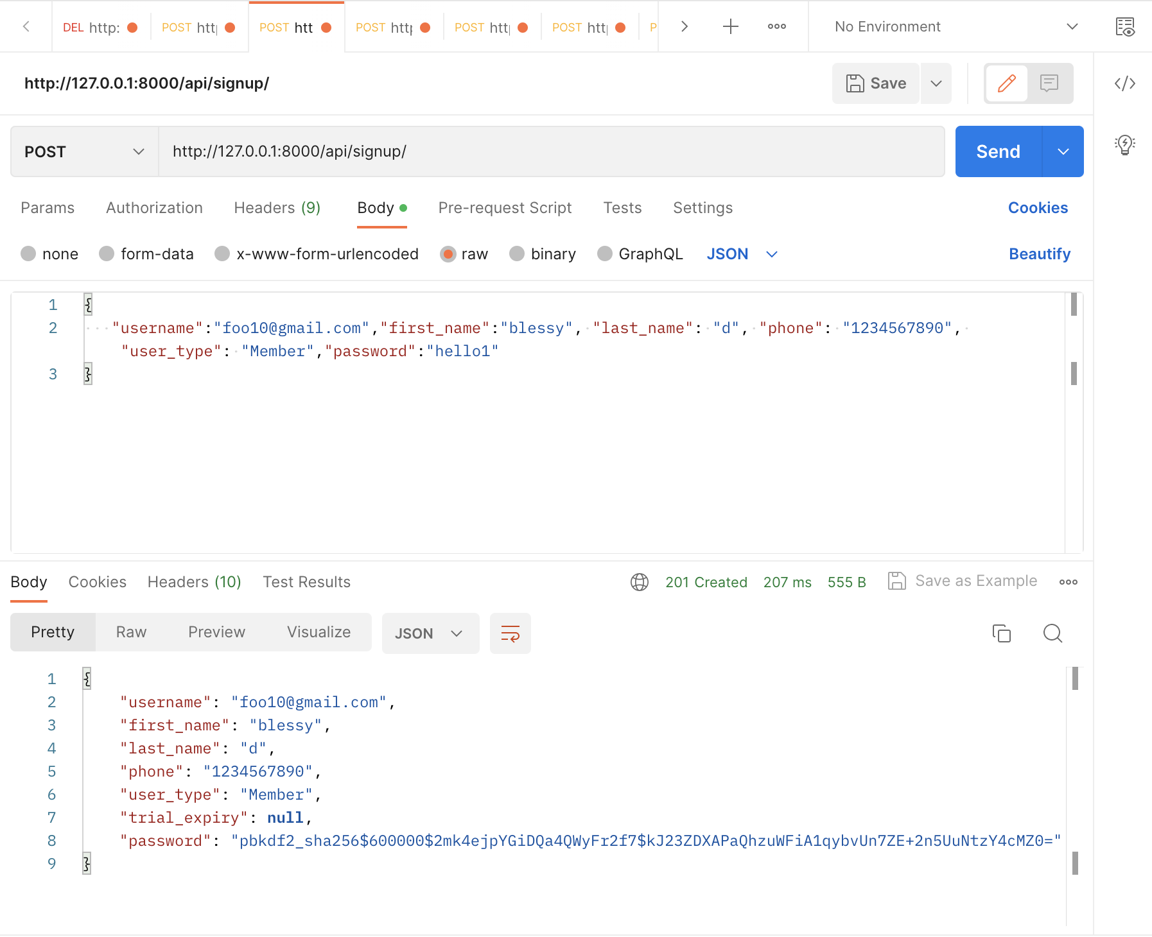

To add admin users:

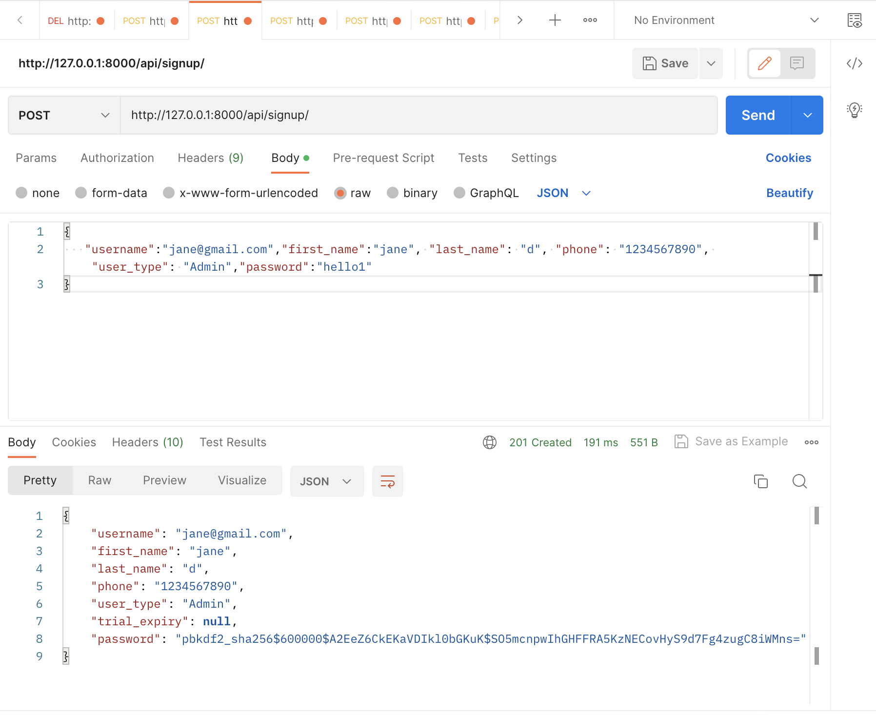

To add Non-members:

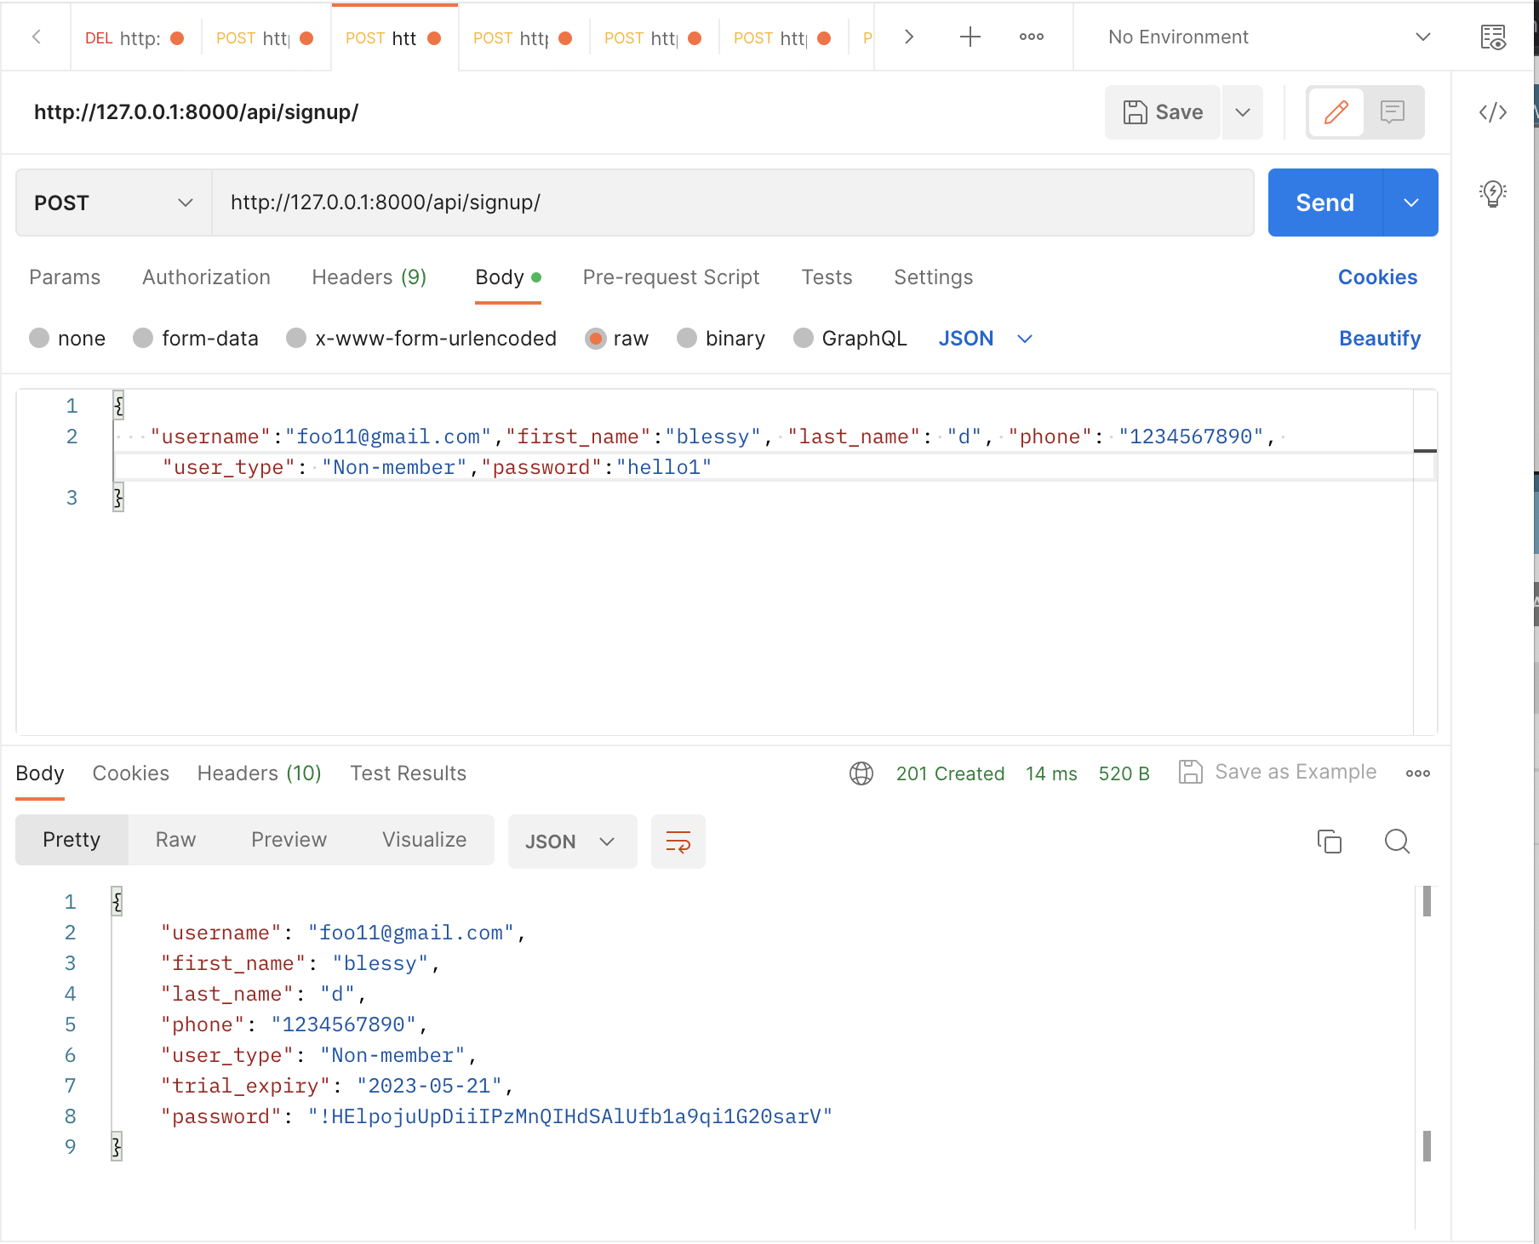

To update membership of non-members to members:

PUT

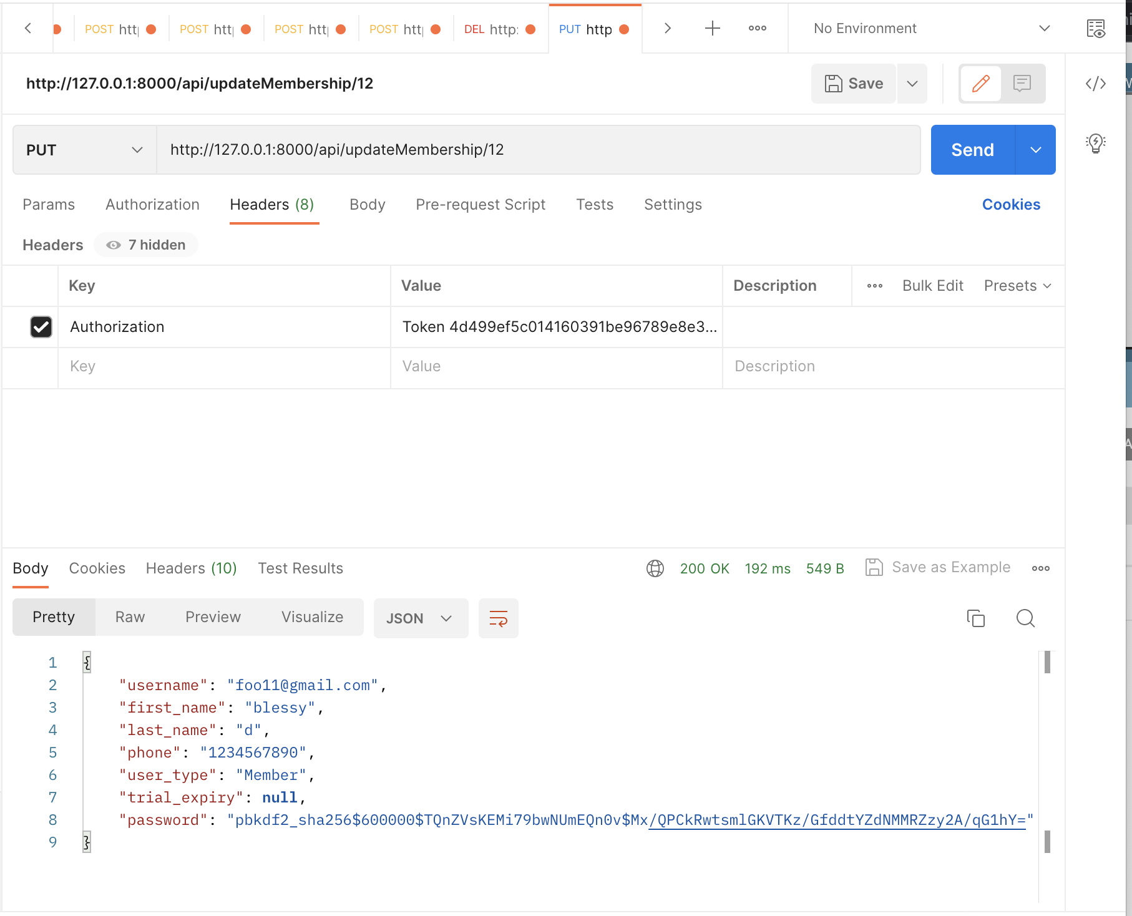

return error if already a member:

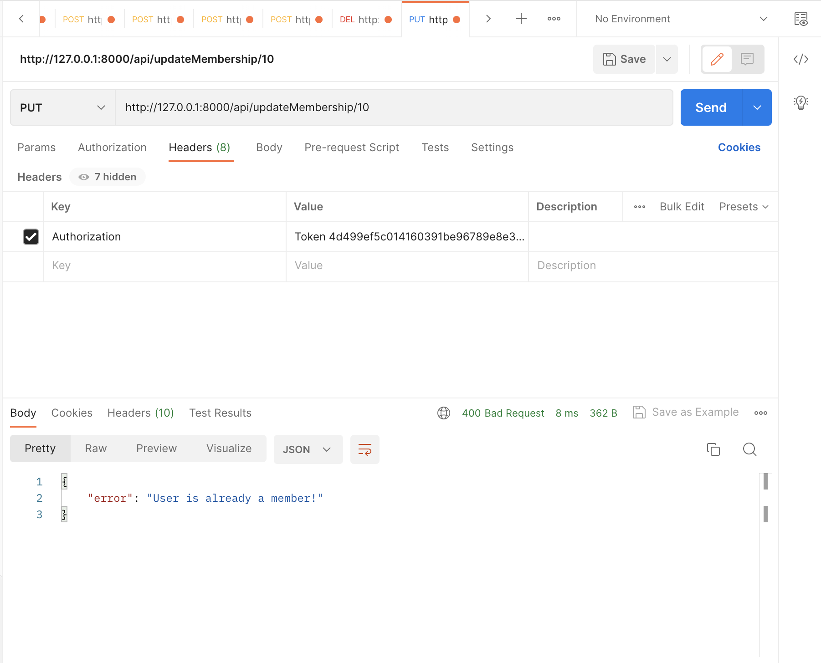

To view activities logged by a member:

GET:

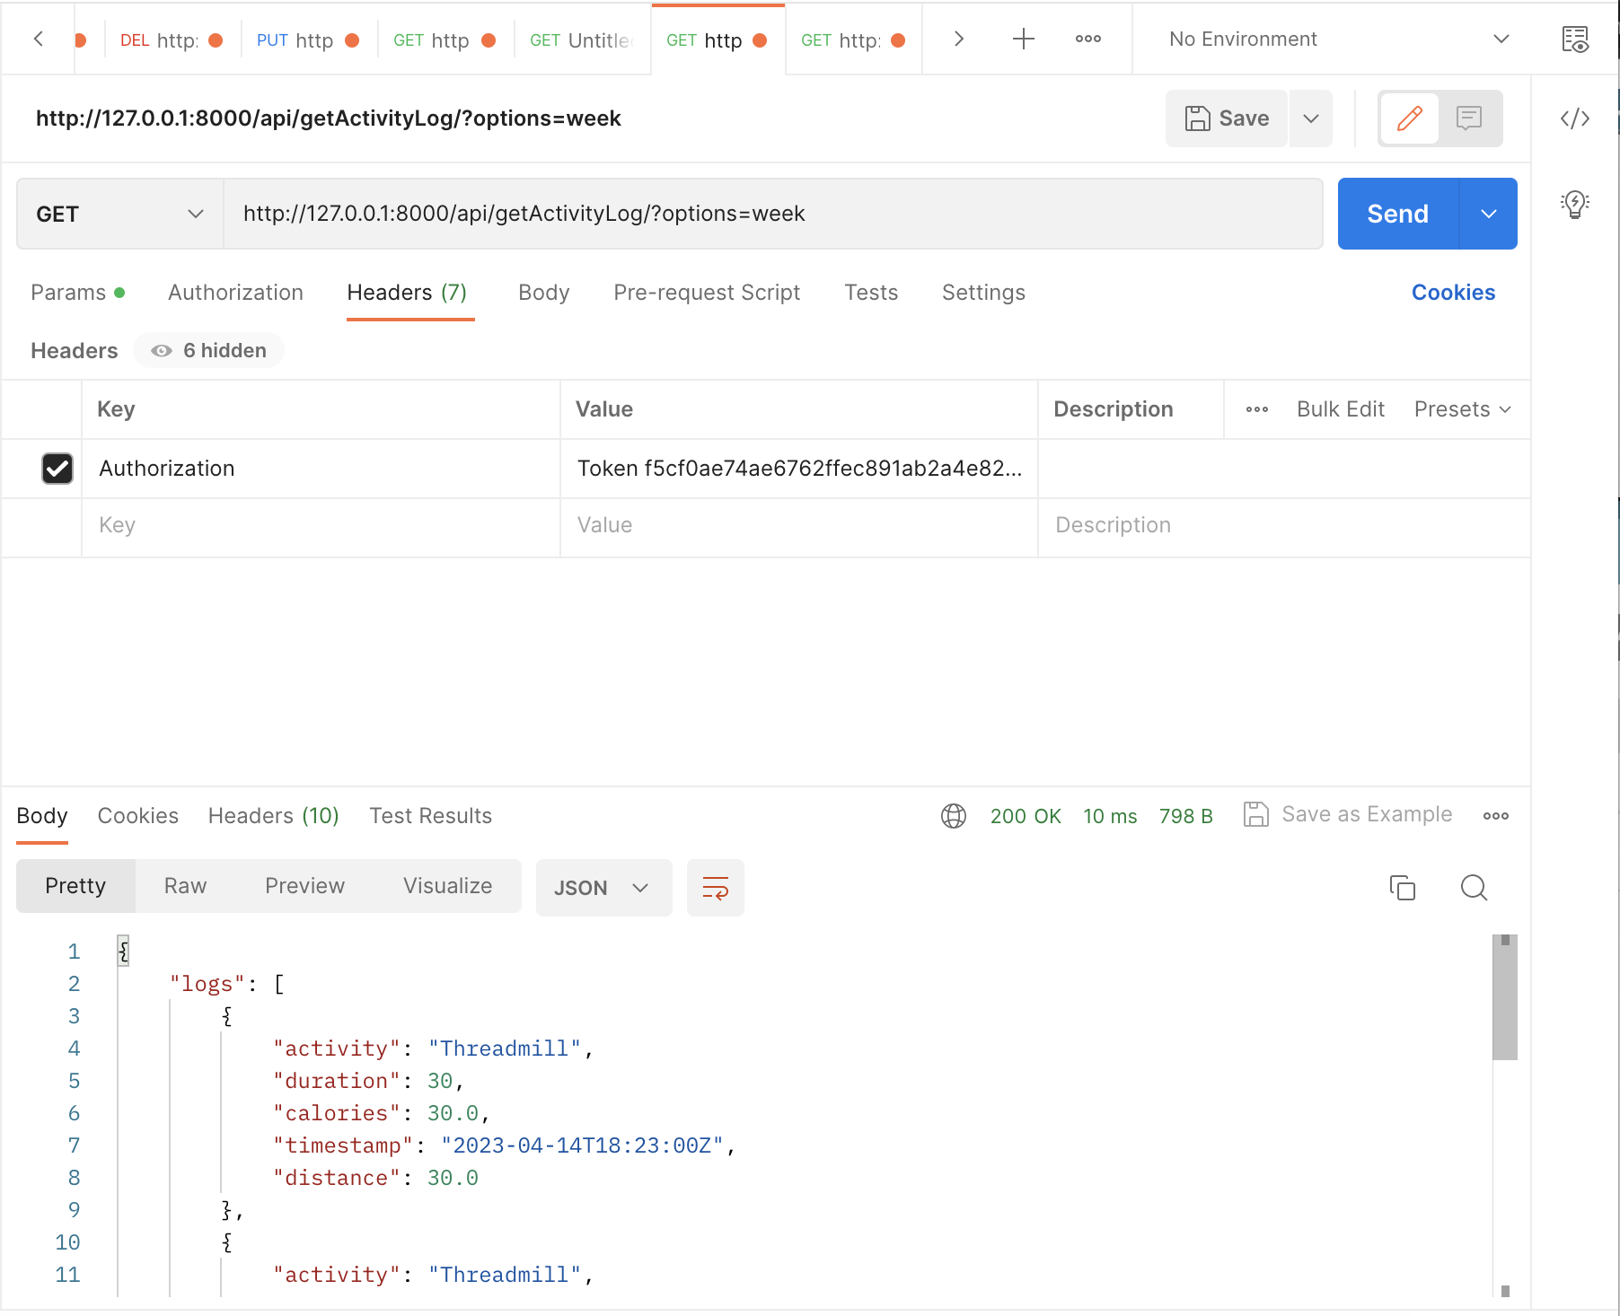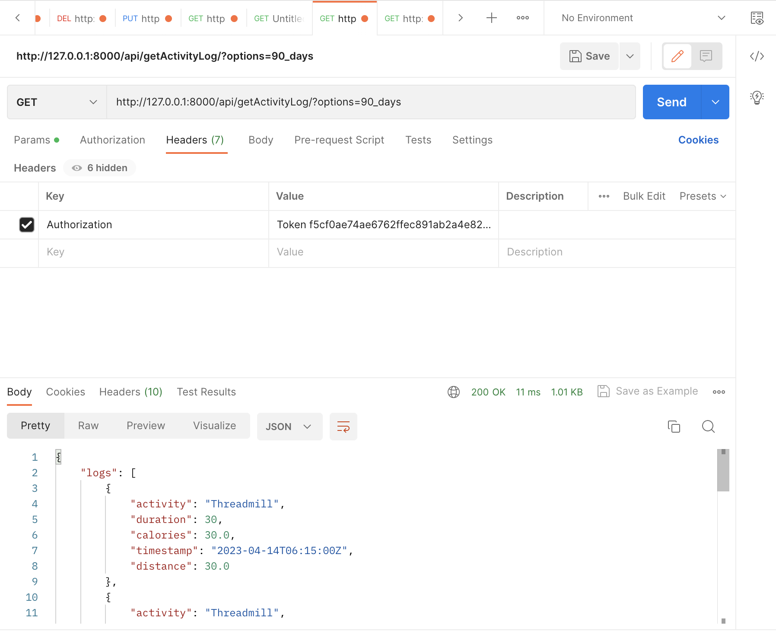

To view analytics of number of visitors by hour:

GET:

Three option in query param:weekday,weekend and date

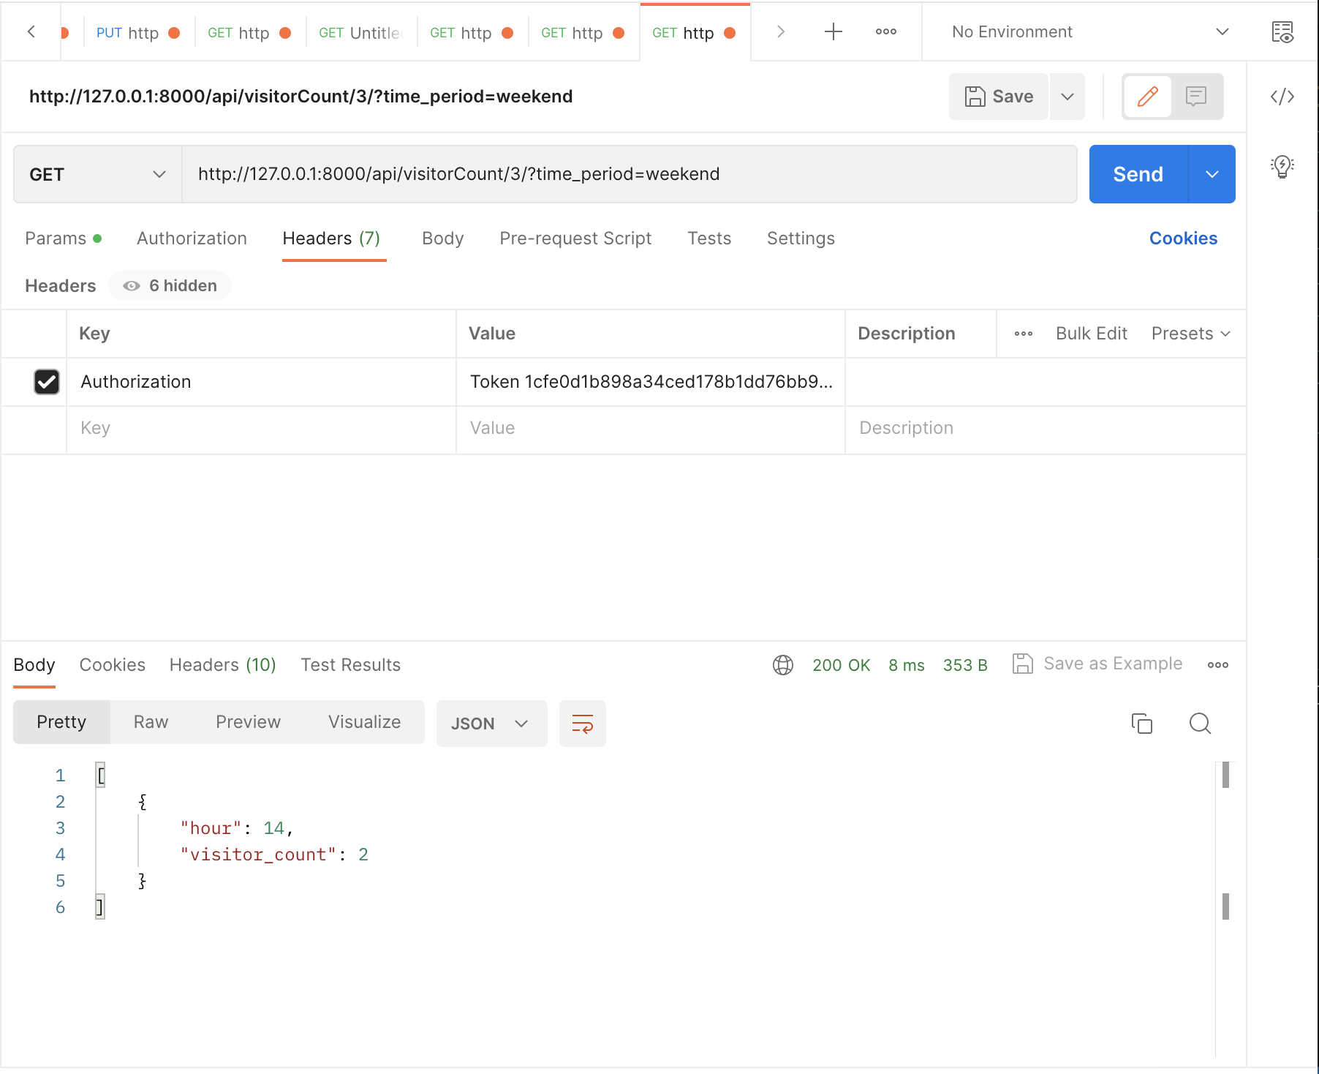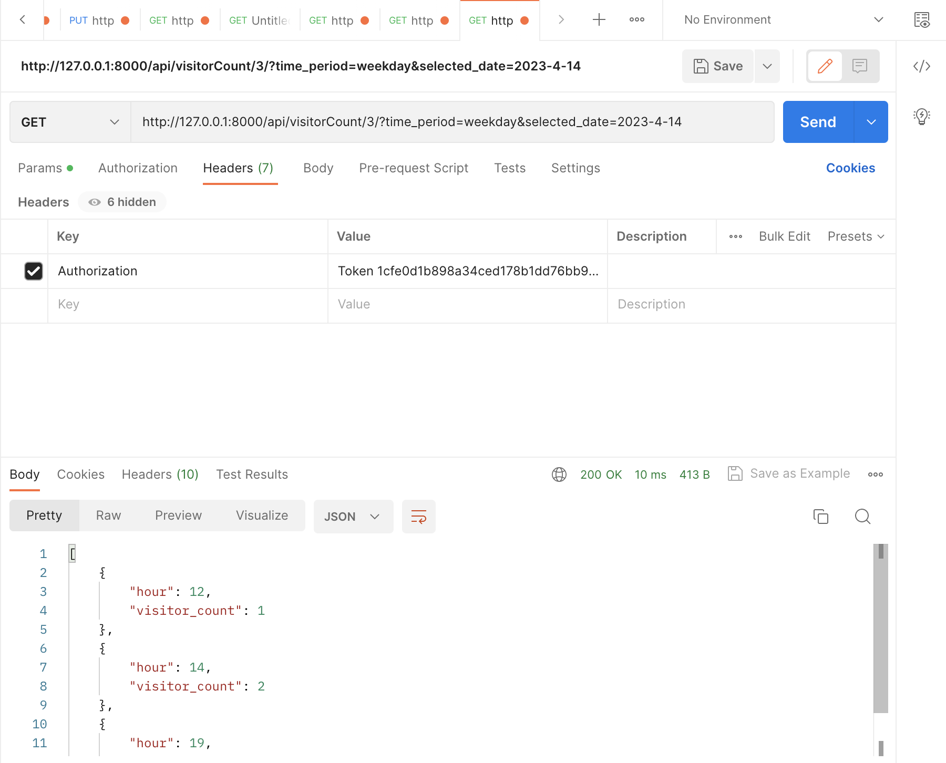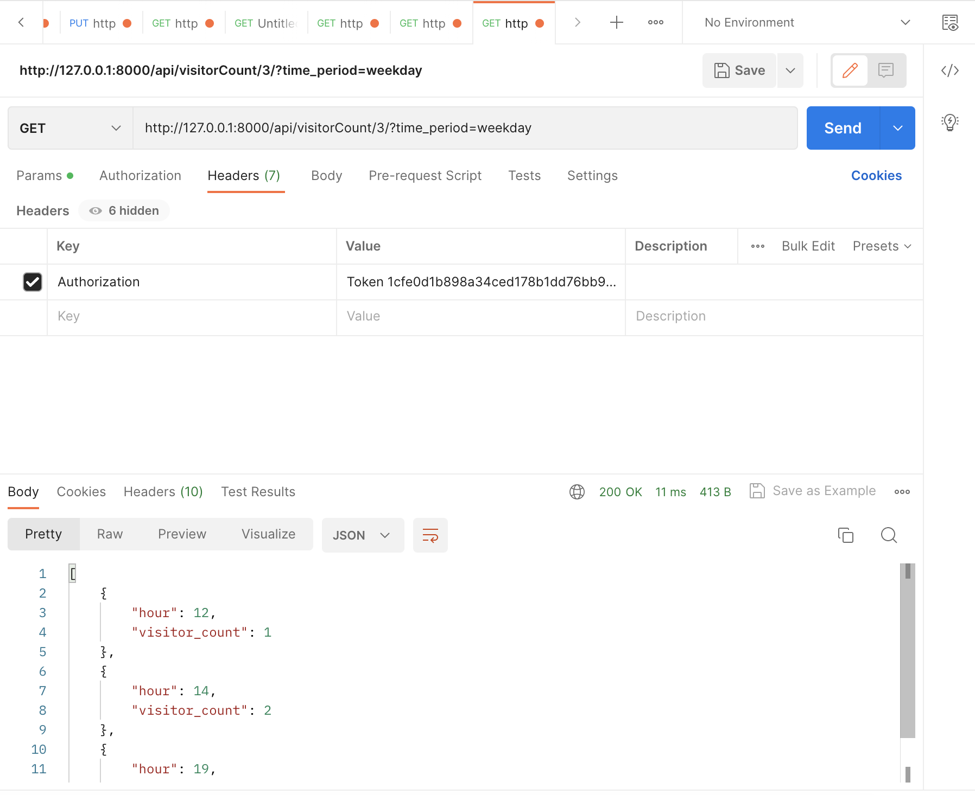

Signup for training Members :

<http://127.0.0.1:8000/api/signupfortraining/>

User must be signed in to enroll for trainings

POST :

**Validation 1**: if the user is already registered

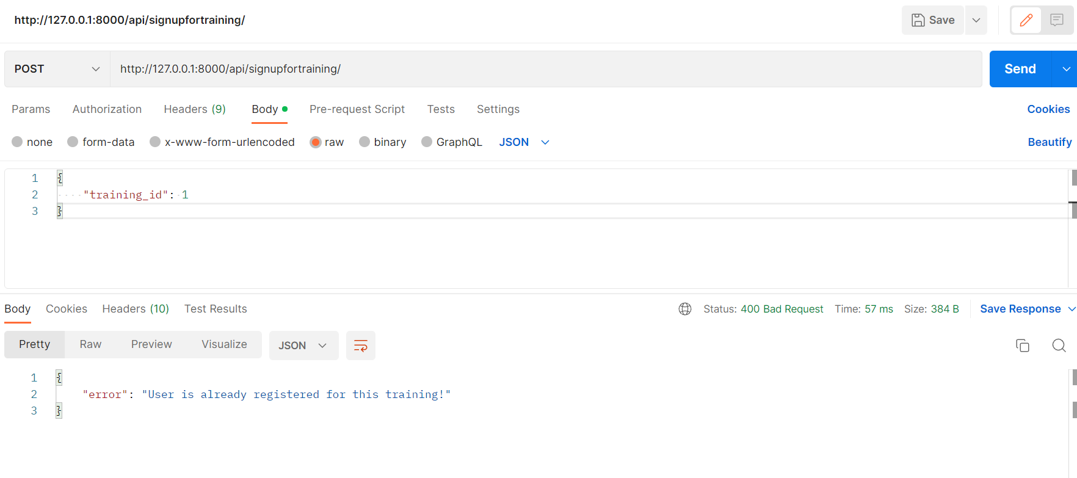

**Validation 2**:

Training capacity is full

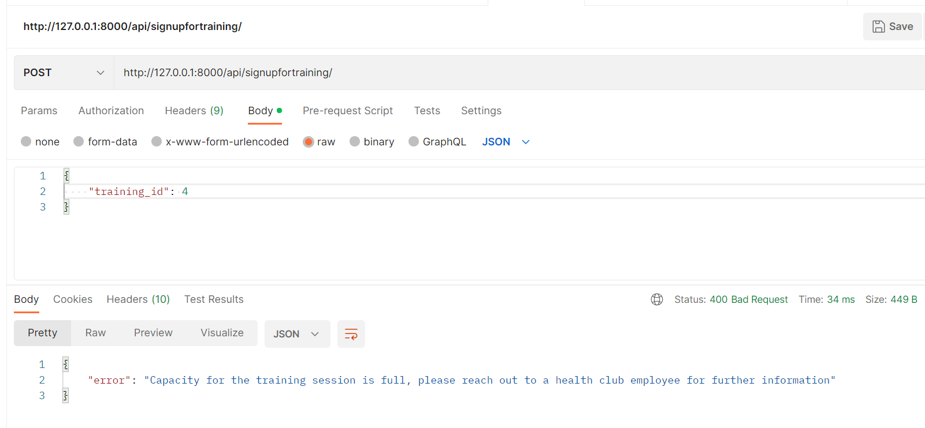

**Success Validation**:

Enrollment Successful:

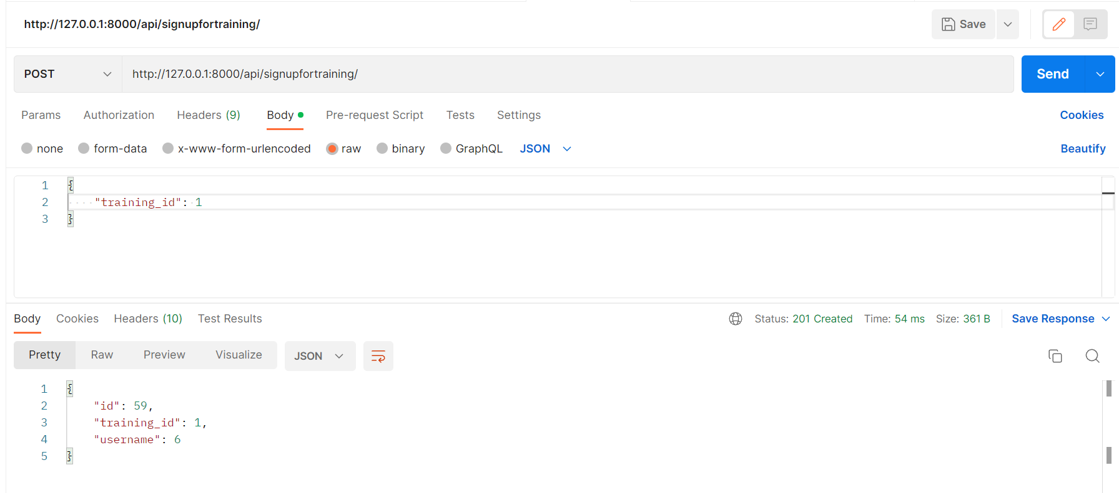

Signup non members for training by admin:

Admin must be signed in to enroll for trainings

POST :

**Validation 1**: if the user is already registered

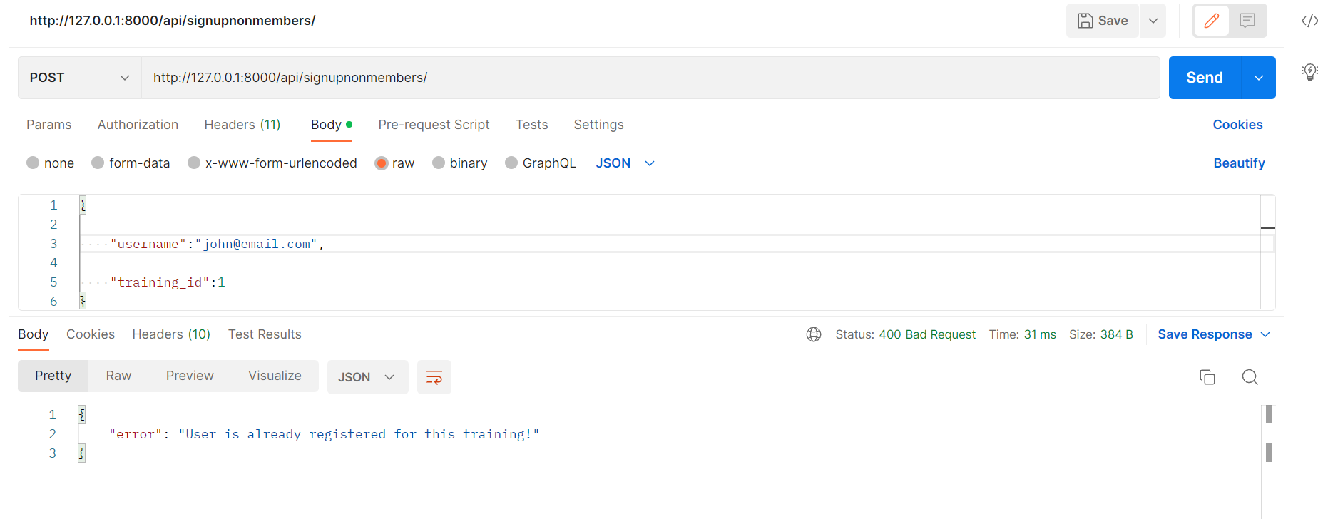

**Validation 2**: If the class is after trial membership expiration

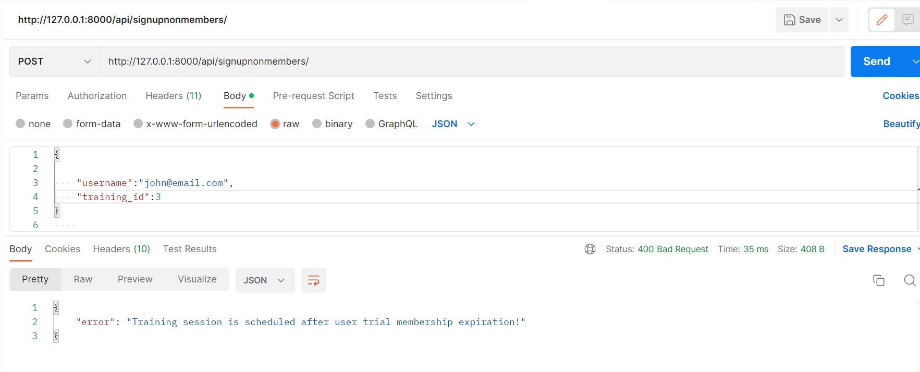

**Success Validation**:

Enrollment Successful:

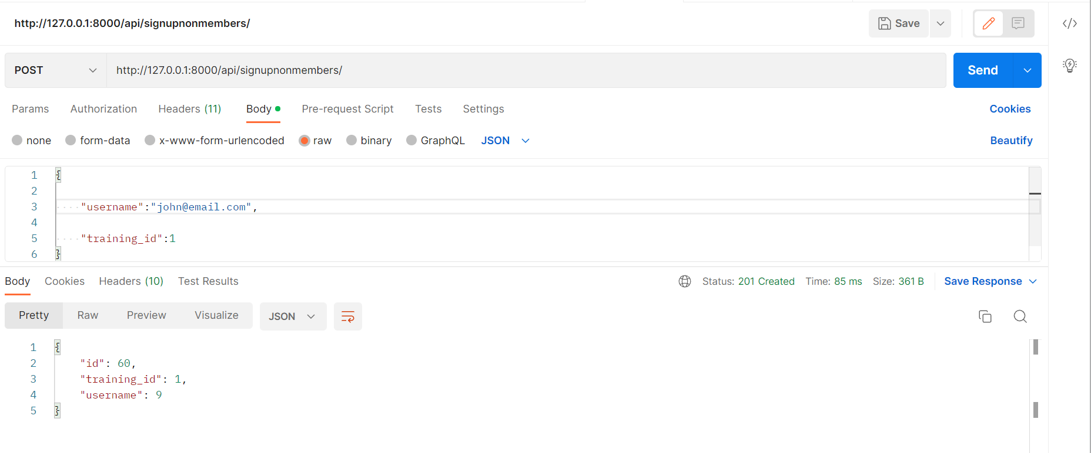

View all the available trainings:

<http://127.0.0.1:8000/api/viewtrainings/>

GET :

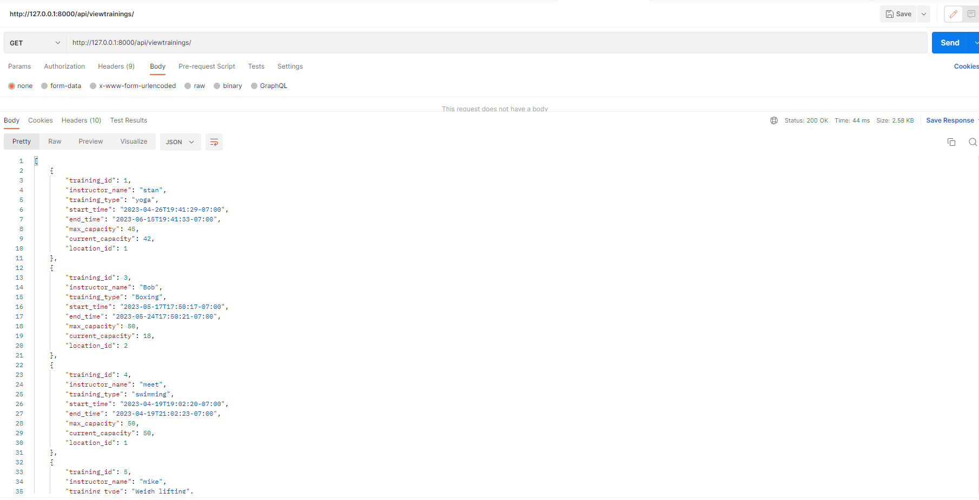

View all the available trainings by location:

<http://127.0.0.1:8000/api/viewtrainings/1>

GET :

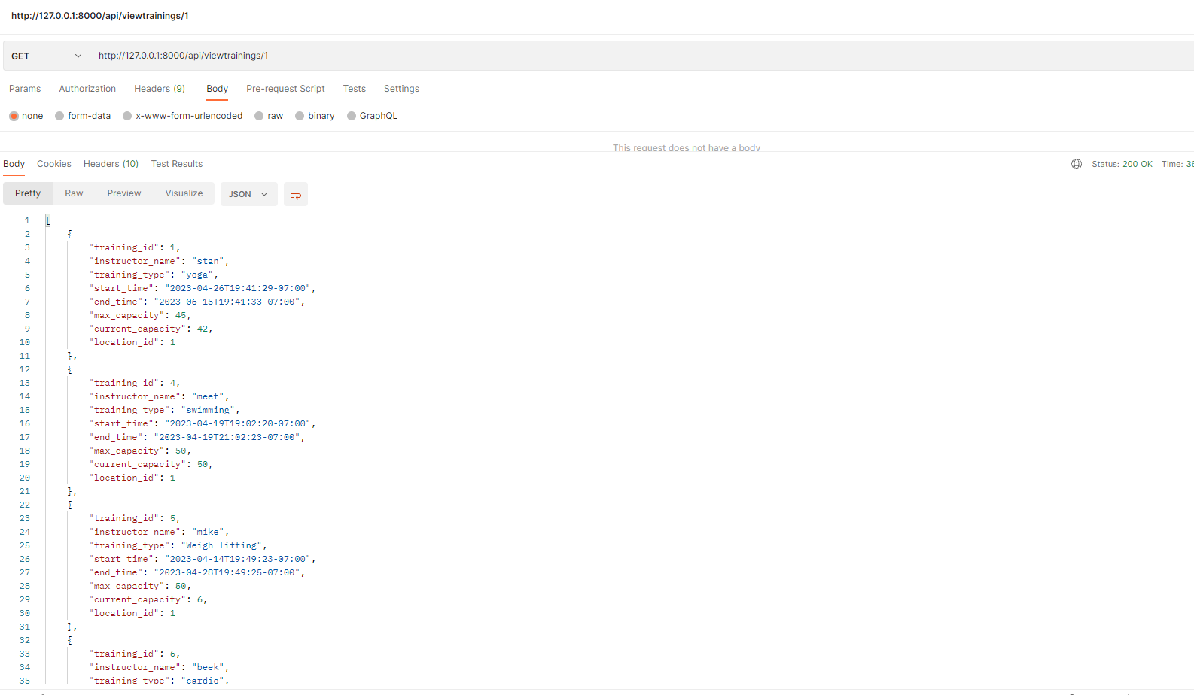

Cancel Enrollment:

User must be signed in to cancel enrollments by training id

<http://127.0.0.1:8000/api/cancelenrollment/1>

DELETE

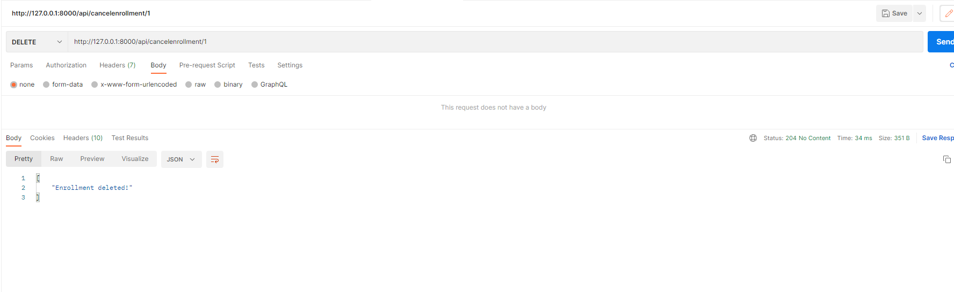

To view enrollments for particular training based on location for admin dashboard:

Admin must be signed in to view the dashboard

<http://localhost:8000/api/enrollmentstats/?start_time=2023-04-01T00:00:00&end_time=2023-05-30T23:59:59&location_id=1>

GET :

