**CMPE 202 – Team Code Wizards – Health Club Management System – AWS Deployment Screenshots**

Team Members

Bhavya Hegde

Blessy Dickson Daniel Moses

Darshini Venkatesha Murthy Nag

Sirisha Polisetty

Route 53 Configuration for hosting

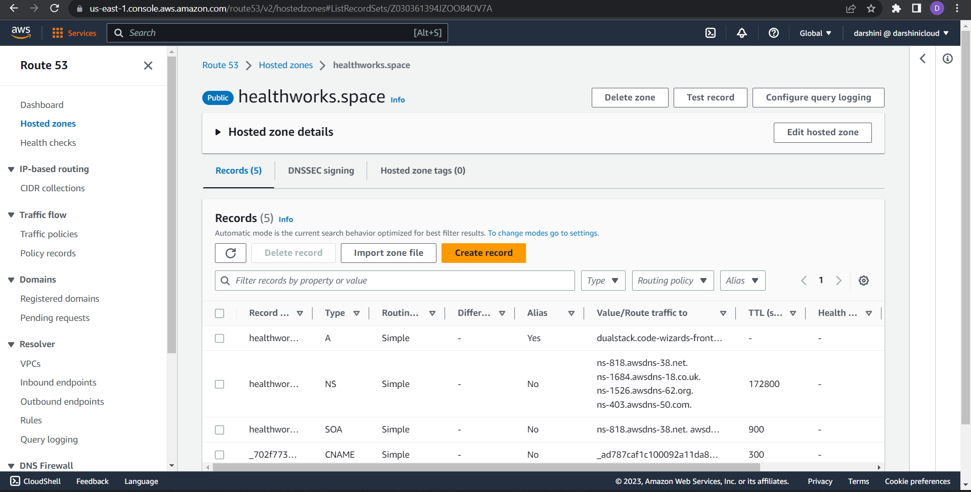

SSL Certificates for domain is obtained from AWS Certificate Manager.

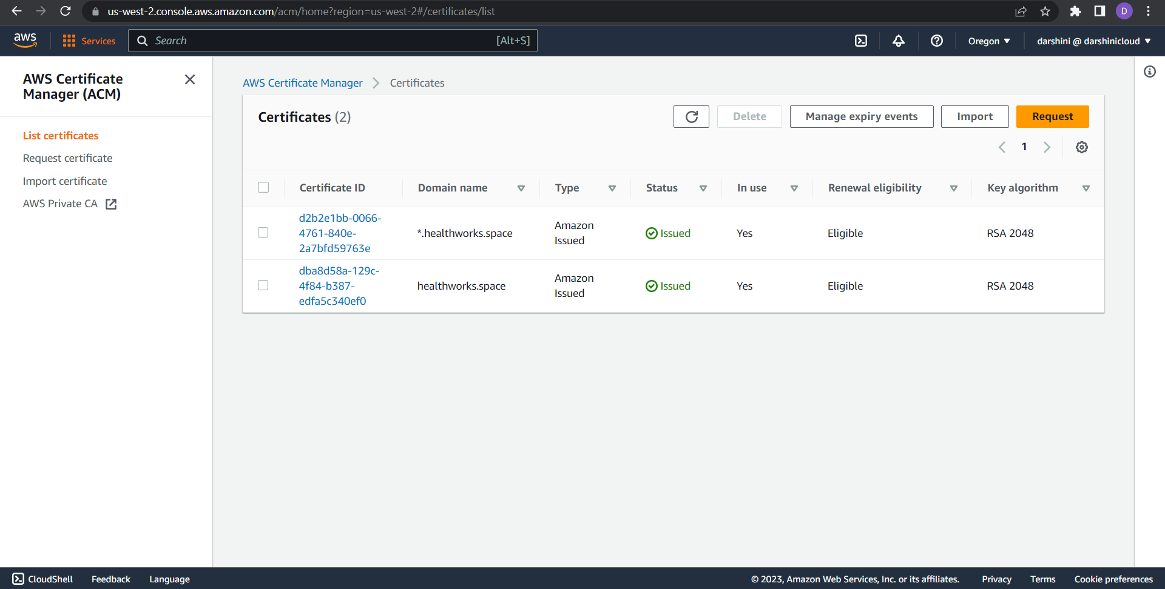

Amazon RDS PostGreSQL for Database

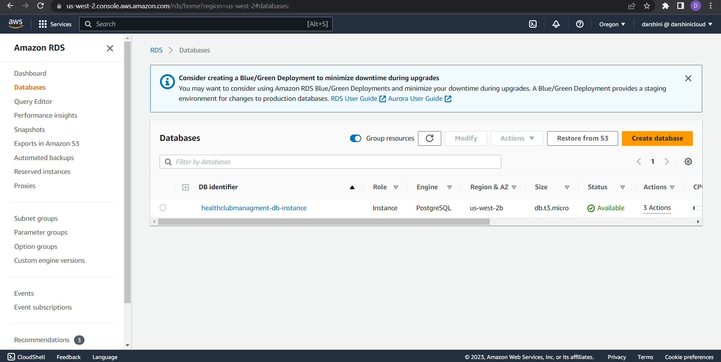

EC2 instances created for running and frontend and backend of the application

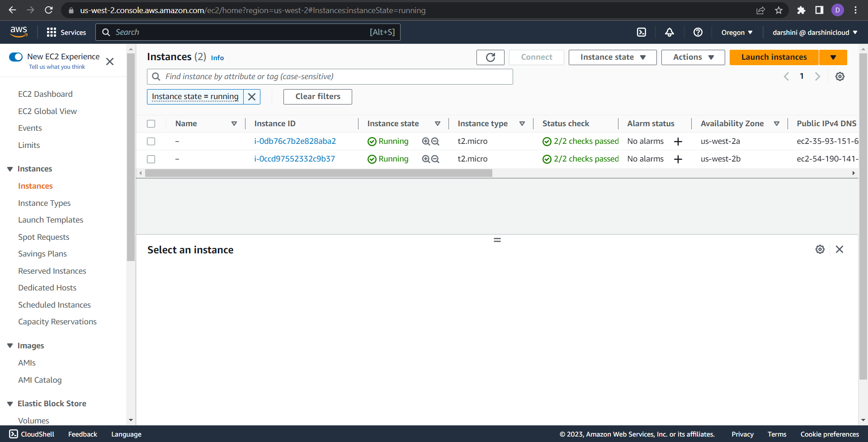

Load Balancers for both frontend and backend servers

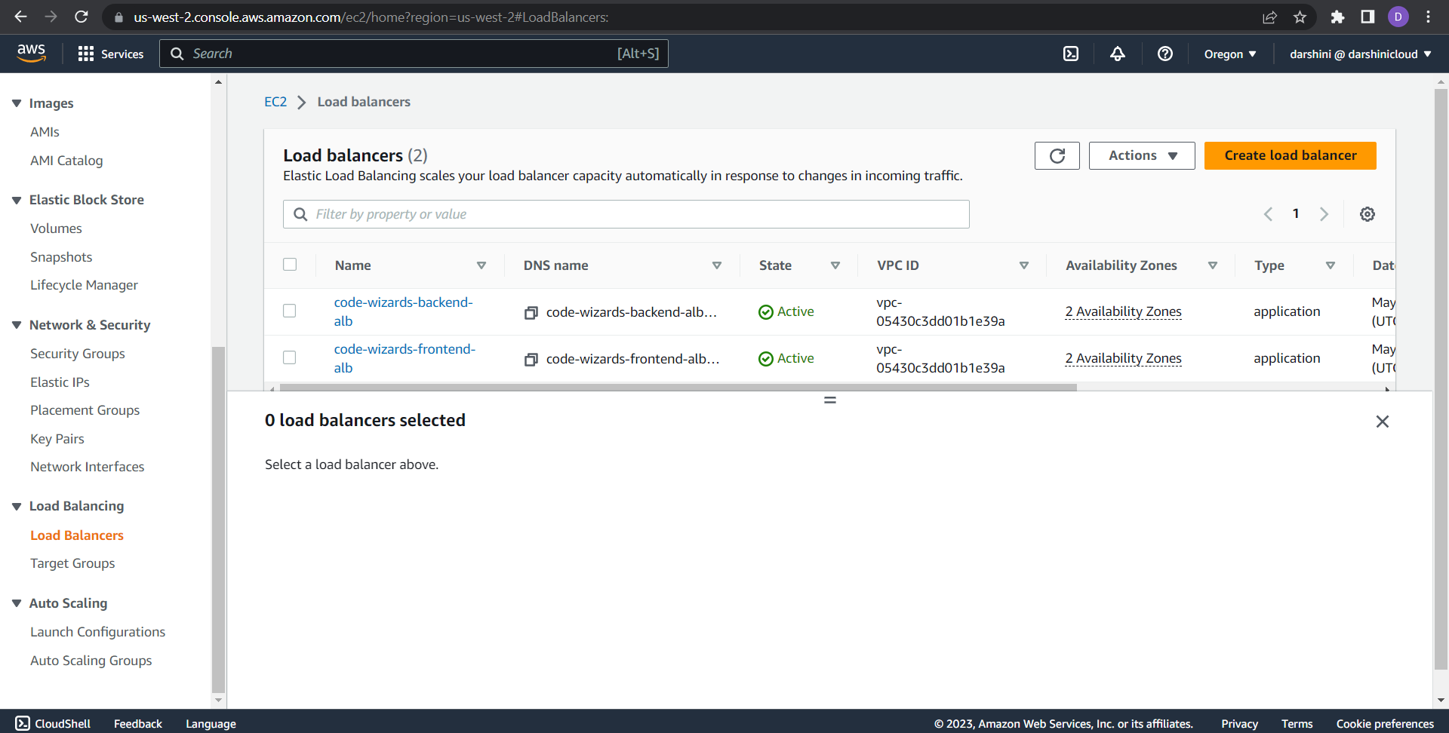

Target Groups Configured for load balancers

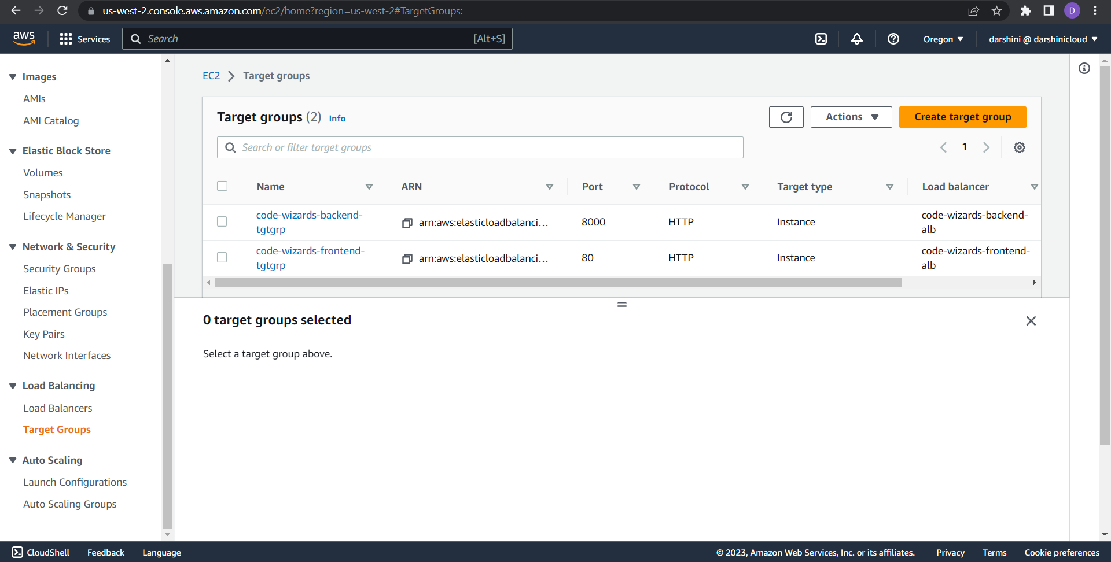

Autoscaling groups created for both frontend and backend instances

