**OUTPUT- When the input by user is a folder containing multiple invoices**

-------------------INVOICE CLASSIFIER-------------------

Enter folder name or image name: dataset

Files and directories in ./dataset are :

['nbill1.jpg', 'nbill10.jpg', 'nbill11.jpg', 'nbill12.jpg', 'nbill13.jpg', 'nbill14.jpg', 'nbill15.jpg', 'nbill16.jpg', 'nbill17.png', 'nbill18.jpg', 'nbill19.png', 'nbill2.jpg', 'nbill20.png', 'nbill3.jpg', 'nbill4.png', 'nbill5.jpg', 'nbill6.jpg', 'nbill7.jpg', 'nbill8.jpg', 'nbill9.jpg']

---------- Initiating (directory) : Recognizing text from nbill1.jpg ----------

This is a FOOD BILL...

------ File copied in './output/food_bills/' directory -------

---------- Initiating (directory) : Recognizing text from nbill10.jpg ----------

This is a MEDICINE/PHARMACY BILL...

------ File copied in './output/medicine_bills/' directory -------

---------- Initiating (directory) : Recognizing text from nbill11.jpg ----------

This is a PHONE BILL...

------ File copied in './output/phone_bills/' directory -------

---------- Initiating (directory) : Recognizing text from nbill12.jpg ----------

This is a PHONE BILL...

------ File copied in './output/phone_bills/' directory -------

---------- Initiating (directory) : Recognizing text from nbill13.jpg ----------

This is a PHONE BILL...

------ File copied in './output/phone_bills/' directory -------

---------- Initiating (directory) : Recognizing text from nbill14.jpg ----------

This is a PHONE BILL...

------ File copied in './output/phone_bills/' directory -------

---------- Initiating (directory) : Recognizing text from nbill15.jpg ----------

This is a SCHOOL FEE BILL...

------ File copied in './output/school_bills/' directory -------

---------- Initiating (directory) : Recognizing text from nbill16.jpg ----------

This is an ELECTRICITY BILL...

------ File copied in './output/electricity_bills/' directory -------

---------- Initiating (directory) : Recognizing text from nbill17.png ----------

This is a SCHOOL FEE BILL...

------ File copied in './output/school_bills/' directory -------

---------- Initiating (directory) : Recognizing text from nbill18.jpg ----------

This is a SCHOOL FEE BILL...

------ File copied in './output/school_bills/' directory -------

---------- Initiating (directory) : Recognizing text from nbill19.png ----------

This is a MEDICINE/PHARMACY BILL...

------ File copied in './output/medicine_bills/' directory -------

---------- Initiating (directory) : Recognizing text from nbill2.jpg ----------

This is a FOOD BILL...

------ File copied in './output/food_bills/' directory -------

---------- Initiating (directory) : Recognizing text from nbill20.png ----------

This is a MEDICINE/PHARMACY BILL...

------ File copied in './output/medicine_bills/' directory -------

---------- Initiating (directory) : Recognizing text from nbill3.jpg ----------

This is an ELECTRICITY BILL...

------ File copied in './output/electricity_bills/' directory -------

---------- Initiating (directory) : Recognizing text from nbill4.png ----------

This is a FOOD BILL...

------ File copied in './output/food_bills/' directory -------

---------- Initiating (directory) : Recognizing text from nbill5.jpg ----------

This is a FOOD BILL...

------ File copied in './output/food_bills/' directory -------

---------- Initiating (directory) : Recognizing text from nbill6.jpg ----------

This is an ELECTRICITY BILL...

------ File copied in './output/electricity_bills/' directory -------

---------- Initiating (directory) : Recognizing text from nbill7.jpg ----------

This is a MEDICINE/PHARMACY BILL...

File already exists at output location!! : nbill7.jpg ******

------ File copied in './output/medicine_bills/' directory -------

---------- Initiating (directory) : Recognizing text from nbill8.jpg ----------

This is a FOOD BILL...

------ File copied in './output/food_bills/' directory -------

---------- Initiating (directory) : Recognizing text from nbill9.jpg ----------

This is a FOOD BILL...

------ File copied in './output/food_bills/' directory -------

Total number of food bills: 6

Total number of electricity bills: 3

Total number of phone bills: 4

Total number of medicine bills: 4

Total number of school bills: 3

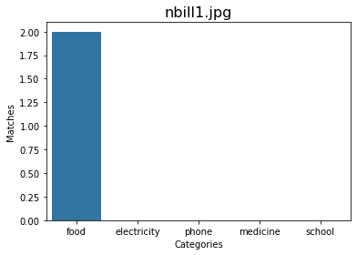

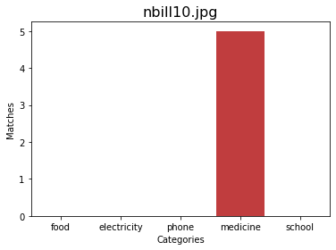

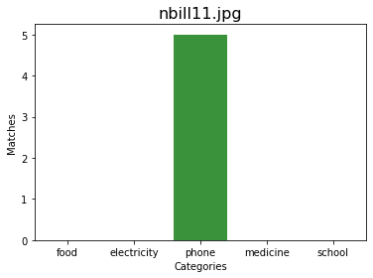

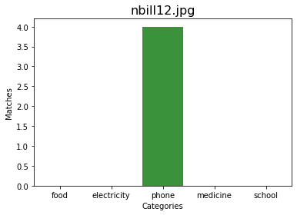

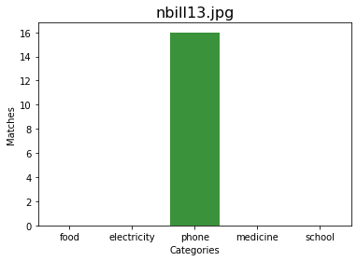

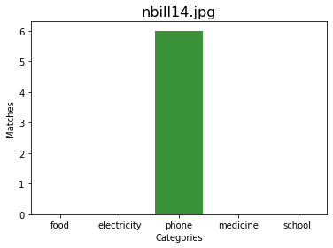

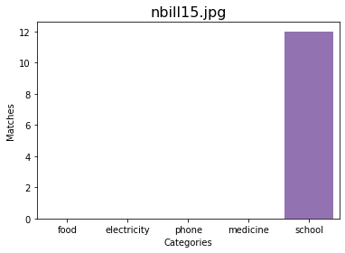

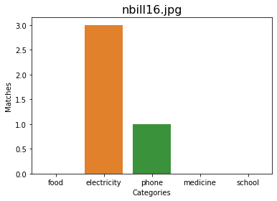

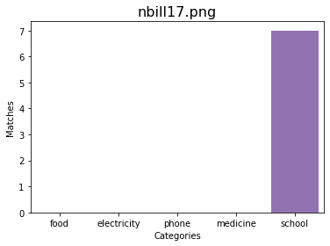

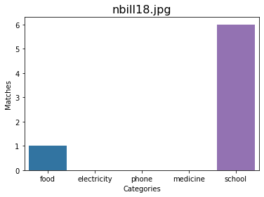

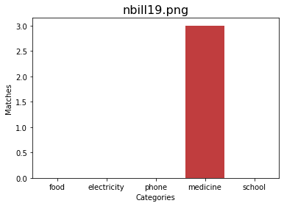

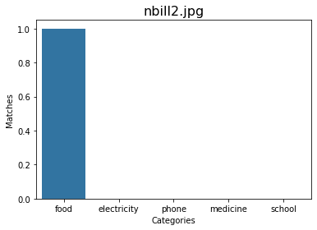

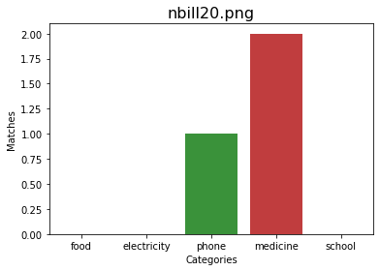

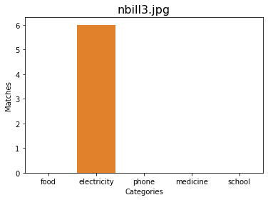

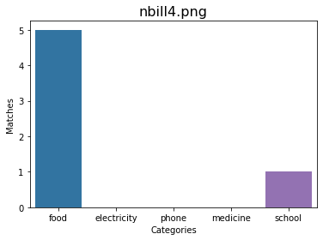

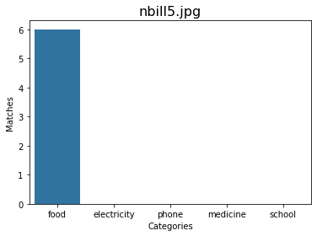

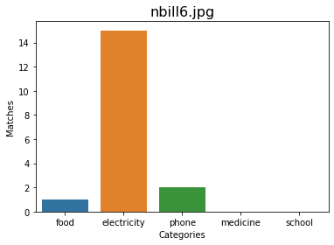

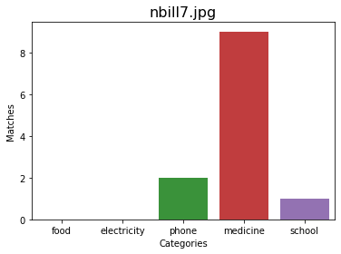

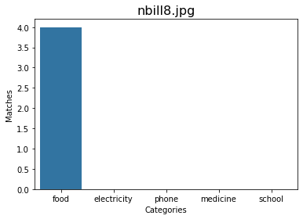

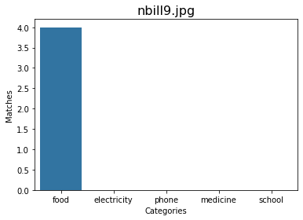

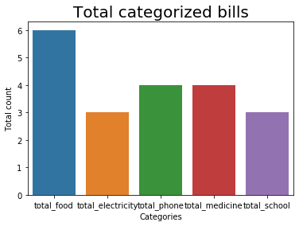

**OUTPUT- When the input path by user exists and is an image file**

-------------------INVOICE CLASSIFIER-------------------

Enter folder name or image name: dataset/nbill7.jpg

----------- Initiating (file) : Recognizing text from image ./dataset/nbill7.jpg -----------

The text recognized from image is:

DEMO PHARMA DISTRIBUTORS

Pharmaceutical Distributors

F-11, Roshanara Plaza, Roshanara Road,

Delhi-110007 (India)

Phone ; +91-11-23994444 (30 Line Fax : +91-11-43850066 E.Mail : Info@margcompusoft.com

TAX INVOICE

DLNo. :32132 208/218 TIN : 3456789012 CST No, : 3456789012

M/s AHUJA MEDICINE CENTRE Invoice No.: 0036 Date :

BUDHA BAZAR, Order No. :DG-2002 Date:

DELHI L.R.No. : 131345 Date:

Cases : 10

BENGE 18 Transport : ABC TPT.

TIN No 3213123, Due Date : 10-04-2004

S| Product Packing | Mfr. | Batch Qty. Fred M.R.P. Rate|vat% Amount

POLYBION SYP 100ML 100ML EMERK P| 562862000 10 18.82 | 15.26 42.50 152.60

AMLOGARD 5MG. 10'S Puizer L| 02005016 3 0.00 | 39.50 |4.00 118.50

BECOSULE 10X10, PHIZER L| 00739 6 115.10 | 101.90 |4.00 611.40

AZMIN CAP. 10X10'S | RANBAXY! 1245, 3 150.00 | 100.00 |4.00 300.00

BRUFOGESIC 10X10'S | SEAGULL) bt-124 10 250.00 |205.00 |4.00 | 2050.00

COFREX SYRUP 6OML SEAGULL] BH-234 10 10.00 | 100.00 |4.00 1000.00

LESS : SALES RETURN

AMLOGARD 10MG 10'S PHIZERL| 1488, 3 0.00} 59.20 |4.00 177.60

LESS : BRK/EXP RETURN

AMLOGARD 5MG. PHIZERL| TEST 3 47,82 143.46

BECOSULES SYRUP 120mI PHIZER L| IUKDIS 2 17.38 34.76

ADD : REPLACEMENT

BECOSULES SYRUP 120mI PHIZERL| 00555 17.38 |0. 312.84

VAT 3634.13°4%=145.36 149.55°12.50% =18.69 S/R=-172.27, B/Exp=-133.66,Rep.=234.63 (Net Amt.=3.70 Tax<SUBJTOTAL 4189.52

Item Discount 304.87

Total 3884.65

VAT 164.05

FREIGHT 100.00

INSURANCE 25.00

Roundoff 0.30

Rs. Four Thousand One Hundred Twenty Four Only GRAND TOTAL 4124.00

Terms & Conditions

Goods once sold will not be taken back or exchanged.

Bills not paid due date will attract 24% interest. For DEMO PHARMA DISTRIBUTOR:

All disputes subject to__Jurisdication only.

Prescribed Sales Tax declaration will be given.

Certified that the particulars given above are true and correct Checked By

and the amount indicated represents the price actually charged. E.80.E. Authorised signatory

------------------------------------------------------------------------------------------------------

This is a MEDICINE/PHARMACY BILL...

------ File copied in './output/medicine_bills/' directory -------



**OUTPUT- When the input path by user doesnot exist**

-------------------INVOICE CLASSIFIER-------------------

Enter folder name or image name: dataset/img.png

Path doesn't exist... Please try again later