# PYTHON FOR DS

*-DARSHANA OJHA*

# PANDAS LIBRARY:

Q. Write a Pandas program to select the rows where the number of attempts in the examination is greater than 2.

Sample Python dictionary data:

exam_data = {'name': ['Anastasia', 'Dima', 'Katherine', 'James', 'Emily', 'Michael', 'Matthew', 'Laura', 'Kevin', 'Jonas'],

'score': [12.5, 9, 16.5, np.nan, 9, 20, 14.5, np.nan, 8, 19],

'attempts': [1, 3, 2, 3, 2, 3, 1, 1, 2, 1],

'qualify': ['yes', 'no', 'yes', 'no', 'no', 'yes', 'yes', 'no', 'no', 'yes']}

import pandas as pd

import numpy as np

df=pd.DataFrame({'name': ['Anastasia', 'Dima', 'Katherine', 'James', 'Emily', 'Michael', 'Matthew', 'Laura', 'Kevin', 'Jonas'],

'score': [12.5, 9, 16.5, np.nan, 9, 20, 14.5, np.nan, 8, 19],

'attempts': [1, 3, 2, 3, 2, 3, 1, 1, 2, 1],

'qualify': ['yes', 'no', 'yes', 'no', 'no', 'yes', 'yes', 'no','no','yes']})

[df[df["attempts"]>2]]

df["attempts"]

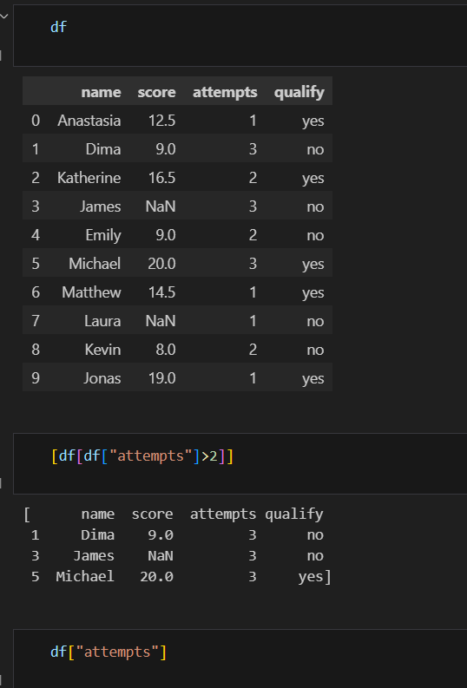

Q. Write a Pandas program to calculate the sum of the examination attempts by the students.

import pandas as pd

import numpy as np

df=pd.DataFrame({'name': ['Anastasia', 'Dima', 'Katherine', 'James', 'Emily', 'Michael', 'Matthew', 'Laura', 'Kevin', 'Jonas'],

'score': [12.5, 9, 16.5, np.nan, 9, 20, 14.5, np.nan, 8, 19],

'attempts': [1, 3, 2, 3, 2, 3, 1, 1, 2, 1],

'qualify': ['yes', 'no', 'yes', 'no', 'no', 'yes', 'yes', 'no','no','yes']})

df=df["attempts"]

df.sum()

OUTPUT:

