# PYTHON FOR DATA SCIENCE

# DAY 2

## -*DARSHANA OJHA.*

Q.1.WAP to identify whether the inputted number is positive or negative.

n=int(input("enter a number to be examined "))

if(n>0):

    print("it is a positive number")

else:

    print("it is a negative number")

OUTPUT:

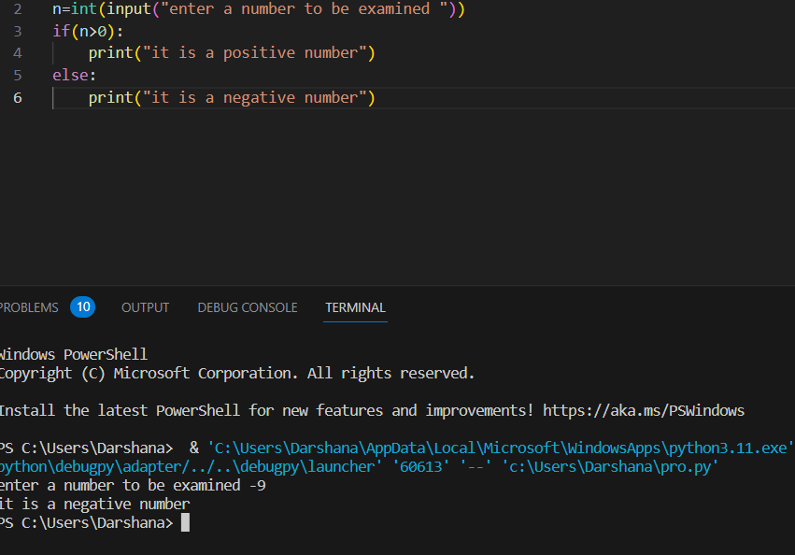

Q.2.WAP to check whether the inputted number is divisible by 3 as well as 5

print("enter a number")

n=int(input(""))

if(n%5==0 & n%3==0):

    print("number is div by 3 as well as  5")

else:

    print("not divisible")

OUTPUT:

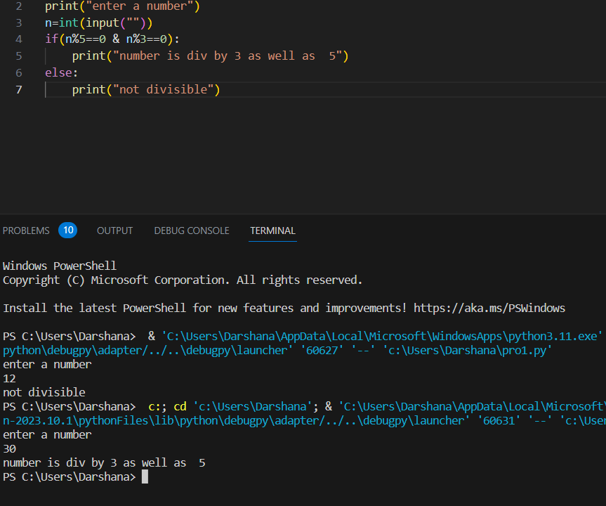

Q.3.WAP whether the inputted character is consonant or vowel, print message accordingly.

print("enter a character/alphabet")

c=str(input(" "))

if(c=='a'or c=='A' or c=='e'or c=='E' or c=='i'or c=='I' or c=='o'or c=='O' or c=='u'or c=='U' ):

    print("inputted character is vowel")

else:

    print("inputted character is consonant")

OUTPUT:

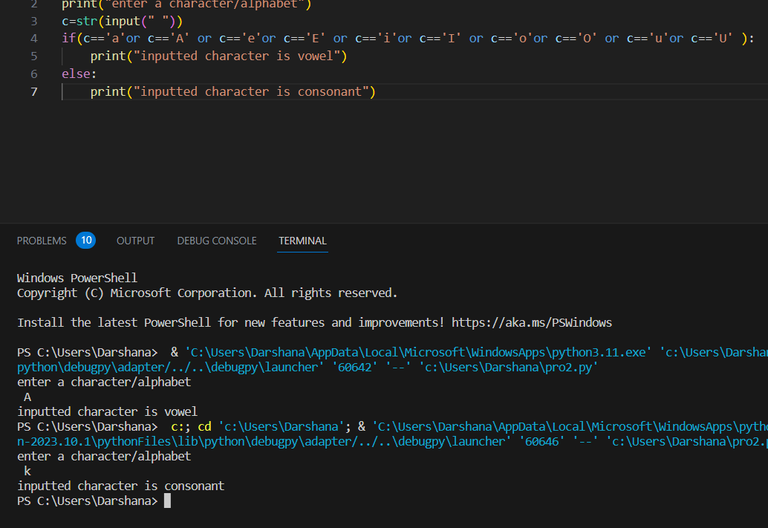

Q.4.WAP to print grade based on the inputted marks of students.

print("enter the  marks of student")

marks=int(input(" "))

if(marks>=90 and marks<=100):

    print("A+ grade")

elif(marks>=80 and marks<90):

    print("A grade")

elif(marks>=70 and marks<80):

    print("B+ grade")

elif(marks>=60 and marks<70):

    print("B grade")

elif(marks>=50 and marks<60):

    print("C grade")

elif(marks>=40 and marks<50):

    print("D grade")

elif(marks>=30 and marks<40):

    print("E grade")

else:

    print("F grade")

OUTPUT:

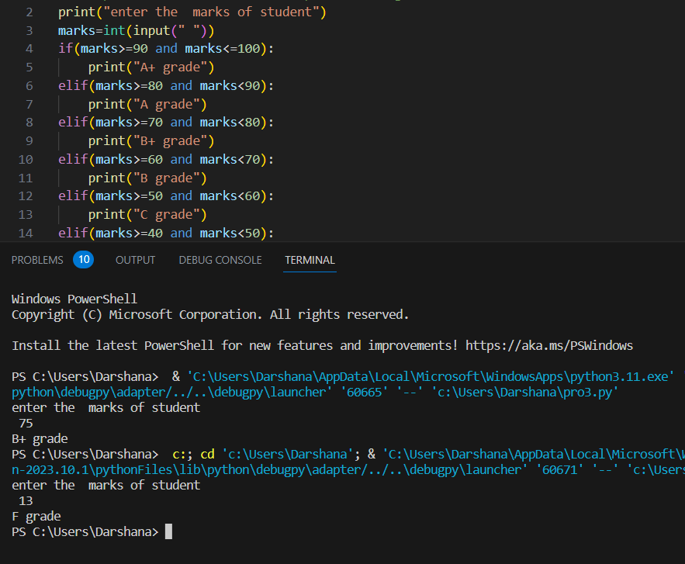

Q.5.WAP to find largest of 3 inputted numbers.

print("input first no")

a=int(input(" "))

print("input 2nd no")

b=int(input(""))

print("input 3rd no")

c=int(input(" "))

if(a>b and a>c):

    print("a is largest")

elif(c>b and c>a):

    print("c is largest")

elif(b>a and b>c):

    print("b is largest")

else:

    print("test case fails")

OUTPUT:

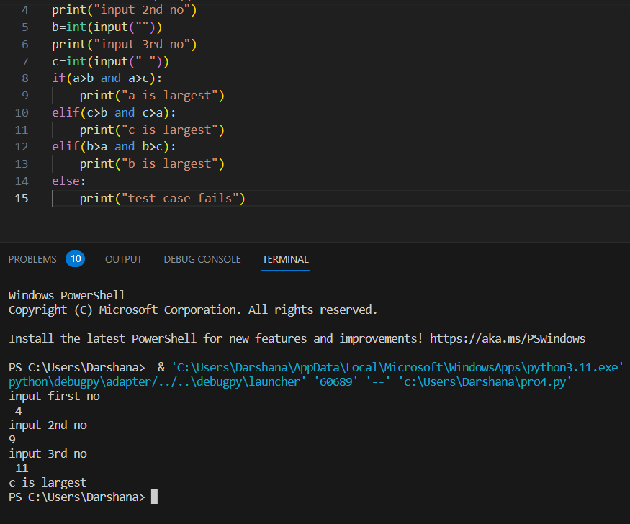

Q.6.WAP to identify if the inputted year is normal year or leap year.

print("enter year")

y=int(input(" "))

if(y%4==0):

    print("it is a leap year")

else:

    print("it is a normal year")

OUTPUT:

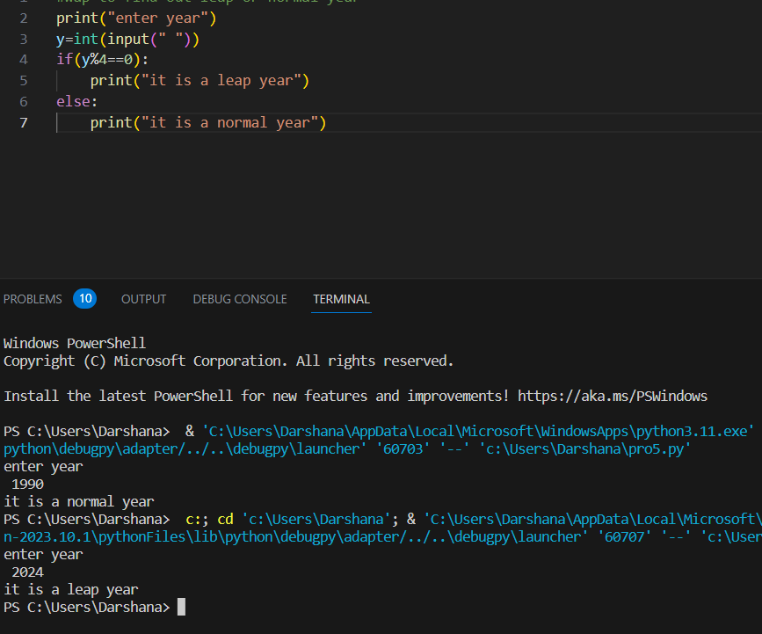

Q.7.WAP to input 2 numbers and an operand, and perform operation accordingly.

print("enter first number")

a=int(input(" "))

print("enter second number")

b=int(input(" "))

print("enter the operand")

op=str(input(" "))

if(op=='+'):

    print("ans is ",a+b)

elif(op=='-'):

    print("ans is ",a-b)

elif(op=='*'):

    print("ans is ",a*b)

elif(op=='%'):

    print("ans is ",a%b)

elif(op=='/'):

    print("ans is ",a/b)

elif(op=='sine'):

    print("enter one more number,and thenconsideriing these three numbers as sides of a triangle a is base,b is height,c is hypotenuse")

    c=int(input(" "))

    print("ans is",b/c)

elif(op=='cosine'):

    print("again considering same conditions for triangle ")

    c=int(input(""))

    print("ans is",a/c)

elif(op=='tan'):

    print("taking value of third side as input")

    c=int(input(" "))

    print("ans is",a/b)

else:

         print("ah sorry ,more features to be added soon!")

OUTPUT:

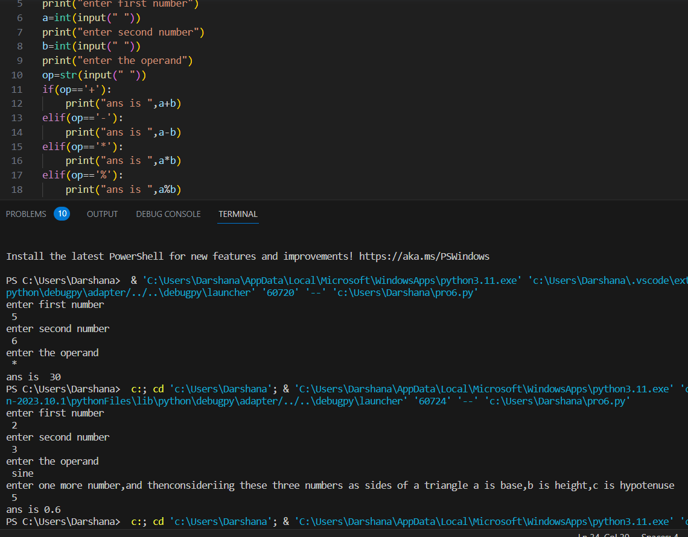

Q.8.WAP to print ‘Weight status’ of a patient using BMI calculation.

Taking height (in m) and weight(in kgs) input.

#bmi=w(kg)/sq h(m)

# BMI               weight

#below 18.5         underweight

#18.5-24.9          normal

#25.0-29.9          overweight

#30.0 above         obese

print("enter patient's weight in kgs")

weight=float(input(" "))

print("enter patient's height in ms")

height=float(input(" "))

BMI=weight/(height*height)

if(BMI<18.5):

    print("weight status: UNDERWEIGHT")

elif(BMI>=18.5 and BMI<=24.9):

    print("weight status: NORMAL")

elif(BMI>=25.0 and BMI<=29.9):

    print("weight status: OVERWEIGHT")

elif(BMI>=30.0):

    print("weight status: OBESE")

else:

OUTPUT:

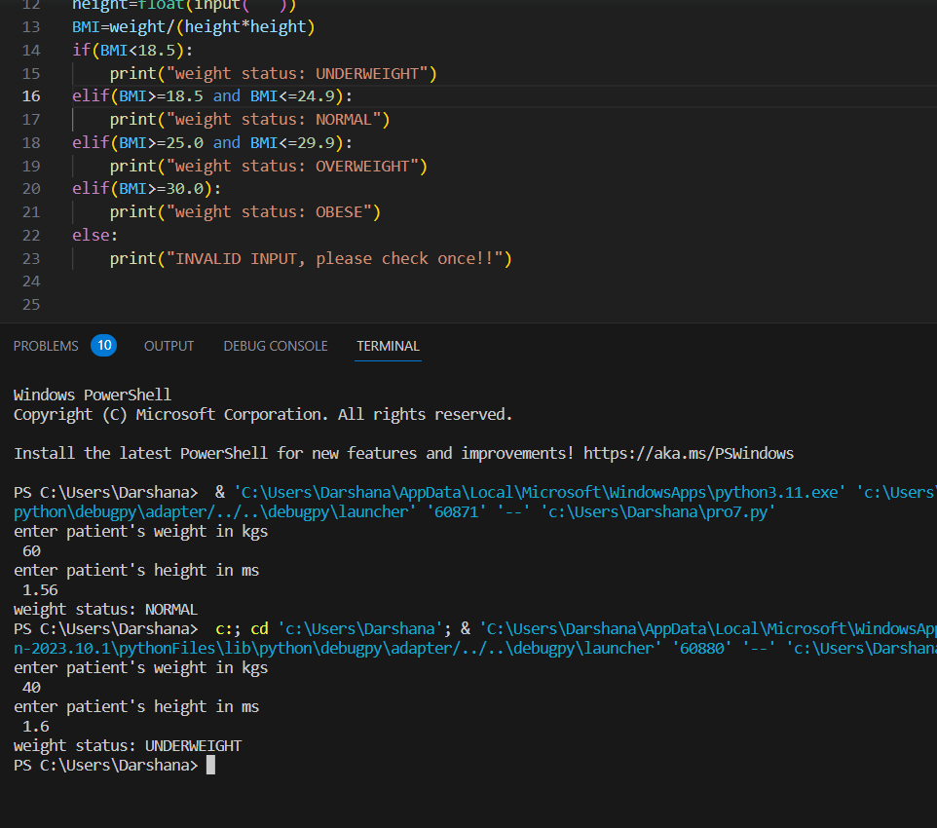

Q.9.WAP to find the largest of three inputted numbers.

print("enter the numbers ")

a=int(input())

b=int(input())

c=int(input())

if(a>b):

    if(a>c):

        print("a is largest")

    else:

        print("c is largest")

elif(b>a):

    if(b>c):

        print("b is largest")

    else:

        print("c is largest")

elif(b>c):

    if(a>b):

        print("a is largest")

    else:

        print("b is largest")

else:

    print("invalid input")

OUTPUT:

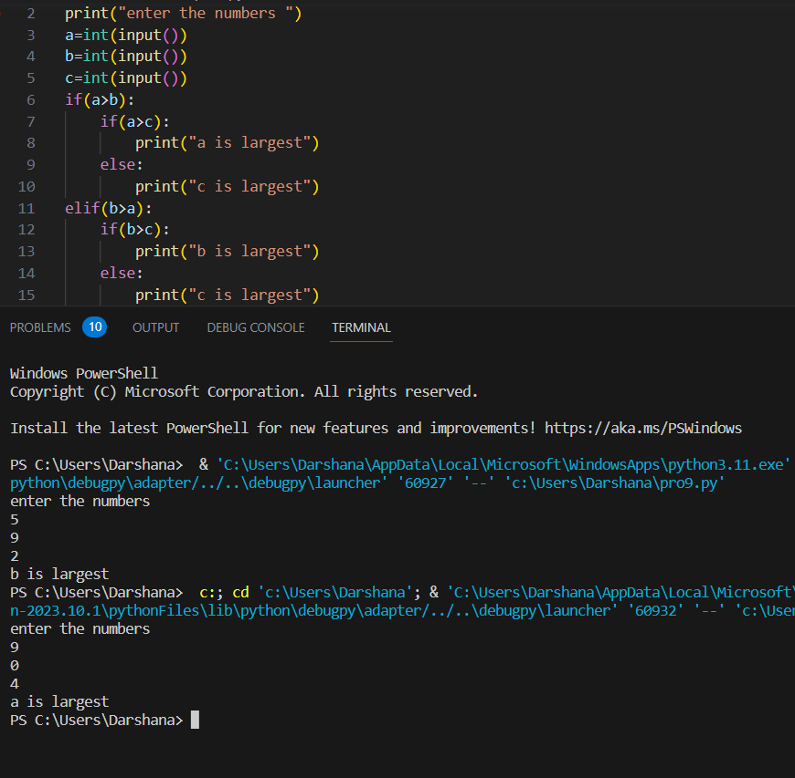

Q.10.WAP to print numbers from 1 to 20 using loop.

for i in range(1,21):

    print(i)

OUTPUT:

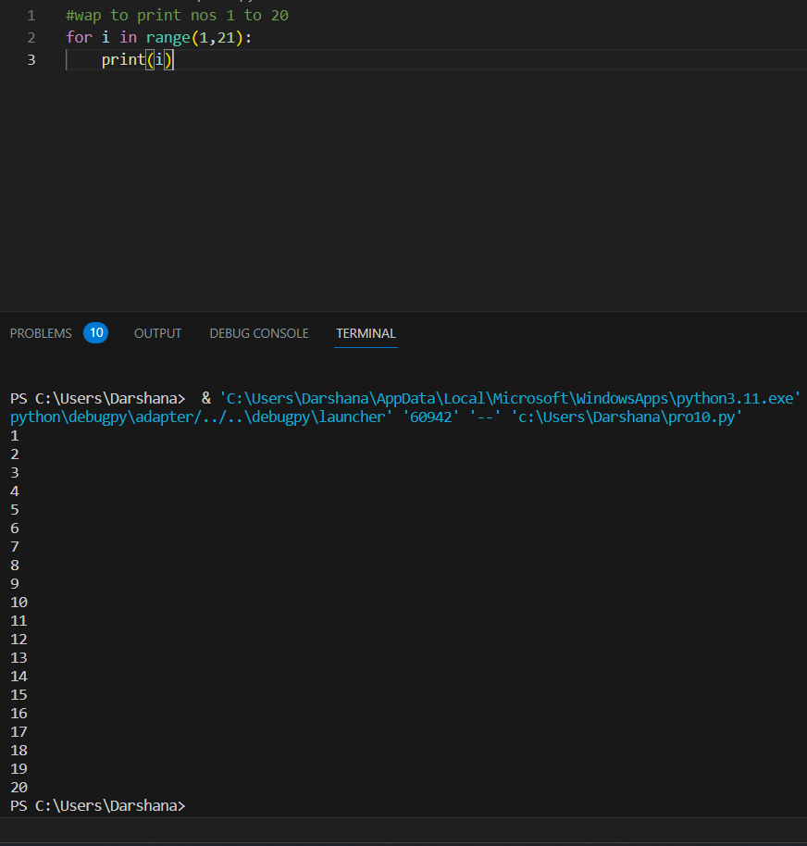Q.11.WAP to print even numbers from 1 to 20.

for i in range(10,22):

    if(i%2==0):

        print(i)

OUTPUT:

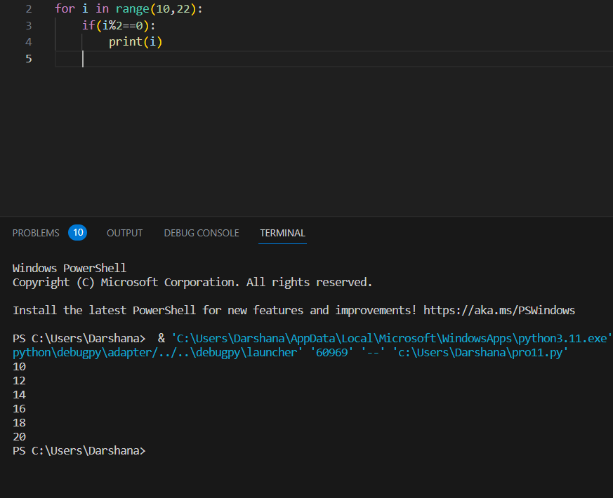

Q.12.WAP to print fibonnaci series.

a=0

b=1

c=a+b

print(a)

print(b)

print(c)

for i in range(1,8):

 a=b

 b=c

 c=a+b

 print(c)

OUTPUT:

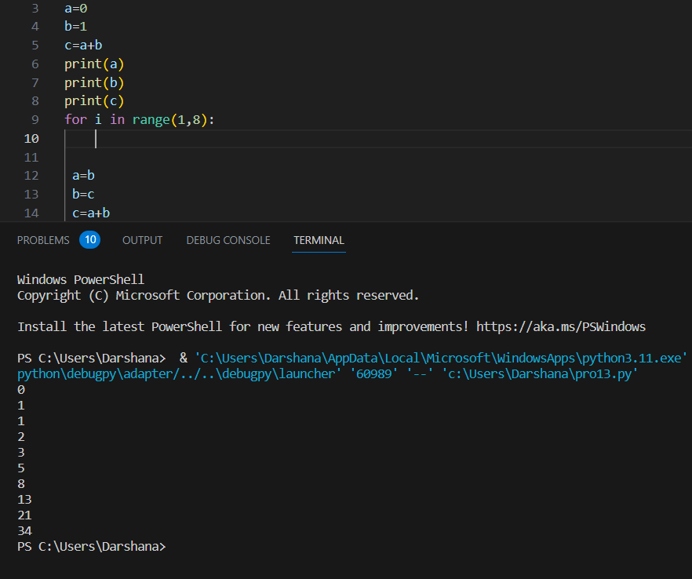

Q.13.WAP to print factorial of inputted number.

print("enter a number whose factorial is to be calculated")

n=int(input(" "))

f=1

for i in range(1,n+1):

 f=f*i

print(f)

OUTPUT:

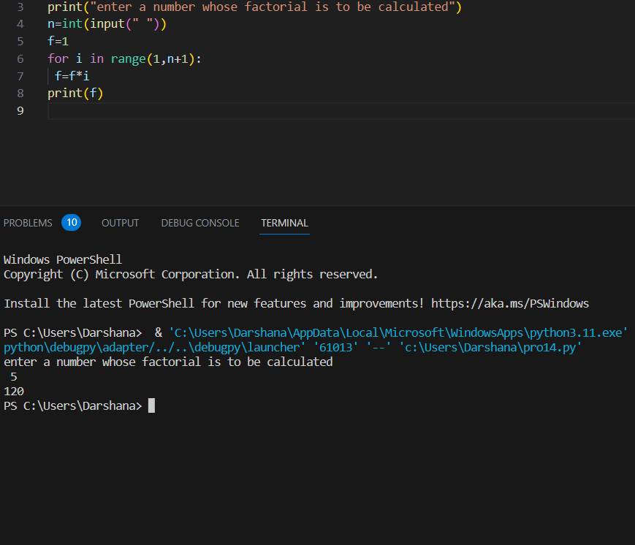

Q.14.WAP to print the series till nth term, taking n as input.

1/1!+1/2!+…+1/n!

print("Enter value of n")

n=int(input(" "))

s=0

for i in range(1,n+1):

  f=1

for j in range(1,i+1):

  f=f*j

  print(f)

s=s+1/f

print(s)

OUTPUT:

