# DAY 1: PYTHON FOR DATA SCIENCE

*---DARSHANA OJHA*

Q. 1.WAP to input radius and print area

print("enter value of r")

r=int(input(" "))

area=3.14*r*r

print("area of circle of given radius is-->",area)

OUTPUT:

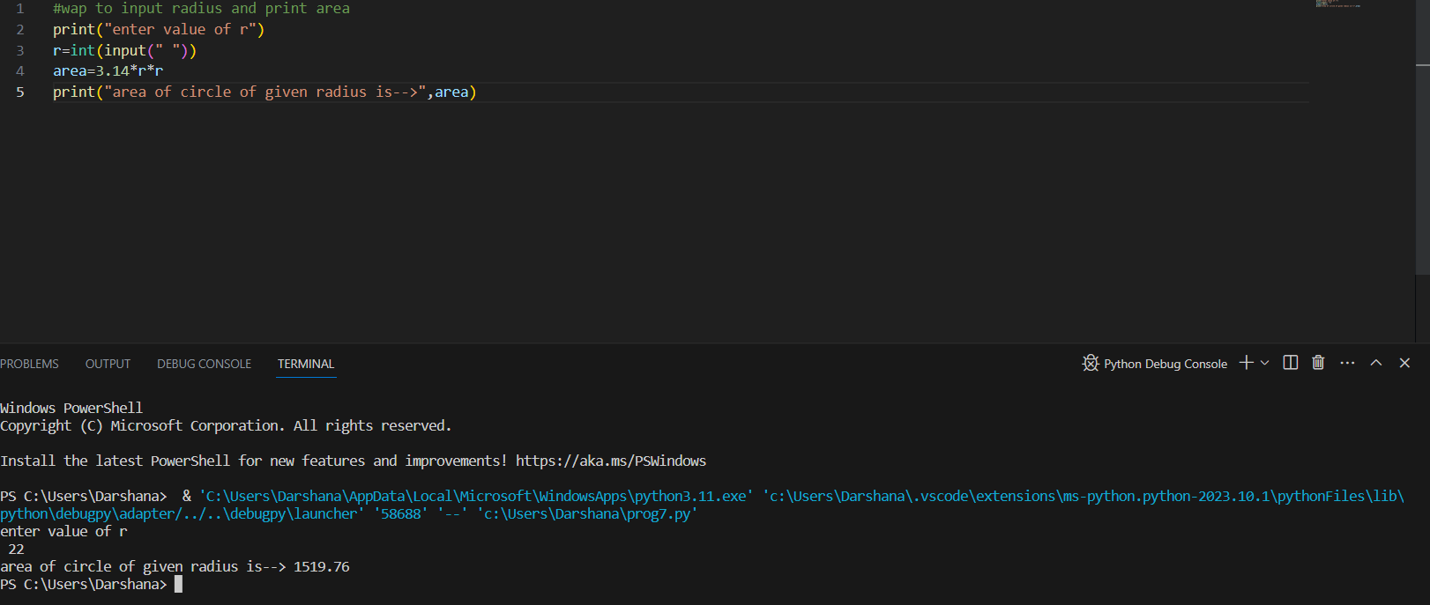

Q.2.WAP that generates the following

5

10

9

print(5)

print(10)

print(9)

OUTPUT:

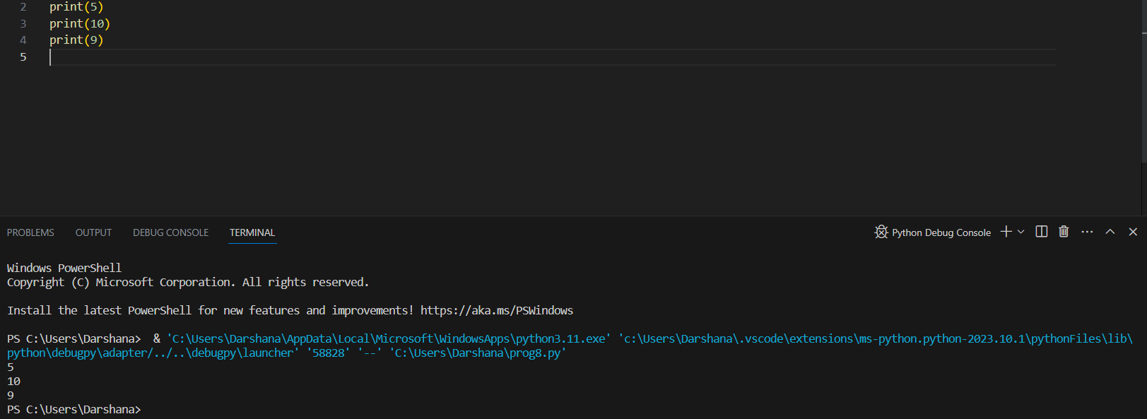

Q.3.WAP to input marks of 3 subjects and find its average, print the average and percentage of marks

print("enter marks of 1st subject")

a=float(input(" "))

print("enter marks of second subject")

b=float(input(" "))

print("enter marks of third subject")

c=float(input(" "))

avg=(a+b+c)/3

print("Average of marks of 3 subjects is-->",avg)

markobt=a+b+c

total=300

perc=(markobt/total)*100

print("percentage is-->",perc)

OUTPUT:

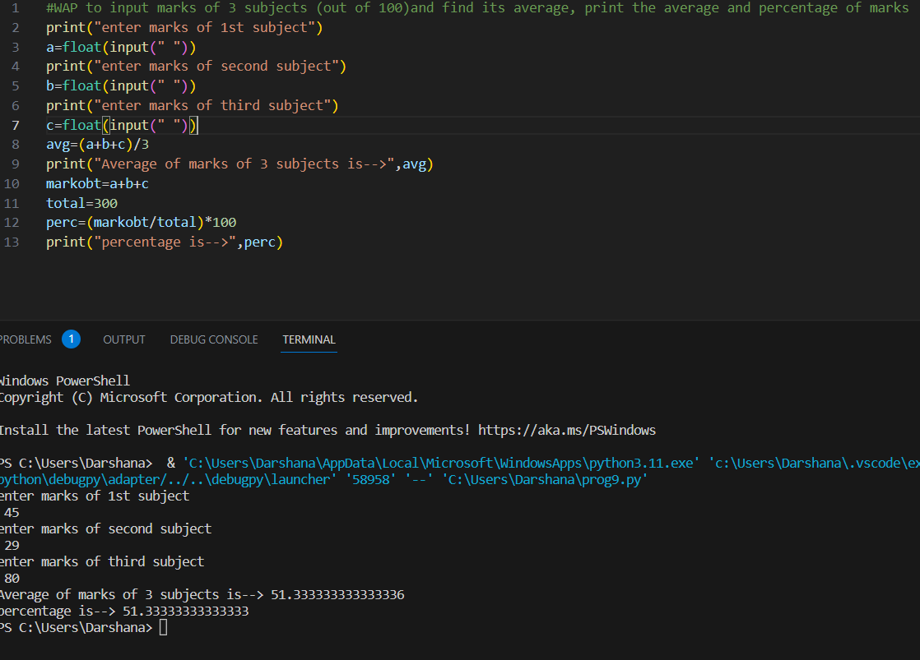

Q.4.WAP to calculate simple interest taking values as input.

#si=prt/100

print("enter value of principal amount")

p=int(input(" "))

print("enter rate ")

r=int(input("  "))

print("enter time period")

t=int(input(" "))

si= p*r*t/100

print("simple interest si=",si)

OUTPUT:

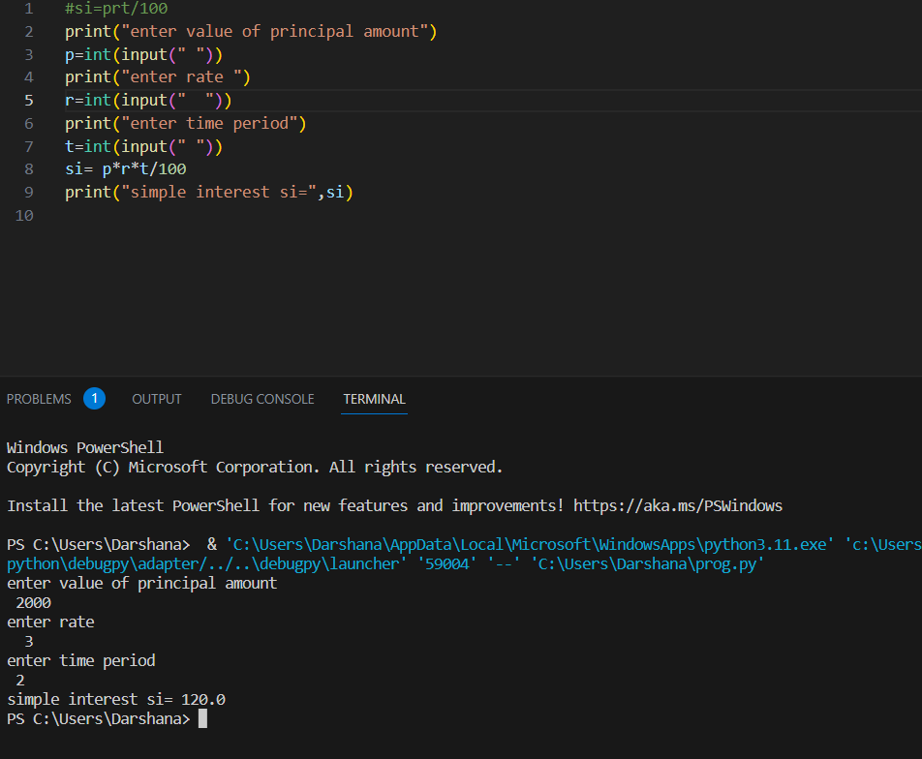

Q.5.WAP to calculate compound interest taking values as input.(using pow function)

#ci=p[1+r/n]^nt

print("enter principal amount")

p=float(input(" "))

print("enter rate")

r=int(input(""))

print("enter value of n")

n=int(input(""))

print("enter value of t ")

t=int(input(" "))

m=pow(1+(r/n),n*t)

ci=p*m

print("compound interest is...",ci)

OUTPUT:

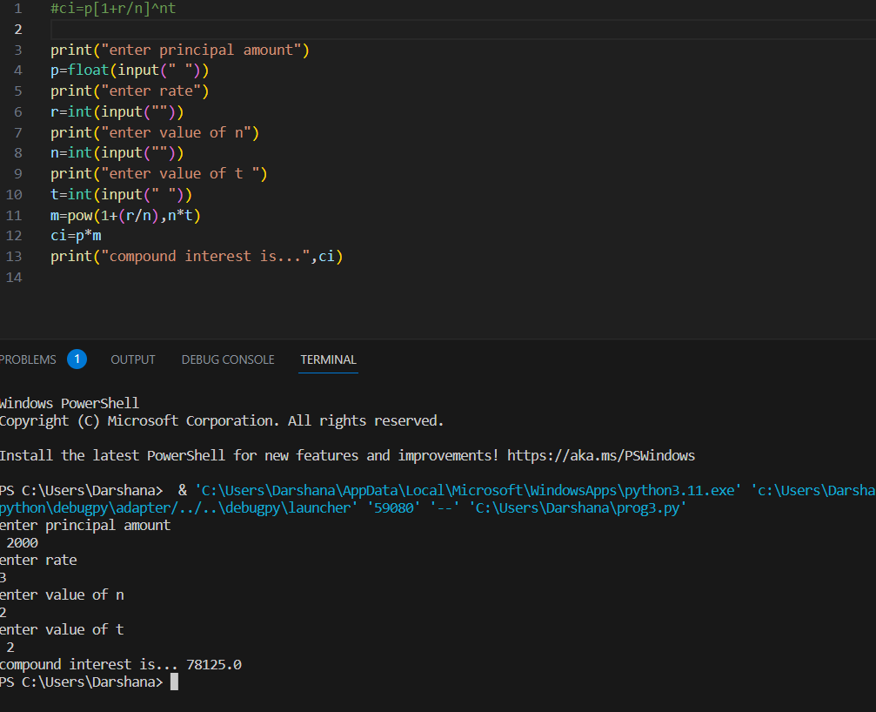

Q.6.WAP to calculate EMI by taking values as input.

print("enter value of principal amount")

p=float(input(""))

print("enter rate")

r=float(input(" "))

print("enter no of monthly installments")

n=float(input("  "))

m =float(r/12)

emi=p*m*((1+m)**n)/(1+m)**(n-1)

print ("emi can be calculated as...",emi)

OUTPUT:

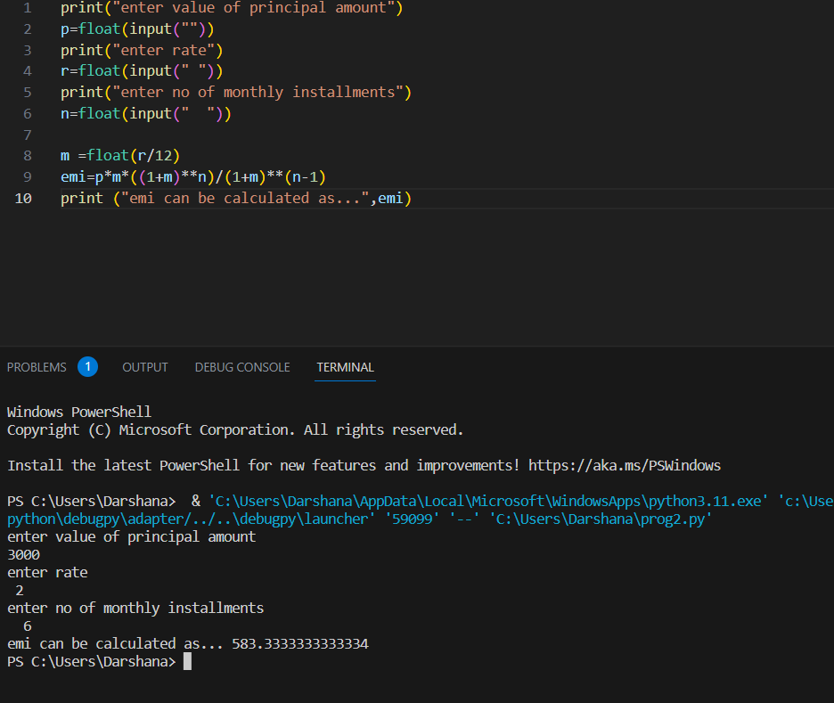

Q.7.WAP to find the area of triangle using heron’s formula.

import math

print("enter first side")

a=int(input(""))

print("rnter second side")

b=int(input(""))

print("enter third side")

c=int(input(""))

s=float((a+b+c)/2)

areain=s*(s-a)*(s-b)*(s-c)

print("area of the triangle of inputted sides ")

print(math.sqrt(areain))

OUTPUT:

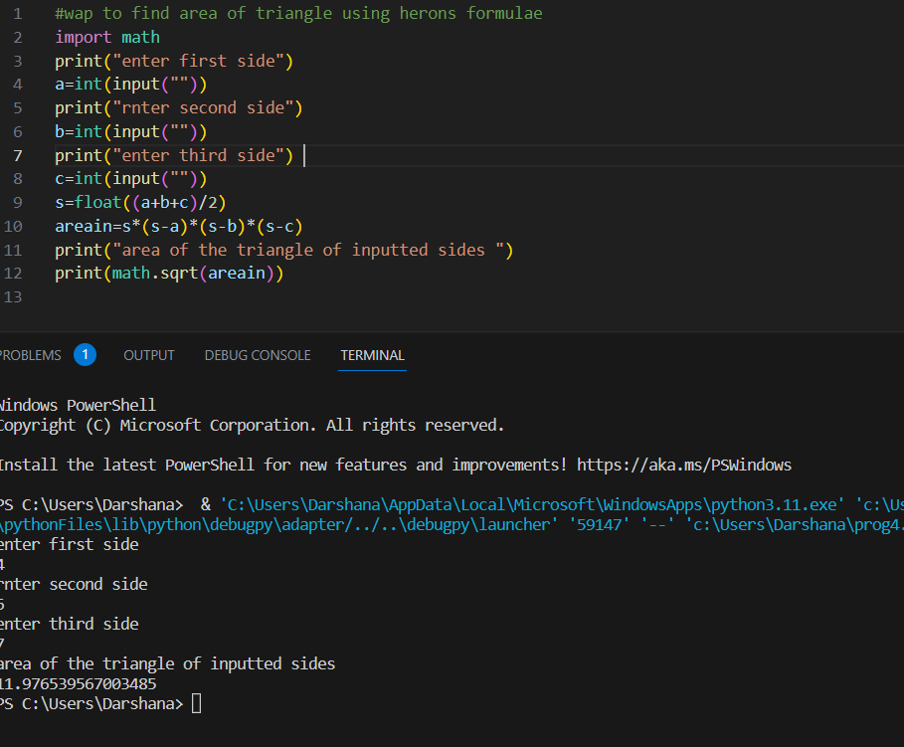

Q.8.WAP to calculate compound interest without using pow function by taking inputs.

print("enter principal amount")

p=int(input(" "))

print("enter rate of interest")

r=float(input(""))

print("enter n")

n=int(input(" "))

print("enter time period")

t=int(input(" "))

m=(1+r/n)**(n*t)

ci=m*p

print("calculated compound interest is...",ci)

OUTPUT:

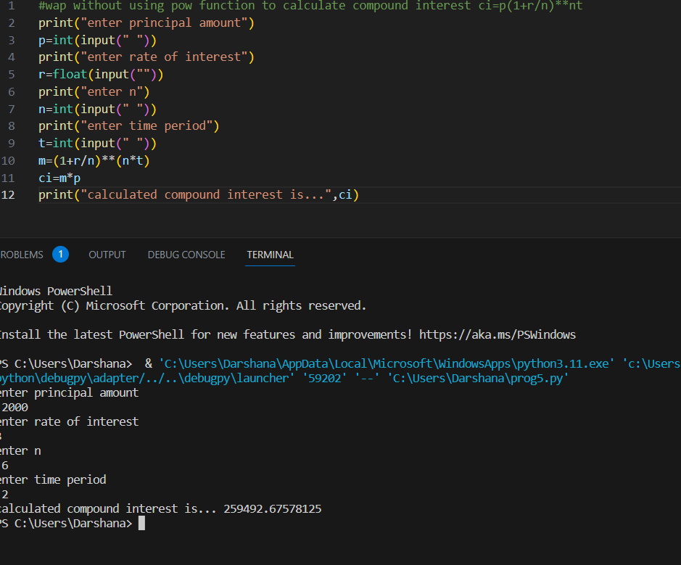

Q.9.WAP to convert seconds to minutes and seconds taking seconds as input.

import math

print("enter seconds that are to be converted into minutes and seconds")

a=int(input(" "))

minutes=a/60

secs=a%60

print (math.floor(minutes),"minutes")

print(secs"seconds",)

OUTPUT:

