Q.1.Read Total profit of all months and show it using a line plot.

dft=pd.read_csv(r'C:\Users\Darshana\OneDrive\Documents\company_sales_data.csv')

dfft=pd.DataFrame(dft)

month=dfft['month_number']

tot_profit=dfft['total_profit']

plt.plot(tot_profit,month,color='b')

plt.xlabel("month")

plt.ylabel("tot_profit")

OUTPUT:

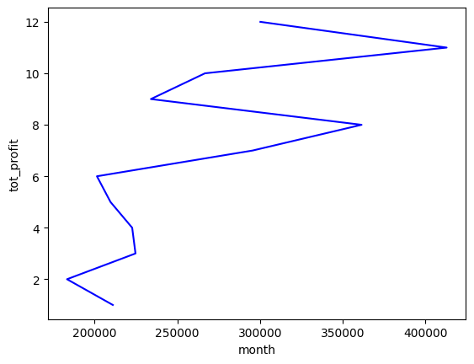

Q.2. Read toothpaste sales data of each month and show it using a scatter plot.

df=pd.read_csv(r"C:\Users\Darshana\OneDrive\Documents\company_sales_data.csv")

gt=df['toothpaste'].values

months=[1,2,3,4,5,6,7,8,9,10,11,12]

plt.scatter(months,gt,marker=",")

OUTPUT:

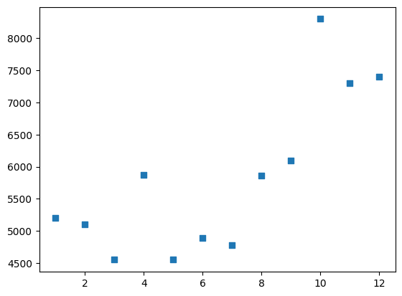

Q.3. Read face cream and facewash product sales data and show it using the bar chart.

df=pd.read_csv(r"C:\Users\Darshana\OneDrive\Documents\company_sales_data.csv")

dff=df['facecream'].values

dfff=df['facewash'].values

wid=0.3

dff_index=np.arange(len(dff))

plt.bar(dff_index,dfff+wid,width=0.7)

plt.bar(dff_index,dff+wid+wid,width=0.3)

OUTPUT:

