# PYTHON FOR DS.

# Assignment:2

## -*DARSHANA OJHA*

Q.1.WAP to print a dictionary that contains a number between 1 to n in form of (x:x**2)

print("enter value of n")

n=int(input(" "))

for i in range(1,n+1):

 d={}

 value=i**2

 d[i]=value

 print(d)

OUTPUT:

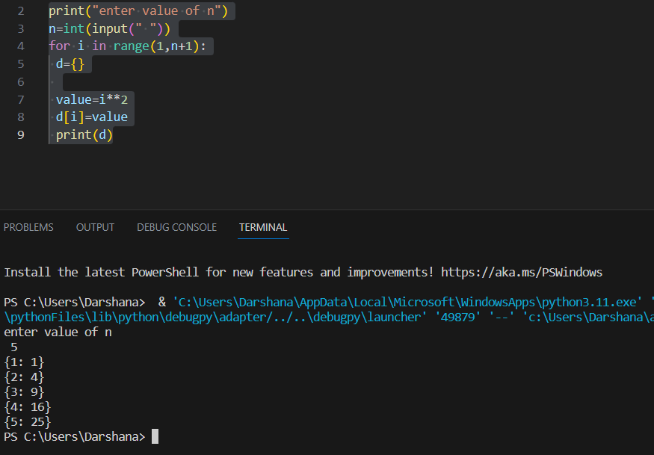

Q.2.WAP to check whether an element is present in dictionary or not.

d={"a":3,"b":5,"c":9,"d":0}

print("enter a key")

ele=str(input(" "))

count=0

for i in d:

    if i==ele:

        print("key found")

count=count+1

if count==0:

        print("key not found")

OUTPUT:

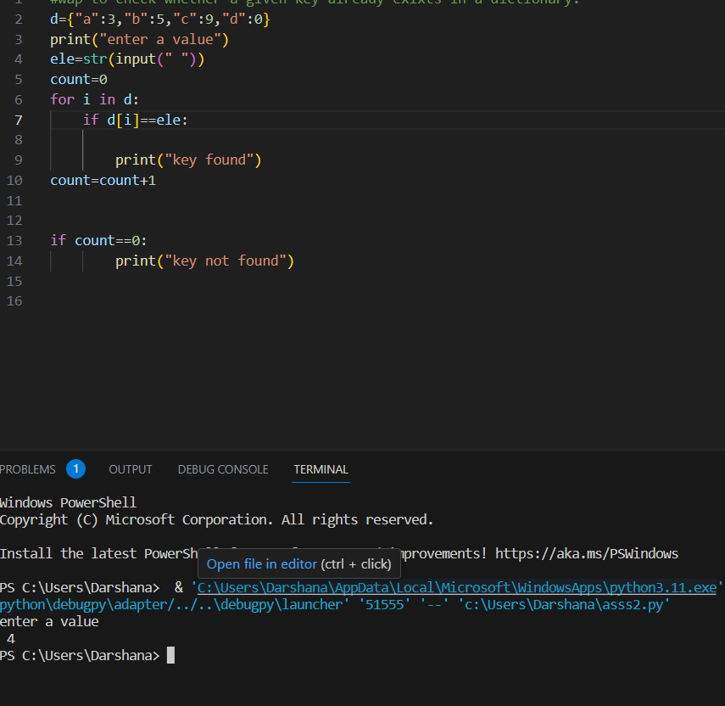

Q.3.WAP to print occurance of each element in the given list.

Lst=[1,1,33,33,2]

lst=[1,1,33,33,2]

print("enter element whole occurence is to be calculated")

ele=eval(str(input()))

count=0

for i in lst:

  if ele==i:

    count=count+1

print(count)

if not(ele)==i:

   None

OUTPUT:

