Assignment:1

## -*DARSHANA OJHA*

Q.1.WAP to identify lowercase and uppercase letters in inputted string and print no of uppercase and lowercase letters.

print("enter a string")

string=str(input())

t=0

p=0

for i in string:

   ''' '''

   if((i.isupper())):

    print(i,"is uppercase")

    t=t+1

   elif((i.islower())):

    print(i,"is lowercase")

    p=p+1

   else:

    print(i,"IS invalid input")

print(t,"are uppercase letters")

print(p,"are lowercase letters")

OUTPUT:

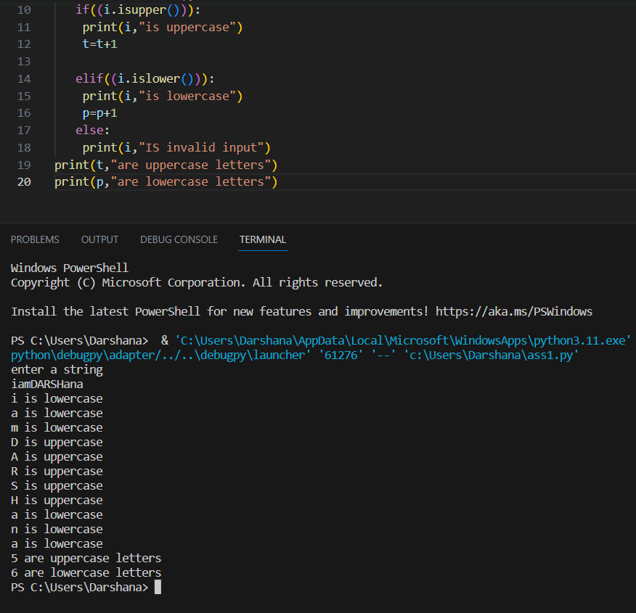

Q.2.WAP to remove elements with odd index numbers.

print("enter a string")

string=str(input(" "))

for i in string:

    print(string[0:10:2]

OUTPUT:

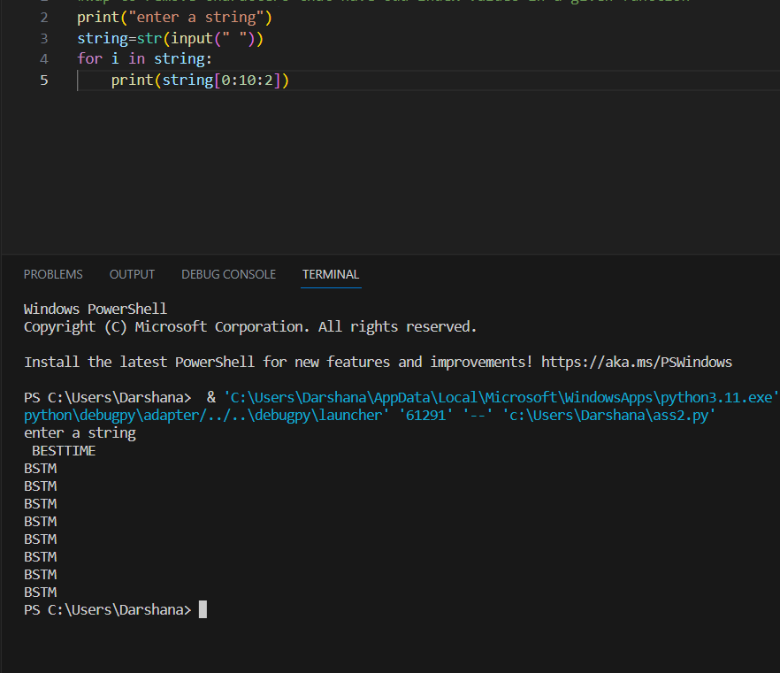

Q.3.WAP to get a string made up of first two and last two characters of inputted string and if length if less than 2,return empty string.

print("enter a string")

string=str(input())

for i in string:

    if(len(string)>=2):

     print( string[0:2]+string[-1:-3:-1])

     break

else:

        print(string[0:0])

OUTPUT:

