
NATIONAL STARTUP AWARDS 6.0 STUDENT INNOVATOR / ASPIRING ENTREPRENEUR
See the machine.
Own the OS.
Upkarna: top-specification smartphones, a transparent flagship, and an Indian operating system that developers build with AI.
STREAM: TECHNOLOGY AND INNOVATION STAGE: PROOF OF CONCEPT
Darshit Yadav, Founder · Individual entry · November 2026
Upkarna is a concept-stage venture and is not yet incorporated. DPIIT recognition is not required for this award category. All specifications are design targets unless marked verified.

★ | Read this first  The 60-second version, a map of where each judging criterion is answered, and how to read the rest.

IN ONE LINE
Phones are sealed boxes that tell you things only by sound and buzz. Upkarna makes a top-specification phone you can see into, lights that speak to people who cannot hear alerts, and an Indian operating system that developers build with AI. A working proof of concept is live today.

24 GB / 1 TB  Top configuration on every line | < ₹1.5 lakh  Price ceiling on every phone | 25%  Gross-margin target, held on every phone | Live  Interactive proof of concept you can open now

Where each judging criterion is answered
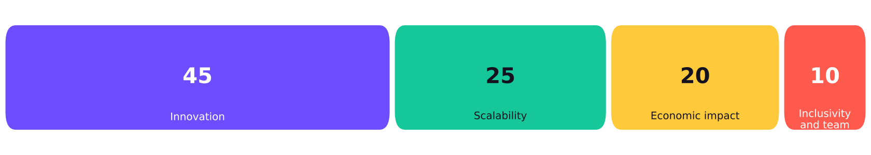
Figure 1. NSA 6.0 Student Innovator scoring weights (100 points)
Source: NSA 6.0 Student Innovator / Aspiring Entrepreneur guidelines, Startup India (DPIIT).
Criterion | Points | Read | What you will find
Innovation | 45 | Chapters 3 and 4 | Five genuinely new ideas; the full phone spec; the transparent engineering; the operating system and AI developer platform
Scalability | 25 | Chapter 6 | Plants, sourcing, repair network, certification, global waves, stage gates and roadmap
Economic impact | 20 | Chapter 7 | Business model, unit economics at a fixed 25% margin, jobs and ecosystem effects, market evidence
Inclusivity and team diversity | 10 | Chapter 8 | Light as an accessibility layer, open developer platform, team plan, what I learned

Your answers at a glance (portal form fields)
Field | Answer
Project title | Upkarna: see the machine, own the OS
Stream | Technology and Innovation (Shakti ki Sapta Dhara). Secondary link to Manufacturing: cost, quality and scale.
Problem | Phones are sealed and hard to repair, alert people only by sound or buzz, and the best specifications keep getting costlier. India has no developer-friendly home-grown mobile platform.
Solution | A top-specification phone range, a transparent edition with a rigid, colour-matched exposed core and lighting, and UpkarnaOS: Android first, a native OS built side by side.
How it works | Design in India, build with a manufacturing partner, ship Opaque Series on Day 1 and Transparent Edition on Day 8, and grow a developer platform with AI-assisted porting.
Users and beneficiaries | Phone buyers, people with hearing disability, developers and start-ups, repair technicians, and Indian manufacturing partners.
Expected impact | Local assembly and service jobs, a developer economy, longer-lived and repairable phones, and a path to an Indian mobile platform.
Development stage | Proof of concept: a working interactive simulation plus a cost-verified paper design. Hardware and native OS are planned, not built.
Team | Individual entry: Darshit Yadav.
Supporting material | This document, the live proof of concept, a schematic, charts and a source-checked evidence register.

Three ways to read this
60 seconds  This page and the one-line summaries at the top of each chapter. | 10 minutes  Each chapter’s opening page: cards, figures and key tables. | Deep read  Every table, the evidence register, assumptions and the guideline check in the appendices.
Labels used throughout: Verified means a product or figure exists today and is cited in Appendix A. Design target means credible and intended, but not built or tested by us. Assumption means a planning input listed in Appendix B.

1 | The problem  Real people hit these walls every day. Here is who, how, and why it matters.

IN ONE LINE
Phones are built to be sealed, not understood. They fail in ways people cannot see, alert people in ways some cannot sense, and top specifications are getting dearer. Meanwhile building a new platform has always failed on one thing: apps.

1.7 Mt  e-waste India generated in FY 2023-24, up 73% in five years. Only 43% was recycled. | 2.68 crore  Indians with a disability (Census 2011). About 19% have a hearing disability. | -22%  Global smartphone shipments, Q3 2026, as memory costs surged. | ~5%  HarmonyOS share of global phone sales, Q2 2026: the only recent new platform at scale, backed by a captive market.

Four problems, one plan
Problem | What people live with today | Why it matters
1. Sealed, hard-to-repair phones | Hidden internals; when a phone fails, few people can see why or fix it. India generated about 1.7 million tonnes of e-waste in FY 2023-24 (CPCB; figures vary by method) and 57% went unprocessed. | Wasted money and materials, and a pollution burden. Longer-lived, repairable devices reduce both.
2. Alerts that need hearing | Phones signal calls, alarms and doorbells by sound and vibration. Census 2011 counted 2.68 crore Indians with disabilities, about 19% with hearing disability. | People who cannot hear an alert can miss the thing that matters most. Light can carry it.
3. The best specs cost more each quarter | Memory costs surged; analysts say makers are protecting margins instead of upgrading specifications. The top tier sits at ₹1.1 to ₹1.7 lakh. | Buyers who want the most capable phone are priced out or told to settle.
4. No developer-friendly home-grown platform | Every new mobile OS that failed, failed on apps. Android and iOS decide what developers can build, and how. | A country of millions of young developers has no platform it can shape.
Sources: CPCB and Parliament data via Down To Earth and Drishti IAS; Census 2011 via MoSPI and Lok Sabha documents; IDC; Counterpoint. See Appendix A.

Who is affected, and how Upkarna helps each
Who | What changes
Phone buyers | A top-specification phone with its engineering visible and a repair route that is published, not hidden.
People with hearing disability | Sound-to-light alerts on the Transparent Edition and in the operating system, so doorbells, calls and alarms can be seen.
Developers and start-ups | A new platform with AI built into the tools, so apps can be built and ported in days, not months.
Repair technicians | Training, genuine parts and diagnostics from an authorised network, creating skilled local work.
Indian manufacturing partners | A premium product line to build, with a design that stays in India.

WHY THIS FITS THE AWARD
This matches the call for Viksit Bharat@2047: technology and innovation (the stream we entered), manufacturing quality and scale, and young people solving real problems.

2 | The solution  Upkarna in one page: three connected parts and five phones, all priced below ₹1.5 lakh.

IN ONE LINE
Three parts that feed each other: phones that earn, a transparent edition that builds the brand, and UpkarnaOS with an AI developer platform that builds the future.

1. Phones  Opaque Series and Transparent Edition. Top chip, big battery, 200 MP periscope camera, 24 GB / 1 TB top tier. | 2. UpkarnaOS  Android-based first so apps work on day one; a new native OS built alongside and switched in only by gates. | 3. AI platform  Developer tools powered by frontier AI models, with AI-assisted porting of Android apps.

The lineup
SKU | Memory / storage | Target price | About | Role
Opaque 12/256 | 12 GB / 256 GB | ₹79,999 | US$847 | Entry point to the flagship chip, battery and cameras
Opaque 16/512 | 16 GB / 512 GB | ₹89,999 | US$952 | The volume flagship of the range
Opaque 24/1TB | 24 GB / 1 TB | ₹1,24,999 | US$1,323 | Top Opaque tier; cost-gated (Chapter 7)
Transparent 16/512 | 16 GB / 512 GB | ₹1,19,999 | US$1,270 | Entry to the transparent edition
Transparent 24/1TB | 24 GB / 1 TB | Up to ₹1,49,999 | US$1,587 | The halo phone; below ₹1.5 lakh
Target prices include Indian GST and are confirmed only after supplier quotes (Appendix B). US-dollar figures use ₹94.5 per dollar (5 November 2026); the rupee has weakened in 2026, which matters for imported parts.

Four price rules
- Every Upkarna phone is priced below ₹1.5 lakh.
- The 25% gross-margin target is held on every phone. It is not traded away.
- The 12/256 and 16/512 Opaque phones are planned below ₹1 lakh to compete head-on with today’s flagships.
- 24 GB / 1 TB ships only when its cost ceiling is met. If memory pricing at launch does not allow it, that model is held back until it does; we do not break the ceiling or the margin.

Opaque or Transparent?
 | Opaque Series (Day 1) | Transparent Edition (Day 8)
Rear | Solid, premium finish | Transparent glass over a rigid exposed core
Internals | Hidden | Colour-matched to the buyer’s choice, fixed to the frame
Lighting | None | Micro-LED matrix and a central Core Lamp
Cooling | Conventional vapor chamber | Vapor chamber styled as visible metal veins
Perks | Standard box | Collector packaging, early developer SDK access, lighting tools
Price | ₹79,999 to ₹1,24,999 | ₹1,19,999 up to ₹1,49,999

Launch sequence
Reveal  Both tiers announced at one event, so the gap reads as anticipation. | Reserve  Colour is chosen at pre-order, which also sets the production mix. | Day 1  The Opaque Series ships. | Day 8  The Transparent Edition ships: a second wave of attention.

3 | Innovation I: the phone  What is genuinely new, how the transparent phone stays rigid, cool and sealed, and the full specification.  WORTH 45 OF 100 POINTS

IN ONE LINE
Not new: rear lights, big batteries, periscope cameras. New: a rigid, colour-matched exposed core at flagship specification below ₹1.5 lakh, a 24 GB / 1 TB top tier built to a stated cost, and light designed as an accessibility layer.

Five ideas that are new together
Idea | What exists today | What Upkarna adds
1. Rigid, colour-matched exposed core | Phones with transparent-look backs and rear lights (for example Nothing, with a 489-LED rear matrix) | A truly see-through back with boards, shields and heat spreaders fixed to the frame and finished in the colour the buyer picks
2. A 24 GB / 1 TB top tier at a stated cost | The latest flagships top out at 16 GB RAM; 24 GB was last sold on the OnePlus 13 | 24 GB / 1 TB on every line, with a published cost ceiling and a rule for when it ships
3. Light as an accessibility layer | Rear lights used for style and basic notifications | Sound-to-light patterns for doorbells, alarms and calls, built into hardware and the operating system
4. AI-assisted developer platform | AI coding tools exist, but not built into a mobile platform’s own SDK | A platform where AI helps port Android apps to a new native OS, closing the app gap
5. Gate-based OS switch | OS switches are announced by date | Android first, native OS built beside it, switched only when app, security and performance gates are met
We do not claim rear-light features (flip-to-silence, countdown, progress bars) as ours; Nothing already ships them. Our difference is the rigid exposed core, the specification and cost discipline, the accessibility design and the platform.

The full specification sheet
The middle column is what we plan. The right columns show a comparable shipping phone and the status. Design target means not yet verified on our own hardware.
Area | Upkarna specification | Market evidence today | Status
Platform | Qualcomm Snapdragon 8 Elite Gen 6 (2 nm). The higher Elite Extreme Gen 6 is evaluated and adopted only if it passes the cost gate. Snapdragon 8 Elite Gen 5 is the fallback. | Both Gen 6 chips announced 22 Sep 2026 on 2 nm; OnePlus, OPPO, vivo, Xiaomi and Motorola among adopters. Gen 5 ships now (OnePlus 15: 4.608 GHz, Adreno 840). | Committed; chip confirmed at supplier quote
Memory | 12 GB, 16 GB or 24 GB LPDDR5X; 24 GB is the top tier | OnePlus 13 sold 24 GB + 1 TB; OnePlus 15 sells 12 GB and 16 GB | Committed; 24 GB is cost-gated
Storage | 256 GB, 512 GB or 1 TB UFS 4.1; 1 TB is the top tier | OnePlus 15 sells up to 1 TB UFS 4.1 | Committed; 1 TB is cost-gated
Display | About 6.8 in LTPO AMOLED, about 1.5K, up to 165 Hz, Dolby Vision and HDR10+. Peak brightness target of 3,000 nits or more. | OnePlus 15: 6.78 in LTPO, 165 Hz, up to 1,800 nits full-screen HBM | 165 Hz committed; brightness is a design target
Main camera | 50 MP large-format sensor with OIS | Triple 50 MP rear cameras on OnePlus 15 | Committed
Telephoto | 200 MP periscope telephoto | realme GT 8 Pro (200 MP telephoto, ₹78,999 for 16/512); OPPO Find X9 Pro (200 MP periscope) | Committed, subject to sensor supply
Ultrawide | 50 MP, about 120 degrees, with real-time distortion correction | Common on current flagships | Committed
Macro | Dedicated 50 MP macro down to about 3 cm | Not common; close-focus on another lens is the usual solution | Stretch; fallback is close-focus on the ultrawide or telephoto
Front camera | 32 to 50 MP with AI auto-framing | 32 MP on OnePlus 15; 50 MP on OPPO Find X9 Pro | Committed
Video | Up to 8K; 8K at 60 fps depends on the chip tier | Qualcomm advertised 8K60 with the Elite Extreme Gen 6 launch | Depends on chip tier
Battery | About 7,500 mAh silicon-carbon | OnePlus 15T and OPPO Find X9 Pro: 7,500 mAh. OnePlus 15: 7,300 mAh. | Committed
Charging | 100 to 120 W wired, 50 W wireless. Times quoted only after our own testing. | OnePlus 15: 120 W wired, 50 W wireless | Committed; times pending test
Connectivity | Wi-Fi 7, Bluetooth 6.0, NFC, UWB, 5G, dual SIM, with regional radio variants | OnePlus 15 lists Wi-Fi 7, Bluetooth 6.0, NFC and dual SIM | Committed
Audio | Gold-plated 3.5 mm jack with an ES9219-class DAC; stereo speakers | ES9219 datasheet: 121 dB dynamic range, 32-bit/384 kHz PCM, DSD256 | Committed
Under-glass speakers | Piezoelectric exciters beneath the display with a bottom woofer | Precedents: LG G8 ThinQ, Xiaomi Mi Mix, Sony TVs | Design target; fallback is conventional speakers
Build | Aluminium unibody, hardened glass front and back, IP68/IP69 sealing | Standard on current flagships | Committed
Security | Hardware secure enclave; post-quantum-ready cryptography as standards allow | NIST finalised post-quantum standards in 2024 | Design target

Why 24 GB / 1 TB is a decision, not a default
- It gives a clear lead. Current flagships stop at 16 GB RAM.
- It is the costliest tier. At Q1 2026 prices, 16 GB plus 1 TB of memory already cost over $280; prices have risen since.
- It is cost-gated, not abandoned. The price rules and the unit-economics gate (Chapter 7) decide whether it ships at launch or after memory prices ease.
- The chip is also a gate. Gen 6 on 2 nm adds cost; Gen 5 is the fallback.
- Camera ambition sits where buyers notice it: a 200 MP periscope telephoto, a strong 50 MP main sensor and optical stabilisation. Macro is a stretch item.

The transparent phone: engineering that makes it credible
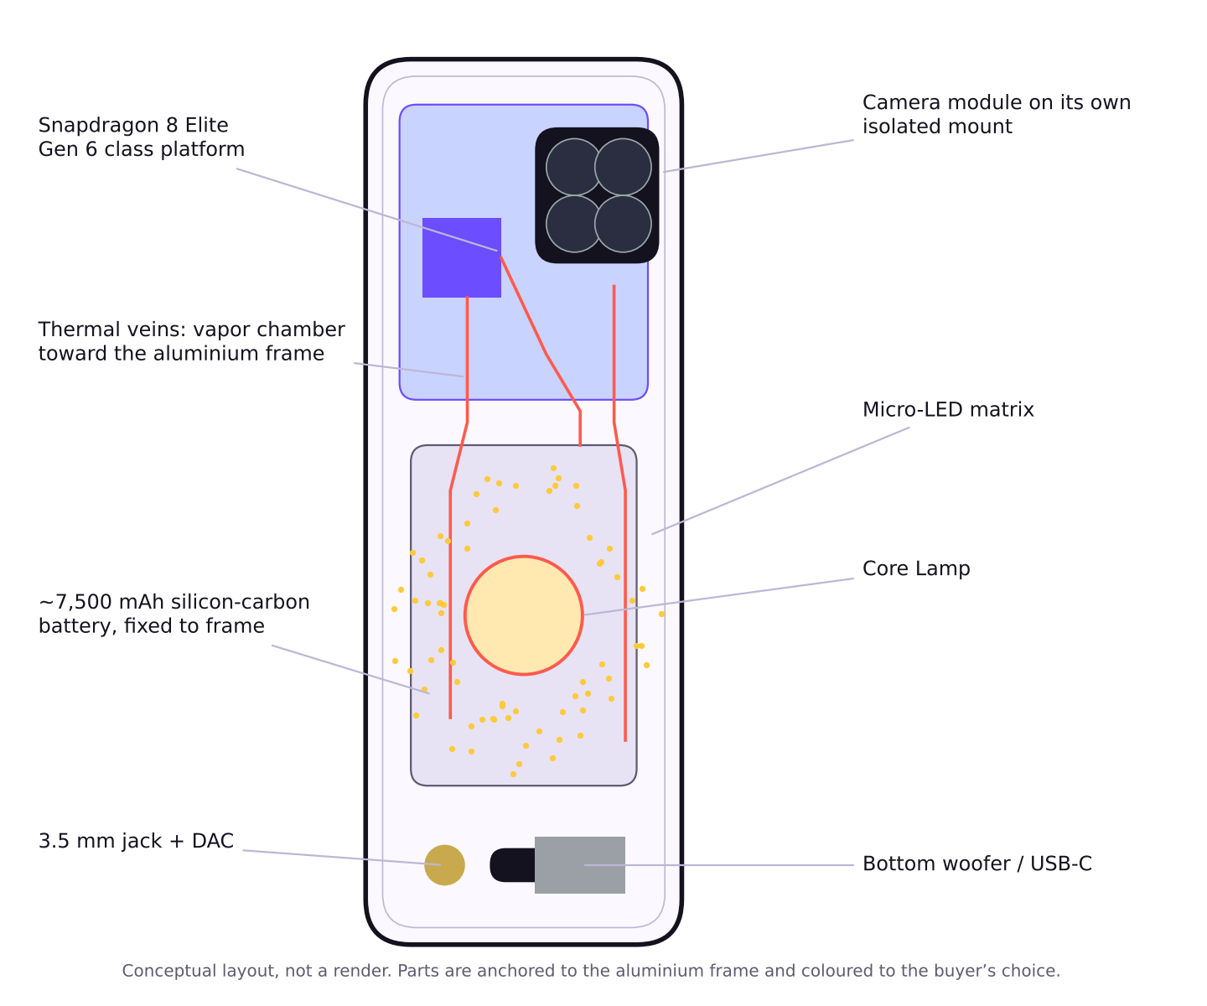
Figure 2. Conceptual layout of the Transparent Edition back
Challenge | Our approach
Nothing may rattle | All boards, shields and the battery are fastened to the aluminium mid-frame with micro-screws, and small parts are bonded. The interior behaves as one rigid assembly. Drop, vibration and shake testing proves it before launch.
Colour that matches the buyer’s choice | Exposed boards, shields and heat spreaders are finished in the chosen colourway at the factory. The set is limited to three colourways at launch to keep tooling and inventory manageable.
Dust, moisture and water | Exposed boards receive a thin conformal coating. Standard parylene-C yellows under UV, so we specify a fluorinated, UV-resistant parylene and add a UV-blocking layer to the rear glass. Perimeter gasketing and port sealing target IP68/IP69; a transparent back does not change the seal.
Heat | Glass conducts heat poorly. A vapor chamber, styled as visible metallic veins, spreads heat into the aluminium frame, and firmware limits the Core Lamp when temperatures rise.
Sound near the camera | The camera module sits on its own isolated mount so display-speaker vibration cannot disturb its stabilisation.

Lighting suite (Transparent Edition only)
- Contact-specific light patterns and persistent “essential” alerts.
- Sound to light: doorbell, alarm and call patterns, designed for people who cannot hear them.
- Progress bars for charging, timers and deliveries; flip-face-down silent mode; camera countdown and soft fill light.
- An audio-synchronised light composer for ringtones, plus an SDK so developers can add light effects.
- The lamp and micro-LEDs sit behind a light barrier so they never bleed into the front display.
The Opaque Series has no LED matrix, by design. This keeps its bill of materials and look conventional.

4 | Innovation II: UpkarnaOS and the AI developer platform  Android first so apps work on day one; a new native OS built alongside; AI to close the app gap.  WORTH 45 OF 100 POINTS

IN ONE LINE
Two tracks. Track A ships phones on an Android base and earns. Track B builds a completely new OS beside it with invited developers and AI tools, and replaces Android only when objective gates are met.

A NOTE ON THE NAME
Upkarna is choosing between two names for its operating system: UpkarnaOS and SovereignOS. This document uses UpkarnaOS as the working name. Whichever is chosen will be used for both tracks and cleared through a trademark search before launch.

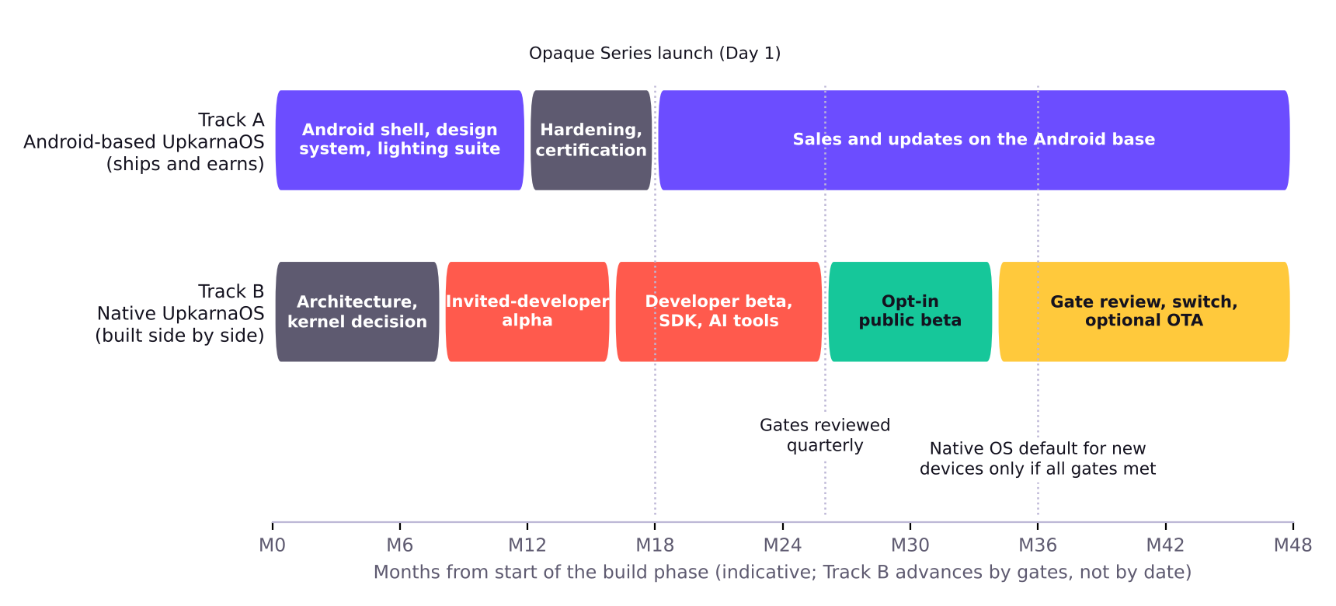
Figure 3. The two operating-system tracks
Month figures are indicative planning inputs from the start of the build phase. Track B advances by gates, not by calendar.

Design principles
Clean  No bloatware or sponsored apps; our own typeface. | Fluid  Physics-based, interruptible animation for high-refresh screens. | Yours  Lock screen, icons, grid, gestures and haptics are settings, not patches. | Private  Everyday AI runs on the phone’s NPU.

- Capable: desktop-style windowing, a proper file manager, background tasks that are not killed aggressively, and per-app network controls.

Track A: UpkarnaOS on an Android base
Phones launch on Android, so customers get payments, banking, maps and messaging from day one. Upkarna’s value sits on top: the shell, design system, customisation engine, lighting suite and update policy. Android 17 became stable in June 2026 and the platform is open source (AOSP), which makes this a practical start. Distributing Google’s services needs licensing and compatibility testing (Chapter 9).

Track B: a completely new operating system
Track B starts with the build phase, in parallel with Track A, and is staffed separately so it cannot slow the phone launch. It has a new runtime, app framework, system services and design system. The kernel foundation is decided in the first architecture phase, because Qualcomm’s hardware support arrives as Linux and Android kernel drivers.
Invited cohort | Role
Anchor apps | The apps people use daily: payments and banking, messaging, maps, ride and delivery, video, shopping. Invited early, supported by our engineers.
Independent developers | Invited builders receive engineering-sample phones, the SDK, AI tooling and direct engineering access.
Universities and open-source contributors | Tools, libraries and a growing pool of engineers.
Hardware accessory makers | Lighting-suite SDK for the Transparent Edition.

The AI developer platform
The hardest part of any new OS is the app gap. Upkarna’s platform builds frontier AI into the developer tools so a small team can build, port and test apps far faster than by hand.
Capability | What it does for developers
Describe to build | A developer describes an app; the platform generates code against the UpkarnaOS SDK, runs it in an emulator and iterates.
Port from Android | AI-assisted conversion of existing Android apps to the native SDK, the biggest lever for closing the app gap.
Test and secure | Automatic test generation, accessibility checks and security review before an app is accepted.
Documentation and support | An assistant that answers SDK questions and writes migration guides.
Lighting and device APIs | AI help for adding Transparent Edition light effects and device features.

Models under consideration
Model | Status and fit
Anthropic: Claude Mythos 5.2, Claude Fable 5.2, Claude Opus 5.5 | Anthropic’s current top-tier models (the Mythos and Fable tier is at version 5.2), available through Anthropic. Opus 5.5 placed second on a leading independent index at the time of Gemini 4 Carbon’s launch.
OpenAI: GPT-6 Astra | Available to developers through OpenAI’s API (gpt-6-astra) since September 2026.
Google: Gemini 4 Carbon | Announced 28 October 2026 with restricted, phased access and no public API date reported yet. It topped one independent index (59, against 58 for Opus 5.5 and 57 for GPT-6 Astra) and is reported at roughly one-fifth the token price of GPT-6 Astra.

How we will use them. The platform will be model-agnostic. A routing layer sends each task to the model that performs best on our own SDK tests, and switches provider if price, access or terms change. No agreements exist with any provider today. Pricing, data-handling and licensing for AI-generated code will be reviewed before launch (Chapter 10), and every AI-generated change passes human review and automated tests before it reaches customers.

The switch-over: gates, not dates
Native UpkarnaOS becomes the default on new Upkarna phones, and is offered to existing owners as an optional update with rollback, only when every gate is met. The board will ratify these thresholds before any switch.
Gate | Proposed criterion
App coverage | The top 200 apps by monthly active use in each launch market are available natively or through a supported compatibility route, including every major payments, banking, messaging, maps and ride-hailing app.
Security | An independent security audit with no open critical findings, and a bug-bounty programme running.
Performance | Battery life, launch times and animation smoothness at or above the Android build on the same hardware.
Stability | Crash and update-failure rates at or below the Android build across a public beta of meaningful size.
Customer protection | Guaranteed rollback to the Android build for a defined period, and continued Android security updates for owners who stay.

Lessons from the closest precedent
Huawei removed Android compatibility from HarmonyOS in October 2024. By August 2026 it reported more than 100,000 native apps (over 400,000 including meta-services) and more than 80 million devices on HarmonyOS 6; Counterpoint puts HarmonyOS at about 5% of global phone sales in Q2 2026.
- It is possible. A new mobile OS can reach real scale in about two years when developers are courted and funded.
- It needed advantages we lack. Huawei had a captive home market, hundreds of millions of devices and a strategic reason to leave Android. Upkarna starts with none of these, so we use gates, a long Android runway, invited developers and AI-assisted porting.
- Apps decide the outcome. Our gates are written around app coverage first.

5 | Proof it can work  Where we are today, what already runs, and how every number was checked.

WHERE WE ARE
The award asks for a prototype, MVP, working model or proof of concept. Upkarna’s proof of concept is live: a working simulation of the lighting suite and the OS customiser, backed by a source-checked specification and cost model.

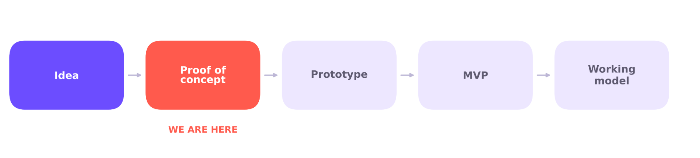
Figure 4. Development stage
Stages named in the NSA 6.0 student guidelines: idea, proof of concept, prototype, MVP, working model.

What already runs
An interactive proof of concept simulates two ideas from the plan. It is software only; the Transparent Edition hardware and the native OS are planned, not built.
Demo | What you can try
Transparent Edition lights | Pick the internal colour, then run message alerts, charging progress, a music beat, a camera countdown, the Core Lamp and the sound-to-light accessibility pattern.
UpkarnaOS customiser | Change icon shape, grid density, clock weight and theme colours live, showing the “settings, not patches” principle.

Open the proof of concept: https://claude.ai/artifact/KsXyrdsV4mxZ4pkr8ezvYS
A copy of the page is also submitted as the file upkarna_proof_of_concept.html. It was tested with scripted checks of every button and control.

What is verified, and what is still a target
Area | Verified today | Still a design target
Chip, memory, storage | Gen 6 and Gen 5 platforms ship; UFS 4.1 up to 1 TB; 24 GB sold on the OnePlus 13 | Supplier quotes at our volume
Battery and charging | 7,500 mAh silicon-carbon and 120 W / 50 W charging ship today | Our own charging times
Cameras and display | 200 MP periscope and 165 Hz LTPO ship today | 3,000 nit peak, 50 MP macro
Audio | ES9219 DAC datasheet figures | Under-glass speakers and isolation from the camera
Transparent back | Parylene UV behaviour; conformal coating practice | Our own sealing, thermal and drop test data
Economics | Memory prices, GST, exchange rate, market data | Real quotes against each cost ceiling

How the numbers were checked
Every external figure was checked against a named source (Appendix A). Where an early idea was wrong, we corrected it and recorded the change (Appendix C). For example, IP69K is a road-vehicle standard, so phones use IP68/IP69; LPDDR6X does not exist, so we use LPDDR5X; and a 120 W charge in 18 minutes is not supported by shipping phones, so we quote times only after testing.

6 | Scalability  How one founder’s plan grows to plants, repair shops, certification and many countries without losing control.  WORTH 25 OF 100 POINTS

IN ONE LINE
Scale by gates: prove each stage, then release the next. Build with a partner first, decide on owned plants later, certify for each region as we enter it, and grow the service network wave by wave.

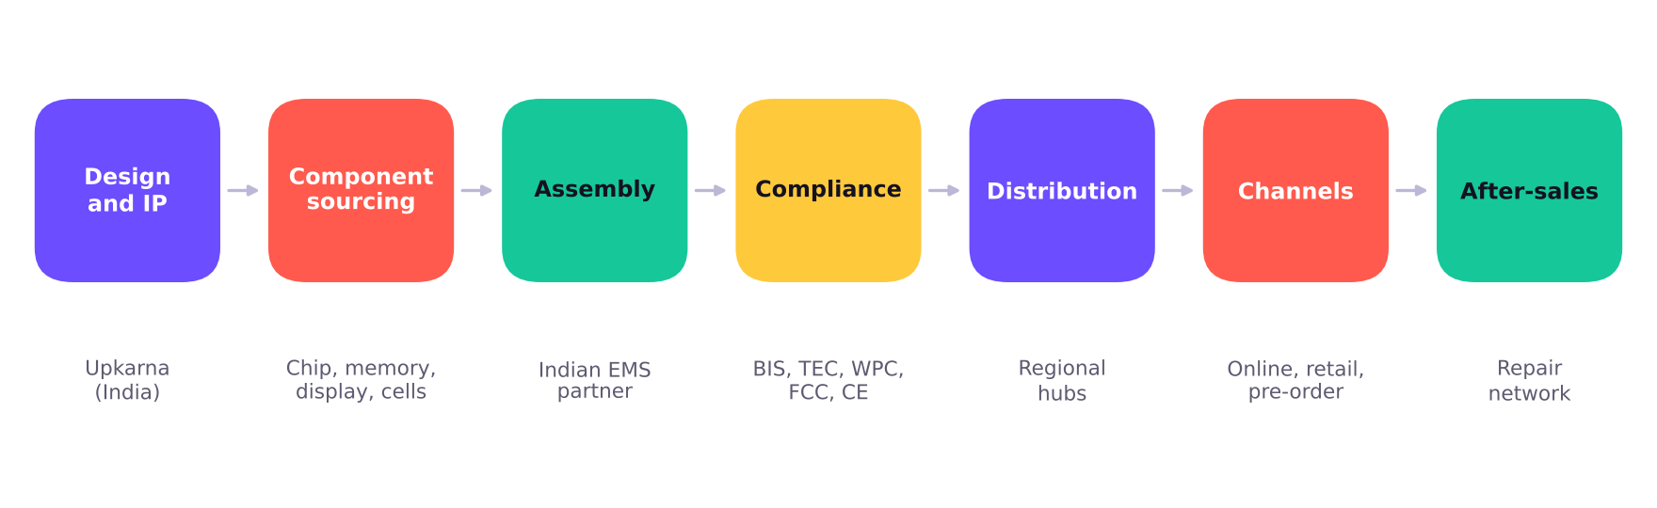
Figure 5. From design to customer

Plants: contract manufacturing or owned assembly
Upkarna has not decided how it will build its phones. This is a deliberate part of the concept phase. A default plan and the options being weighed are below.
Option | What it means | When it makes sense
A. Contract manufacturer (default) | An EMS partner assembles Upkarna phones. India makes nearly all handsets it sells; Dixon Technologies was India’s largest smartphone maker by volume in 2025 (19% share); Indian-origin EMS firms assembled about one in four phones made in India in FY26. | From day one: low capital, faster start, existing quality systems
B. Dedicated line at a partner | A line or cell at a partner’s plant reserved for Upkarna, with Upkarna engineers on site. | Once volumes justify dedicated tooling and tighter control of the Transparent Edition
C. Owned plant | Upkarna builds and runs its own assembly plant. | Only at significant scale; large capital and management load

Decision criteria: volume, capital, control of the transparent assembly (sealing, cleanliness, colour matching), incentives, tariffs and export routes, and time to launch. Default: start with A, move to B if the Transparent Edition needs it, revisit C only at scale. No manufacturing agreement exists today.

Components and sourcing candidates
Component | Candidate sources (no agreements exist yet) | Key risk
Chipset | Qualcomm Snapdragon 8 Elite Gen 6 (Gen 5 fallback) | Allocation and price at low volume
DRAM and NAND | The three DRAM makers (Samsung, SK hynix, Micron) and NAND suppliers | Price and supply; the largest cost risk, especially 24 GB / 1 TB
Display | Established AMOLED panel makers | Qualification for 165 Hz LTPO and brightness
Camera sensors and lenses | Established sensor and module suppliers | Availability of 200 MP periscope sensor
Battery cells | Silicon-carbon cell makers | Safety certification and consistency
Cover glass | Corning Gorilla Glass or equivalent | Optical clarity and UV-blocking for the transparent back
Audio | ESS ES9219-class DAC; piezo and woofer suppliers | Acoustic isolation from the camera
Aluminium frame | CNC machining partners | Tolerance and yield on the transparent edition
Assembly | Indian EMS partners such as Dixon Technologies or Tata Electronics | Capacity, willingness for low initial volume

Stage-gated production
Standard validation stages. Month figures are indicative from the start of the build phase; quantities are typical industry ranges to be set with the manufacturing partner.
Stage | Months | Units | Exit criteria
Design and sourcing | 0 to 6 | Prototypes | Supplier quotes meet the cost ceilings; IP filings made; design frozen for tooling
EVT (engineering validation) | 6 to 10 | Tens | Phone boots and runs all core functions; thermal, battery and display meet targets; transparent-back sealing validated
DVT (design validation) | 10 to 14 | Hundreds | Drop, vibration, water and dust, heat and rattle tests passed; certification tests begun
PVT (production validation) | 14 to 17 | Thousands | Line yield at target; certification complete; accessories and packaging ready
Launch and ramp | 17 to 18+ | Per forecast | Opaque Series ships Day 1; Transparent Edition Day 8; monthly build plan follows pre-orders

Certification, region by region
Region | Expected requirements (to be confirmed with a certification consultant)
India | BIS compulsory registration (including battery and charger safety), telecom testing (TEC MTCTE), WPC equipment type approval, IMEI registration, SAR compliance, e-waste (EPR) registration.
United States | FCC authorisation and, for carrier sales, carrier and industry certifications.
European Union and United Kingdom | CE marking (radio equipment), UKCA for the UK, battery and eco-design rules, and e-waste schemes.
Other markets | Local type approval and import rules, assessed market by market as expansion waves are planned.

Shipping and logistics
Step | Plan
Inbound | Components ship to the plant on contracted schedules. High-value parts such as chips and memory are air-freighted in insured, tracked consignments.
Finished goods | Phones move from the plant to regional distribution hubs in tamper-evident, shock-tested packaging. Hubs are added as each expansion wave opens.
Channels | Company website and large online marketplaces first; selected large-format retail and experience points in major cities as volume allows. Financing and EMI offers, which Counterpoint credits for the resilience of premium phones, are part of the plan.
Transparent Edition | Reserved units are built in the colour chosen at pre-order and shipped prepaid with signed delivery. Collector packaging protects the glass back in transit.
Currency and tariffs | Pricing and landed cost are modelled per market, including duties and exchange-rate swings; the rupee has weakened through 2026.

Repair and service network
A transparent phone invites repair, and a premium phone needs trusted service. The model is still being designed. Options:
Option | What it means | Trade-off
Authorised repair shops | Independent shops trained and certified by Upkarna, supplied with genuine parts and diagnostic tools | Fast coverage and low capital, but quality depends on partners
Own service centres | Upkarna-run centres in key cities | Best control and brand experience, but higher fixed cost
Hybrid (default) | Own centres in launch cities, authorised shops elsewhere, mail-in repair as a backstop, and a parts store for owners | Balanced cost and coverage; needs strong training

- A published repair-price list and stocked spare parts, including the transparent back glass.
- Repair guides and diagnostics for authorised partners; repairability is a design goal of the transparent edition.
- One-year warranty, an optional accidental-damage plan, and a published software-update policy for the Android track.

Going global in waves
India is confirmed as the first launch market. The later waves are proposals.
Wave | Markets | What must be ready
1. Home market (confirmed) | India, the first launch market, where target prices are set and the supply base sits | BIS, TEC and WPC approvals; service centres in launch cities; marketplace and EMI partners
2. Nearby premium markets | Selected markets in Asia and the Middle East | Local type approvals; regional hubs; localisation of the OS and support
3. Europe and the UK | EU member states and the UK | CE and UKCA, battery and eco-design compliance, repair and warranty rules, local-language support
4. United States | Direct and, if justified, carrier sales | FCC and carrier certifications; US service and logistics; tariff review

Roadmap and milestones
Phase | Timing | Key deliverables | Gate to pass
Concept phase (now) | Set by readiness, not date | Full design; plants and repair decisions; OS and feature definition; developer-platform design; supplier conversations; incorporation | Readiness gate (Chapter 11)
0. Protect and quote | Months 0 to 6 | Patent, design and trademark filings; freedom-to-operate review; supplier and EMS quotes; Track B architecture | Quotes within cost ceilings; IP filed
1. Prove the product | 6 to 14 | EVT and DVT builds; sealing, thermal and drop data; Track A shell on samples; developer alpha | Test results meet targets
2. Prepare to ship | 14 to 18 | PVT run; certification; channels and pre-orders; developer beta begins | Certification complete; yield at target
3. Launch | 18 | Opaque Series Day 1; Transparent Edition Day 8 | Pre-order conversion; early returns
4. Scale and build the platform | 18 to 36 | Volume ramp; first expansion waves; public beta and SDK programme; quarterly gate reviews | Native OS gates
5. Switch and extend | 36 onward | If gates are met: native OS default on new devices, optional update for owners; then ecosystem devices | Board decision per device
Month figures are indicative. Gates, not dates, control the release of capital and the OS switch. A smartwatch, tablet and thin laptop on the same OS can follow once the phone is established; none is in this plan.

7 | Economic impact  How the business earns, what each price allows us to spend, and what it does for jobs and industry.  WORTH 20 OF 100 POINTS

IN ONE LINE
Three revenue layers, a fixed 25% margin, and a published cost ceiling for every phone. If a configuration cannot meet its ceiling, it is held back, not discounted.

Three layers of revenue
Phones  Opaque Series for volume; Transparent Edition for margin and brand. | Accessories and services  Cases, chargers, collector packs, extended warranty and damage plans. | Platform  Developer programme, SDK and, in time, an app store and services.

The price as a cost ceiling
Target costing: start from the price the customer pays and work back to the most we can spend on the phone itself. For India: GST 18%, channel and marketplace cost 10% of the pre-GST price, and a 25% gross margin held fixed. Taxes differ by country, so other markets are recalculated.
Per phone | Opaque 12/256 | Opaque 16/512 | Opaque 24/1TB | Transp. 16/512 | Transp. 24/1TB
Price paid (incl. GST) | ₹79,999 | ₹89,999 | ₹1,24,999 | ₹1,19,999 | ₹1,49,999
GST (18%) | ₹12,203 | ₹13,729 | ₹19,068 | ₹18,305 | ₹22,881
Price before GST | ₹67,796 | ₹76,270 | ₹1,05,931 | ₹1,01,694 | ₹1,27,118
Channel cost (10%) | ₹6,780 | ₹7,627 | ₹10,593 | ₹10,169 | ₹12,712
Upkarna receives | ₹61,016 | ₹68,643 | ₹95,338 | ₹91,525 | ₹1,14,406
Gross margin (25%) | ₹15,254 | ₹17,161 | ₹23,835 | ₹22,881 | ₹28,602
Cost ceiling per phone | ₹45,762 | ₹51,482 | ₹71,504 | ₹68,643 | ₹85,805
Cost ceiling in US$ | US$484 | US$545 | US$757 | US$726 | US$908
The ceiling must cover components, assembly, freight, warranty reserve, packaging and certification per unit. US-dollar figures use ₹94.5 per dollar. Planning calculations, not forecasts.
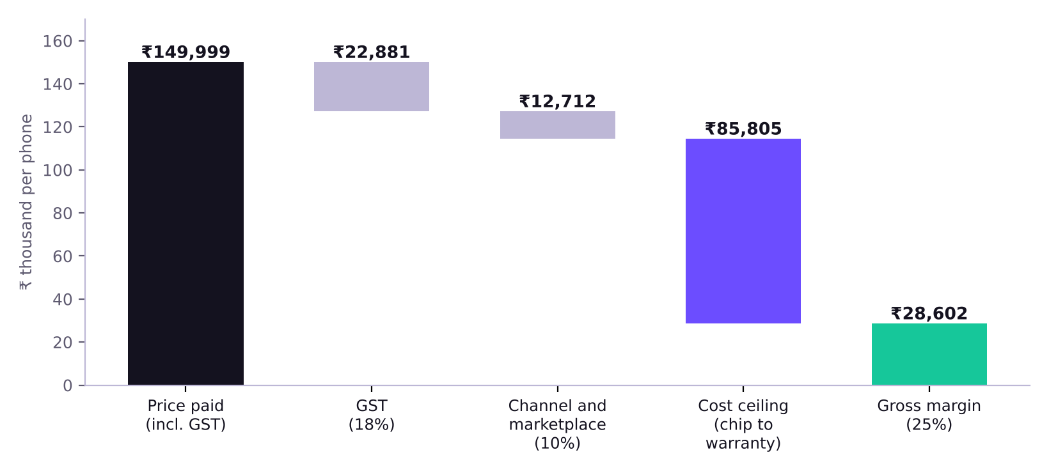
Figure 6. From the ₹1,49,999 price to the cost ceiling (Transparent 24/1TB)

Why 24 GB / 1 TB is the hardest line
At Q1 2026 prices, 16 GB plus 1 TB of memory alone crossed US$280, and prices have kept rising (TrendForce: mobile DRAM contract prices up 78% to 83% in Q2 2026; a further 10% to 15% for DRAM and 15% to 20% for NAND projected for Q4). Adding 8 GB of RAM raises the bill further. Supplier quotes are the only valid number.
Cost to build one phone (hypothetical) | Price needed in India (incl. GST) | Below the ₹1.5 lakh ceiling?
US$500 | ₹83,000 | Yes
US$600 | ₹99,000 | Yes
US$700 | ₹1,16,000 | Yes
US$800 | ₹1,32,000 | Yes
US$908 | ₹1,50,000 | Yes
US$1,000 | ₹1,65,000 | No: above the ceiling
US$1,150 | ₹1,90,000 | No: above the ceiling
Illustrative: the same 18% GST, 10% channel cost and 25% margin. The cost figures are hypothetical, not estimates of Upkarna’s actual bill of materials.
- Opaque 24/1TB at ₹1,24,999 must be built for about US$757 or less, including a 25% margin.
- Transparent 24/1TB at up to ₹1,49,999 has about US$908 per phone, but carries the transparent-edition extras.
- Order of response if a quote does not close: negotiate supply; change the specification (Gen 5 instead of Gen 6, drop macro); hold back the 24 GB / 1 TB tier until memory prices ease; then tell the investor. The ceiling and the margin are not traded away.

Other places the numbers are tight
- A rival with scale sells a 16/512 flagship at about ₹93,999 (July 2026 listing). Our ₹89,999 Opaque 16/512 undercuts it with far lower volume, so the margin target is the first thing the quotes will test.
- Memory prices have not stabilised, so memory is modelled as the most volatile input and each ceiling carries a buffer.
- The rupee has weakened in 2026, raising the rupee cost of imported components while prices are set in rupees.
- No government incentive is in the base case, and we have not forecast unit volumes or revenue: there is no sales history, and pre-order data will set the first forecast.

The market we serve
Measure | Figure | Source
Global smartphone shipments, 2025 | 1.26 billion units, up 1.9% | IDC
Apple and Samsung, 2025 | 247.8 million (19.7%) and 241.2 million (19.1%) | IDC
Global shipments, Q3 2026 | 255.3 million, down 22% year on year; the largest quarterly fall IDC has recorded | IDC
Global outlook | No recovery expected before 2028; record US$550 average selling price in 2026 | IDC via TechSpot
India shipments, Q3 2026 | Down 20% year on year, lowest in a decade; sub-₹20,000 phones down 47% | Counterpoint
India ultra-premium (above ₹45,000) | Record 17% share in Q4 2025; resilient in 2026 helped by financing | Counterpoint
Indian-owned brands’ share of India | Rose from 2% (Q3 2025) to 7% (Q3 2026) | Counterpoint

Design-led hardware finds capital. Nothing, founded in 2020, raised a $200 million Series C and reported more than $1 billion in cumulative sales. The premium end of the market holds up while cheaper tiers shrink, which is where Upkarna sits.
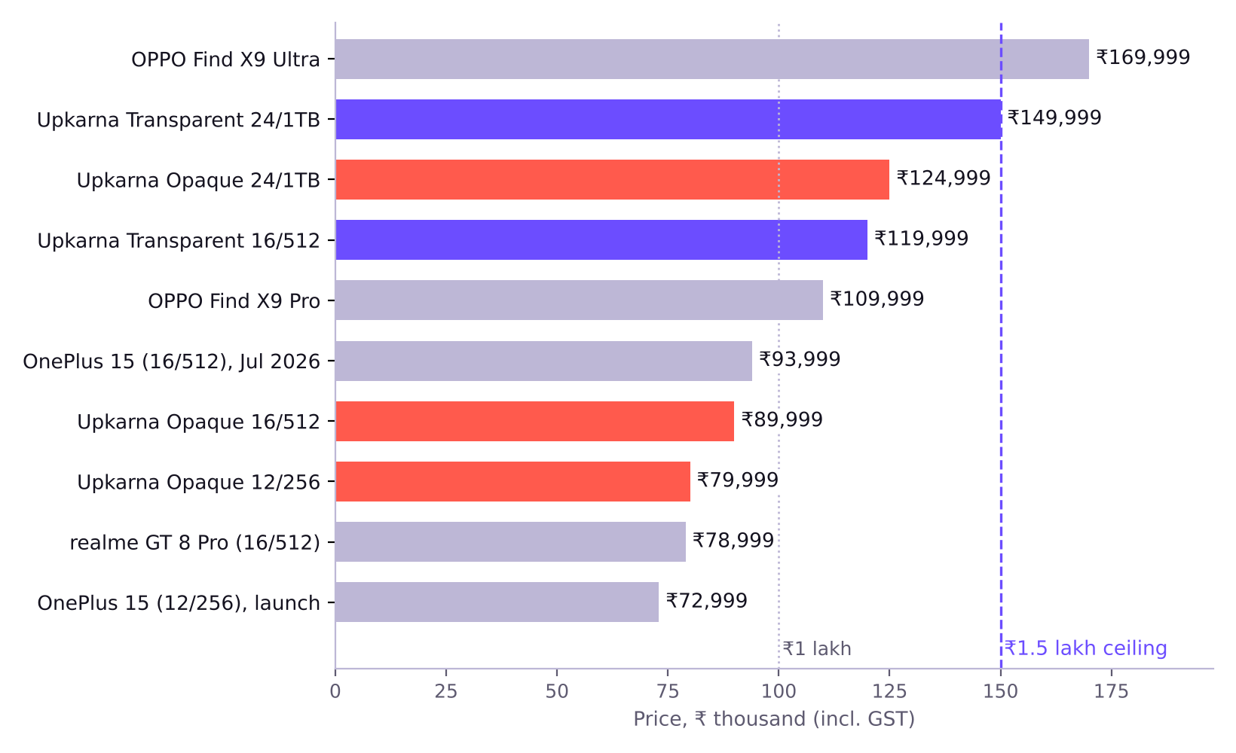
Figure 7. Upkarna’s target prices against comparable phones in India
Competitor prices are list prices reported in launch coverage and price listings from late 2025 to mid-2026 and change often. Upkarna prices are targets (Appendix B).
Segment | Typical offer today | Upkarna’s position
₹70,000 to ₹95,000 | Top Snapdragon, 12 to 16 GB RAM, big battery, conventional slab design (OnePlus 15, realme GT 8 Pro) | A distinctive design and an owned OS in the same price band, with the 12/256 and 16/512 Opaque phones
₹1.1 lakh and above | Camera-led flagships with 200 MP periscope lenses (OPPO Find X9 Pro ₹1,09,999; Find X9 Ultra ₹1,69,999) | Opaque 24/1TB and the Transparent Edition sit below the Ultra, all under ₹1.5 lakh
Design-led niche | Rear lighting and bold styling on mid-to-upper phones | A fully transparent flagship, with matched internals, at flagship specification

Jobs and ecosystem effects
Impact levers are listed with the measure we will track. We give no job or revenue numbers because none can yet be supported.
Lever | Why it creates value | How we will measure it
Manufacturing in India | Assembly, machining and testing work at partner plants; India assembles nearly all handsets it sells | Phones assembled in India; share of value added locally
Service and repair | Trained technicians, parts logistics and a repair market for premium phones | Technicians trained and certified; repairs done locally
Developer economy | A new platform with AI tools lets students and small teams build apps and light effects | Developers onboarded; apps ported or built
Longer-lived devices | Repairable design and published parts reduce e-waste | Repair rate; spare parts sold
Design and IP in India | Designs, code and filings owned by an Indian company | Patents and designs filed and granted
Exports | Global expansion waves bring foreign earnings | Units and revenue by market

Policy context. In July 2026 India approved the ₹62,500 crore Mobile Phone Manufacturing Scheme (FY27 to FY31), which rewards Indian-owned brands with 5%, plus 3% for Indian design and R&D, from ₹1,000 crore of annual turnover. Upkarna is not eligible today and the base case assumes no incentive. It is potential upside later.

8 | Inclusivity and team  Designed for people who are usually designed around, and a team plan that keeps growing.  WORTH 10 OF 100 POINTS

IN ONE LINE
Inclusion here is built into the product: light that speaks to people who cannot hear alerts, customisation for every eye and hand, an open developer platform, and local repair jobs. The team plan adds diverse skills and voices as the venture grows.

Inclusive by design
Feature | Who it helps and how
Sound-to-light alerts | People who are deaf or hard of hearing: doorbells, alarms and calls shown as distinct light patterns. Census 2011 counts about 19% of the 2.68 crore Indians with disabilities as having a hearing disability.
Deep customisation | Font weight, colours, icon size, grid density and haptics are settings, so people with low vision, motor difficulty or personal preference can tune the phone.
Open developer platform | Students and small teams, including those without big budgets, can build for a new platform with AI tools doing the heavy lifting.
Local repair and training | Technicians in many towns can be trained and certified, opening skilled work beyond big cities.
Language support | The OS plan includes localisation and regional-language support as expansion waves open, so more people can use it in their own language.
Upkarna’s phones are premium. Inclusion works through accessibility, customisation, repair jobs and an open platform, not through low price.

Team and diversity plan
This is an individual entry by the founder, Darshit Yadav. The venture is at concept stage, so we describe the team we will build instead of claiming one.
Role | Purpose
Head of hardware engineering | Transparent-back architecture, thermal and acoustic design, EVT to PVT
Head of supply chain and manufacturing | Supplier quotes, manufacturing partner, quality and logistics
Head of operating systems (Track A) | UpkarnaOS shell, customisation engine and lighting suite on Android
Head of platform (Track B) | Native OS architecture, developer platform and invited-developer programme
Accessibility lead | Sound-to-light, assistive settings and testing with disabled users
Regulatory and certification lead | Certification across India, the US, the EU and other markets
Service and repair lead | Repair network, parts and warranty
IP counsel | Patent, design and trademark filings; freedom-to-operate
Head of go-to-market | Channels, pre-orders, financing partners, expansion waves and launch

- Mentors and advisers: none engaged yet. The concept phase seeks advisers in hardware, supply chain, regulation and operating systems.
- Diversity in hiring: we will recruit across gender, region, background and ability, and include people with disabilities in testing and design.
- Ownership and governance: the company is not yet incorporated; ownership is set at incorporation, and board and investor rights when capital is raised.

What I learned building this
Skill | Where it showed up
Feasibility assessment | Checking each claim against sources and dropping or correcting the ones that failed, such as 120 W in 18 minutes, IP69K and LPDDR6X.
Problem-solving | Turning a memory-cost shock into a cost ceiling and a rule for when 24 GB / 1 TB ships.
Communication and presentation | Rewriting a long technical plan into a one-line summary, cards and tables that a judge can read in 60 seconds.
Teamwork (planned) | Defining the roles a real team needs and how each would contribute and present.

9 | Risks and how we handle them  The honest list. Every risk has a response.

Risk | Why it matters | Mitigation
Memory cost and supply, especially 24 GB / 1 TB | Memory has surged in price and the top tier needs the most | Cost gate on every SKU; order of response in Chapter 7; hold back a tier rather than break the ceiling or margin
Margin at low volume | Large rivals sell similar specifications at similar prices | Target costing; accessories and services; Transparent Edition premium; no reliance on subsidies
Transparent-back engineering | Sealing, heat, UV yellowing and rattle are hard in a see-through phone | Dedicated test plan; fluorinated parylene and UV-blocking glass; limited colourways; stage gates before tooling
Component availability | 200 MP sensors, 2 nm chips and 24 GB memory may be allocated to larger customers | Early supply discussions; fallback configurations
Operating-system ambition | App ecosystems are the hardest part | Android first; invited developers; AI-assisted porting; objective gates; rollback guarantee
Dependence on AI providers | Pricing, access and terms can change; access to some models is restricted | Model-agnostic routing; human review of AI output
Quality of AI-generated code | Generated code can hide bugs or licence issues | Human review, automated tests and security scanning on every change
Platform licensing | Distribution terms may constrain a parallel OS | Counsel review before committing; documented decision
Global compliance and tariffs | Each region has its own certification, taxes and rules | Regional radio variants from the start; wave-by-wave expansion; consultant-led certification
Currency | The rupee has weakened in 2026 while component prices are in dollars | Model currency per market; buffer in the cost ceilings
Service network cost | A premium phone needs trusted repair worldwide | Hybrid service model; expand with each wave
Demand in a falling market | Global shipments fell 22% in Q3 2026 | Premium is more resilient; financing offers; pre-orders as demand signal
Concept-stage company | Not yet incorporated; no team beyond the founder | Readiness gate before any raise; team plan in Chapter 8
IP position | No patents yet | Filings in phase 0; avoid public disclosure of key designs before filing

10 | IP, legal and naming  What we own today (nothing yet), what we will protect, and what we will not copy.

TODAY
Upkarna is not incorporated and holds no patents or licences. This document makes no IP claims. Everything described is a plan.

Plan
- Incorporate the company first, so all designs, code and filings are owned by it.
- File provisional patents for the rigid, sealed, colour-matched transparent architecture and any novel thermal or acoustic isolation designs, in India and, as advised, abroad.
- Register designs for the visual appearance of the Transparent Edition.
- Search and file trademarks for Upkarna and the chosen OS name (UpkarnaOS or SovereignOS).
- Run a freedom-to-operate search, especially around rear-light interfaces, under-display audio and transparent-back constructions.
- Treat component platforms (Qualcomm, glass, audio chips) as supply agreements, not licences we hold.

Platform terms and AI
Google’s distribution agreements have in the past restricted manufacturers that ship Google-certified Android phones from also shipping devices on non-compatible Android variants. Because Upkarna plans a parallel OS, counsel must review the current terms before the dual-track plan is committed.
The developer platform uses third-party AI models. Each provider’s terms on pricing, data handling and ownership of generated code will be reviewed before launch, and AI-generated code will be checked for licence and security issues.

Naming hygiene
We use plain descriptions in place of competitors’ marketing names: “auto-framing front camera” instead of Apple’s Centre Stage, “folded periscope lens” instead of tetraprism, “LTPO AMOLED” instead of Dynamic AMOLED 2X, and “rear lighting matrix” instead of Glyph. Names for phones and the OS are cleared before use.

11 | Next 12 months and what the award unlocks  We are not asking for funding now. Here is what we will finish first, and how any prize would be used.

THE HONEST ASK
Upkarna is not asking for funding now. The founder wants time to settle the design, the plants, the repair shops, the OS, the features and how each will be built. This award would help us start that work properly.

If Upkarna wins: first uses of the prize, in order
- Incorporate the company and apply for DPIIT recognition.
- File IP: provisional patents and design registrations for the transparent architecture.
- Extend the proof of concept toward a working prototype of the lighting hardware and the OS shell.
- Get real quotes from at least two manufacturing partners and key component suppliers, and test them against every cost ceiling.
- Find mentors in hardware, supply chain, regulation and operating systems, and begin recruiting the team.

Readiness gate before approaching investors
Readiness item | What will exist
Company | Incorporated, with the founder’s ownership and the IP assigned to the company
Design | Complete industrial and engineering design of both lines, with the Transparent Edition architecture drawn and reviewed
Manufacturing | A decision on plants and quotes from at least two manufacturing partners
Service | A decision on the repair and service model
Operating system and platform | Architecture for Track B, the developer-platform design and the AI-model plan
Economics | Quotes tested against every cost ceiling, including the 24 GB / 1 TB gate
Team | The first key hires and advisers identified

When Upkarna raises
Capital is released in tranches against proof. Amounts will be agreed with the investor once the readiness items above are complete.
Tranche | Funds | Proof required before next | Amount
1. Foundations | IP filings; engineering team; supplier and EMS quotes; Track B architecture; EVT build | Quotes within cost ceilings; EVT results | To be agreed
2. Validate | DVT; transparent-back engineering; certification; developer alpha; pilot tooling | DVT and compliance results; developer alpha running | To be agreed
3. Launch | PVT; launch inventory; marketing; channel set-up; service network | PVT yield; pre-order volume | To be agreed
4. Platform | Track B beta, SDK, AI tooling, grants; second-generation devices; expansion waves | Native OS gates met | To be agreed

A | Evidence register  Every external figure used in this document, with its source.

Claim | Figure | Source
Global shipments 2025 | 1.26 billion, up 1.9%; Apple 247.8 million, Samsung 241.2 million | IDC
Global shipments Q3 2026 | 255.3 million, down 22%; memory crisis | IDC press release, 15 Oct 2026
Global outlook | No recovery before 2028; record US$550 average selling price in 2026 | IDC via TechSpot
Memory share of BOM, 16/512 flagship | DRAM 23%, NAND 18%; BOM up $100 to $150 in Q2 2026 | Counterpoint Research, Mar 2026
Memory cost, 16 GB + 1 TB | Crossed US$280 per device in Q1 2026, more than the Snapdragon 8 Elite Gen 5 | Gizchina summary of analyst data
Mobile DRAM contract prices | LPDDR5X up 78% to 83% in Q2 2026; 12 GB becoming mainstream high-end | TrendForce via EE Times Europe, May 2026
Q4 2026 memory outlook | Conventional DRAM +10% to 15%; NAND +15% to 20% quarter on quarter | TrendForce, 30 Sep 2026
Exchange rate | ₹94.46 per US dollar on 5 Nov 2026; record lows of about ₹96 in mid-2026 | PTI via HDFC Sky; Upstox
India shipments | Q3 2026 down 20%; sub-₹20,000 down 47%; 2026 outlook about -13% | Counterpoint Research, Oct 2026
India ultra-premium | Above ₹45,000: record 17% share Q4 2025; resilient in 2026 with financing | Counterpoint Research
Indian brands’ share | 2% (Q3 2025) to 7% (Q3 2026) | Counterpoint Research
India e-waste | About 1.75 million tonnes in FY 2023-24, up 73% in five years; 43% recycled, 57% unprocessed (figures vary by method) | CPCB data tabled in Parliament, via Down To Earth; Drishti IAS
Disability in India | 2.68 crore persons with disabilities (2.21% of population); about 19% hearing disability | Census 2011, MoSPI; Lok Sabha documents
Snapdragon 8 Elite Gen 6 and Extreme Gen 6 | Announced 22 Sep 2026; 2 nm, TSMC | Qualcomm; The Next Web; ETV Bharat
Snapdragon 8 Elite Gen 5 | 4.608 GHz prime cores, Adreno 840 | OnePlus India launch material
OnePlus 15 | ₹72,999 (12/256) at launch; 7,300 mAh; 120 W wired; 50 W wireless; 165 Hz LTPO; 1,800 nits HBM; UFS 4.1 up to 1 TB; up to 16 GB RAM | Launch coverage, Nov 2025; Republic World; Kimovil
OnePlus 13 (24 GB + 1 TB) | 24 GB RAM and 1 TB storage sold; listed at ₹80,999 in India, out of stock, Oct 2026 | Smartprix; Soyacincau
OnePlus 15 (16/512) | ₹93,999 | Price listing, Jul 2026
realme GT 8 Pro (16/512) | ₹78,999; 200 MP telephoto | Price listing, Jul 2026
OPPO Find X9 Pro and Ultra | ₹1,09,999 (200 MP periscope, 7,500 mAh) and ₹1,69,999 | Price listings, 2026
7,500 mAh batteries | OnePlus 15T, OPPO Find X9 Pro and others | Android Authority; price listings
ES9219 DAC | 121 dB dynamic range; 32-bit/384 kHz PCM; DSD256 | ESS datasheet
Nothing | $200 million Series C; more than $1 billion cumulative sales; 489-LED rear matrix on Phone (3) | Sacra; GSMArena; Gizmochina
MPMS | ₹62,500 crore, FY27 to FY31; Indian-brand track 5% plus 3% R&D, up to 1.5% localisation; ₹1,000 crore turnover threshold | The Week, 22 Aug 2026; Business Standard
India manufacturing base | Dixon 19% volume share in 2025; Indian EMS about one in four phones in FY26; near 99% of handsets sold are made in India | Counterpoint Make in India Tracker; MeitY
HarmonyOS | Android compatibility removed Oct 2024; over 100,000 native apps; over 80 million HarmonyOS 6 devices; about 5% global share Q2 2026 | Huawei conference reports, Aug 2026; Counterpoint
Android 17 | Stable rollout to Pixel in June 2026 | Android Authority; 9to5Google
GPT-6 Astra | Available through OpenAI’s API as gpt-6-astra | OpenAI launch coverage, Sep 2026
Gemini 4 Carbon | Announced 28 Oct 2026; restricted phased access; index score 59 vs 58 (Opus 5.5) and 57 (GPT-6 Astra) | Tom’s Hardware; Engadget; Artificial Analysis
Parylene UV behaviour | Parylene-C is not UV-stable; fluorinated types are | SCS Coatings technical notes
NSA 6.0 Student guidelines | Four sub-categories by age; stream selection; scoring Innovation 45, Scalability 25, Economic Impact 20, Inclusivity and Team Diversity 10; DPIIT recognition not required; individuals or teams of up to four; prototype, MVP, working model or proof of concept | Startup India (DPIIT): NSA 6.0 Guidelines, Student Innovator / Aspiring Entrepreneur

B | Assumptions register  Planning inputs chosen by Upkarna. Change any one and the economics change with it.

Assumption | Value used | How it is validated
Opaque 12/256 and 16/512 prices | ₹79,999 and ₹89,999 including GST | Confirm at cost freeze; planned below ₹1 lakh
Opaque 24/1TB price | ₹1,24,999 including GST | Confirm at cost freeze; below ₹1.5 lakh
Transparent 16/512 price | ₹1,19,999 including GST | Confirm at cost freeze
Transparent 24/1TB price | Up to ₹1,49,999 including GST | Founder’s decision: every phone below ₹1.5 lakh
Gross margin | 25% of what Upkarna receives, held fixed | Founder’s decision
Exchange rate | ₹94.5 per US dollar | Re-set at each quote
GST rate on phones in India | 18% | Confirm with tax adviser
Channel and marketplace cost | 10% of pre-GST price | Confirm with distributors and marketplaces
Production timeline | About 18 months from the start of the build to launch | Confirm with manufacturing partner
Colourways at launch | Three | Confirm after tooling quotes
MPMS incentive | Zero in base case | Revisit if eligibility is reached
Volumes and revenue | Not forecast | Set from reservation data
Native OS gate thresholds | Chapter 4 | Ratified by the board
Expansion order | India first (confirmed), then Asia and the Middle East, Europe and the UK, the United States | Later waves are proposals

C | How the plan has evolved  Our early concept was broader and, in places, over-stated. These are the changes and why.

Earlier concept | This plan | Reason
24 GB RAM and 1 TB storage, no gate | 24 GB / 1 TB kept as the top configuration, with a cost gate | Founder decision; memory costs make it the hardest tier
Transparent Edition priced “significantly higher” | Every phone below ₹1.5 lakh with a fixed 25% margin | Company decision on the price ceiling and margin
Launch funding ask | Not raising now; readiness gate first | Founder wants to finish the design thinking first
India only | Global expansion in waves, India first | Founder decision
3 nm Snapdragon 8 Elite Gen 5 | Snapdragon 8 Elite Gen 6 (2 nm), Gen 5 as fallback | Gen 6 was announced in September 2026
120 W, 0 to 100% in 18 minutes | 100 to 120 W; times quoted only after testing | Not supported by shipping phones
200 MP main sensor at f/1.4 | 50 MP main plus 200 MP periscope | The combination is not shipping; matches phones at this price
IP69K | IP68/IP69 | IP69K is a road-vehicle standard
Parylene-C coating claimed UV-stable | Fluorinated parylene plus UV-blocking glass | Parylene-C yellows under UV
LPDDR6X memory | LPDDR5X | LPDDR6X does not exist
“Ground-up” OS from day one | Android first, native OS side by side, switch by gates, AI-assisted developer platform | Company decision; lowers risk
Competitor terms (Centre Stage, tetraprism, Glyph) | Plain descriptions | Trademark and clarity
Investor-pitch framing | Award submission against the NSA 6.0 scoring criteria | Submission to the National Startup Awards 6.0

D | Guideline check  How this submission meets the NSA 6.0 Student Innovator / Aspiring Entrepreneur guidelines.

Guideline | How Upkarna meets it
DPIIT recognition is not required | Upkarna is not DPIIT-recognised and does not need to be for this category.
Individual or a team of up to four | Individual entry by the founder, Darshit Yadav.
Demonstrate a prototype, MVP, working model or proof of concept | A live interactive proof of concept (Chapter 5) plus a source-checked specification and cost model.
Clear problem-solving | Chapter 1 names four problems, who is affected and why it matters.
Scalability | Chapter 6: plants, sourcing, certification, repair network, global waves and stage gates.
Potential impact | Chapter 7: unit economics, jobs and ecosystem levers, market evidence.
One Shakti ki Sapta Dhara stream | Technology and Innovation, with a secondary link to Manufacturing.
Explain problem, users, feasibility, stage, impact | Chapters 1, 2, 5 and 7, and the portal-field summary on the first page.
Supporting material: description, photographs, presentation, video, prototype link | This document, schematic and charts, and the proof-of-concept link.
Scoring criteria: Innovation 45, Scalability 25, Economic Impact 20, Inclusivity and Team Diversity 10 | Mapped in the first-page table; each criterion has its own chapter.
Learning outcomes: teamwork, communication, problem-solving, feasibility, presentation | “What I learned building this” in Chapter 8.
Source: Startup India (DPIIT), National Startup Awards 6.0, Student Innovator / Aspiring Entrepreneur guidelines and portal.

CLOSING STATEMENT
Every number in this document is cited, labelled as a target, or listed as an assumption. Where we do not yet know, we say so and show the gate that will tell us.


See the machine. Own the OS.
Darshit Yadav, Founder · Upkarna · November 2026

