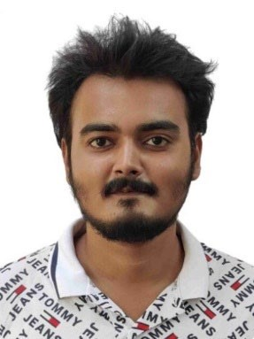

**EDUCATION**

Bachelors in Computer Science Engineering | Chandigarh University,

Gharuan

*Session: 2019-2023 | Score: 7.67 CGPA*

Intermediate (CBSE) |Krishna Nand Memorial Academy, Asarganj

*Session: 2018-2019 | Percentage: 70%*

Matriculation (CBSE) | St. Xavier’s International School, Dhanbad

*Session: 2016-2017 | Percentage: 95%*

**TRAINING & PROJECTS**

**HIGHRADIUS | INTERN**

February 2022 - May 2022

▪

Built a data-driven and AI-enabled FinTech B2B Cloud Application.

▪

Developed and integrated ML model and Chatbot along with Analytics

in the UI.

▪

Tech Stack: Java, MySQL, React.JS, Python, Highcharts, Crossfilter,

DialogFlow.

**IN**

**TERNSHALA | INTERN**

July 2021 - August 2021

▪

Built a JAR file for Temperature Converter Tool app.

▪

Built Connect Four Game based on Indian Bingo Game.

**ACADEMIC ACHIEVEMENTS**

▪

Certificate of Data Science and its Applications, NIT Patna

**CE**

**RTIFICATIONS & AWARDS**

▪

Programming Fundamentals certification from Coursera

▪

Object-Oriented Data Structures in C++ certification from Coursera

▪

Getting Started with Python certification from Coursera

▪

Python Data Structures certification from Coursera

▪

Core Java certification from Internshala

▪

Programming Foundations with JavaScript, HTML and CSS

certification from Coursera

▪

Introduction to Data Science in Python certification from Coursera

▪

Neural Networks and Deep Learning certification from Coursera

▪

R Programming Certification from Coursera

**EXT**

**RA CURRICULAR & CO-CURRICULAR ACHIEVEMENTS**

▪

Won District Volleyball Championship

**ATUL PRIYADARSHI**

Address: JHAPANI, SURYAGARHA,

LAKHISARAI, BIHAR- 811106

E-mail:

*darshiatul@gmail.com*

Phone: +91

8405870971

LinkedIn:

[l](https://www.linkedin.com/in/darshiatul/)

[darshiatu](https://www.linkedin.com/in/darshiatul/)

**PROFESSIONAL SUMMARY**

To work in an environment that promotes

learning, innovation and at the same time

provides to design

and integrate with

solving intuitive problems. Passionate to

implement and launch new projects.

**TECHNICAL COMPETENCIES**

C++ | JAVA | PYTHON | R | ReactJS | SQL

**INTERPERSONAL SKILLS**

Team Leadership

**|**

Management &

Coordination

**|**

Decision Making

**INTERESTS & HOBBIES**

Movies

**|**

Travelling

**|**

Reading

**LANGUAGES KNOWN**

English

**|**

Hindi

**PERSONAL DETAILS**

Mother’s Na

me:

Babita Kumari

Father’s Name:

Abinash Kumar

D.O.B.: 04

th

Nov

ember

2001

