Serverless Amazon Product Data ETL Pipeline
1. Introduction
This document outlines the architecture and implementation of a serverless ETL (Extract, Transform, Load) pipeline built on Amazon Web Services (AWS). The project's primary goal is to create an automated system that extracts real-time product data from the Real-Time Amazon Data API, processes it, and loads it into a queryable format for business intelligence and analytics.
By leveraging a suite of serverless AWS services, this solution is designed to be highly scalable, cost-effective, and require minimal operational overhead.

2. Architecture
The pipeline follows a classic ETL pattern, orchestrated entirely within the AWS ecosystem. The architecture is designed for automation and efficiency, with each component playing a specific role in the data's journey.
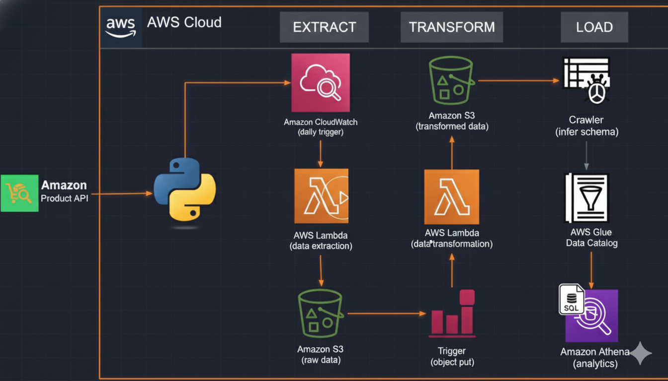

3. Data Source
The data for this project is sourced from the Real-Time Amazon Data API, available on the RapidAPI marketplace. This API provides access to up-to-date information on Amazon products, including pricing, ratings, and seller details.
- API Provider: RapidAPI
- API Endpoint: Real-Time Amazon Data API

4. Methodology
The ETL process is broken down into the following automated steps:
Step 1: Data Extraction
An AWS Lambda function is responsible for the initial data extraction. This function is triggered on a schedule by Amazon CloudWatch Events (e.g., daily). It sends a request to the Real-Time Amazon Data API, retrieves the product data in JSON format, and prepares it for storage.
Step 2: Raw Data Storage
The freshly extracted raw JSON data is immediately stored in an Amazon S3 bucket. This bucket is structured with a raw_data/to_process/ prefix, creating a dedicated landing zone for new, unprocessed files. Storing the raw data ensures that we have a persistent, unaltered copy of the source data for archival purposes or for reprocessing if needed.
Step 3: Data Transformation
A second AWS Lambda function handles the transformation stage. This function is automatically triggered whenever a new object is created in the raw_data/to_process/ S3 path. The transformation logic includes:
- Parsing the raw JSON.
- Cleaning the data (e.g., removing newline characters from product titles).
- Structuring the data into a tabular format.
- Converting data types (e.g., price strings to numerical types).
- Enriching the data where necessary.
Step 4: Transformed Data Storage
The cleaned and transformed data, now in CSV format, is saved to a different path within the same S3 bucket: transformed_data/products/. This separation of raw and transformed data is a best practice that simplifies data management and access control.
Step 5: Schema Discovery with AWS Glue
An AWS Glue Crawler is configured to run on the transformed_data/ S3 bucket. The crawler automatically scans the CSV files, infers the data schema (column names, data types, etc.), and creates a metadata table in the AWS Glue Data Catalog. This catalog acts as a central repository for all our data assets.
Step 6: Data Analytics with Amazon Athena
With the metadata now available in the Glue Data Catalog, Amazon Athena can be used to run standard SQL queries directly on the CSV files stored in S3. This allows for powerful, ad-hoc data analysis without the need to set up or manage any database servers.

5. Challenges and Resolutions
During the development of this project, several technical challenges were encountered and resolved:
- Lambda Timeout Errors:
  - Problem: The initial data extraction Lambda function would occasionally fail with a timeout error, especially when the external API response was slow or when processing a large volume of data.
  - Resolution: The default Lambda timeout (3 seconds) was insufficient. The issue was resolved by navigating to the function's Configuration > General configuration settings and extending the timeout to a more appropriate value (e.g., 1 minute).
- S3 Access Permissions:
  - Problem: The Lambda functions were initially unable to read from or write to the S3 bucket, resulting in "Access Denied" errors.
  - Resolution: This was a permissions issue. It was resolved by creating an IAM (Identity and Access Management) Role with the necessary S3 access policies (S3:GetObject, S3:PutObject, S3:ListBucket) and assigning this role to both Lambda functions. This grants the functions explicit permission to interact with the specified S3 bucket.

6. Conclusion and Future Scope
This project successfully demonstrates the power and flexibility of serverless architecture for building robust ETL pipelines. By integrating services like Lambda, S3, Glue, and Athena, we have created an automated, scalable, and cost-effective solution for analyzing Amazon product data.
Potential future enhancements for this project could include:
- Data Visualization: Connecting Amazon QuickSight to Athena to create interactive dashboards and visualizations.
- Historical Analysis: Partitioning the data in S3 by date to optimize query performance and enable efficient historical analysis.

