Development of Motor Racing Game
Using Generative AI and Prompt Engineering
Practical Report
Submitted: 17 October 2026

1. Aim
The aim of this practical is to design, develop, and document a simple 2D browser-based motor racing game using prompt engineering with a generative AI assistant. The work demonstrates how structured prompts can be used for game planning, modular architecture design, code generation, testing, debugging, and feature enhancement—while producing a working application with Django, HTML5 Canvas, Vue.js, and SQLAlchemy.

2. Software / Tools Used
- Python 3.x — server-side logic and API
- Django 6.x — web framework, routing, templates
- HTML5 Canvas + JavaScript — 2D game rendering and game loop
- Vue.js 3 — user interface (HUD, menus, leaderboard)
- SQLAlchemy + SQLite — high-score persistence (racer_game.db)
- Alembic — database schema migrations
- CSS3 — neon-themed UI styling
- Cursor IDE with AI (Composer) — prompt-driven development
- Git / GitHub — version control and project submission
- Microsoft Word — practical documentation

3. Game Description

3.1 Objective
The player drives a car on a three-lane neon highway. The objective is to survive as long as possible by dodging opponent vehicles, collecting coins for bonus points, and gathering fuel to stay alive. Higher survival time and successful dodges increase the score. Top scores are saved on a server-side leaderboard.

3.2 Rules
- The player may occupy only one of three lanes at a time (left, centre, right).
- Opponent cars spawn at the top and move toward the player; contact causes a crash (game over).
- Fuel drains continuously during play; reaching zero fuel ends the game.
- Coins and fuel pickups appear on lanes; collecting them adds score or restores fuel.
- Game speed and difficulty increase as level rises (based on score).
- Each completed run can be submitted with a player name to the high-score API.

3.3 Controls
Keyboard: Left Arrow — move one lane left; Right Arrow — move one lane right.
Mobile / touch: On-screen LEFT and RIGHT buttons when playing.
Menus: START RACE, RACE AGAIN, LEADERBOARD, Main Menu buttons.

3.4 Game Objects
- Player car — user-controlled vehicle at bottom of road
- Opponent cars — five colour palettes, spawn in random lanes
- Coins — bonus score pickups
- Fuel canisters — restore fuel gauge
- Road — three lanes with animated dashed dividers
- Particles — explosion effect on crash or pickup
- HUD elements — score, level, fuel bar, coins, speed

3.5 Score System
Score increases from: (1) survival time (continuous per-frame rate scaled by speed), (2) +10 points per opponent car safely passed (dodge bonus), (3) +50 points per coin collected. Level increases every 800 score points.

3.6 Game-Over Conditions
Game over occurs when: (1) the player collides with an opponent car (AABB collision), or (2) fuel reaches zero. A crash animation plays, final statistics are shown, and the score may be saved to the leaderboard.

3.7 Restart Functionality
From the Game Over screen, RACE AGAIN resets game state and starts a new session. From Leaderboard or Game Over, Main Menu returns to the start screen with name input and top scores preview.

4. Game Flow
The following flowchart describes the logical flow of NeonRacer from launch to restart.
START
↓
Load Start Screen (fetch leaderboard from API)
↓
Player enters name → Press START RACE
↓
Initialize GameEngine (reset score, fuel, level, entities)
↓
┌──────────────────────────────────────┐
│ MAIN GAME LOOP (RAF) │
│ Read keyboard / mobile input │
│ Smooth lane transition for player │
│ Update score, level, speed, fuel │
│ Spawn / move opponents and pickups │
│ Particle updates │
│ Collision: player vs opponent? │
│ Fuel <= 0? │
└──────────────────────────────────────┘
↓ ↓
YES (collision / no fuel) NO → continue loop
↓
Crash particles → Game Over screen
↓
POST score to API → refresh leaderboard
↓
RACE AGAIN? ──YES──→ Initialize GameEngine
↓ NO
Main Menu or END

5. STEP 1 – Game Design (Prompt 1 – Game Planning)

5.1 Game Objective
Survive on a three-lane highway, maximize score through time, dodges, and coins, and compete for leaderboard ranking.

5.2 Player Controls
Arrow Left / Arrow Right for lane changes; optional touch buttons.

5.3 Variables Required
Variable / State | Purpose
player.lane, player.x, player.y | Player position and target lane
score, scoreFloat | Integer display score and fractional accumulator
level, speed, frame | Difficulty progression
fuel | Resource; drains per frame
coins, carsDodged | Statistics and bonuses
opponents[] | Active enemy cars
pickups[] | Coins and fuel on road
particles[] | Visual effects
gameState (Vue) | start | playing | gameover | leaderboard
leaderboard (Vue) | Top scores from API

5.4 Functions / Components Required
Function / Class | Purpose
GameEngine.start() / stop() | Lifecycle control
GameEngine._loop() | Main animation frame loop
GameEngine._update() | Logic: input, movement, spawn, collision
GameEngine._render() | Draw road, entities, HUD canvas layer
rectsOverlap() | AABB collision detection
drawCar(), drawCoin(), drawFuelPickup() | Rendering helpers
fetchLeaderboard(), submitScore() | Vue API integration
get_scores(), post_score() (Django) | REST backend for scores

5.5 Collision Conditions
Player–opponent: axis-aligned bounding box overlap with small margin (rectsOverlap in game.js). Player–pickup: circle distance check between player centre and pickup centre. No collision between opponents and pickups required.

5.6 Score Calculation
TIME_SCORE_RATE × speed per frame (floored into score); +DODGE_BONUS (10) per car passed; +COIN_VALUE (50) per coin. Level = 1 + floor(score / 800).

5.7 Suggested Program Structure
Frontend: static/js/game.js (GameEngine, Road, Particle), game/templates/game/index.html (Vue app + canvas), static/css/style.css. Backend: game/views.py, game/models.py (SQLAlchemy HighScore), game/db.py, game/urls.py.

6. STEP 2 – Program Architecture (Prompt 2)
Component | Purpose | Key variables
Game initialization | GameEngine constructor, _resetState(), Django init_db() | player, speed, fuel, lists
Player creation | _resetState sets lane 1, position bottom | player object
Keyboard input | _bindKeys(), _movePlayer() | keyLeft, keyRight
Object generation | _spawnOpponent(), _spawnPickup() | oppTimer, pickupTimer
Movement | _update() updates y positions and lane easing | speed, opponents, pickups
Collision detection | rectsOverlap(), distance for pickups | margin, radii
Score management | _update() + callbacks onScore/onCoins | score, carsDodged
Game-over detection | collision or fuel <= 0 → _triggerCrash() | crashed, onGameOver
Game restart | Vue startGame() destroys engine, new GameEngine | gameState
Main game loop | _loop() via requestAnimationFrame | running flag

7. STEP 3 – Code Generation Summary (Prompt 3)

7.1 How to Run the Project
1. Install dependencies: pip install -r requirements.txt
2. Apply DB migration (optional fresh DB): alembic upgrade head
3. Start server: python manage.py runserver
4. Open browser: http://127.0.0.1:8000/
5. Run automated tests: python manage.py test game

7.2 Required Libraries
Django, SQLAlchemy, Alembic (see requirements.txt). Browser loads Vue 3 from CDN.

7.3 Important Functions
GameEngine._update() — core rules; rectsOverlap() — collisions; views.post_score / get_scores — persistence; Vue startGame / onGameOver — UI flow.

7.4 How Collision Detection Works
Opponents use AABB: compare centre positions and half-widths/heights with a margin. Pickups use Euclidean distance between centres compared to combined radius.

7.5 GitHub Repository
[Student to insert GitHub repository URL after upload. Example: https://github.com/<username>/neonracer-prompt-engineering]

8. STEP 4 – Test Cases
Manual and automated tests performed on the implemented game. Status reflects verification during development.
Test No. | Test Performed | Expected Result | Actual Result | Status
1 | Start game (START RACE) | Game starts, HUD visible, canvas animates | Road scrolls, player car shown | Pass
2 | Press Left Arrow | Player moves to left lane | Lane changes with smooth easing | Pass
3 | Press Right Arrow | Player moves to right lane | Lane changes correctly | Pass
4 | Collision with opponent | Game Over, explosion particles | Crash flash, stats screen | Pass
5 | Survive / collect coin | Score increases | Score updates in HUD | Pass
6 | RACE AGAIN after game over | New game starts | Score reset, play resumes | Pass
7 | Fuel depletion | Game Over when fuel empty | Game ends without collision | Pass
8 | GET /api/scores/ | JSON list of scores | Returns scores array | Pass
9 | POST /api/scores/submit/ | Score saved | 201 success, entry in DB | Pass
10 | python manage.py test game | All tests pass | 4 tests OK | Pass

9. STEP 5 – Debugging (Prompt 4 Example)
Problem: Home page failed when rendered by Django; tests reported TemplateSyntaxError.
Error: Could not parse the remainder: '()' from 'score.toLocaleString()'
Expected: Vue bindings should display score on the page.
Actual: Django template engine interpreted {{ }} as Django tags.
Cause: Django and Vue both use double curly braces. Fix: Wrapped the Vue root markup in {% verbatim %}…{% endverbatim %} in index.html so Django leaves Vue syntax unchanged. Unrelated game logic was not modified.

10. STEP 6 – Feature Enhancements (Prompt 5)
At least three improvements were implemented beyond a minimal dodging game:
Feature | Description
High-score system | Django API + SQLAlchemy + leaderboard UI on start/game over screens
Start screen & Game-over screen | Vue overlays with name input, stats grid, navigation
Increasing difficulty | Level-based speed and spawn interval; speed lines at high speed
Better graphics | Neon cars, gradients, particle explosions, glassmorphism HUD
Multiple obstacle types | Five opponent colour palettes
Fuel & coin systems | Secondary game-over condition and bonus scoring
Mobile controls | Touch LEFT/RIGHT buttons
Alembic migrations | Schema versioning for high_scores table

11. PART E – Prompt Engineering Techniques Used
At least five techniques were applied during development:
No. | Technique | How It Was Used in This Project
1 | Role prompting | Asked AI to act as game developer to plan NeonRacer mechanics and stack
2 | Context provision | Provided Django + Vue + existing file structure when completing project
3 | Task decomposition | Separated planning, architecture, backend API, canvas engine, and UI
4 | Constraint prompting | Specified arrow keys only, no removal of score system when adding features
5 | Structured output | Requested game design sections (rules, variables, collisions) before code
6 | Iterative prompting | Basic loop first, then leaderboard, fuel, particles, styling
7 | Debugging prompting | Supplied TemplateSyntaxError, expected vs actual for Vue/Django fix
8 | Refinement | Asked to complete only missing parts (Alembic, tests, template fix)
9 | Verification | Ran manage.py test and API checks against requirements

12. PART G – Prompts Used (Sample)

12.1 Prompt — Game planning
Purpose: Game planning
Prompt used:
I want to develop a simple 2D NeonRacer motor racing game using Django, HTML5 Canvas, and JavaScript. Before code, provide game objective, rules, controls, objects, variables, functions, collisions, score, game-over, and program structure. Do not code yet.
AI response / result: Full game design document with lane-based dodging, fuel, and scoring.
Modification by student: Adjusted level gap to 800 points and three lanes for playability.

12.2 Prompt — Program architecture
Purpose: Program architecture
Prompt used:
Based on the design, create modular structure: init, player, input, spawn, movement, collision, score, game-over, restart, main loop. No full code yet.
AI response / result: Component table mapping to GameEngine methods and Vue callbacks.
Modification by student: Merged API layer as separate Django views component.

12.3 Prompt — Code generation
Purpose: Code generation
Prompt used:
Generate complete working code: meaningful names, functions, comments, keyboard controls, collision, score, game over, restart. Explain how to run and how score works.
AI response / result: game.js GameEngine, index.html Vue app, views and SQLAlchemy models.
Modification by student: Tested on runserver; fixed static files path in settings.

12.4 Prompt — Complete incomplete work
Purpose: Complete incomplete work
Prompt used:
Complete this project; do only things which are not complete.
AI response / result: Alembic setup, tests, EMAIL settings, verbatim Vue fix.
Modification by student: Accepted changes; prepared GitHub upload separately.

12.5 Prompt — Documentation
Purpose: Documentation
Prompt used:
Make Word document for all practical requirements including prompt log and screenshots.
AI response / result: This report document.
Modification by student: Embedded screenshots in Part I of this report.

12.6 Prompt — Debugging
Purpose: Debugging
Prompt used:
TemplateSyntaxError on score.toLocaleString() — expected Vue rendering, Django parsed tags.
AI response / result: Identified brace conflict; verbatim block solution.
Modification by student: Applied {% verbatim %} in index.html.

13. PART H – Prompt Log
Prompt No. | Purpose | Prompting Technique | AI Output | Modification Made
1 | Game planning | Task decomposition | Game design for NeonRacer | Tuned rules and scoring constants
2 | Program structure | Structured output | Module/function list | Aligned with GameEngine class
3 | Code generation | Constraint prompting | Full stack initial code | Tested and integrated
4 | Debugging | Context + error prompting | Vue/Django template fix | Applied verbatim block
5 | Feature addition | Iterative prompting | Leaderboard, fuel, UI screens | Kept arrow-key controls
6 | Code review | Verification | Tests + Alembic + settings | Ran manage.py test game

14. PART I – Screenshots
Screenshots captured from the running NeonRacer application (python manage.py runserver → http://127.0.0.1:8000/).
Figure 1 — Start screen: title, racer name, START RACE, controls hint, top racers preview.
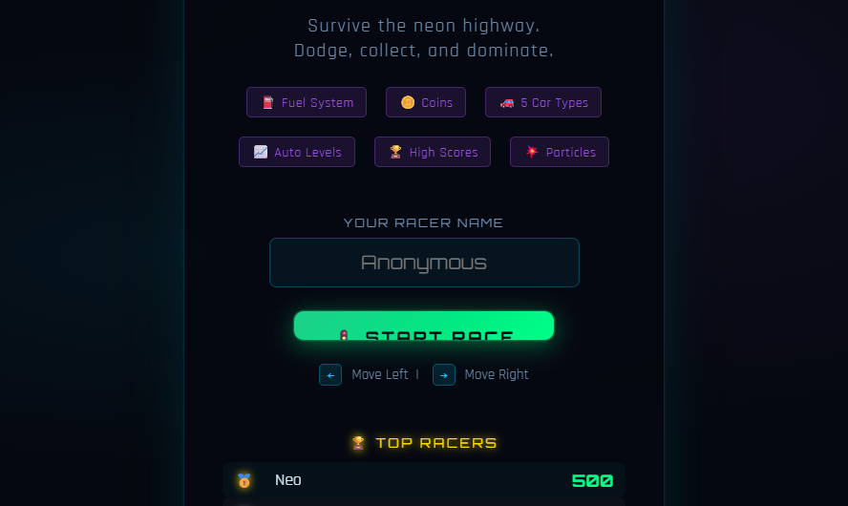

Figure 2 — Running game (gameplay): three-lane road, player car, opponents, fuel pickup.
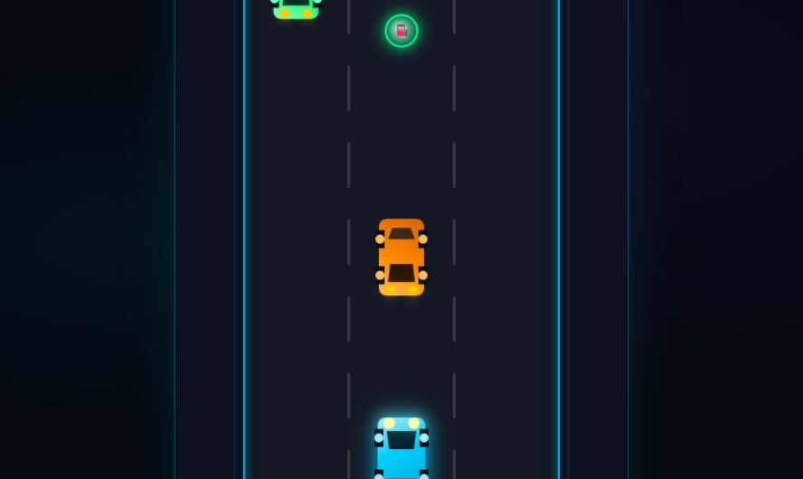

Figure 3 — Score / achievement state and Game Over (after collision): final score, statistics, new high score flag, and restart options.
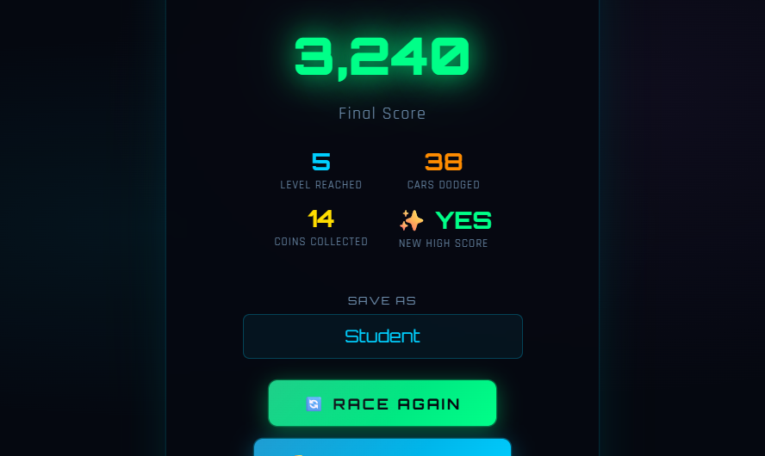

Figure 4 — Leaderboard: top racers with scores, levels, and coins from the API.
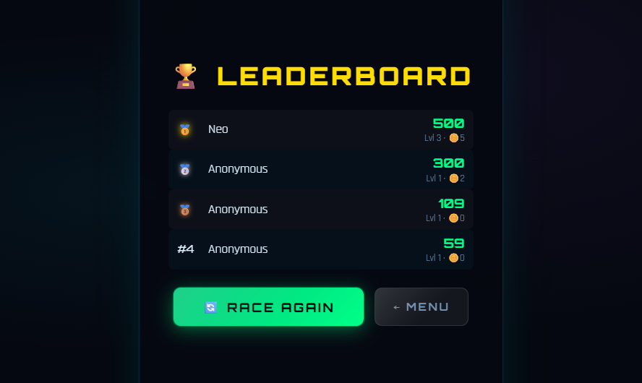

15. Conclusion
NeonRacer demonstrates end-to-end development with generative AI and deliberate prompt engineering: from structured game design through modular implementation, testing, debugging, and iterative enhancements. The final product meets assignment requirements including player control, obstacles, collision, scoring, game over, restart, UI screens, high scores, and documented prompt techniques.
Student Name: Darshil Sapara Roll No.: 92400133027
Date: 17/10/2026

