ASSIGNMENT – 3
Topic: SQL Data Analysis – Joins, Aggregations & Subqueries
Course: Data Analytics
Week: 3

--Task 1.1
SELECT c.Name, o.Product, o.Amount
FROM Customers c
INNER JOIN Orders o
ON c.CustomerID = o.CustomerID;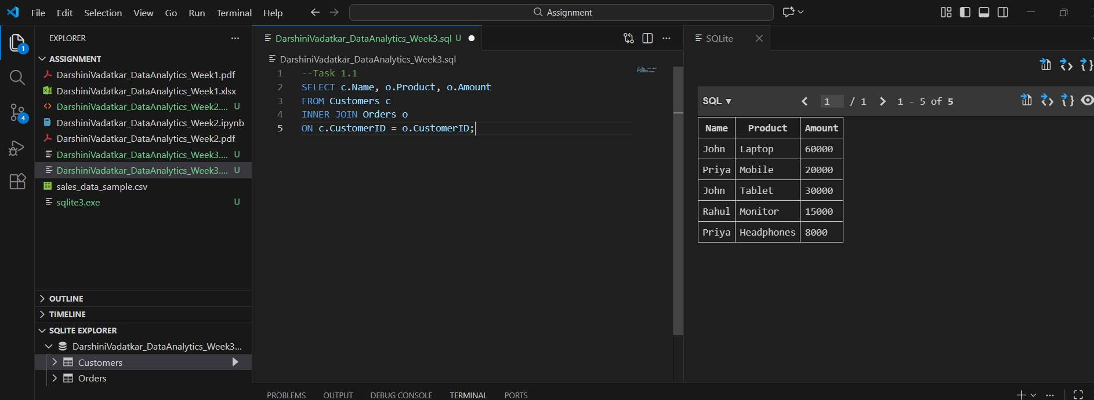
-- Task 1.2: Display all customers even if they have not placed any orders
SELECT c.Name, o.Product, o.Amount
FROM Customers c
LEFT JOIN Orders o
ON c.CustomerID = o.CustomerID; 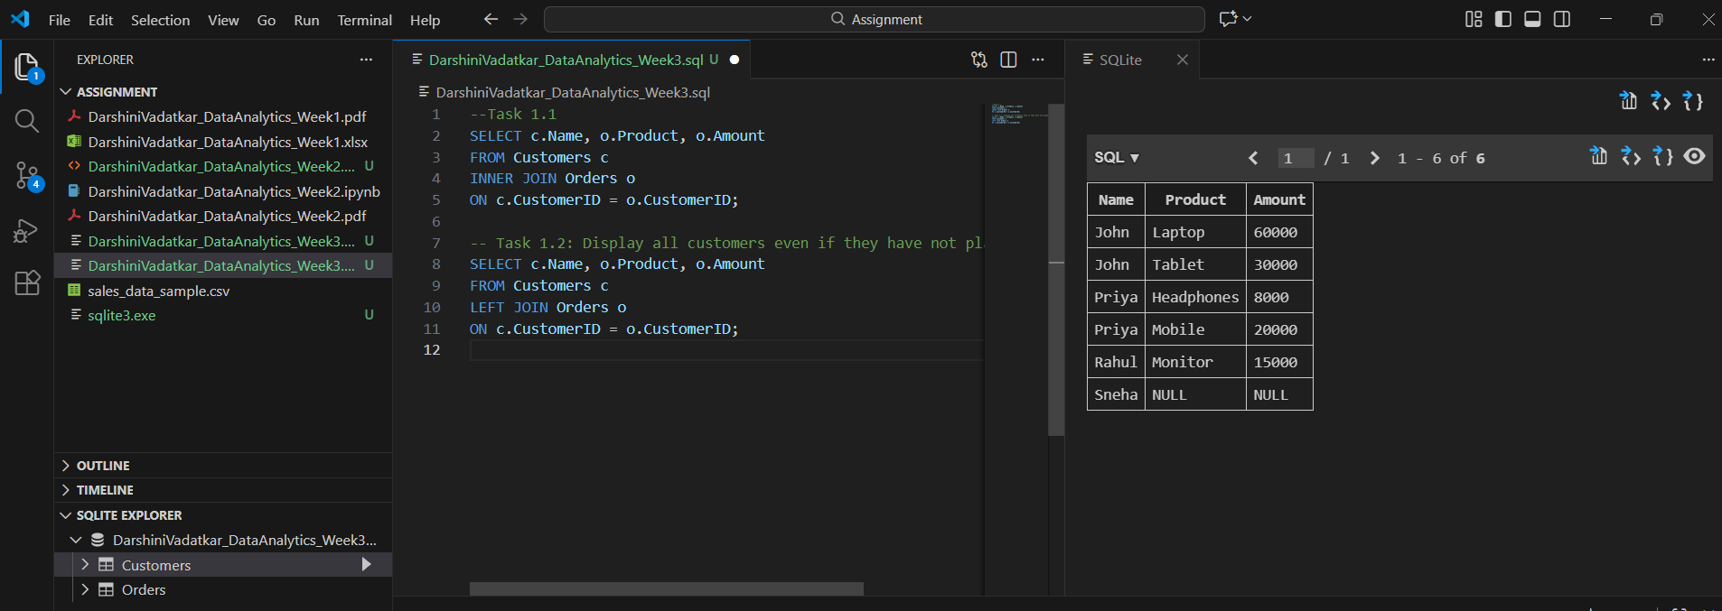
-- Task 1.3: Display only orders with amount greater than 20,000
SELECT c.Name, o.Product, o.Amount
FROM Customers c
INNER JOIN Orders o
ON c.CustomerID = o.CustomerID
WHERE o.Amount > 20000;
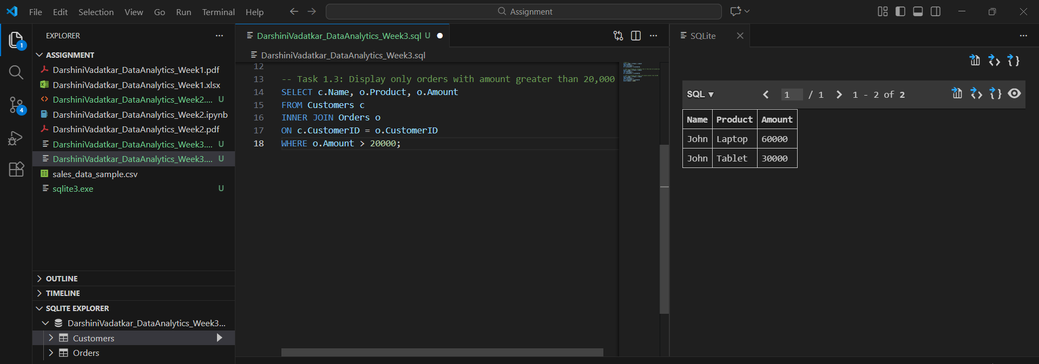
-- Task 2.4: Find the total purchase amount for each customer
SELECT c.Name, SUM(o.Amount) AS TotalSpent
FROM Customers c
INNER JOIN Orders o
ON c.CustomerID = o.CustomerID
GROUP BY c.Name;
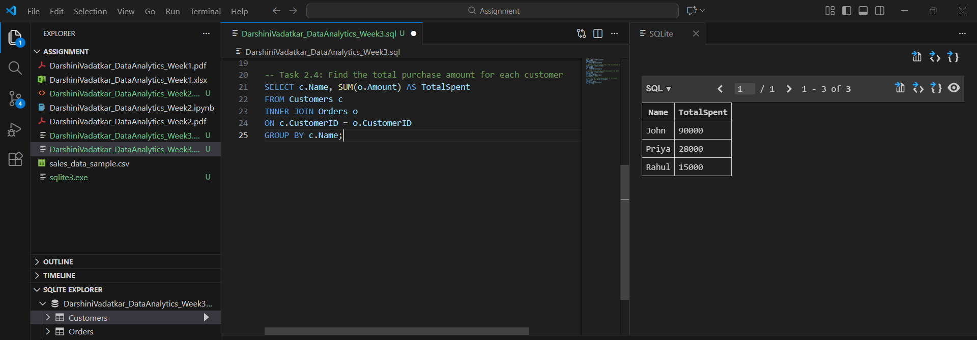

-- Task 2.5: Display customer names whose total spending is greater than 40,000
SELECT c.Name, SUM(o.Amount) AS TotalSpent
FROM Customers c
INNER JOIN Orders o
ON c.CustomerID = o.CustomerID
GROUP BY c.Name
HAVING SUM(o.Amount) > 40000;
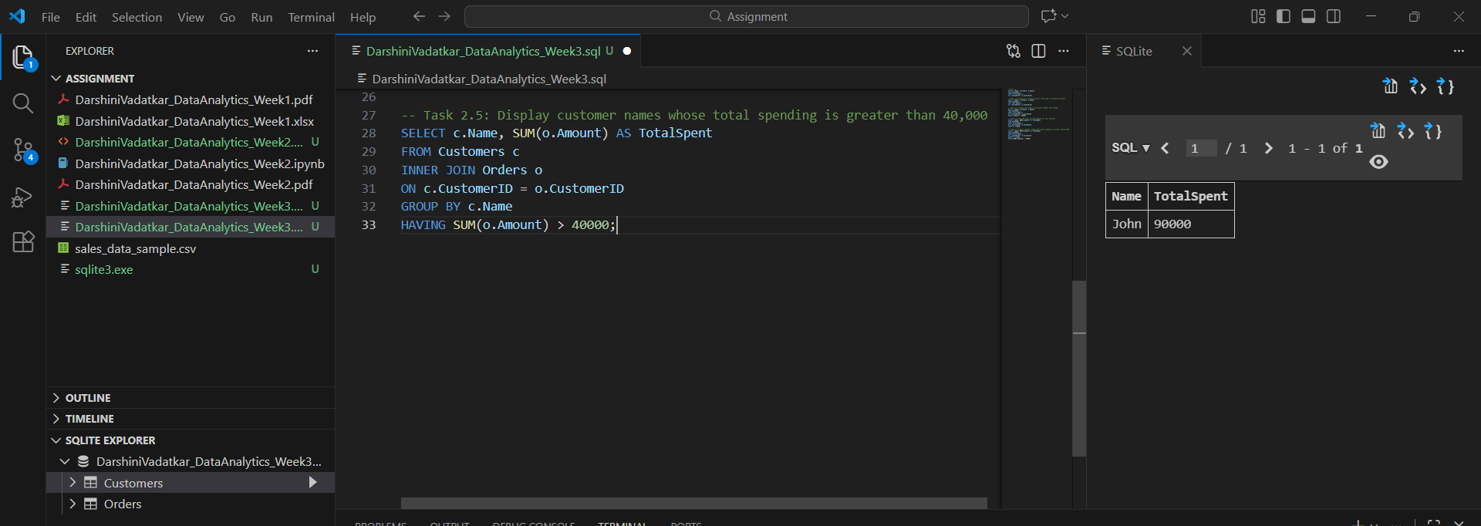
-- Task 2.6: Find the average order amount for each city
SELECT c.City, AVG(o.Amount) AS AvgOrderAmount
FROM Customers c
INNER JOIN Orders o
ON c.CustomerID = o.CustomerID
GROUP BY c.City;
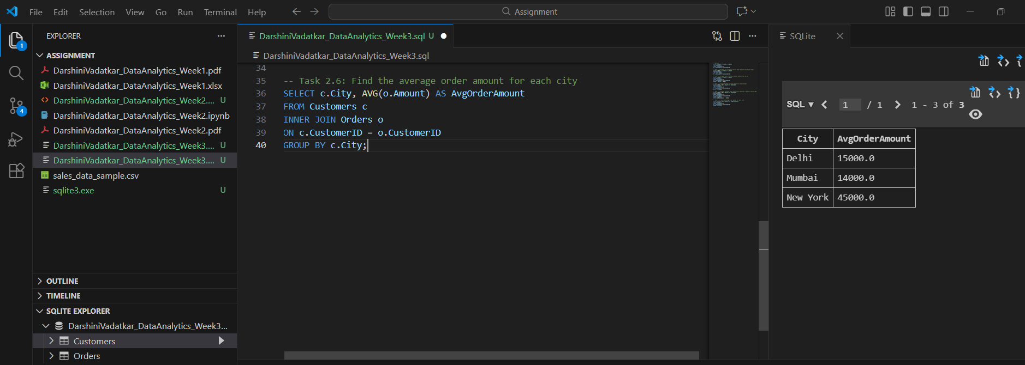

-- Task 3.7: Display cities where total sales exceed 50,000
SELECT c.City, SUM(o.Amount) AS TotalSales
FROM Customers c
INNER JOIN Orders o
ON c.CustomerID = o.CustomerID
GROUP BY c.City
HAVING SUM(o.Amount) > 50000;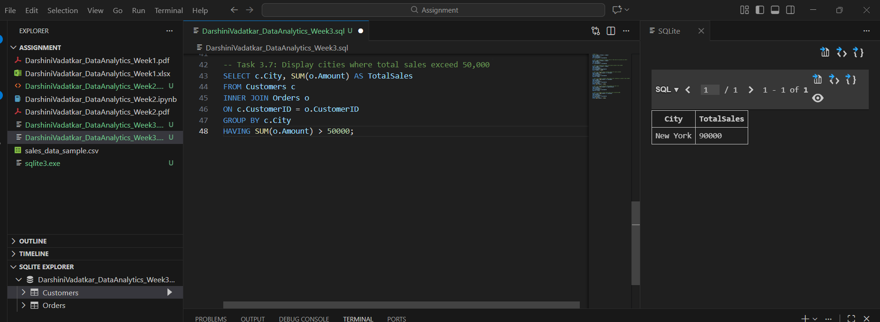
-- Task 3.8: Show customers who have placed more than one order
SELECT c.Name, COUNT(o.OrderID) AS OrderCount
FROM Customers c
INNER JOIN Orders o
ON c.CustomerID = o.CustomerID
GROUP BY c.Name
HAVING COUNT(o.OrderID) > 1;
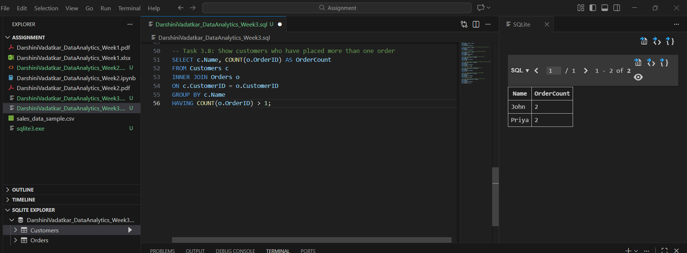
-- Task 4.9: Find customers who have spent more than the average order amount
SELECT c.Name, SUM(o.Amount) AS TotalSpent
FROM Customers c
INNER JOIN Orders o
ON c.CustomerID = o.CustomerID
GROUP BY c.Name
HAVING SUM(o.Amount) > (
SELECT AVG(Amount)
FROM Orders
);
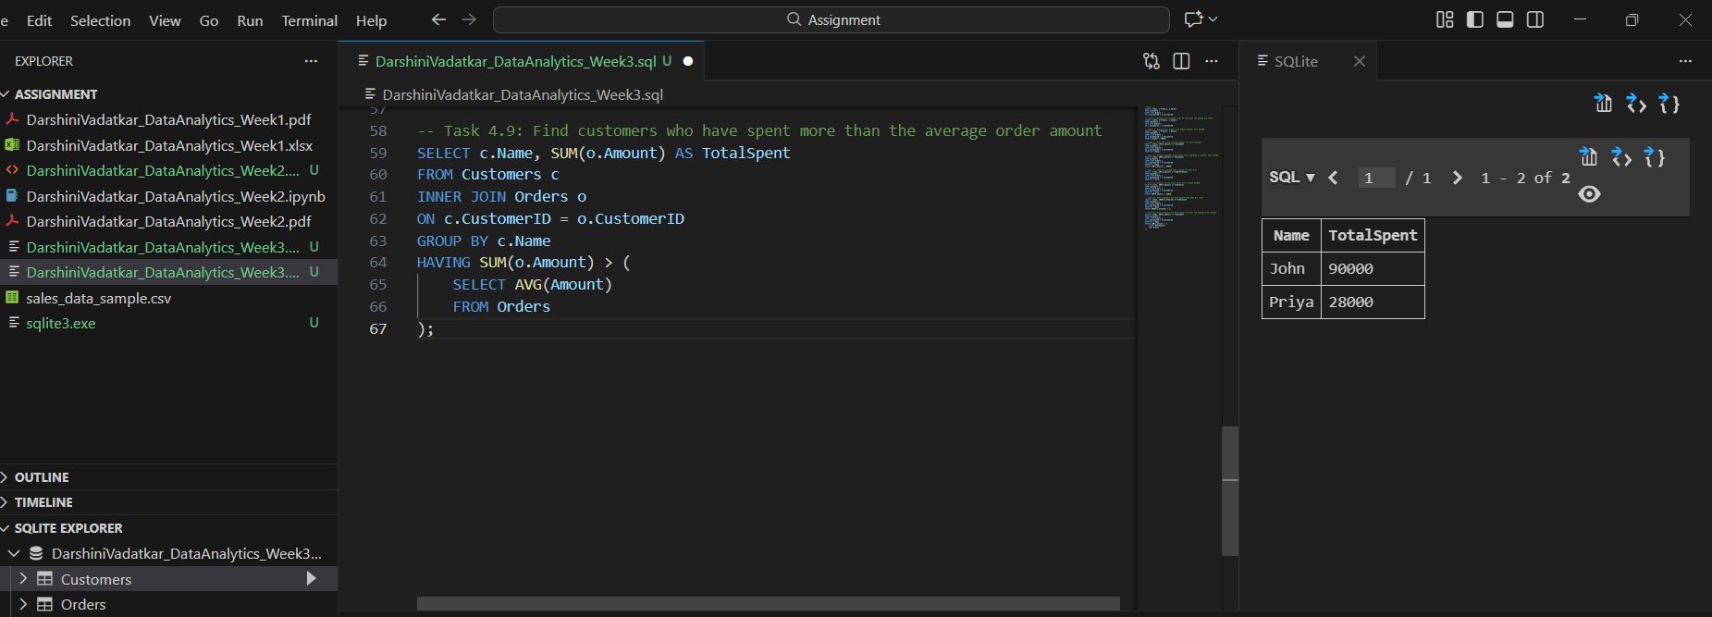
-- Task 4.10: Display the name of the customer who placed the highest value order
SELECT c.Name, o.Amount
FROM Customers c
INNER JOIN Orders o
ON c.CustomerID = o.CustomerID
WHERE o.Amount = (
SELECT MAX(Amount)
FROM Orders
);

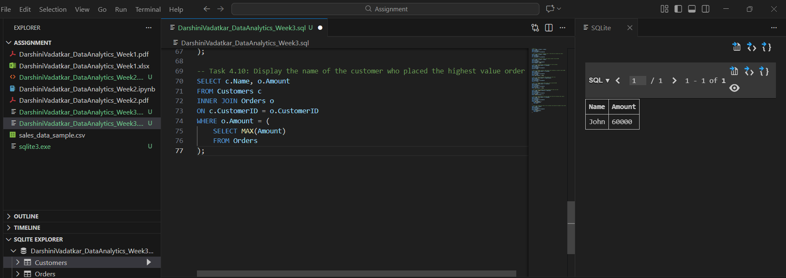
-- Task 4.11: Find customers who have never placed an order
SELECT Name
FROM Customers
WHERE CustomerID NOT IN (
SELECT CustomerID
FROM Orders
);
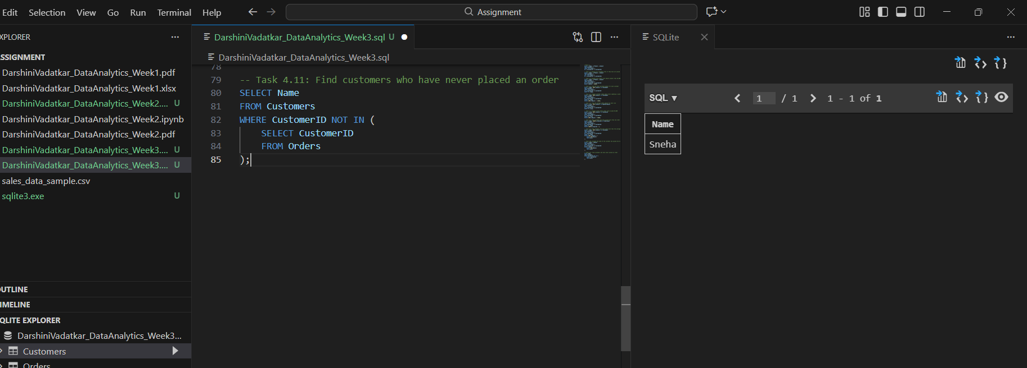

TASK 5: Conceptual Questions
12. What is the difference between WHERE and HAVING?
Answer: The difference between WHERE and HAVING is mainly about when the filtering happens. WHERE is used to filter rows before any grouping takes place, so it works on individual records in a table. HAVING, on the other hand, is used to filter groups after aggregation, for example when you want to show only customers whose total purchases exceed a certain amount.
13. Explain INNER JOIN vs LEFT JOIN with one real-life example.
Answer: INNER JOIN and LEFT JOIN differ in what records they return. INNER JOIN only shows records that have matches in both tables, while LEFT JOIN shows all records from the left table and the matching records from the right table. If there is no match, the right table values appear as NULL. For example, if you have a Customers table and an Orders table, an INNER JOIN would show only customers who have placed orders, while a LEFT JOIN would show all customers, including those who haven’t placed any orders.
14. What is a subquery and when should it be used?
Answer: A subquery is a query written inside another query. It provides intermediate results that the outer query can use for filtering, comparison, or calculation. Subqueries are useful when you need to compute something first and then use that result in the main query. For instance, if you want to find customers who spent more than the average order amount, you can calculate the average in a subquery and then use it to filter the customers in the outer query.

