Echo Example – Run the echo.html file for better understanding.

URL: <https://uzvey6qk8b.execute-api.us-west-2.amazonaws.com/echo-api-test>

Screenshot:

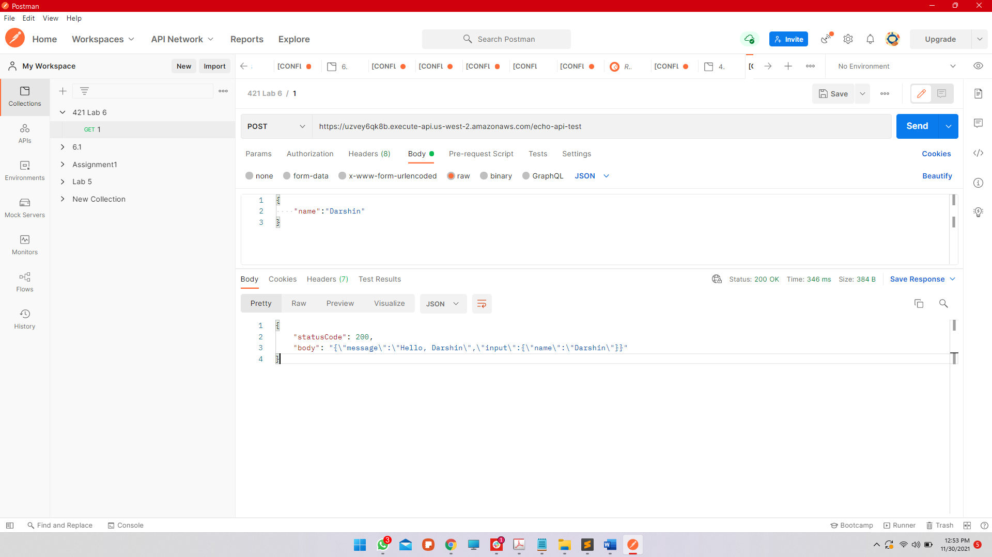

Joke API – Run the simple_fetch_example.html file for better understanding.

URL: <https://6suqxfxk08.execute-api.us-west-2.amazonaws.com/random-joke>