
Journal Homepage: -www.journalijar.com

Article DOI:10.21474/IJAR01/8483
DOI URL: http://dx.doi.org/10.21474/IJAR01/8483

RESEARCH ARTICLE

DIGITAL MARKETING: CONCEPTS & ASPECTS.

Sandeep Ponde and Arjita Jain.
Management Studies, University of Mumbai, NCRD’s Sterling Institute of Management Studies Nerul, Navi Mumbai-Maharashatra,400706, India.

…………………………………………………………………………………………………….... Manuscript Info Abstract
……………………. ………………………………………………………………

Manuscript History
Received: 02 December 2018
Final Accepted: 04 January 2019
Published: February 2019

Key words:-
Digital Marketing, Internet Marketing, Mobile Phone, Social Media Marketing, Traditional Marketing.
In the current era Digital Marketing is one of the most preferred forms of marketing. It is extremely popular in the younger generations, also being used by middle and the older generations. Today marketers are using digital marketing as a channel to market their products and the services. Digital Marketing is the way of electronic communication with customers and consumers. Due advancements in technology, the use of digital marketing, social media marketing, and search engine marketing is increasing rapidly. Digital marketing requires a new understanding of customer behavior. Digital marketing is a strategy that gives an individual or organization the ability to get in touch with clients by establishing innovative practices, combining technology with traditional marketing strategies. Digital marketing is beyond internet marketing including channels that do not require the use of Internet. Digital marketing includes Mobile phones -SMS and MMS, social media marketing, display advertising, search engine marketing and many other forms of digital media. The purpose of this paper is to study the concept and various aspects of digital marketing and to explore the differences between digital marketing and traditional marketing.

Copy Right, IJAR, 2019,. All rights reserved.
……………………………………………………………………………………………………....

Introduction:-
Marketing is a restless, changing, and dynamic business activity. The role of marketing itself has changed dramatically due to various crises - material and energy shortages, inflation, economic recessions, high unemployment, dying industries, dying companies, terrorism and war, and effects due to rapid technological changes in certain industries.⁵ Digital Marketing has created a huge buzz in today’s world. Digital marketing is the use of electronic media by the marketers to endorse the products or services into the market. The key objective of digital marketing is attracting customers and allowing them to interact with the brand through digital media. Digital marketing is the style of online promoting of your products, events or simply your business. Consumers can access information any time and any place where they want through digital media.
Digital marketing is a wide term that refers to a variety of promotional techniques used to reach customers via digital technologies. Digital marketing embodies a wide selection of service, product and brand marketing tactics which mainly use Internet as a core promotional medium in addition to mobile and traditional TV and radio. Digital marketing campaigns are becoming common as well as efficient, as digital platforms are increasingly incorporated into marketing plans and everyday life, and as people use digital devices instead of going to physical shops. It helps a buyer to compare a product with another product and it also allows 24 X7 services to purchase, even it allows
Corresponding Author:-Sandeep Ponde.
Address:-Management Studies, University of Mumbai, NCRD’s Sterling Institute of Management Studies Nerul, Navi Mumbai-Maharashatra,400706, India.

260

customers to return a delivered product if they are not satisfied with it.Canon iMage Gateway helps consumers share their digital photos with friends online. L’Oréal’s brand Lancôme uses email newsletters to keep in touch with customers and hence tries to strengthen customer brand loyalty (Merisavo et al., 2004). Magazine publishers can activate and drive their customers into Internet with e-mails and SMS messages to improve re-subscription rate (Merisavo et al., 2004).

Literature Review
Review of Literature is an attempt made to go through the available research papers to understand how different researchers have explored concepts, different aspects of digital marketing. Kaini (1998) Innovation of new technology i.e vide internet, helps in opening the gate for marketers and do online marketing to achieve their business goals. Also presents a set of guidelines for advertising on the web; attract users by making it easy to find your site, engage their interests by creating communities or linking to other sites they will find valuable, ensure they return by constantly updating your content and keeping it „fresh‟, learn their preferences by tracking their activity on your site, and relate to them by taking the information gathered to provide customized content. Song (2001) more choices are available for customers. So it is difficult to enterprise to build brand image. Online advertising is powerful marketing tool used for creating brand image and helps the corporate to increase the sale up to many extents. Mort, et al(2002) Due to advancement in technologies and market dynamics, digital market is rapidly growing. Teo(2005)The survey was conducted by firms in Singapore and findings revealed that digital marketing is effective marketing tool for gaining results. Jarvinen, Tollinen, Karjaluoto and Jayawardhena (2012) has studied how widely are social media tools used as a part of the digital marketing mix in B2B industry, the important objectives aimed at, and the major barriers to utilization of digital marketing in B2B firms. Kwak, Lee, Park and Moon (2014) present an empirical study of Twitter and how information spreads across the service. The authors analyzed 41.7 million users, 1.47 billion social relations, 4,262 trending topics and 106 million tweets. During the research the authors noted a tendency on Twitter; contact between similar people occurs at a higher rate than among dissimilar people. Roberts & Micken (2015) explained that society has experienced an economical shift, driven by digital technology. Roberts & Micken (2015) cited Dean et al. (2012) discoveries of a 4.7% gross domestic product contribution to the United States (U.S.) economy in 2010. Afrina Yasmin, Sadia Tasneem, Kaniz Fatema (2015), has explained the various elements od digital marketing as well as the studies the comparative analysis of traditional marketing vs digital marketing. (Zimmer, 2017) Social Media Marketing as being a powerful marketing tool. Social networking through an online community allows users to communicate with each other. The social networking platform allows marketing between individuals or organizations to be facilitated through online information post and messaging (Zimmer, 2017).

Objectives
The objective of this paper is as follows:-
- To study the concepts & various aspects of digital marketing
- Traditional Vs Digital Marketing.
- To identify the advantages of digital marketing

Digital Marketing
What Is Digital Marketing?
Digital marketing encompasses all marketing efforts that use an electronic device or the internet. Businesses leverage digital channels such as search engines, social media, email, and their websites to connect with current and prospective customers. In today’s time, digital marketing has become a new trend that brings together customization and mass distribution to achieve the marketing goals. Technological convergence and the multiplication of devices have led to an opening up of the ways in which we thinking about 38 T. Piñeiro-Otero and X. Martínez-Rolán marketing in Internet and have pushed the boundaries towards a new concept of digital marketing—user-centred, more measurable, ubiquitous and interactive. Digital marketing strategies offer much potential for brands and organizations. Some of them are as like Branding, Completeness, Usability, Interactivity, Relevant advertising, Community connections**

Digital Marketing Plan
A digital marketing plan is a tactical document that takes the current situation of a particular organization to set some midterm goals and to determine the strategy and means to accomplish them. This document includes the responsibilities, the time frame and control tools for monitoring. The aims of a digital marketing plan include discussing organizations and their environment. Similarly, it needs to be a roadmap of how to manage the
organization’s marketing strategy, so that resources are properly allocated. The plan also helps control and evaluates output and tackles any potential variation from the organization’s expected outcomes. In this line, a marketing plan becomes a flexible document that must be adapted to the situation of the company and that must feed into the results obtained by each of the actions developed, especially in the digital arena.
Steps in digital marketing plan are as follows –
- Situation Analysis
- Goal Definition
- Strategy
- Action & Control

Fig1:-Digital Advertising Revenues.
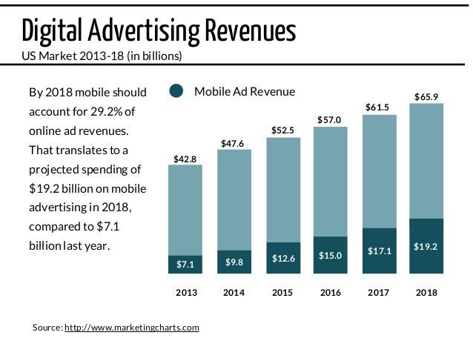

According to Wikipedia World population in the year 2005 was 6.5 billion which has increased to 7.4 billion by the year 2017. In the year 2005 internet users in the world 51% which increased to 81% in the year 2017. The increased use of internet has resulted increased revenue from digital marketing. The above figure clearly shows increased revenue from digital marketing.

Aspects of Digital Marketing
Today digital marketing depends upon the types of audience communications. It revolves around managing and harnessing of different types of digital marketing channels- following are digital marketing services-
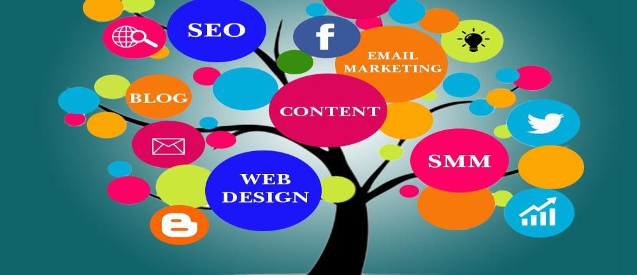
Fig2:-Aspect of Digital Marketing

Search Engine Marketing & PPC
Search Engine Marketing (SEM) is one of the most basic types of digital marketing services that help businesses increase market online via Ads on search engines such as Google, Bing or Yahoo.
SEM is a type of internet marketing that involves the promotion of websites by escalating their visibility in search engine results pages (SERPs) mainly through paid advertising. SEM may incorporate search engine optimization (SEO), which adjusts or rewrites website content and site architecture to achieve a higher ranking in search engine results pages to enhance pay per click (PPC) listings. To optimize websites Search engine marketing
uses five methods and metrics - Keyword research, Website saturation and popularity, Back end tools, Whois , Google Mobile etc.

Pay Per Click (PPC)
Pay-per-click marketing is a method of using search engine advertising to generate clicks to your website rather than
―earning‖ those clicks organically. Pay per click is good for searchers and advertisers. It is the best way for company’s ads since it brings low cost and greater engagement with the products and services.

Search Engine Optimization (SEO)
Search engine optimization (SEO) is the method of affecting the visibility of a website or a web page in a search engine’s ―natural‖ or un-paid (―organic‖) search results. In general, the earlier (or higher ranked on the search results page), and more frequently a website appears in the search result list, the more visitors it will receive from the search engine users. SEO may target different kinds of search including image search, local search, video search, academic search, news search and industry-specific vertical search engines.⁴

Search engine optimization (SEO) helps you put on higher positions in search results via organic means that help you get more activity, awareness, traffic, digital branding, lead generation, and conversions.

Social Media Marketing (SMM)
Social Media Marketing is the newest and most admired types of Digital Marketing that help marketers press forward their brand image in the most powerful and trendy manner.SMM is nowadays preferred by different businesses for optimizing the image of a brand, business, product, or an individual. Facebook, Google+, Twitter, Instagram, YouTube, LinkedIn, Snapchat Pinterest, etc. are the most well known Social networks.

Email Marketing
Email marketing is the form of marketing in which information/ message about the goods or services is sent to customer through email. Email marketing is one of the oldest and easiest types of Digital Marketing. It is still highly modern and productive. Marketers use emails for developing relationships with their probable and existing customers that help them produce leads and ensure their conversions.

Content Marketing
Nowadays Content Marketing is the most important types of Digital Marketing that spin around the management and execution of different written, engaging, downloadable and visual Digital Media Content. Content Marketing focuses on attracting and converting targeted audiences into customers by designing, publishing, promoting, distributing and sharing valuable and relevant free content on different digital marketing channels.

Web Analytics
Web Analytics is the most recent aspect of your Digital Marketing. Basically, Web Analytics helps us to collect, measure, understand, analyze, plan, report and predict the web activities for our business. Web Analytics should not be misunderstood with Web Statistics. Web Analytics gives you analyses and different angles to consider vis-à-vis your business. Google Analytics, Spring Metrics, Woopra, Clicky, Mint and Chart beat are the important tools of Web Analytics. Nowadays every advertiser use Web Analytics to understand his business and improve the ROI and conversions.

Most Effective Digital Marketing
As per Ascend2 and its other research partners conducted a survey of marketing professionals. The results are shown in the following Fig.3

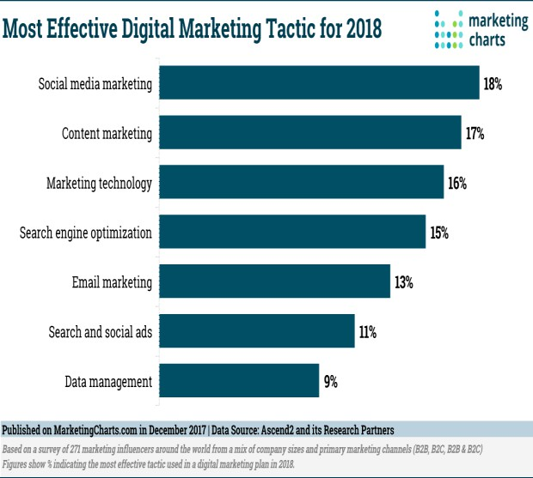
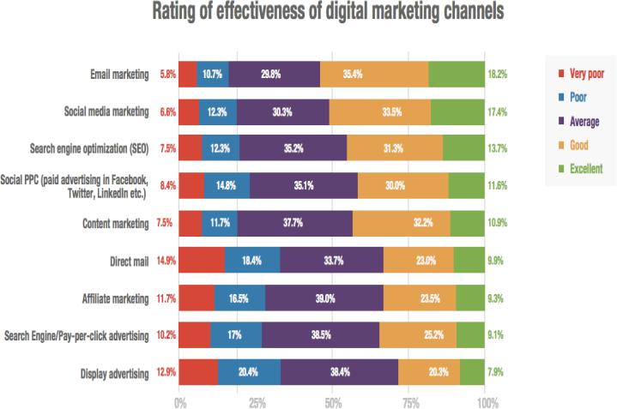
Fig 3: Most Effective Digital Marketing Tactics.
Source:-MarketingCharts.com

The above figure clearly shows that currently social media marketing is the most preferred as Compare to content marketing, search engine optimization or email marketing etc. In terms of effectiveness email marketing is most effective then comes social media marketing and search engine optimization

Traditional Marketing v/s Digital Marketing
Traditional marketing is the most familiar form of marketing. Traditional marketing is non-digital approach used to endorse the product/ goods or services of industry. Whereas, digital marketing is the marketing of products or services using digital channels to reach consumers.

Traditional Marketing | Digital Marketing
No communication with customer | communication with customer
Communication is unidirectional | Communication is bidirectional
Advertising campaign planning takes more time for designing & Launching. | Advertising campaign planning is fast as compared to traditional marketing.
Difficult to measure the success of a campaign | Easier to measure the success of a campaign through  analytics.
Medium for communications are print, mail, telephone. | It includes online advertising, email marketing, social  media, text messaging, affiliate marketing, search engine optimization, pay per click
Limited reach to the customer because of geographical  constraint | Wider reach to the customer because of the use of various  technologies.
24x7 exposure is not possible | 24x7 exposure is not possible
Product / Services feedback can take within working  hours | Response or feedback can occur anytime
Traditional Marketing is expensive & time consuming | Digital Marketing is comparatively cheap and fast.

Advantages Digital Marketing brings to customers
In short period of time & rapid technological development digital marketing has changed customers buying behavior. The core advantage of digital marketing is that a targeted audience can be reached in a cost-effective and measurable way. Besides this Digital marketing increases the brand loyalty and driving online sales.
The benefits of digital marketing include:

Global reach
website is the medium that allows customer to find new markets and do business globally for only a small investment.

Lower cost & Apparent Pricing
Well designed and effectively targeted digital marketing campaign can reach the right customers at a much lower cost than traditional marketing methods. Company displays the prices of goods or services through digital marketing channel and this makes prices very clear and transparent for the customers.

Track able, measurable results
measuring your online marketing with web analytics and other online metric tools makes it easier to establish how effective your campaign has been. With the help of certain tools company can analyzes the customer’s responses towards the website and for adverting. Through Web analytics can be set up to show you exactly how much money you make from each digital tactic.

Personalization
Personalization of loyal customer’s database can be possible through the digital marketing, if your customer database is linked to your website, then whenever someone visits the site, you can greet them with targeted offers. That helps in boost of company’s sale.

Openness
by getting involved with social media and managing it carefully, you can build customer loyalty and create a reputation for being easy to engage with.

Social currency
It lets you create attractive campaigns using different types of rich media content. On the internet these campaigns can increase social currency - being passed from user to user and becoming viral.

Improved conversion rates
Digital marketing is seamless and immediate. With the help of a website, your customers are only ever a few clicks away from completing a purchase. Unlike other media which require people to get up and make a phone call, or go to a shop.

Shopping
As internet is available all day, there is no time restriction to customer wants to buy a product online anytime and anywhere.

Methodology:-
This research paper is purely qualitative in nature. For this study researchers have mainly relied on secondary data. Secondary data was collected from the published articles, research papers, census survey, published general reports, sources through related websites etc.

Conclusion:-
Internet and electronic commerce technologies are changing the total economy and shifting business models, revenue streams, customer bases, and supply chains. Because of internet new business models are up-and-coming in every industry of the New Economy. Digital marketing is the new form of doing business through the digital media. It has turn out to be crucial part of approach of many companies. Today small business proprietors have an extremely inexpensive and competent method by using digital marketing to market their products or services in the society. The manner in which digital marketing has grown up it has changed the way brands and businesses make use of technology and digital marketing for their marketing. Digital marketing campaigns are becoming more ubiquitous as well as well-organized, effective as digital platforms are increasingly incorporated into marketing plans and everyday life, and as people use digital devices like mobile phone, laptops, TV, social media instead of going to physical shops. It has no borders. Organizations should create ingenious customer experiences and specific strategies for media to spot the best path for increasing digital marketing performance.

Reference:-
- G.R. Kiani, ―Marketing opportunities in the digital world‖, Internet Research: Electronic
- Networking Applications and Policy. Volume 8, 1998, pp. 185- 194.
- Roberts, S. D., & Micken, K. S. (2015). Marketing digital offerings is different: Strategies for
- teaching about digital offerings in the marketing classroom. Journal of Education for Business, 90(2), 96-102.
- Zimmer, S. (2017). Marketing. Marketing -- Research Starters Business, 1-4.
- Afrina Yasmin, Sadia Tasneem, Kaniz Fatema, Effectiveness of Digital Marketing in the Challenging Age: An Empirical Study, Volume 1, Issue 5, April 2015, Pages 69-80.
- Dr. Madhu Bala, Mr. Deepak Verma,‖ A Critical Review of Digital Marketing‖, International Journal of Management, IT & Engineering,Vol. 8 Issue 10, October 2018.
- Giedd, J. N., & Chief, M. (2012), ―The Digital Revolution and Adolescent Brain Evolution: Elsevier Inc.
- A Munshi, MSS MUNSHI (2012), ―Digital matketing: A new buzz word‖, International Journal of Business Economics & Management Research, Vol.2 Issue 7.
- Kotler, P., Keller, L (2007), Marketing management, Grada Publishing, ISBN 80-247-1359-5
- Teresa Piñeiro-Otero and Xabier Martínez-Rolán, Understanding Digital Marketing—Basics and Actions, Springer International Publishing Switzerland 2016
- https://www.digitalvidya.com/blog/five-types-of-digital-marketing/
- https://www.omnicoreagency.com/digital-marketing-statistics.

