UML Diagram Assignment

Name: DARSHIT
Intern ID: INT_1051
Date: 21/02/2026
Project: Task Management System

Task 1: Use Case Diagram

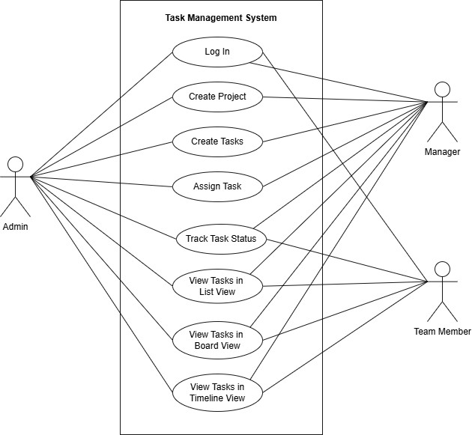

Task 2: Activity Diagram

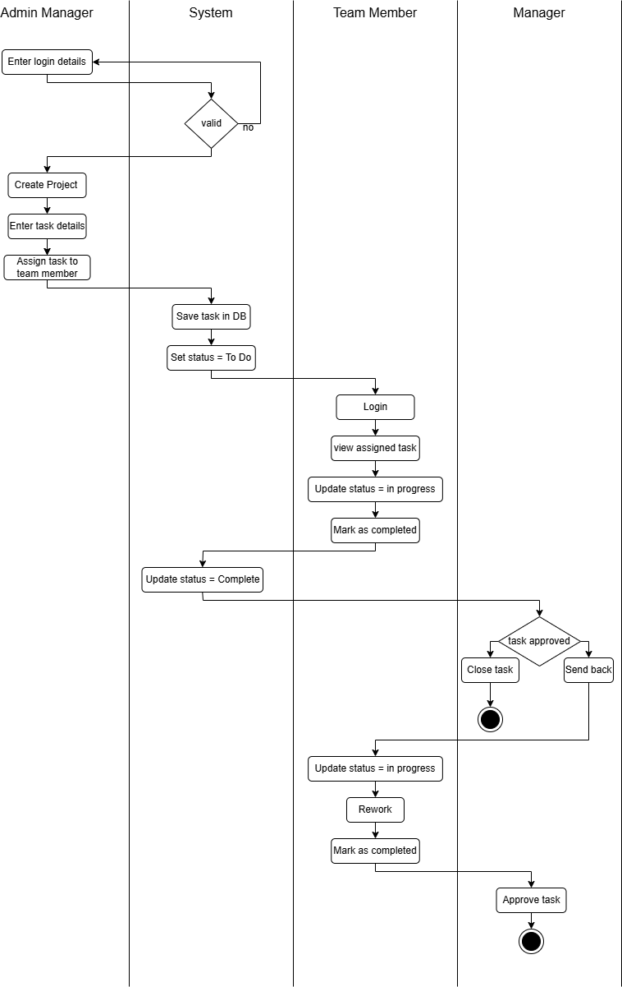

Task 3: Class Diagram
