**Veer Narmad South Gujarat University, Surat.**

**Department of Information and Communication Technology**

**B.Sc. (Information Technology)**

# **Project Report**

**6th Semester**

**M.Sc. (Information Technology)**

**5 Year Integrated Course**

Year 2021 – 2022

## SOCIETY MANAGEMENT SYSTEM

**Guided By** : **Submitted By** :

Dr. Tejas Shah Darshit Sorathiya

SPID : 2019008979



**Department of Information and Communication Technology**

**M.Sc.(Information Technology) Programme**

**B.Sc(IT) 6th Semester**

***Certificate***

This is to certify that  **Mr. Darshit G. Sorathiya** with exam seat number **2019008979** and SPID **2019008979**  has worked on his project work entitled as **SOCIETY MANAGEMENT SYSTEM** at **Department of ICT** as a partial fulfillment of requirement of B. Sc. (Information Technology) - 6thSemester , during the academic year 2021-2022.

Date: 18/6/2022

Place: Department of ICT, VNSGU, Surat

**Internal Project Guide Head of the Department**

**BSc(IT) 6th Semester Department of ICT**

**Department of ICT VNSGU, Surat**

**VNSGU, Surat**

**INDEX OF PROJECT**

|  |  |  |
| --- | --- | --- |
| **Sr. No** | **Topics** | Page no |
| **1** | **Introduction**  **1.1 Project Profile** |  |
| **2** | **Proposed System**  **2.1 Scope**  **2.2 Objective** |  |
| **3** | **Environment Specification**  **3.1 Hardware & Software Requirements** |  |
| **4** | **System Planning**  **4.1 Feasibility Study**  **4.2 Software Engineering Model** |  |
| **5** | **System Analysis and Modelling**  **5.1 SRS(Module wise specification with brief description**  **5.2 UML Diagram**  **5.2.1 Use Case Diagram**  **5.2.3 Class Diagram**  **5.2.4 Activity Diagram**  **5.2.5 Sequence Diagram**  **5.3 E-R Diagram**  **5.4 Data Flow Diagram**  **5.5 Process Specifications**  **5.6 Data Dictionary** |  |
| **6** | **Software Design**  **6.1 Database Design (Table Design)**  **6.2 Interface Design (page snapshots)** |  |
| **7** | **Testing**  **7.1 Unit Testing**  **7.2 Integration Testing** |  |
|  |  |  |
| **8** | **Future Enhancement** |  |
| **9** | **Reference** |  |

**1.INTRODUCTION**

Society management system as name suggest is a system which helps to do better management for the society’s buildings,owners,income and expenses.As admin can register the buildings,manage flats can manage committee.And committee members can manage owners,make announcements,resolve complaints and also can manage maintainance and can handle income and expenses reports so that all the management can be done digitally without pen and paper.Owners and renters panel is also there for better management of the society.

Owners and renters can pay the maintainance,register their vehicles,raise complaints,see announcements and owner can manage the renter so this system will be helpful as a dynamic system for societies.

|  |  |
| --- | --- |
| PROJECT TITLE | Society Management System |
| FRONT END TOOLS | HTML  CSS  Java Script  AJAX  Bootstrap |
| BACK END TOOLS | core PHP |
| DATABASE | MYSQL-phpmyadmin |
| PROJECT CATEGORY | Web Application |
| TOTAL MEMBER | 1 |
| PROJECT GUIDE | Dr. Tejas Shah |
| SUBMITTED BY | Darshit G. Sorathiya |
| SUBMITTED TO | Department of ICT ,VNSGU |

* 1. **PROJECT PROFILE**

1. **PROPOSED SYSTEM**

***2.1 Scope:***

* The major goal of the society management system is to provide a better management technique without pen and paper to society member’s and committee member’s.
* This system is totally web based system and also has user friendly interface.
* Huge amount of time of the member’s can be saved by using this system.
* There are five types of user in this system:
* **Admin**: Admin can handle buildings,committee and can modify that.
* **Secretary**: He is the committee member of the society.Secretary can manage owners,can maintain maintainance records,can see vehicle details of the particular flat,can make announcements and manage announcements and complaints.
* **Treasure**:He is the committee member which keeps the all records of the income and expense of the building.
* **Owner**:He is the member of the society who provides the information about his flat to the secretary and also gives feedback to the secretary about his experiences.
* **Renter**:He is also the member of the society who also act as same as owner and provide same things to secretary and same access as owner except managing renter.

***2.2 Objectives :***

* Secretary can make announcements,can review complaints and manage maintainance from their place without any restriction of time and their comfort.
* Tresure can also keep records on digital platform without any physical material.
* Owner and renter can also pay maintainance from their home without any restriction of time and their comfort.
* Most of the management can be done digitally without use of the pen and paper.

1. **Environment Specification**

**3.1 Hardware and Software requirement:**

**Hardware Requirement:**

**Client Side:**

|  |  |
| --- | --- |
| **RAM** | 512 MB |
| **Hard Disk** | 10 MB |
| **Processor** | 1.0 GHz |

**Server Side:**

|  |  |
| --- | --- |
| **RAM** | 1 GB |
| **Hard Disk** | 20 GB |
| **Processor** | 1.0 GHz |

**Software Requirement:**

**Client Side:**

|  |  |
| --- | --- |
| **Web Browser** | Chrome or any Compatible browser |
| **Operating System** | Windows or any compatible OS |

**Server Side:**

|  |  |
| --- | --- |
| **Web Server** | APACHE |
| **Server-side language** | PHP |
| **Database Server** | MYSQL |
| **Web Browser** | Chrome or any Compatible browser |
| **Operating System** | Windows or any compatible OS |

1. **System Planning**

**4.1 Feasibility Study**

* **Technological Feasibility :**

The system is feasible for front-end and the back-end requirements are already installed.

System is developed by using PHP and data will be stored in the database. For individual user access we have installed xampp server and implemented this application. This system do not require communication with other system and only with the database the security issues with this system are very less.

All the software or components that are required to run this web application are already available and thus no need to purchase anything.

**4.2 Software Engineering Model**

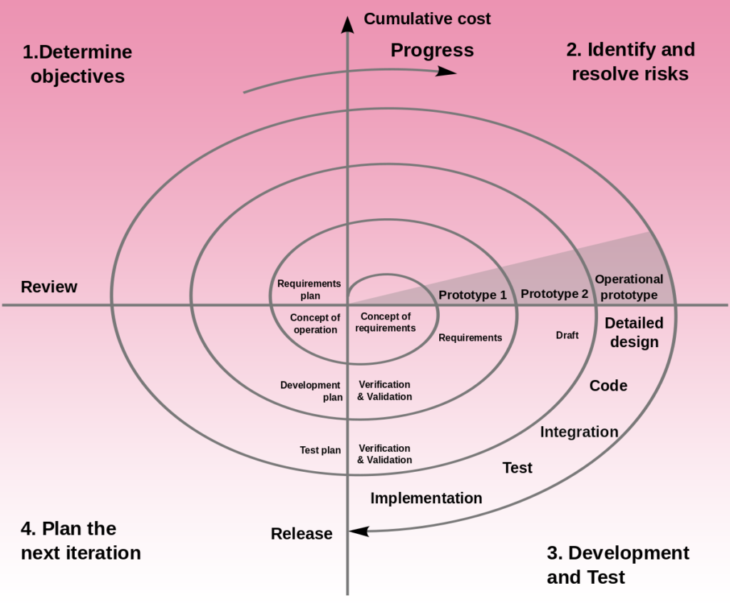

* We followed spiral model for development so we can add new functionalities with better risk management and we can do same process till system is completely buid for hosting.

1. **System Analysis and Modelling**

**5.1 SRS :**

**Functional Requirements :**

**ADMIN:**

Register new building:

Admin can add new building ,which is the part of the society.

Edit Building:

Admin can edit building details as per requirement.

Remove Building:

Admin can remove building .

Manage Committee:

Admin can create ,update and remove the committee of the all buildings.

Manage Flats:

Admin can give the flat numbers to all the flats of the particular building and can see which flat is owned and which flat is on rent.