Energy Consumption Analysis and Insights Report
Darshit Chauhan | darshitchauhan2001@gmail.com
Visualizations Created by MS Power BI
I. Energy Trends (Hourly, Weekly, Monthly.)
Chart 1: Average Energy by Hour of Day:
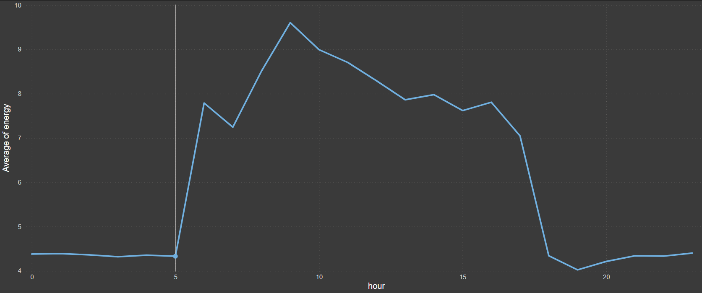
🔍 Insights:
- Lowest energy consumption occurs between midnight and 5 AM, which makes sense for non-operational hours.
- Sharp rise starts from 6 AM, peaking between 9 AM and 11 AM.
- Gradual decline post-lunch with a sharp drop again after 6 PM.
- Lowest activity resumes between 8 PM to midnight.

Chart 2: Average Energy Consumed by Weekday:
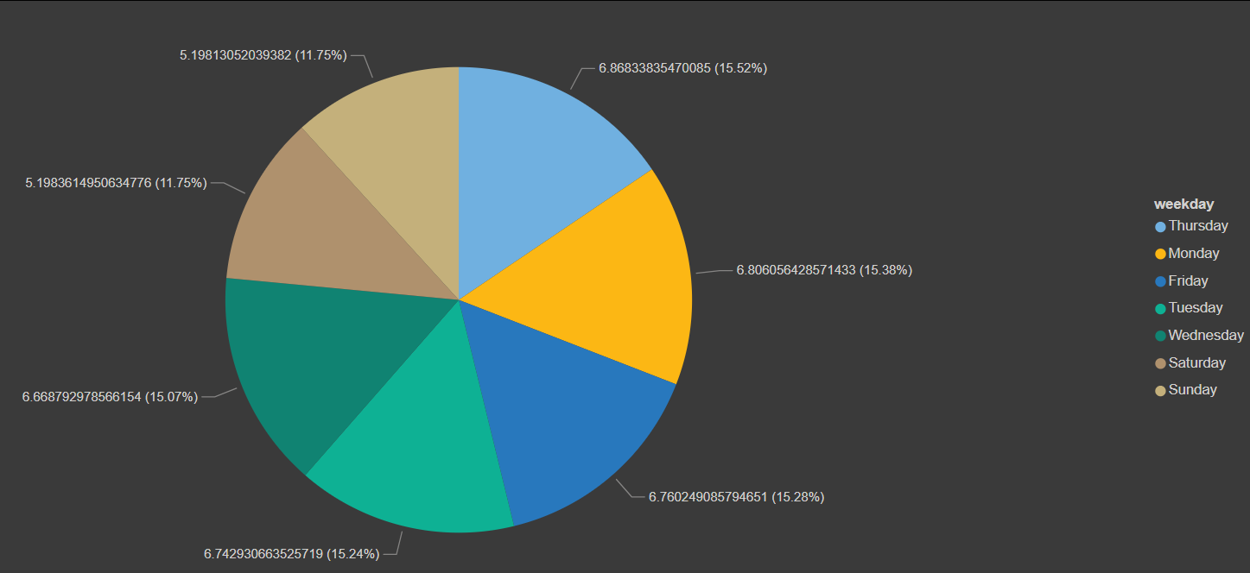
🔍 Insights:
- Energy consumption is slightly higher on weekdays, particularly on Thursday (15.52%), Monday (15.38%), Wednesday (15.24%), and Tuesday (15.07%).
- Saturday and Sunday have the lowest share, both around 11.75%, indicating a likely reduction in operational load during weekends.

Chart 3: Average Energy Consumed by Month:
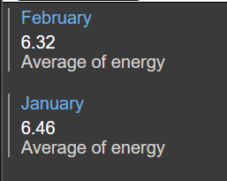
🔍 Insights:
- Energy consumption decreased by 1.09% from January to February.

---- Together, these charts provide a time-based energy usage profile—both across the week and within each day—that can be used for:
- Operational scheduling
- Cost optimization (especially if tied to variable tariff plans)
- Identifying high-usage periods for load balancing or energy audits

II. Top Energy Consuming Devices.
Chart 4: Total Energy Consumed by Device and Type:
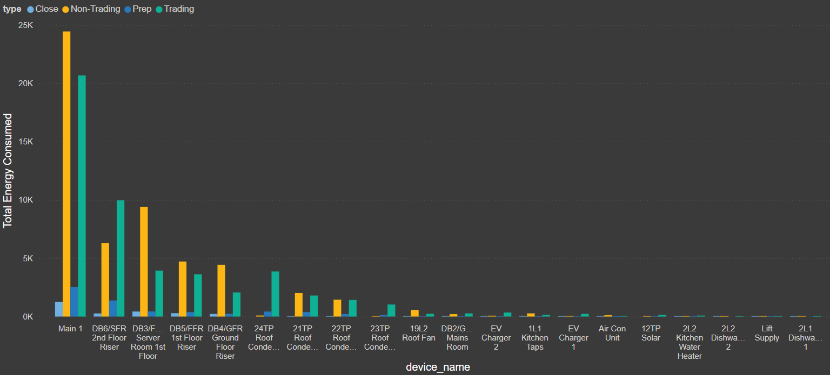
🔍 Insights:
- The Main 1 device consumed the highest energy overall, particularly during Non-Trading and Trading times.
- Other high energy-consuming devices include:
DB6/SFR 2nd Floor Riser
DB3/FFSR Server Room 1st Floor
- Energy consumption varies significantly by type (Close, Non-Trading, Prep, Trading).
- Trading and Non-Trading hours show consistently high usage across many devices.

Chart 5: Total Energy by Hour and Type:
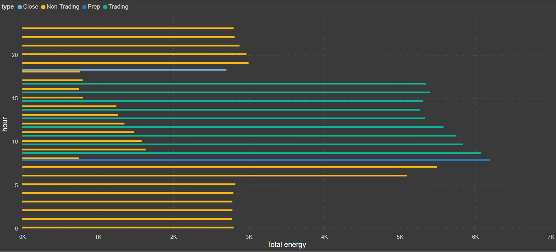
🔍 Insights:
- Energy consumption peaks between 10 AM and 4 PM, especially during Trading hours.
- Prep and Trading hours dominate midday consumption, suggesting high operational or work-related usage.
- Close hours (late evening and night) also show notable energy use, which could indicate either overnight systems or inefficiencies.

Chart 6: Average of Power Factor and Energy by Device:
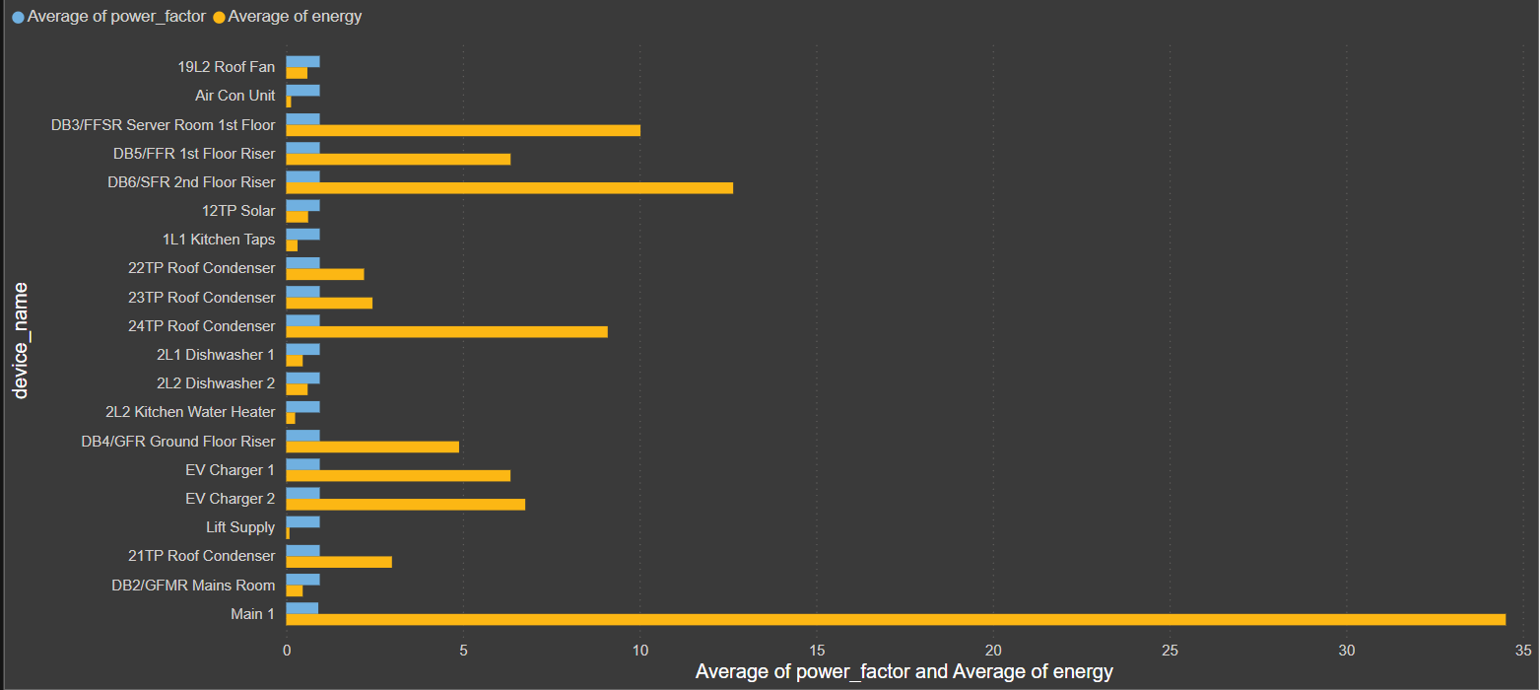
🔍 Insights:
- Main 1 again stands out with the highest average energy consumption.
- Devices like 24TP Roof Condenser, DB6/SFR 2nd Floor Riser, and DB3/FFSR Server Room also show high energy use.
- The power factor (indicator of energy efficiency) is generally low across most devices, suggesting possible inefficiencies or reactive power issues.

---- Together, these charts depict that:
- The Main 1 unit is the most energy-intensive and should be reviewed for efficiency opportunities.
- Energy spikes during working hours (10 AM - 4 PM), especially for Trading and Prep types.
- Many devices show low power factors, pointing to possible inefficiencies and potential cost-saving opportunities with optimization or power factor correction.

III. Consumption VS Trading Hours:

Chart 7: Average Energy Consumed by Device Type and Power Factor:

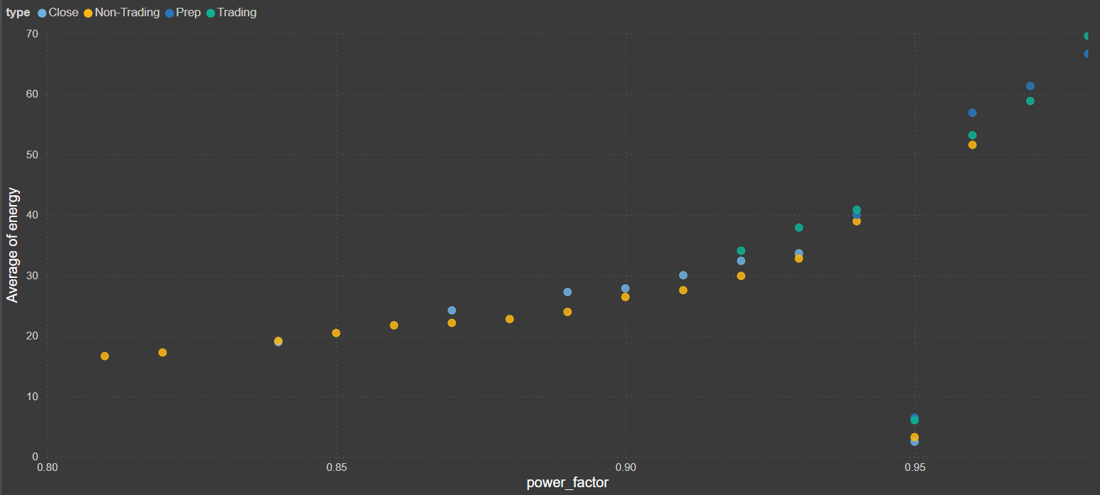
🔍 Insights:
- A strong positive correlation is visible: as power factor increases, energy consumption increases.
- Non-Trading hours dominate the lower end:
Avg Energy: ~20–30 units
Power Factor: 0.82–0.90
- Trading and Prep periods operate at higher power factor levels (0.93–0.98) with energy usage peaking at ~70 units.
- Efficiency Focus: Low power factor during Non-Trading hours may indicate reactive power waste — this could lead to inefficiency or penalties.
Chart 8: Average Voltage by Hour and Type:
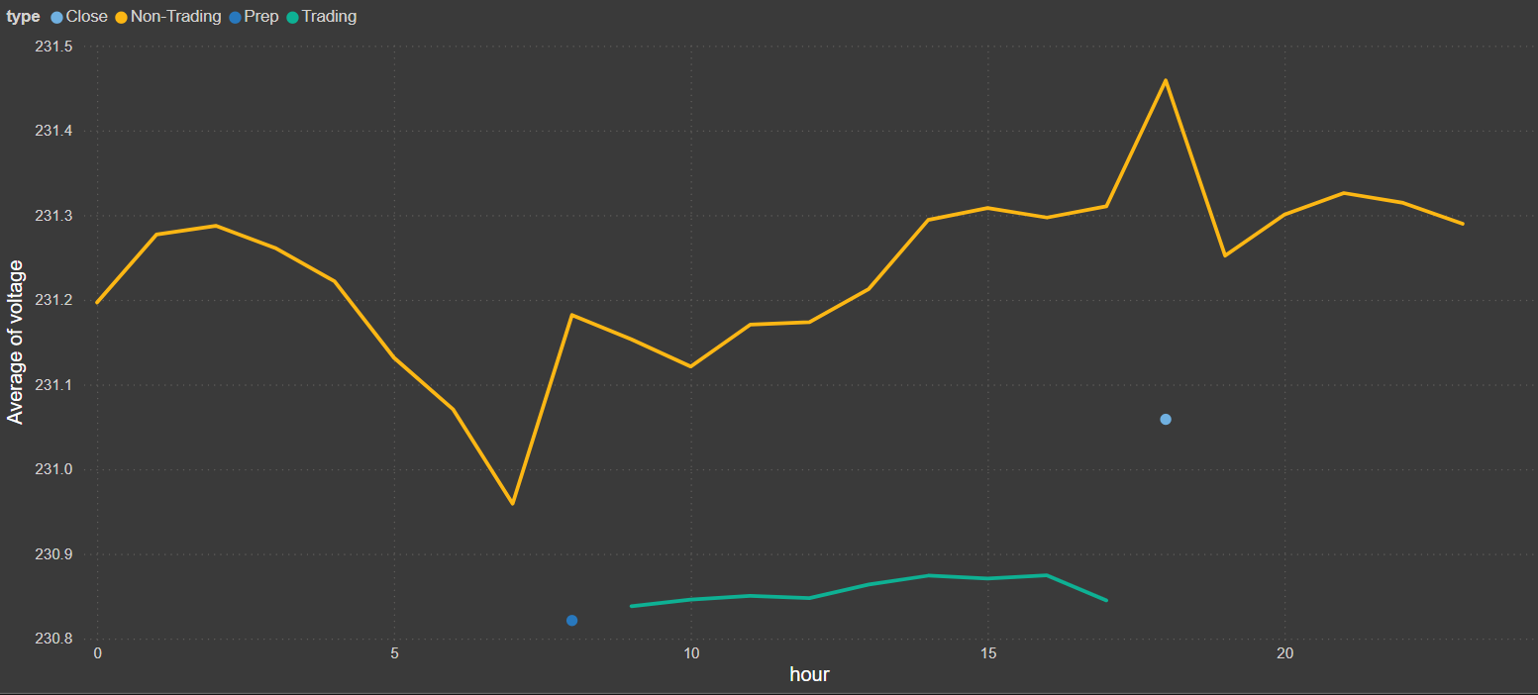
🔍 Insights:
- Non-Trading hours show a complete voltage curve: mild dip during early hours, gradual rise throughout the day, with a peak at 18:00 (231.45 V).
- Trading periods have consistently lower voltage (avg ~231.00 V) than non-trading, which might affect sensitive equipment.
- Difference between lowest and highest observed voltages is ~0.65 V, small but worth monitoring during critical hours.

---- Together, these insights indicate that:
- Energy Efficiency is Linked to Power Factor and Operation Type: Higher power factors are associated with significantly higher energy usage, especially during Trading and Prep hours. However, Non-Trading hours still consume moderate energy at lower power factors, indicating inefficiencies and potential for cost-saving through power factor correction.
- Voltage Stability Varies by Operational Period: Non-Trading hours experience relatively stable and slightly higher voltages, while Trading hours operate at consistently lower voltage levels (~231.00 V). This could affect performance or equipment longevity during peak operational periods.
- Opportunity for Operational Optimization: the insights highlight opportunities to optimize both power factor and voltage performance, particularly during Non-Trading and Trading periods, to reduce energy waste, improve power quality, and lower operational costs.
IV. Insights and recommendations for saving energy:
🔍 Insights:
- High Energy Consumption During Trading Hours
  - Devices like "Main 1", "DB6", and "DB3" are consistently consuming the highest amount of energy, particularly during Trading and Non-Trading hours.
  - Trading hours show significant spikes in total energy consumption, which aligns with peak operational activity.
- Prep and Non-Trading Hours Also Contribute Substantially
  - Surprisingly, Prep hours (likely pre-opening operational setups) also show high energy usage, particularly in HVAC and server-related equipment.
  - Non-Trading hours still consume energy, indicating that some systems may be left running unnecessarily.
- Power Factor vs Energy Consumption
  - Higher power factors correlate with higher energy consumption, especially during Trading and Prep hours.
  - This implies the equipment used is relatively efficient (less reactive power), but the load is high, suggesting a need for demand-side management.
- Voltage is More Stable During Non-Trading Hours
  - Voltage drops slightly during Trading hours, possibly due to load surge from high power equipment.
  - This could indicate power quality issues or excessive demand that may affect equipment longevity.

💡 Recommendations for Saving Energy:
1. Implement Load Scheduling and Equipment Zoning
- Stagger equipment startup during Prep and Trading hours to avoid load spikes.
- Automate shutdown of non-critical systems during Non-Trading hours (e.g., dishwashers, EV chargers, kitchen taps).
- Group devices by priority and usage to control them in tiers.
2. Audit and Upgrade High Consumption Devices
- Focus on Main 1, DB6, and DB3 systems—consider an energy audit for inefficiencies.
- If feasible, replace older HVAC, server room units, and riser panels with more energy-efficient models.
3. Optimize HVAC and Cooling Systems
- Roof condensers (21TP, 22TP, 23TP) contribute notable energy usage.
- Introduce smart thermostats and occupancy sensors to reduce usage when areas are unoccupied.
4. Enhance Power Factor Management
- Although power factors are good, consider installing capacitor banks or smart meters to further optimize performance and reduce energy bills tied to reactive power.
5. Voltage Stabilization and Power Quality Monitoring
- Monitor voltage drops during trading hours to prevent power quality issues.
- Voltage optimization equipment can help maintain steady voltage and reduce unnecessary consumption.
6. Introduce Awareness and Behaviour Change
- Educate staff on energy-saving practices, especially regarding unnecessary usage during Non-Trading hours.
- Conduct regular reviews and provide dashboards or alerts for unusual consumption patterns.
7. Use Real-Time Monitoring & Analytics
- Continue leveraging dashboards to track energy by device, time, and type.
- Implement alerts for abnormal energy use, helping with quick corrective actions.

>>>Recommendations Based on Electrical Hierarchy and Device Names:
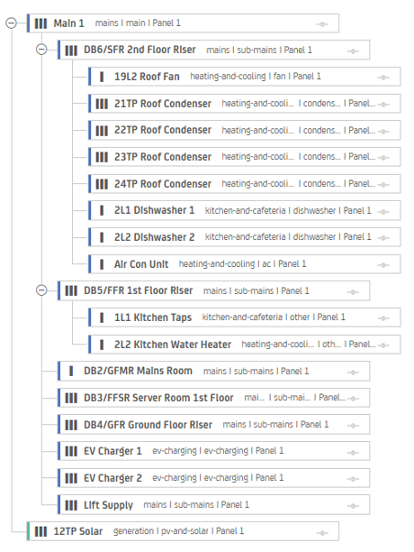
Key Components:
- DBx: Distribution Boards (like DB6, DB5) – intermediate panels.
- Devices: Final consumers like:
  - HVAC units (21TP Roof Condenser, Air Con Unit)
  - Kitchen equipment (Dishwasher, Kitchen Taps)
  - EV Chargers
  - Lift Supply
  - Solar generation (12TP Solar) is a generation source, feeding into the system.

Analysis:
1. Granular Tracking of Energy Use
- We can analyze energy consumption device-wise or panel-wise.
- Example: Compare how much energy is used by Kitchen Equipment (DB5) vs. Cooling Systems (DB6).
2. Identifying High-Consumption Areas
- Pinpoint which devices or panels are responsible for the most energy usage.
- E.g., If Roof Condensers consistently show high usage, it might be time to upgrade to energy-efficient models.
3. Energy Optimization
- Grouping by function (HVAC, kitchen, EV, etc.) helps tailor efficiency strategies.
  - HVAC might need timers or smart thermostats.
  - EV chargers could be scheduled during off-peak hours.
4. Solar Contribution Tracking
- The inclusion of 12TP Solar allows for analysis of how much load is offset by renewable sources.
- Supports sustainability metrics like CO2 reduction and cost savings.
5. Maintenance and Alerts
- Knowing the hierarchy allows for targeted alerts.
- If DB5 is overloaded, you know it impacts dishwashers and kitchen taps, which can affect operations.
6. Time-based Load Analysis
- Cross-reference with time series data (timestamped energy readings) to analyze:
  - Load patterns across days/hours
  - Load balancing needs across panels

