**1. Using a graph to illustrate slope and intercept, define basic linear regression.**

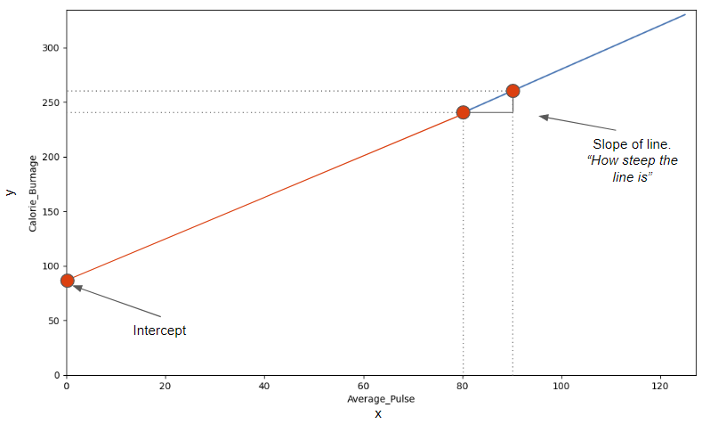

**2. In a graph, explain the terms rise, run, and slope.**

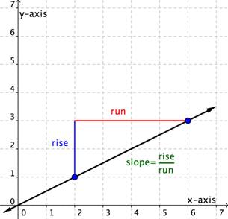

**3. Use a graph to demonstrate slope, linear positive slope, and linear negative slope, as well as the different conditions that contribute to the slope.**

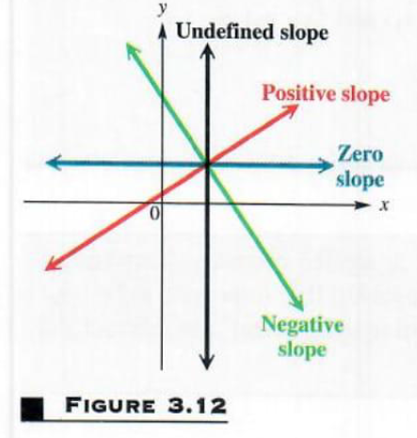

**4. Use a graph to demonstrate curve linear negative slope and curve linear positive slope.**

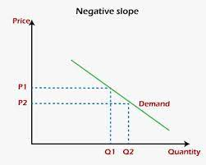 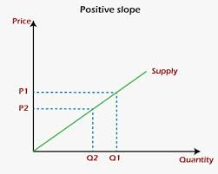

**5. Use a graph to show the maximum and low points of curves.**

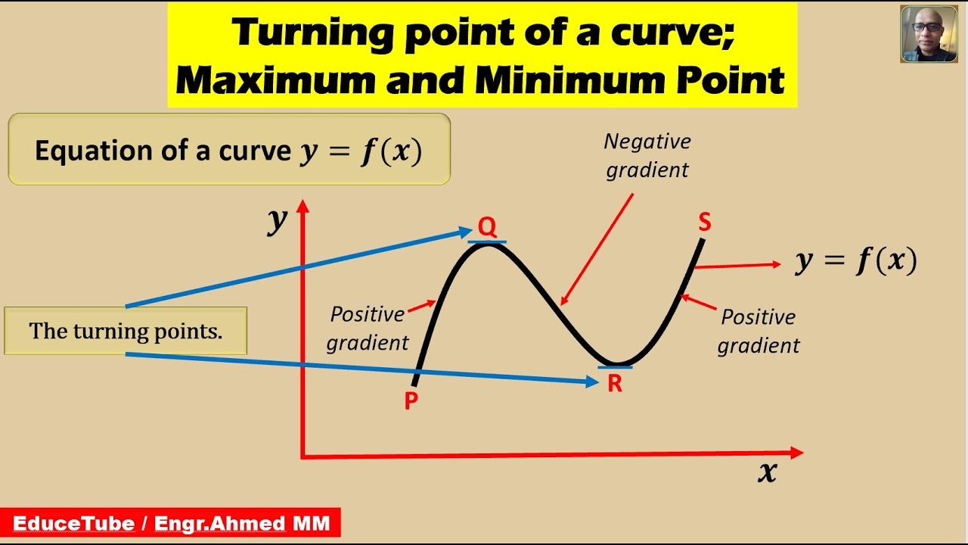

**6. Use the formulas for a and b to explain ordinary least squares.**

The equation of least square line is given by Y = a + bX. Normal equation for 'a': ∑Y = na + b∑X. Normal equation for 'b': ∑XY = a∑X + b∑X2.

**7. Provide a step-by-step explanation of the OLS algorithm.**

1. Set a difference between dependent variable and its estimation:
2. Square the difference:
3. Take summation for all data.
4. To get the parameters that make the sum of square difference become minimum, take partial derivative for each parameter and equate it with zero,

**8. What is the regression's standard error? To represent the same, make a graph.**The standard error of the regression is the average distance that the observed values fall from the regression line

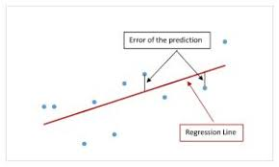

**9. Provide an example of multiple linear regression.**

* Price of a house

The price of a house can be predicted based on its square footage, number of bedrooms, and location.

* Student performance

A researcher can predict a student's performance based on their grades on past assignments, study hours, and attendance.

* Heart disease

A public health researcher can predict the likelihood of heart disease based on a person's age, weight, and cholesterol levels.

* Credit score

A bank can predict a person's credit score based on their income, debt, and payment history.

* CO2 emission

An environmental scientist can predict the amount of CO2 emitted by a car based on its engine size and number of cylinders.

* Stock price

A financial analyst can predict the price of a stock based on its past performance, industry trends, and economic conditions.

**10. Describe the regression analysis assumptions and the BLUE principle.**

The BLUE principle states that in a linear regression model, the estimators for the regression coefficients should be unbiased, have minimum variance, and be linear in the observations.

**11. Describe two major issues with regression analysis.**

Assumption Violation: Linear regression assumes that the relationship between the independent and dependent variables is linear, the errors are normally distributed, and the variance of the errors is constant. If these assumptions are violated, the results of the analysis may be unreliable.

**12. How can the linear regression model's accuracy be improved?**

There are several ways to increase the accuracy of a regression model, such as collecting more data, relevant feature selection, feature scaling, regularization, cross-validation, hyperparameter tuning, adjusting the learning rate, and ensemble methods like bagging, boosting, and stacking.

**13. Using an example, describe the polynomial regression model in detail.**

When accidents happen, such as epidemics, fires, or tsunamis, it is important for catastrophe management teams to predict the number of injured or passed away people so that they can manage resources. It may take days, if not months, to mitigate the consequences of such events, and the team must be prepared. Polynomial regression allows us to build [flexible machine learning models](https://link.springer.com/article/10.1007/s00530-021-00798-2) that report the potential death rate by analysing many dependent factors. For example, in COVID-19 pandemics, these factors can be whether the patient has any chronic diseases, how often they are exposed to being in large groups of people, whether they have access to protective equipment, etc.

**14. Provide a detailed explanation of logistic regression.**

Logistic regression is a data analysis technique that uses mathematics to find the relationships between two data factors. It then uses this relationship to predict the value of one of those factors based on the other. The prediction usually has a finite number of outcomes, like yes or no.

**15. What are the logistic regression assumptions?**

Basic assumptions that must be met for logistic regression include independence of errors, linearity in the logit for continuous variables, absence of multicollinearity, and lack of strongly influential outliers.

**16. Go through the details of maximum likelihood estimation.**

In statistics, maximum likelihood estimation (MLE) is a method of estimating the parameters of an assumed probability distribution, given some observed data. This is achieved by maximizing a likelihood function so that, under the assumed statistical model, the observed data is most probable.