PEN: 180840131010

PRACTICAL: 1.2

Topic:- Sports Manager

AIM: Study of various Problem domains and Identify Problem definition:

Describe SDLC model used your project

In our project, “Sports Manager” we have used the agile method as agile method simplifies the task by breaking the tasks into smaller iterations and it is also a quick method. The process of agile model is described below.

The meaning of Agile is swift or versatile. "Agile process model" refers to

- software development approach based on iterative development. Agile methods break tasks into smaller iterations, or parts do not directly involve long term planning. The project scope and requirements are laid down at the beginning of the development process. Plans regarding the number of iterations, the duration and the scope of each iteration are clearly defined in advance.

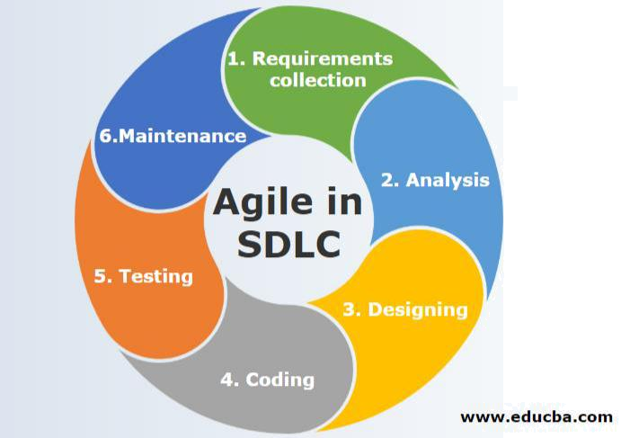

Each iteration is considered as a short time "frame" in the Agile process model, which typically lasts from one to four weeks. The division of the entire project into smaller parts helps to minimize the project risk and to reduce the overall project delivery time requirements.

2

PEN: 180840131010

Advantages:

- Customer satisfaction is rapid, continuous development and delivery of useful software.

- Product is developed fast and frequently delivered (weeks rather than months.)

- It continuously gave attention to technical excellence and good design.

- Daily and close cooperation between business people and developers.

- Regular adaptation to changing circumstances.

- Even late changes in requirements are welcomed.

Disadvantages:

- It is not useful for small development projects.

- There is a lack of intensity on necessary designing and documentation.

- It requires an expert project member to take crucial decisions in the meeting.

- Cost of Agile development methodology is slightly more as compared to other development methodology.

- The project can quickly go out off track if the project manager is not clear about requirements and what outcome he/she wants

3

