PEN: 180840131036

Practical 3.2

Aim: To perform function oriented diagram for the system : Prepare ER diagram

Program :

ER Diagram of Sports Manager

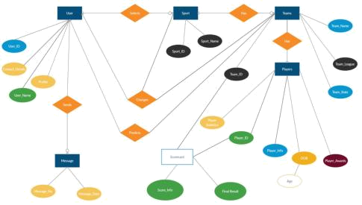

Here there are 6 entities and 6 relations:

User contains 4 attributes:

User_ID, Contact_Details, User_Name and Profile.

Here, In the User entity the key attribute is User_ID. This entity is there to help the user to operate this web application. User entity has a relation(sends) with message entity which has 2 attributes of its own Message_No and Message_Date

- relation(selects) with Sport entity which has 2 attributes Sport_ID and Sport_Name.

Sport entity is further connected to teams entity which has 4 attributes :

Team_Id, Team_Name, Team_League and Team_States.

33

PEN: 180840131036

Players entity which is solely related to Teams entity has 5 main attributes:

Player_Statistics, Player_Id, Player_Info, Player_Awards, DOB (which has a derived attribute : age).

User has a change relation with Sport and Teams which means User has the authority to change a Sport and/or Team whenever he/she wishes. Scorecard entity has 2 main attributes Score_Info and Final_Result and has 2 foreign attributes Team_Id and Player_Id.

34

