PEN NO: 180840131036

Practical – 3.1

Aim : To perform function-oriented diagram for the system : Prepare Data Flow Diagram

Program :

Sport Manager Web App Data Flow Diagram

A data flow diagram (DFD) maps out the flow of information for any process or system. It uses defined symbols like rectangles, circles and arrows, plus short text labels, to

show data inputs, outputs, storage points and the routes between each destination.

0th level DFD :

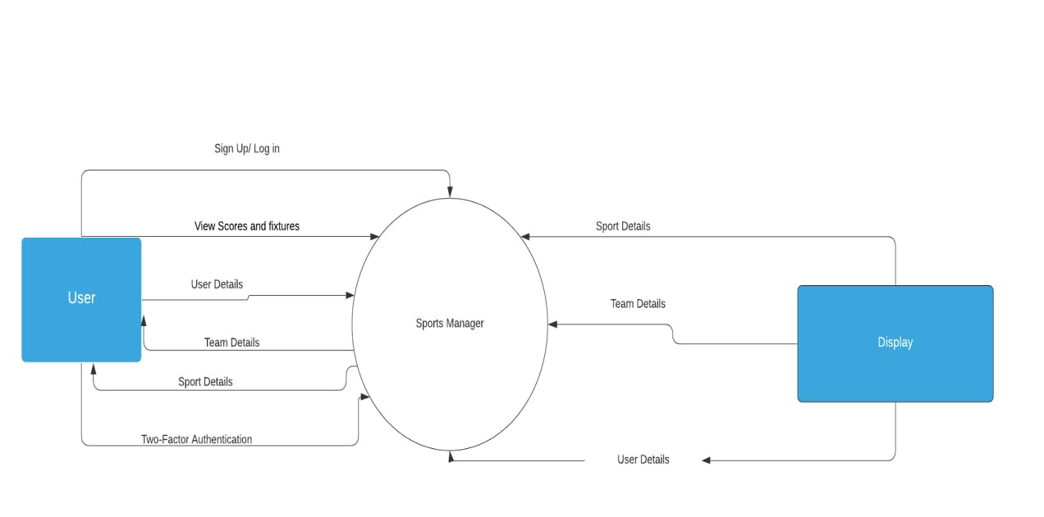

Sports Manager is connected to two entity User and Display. User can Sign Up/Log In, Update his/her details, View Scores and Results in the Sports Manager Web App.

Display entity helps in displaying the requested details such as Sport, Team or User details.

1

PEN NO: 180840131036

1st level DFD :

There are 10 key processes in Sports Manager Web App. Display is used to showcase the information related to team , player or user or for viewing Results and other things as well.

After the User has signed up in the app for the first time, He/she chooses the Sport and Team which they want to follow. After selecting them, User also has the ability to change them at the later time as well.

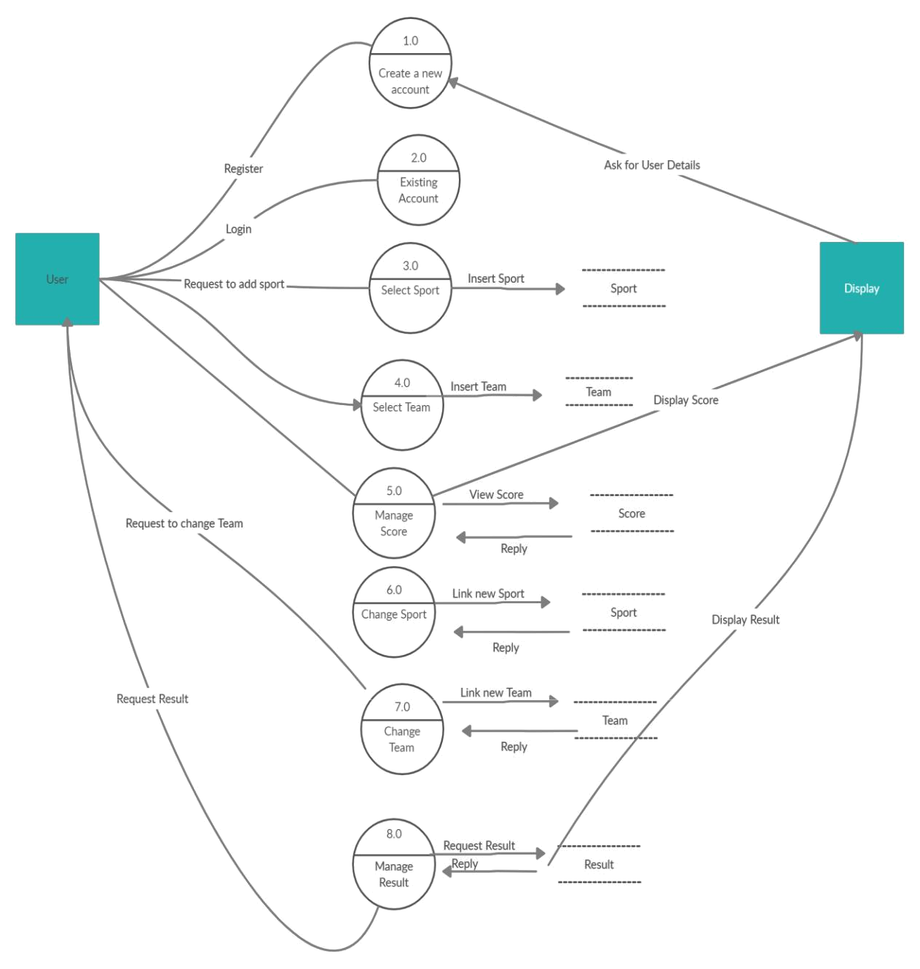

2

PEN NO: 180840131036

2nd level DFD :

In the 2nd level of the Data Flow Diagram, We have mainly focused on Managing all kinds of Information as Sports Manager’s main purpose is to manage information about various sports.

There are two processes. The User has to login into his account. After a successful login, The User can see information regarding various Sports, Teams and Users. The display would showcase the information the user requested for.

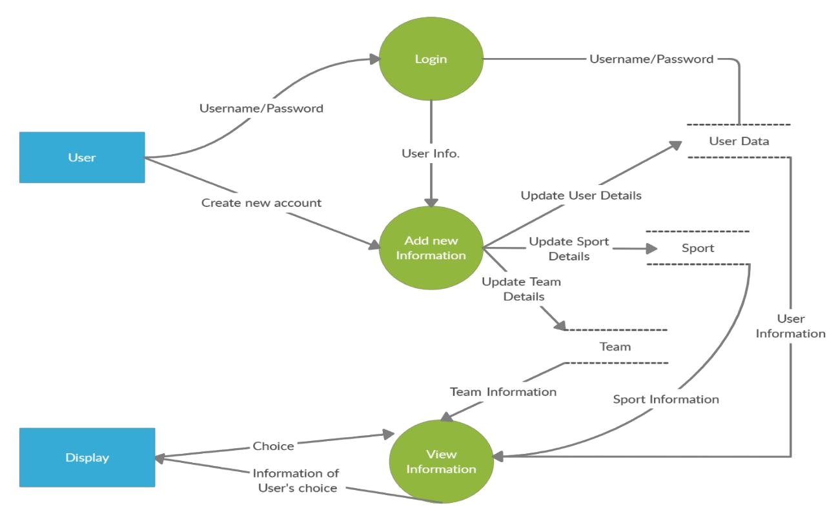

3

