**Project Report**

**On**

### ACCIDENT EMERGENCY INTELLIGENCE

# *Submitted By*

# DARSHIT A. DOBARIYA (170160116022)

# DEEP M. PANSERIYA (170160116055)

**Guided By:**

Prof. Sameer chauhan



#### OCTOBER-2020

**Submitted To,**

Department of Computer Engineering & Information Technology

Government Engineering College, Modasa

**CERTIFICATE**

**“**

**“**

**Internal Guide Head of Department**

**Date: Date:**

**Certificate of Company (if applicable)**

**ACKNOWLEDGEMENT**

We would like to take the opportunity to express our sincere thanks to our guide Prof. Sameer chauhan for their invaluable support and guidance throughout our project research work. Without their kind guidance and support this was not possible.

We are grateful to them for their timely feedback which helped us track and schedule the process effectively.

Their time, ideas and encouragement that they gave has helped us to complete our project efficiently.

We would also like to thank Prof. M.B Chaudhari Head of Department for his encouragement and for providing an outstanding academic environment, also for providing the adequate facilities.

We are thankful to all our teachers for providing advice and valuable guidance.

We also extend our sincere thanks to all the faculty members and the non-teaching staff.

**Date: Student’s Name:-**

# DARSHIT A. DOBARIYA

**DEEP M. PANSERIYA**

# ABSTRACT

Our project is about the device which provides the service for the vehicles (except 2 wheelers)

Nowadays we can hear many news about accidents happen on daily basis, so thinking of that we have decided to select this project which could help us in upcoming future

The main work of our project is to make a device which will be added into the vehicles and will work as software.

In some cases accidents happen at the places where victims can’t ask for help or are unconscious..

Our device will manage to call an ambulance to provide the information of vehicle and the location where the accident has happened.

By the help of our device there are much increased chances of victims to survive in the accidents if no one is there for help.

It will decrease the number of the cases where people die in this type of situations because lack of help.

.

CONTENTS

Page No.

CERTIFICATE (ii)

ACKNOWLEDGEMENT (v)

ABSTRACT (vi)

**CHAPTER 1: INTRODUCTION……………………………………………………...**

* 1. BACKGROUND INTRODUCTION

1.2 MOTIVATION

1.2.1 CURRENT SYSTEMS

1.3 THE PROBLEM WITH CURRENT SYSTEM

**CHAPTER 2: PROBLEM STATEMENT…………………………………………..**

**CHPATER 3: PROJECT DEFINITION……………………………………………**

3.1PROJECT DEFINITION

3.2 FUNCTIONS OF THE SYSTEM…………….

3.2.1 FLOW CHART …………………………

3.2.2 USE CASE DIAGRAM…………………

3.3 DATA MODELING……………………………

3.3.1 ACTIVITY DIAGRAM………………

3.3.2 CLASS DIAGRAM…………………..

3.3.3 E-R DIAGRAM……………………..

3.3.4 SEQUENCE DIAGRAM…………….

3.4 FUNCTIONAL MODELING…………………

3.4.1 DATA FLOW DIAGRAM…………..

**APPENDIX…..…………………………………………………………………………**

# List of Figures

Fig. 1 GPS

Fig. 2.1 Waterfall Model

Fig. 2.5 Flow Chart

Fig. 2.6 Use Case Diagram

Fig. 2.7 Activity Diagram

Fig. 2.8 Class Diagram

Fig. 2.9 E-R Diagram

Fig. 2.10 Sequence Diagram

**CHAPTER-1**

**INTRODUCTION**

.

* 1. **BACKGROUND INTRODUCTION**

In a current situation we can hear many news about accidents happen on daily basis and in most of cases the victim of the accident dies because of not getting any emergency help. So, why not shift to an automated accident emergency intelligence system which works as a software in vehicles. It can save so many lives by helping the people in this type of incidents.

* 1. **MOTIVATION**

The main motivation for us to go for this project was the news once we heard; it was about the incident when a man died in a car accident because he did not get any help on time.

Hues in this type of situations.

* + 1. **Current Systems**

Accident Occurred

Report Accident by person and call ambulance

Arrival ambulance

Initial access

**1.3 The Problems with Current System**

* In old accident system when accident happened person call ambulance for help itself if accident is not critical but sometimes some critical situation in accident some other person call ambulance or sometimes person not able to help for medical emergency.
* So, in this case person goes to critical situation or also dies.
* In old accident system lots of golden hour goes when accident happen.

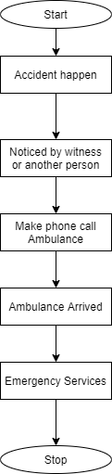

* **Proposed accident system**
* In proposed system when accident detected by sensor with help of API automatically call ambulance to accident spot.
* So, in this situation no need another person whose call ambulance.
* In our proposed system no other time waste.
* So, in cases chance to save person life.

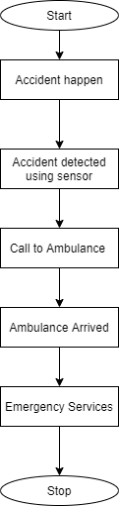

**CHAPTER-2**

**PROBLEM STATEMENT**

To overcome the problems in existing accident emergency system we shall develop a IOT based intelligent calling system over simple system. Interactive system over static one. There are many solutions to automate alert system like GSM message based system; uploading data on cloud but all these systems have limitations over work and security point of view. Our proposed system shall be a “Automate Intelligence IOT System” which uses the basic idea of generating the automatic calls by system.

**2.0- Proposed System Components**

* Twilio
* GPS tracker
* Shock sensor
* Raspberry Pi
* LCD Display

**2.0.1 Twilio**

We generate system calls & message with help of twilio. Twilio code writes in python file. Twilio is library which is available in python. In our project twilio used for system call generate.



**2.0.2 GPS**

A **GPS tracking** system **uses** the Global Navigation Satellite System (GNSS) network. This network incorporates a range of satellites that **use** microwave signals that are transmitted to **GPS** devices to give information on location, vehicle speed, time and direction.

In our project GPS used when accident occurs vehicle location share to ambulance driver which will be help to reach to accident spot. GPS main used vehicle tracking.

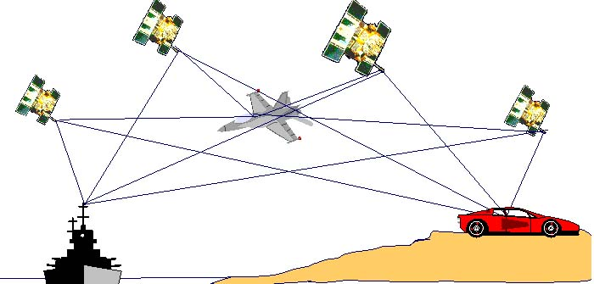

Figure 1 GPS

**2.0.3 Shock Sensor**

A **shock sensor works** by detecting the shockwaves that are associated with a window or a door being broken. When a large **shock** wave is detected, the **shock sensor** will activate. ... The force behind a powerful **shock** wave can be detected by a **shock sensor** and cause it to activate. The sensor detect accident in shock sensor. This single stage shock sensor, it Detect any hard impact acted on it.

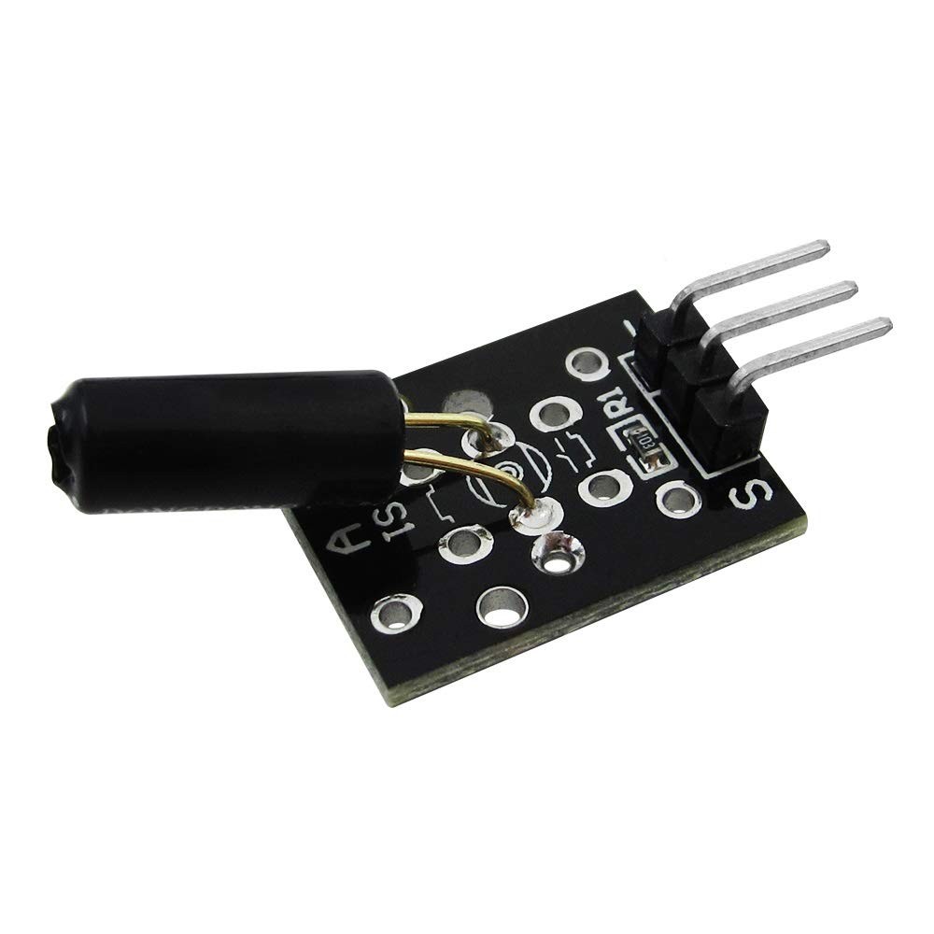

Figure 2 SHOCK SENSOR

**2.0.4 Raspberry Pi**

A  Raspberry pi it is main component of our project.

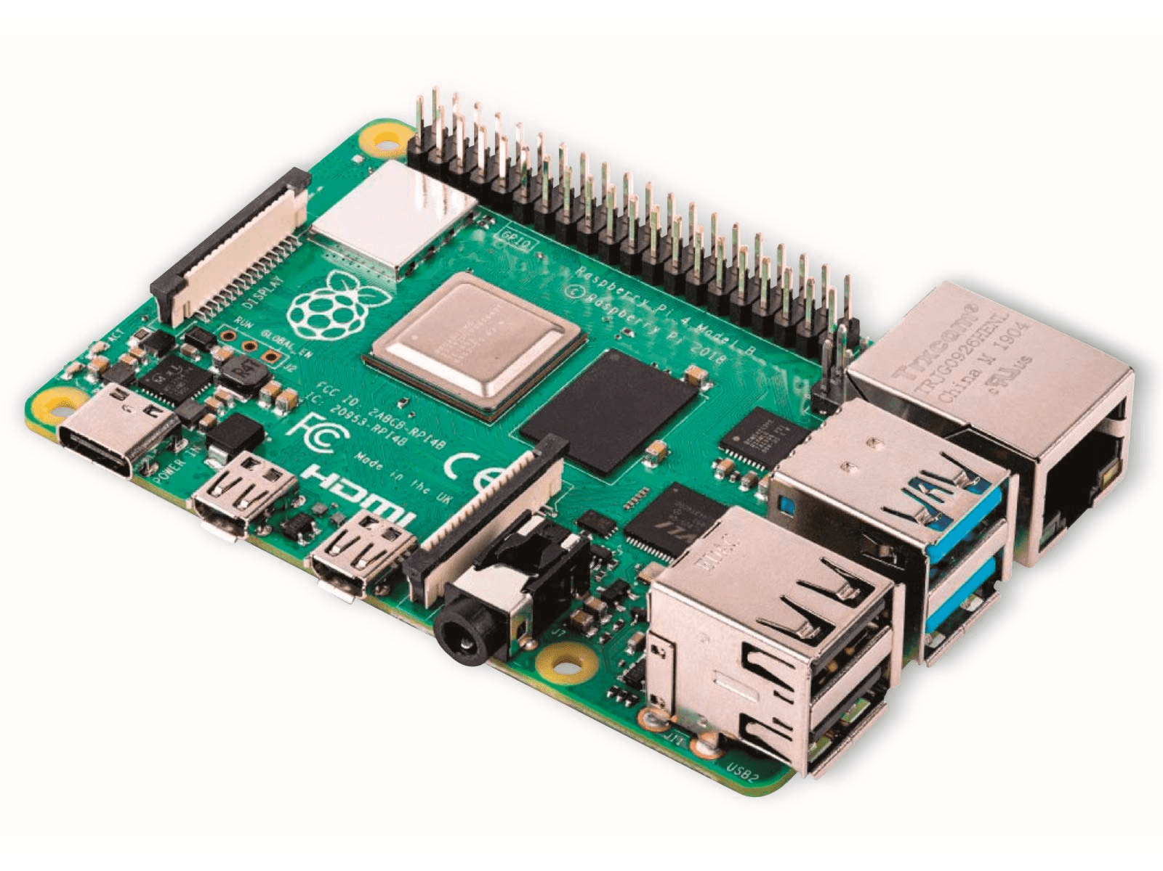

# Figure 3 Raspberry Pi

# 2.0.4 Shock sensor integration

It is integrated in the circuit system by connecting all the sensors to or gate whose output is connected to the int pin of microcontroller. These sensors are connected in such a way that they detect force impact occurring from any side of the car. This is concerned to the safety of the system of the human driving the car so that once accident is detected the paramedics can reach to the location as soon as they can.

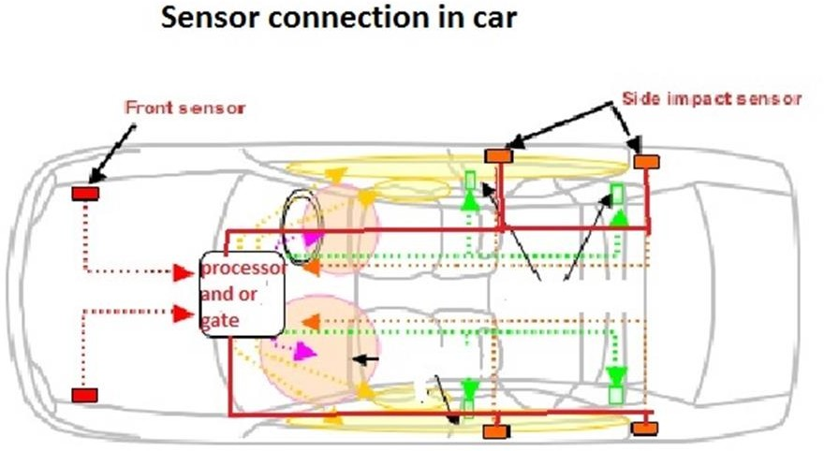

Figure 4 Shock sensors position on vehicle

## Software Model - Waterfall Model

Waterfall Model is a sequential approach, where each fundamental activity of a process represented as a separate phase, arranged in linear order.

In the waterfall model, you must plan and schedule all of the activities before starting, working on them (plan-driven process).

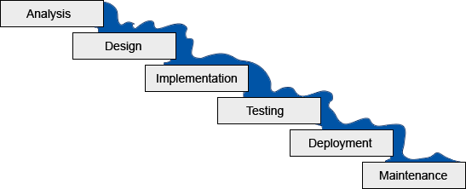

Figure 5 Waterfall Model

**CHAPTER-3**

**PROJECT DEFINITION**

**3.1 Project Definition:-**

* Accident emergency intelligence is a system which detects the accident with the help of raspberry pi and twillo API and generates calls whenever accidents happen.

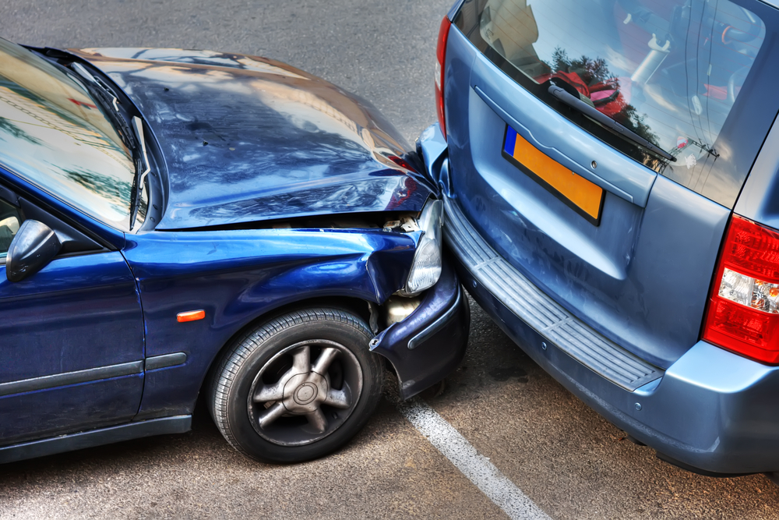

## 3.1.1 Project Scope

* Provides an automated emergency calling system that is practical, reliable and eliminate disturbance and time loss of traditional present systems.

**3.2 Functions of the System:-**

**3.2.1 Flow Chart**

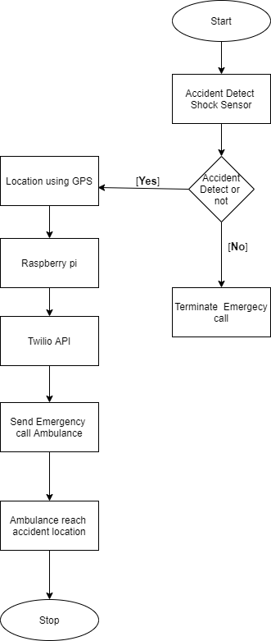

Figure 1. Flow Chart

**3.2.2 Use Case Diagram:-**

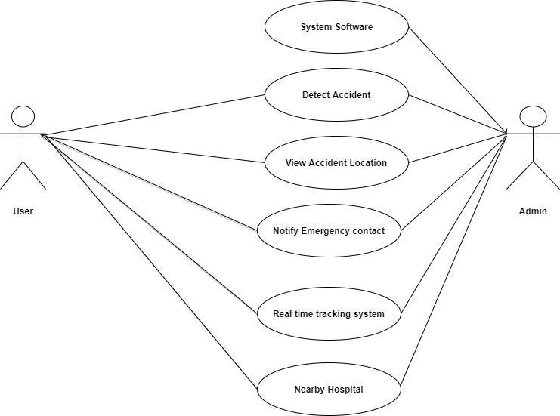

Figure 2 . Use Case Diagram

**3.3.1 Activity Diagram**

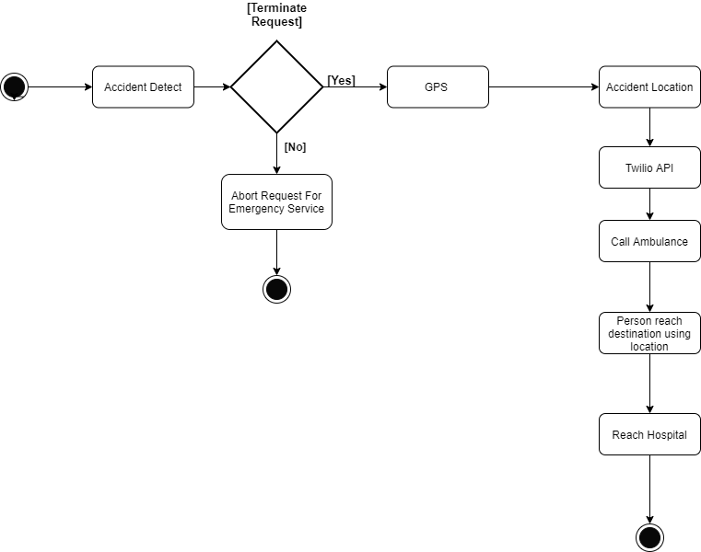

Figure 3. Activity Diagram

**3.3.2 Class Diagram:-**

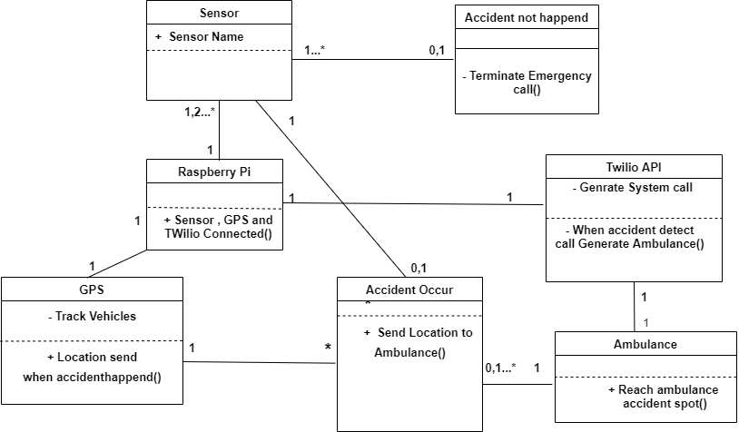

Figure 4. Class Diagram

**3.3.3 Sequence Diagram:-**

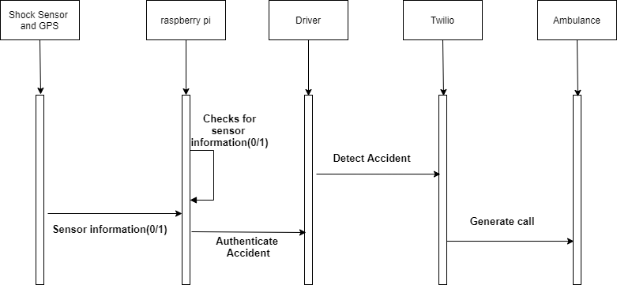

Figure 5. Sequence diagram

**3.3.4 ER Diagram:-**

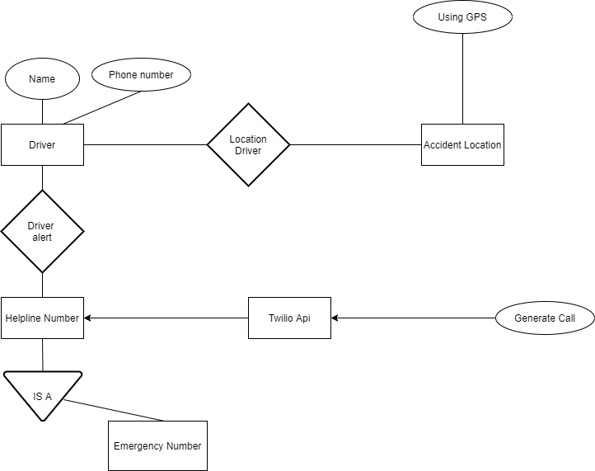

Figure 6. ER Diagram

**Working of the device**

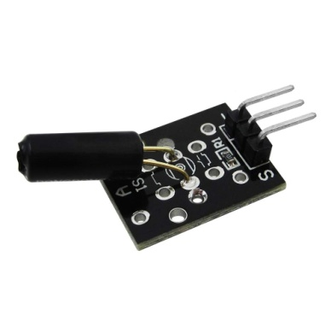  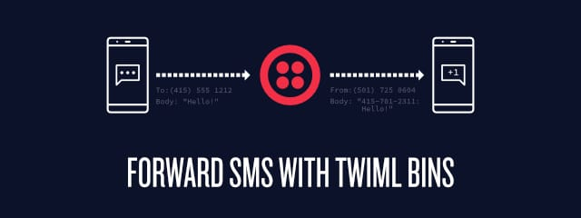

**(3). Shock Sensor use**

**Detect accident. (4). Twilo API use**

**Call Ambulance and**

**Share Live Location**

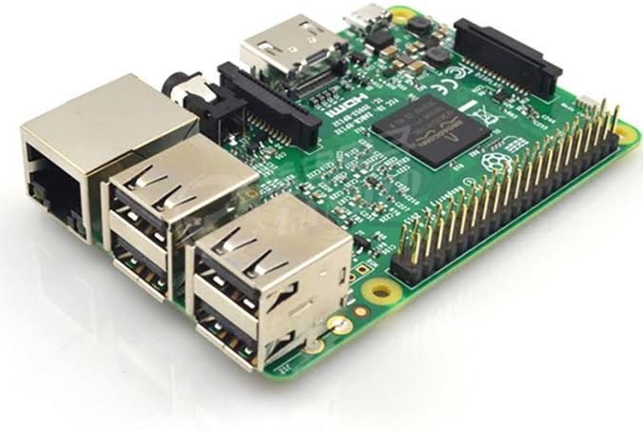

**(2). Raspberry Pi**

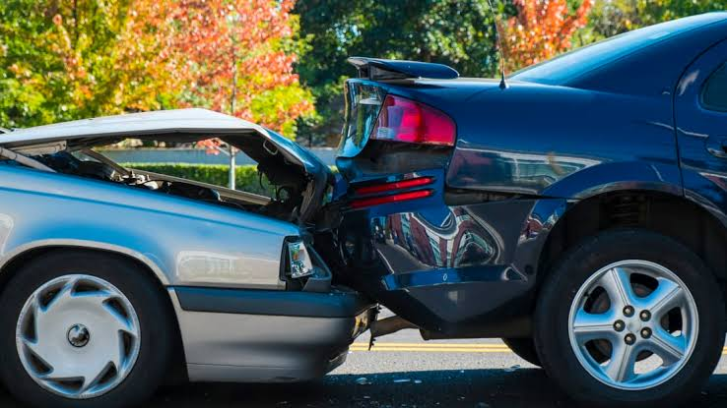 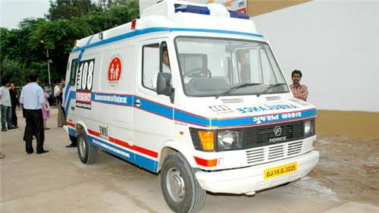

**(1). Accident happen between cars (5). Ambulance**

* Sensor will detect the accident and will send the command to the device.
* After getting command from the sensor device will ask the driver a particular question that ”

ARE YOU OKAY?”

* After asking 3 times if there is no response from the driver, the following program will contact the

twilio api and will share the GPS data.

* After getting the data twilio api will call the ambulance in nearest area to share the live location

through system generated voice call.

* It will also send the message to registered mobile number and will send the location co-ordinates.

**Operation: 1. Accident happened**

1. **Project setup :**

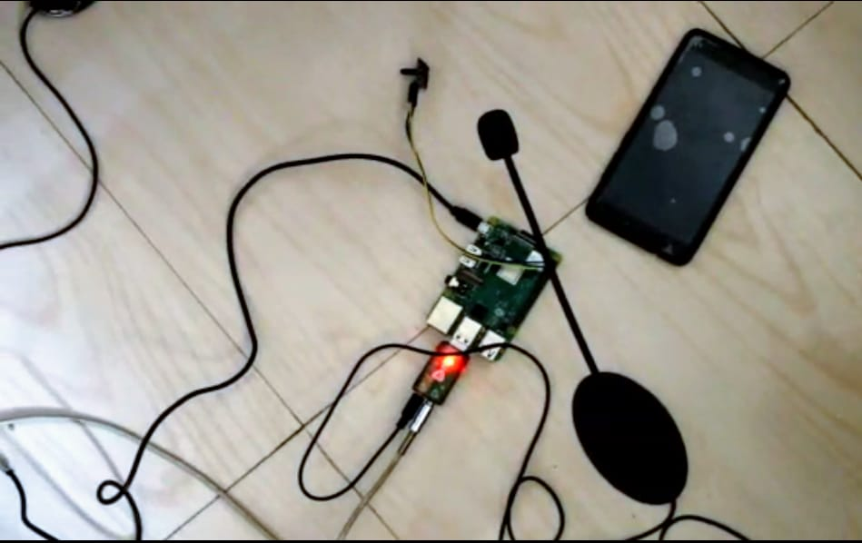

**Fig: Project Setup**

* In fig shows raspberry pi connected with shock sensor and twillio api.

1. **Accident occurred.**

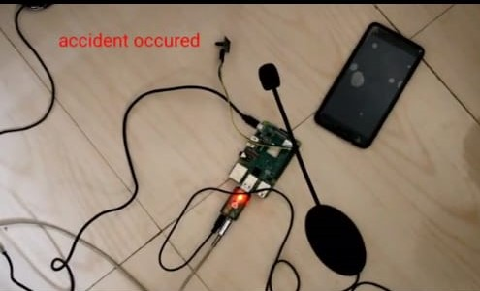

**Fig: Accident Occurred**

* Now, the shock sensor detect accident

1. **Call the ambulance**

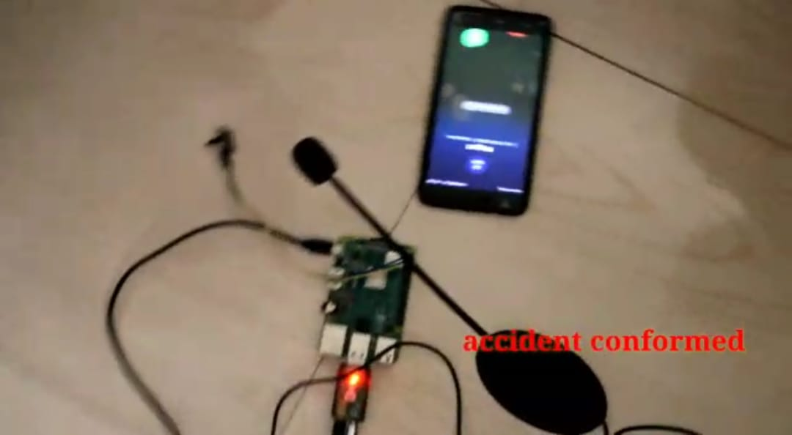

**Fig: Call the Ambulance**

* Our device ask the person ‘Are you Okay’ at 3 times , accident situation

Person cannot give answer call the ambulance.

* This call will be generated by Twilio API.
* With help of IP-address spot the location

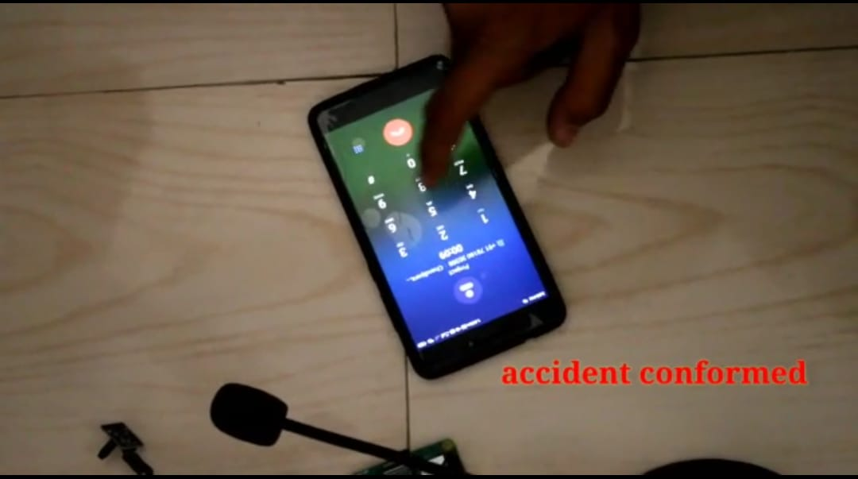

**Operation: 2. Accident happened but user say I am safe**



* Our device ask the person ‘Are you Okay’ at 3 times , user say ‘I am Okay’

then don’t call the ambulance.

**ADVANTAGES:**

* By the help of our device there are much increased chances of victims to survive in the accidents if no one is there for help.
* It will decrease the number of the cases where people die in this type of situations because lack of help.

**DISADVANTAGES:**

* Device can be broken and could not work in some situations where the vehicle is highly damaged by the accident.

**CONCLUSION**

* The main work of our project is to make a device which will be added into the vehicles

and will work as a software.

* In some cases accidents happen at the places where victims can’t ask for help or

are unconscious.

* Our device will manage to call an ambulance to provide the information of vehicle and

the location where the accident has happened.

**APPENDIX**

**The project report also include below information (as an appendix to project report), submitted/generated via project management site: http://projects.gtu.ac.in/**

1. Copy of four Periodic Progress Reports (PPR) as submitted by each student, along with guide comment
2. On it– For both semesters.

2. Patent Search & Analysis Report (PSAR) as submitted by each student, along with guide comment on it– For semester 7 ONLY

3.Design Engineering canvases: AEIOU Summary, Empathy Summary, Ideation, Product Development and its report generated in line with the existing project.– For semester 7 ONLY ·

4. Business Model Canvas (BMC) and its report generated in line with the existing project. – For semester 8 ONLY ·

5. Copy of Project Review Card