

Mobile Commerce MSE265D4

**Experiential Learning Report On**

**“API Web App Suite: A Multi-Functional API-Driven Web Application for Everyday Utility”**

Submitted by

**DARSHITH V 1RV23SSE10**

**Department of Information Science and Engineering**

**M.Tech in Software Engineering 2024-25**

# TABLE OF CONTENTS

|  |  |  |
| --- | --- | --- |
| **SI No.** | **Chapters** | **Page No.** |
| 1. | Introduction | 1-2 |
| 2. | Design and Implementation | 3-6 |
| 3. | Conclusion | 7 |
| 4. | References | 8 |

**CHAPTER 1**

# INTRODUCTION

* 1. **Background and Motivation**

The rapid advancement of web technologies has led to the development of applications that integrate real-time data from various APIs to simplify everyday tasks. However, users often struggle to find a single platform that consolidates multiple utilities such as currency conversion, weather forecasting, sentiment analysis, stock price tracking, unit conversion, and expense management. Manually navigating through different websites or apps can be time-consuming and inefficient.

To address these challenges, this project introduces the API Web App Suite, a multi-functional API-driven web application designed to provide users with a seamless and consolidated experience for performing diverse utility tasks. The system leverages external APIs and JavaScript-based logic to deliver accurate and actionable results. The primary objectives of this project are to:

* Provide Multi-Functionality: Offer a single platform for performing tasks like currency conversion, weather forecasting, sentiment analysis, stock price tracking, unit conversion, and expense management.
* Enhance User Convenience: Simplify the user experience by reducing the need to switch between multiple apps or websites.
* Ensure Real-Time Data Integration: Use real-time data from APIs to ensure accuracy and relevance.
* Deliver an Interactive Interface: Provide a clean and intuitive UI for seamless interaction and visualization of results.

By leveraging modern web technologies and integrating APIs, the project enhances user productivity by offering quick, accurate, and actionable outputs.

* 1. **Overview of *APIs in Web Applications***

APIs (Application Programming Interfaces) play a pivotal role in modern web applications by enabling the integration of third-party services and real-time data. In this project, we utilize APIs to perform various tasks, including:

* Currency Conversion: Fetching real-time exchange rates using the ExchangeRate-API.
* Weather Forecasting: Retrieving weather data using OpenWeatherMap API.
* Sentiment Analysis: Analyzing text sentiment using a sentiment analysis API.
* Stock Price Tracking: Fetching stock prices using a stock market API.
* Unit Conversion: Implementing custom logic for unit conversions.
* Expense Management: Storing and displaying user expenses locally for personal tracking.

Key strategies implemented in this project include:

* Data Integration: Extracting meaningful data from APIs and processing it to provide relevant results.
* Error Handling: Ensuring robust error handling for invalid inputs and API failures.
* Dynamic Updates: Using JavaScript to dynamically update the UI based on user interactions.
* Modular Design: Building independent modules for each functionality to ensure scalability and maintainability.
  1. **Project Objectives**

The API Web App Suite is developed with the following objectives in mind:

1. Multi-Functionality
   * Integrate diverse utilities into a single platform for enhanced convenience.
   * Ensure accurate and reliable results for each module.
2. Enhancing User Experience
   * Develop an intuitive web interface using HTML, CSS, and JavaScript.
   * Allow users to interact seamlessly with the app through simple input fields and buttons.
3. Ensuring Scalability
   * Design a modular system capable of adding new functionalities in the future.
   * Enable seamless integration with additional APIs for expanded capabilities.

**CHAPTER 2**

# DESIGN AND IMPLEMENTATION

The API Web App Suite is built using a modular architecture that integrates API calls, data processing, and interactive UI components. The application consists of a frontend interface and backend logic, working together to provide a seamless user experience.

The frontend is developed using HTML, CSS, and JavaScript. It offers a clean and intuitive interface where users can select a specific utility (e.g., Currency Converter, Weather Forecaster) and view results dynamically. Key features of the frontend include:

* A menu with buttons to load different app modules.
* Input fields and buttons for user interaction.
* Dynamic result display using JavaScript DOM manipulation.

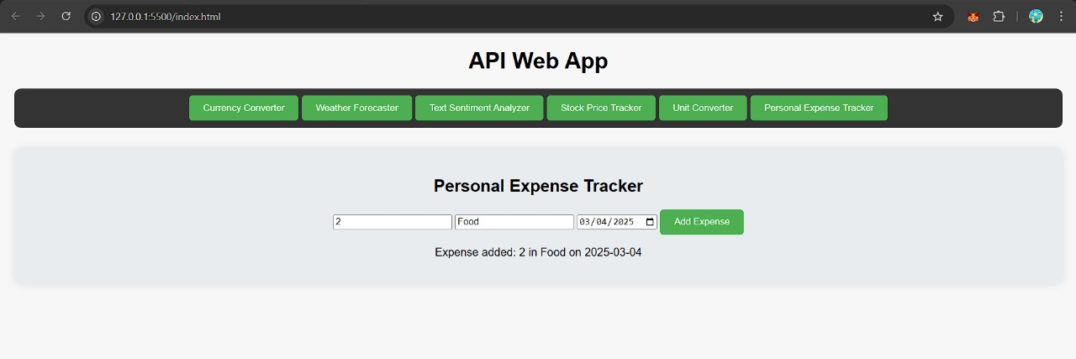

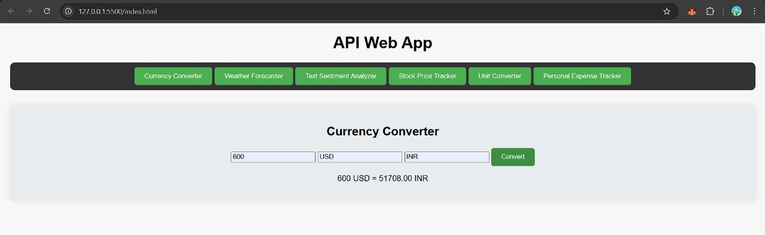

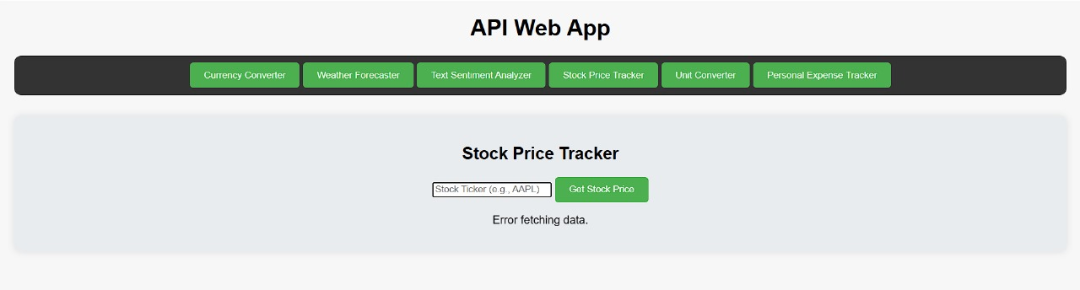

**Fig 1 :**

The backend processes user inputs and interacts with APIs to generate results. Key steps include:

* Data Preprocessing: Validating user inputs and preparing them for API requests.
* API Integration: Making HTTP requests to external APIs and handling responses.
* Error Handling: Displaying appropriate error messages for invalid inputs or API failures.
* Dynamic Updates: Updating the UI in real-time based on API responses.

**Modules Overview**

1. Currency Converter: Converts amounts between different currencies using real-time exchange rates.
2. Weather Forecaster: Displays weather conditions and temperature for a given city.
3. Text Sentiment Analyzer: Analyzes the sentiment of user-provided text and displays confidence levels.
4. Stock Price Tracker: Fetches the latest stock price and trend for a given ticker symbol.
5. Unit Converter: Converts values between different units (e.g., kilometers to miles).
6. Personal Expense Tracker: Allows users to add and track their expenses.

**CHAPTER 4**

# CONCLUSION

The API Web App Suite successfully demonstrates the potential of integrating APIs into a single platform to enhance user productivity. By combining diverse utilities such as currency conversion, weather forecasting, sentiment analysis, stock price tracking, unit conversion, and expense management, the system provides a comprehensive and user-friendly solution.

Key achievements of the project include:

* Developing a clean and intuitive interface for seamless interaction.
* Leveraging APIs to deliver accurate and real-time results.
* Implementing robust error handling and dynamic updates.

Future enhancements could further expand the system's capabilities, including:

* Adding more utility modules (e.g., translation, geolocation).
* Integrating advanced analytics and visualization tools.
* Deploying the application on a live server for broader accessibility.

This project highlights the transformative potential of API integration in web applications, paving the way for smarter and more versatile utility platforms.

**REFERENCES**

[1] N. Patni, "Architecting web applications for the future: API-driven development vs web frameworks," *NP Group Blog*, Oct. 15, 2018.

[2] S. Smith, "Architecture - Stand-alone web application vs API-driven application," *Stack Overflow*, Jan. 11, 2016.

[3] Microsoft Corporation, "ASP.NET Web APIs | REST APIs with .NET and C#," *dotnet.microsoft.com*, Aug. 17, 2023.

[4] J. Doe and K. Lee, "The differences between API and web service," *SiliconExpert Blog*, Nov. 29, 2022.

[5] A. Kumar, "16 great web APIs to use in web development," *Educative.io*, May 28, 2024.

[6] Mozilla Developer Network, "Web APIs," *MDN Web Docs*, Feb. 18, 2023.

[7] X. Zhang, Y. Liu, and Z. Chen, "Data-driven web APIs recommendation for building web applications," *IEEE Trans. Services Comput.*, vol. 15, no. 4, pp. 1987-1999, Jul.-Aug. 2022.

[8] J. Ofoegbu, "How to use web APIs in your coding projects," *freeCodeCamp*, Aug. 8, 2023.

[9] R. Sharma, "What is Web API?" *TutorialsTeacher*, May 30, 2020.

[10] P. Jones, "Building modern web apps with API-driven development," *Brainvire Blog*, Feb. 23, 2024.