**A**  
**Project Report**  
**On**  
**"SMART NAVIGATION SYSTEM USING PYTHON"**

**Prepared by**  
Dev Faldu (22AIML011)

Darshit Kachhadiya(22AIML016)

**Under the guidance of**  
Prof. [Spoorthy V]

A Report Submitted to  
Charotar University of Science and Technology  
for Partial Fulfillment of the Requirements for the  
Degree of Bachelor of Technology  
in Information Technology  
(5th Semester Project II – AIML305)

**Submitted at**  


**DEPARTMENT OF ARTIFICIAL INTELLIGENCE AND**

**MACHINE LEARNING**  
Chandubhai S. Patel Institute of Technology  
At: Changa, Dist: Anand – 388421  
October 2024

Contents

Abstract 2

Introduction 2

Background/Literature Survey 2

Methodology 3

Results and Discussion 4

Conclusion 4

References 5

# Abstract

This report presents a project that visualizes a college campus using interactive mapping tools. The project leverages Python’s Folium library to generate maps and GeoJSON data to represent various campus locations such as the basketball court, lake, and grounds. The interactive interface is enhanced Interactive with ipywidgets, allowing dynamic selection of markers. The tool is intended for students and visitors to explore campus facilities conveniently and is designed to be extensible with additional locations and features.

# Introduction

Modern mapping technologies have transformed how geographic data is visualized and interacted with. Folium, a powerful Python library, enables users to generate interactive maps that integrate geographic data with an intuitive interface. This project demonstrates the creation of an interactive map of a college campus, leveraging GeoJSON data to visualize key locations and landmarks. The project’s goal is to provide a useful tool for students, staff, and visitors, offering an interactive method to explore campus facilities.

# Background/Literature Survey

Mapping technologies have evolved with advancements in geographic information systems (GIS) and web-based mapping services. Tools like Folium and Leaflet.js, which Folium is based on, have democratized access to high-quality map visualizations. Folium allows seamless integration with Python, making it ideal for data scientists and developers working with geographic data.

GeoJSON, a format for encoding geographic data structures, plays a crucial role in representing the geometry of real-world objects like buildings, roads, and lakes. Numerous studies have shown the benefits of using interactive maps in educational and institutional contexts, improving spatial understanding and user engagement. This project builds on this foundation by implementing a highly interactive map for a college campus.

# Methodology

1.Google Drive Integration: The project begins by accessing necessary GeoJSON files stored in Google Drive. Using the `drive.mount()` function from Google Colab, files containing geographical data of campus landmarks are retrieved.  
  
2. Folium Map Creation: A base map is created using Folium centered at the latitude and longitude coordinates of the college. A high-resolution tile layer is added to enhance the visual detail, particularly for locations like sports grounds and the campus lake.  
  
3. GeoJSON Data Integration: Multiple GeoJSON files corresponding to different campus locations (e.g., basketball court, charusat ground, lake) are loaded onto the map. These files define the geographical boundaries of each location, which are then visualized as layers.  
  
4. Marker Addition: Interactive markers are added to the map for specific locations, with tooltips providing information such as the name of the building or facility. The `folium.Marker` function is used with customized icons and tooltip descriptions.  
  
5. Interactive Widget Implementation: The map is further enhanced with `ipywidgets`, allowing users to dynamically select points of interest from a dropdown menu. This provides an engaging way for users to navigate the map and focus on specific areas.

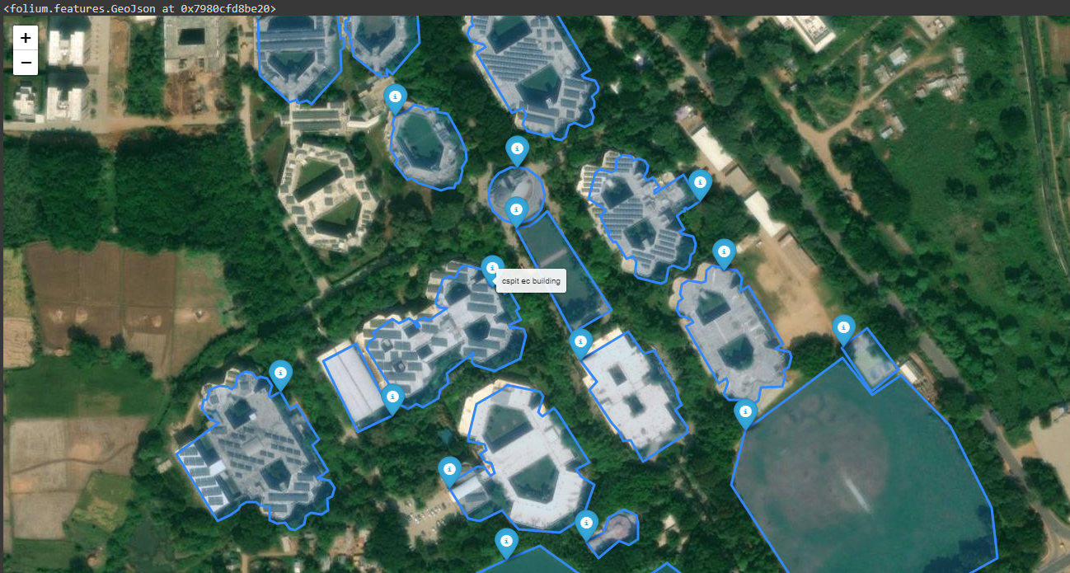



# Results and Discussion

The project successfully created an interactive map of the college campus, with markers and GeoJSON overlays accurately representing various facilities. Users can explore different sections of the campus, such as sports grounds, hostels, and educational buildings, through the dynamic interface.

-Mapping Accuracy: The coordinates and GeoJSON files accurately depict the physical layout of the campus. Each building and landmark is correctly positioned, and the markers make it easy to identify key areas.  
- Interactive Features: The ipywidgets integration enhances the user experience, allowing for real-time selection of markers and map layers. This dynamic approach increases user engagement and provides a practical tool for campus navigation.  
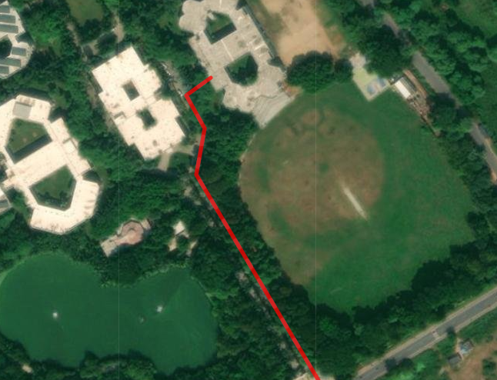

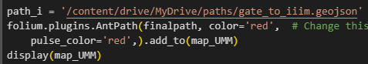

# Conclusion

This project demonstrates the power of Folium and GeoJSON in creating interactive, data-driven maps for institutional use. By visualizing the campus layout, students, visitors, and staff can navigate and explore campus locations efficiently. The use of interactive widgets further enhances the experience, making the tool adaptable to various needs. Future enhancements could include incorporating more locations and adding layers of information, such as building details or live campus updates.

# References

1. Python Software Foundation. (2023). Folium Documentation.
2. GeoJSON Format Specification. (2016).
3. Google Colab Documentation. (2024).
4. Widgets Documentation - ipywidgets (2024).

# Flask Integration for Web-based Mapping

To further enhance the accessibility and usability of the project, we have integrated the mapping system with Flask,   
a lightweight web framework for Python. Flask enables us to serve the interactive Folium-based map as a web application,   
allowing users to interact with the map through a browser. This makes it easier for students, staff, and visitors to explore   
the campus from any device.

## Steps for Web Conversion Using Flask

1. **Setting Up Flask:** The first step involved setting up a Flask web server to serve the map. Flask was chosen for its simplicity   
and ease of integration with Python-based projects.   
2. **Serving the Map:** We created routes in Flask that generate the Folium map dynamically. The map is embedded into an HTML template   
and rendered as a webpage using the Flask `render_template()` function.  
3. **User Interaction:** The web version allows for real-time interaction through the browser. Flask handles the requests, and the Folium map   
responds dynamically, allowing users to select locations and view their details.  
4. **Deployment:** The Flask application can be deployed on a web server, making it accessible to anyone within the network or even publicly.

## Benefits of Flask Integration

- **Accessibility:** With the web-based system, users can access the campus map from anywhere without needing to install any software.  
- **Scalability:** The Flask integration allows us to scale the project further by adding additional features, such as search functionality,   
live campus updates, and more.  
- **Responsive Design:** The use of HTML, CSS, and Flask ensures that the web application can be made responsive and user-friendly   
on both desktop and mobile devices.

# Conclusion

With the integration of Flask, the project has evolved from a Python-based tool into a fully functional web application.   
This transition increases the project's usability and potential for real-world application, enabling users to explore the campus   
interactively and conveniently through any web-enabled device. Future improvements could include real-time campus updates,   
mobile compatibility, and further enhancements in UI/UX.