Name: Darsh Mehta

TE COMPS

Batch B

UID: 2018130023

# CEL 51, DCCN, Monsoon 2020

**Lab 4: Prototyping a Network**

**Objective:**

Prototype a network using Packet Tracer

**Background**

A client has requested that you set up a simple network with two PCs connected to a switch. Verify that the hardware, along with the given configurations, meet the requirements of the client.

**Switches** facilitate the sharing of resources by connecting together all the devices, including computers, printers, and servers, in a small business network. It connects devices on a computer network by using packet switching to receive and forward data to the destination device. A network switch is a multiport network bridge that uses MAC addresses to forward data at the data link layer of the OSI model.

**Router** connects multiple switches, and their respective networks, to form an even larger network. It works as a dispatcher, directing traffic and choosing the most efficient route for information, in the form of data packets, to travel across a network.

**Step 1: Set up the network topology**

1. Add two PCs and a Cisco 2950T switch

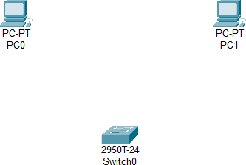

1. Using straight-through cables, connect **PC0** to interface

**Fa0/1** on **Switch0** and **PC1** to interface **Fa0/2** on **Switch0**.

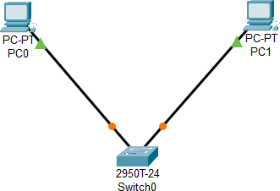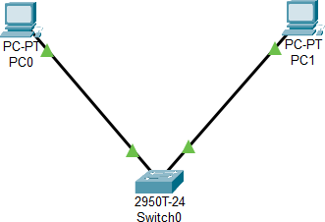

1. Configure PC0 using the **Config** tab in the PC0 configuration window:

a. IP address: 192.168.10.10

b. Subnet Mask 255.255.255.0

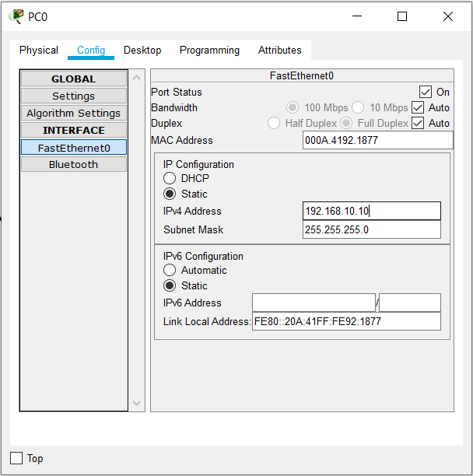

1. Configure PC1 using the **Config** tab in the PC1 configuration window

a. IP address: 192.168.10.11

b. Subnet Mask 255.255.255.0

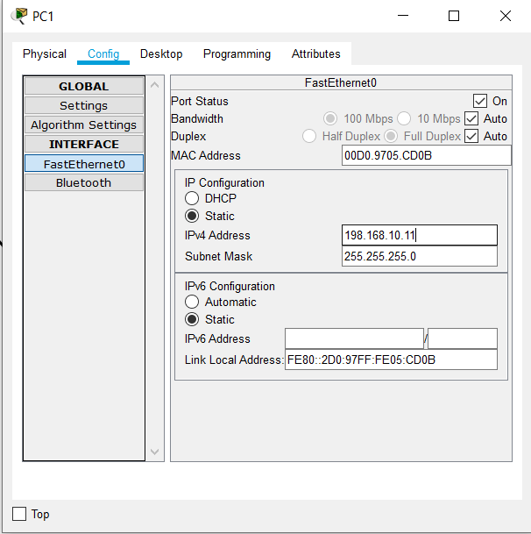

**Step 2: Test connectivity from PC0 to PC1**

1. Use the **ping** command to test connectivity.
   1. Click PC0.
   2. Choose the **Desktop** tab.

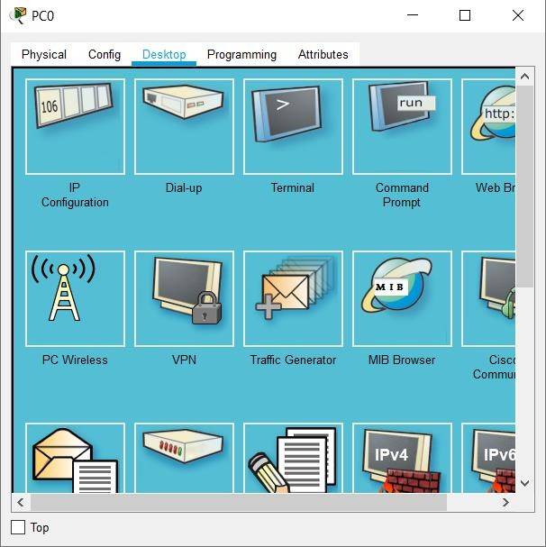

* 1. Choose **Command Prompt**.
  2. Type: **ping 192.168.10.11** and press *enter*.

1. A successful **ping** indicates the network was configured correctly and the prototype validates the hardware and software configurations. A successful ping should resemble the below output:

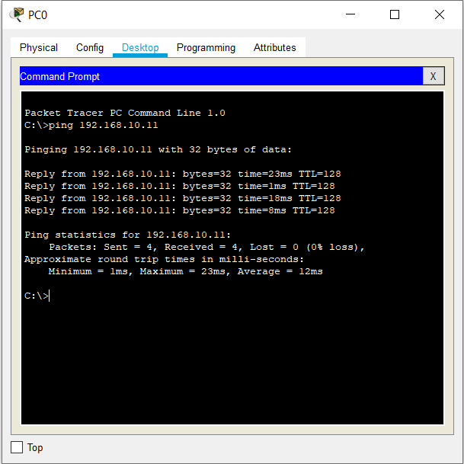

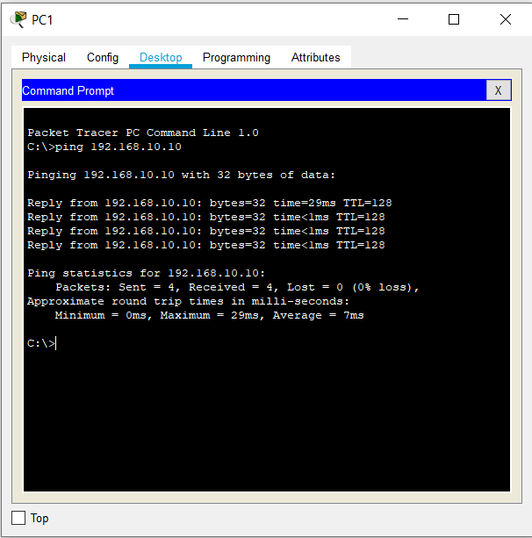

1. Close the configuration window.

192.168.10.10

192.168.10.11



1. Click the **Check Results** button at the bottom of the instruction window to check your work.

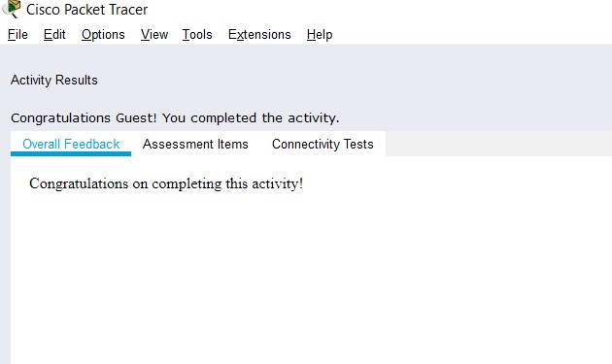

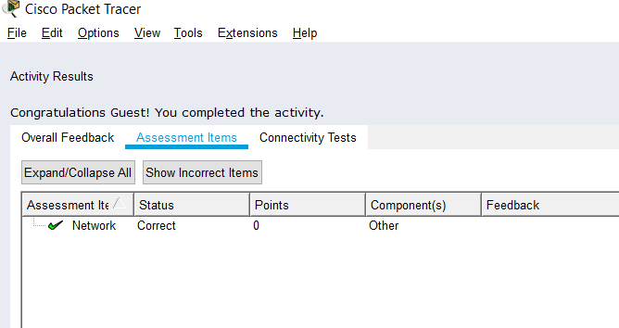

# CEL51, DCCN, Monsoon 2020

**Lab 4.1: Basic configuration - hostname, motd banner, passwd etc**

**Objective:**

This lab will test your ability to configure basic settings such as hostname, motd banner, encrypted passwords, and terminal options on a Packet Tracer 6.2 simulated Cisco Catalyst switch.

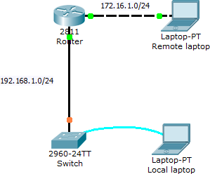

1. Use the local laptop connect to the switch console.

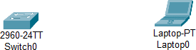

Rename Laptop0 –> Local Laptop

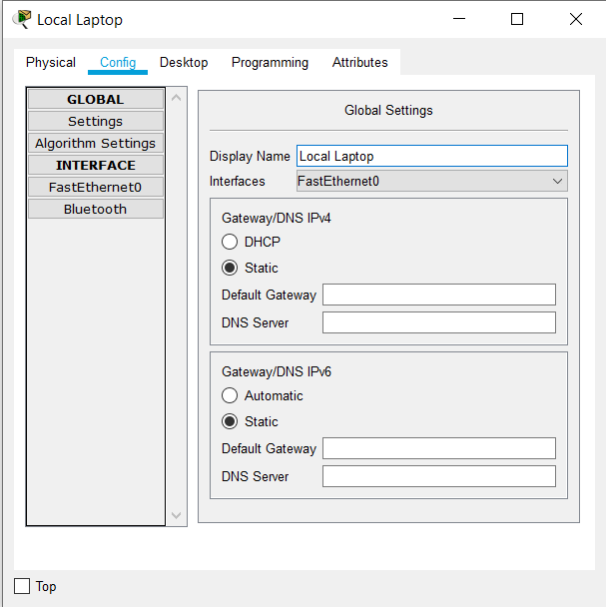

Connect console connection to RS232 port of Local Laptop and Console port of Switch

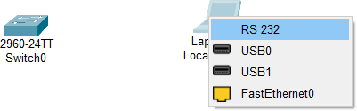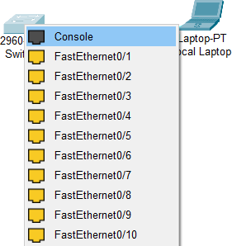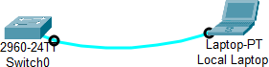

Open terminal of local laptop

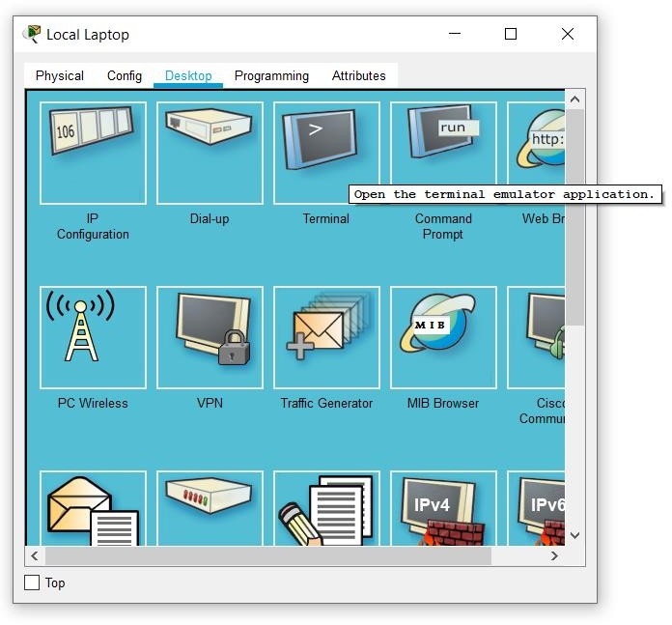

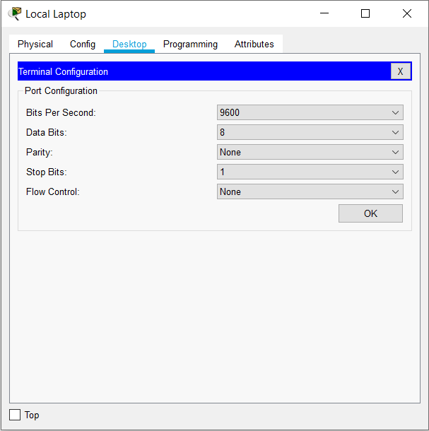

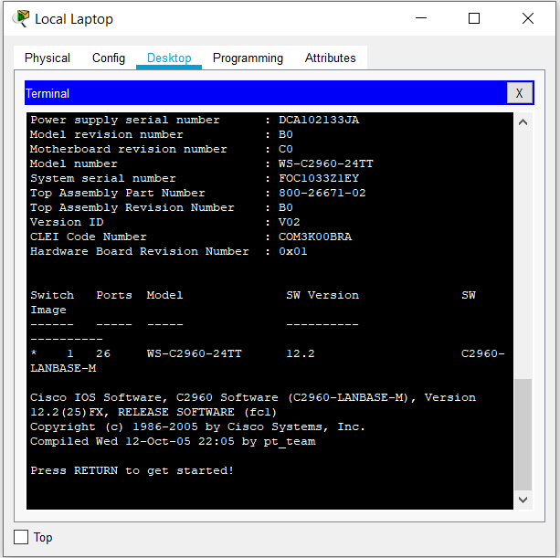

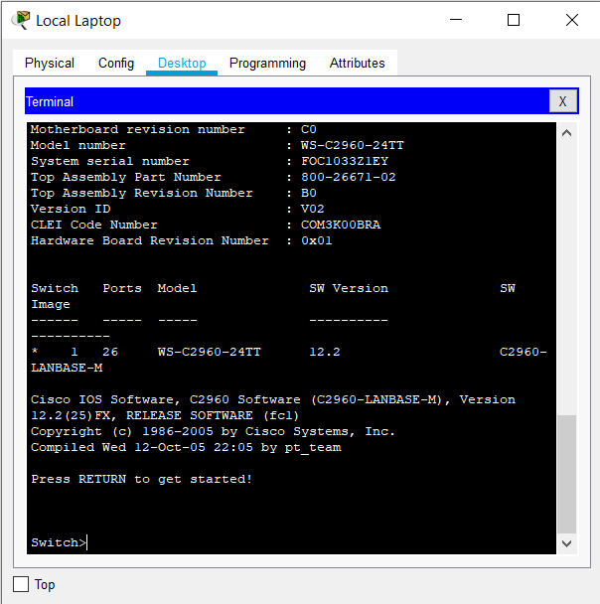

Enable command - To enter in privilege exec mode

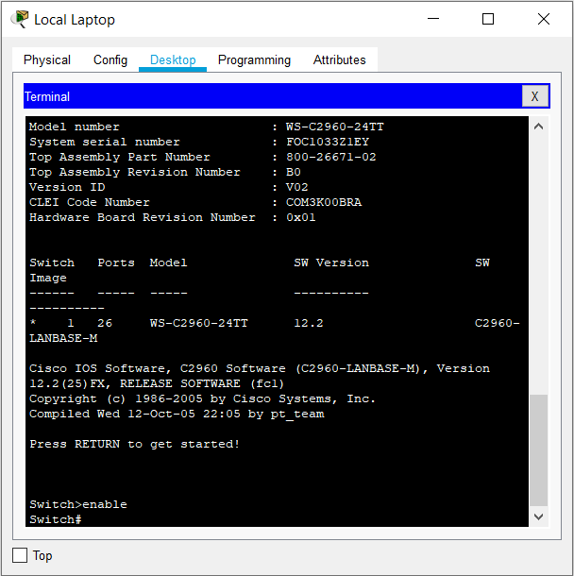

1. Configure Switch hostname as LOCAL-SWITCH Enter configuration mode

Use the configure privileged EXEC command to enter global configuration mode.

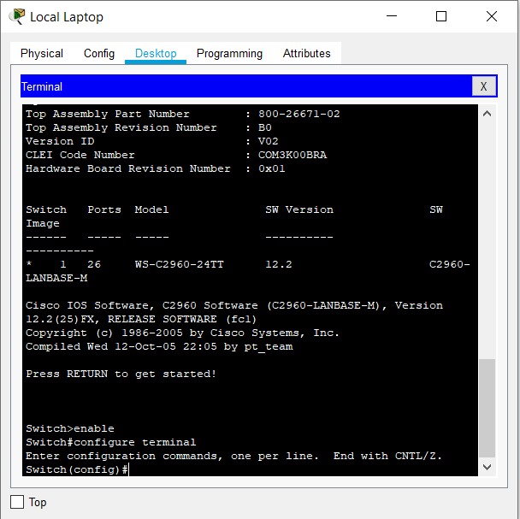

Set hostname as LOCAL-SWITCH using hostname LOCAL-SWITCH command

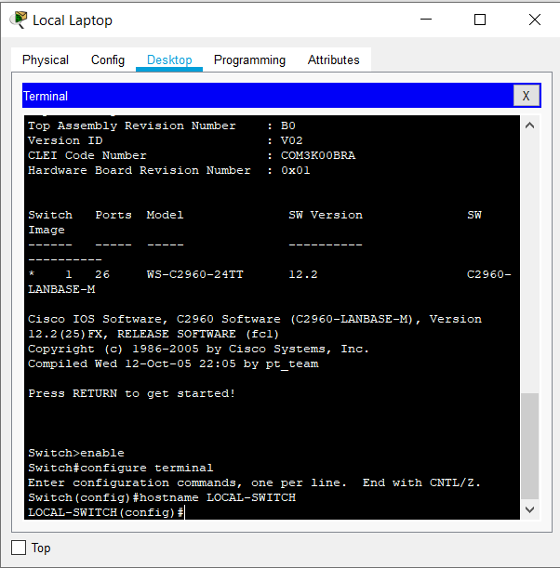

Run show running-config command to check the hostname.

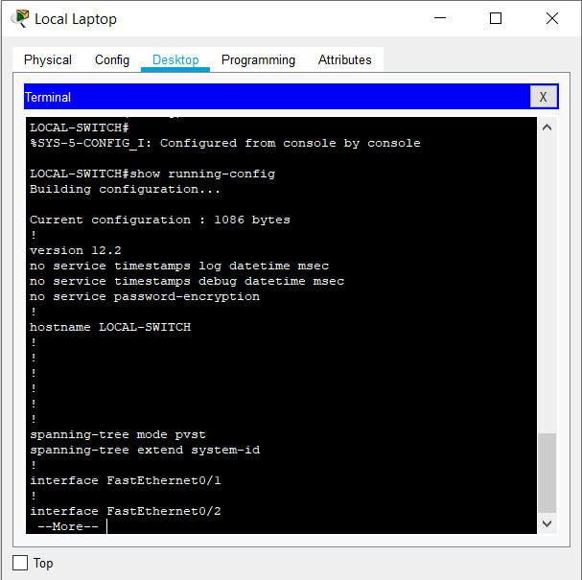

1. Configure the message of the day as "Unauthorized access is forbidden"

Use command banner motd #

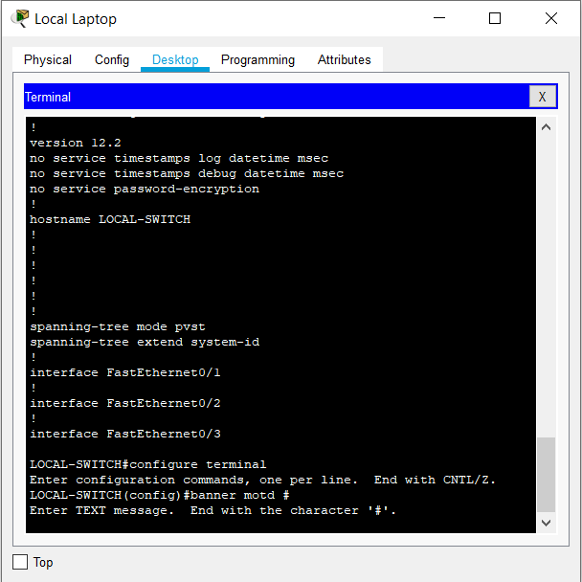

Type the message and add # at the end.

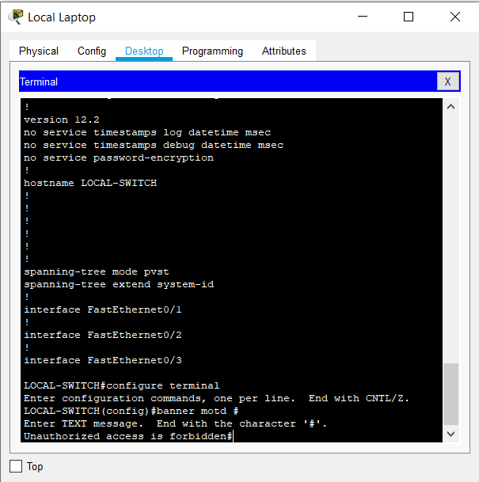

You can check the message of the day when you open the terminal for accessing switch again.

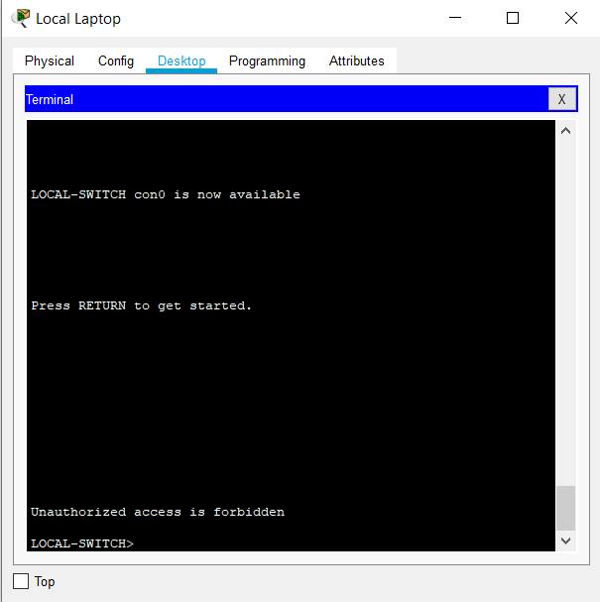

1. Configure the password for privileged mode access as "cisco". The password must be md5 encrypted

Use command enable secret cisco

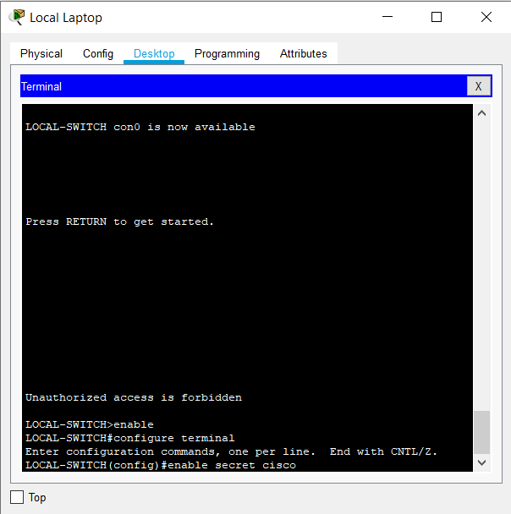

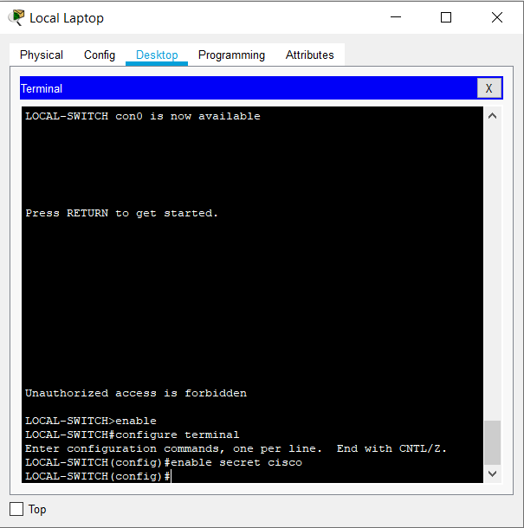

In running-config it displays as enable secret.

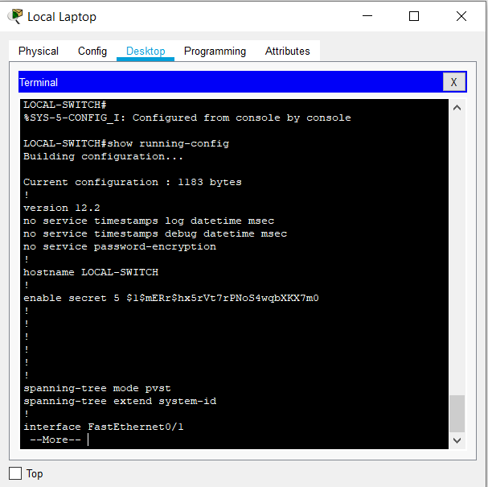

When we try to enable switch again, it will ask for password.

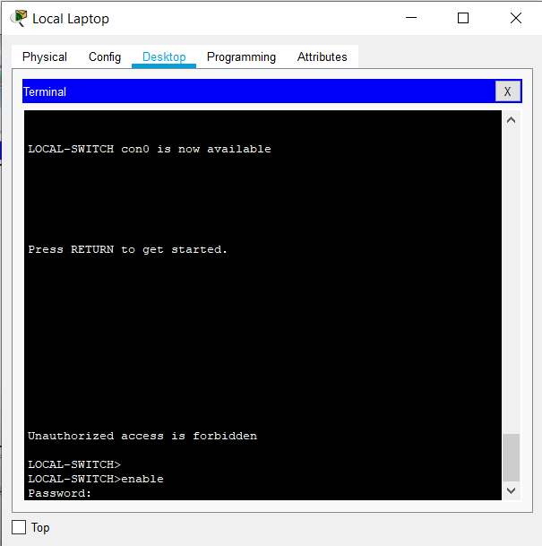

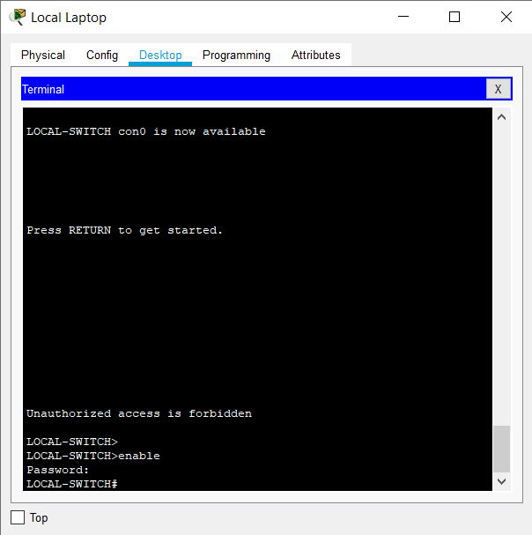

1. Configure password encryption on the switch using the global configuration command

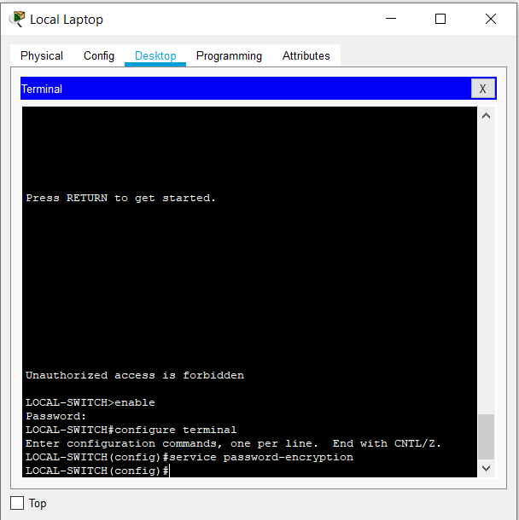

In running-config, service password-encryption is displayed.

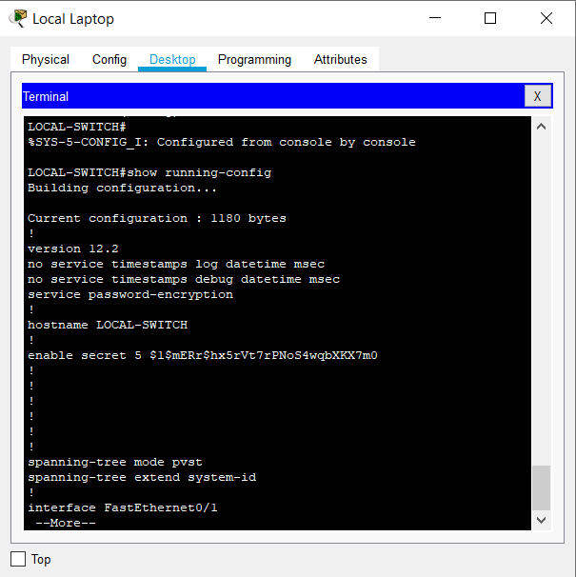

1. Configure CONSOLE access with the following settings:

* Login enabled
* Password: whatever you like
* History size: 15 commands
* Timeout: 6'45''
* Synchronous logging

The con 0 configuration is empty in the beginning

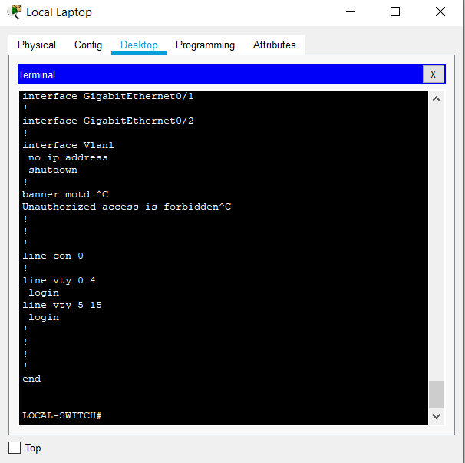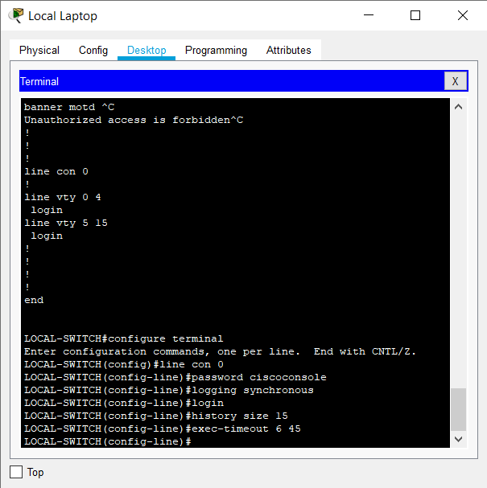

Line con 0 now shows the console configuration.

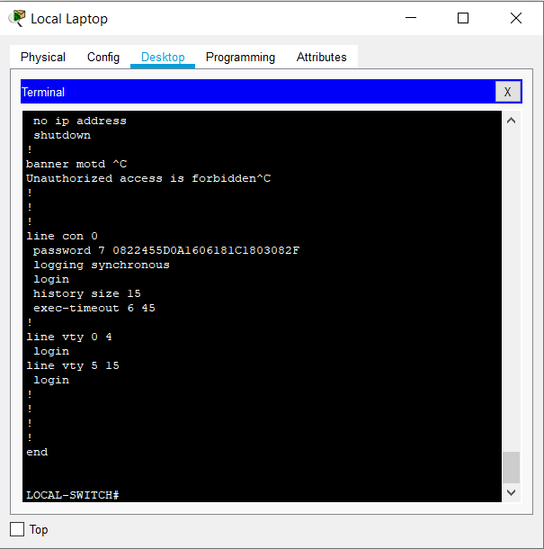

1. Configure TELNET access with the following settings:

* Login enabled
* Password: whatever you like
* History size: 15 commands
* Timeout: 8’20’’
* Synchronous logging

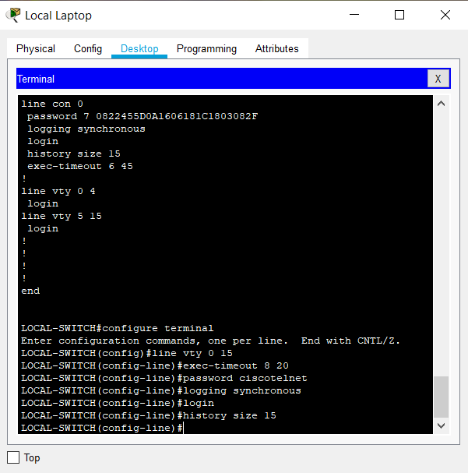

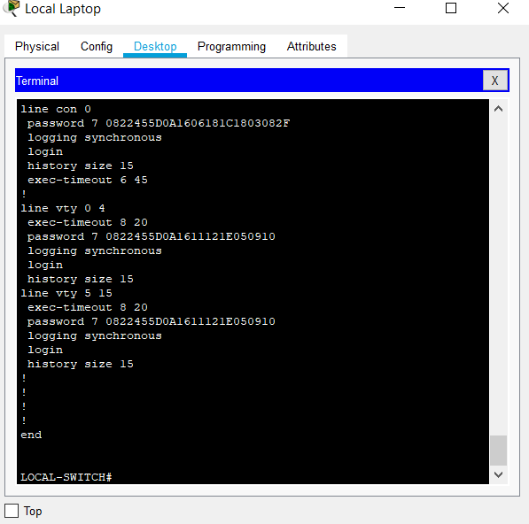

1. Configure the IP address of the switch as 192.168.1.2/24 and its default gateway IP (192.168.1.1).

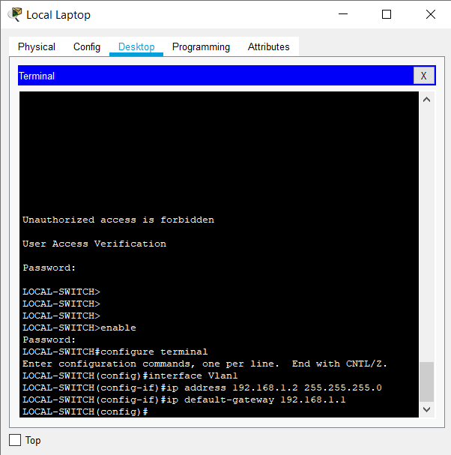

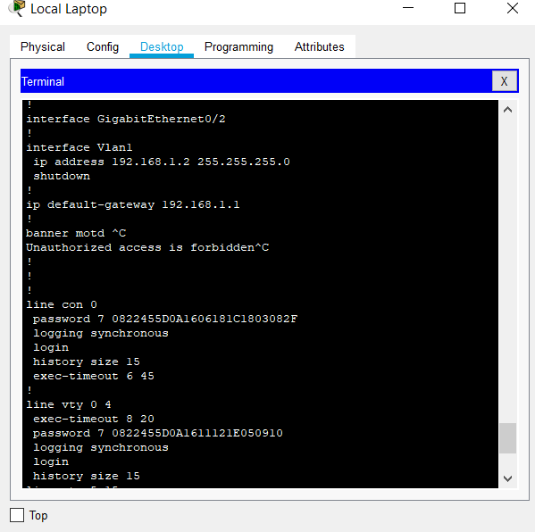Ip address and default gateway are now displayed in interface vlan The default gateway address is the ip address of the router.

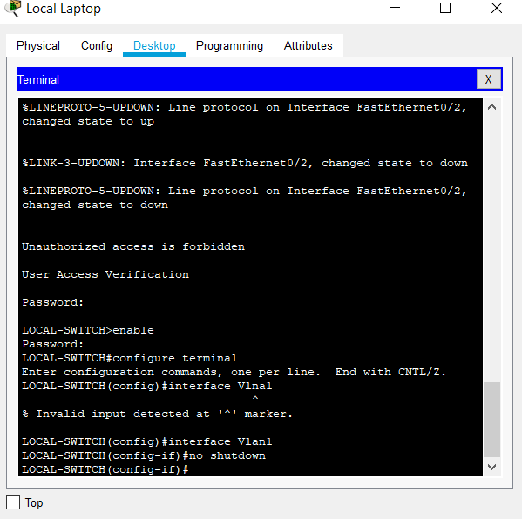

1. Test telnet connectivity from the Remote Laptop using the telnet client.

Configuration of Remote laptop

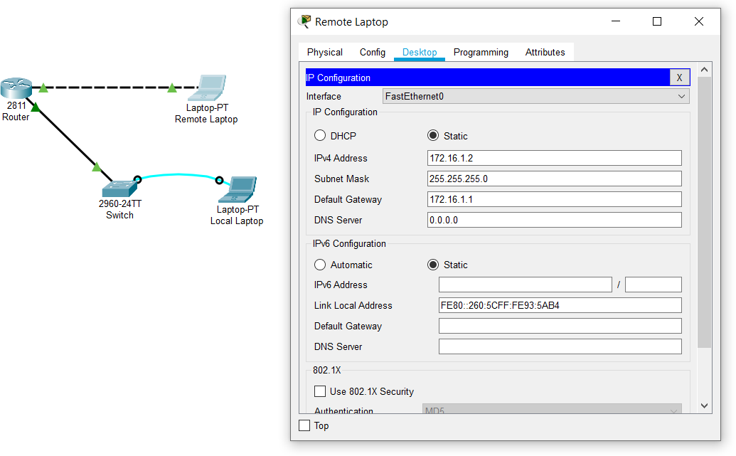

Configuration of Router

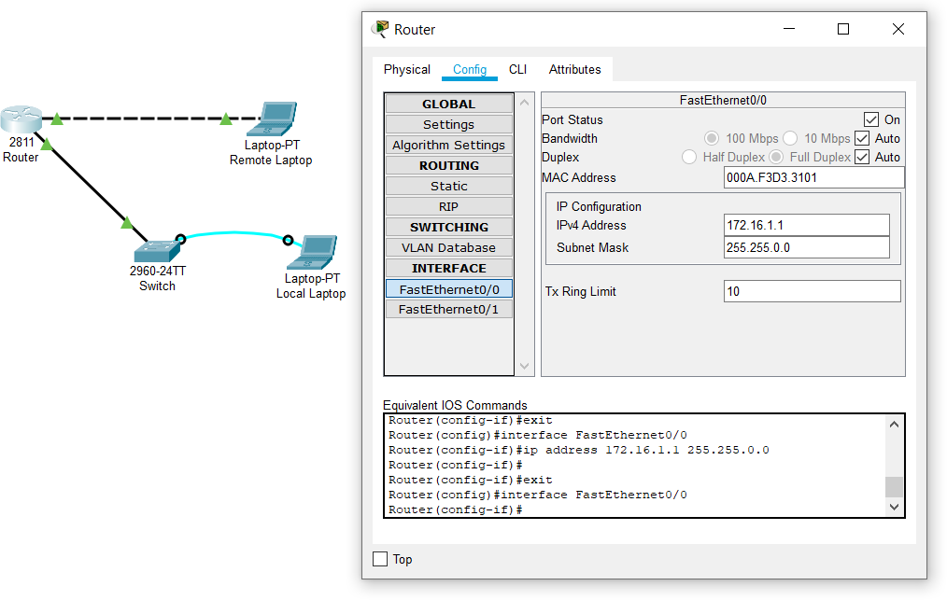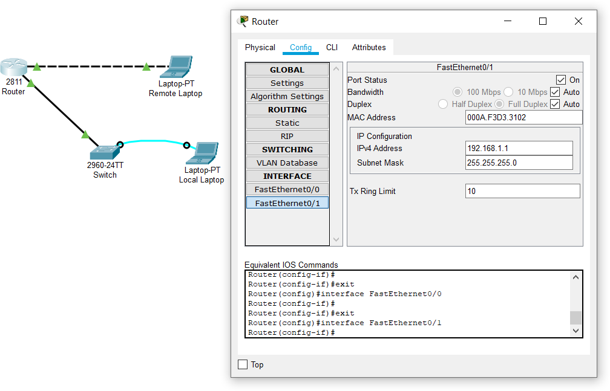

Configuration of Switch

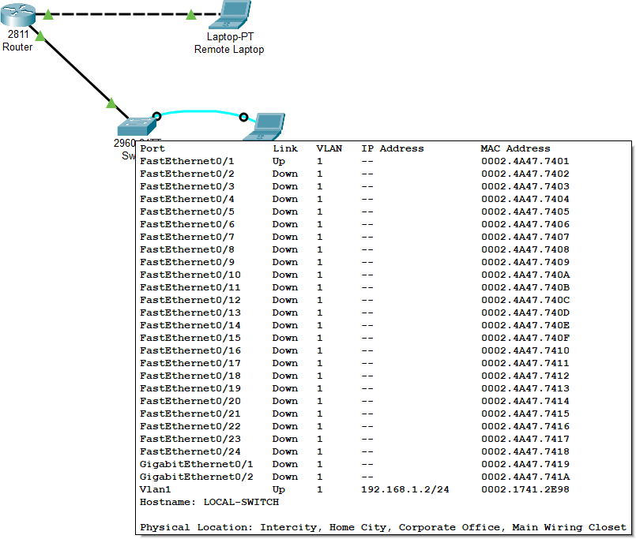

Configuration of Remote Laptop

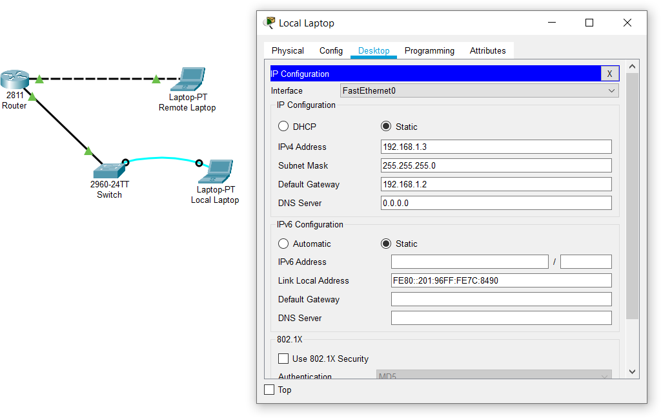

Pinging Router from Remote Laptop

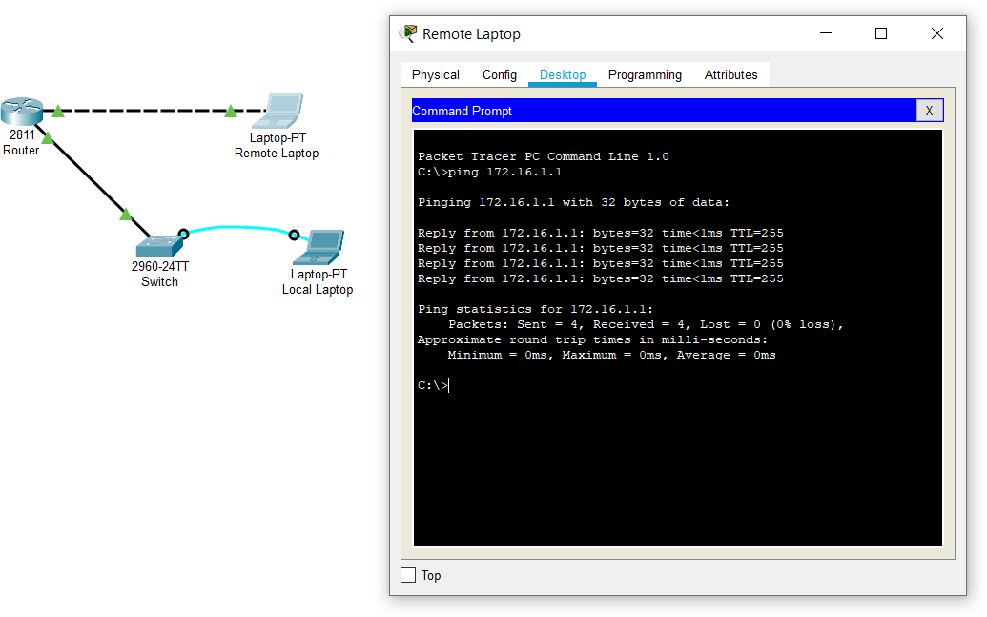

Pinging another Ethernet port of Router from Remote Laptop

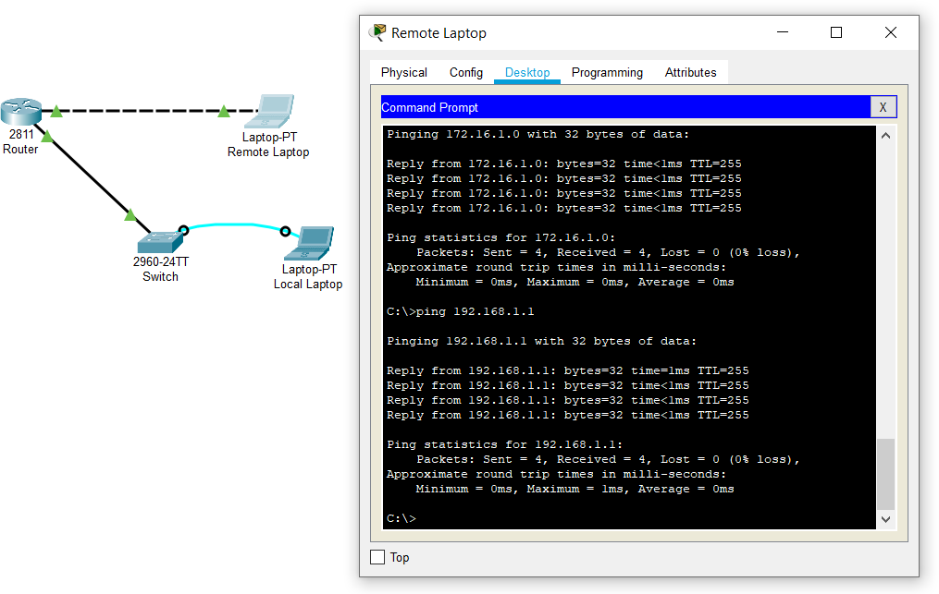

Pinging Switch from Remote Laptop

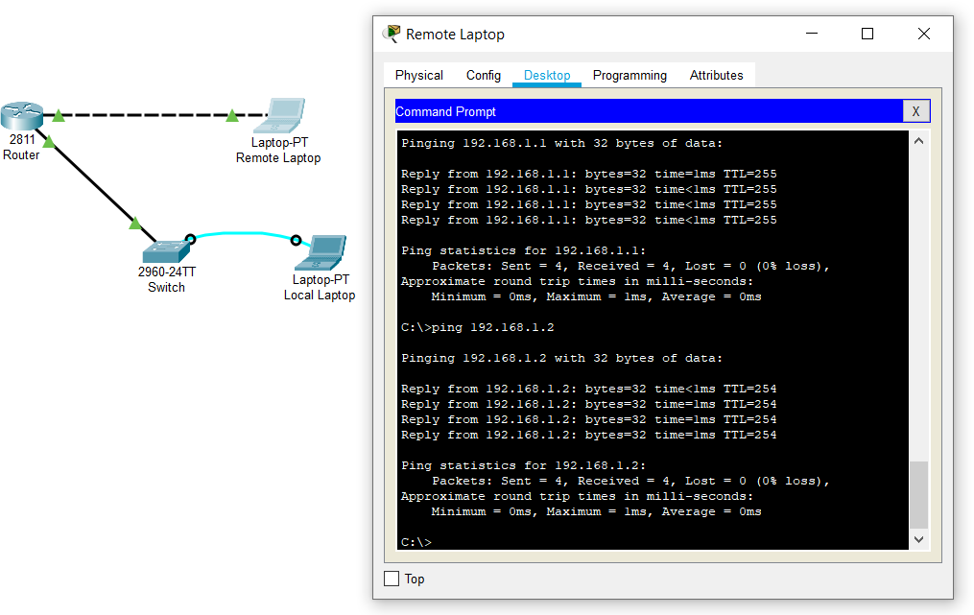

Telnet Switch from Remote Laptop

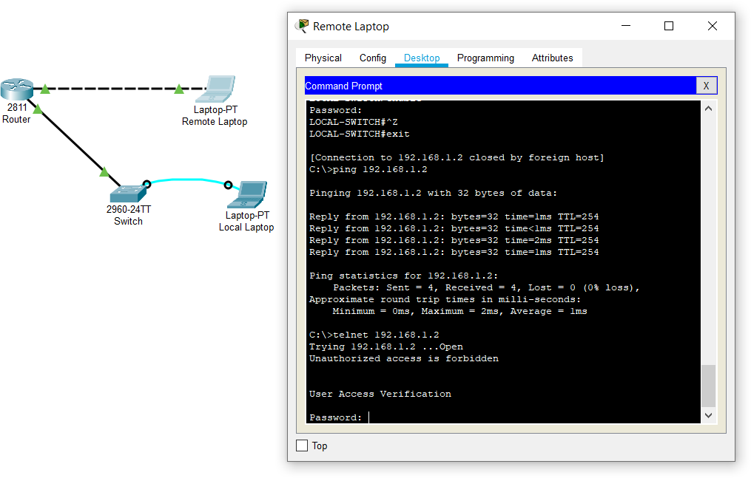

After entering password for telnet

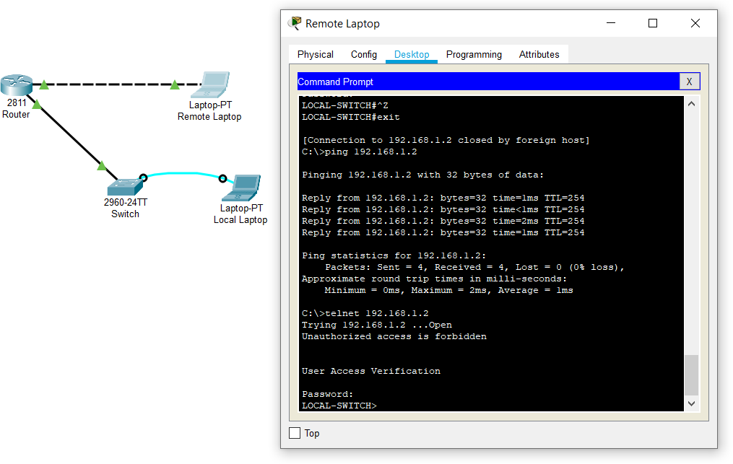

Enabling switch from Remote Laptop

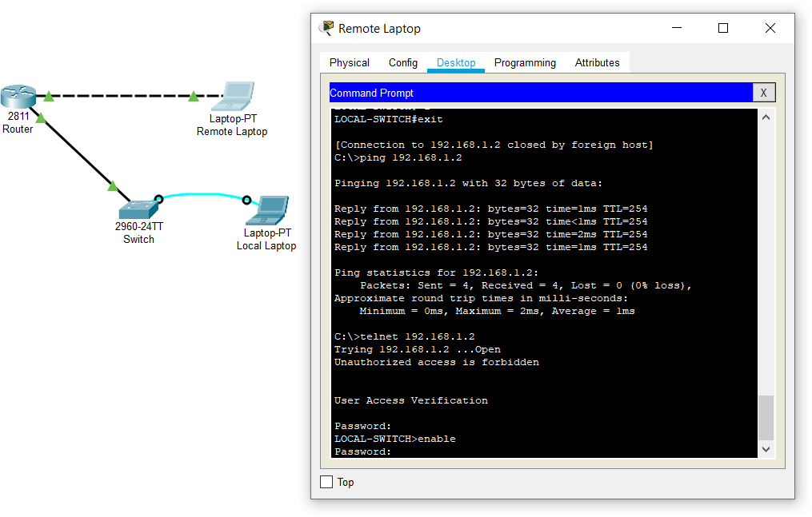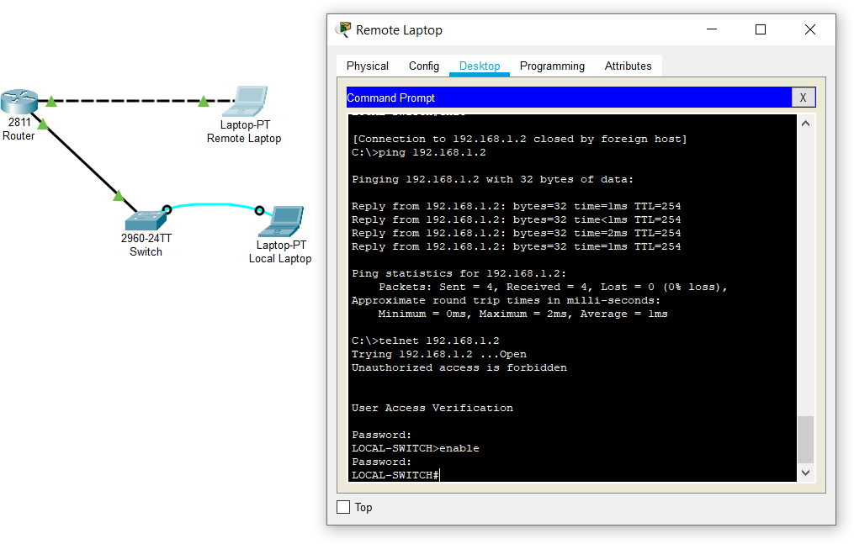

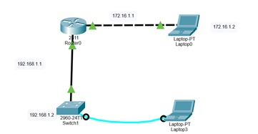

**Conclusion:**

* 1. In this experiment, I learned about setting up network with Router and Switch.
  2. I learned to configure Switch using console. I understood how to configure terminal.
  3. I configured telnet for switch and checked its connectivity from remote laptop.